SLIDE 1

Desing goals of PDC:

- Performance improvement: Speedup, High Throughput, Low Latency

- Scalability: Horizontal, Vertical, Load Balancing

- Reliability & Fault Tolerance: Redundancy, Replication, Recovery Mechanism

- Resource Sharing & Utilization: Efficient resource utilization, Multi-user support

- Transparency: Access, Location, Replication, Concurrency, Failure.

- Modularity & Flexibility

- Heterogeneity Support: Support for different hardware, OS, protocols

- Cost Effectiveness

- Security and Privacy

Parallel Overhead:

- Task start-up time

- Synchronizations

- Data communications

- Software overhead imposed by parallel languages, libraries, operating system, etc.

- Task termination time

Some Terminologies:

Distributed Systems: A collection of autonomous computers, connected through a network and distribution middleware.

Distributed Computing: This type of computing is mainly concerned with developing algorithms for the distributed cluster system.

Overall Speedup: (Wall-clock time for Serial execution)/ (Wall-clock time for Parallel execution)

Pipelining: is a technique where multiple tasks are divided into smaller steps and processed at the same time, like an assembly line, to make things faster.

Shared Memory: All processors access the same global memory space. Easy to program. Faster communication between processes. Limited Scalability and risk of race condition.

Distributed Memory: Each processor has its own private memory. Processors communicate by sending messages. Scalable, where each processor can work independently. Its harder to program and slower communication.

Parallel Systems: Memory can be shared or distributed, Communication is fast, with limited scalability and lower fault tolerance

Distributed Systems: Memory is distributed, uses network (LAN, WAN) for communication, Highly scalable, with high fault tolerance

Fylnn’s Classical Taxonomy:

SISD, SIMD, MISD, MIMD

SLIDE 2

1. Explicit Parallelism
- The programmer manually defines how and where parallel execution should happen.
- Requires handling threads, synchronization, and communication.
- Common techniques:
  - Data Parallelism: Same operation on large datasets in parallel. Each processor works on a different part of the data.
  - Task Parallelism: Different tasks operate on different data parts, executed concurrently.
  - Loop-Level Parallelism: Independent loop iterations are executed in parallel.
  - Thread-Level Parallelism: Multiple threads run simultaneously to perform different tasks.

2. Implicit Parallelism
- The compiler, runtime, or system automatically identifies opportunities for parallelism.
- No manual intervention by the programmer.
- Common techniques:
  - Instruction-Level Parallelism (ILP): Executes multiple instructions simultaneously in a single CPU core.
    - Techniques include:
      - Pipelining: Different stages of multiple instructions are executed at the same time.
      - Superscalar: Executes multiple instructions in parallel.
      - Super-pipelining: Combines pipelining and superscalar.
      - Vectorization: Performs the same operation on multiple data elements simultaneously.
  - Compiler-Driven Optimizations:
    - Copy Propagation
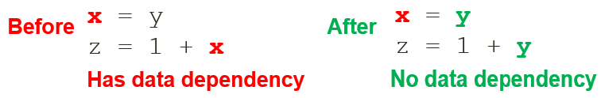

    - Constant folding
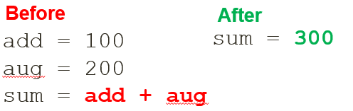
    - Dead code elimination
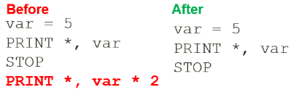
    - Strength reduction
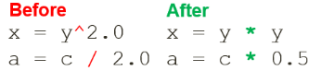
    - Common Subexpression elimination
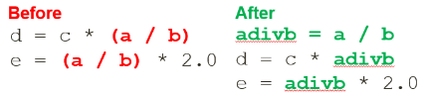
    - Variable renaming
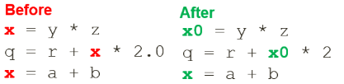
  - Loop Optimizations:
    - Hoisting Loop Invariant Code
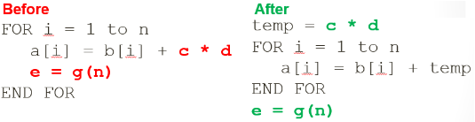
    - Unswitching
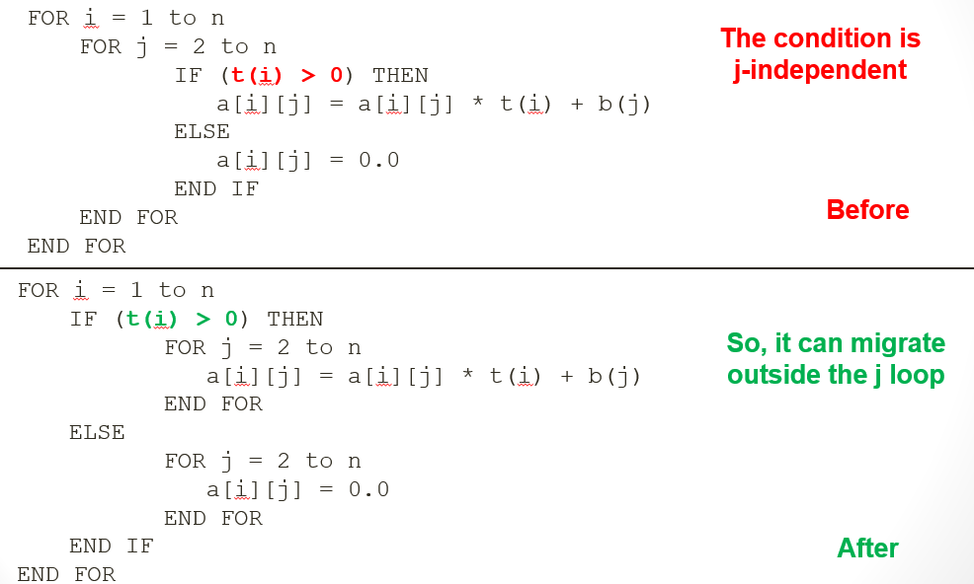

    - Iteration peeling
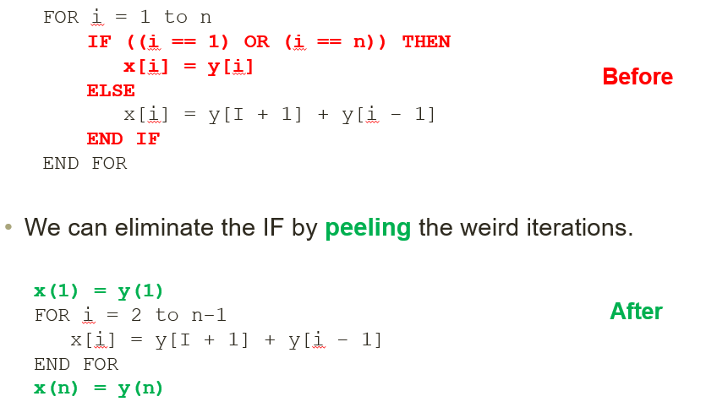
    - Index set splitting
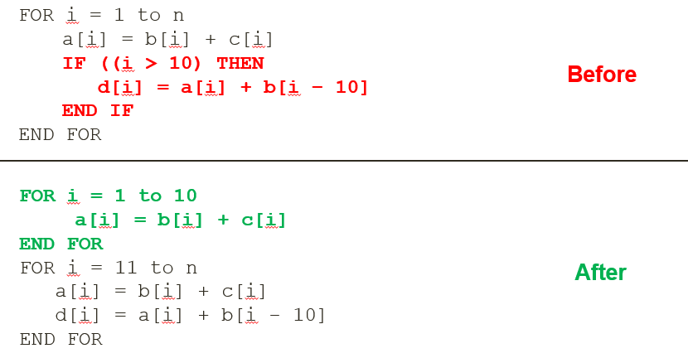
    - Loop interchange
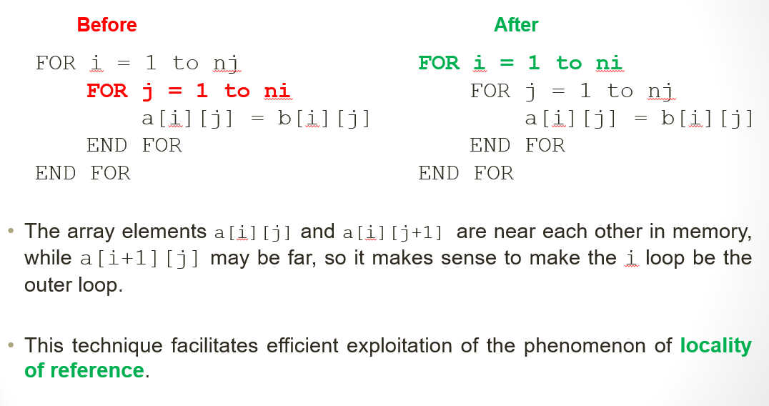
    - Unrolling
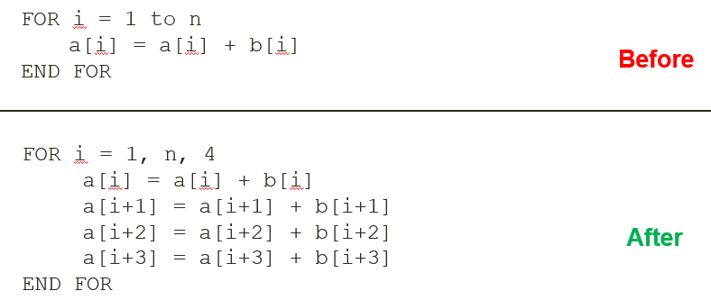

Dependencies and Hazards
- Data Dependency: RAW (RAW data) ---------->
- Anti Dependency: WAR (Anti-WAR dependency) -----|---->
- Output Dependency: WAW (Only getting output WAW) ----O--→

SLIDE 3
Shared Memory Model (without threads)
  - Processes share a common address space.
  - Communication through shared variables (no explicit messaging).
  - Requires synchronization (locks, semaphores) to avoid race conditions/deadlocks.
  - Simple to develop but hard to manage data locality and memory contention.

Threads Model
  - One heavyweight process (a.out) spawns lightweight threads.
  - Threads share global memory but have their own local data.
  - Common implementations:
    - Pthreads: Manual, detailed, low-level control (C language).
    - OpenMP: Compiler directives, easier and more portable.
    - Other: Java threads, Python threads, CUDA threads (GPU).

Distributed Memory / Message Passing Model
  - Tasks have their own memory and exchange data via message passing (e.g., send/receive).
  - Most popular implementation: MPI (Message Passing Interface).
  - Great for multi-node systems, scalable, and widely supported.

Data Parallel Model
  - Same operation applied to different parts of a data set.
  - Common in large data structures like arrays.
  - Each task handles a separate chunk of data.
  - Implementations: Coarray Fortran, UPC, Global Arrays, X10, Chapel.

Hybrid Model
  - Combines models for efficiency.
  - Example: MPI + OpenMP – MPI across nodes, OpenMP within a node.
  - Another: MPI + CUDA – CPUs communicate via MPI, GPUs handle heavy computation.

SPMD (Single Program, Multiple Data)
  - All tasks run the same program but operate on different data.
  - Often used with MPI or hybrid models.
  - Supports conditional branching within tasks.

- MPMD (Multiple Program, Multiple Data)
  - Each task can run different programs on different data.
  - Used in complex systems requiring specialized task behavior.

SLIDE 4

Understand the Problem:
* Identifiy the hotspots * Identify the bottlenecks

Partitioning:
Domain Decomposition: In this type of partitioning, the data associated with a problem is decomposed
Functional Decomposition: he focus is on the computation that is to be performed rather than on the data manipulated by the computation. The problem is decomposed according to the work that must be done. Each task then performs a portion of the overall work.

Embarrassingly Parallel: As little, or no communication is required

Factors to Consider during parallelization:
* Cost of Communications
* Latency vs. Bandwidth
* Visibility of Communications
* Synchronous vs. Asynchronous Communications
* Scope of Communications
* Efficiency of Communications
* Overhead and Complexity
* And many moooore

Types of Synchronization
* Barrier: All the tasks wait until the last task reaches the barrier and then all tasks are synchronized
* Locks/Semaphores: Critical section is secured using locks so only one task can use it at a time
* Synchronous Communication Operations: Tasks performing communication operation require some form of communication. Like a task must reciever 200 OK, before it can perform send operation

Load Balancing:
Load balancing refers to the practice of distributing work among tasks so that all tasks are kept busy all the time

Equally partition the work each task receives:
* For array/matrix operations where each task performs similar work, evenly distribute the data set among the tasks.
* For loop iterations where the work done in each iteration is similar, evenly distribute the iterations across the tasks
* If a heterogeneous mix of machines with varying performance characteristics are being used, be sure to use some type of performance analysis tool to detect any load imbalances. Adjust work accordingly.

Use dynamic work assignment:
* Sparse arrays – some tasks have actual data to work on while others have mostly "zeros".
* Adaptive grid methods - some tasks may need to refine their mesh while others don't.
* N-body simulations - where some particles may migrate to/from their original task domain to another task's; where the particles owned by some tasks require more work than those owned by other tasks.
* Scheduler – task pool approach: When the amount of work each task will perform is intentionally variable, or is unable to be predicted,

Granularity:
Computation/Communication Ratio
Fine-grain:
* Relatively small amounts of computational work are done between communication events.
* Facilitates load balancing.
* Low granularity.
* Implies high communication overhead and less opportunity for performance enhancement

Coarse-grain:
* Relatively large amounts of computational work are done between communication/synchronization events.
* High computation to communication ratio
* Implies more opportunity for performance increase
* Harder to load balance efficiently

Limits and Costs of Parallel Programming
* Complexity
* Portability
* Scalability
* Resource Requirements

Amdahl’s Law:
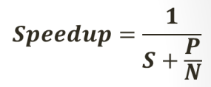

* Amdhals law shows how execution time decreases as no. of processors increase up to a certain limit
* Parallelization overhead is ignored by this law
* Optimistic estimate of speedup
To achieve desired speedup the number of processos needed (wher P:parallel and S:speedup)=
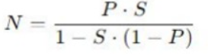

Gustafson-Barsis’s Law:
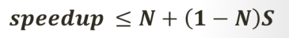

* Gustafson’s law argues that parallel portion grows as the problem size grows
* Gustafson’s law explains why supercomputers remain highly effective for solving large-scale problems despite having inherit serial portions

Karp-Flatt Metric:
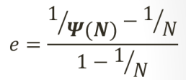

If e is small: problem is highly parallelizable
If e is large: The speedup is significantly limited by sequential execution or parallel inefficiencies (e.g. communication and sync overhead)
* If e remains constant as N increases it has inherent sequential bottleneck
* If e increases as N increases parallelization overheads dominates the speedup

Isoefficiency Metric:
Isoefficiency metric tells us how much we need to increase the problem size or computational work W to maintain a constant effeciency (E) as we add more processors.
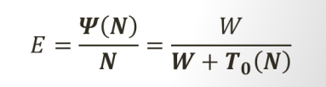

T(N) = Parallelization overhead (communication, sync, ..)

For a system to be scalable, the problem size W must grow at least as fast as total parallelization overhead T(N).

