Cavalry Recruitment Portal

Intro:

Cavalry recruitment portal is used to manage recruitment, on board and off board of applicant. Through this portal we can manage. Below are the features I have develop since I got hold of this dashboard

IP Authorize dashboard

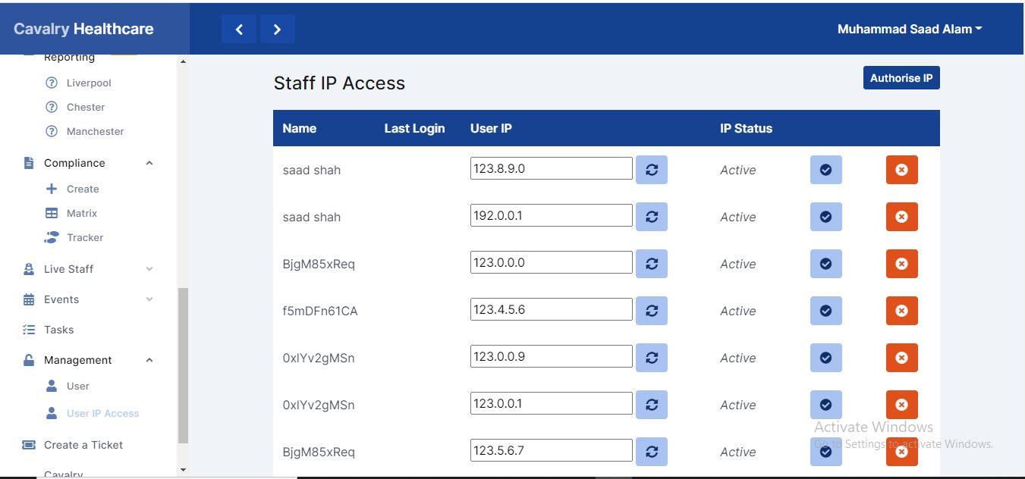

Intro:

This dashboard is used to manage access of user in this cms through ip authorization.

Features and functions:

Create IP:

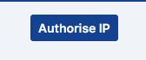

By Pressing this button a form will appear. Where you can insert IP by selecting active staff name to allow access. Below is the image of form.

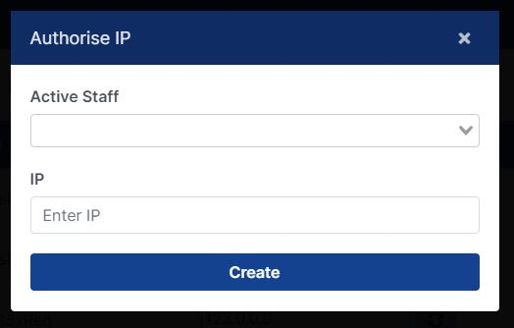

Update IP:



Here we can update IP. By simply entering new and and press update button.

Activate and Deactivate IP:



We use these button to activate and deactivate user according to needs.

Sms Sending System

Intro:

This system is used to send sms to members, creating templates for sms and review sms logs for status.

Function and features:

* Sms Sending System
* Template Creation
* Sms Logs

Sms Sending System (indvidual):

Using this system we can send sms to members individually. Below are the image to show. How to send individual sms. Please review this image for better understanding.

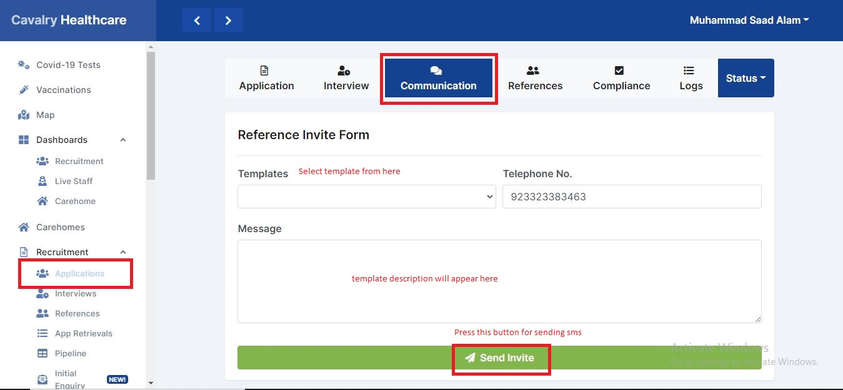

Sms Sending System (Mass):

How to send mass sms. Please review these image for better understanding.

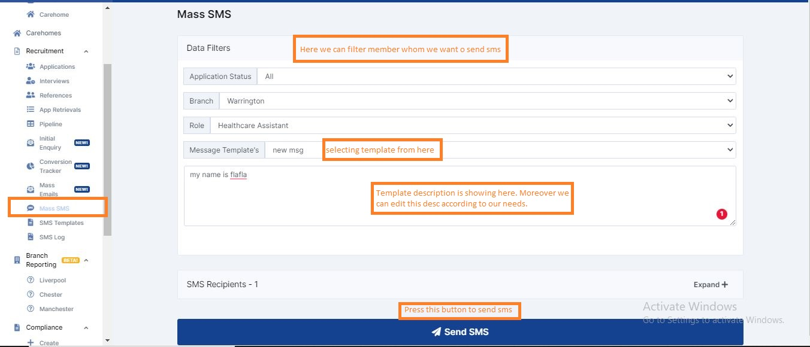

As you see in above image how you can filter members, select template and edit the description if needed and send sms.

Filter results:

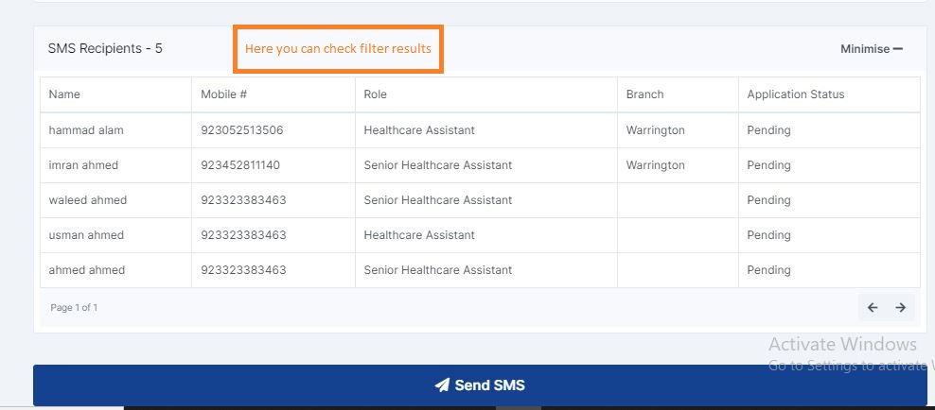

Template Creation:

Intro:

This section is used to create, list, activate and deactivate templates for sms.

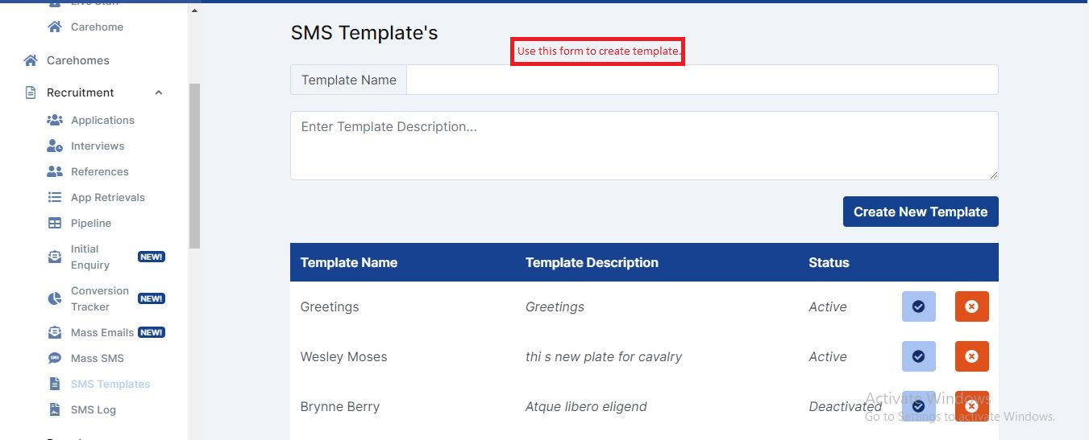

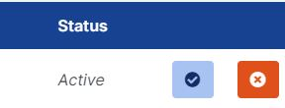

Above images show the submission form and listing of templates. By filling form we can create a new template and using these button we can activate and deactivate it accordingly.

Sms Logs:

Sms logs are used to see batch id, status, number of recipients, and massage of send sms. Once we send sms, we can review this section for results.

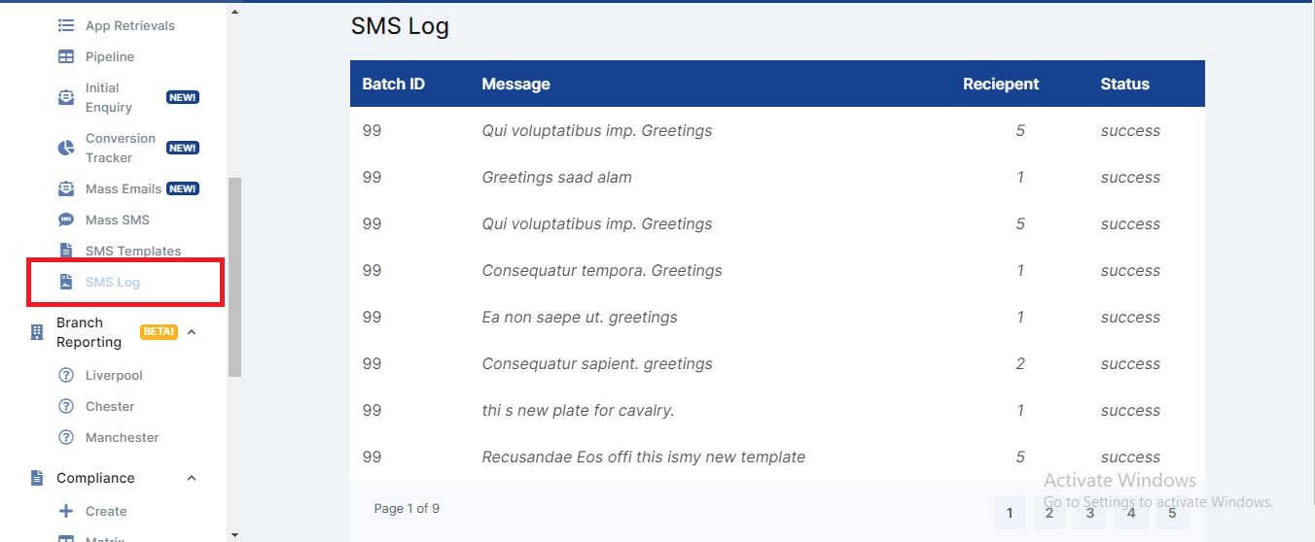

Branch updates in filters and sidebar menu:

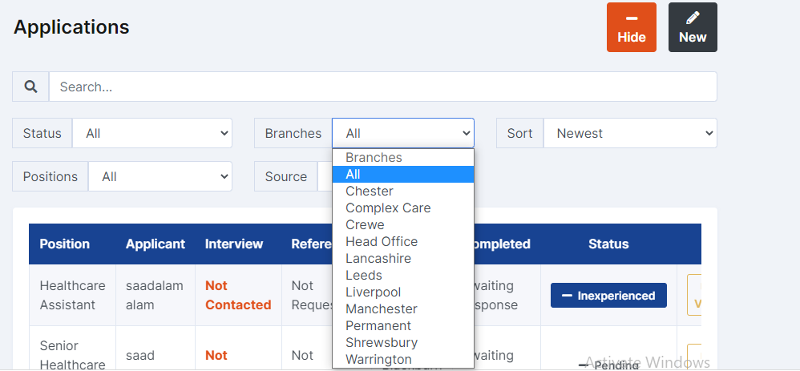

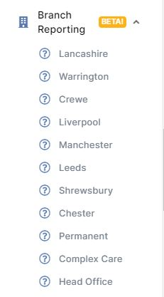

Sidebar Menu Updates:

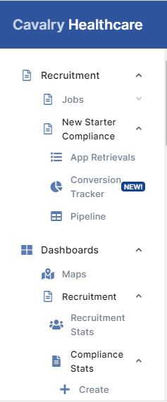

Branch Reporting Section:

In this section we can calculate working hours of a branches

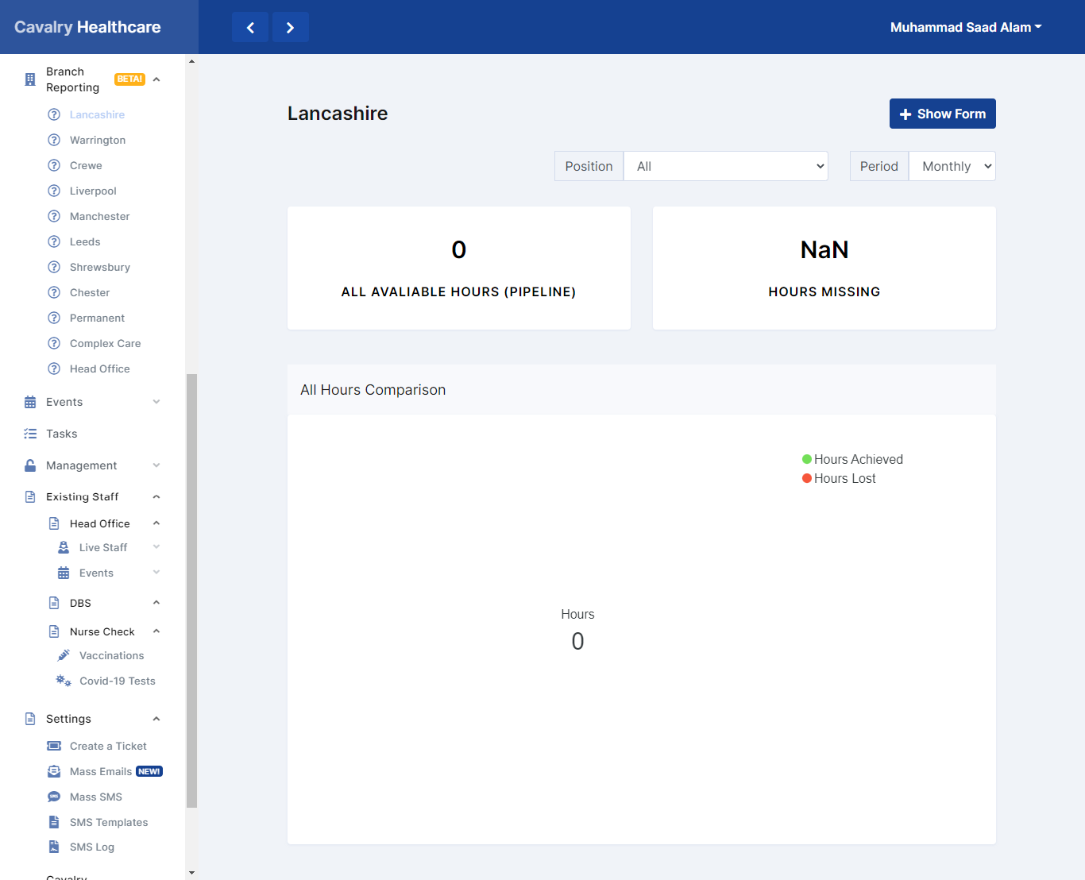

On-Board & Off-Board:

These features are to for on and off boarding of an employee. Below is the form used image used for the purpose

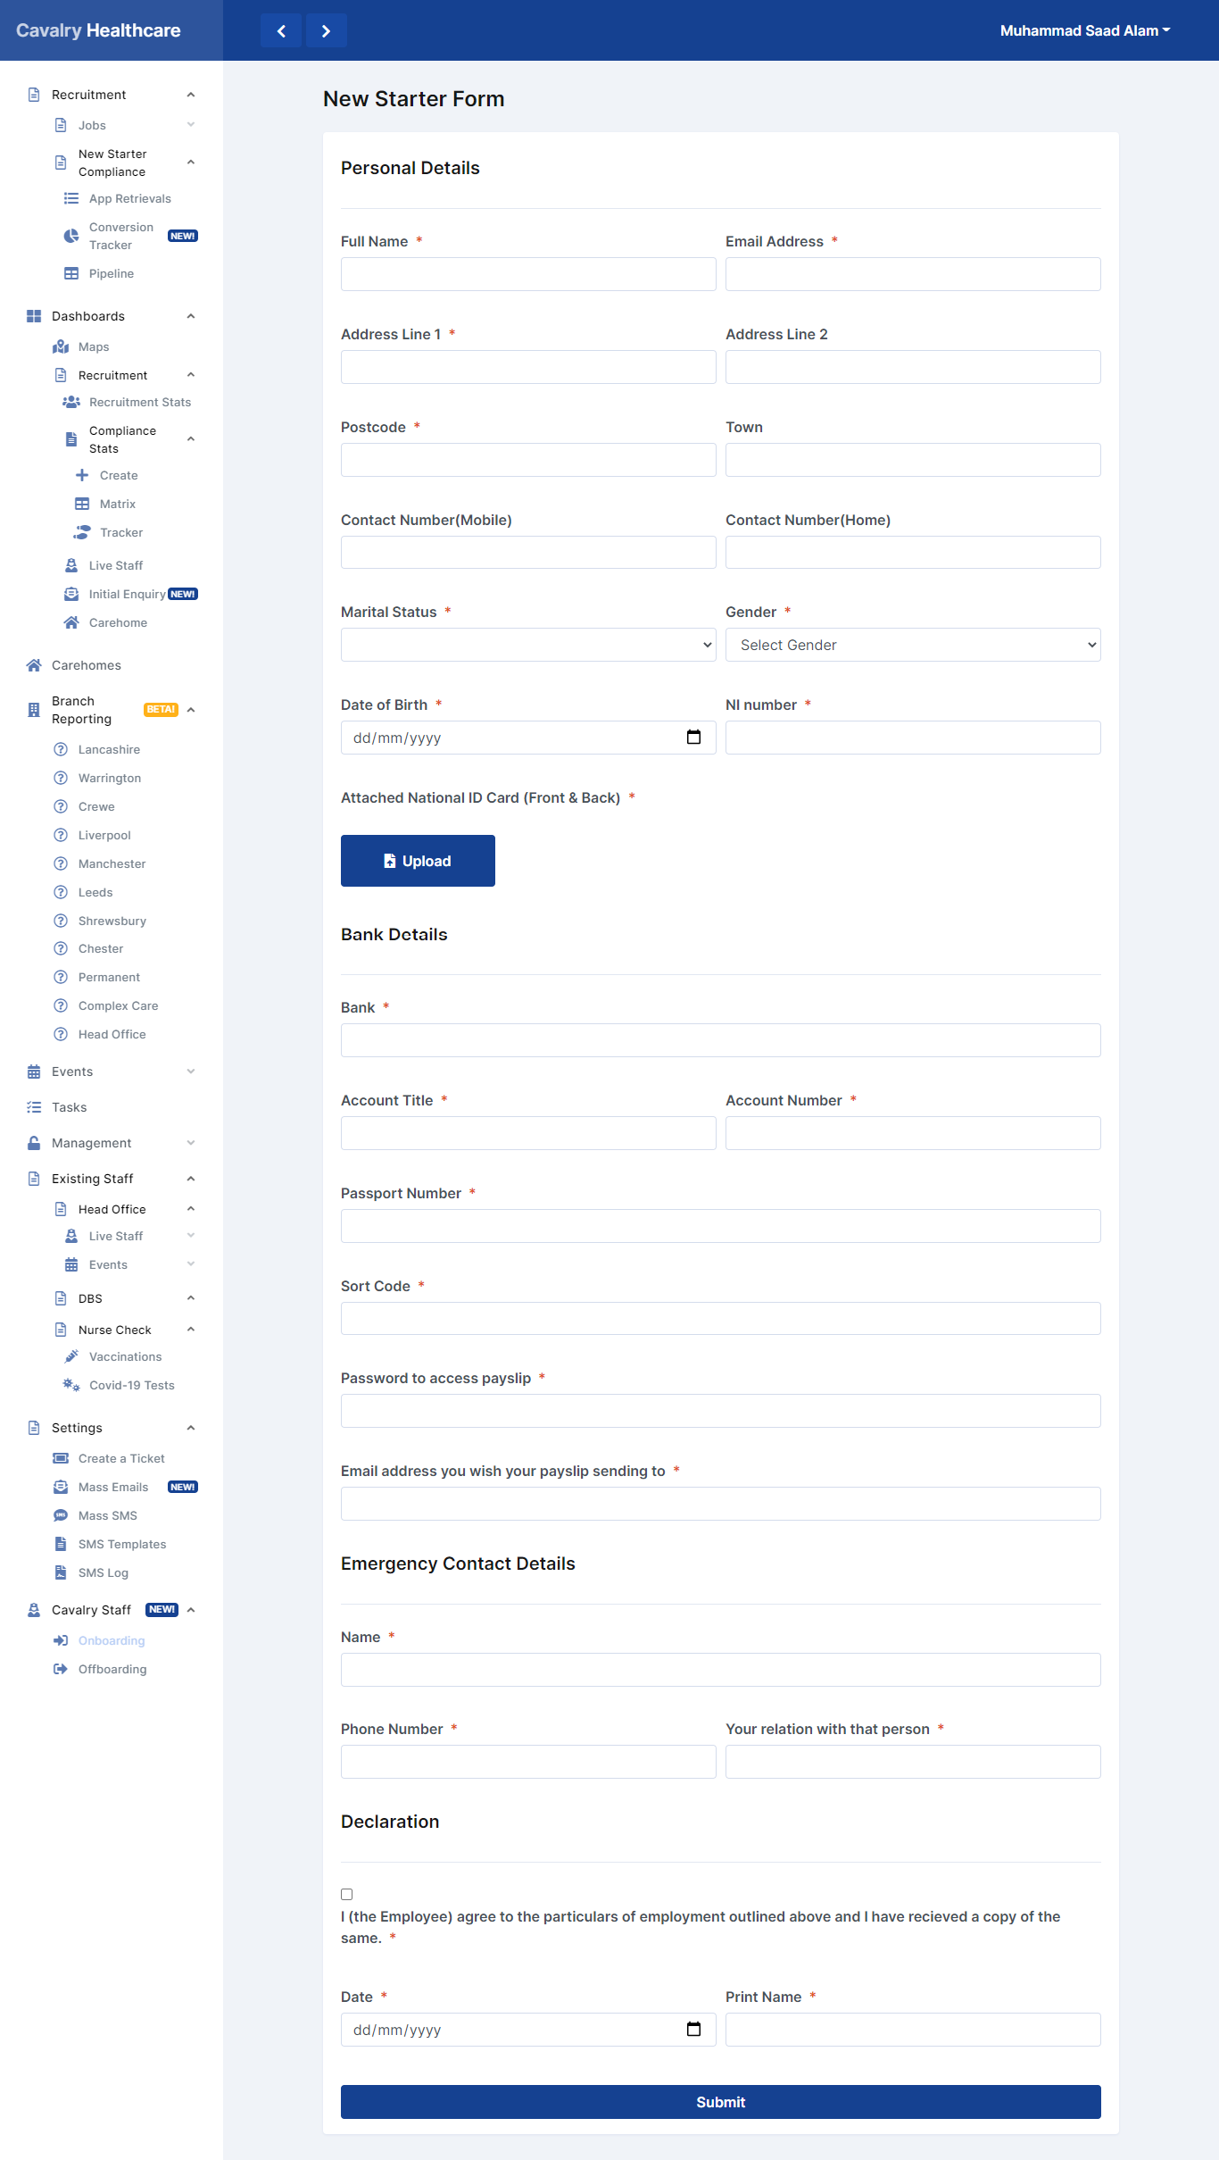

Create a Ticket:

This feature is used for crating tickets for any bug or new feature a/c to requirement. Below is image.

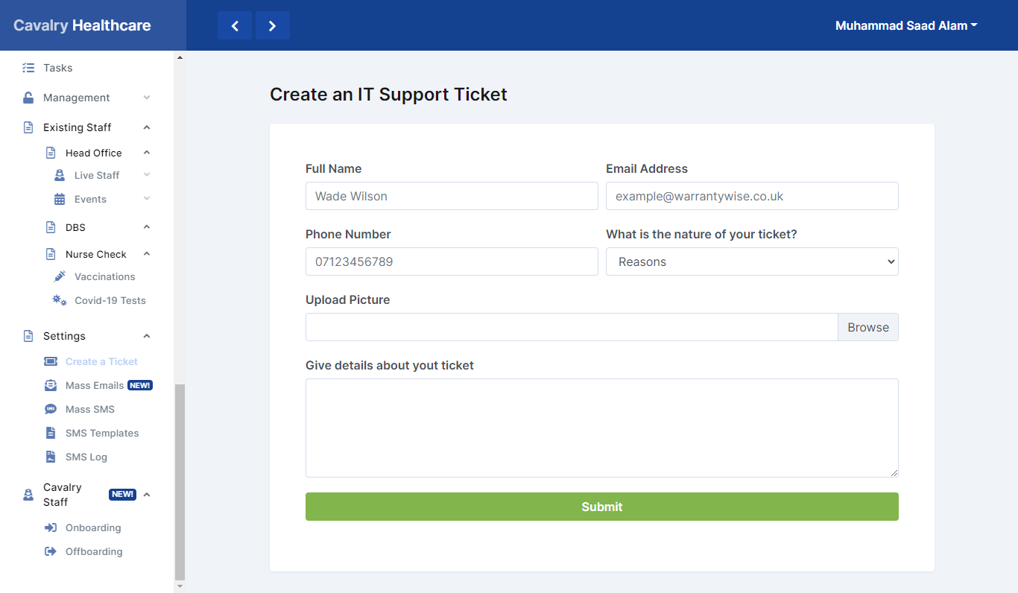

Recruitment Application Section:

This section is used for processing applicant applications. Below is the image.

