### **Project Objective:**

The primary goal of this data science project is to analyze and understand the trends, patterns, and factors influencing food prices in Pakistan. By leveraging data, the project aims to provide valuable insights for policymakers, researchers, and the general public to make informed decisions about food consumption, pricing strategies, and potential interventions.

**Data Acquisition:**

The dataset that we used is from kaggle.

<https://www.kaggle.com/datasets/amaanfaheem/pakistan-food-prices-2022>

The dataset contains food prices data for Pakistan, sourced from the World Food Programmed Price Database.

**Dataset description:**

Data Set is contains on 9723 rows × 14 columns

Dataset Columns:

['date', 'Provinces name', 'City Name', 'City market', 'latitude', 'longitude', 'category', 'commodity', 'unit', 'price flag','price type', 'currency', 'price', 'usd price']

RangeIndex: 9723 entries, 0 to 9722

Data columns (total 14 columns):

# Column Non-Null Count Dtype

--- ------ -------------- -----

0 date 9723 non-null object

1 Provinces name 9723 non-null object

2 City Name 9723 non-null object

3 City market 9723 non-null object

4 latitude 9723 non-null float64

5 longitude 9723 non-null float64

6 category 9723 non-null object

7 commodity 9723 non-null object

8 unit 9723 non-null object

9 price flag 9723 non-null object

10 price type 9723 non-null object

11 currency 9723 non-null object

12 price 9723 non-null float64

13 usd price 9723 non-null float64

dtypes: float64(4), object(10)

We have Applied Different Data Visualization Techniques and Libraries

**\*\* Machine Learning Model \*\***

We used 5 machine learning model for prediction:

1. Linear Regression
2. AdaBoost
3. Random Forest
4. MLP Regression
5. SVM

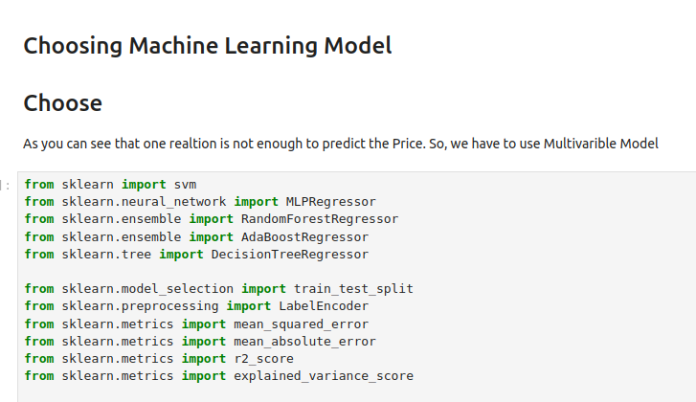

Different Models Accuracy

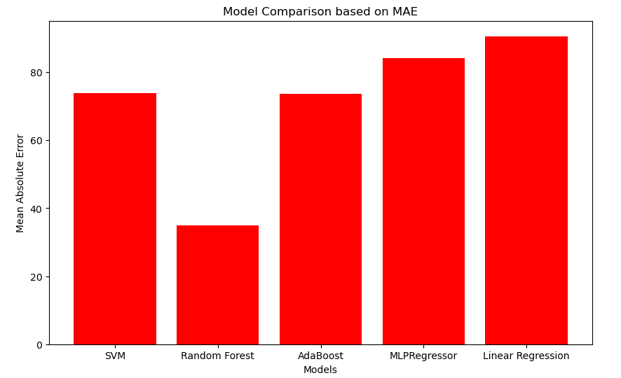

**These are some Data Visualization:**

Here are some Data Analysis based on Different PaComparisions.

