**EMBEDDED SYSTEM**



Submitted By:

**HASSAN ALI 2021-MC-06**

**MUHAMMAD SAAD s2021-MC-09**

**MUHAMMAD SUFYAN 2021-MC-10**

**HAMMAD SAJJAD 2021-MC-17**

**BURHAN RASHEED 2021-MC-27**

Submitted To:

**Sir Shujat Ali**

**“**MECHANICAL VENTILATION SYSTEM**”**

Mechatronics and Control Engineering Department

**University of Engineering and Technology, Lahore**

***MAY 23, 2023***

Table of Contents

**INTRODUCTION3**

TYPES OF MECHANICAL VENTILATION3

COMPONENTS USED4

**AMBU BAG4**

NEMA 235

MOTOR DRIVER6

CONTROLLING FEATURES…………………………………………………………………………………………………………………………7

TIDAL VOLUME'………………………………………………………………………………………………………………………………………7

RESPIRATORY RATE………………………………………………………………………………………………………………………………….8

I: E RATIO……………………………………………………………………………………………………………………………………………….8

PROBLEM FACAED………………………………………………………………………………………………………………………………….8

COST……………………………………………………………………………………………………………………………………………………….9

**MECHANICAL VENTILATION SYSTEM**

**INTRODUCTION:**

Mechanical ventilation is a form of life support. A mechanical ventilator is a machine that takes over the work of breathing when a person is not able to breathe enough on their own. The mechanical ventilator is also called a ventilator, respirator, or breathing machine.

**How Mechanical Ventilation Differs from Manual Ventilation**

The terms “mechanical ventilation” and “manual ventilation” are sometimes used interchangeably. However, mechanical ventilation properly refers to the use of a specialized machine, called a ventilator, while manual ventilation implies the use of a bag valve mask (BVM).

Typically, **manual ventilation** is performed by a trained specialist squeezing a BVM to alter the air pressure in the patient’s lung. A BVM is inexpensive compared to a ventilator and does not require electricity to function, making it suitable for rescuers in many different environments and situations. Unfortunately, manual ventilation is subject to human error since the BVM is hand operated.

To avoid human error, many hospitals and EMS providers choose to use ventilators whenever possible. While a specialist will still need to assess a patient’s breathing and provide recommendations regarding the ventilator’s settings, the machine provides a much more consistent, hands-off means of ventilation. A patient on a ventilator still requires ongoing monitoring and assessment, but overall, these machines help give the care team more time to focus on treating the patient’s underlying condition.

**Types of Mechanical Ventilation**

There are two primary types of mechanical ventilation: negative pressure ventilation (NPV) and positive pressure ventilation (PPV).

**Negative pressure ventilation** exposes the thorax to sub-atmospheric pressure, which causes breathing by sucking air into the lungs. NPV is largely out of practice, but it still has a few niche uses (such as preparing a donor lung for transplantation).

**Positive pressure ventilation** delivers either room air or oxygen gas to a patient’s lungs via a tube and is the most common form of ventilation used today. There are two types of positive pressure ventilators: invasive and non-invasive.

An invasive ventilator is used in clinical settings and ventilates the patient via an endotracheal or tracheostomy tube that is inserted into their airway. A non-invasive ventilator can be used in clinical settings or in the home to help patients who experience conditions like COPD or sleep apnea, and uses a face mask, nasal mask, or helmet to ventilate the patient. Hospitals should have both types of ventilator available.

**COMPONENTS USED:**

* Ambu bag
* Motor(Nema 23)
* Motor Driver(PP6600)
* Switches
* Wires

**AMBU BAG:**

An AMBU bag, also known as a manual resuscitator or bag valve mask (BVM), is a device used to provide respiratory support to patients in emergency and non-emergency situations. It consists of a self-inflating bag, a mask or mouthpiece, and a valve to control the flow of air.

The term “Ambu bag” refers to a type of device known as a bag valve mask, which is used to provide respiratory support to patients. The name “Ambu” is an acronym for “artificial manual breathing unit,” and it was originally used as the brand name for this type of device when it was first invented by Testa Laboratory. In the 1980s, the company rebranded as Ambu and the term “Ambu bag” has become widely used to refer to this type of device.

**Ambu Bag Used:**

One of the primary uses of an Ambu bag is resuscitation in emergency situations, such as cardiac arrest. It can also be used to provide respiratory support to patients who are unable to breathe on their own, either temporarily or on a long-term basis. Ambu bags can also be used to maintain airway patency, for example, in cases of severe asthma attacks or allergic reactions.

**Ambu Bag Working:**

So, how does an Ambu bag work? The user manually squeezes the bag to deliver breaths to the patient through the mask or mouthpiece. The valve allows the user to control the flow of air and the amount of pressure applied. Ambu bags can be used on patients of all ages, from newborns to adults.

**Advantages of Using an Ambu Bag:**

There are several advantages to using an AMBU bag. One of the main benefits is that it is portable and easy to use, making it suitable for use in a variety of settings, including hospitals, ambulances, and emergency care units. It is also a useful tool to have on hand in case of an emergency, as it can provide life-saving support to a patient until more advanced medical care is available.

In conclusion, an Ambu bag is a crucial device used to provide respiratory support to patients in emergency and non-emergency situations. It is portable, easy to use, and can be used on patients of all ages. It is important to have an Ambu bag on hand in case of an emergency, as it can potentially save a life.

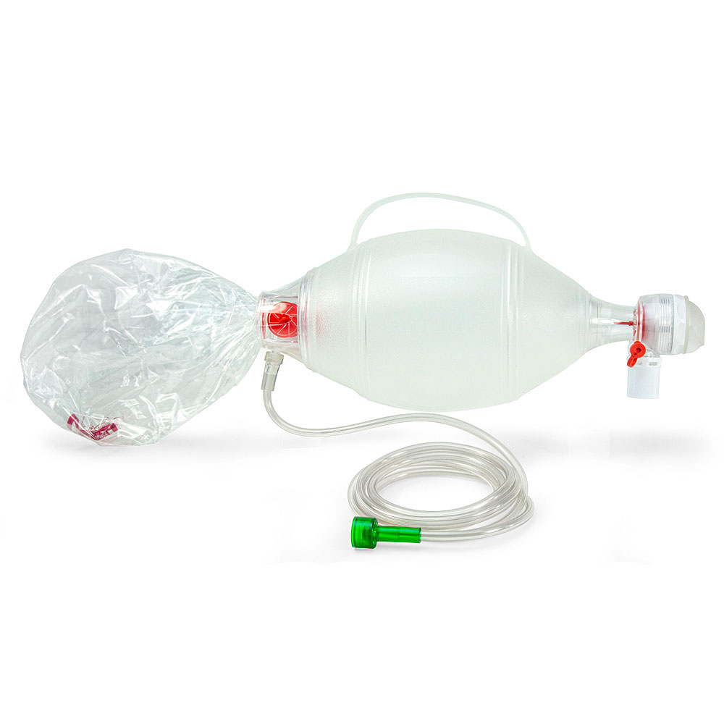

**NEMA 23 MOTOR:**

NEMA 23 is a high torque hybrid bipolar stepper motor with a 2.3×2.3 inch faceplate. This motor has a step angle of 1.8 deg., this means that it has 200 steps per revolution and for every step it will cover 1.8°. The motor has four colour coded wires (Black, Green, Red & Blue) terminated with bare leads. Black and Green wire is connected with one coil; Red and Blue is connected with other. This motor can be controlled by two H-bridges but it is recommended to use a stepper motor driver.

**NEMA 23 Stepper Motor Specifications**

* Voltage Rating: 3.2V
* Current Rating: 2.8A
* Holding Torque: 270 oz. in
* Step Angle: 1.8 deg.
* Steps Per Revolution: 200
* No. of Phases: 4
* Motor Length: 3.1 inches
* No. of Leads: 4
* Inductance Per Phase: 3.6mH

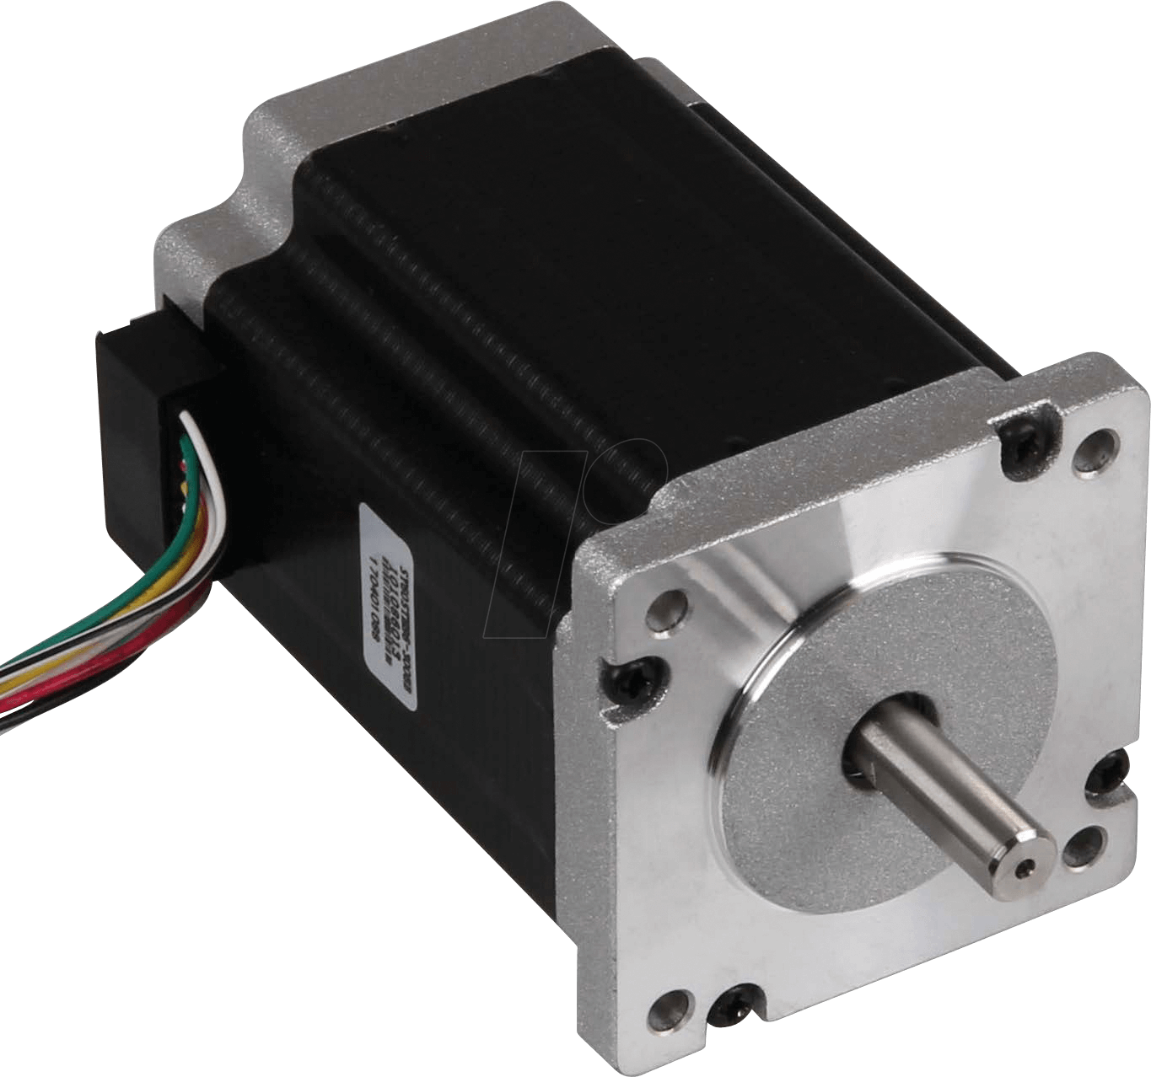

**Motor Driver (TB6600):**

TB6600 arduino Stepper Motor Driver is an easy-to-use professional stepper motor driver, which could control a two-phase stepping motor. It is compatible with Arduino and other microcontrollers that can output a 5V digital pulse signal. TB6600 arduino stepper motor driver has a wide range power input, 9~42VDC power supply

The TB6600 Stepper Motor Driver can input from 9V to 42V. The current output from the driver can be set to: 0.5A, 1A, 1.5A, 2A, 2.5A, 2.8A, 3.0A, 3.5A. The recommended voltage of the RB-Phi-266 is 12V and its rated current is 2.8A

The TB6600 Arduino is a simple professional stepper motor driver capable of controlling a two-phase stepping motor. It is suitable for driving 2 phase and 4 phase hybrid stepper motors. The motor driver compatible with any microcontroller providing a 5V signal.

A large stepper motor, this NEMA 23 is strong enough to move large loads that undergo a lot of variation. This stepper can be used with all SlushEngine models. It provides 1.3 N.m of torque and can travel up to 400 rpm.

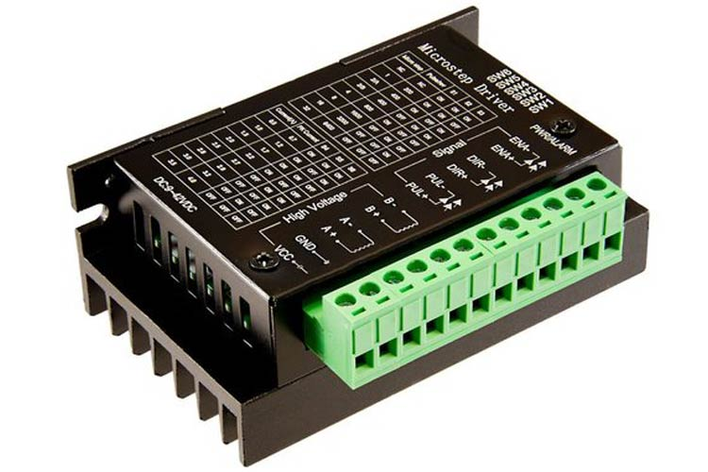

**CONTROLLING FEATURES:**

Using mechanical ventilation we have to control three things

* **TIDAL Volume**
* **Respiratory Rate**
* **I:E ratio**

**TIDAL VOLUME:**

Tidal volume is the amount of air that moves in or out of the lungs with each respiratory cycle. It measures around 500 mL in an average healthy adult male and approximately 400 mL in a healthy female. It is a vital clinical parameter that allows for proper ventilation to take place. When a person breathes in, oxygen from the surrounding atmosphere enters the lungs. It then diffuses across the alveolar-capillary interface to reach arterial blood. At the same time, carbon dioxide continuously forms as long as metabolism takes place. Expiration occurs to expel carbon dioxide and prevent it from accumulating in the body. The volume of inspired and expired air that helps keep oxygen and carbon dioxide levels stable in the blood is what physiology refers to as tidal volume

ss

**RESPIRATORY RATE:**

Respiratory rate must be adjusted during mechanical ventilation to maintain a minute volume appropriate to the patient’s metabolic demands. Although higher RR is often needed to maintain CO2 levels within safe range (39), it can alter the inspiratory-to-expiratory ratio, thus leading to intrinsic PEEP due to short expiratory time. In this context, Vieillard-Baron et al. compared two levels of RR—15 breaths per minute (bpm) vs. 30 bpm—while maintaining lower Pplat (<25 cmH2O). No difference in PaCO2 due to increased intrinsic PEEP or dead space ventilation was observed between groups (40). Increased RR may also cause lung damage due to cyclic recruitment/derecruitment.

**I: E RATIO:**

I: E ratio denotes the proportions of each breath cycle devoted to the inspiratory and expiratory phases. The duration of each phase will depend on this ratio in conjunction with the overall respiratory rate. The total time of a respiratory cycle is determined by dividing 60 seconds by the respiratory rate. Inspiratory time and expiratory time are then determined by portioning the respiratory cycle based on the set ratio. For instance, a patient with a respiratory rate of 10 breaths per minute will have a breath cycle lasting 6 seconds. A typical I: E ratio for most situations would be 1:2. If we apply this ratio to the patient above, the 6-second breath cycle will break down to 2 seconds of inspiration and 4 seconds of expiration. Changing I: E ratio to 1:3 will result in 1.5 seconds of inspiration and 4.5 seconds of expiration. Thus, changing I: E ratio from 1:2 to 1:3 results in less inspiratory time and more expiratory time for the same length of the breath cycle.

Standard Pressure Control ventilation modes typically use I: E ratio of 1:2 or as high as 1:3 or 1:4 in specific populations. In these cases, the expiratory phase is set longer than the inspiratory phase mimics normal physiology. Inverse Ratio Ventilation instead uses I: E ratios of 2:1, 3:1, 4:1, and so on, sometimes as high as 10:1, with inspiratory times that exceed expiratory times.

**PROBLEM FACED:**

While the Scotch yoke mechanism can be used in mechanical ventilators, there are certain challenges or issues that you may face during the design and implementation process. Here are a few potential issues:

**Complex Design:** The Scotch yoke mechanism involves a complex design with various moving parts, including the yoke, slider, and connecting rod. Achieving precise motion control and ensuring proper alignment of these components can be challenging.

**Friction and Wear**: The sliding motion of the yoke in the Scotch yoke mechanism can lead to increased friction and wear between the moving parts. This friction can result in reduced efficiency, increased power consumption, and the need for frequent maintenance.

**Noise and Vibration**: The reciprocating motion of the Scotch yoke mechanism can generate noise and vibration. In a medical environment, excessive noise and vibration can be undesirable and may cause discomfort to the patient or medical staff.

**Limited Stroke Length:** The Scotch yoke mechanism typically provides limited stroke length compared to other mechanisms like crank and slider. This limitation may impact the tidal volume or the range of motion that can be achieved by the ventilator.

**Control and Regulation:** Achieving precise control and regulation of the ventilation parameters, such as the respiratory rate and tidal volume, can be more challenging with the Scotch yoke mechanism compared to other mechanisms. This may require advanced control systems and feedback mechanisms.

**Size and Weight:** The Scotch yoke mechanism can be relatively bulky and heavy compared to other mechanisms, which can make the ventilator less portable or increase the space required for installation

**COST:**

|  |  |
| --- | --- |
| **Items** | **Cost** |
| Belt | 30 |
| Big Pulley | 150 |
| Small Pulley | 50 |
| Plate | 350 |
| Nut Bolts | 300 |
| Two Clamps | 100 |
| Screws | 30 |
| Square Iron Rod | 150 |
| Round Iron Rod | 80 |
| Bush | 70 |
| Wooden Board | 250 |
| Other Iron Items | 460 |
| Motor (Nema-17) | 450 |
| DRIVER(NEMA-17) | 1250 |
| **Total Cost** | **3720/-** |

**FIGURE:**

