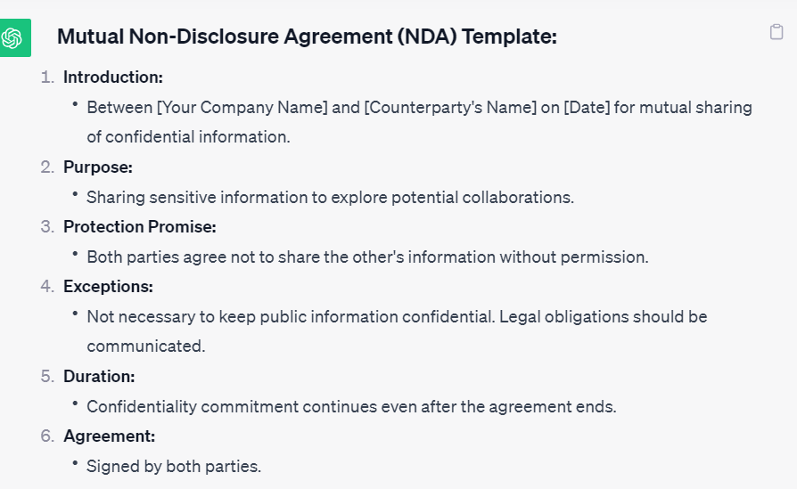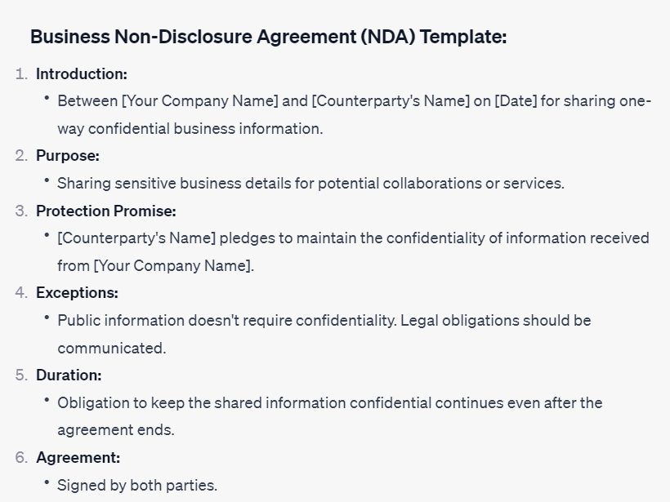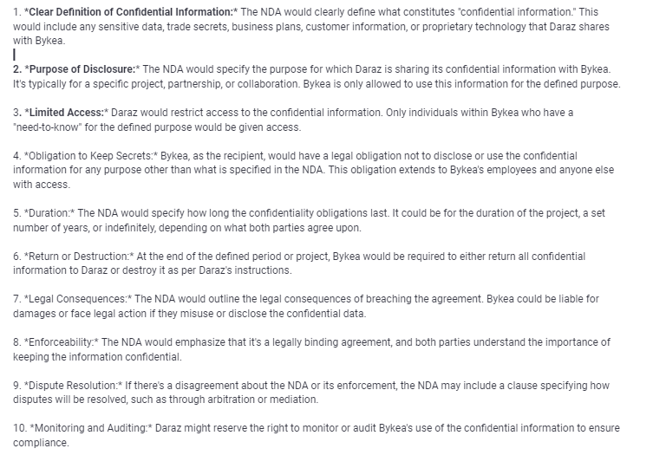

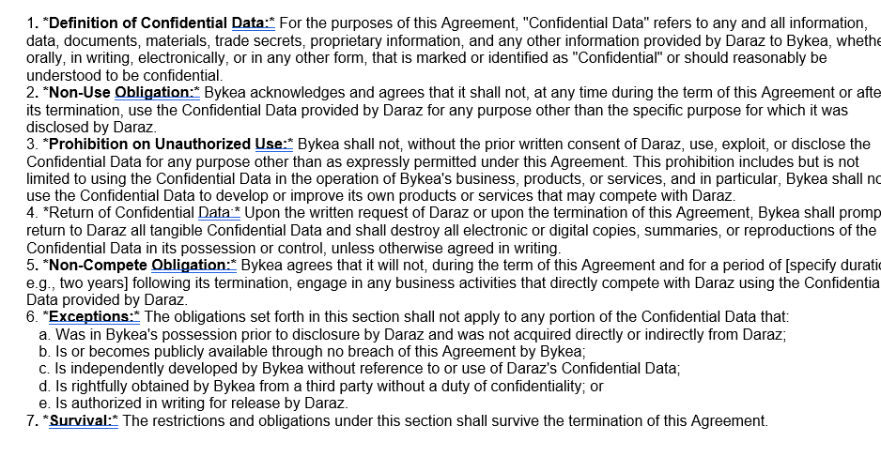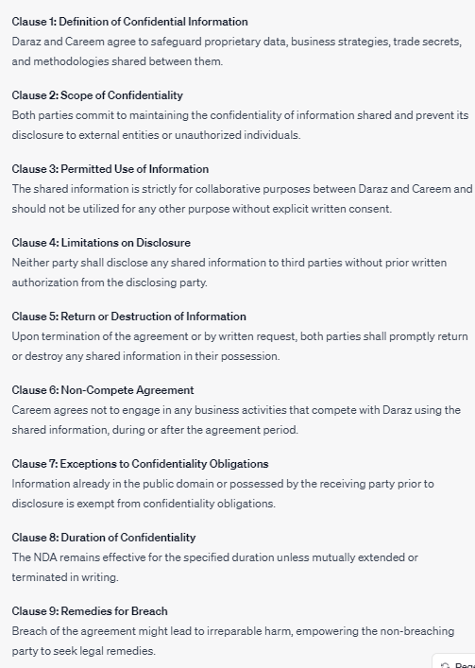

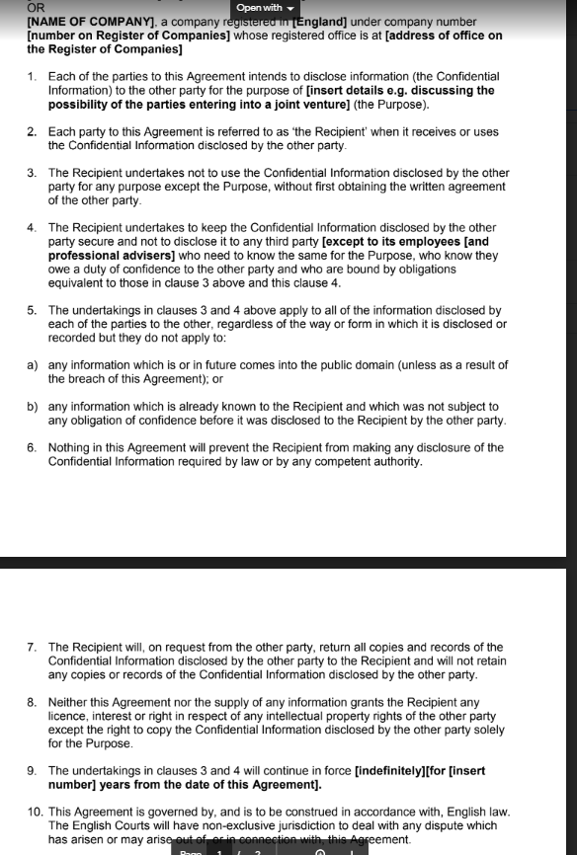

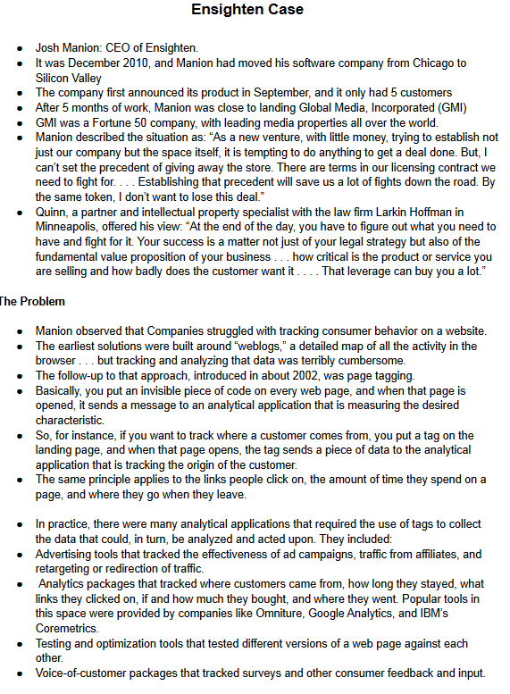

.

**Problem:**Companies were struggling to track consumer behavior on their websites. The earliest solutions involved analyzing weblogs, which was a cumbersome process. Page tagging was introduced as a more efficient solution, but it still required companies to manually insert code on every web page. This was a time-consuming and error-prone process, especially for large companies with hundreds or thousands of web pages.

**Ensighten's Solution:**Ensighten developed a cloud-based solution that automated the process of page tagging. With Ensighten's solution, companies could quickly and easily deploy tags across all of their web pages without having to manually insert code. This saved companies a significant amount of time and effort, and it also reduced the risk of errors.

**Ensighten's Pricing**:Ensighten priced its services based on the number of websites or client domains and the amount of traffic on those domains. A typical early deal was approximately $200,000 in annual licensing fees and a $25,000 setup and installation charge.

**Ensighten's Challenges:**One of the biggest challenges Ensighten faced was convincing large enterprises to rely on them as a mission-critical platform. Ensighten also had to manage a large and complex infrastructure to support its growing customer base.

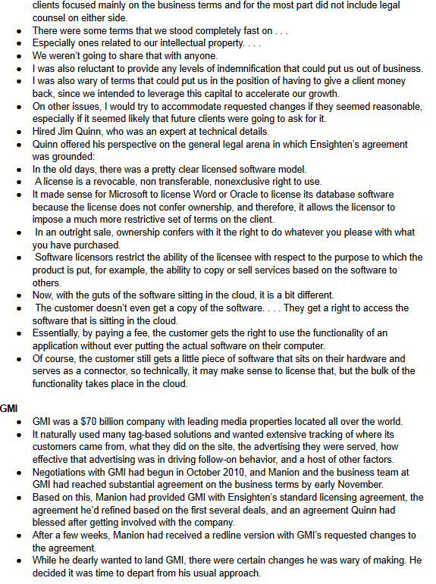**Ensighten's Success:**Despite these challenges, Ensighten was able to attract a number of large clients, including Sony and 3M. The company's success was due in part to its innovative solution and its ability to meet the needs of large enterprises.

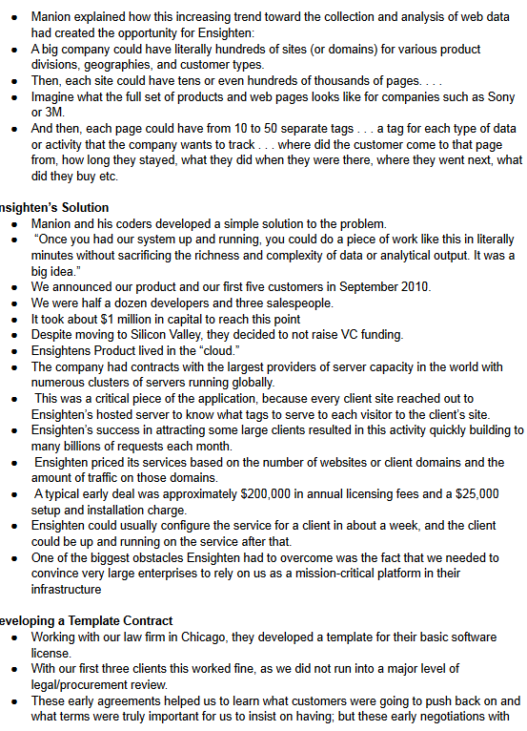

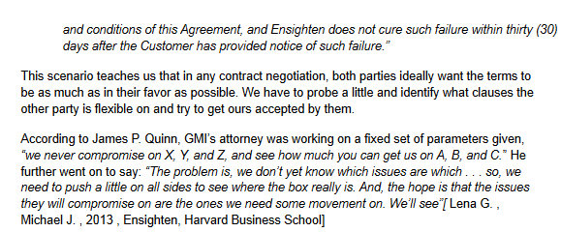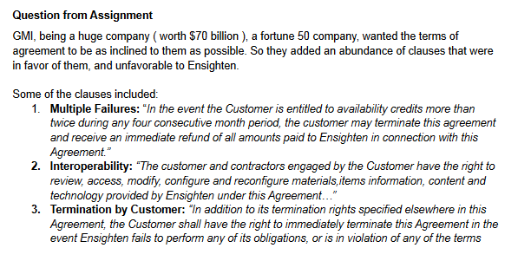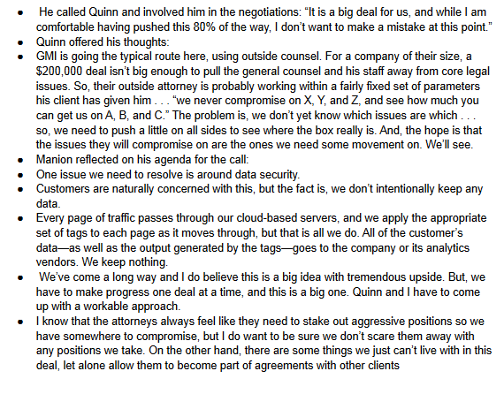

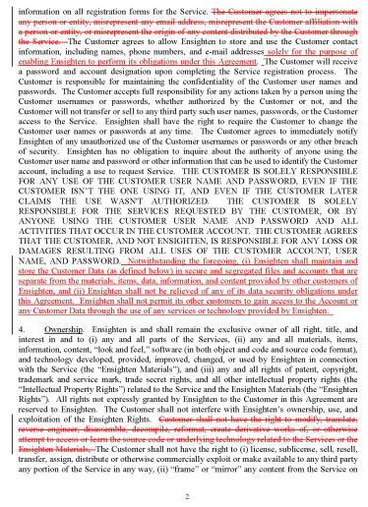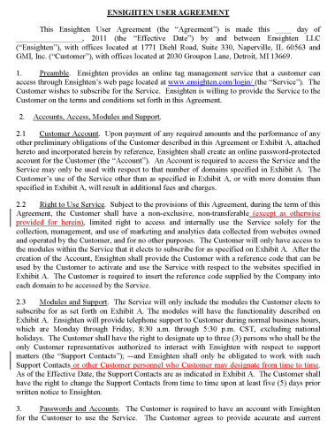

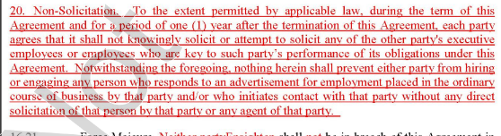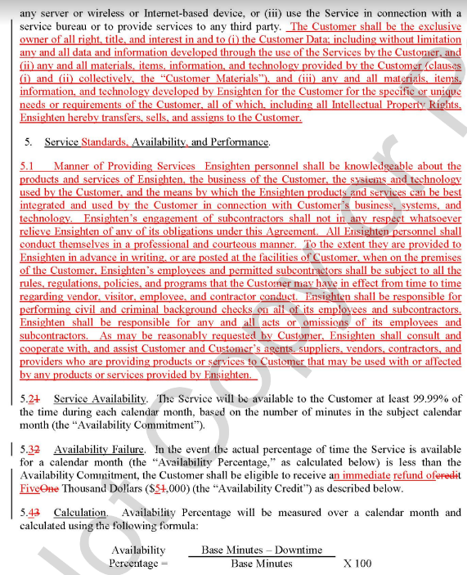

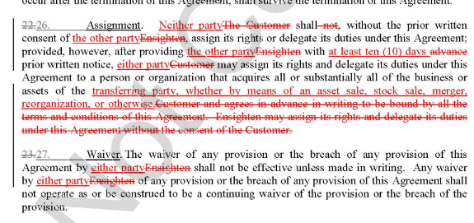

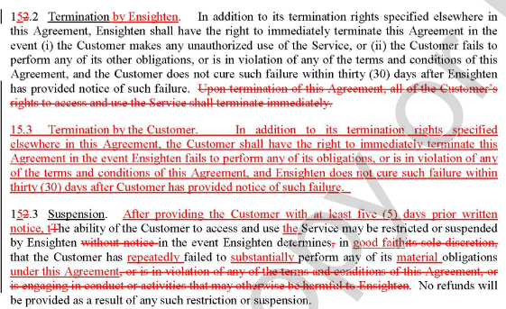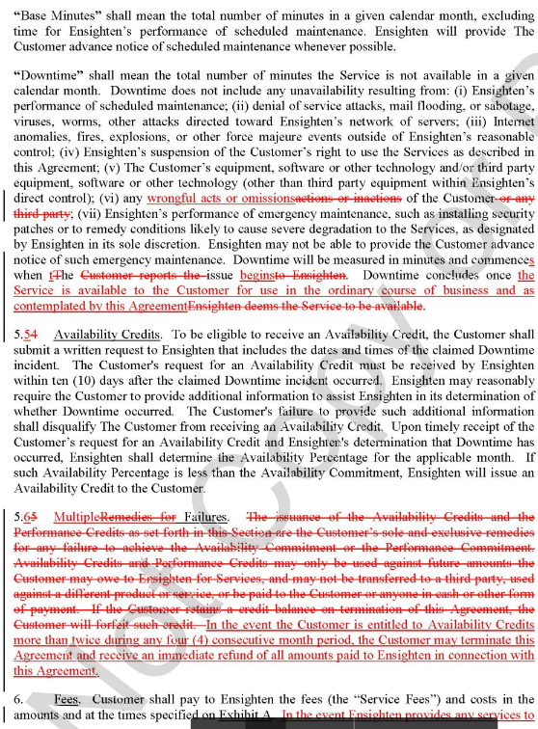

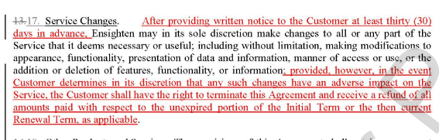

Summary  
The case describes a complex scenario involving Prime ElektroTek, a Taiwanese company, and their potential business dealings with Blue Sky, a Chinese automaker. The main focus is on the negotiation between these two companies regarding Prime supplying components for Blue Sky's vehicles, particularly the vehicle control unit.

The chairman of Prime announced a major partnership with Blue Sky, which intended to use Prime's components for their vehicles. The Vice President (VP) and General Manager, Lin, was excited about this partnership and confident about Prime's technology's superiority.

However, Wang, an engineer at Prime, was highly skeptical. He doubted the positive implications of the deal, suspecting that Blue Sky would replicate Prime's technology and eventually compete against them. Despite reassurances, Wang remained unconvinced, fearing that Blue Sky would reverse-engineer Prime's components and replicate them for their own purposes.

The case details Blue Sky's interest in specific components and their decision to develop their vehicle control unit instead of purchasing it from Prime. Lin visited Blue Sky's facilities and was not impressed by their technical expertise. They displayed difficulty in understanding complex systems, which validated Wang's earlier concerns.

Blue Sky's progress in developing the vehicle control unit was slower than anticipated, and eventually, they proposed a significant condition to Prime. They would accept the control unit only if Prime handed over the intellectual property (IP) for the unit, including software source codes and control system algorithms. This condition led to a critical dilemma for Prime, as complying with it might mean relinquishing their valuable IP..The story talks about a Chinese car company, Blue Sky, wanting some parts from a Taiwanese company called Prime ElektroTek for their cars. Instead of buying a specific part from Prime, Blue Sky decided to make it themselves. When the Prime team visited Blue Sky, they saw that the Blue Sky people didn't seem very good at understanding complex car systems, which confirmed their worries that Blue Sky might not be able to copy Prime's technology.

The chairman expressed deep concerns about the potential business impact of not complying with Blue Sky's terms. Losing the deal could severely impact Prime's future prospects in the auto parts business.

The case concludes with Prime being faced with a tough decision: either give in to Blue Sky's IP demands, risking their valuable intellectual property, or refuse and potentially lose a crucial business opportunity, which could significantly affect their position in the auto parts market.

