1. When the app is open for the first time, it checks if the person has signed up. If not signed up;

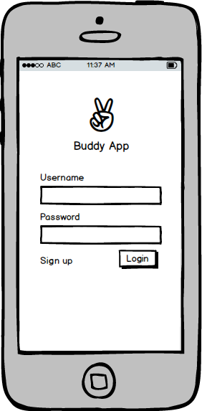

1. Then when the user signs up, the screen moves to a map asking them to confirm an organization

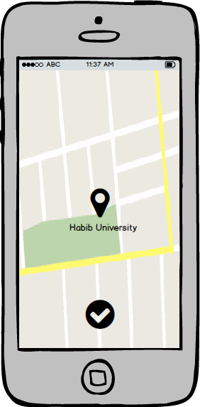

1. The next menu after confirming location is asking the user to navigate to an activity

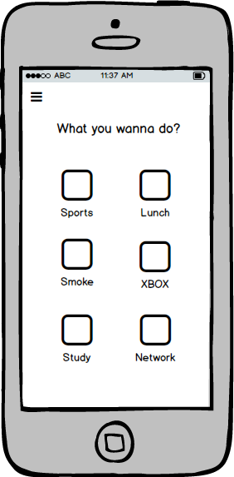

Each Icon will be taken from <http://www.flaticon.com/>

The sports menu has the following sub-menu as well. We intend to maintain the collection of all of these icons.

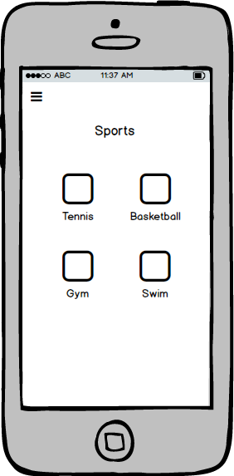

1. Once an activity is selected, the user is asked when they would like to play.

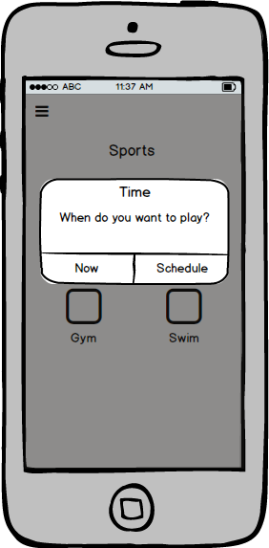

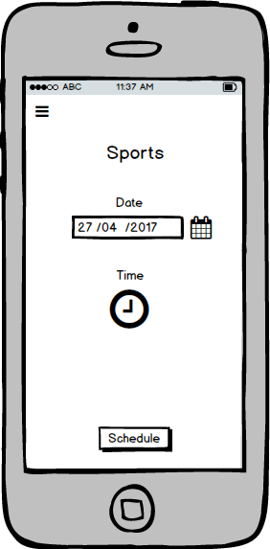

Schedule Menu

1. When a time is scheduled, the following menu shows up showing a list of people and the number of people one can rsvp.

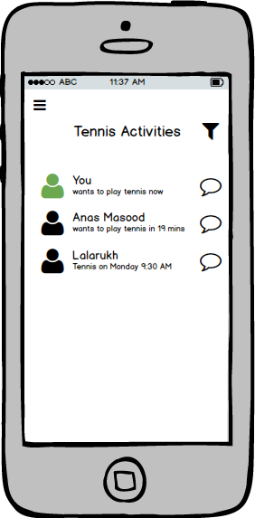

1. People can also RSVP the user if the user says they are currently free.

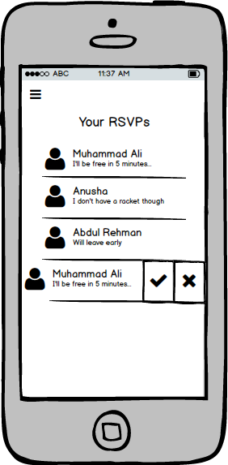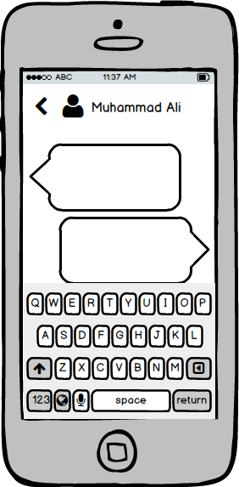

Once an RSVP is selected, the app would allow users to send messages to each other with an RSVP.

1. A timer appears to allow the other user to respond.

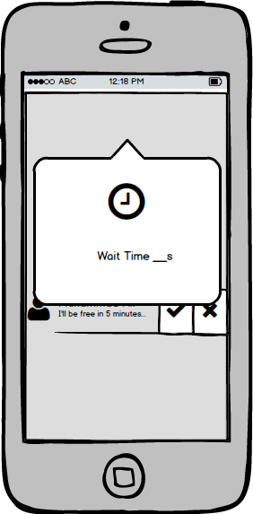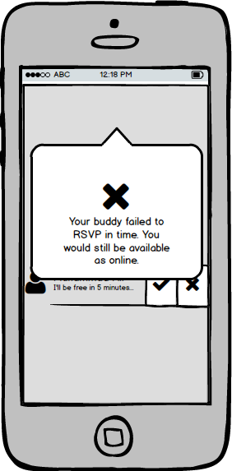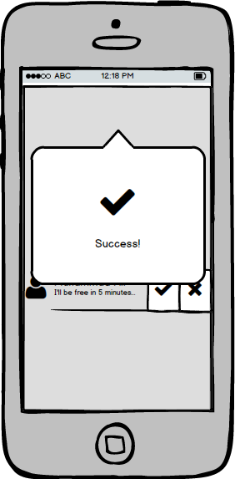

1. Side Menu

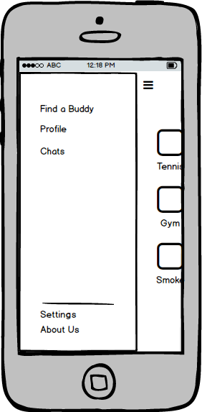

1. Settings Menu

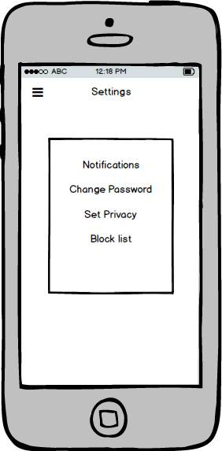

Each submenus in notifications, change password, set privacy, and block list is a generic menu which is similar to menus found in everyday apps.

1. Profile Menu. It allows user to change picture and manage the blocked list.

