TECHNICAL PROJECT DOCUMENTATION

ESP32 Smart Lighting System
Complete project update: firmware, REST API, Flutter application, debugging history and test status

Electrical Engineering and Automation

Student: Dhifet Mohamed Amin
Supervisor: Ghribi Faouzi
Institution: National Engineering School of Gabes
Date: 11 November 2026

About This Document and Its Evidence Basis
Purpose: to preserve an accurate record of what was developed and tested, so that the project can be resumed later without losing technical context. The project is treated as a working baseline. This document proposes no redesign and no new features.
The author of this document could not open the project files on the student's computer. Every statement is therefore tagged with the evidence behind it:
Tag | Meaning
Verified | Backed by output pasted into the project conversation (Wokwi serial output, compiler summary, flutter doctor, flutter pub add, flutter emulators, winget output, and the file listings and masked source scans made while preparing the repository).
Reference code | Taken from the reference source code delivered in the project conversation. The version that was finally tested may contain later edits that were not shown.
User-reported | Stated by the student in the project update. The underlying files, logs or screenshots were not reviewed.
Unverified | Information that is missing. It is deliberately not guessed. Appendix A lists what is needed to close each gap.

Discrepancies between the project record and the student's update
Item | Project conversation record | Student's update | Handling here
Microcontroller | ESP32 DevKit V1 (classic ESP32); Wokwi ESP32 board | ESP32-S3 | S3 is reported. The reference pin map was chosen for the classic ESP32 (see 2.3).
Pin map | LDR on GPIO34 (ADC1), relay on GPIO27 | Not stated | Final pins unverified.
Onboard LED | No onboard LED code in the reference sketch | Sketch initialises an onboard LED output | Reported change. Pin unverified.
Network | Phone hotspot was suggested | Home router; ESP32 previously on a private 192.168.x.x address | Home router used. Address recorded as reported.
Flutter app | Multi-file app, 2 s polling, ON/OFF buttons, notification code | UI and API code in lib/main.dart; 3 s polling; switch; RSSI and uptime shown; settings dialog; no notifications mentioned | Confirmed by the repository scan: main.dart is one file (22,562 bytes) with no notification package. Its detailed behaviour is described as reported.
ApiServer.cpp | No debug output in the reference | Serial debug added (method, URI, body, response) | Reported modification, not reviewed.
Main sketch history | ON/OFF logic only in ApiHandler::postLight() | A block was wrongly inserted into loop(), then removed | Reported history. Restored structure matches the reference design.
Test status | Earlier report listed hardware and app tests as Pending | Physical ON/OFF test passed; app runs and talks to the ESP32 | Reported results recorded. The earlier DOCX report is outdated and must not be submitted as it stands.

1. Project Introduction and Objectives
The ESP32 Smart Lighting System lets a user control a light from a Flutter Android application over the local Wi-Fi network. The ESP32 hosts an HTTP REST API, drives an output through a relay, and measures ambient brightness with an LDR. A darkness-detection state machine reports dark conditions. The user, not the detector, decides when to switch the light.
Objective | Basis
Manual ON/OFF control of a physical output from a mobile application over Wi-Fi | User-reported
Ambient brightness monitoring (LDR, ADC, moving average, percentage) | Reference code
Darkness detection with hysteresis, confirmation delay and event counter | Reference code
Darkness detection never switches the relay automatically (current implementation) | Reference code
Modular, non-blocking firmware with safe OFF output after boot | Reference code

Important distinction. The LDR measures brightness. The darkness detector classifies it. Manual ON/OFF is the application's job. In the reference code no path connects the detector to the relay.

2. Hardware Architecture
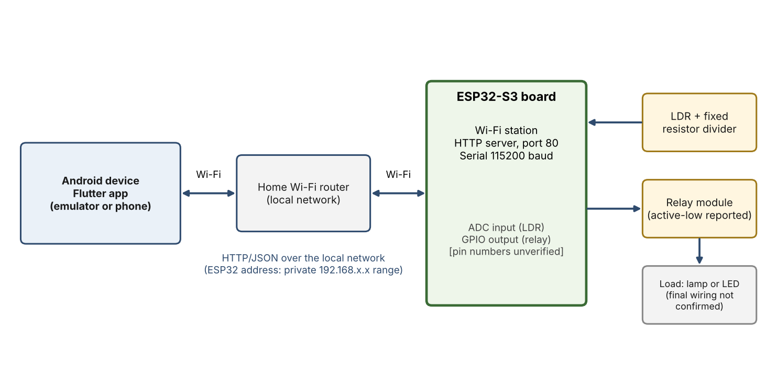
Figure 1. Block diagram: Flutter app, router, ESP32-S3, LDR, relay and load.

2.1 Components
Component | Role | Basis
ESP32-S3 board | Runs the firmware, Wi-Fi station and HTTP server. Exact board model not recorded. | User-reported
LDR with fixed resistor (voltage divider) | Produces an analog voltage that changes with light, read by the ADC. Resistor value in the tested build not recorded; the reference used 10 kΩ. | Reference code
Relay module | Switches the output. Active-low logic is reported. Module model not recorded. | User-reported
Load (lamp or LED) | Physical output. What exactly responded in the physical test is not recorded. | Unverified
Home Wi-Fi router | Local network shared by the ESP32 and the Android device. | User-reported
Android device | Runs the Flutter application (emulator Android 17 / API 37 and, optionally, a physical phone). | User-reported

2.2 LDR divider
In the reference design the divider is 3V3, fixed resistor, measurement node, LDR, GND. The node voltage is V = 3.3 V × R_{LDR} / (R_{LDR} + R_{fixed}). Darkness raises the LDR resistance, so the voltage and the ADC count rise. The firmware converts this to a relative brightness. It is not calibrated illuminance in lux.

2.3 GPIO assignment: caution
The reference configuration (config.h) assigned GPIO34 to the LDR (an ADC1 input on the classic ESP32) and GPIO27 to the relay. Those choices were made for the classic ESP32 DevKit V1. On ESP32-S3 modules the ADC1 inputs are on GPIO1 to GPIO10, and GPIO26 to GPIO32 are generally reserved for the flash and PSRAM interface. If the tested hardware is an ESP32-S3, the pin constants in config.h must therefore differ from the reference values. The actual pins used are not recorded, and no onboard LED pin is assumed here.
Signal | Reference value (classic ESP32) | Tested value
LDR analog input | GPIO34 (ADC1_CH6) | Unverified
Relay control | GPIO27 | Unverified
Onboard LED | none | Unverified

2.4 Relay and power notes
- Relay polarity is a single constant, RELAY_ACTIVE_LOW. With active-low logic the output is driven HIGH for OFF and LOW for ON.
- The relay contacts are isolated from the logic side. A lamp circuit needs its own supply; a common ground is needed only between the ESP32 and the relay module's logic side.
- Low-voltage loads only. Mains wiring is not part of this prototype.
- Final relay-to-lamp wiring and the full lighting installation are not confirmed as completed (Section 11).

3. Software Architecture
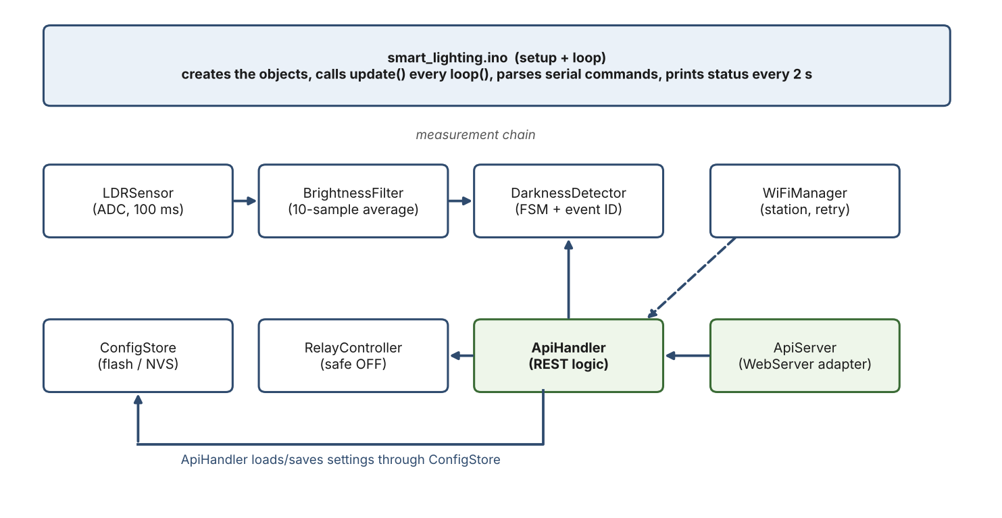
Figure 2. Firmware architecture: the main sketch and its modules.
Module | Responsibility | Basis
smart_lighting.ino | Creates the objects, runs setup() and loop(), processes serial test commands, prints status. | Reference code
config.h | Pin map, relay polarity, Wi-Fi settings, timing, calibration, filter size, detector defaults. | Reference code
LDRSensor | Configures the 12-bit ADC and samples every 100 ms; converts a value to relative brightness. | Reference code
BrightnessFilter | 10-sample moving average with a running sum. | Reference code
DarknessDetector | Three-state machine, hysteresis, confirmation timer, event counter, settings validation. | Reference code
RelayController | Forces the relay OFF at start, switches it, reads the output level back. | Reference code
ConfigStore | Saves and loads the detector settings in flash (NVS). | Reference code
WiFiManager | Non-blocking station connection with periodic retry. | Reference code
ApiHandler | REST logic: (method, path, body) to (status, JSON). Holds references to the detector, relay, Wi-Fi manager and config store. | Reference code
ApiServer | Adapter from the ESP32 WebServer to ApiHandler. Serial debug output was added to it during development. | User-reported

Design principle: logic that decides (ApiHandler, DarknessDetector) is separate from transport (ApiServer, WiFiManager) and hardware (LDRSensor, RelayController). This allowed the API logic to be tested in the simulator through serial commands before any network was available.

4. ESP32 Firmware Implementation

4.1 Main sketch operation
As described by the student, and consistent with the reference sketch, the firmware proceeds as follows:
- Initialise Serial at 115200 baud.
- Initialise the onboard LED output (added in the tested build; reported, pin unverified).
- Initialise the relay and force it OFF. This is done first so that no ON glitch occurs.
- Initialise the LDR sensor (12-bit ADC).
- Load the detector settings from flash. Stored values are used only if they pass validation; otherwise the defaults apply.
- Start Wi-Fi in station mode (non-blocking).
- In loop(): update Wi-Fi and the HTTP server, process serial commands, sample the LDR every 100 ms, filter, convert to a percentage, update the state machine, and print system information every two seconds.
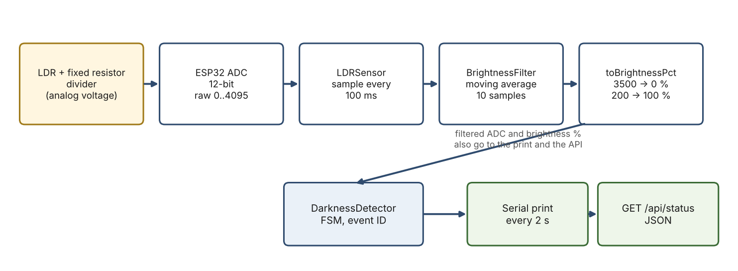
Figure 3. Data flow of the LDR measurement.

4.2 From ADC reading to brightness percentage
The ADC returns 0 to 4095 at 12-bit resolution. Because of the divider orientation, a higher count means darker. The filtered count is mapped linearly between two calibration constants:
brightness_pct = 100 * (ADC_DARK_REF - filtered) / (ADC_DARK_REF - ADC_BRIGHT_REF)
clamped to 0 .. 100 ADC_BRIGHT_REF = 200, ADC_DARK_REF = 3500

Configured values: bright reference 200, dark reference 3500, filter window 10, sampling period 100 ms (reference code; the student's update states the same values). These constants were not re-measured on real hardware in the available record. The simulator results below show the mapping working:
Simulated light | Raw ADC (measured) | Brightness | Basis
100 lux | 2045 | 44.1 % | Verified
1000 lux | 680 | 85.5 % | Verified
10000 lux | 161 | 100.0 % (clamped) | Verified

4.3 Moving-average filter
The filter keeps the last 10 samples (one second at 100 ms). A running sum is updated by adding the new sample and subtracting the oldest, so each update takes constant time. For uncorrelated noise the spread falls by about the square root of 10, roughly a factor of three, at the price of up to one second of lag after a step change. The ESP32 ADC is noisy, so this smoothing prevents the state machine from reacting to single-sample fluctuations.

4.4 Darkness state machine
From | To | Condition
BRIGHT | DARK_PENDING | filtered brightness below the dark threshold (default 30 %)
DARK_PENDING | BRIGHT | brightness returns to or above the threshold; the dip was too short and no event is created
DARK_PENDING | DARK_CONFIRMED | brightness stays below the threshold for the confirmation time (default 10 s); the event counter increases by 1
DARK_CONFIRMED | BRIGHT | brightness reaches threshold + hysteresis (default 30 % + 10 % = 40 %)

Hysteresis prevents repeated events when the reading hovers near the threshold: a new event needs a full return above the upper threshold first. The event counter (event ID) increments once per confirmed darkness episode; 0 means no event yet. In simulation, darkness at 19 lux produced DARK_CONFIRMED with event ID 1 while the relay stayed OFF (Verified).

4.5 Relay controller
The relay output pin is set up so that the OFF level is written before the pin becomes an output. With active-low logic OFF is HIGH and ON is LOW. The current state is obtained by reading the pin back, which reports the level the ESP32 is driving, not the physical contact position.
void RelayController::begin() {
digitalWrite(_pin, offLevel()); // preload OFF level before enabling the driver
pinMode(_pin, OUTPUT);
digitalWrite(_pin, offLevel());
}
void RelayController::set(bool on) { digitalWrite(_pin, on ? onLevel() : offLevel()); }
bool RelayController::isOn() const { return digitalRead(_pin) == onLevel(); }

In the simulator the relay module behaved as active-HIGH (Verified); the student reports active-low logic for the physical relay (User-reported). The polarity constant exists for exactly this reason.

4.6 Wi-Fi connectivity
The ESP32 joins the home router in station mode. WiFi.begin() is called once and returns immediately. If the link is lost, WiFiManager retries every 10 seconds without blocking sensing or the relay. The HTTP server starts after the first successful connection. Credentials are stored in config.h and are intentionally not reproduced in this document.
In the tested setup the ESP32 was previously assigned a private address in the 192.168.x.x range (User-reported). This is a DHCP assignment; a fixed reservation is not recorded, so the address must be re-checked in the Serial Monitor if it changes. The Flutter application needs this IP to reach the device.
Simulation evidence: the simulated ESP32 connected, was assigned 10.10.0.2 and printed 'HTTP server started' (Verified).

4.7 Persistent configuration
Accepted settings are stored in flash using the Preferences library (namespace smartlight: dark_pct, hyst_pct, confirm_ms) and loaded at boot after validation. Whether the values survive a reset on the physical board was not recorded (Unverified).

5. REST API Design
The ESP32 serves HTTP on port 80. All bodies are JSON. POST requests must send Content-Type: application/json because the ESP32 WebServer exposes the raw body only for non-form content types.
Method and path | Purpose | Success | Errors
GET /api/status | System state | 200 | 405
POST /api/light | Set the relay: {"state":"on"} or "off" | 200 {"relay_state":...} | 400 invalid_json, invalid_state; 405
GET /api/config | Read detector settings | 200 | 405
POST /api/config | Partial update of settings | 200 with the new settings | 400 invalid_json, invalid_value; 405
any other path | - | - | 404 not_found

All entries above are from the reference code (Reference code). The ten API cases were also exercised in the simulator by serial-injected requests and reported as matching the expected results (Verified).

5.1 GET /api/status
{ "api_version": 1, "uptime_s": 8,
"wifi": {"connected": true, "ip": "10.10.0.2", "rssi": -83},
"sensor": {"adc_raw": 999, "adc_filtered": 999, "brightness_pct": 75.8},
"environment": "bright", "fsm_state": "BRIGHT",
"dark_event_id": 0, "dark_event_age_s": null,
"relay_state": "off", "lora": {"initialized": false} }

This is the actual simulator output. The lora field is a reserved placeholder and is always false; whether the final build still contains it is unverified. environment is "dark" only in DARK_CONFIRMED.

5.2 POST /api/light
The handler parses the JSON, requires a string field state equal to "on" or "off", commands the relay, then reads the output back and returns that value, so the answer reflects the real output rather than echoing the request.
Request body | Response
{"state":"on"} | 200 {"relay_state":"on"}
{"state":"off"} | 200 {"relay_state":"off"}
{"state":"banana"} | 400 invalid_state
{bad | 400 invalid_json

5.3 Configuration endpoints
GET /api/config returns dark_threshold_pct, hysteresis_pct and confirm_time_s (defaults 30, 10, 10). POST accepts any subset. Validation limits: threshold 1 to 99, hysteresis at least 1, threshold + hysteresis at most 100, confirmation time an integer from 1 to 600 seconds. Invalid input returns 400 invalid_value and changes nothing. Valid input is applied and saved to flash.
{"dark_threshold_pct":25,"confirm_time_s":5} -> 200 {"dark_threshold_pct":25,"hysteresis_pct":10,"confirm_time_s":5}
{"dark_threshold_pct":95} -> 400 invalid_value (95 + 10 > 100)

5.4 Testing the API from Windows
Example request used to test the API from PowerShell (replace <ESP32_IP> with the address printed in the Serial Monitor):
Invoke-RestMethod -Uri http://<ESP32_IP>/api/light -Method Post `
-ContentType "application/json" -Body '{"state":"on"}'
Invoke-RestMethod -Uri http://<ESP32_IP>/api/status

6. Flutter Application Development
The application is at C:\Users\User\smart_lighting_app. The main UI and the API integration are in lib/main.dart, the only file in lib. It imports dart:async, dart:convert, Flutter Material, http and shared_preferences (Verified from the import scan). The package provider is declared in pubspec.yaml but is not imported, so state is not managed with Provider. No notification package is present in pubspec.yaml, so the final application has no notification feature.

6.1 Dashboard (as reported)
Element | Basis
Manual light ON/OFF switch and current relay state | User-reported
Ambient brightness percentage; raw and filtered ADC readings | User-reported
Environment status and darkness FSM state; darkness event information | User-reported
Wi-Fi signal strength (RSSI) and ESP32 uptime | User-reported
Connection and communication status | User-reported
Polling of GET /api/status every three seconds | User-reported

6.2 ON command sequence
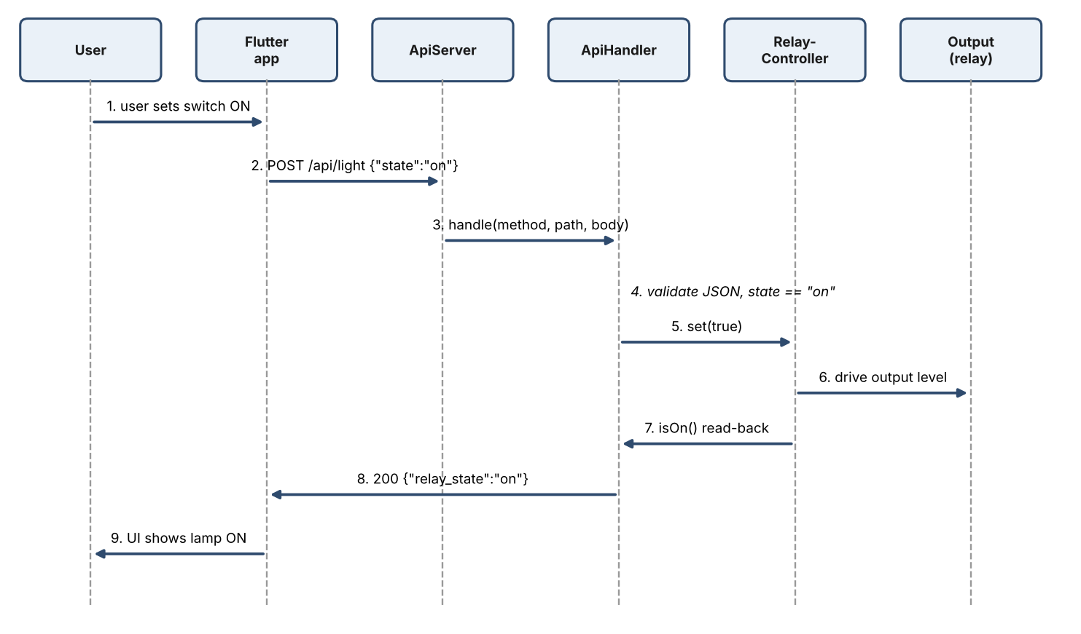
Figure 4. Sequence of an ON command.

6.3 OFF command sequence
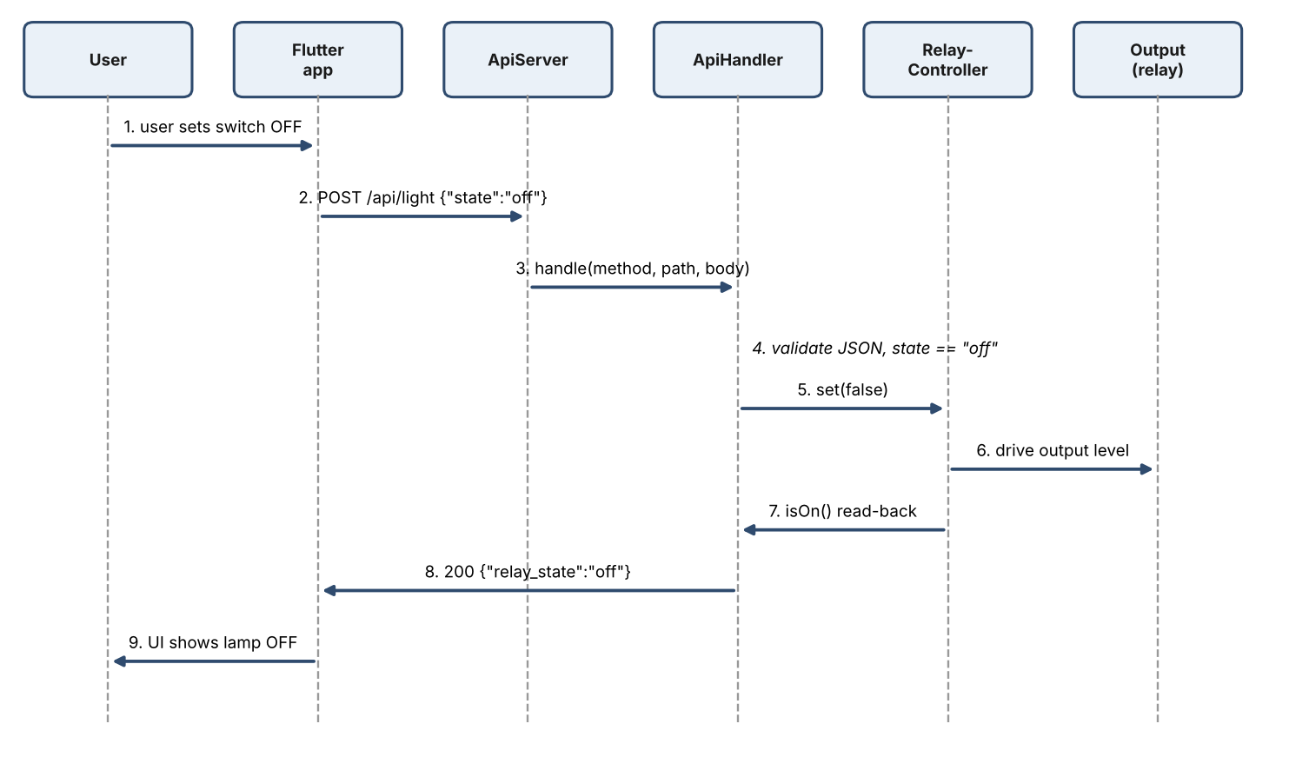
Figure 5. Sequence of an OFF command.
In words: the user operates the switch; Flutter sends POST /api/light with {"state":"on"} or "off"; the ESP32 receives it and ApiHandler validates the JSON; the relay controller changes the output; the ESP32 replies with the relay state it read back; Flutter updates the display from that reply. The following status poll confirms the same state.

6.4 Error handling and synchronisation
The reference application used a 3-second request timeout, mapped network errors (unreachable device, timeout, malformed response) to readable messages, disabled the controls while offline, and always showed the lamp state taken from the device reply or the latest status. Because the application re-reads the device every poll, a command that failed or an externally changed state is corrected on the next poll. The final main.dart was not reviewed, so these behaviours are Reference code, not confirmed for the final app.

6.5 Settings dialog (as reported)
The settings dialog lets the user change the darkness threshold, the hysteresis and the confirmation time. The application reads the values with GET /api/config and writes them with POST /api/config. The device validates them (Section 5.3), so a rejected value comes back as a 400 error. The ESP32 address is held in a variable with a default value and is loaded from shared_preferences, so it is a saved setting (Verified from the source lines located by the scan; the file content was not reviewed).

7. Android Configuration
Setting | Why it is needed | Basis
INTERNET permission | Android apps need it to open network sockets, including connections to a device on the local network. | User-reported
Cleartext HTTP allowed (usesCleartextTraffic) | The ESP32 serves plain HTTP. Android 9 and later block cleartext traffic by default, so requests to a plain-HTTP address on the local network fail without it. This is acceptable for a local prototype and is a security trade-off: traffic is unencrypted. | User-reported
Android NDK 28.2.13676358 | Installed by the Android toolchain for the Gradle build. | User-reported
Core-library desugaring (Gradle) | Not applicable: it was needed only for the notification plugin, which is not in the final pubspec.yaml. | Verified

8. Development Environment and Tools
Item | Value | Basis
Operating system | Windows 11, version 25H2 | Verified
Flutter | 3.47.9, stable channel | Verified
Android SDK | 36.0.0 (command-line tools installed) | Verified
Android Studio | 2026.2.2.8 (installed with winget) | Verified
Emulator | Medium_Phone_API_37.0 (reported as Android 17, API 37) | Verified
Packages (pubspec.yaml) | http ^1.6.0, provider ^6.1.5+1 (declared, not imported), shared_preferences ^2.5.6 | Verified
flutter doctor | Flutter and Android toolchain OK. Chrome and Visual Studio reported missing; irrelevant for Android builds. | Verified
Arduino IDE, ESP32 core, ArduinoJson | Reference used Arduino IDE, ESP32 core 3.x and ArduinoJson 7.x. Installed versions not recorded. | Unverified
Wokwi | Free plan. Used for the simulation milestones. | Verified

8.1 Important commands
Command | Where to run | When and why
flutter doctor -v | any PowerShell | Check the toolchain; read it first when a build fails.
flutter devices | any PowerShell | List available targets (emulator, phone). The emulator must be running first.
flutter pub get | project folder | After changing pubspec.yaml, to download the packages.
flutter clean | project folder | When the build cache is stale or Gradle errors persist. The next build is slower.
flutter run -d emulator-5554 | project folder | Build, install and start the app on the emulator.
flutter build apk --release | project folder | Produce an installable APK (output under build\app\outputs\flutter-apk). Whether it was built is unverified.

8.2 Testing on a physical Android phone
- Enable Developer options and USB debugging on the phone and connect it with a data-capable USB cable.
- Run flutter devices and note the phone's device id.
- Connect the phone to the same Wi-Fi network as the ESP32 (the home router), not to mobile data.
- Make sure the application targets the ESP32's current IP address.
- Run flutter run -d <device id>, or install the release APK on the phone.

9. Debugging and Troubleshooting History
Entries marked Verified are supported by outputs shown in the project conversation; the rest are the student's account.

A. Flutter and Android setup
Android Studio was installed with winget; the first download failed a size check (error 0x8a15002e) and a retry installed it (Verified). Flutter initially could not find the SDK; the SDK path was set with flutter config --android-sdk. The command-line tools had to be installed from the SDK Manager before licences could be handled, and the licence command then reported that the older sdkmanager flow is deprecated (Verified). flutter doctor then showed Flutter and the Android toolchain OK (Verified). The project was created, dependencies were installed, and an emulator was available (Verified). Successful execution of the initial Flutter application and the NDK configuration are reported by the student (User-reported).

B. ESP32 Wi-Fi configuration
The firmware has a build switch, TARGET_WOKWI. With 1 it uses the simulator's open network; with 0 it uses the real home network credentials, and the relay polarity default follows the physical-module assumption. Wokwi's free plan cannot accept incoming connections, which is why the physical ESP32 was needed to test the real HTTP path (Verified from the simulator documentation check). The student set the switch for hardware, entered the home SSID and password, put the ESP32 and the computer or phone on the same router, and identified the ESP32 address from the Serial Monitor (User-reported).

C. HTTP JSON parsing
A POST to /api/light initially returned invalid_json (User-reported). Investigation used PowerShell Invoke-RestMethod with an explicit content type and body (Section 5.4) so the request could be controlled precisely. In the reference design the usual causes are a missing Content-Type: application/json header (the ESP32 then does not expose the body), quoting that damages the JSON in a shell, or an empty body. The actual root cause found in the project is not recorded and is Unverified.

D. HTTP server debugging
Serial debugging was added to ApiServer.cpp to print the HTTP method, the request URI, the request body, the response code and the response JSON (User-reported). This shows what the ESP32 actually received, which separates client problems (wrong body or header) from firmware problems (validation), and it let the Flutter requests be compared with the PowerShell requests that worked.

E. Misplaced code and compilation errors
An ON/OFF control block was inserted into loop() instead of ApiHandler::postLight(). The reported errors were: 'state was not declared in this scope', '_relay was not declared in this scope', 'wifi does not name a type', and unexpected closing braces (User-reported). Explanation of the two names:
- relay is the global RelayController object created in the main sketch. It is visible in loop() and setup().
- _relay is a private member of ApiHandler: a reference, bound in the constructor to that same global object. It exists only inside ApiHandler's member functions, so using it in loop() cannot compile.
- state is a local variable parsed from the JSON inside postLight(); it does not exist anywhere else.
- 'wifi does not name a type' and the stray-brace errors are typical follow-on errors: once a block is pasted into the wrong place the braces no longer balance, and the compiler then misreads the code that follows.
The fix was to restore the main sketch and keep all HTTP request handling in ApiHandler.cpp, which matches the reference architecture (User-reported).

F. LED behaviour
A test that blinked an LED with digitalWrite() and delay() was not the intended behaviour: it blocks the loop, so sensing and the HTTP server would stall, and it produces a periodic pattern instead of a persistent state that follows the application. The intended behaviour is ON or OFF held until the next command. Any LED code must match the actual ESP32-S3 board: boards differ, some use a simple GPIO LED while others use an addressable RGB LED, and the pin changes between board versions. For that reason no LED pin, including GPIO2, is assumed here (Unverified).

10. Testing Methodology and Results
Testing proceeded in three stages: simulation in Wokwi, compilation for a real ESP32 target, and physical testing with the application. The API logic was tested in the simulator through serial-injected requests because incoming network connections are not available on the free plan.

10.1 Simulation results
Observation | Result | Basis
Brightness mapping | 2045 / 680 / 161 raw at 100 / 1000 / 10000 lux; 44.1 / 85.5 / 100.0 % | Verified
Boot state | Config 30 % / 10 % / 10 s; relay OFF | Verified
Wi-Fi | Connected to the simulated network (10.10.0.2); HTTP server started | Verified
Darkness | 19 lux: DARK_CONFIRMED, event 1, relay stayed OFF | Verified
Manual command | on gave Relay: ON and the simulated LED lit; relay module active-HIGH in Wokwi | Verified
API requests | Ten serial-injected requests reported as passing: status, light on and off, invalid state, invalid JSON, wrong method, unknown path, config read, update, out-of-range update | Verified
Settings surviving a reset | Result not recorded | Unverified

10.2 Compilation
The firmware compiled for an ESP32 Dev Module target: 947,612 bytes of program storage (72 % of 1,310,720) and 47,640 bytes of dynamic memory (14 % of 327,680) (Verified). A compile for the ESP32-S3 target is not recorded.

10.3 Physical testing (reported)
The student reports that the latest physical tests were successful and that the system responds correctly:
Outcome | Basis
ESP32 firmware compiles successfully | User-reported
ESP32 connects to the home Wi-Fi network | User-reported
Flutter application launches | User-reported
Flutter communicates with the REST API | User-reported
ON/OFF commands are received by the ESP32 | User-reported
The physical output responds correctly to the application commands | User-reported
The project passed its current physical ON/OFF test | User-reported

No logs, photographs, screenshots, dates or measured values of the physical tests were provided, and the output that responded (onboard LED, external LED, or relay with a load) is not recorded. These results are therefore accepted as reported and are not independently verified.

10.4 Not yet confirmed
- Final relay-to-lamp wiring.
- Full lighting installation.
- Automatic lighting based on darkness detection (the current design intentionally has none).
- Long-duration reliability.
- Calibration of the ADC constants on the real board, and real ADC noise.
- Persistence of settings after a power cycle on hardware.
- Any hardware integration not demonstrated by the source code or test records.

11. Current Implementation Status
The system is a working baseline. Development is paused because the current tests succeeded; nothing further is proposed.
Area | Status | Basis
Firmware modules and REST API | Implemented; compiled; API logic tested in simulation | Verified
Wi-Fi connection to the home router | Working | User-reported
Flutter app running and talking to the ESP32 | Working | User-reported
Manual ON/OFF with physical response | Passed the current physical test | User-reported
Brightness monitoring and darkness detection on hardware | Implemented; hardware behaviour not recorded | Unverified
Relay-to-lamp wiring and full installation | Not confirmed | Unverified
Long-duration reliability | Not tested | Unverified

11.1 Checklist to resume the project later
- Back up the whole sketch folder and the smart_lighting_app folder. Keep a copy of the final config.h (without publishing the Wi-Fi password).
- Record the real pin numbers, the exact ESP32-S3 board model and the relay module model in config.h comments.
- Re-check the ESP32 IP address in the Serial Monitor, because DHCP may have changed it, and update the application if needed.
- Confirm that TARGET_WOKWI is 0 for hardware and 1 for the simulator.
- Run flutter doctor -v and flutter pub get before the first build after a break.
- Use the status endpoint and the Serial output as the first diagnostic.

12. Conclusion
The project delivers a modular ESP32 firmware, a documented REST API and a Flutter application that together allow a light output to be switched from a phone over the local network, with brightness monitoring and darkness detection available as information. The sensing, filtering, state machine, relay logic and API behaviour were verified in simulation, and the student reports that the physical ON/OFF test passed. Evidence for the final hardware details, the final source files and the long-term behaviour is not part of the available record and is labelled as unverified throughout, so that these points can be closed when work resumes.

Appendix A. Missing Information
Providing the following would let every Unverified item in this document be completed or corrected.
Missing item | Needed for
Exact ESP32-S3 board model | Section 2.1 and the pin map
Final config.h pin constants (LDR, relay, onboard LED) | Section 2.3
What responded in the physical test (onboard LED, external LED, relay, lamp) and the relay module model | Sections 2.1, 10.3
Final smart_lighting.ino, ApiServer.cpp and ApiHandler.cpp | Sections 3, 4, 5, 9
Final lib/main.dart (settings dialog fields, exact error handling) | Section 6
Root cause of the invalid_json error and the exact fix | Section 9.C
Serial logs, photographs or screenshots with dates of the physical tests | Section 10.3
Result of a reset test for stored settings; real ADC readings (covered and bright) | Sections 4.7, 10.4
Whether a release APK was built; whether the router reserves the ESP32 address | Sections 8.1, 4.6

