# [Software Design and Architecture](https://classroom.google.com/c/NjU2NzYzMjk4OTg0)

# Phase 1 – Design

**USE CASES**

**Group Members**

Muneeb Tariq

Hammad-ul-Hassan

Haris Sajid

|  |  |  |  |  |
| --- | --- | --- | --- | --- |
| Use case ID | | | UAC.UC.21 | |
| Use case name | | | |  |  |  | | --- | --- | --- | | **Check with latitude longitude** | **Version no** | **1.0** | | |
| End objective | | | **User successfully logins** | |
| Created by | | | **Muneeb Tariq** | |
| Approved by | | | **Amir Iqbal** | |
| User/Actor | | | **Customer** | |
| Preconditions | | | | |
| User has already signed up in the system | | | | |
| Basic flow | | | | |
| Steps | **User Actions** | | **System Actions** | |
| 1 | User enters latitude longitude | | System stores the latitude and longitude | |
| 2 | User enters multiple locations | | System successfully stores locations | |
| Alternative Flow | | | | |
| Steps | | **User actions** | | **System Actions** |
| 1(a) | | User enters wrong latitude longitude | | System Displays “Wrong latitude longitude” |
| 1(b) | | User enters latitude longitude | | System Displays” These coordinates don’t lie within the locations you entered” |

|  |  |  |  |  |
| --- | --- | --- | --- | --- |
| Use case ID | | | UAC.UC.21 | |
| Use case name | | | |  |  |  | | --- | --- | --- | | **Check with country name** | **Version no** | **1.0** | | |
| End objective | | | **User successfully Signup** | |
| Created by | | | **Muneeb Tariq** | |
| Approved by | | | **Amir Iqbal** | |
| User/Actor | | | **Customer** | |
| Preconditions | | | | |
| User has successfully logged in the system | | | | |
| Basic flow | | | | |
| Steps | **User Actions** | | **System Actions** | |
| 1 | User enters locations | | System stores locations | |
| 2 | User enters city/country name | | System stores city/country name | |
| 3 | User clicks generate report | | System displays report for user specifications | |
| Alternative Flow | | | | |
| Steps | | **User actions** | | **System Actions** |
| 3 | | User clicks generate report | | System Displays “Sorry no reports available for these city/country” |
| 2 | | User enters city/country name | | System Displays” Wrong city/country name” |

|  |  |  |  |  |
| --- | --- | --- | --- | --- |
| Use case ID | | | UAC.UC.21 | |
| Use case name | | | |  |  |  | | --- | --- | --- | | **Show current conditions** | **Version no** | **1.0** | | |
| End objective | | | **User successfully Views conditions** | |
| Created by | | | **Muneeb Tariq** | |
| Approved by | | | **Amir Iqbal** | |
| User/Actor | | | **Customer** | |
| Preconditions | | | | |
| User has successfully logged in the system | | | | |
| Basic flow | | | | |
| Steps | **User Actions** | | **System Actions** | |
| 1 | User selects view forecast | | System Shows the weather conditions | |
| Alternative Flow | | | | |
| Steps | | **User actions** | | **System Actions** |
| 1 | | User Selects view forecast | | System Displays” Sorry no forecasts available currently” |

|  |  |  |  |  |
| --- | --- | --- | --- | --- |
| Use case ID | | | UAC.UC.21 | |
| Use case name | | | |  |  |  | | --- | --- | --- | | **Show basic info** | **Version no** | **1.0** | | |
| End objective | | | **User successfully views basic info** | |
| Created by | | | **Muneeb Tariq** | |
| Approved by | | | **Amir Iqbal** | |
| User/Actor | | | **Customer** | |
| Preconditions | | | | |
| User has successfully logged in the system | | | | |
| Basic flow | | | | |
| Steps | **User Actions** | | **System Actions** | |
| 1 | User opens website | | System shows basic info like “Feels like minimum maximum temperature” according to user location | |
| Alternative Flow | | | | |
| Steps | | **User actions** | | **System Actions** |
| 1(a) | | User clicks on website | | System Displays “Sorry website is under maintenance currently” |
| 1(b) | | User clicks on website | | The website crashes due to some reason |

|  |  |  |
| --- | --- | --- |
| Use case ID | | UAC.UC.21 |
| Use case name | | |  |  |  | | --- | --- | --- | | **View Time** | **Version no** | **1.0** | |
| End objective | | **User successfully views time** |
| Created by | | **Muneeb Tariq** |
| Approved by | | **Amir Iqbal** |
| User/Actor | | **Customer** |
| Preconditions | | |
| User has successfully logged in the system | | |
| Basic flow | | |
| Steps | **User Actions** | **System Actions** |
| 1 | User opens website | System shows Home page to user |
| 2 |  | System displays sunset and sunrise time to user on main page |

|  |  |  |  |  |
| --- | --- | --- | --- | --- |
| Use case ID | | | UAC.UC.21 | |
| Use case name | | | |  |  |  | | --- | --- | --- | | **Weather for 5 days** | **Version no** | **1.0** | | |
| End objective | | | **User successfully views weather for 5 days** | |
| Created by | | | **Muneeb Tariq** | |
| Approved by | | | **Amir Iqbal** | |
| User/Actor | | | **Customer** | |
| Preconditions | | | | |
| User has successfully logged in the system | | | | |
| Basic flow | | | | |
| Steps | **User Actions** | | **System Actions** | |
| 1 | User selects view weather conditions | | System displays respective menu to him | |
| 2 |  | | System displays forecasts for 5 days of week | |
| Alternative Flow | | | | |
| Steps | | **User actions** | | **System Actions** |
| 2 | |  | | System Displays “Sorry weather forecasts are not available for some days” |

**Sequence Diagrams**

Sequence diagram for Use Case

1

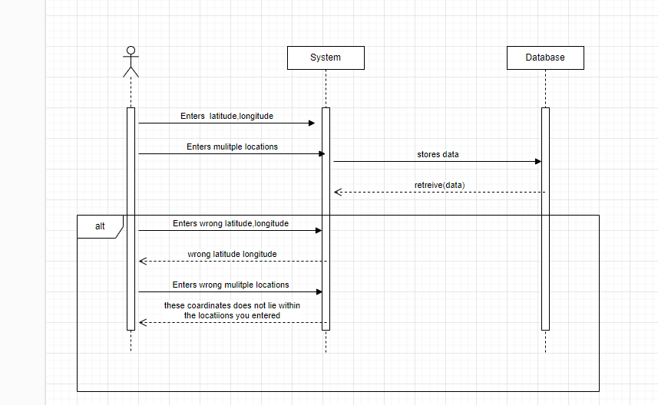

2

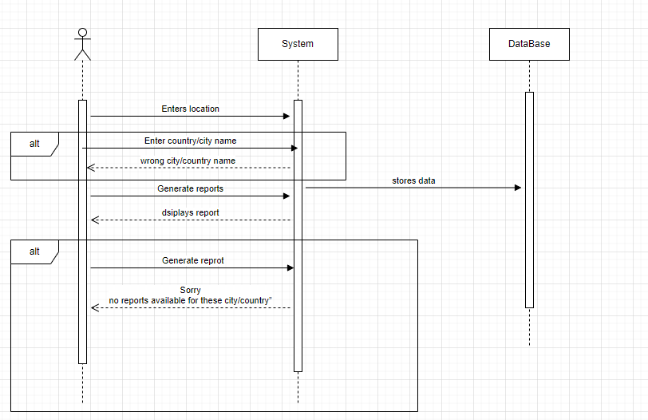

3

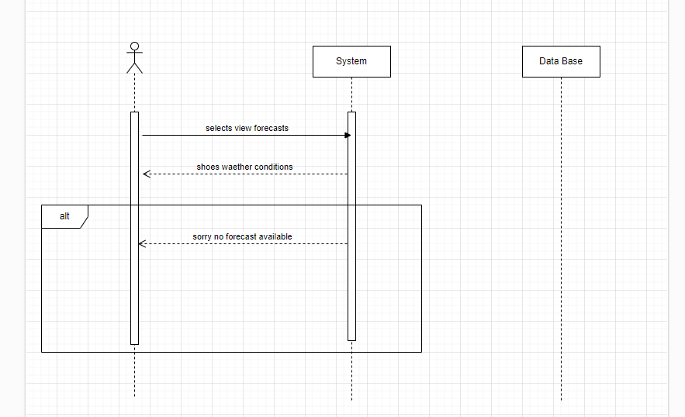**4**

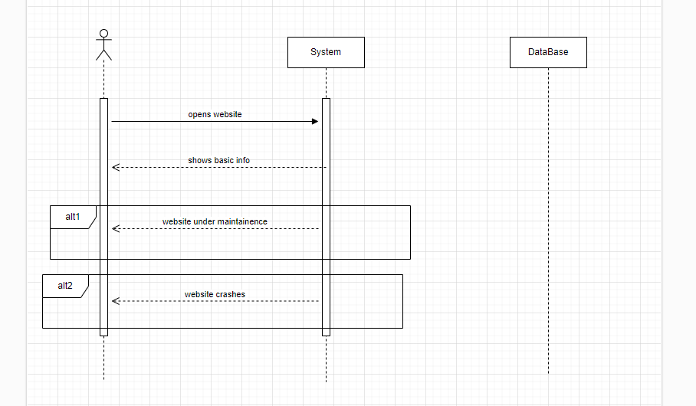

5

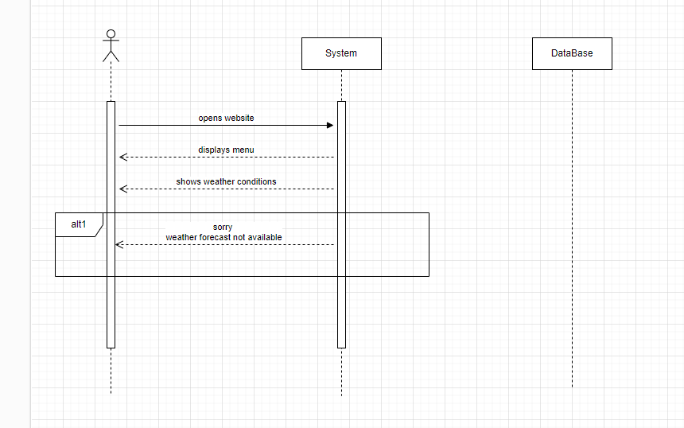

**6**

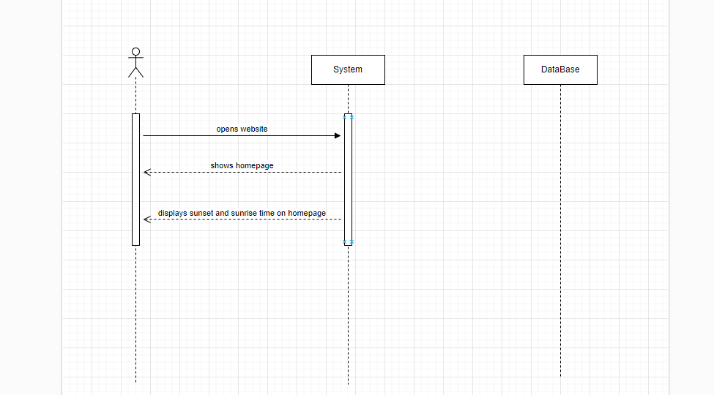

**Class Diagram**

