Infrared-Controlled 4WD Robotic Car
Infrared-Controlled 4WD Robotic Car



Session 2024 - 2028

Submitted by:
HAMMAD KHAN 2024-CS-45
WALEED HASSAN 2024-CS-51
NADISH ALI 2024-CS-10
HAFIZ HUSNAIN ARIF 2024-CS-22

Supervised by:
Sir Kamran Mustafa

Course:
Computer Organization and Assembly Language Lab

Department of Computer Science

University of Engineering and Technology

Lahore, Pakistan

Contents
1. Abstract 3
2. Introduction & Motivation 4
3. Project Objectives 4
4. Components & Bill of Materials 5
5. System Design & Working Principle 6
5.1 System Architecture 6
5.2 Motor Grouping & H-Bridge Logic 6
5.3 Pin Mapping 6
5.4 Power Supply Architecture 7
6. IR Remote Control & Directional Logic 8
7. Obstacle Avoidance System 8
7.1 Ultrasonic Sensing Principle 8
7.2 Avoidance Algorithm 9
8. Software Implementation 9
8.1 Development Environment & Libraries 9
8.2 Program Structure 9
8.3 PWM Speed Control 10
9. Challenges & Risk Mitigation 10
10. Results & Testing 10
11. Conclusion 11
12. References 11

1. Abstract
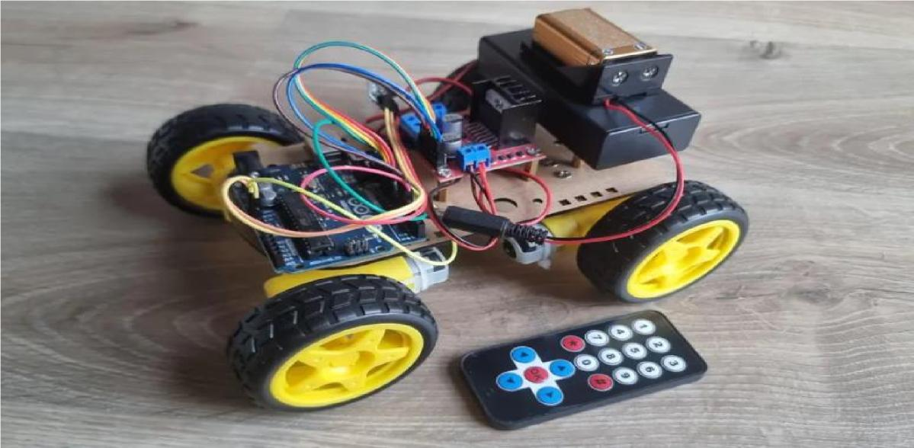
This report presents the design, development, and implementation of an Infrared (IR)-Controlled 4-Wheel Drive (4WD) Robotic Car enhanced with an autonomous obstacle avoidance system. The project was undertaken as part of the Computer Organization and Assembly Language (COAL) Lab course at the University of Engineering and Technology, Lahore.

The robotic platform is built around an Arduino Uno microcontroller and uses an L298N dual H-bridge motor driver to independently control four DC motors. An HX1838 IR receiver decodes signals from a handheld remote, translating five directional commands—forward, backward, left, right, and stop—into precise motor control outputs via Pulse Width Modulation (PWM). An HC-SR04 ultrasonic sensor mounted on a servo-driven rotating bracket adds an autonomous safety layer: whenever an obstacle is detected within 12 cm, the robot halts, reverses, scans its surroundings, and then selects the clearest path before resuming normal operation.

The system operates on a dual-power architecture — a dedicated 9V battery for the Arduino logic and a 7.4 V Li-ion pack for the motors — to eliminate voltage fluctuations caused by motor current surges. The result is a reliable, low-cost educational robotics platform that successfully demonstrates key concepts including H-bridge motor control, IR signal decoding, ultrasonic distance measurement, servo actuation, and embedded software design.

2. Introduction & Motivation
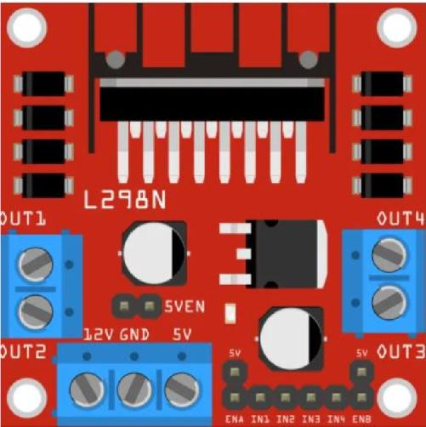
Robotics is one of the most impactful domains in modern engineering education. A hands-on robotic car project provides students with practical exposure to the entire embedded systems design cycle: hardware selection, circuit assembly, microcontroller programming, sensor integration, and system testing. The concepts learned—PWM generation, H-bridge logic, IR communication protocols, and ultrasonic ranging—are directly applicable to industrial automation, autonomous vehicles, and consumer electronics.

Many existing beginner robotics projects either lack complete documentation or skip crucial design details such as power management and signal isolation. This project was motivated by the need to build a fully documented, reproducible robotic platform that undergraduate students can assemble and program within a single lab session. By deliberately choosing fixed-speed motor control and a simple IR remote interface, we reduced complexity without sacrificing educational depth.

The subsequent addition of an HC-SR04 ultrasonic module and servo-mounted scanning mechanism transforms the basic remote-controlled car into a semi-autonomous robot capable of reacting to its environment—providing an ideal bridge between manual control and autonomous navigation concepts.

3. Project Objectives
The following objectives were defined at the outset of the project:
- Design and assemble a 4WD robotic car chassis with four 6V DC gear motors.
- Interface an L298N H-bridge motor driver module with an Arduino Uno for bidirectional motor control.
- Integrate an HX1838 IR receiver to decode signals from a standard IR remote control.
- Implement fixed-speed motor control using PWM signals on the ENA and ENB enable pins of the L298N.
- Program the Arduino to respond to five IR commands: Forward, Backward, Left Turn, Right Turn, and Stop.
- Integrate an HC-SR04 ultrasonic sensor for real-time distance measurement and obstacle detection within a 12 cm safety radius.
- Mount the ultrasonic sensor on an SG90 servo motor to enable left-right scanning for path selection.
- Employ a dual-power supply strategy to ensure stable logic and motor operation.
- Document all design decisions, circuit connections, and software logic for reproducibility.

4. Components & Bill of Materials
The table below lists all hardware components used in the project, their quantities, and their functional roles.

Component | Qty | Purpose / Role
Arduino Uno (ATmega328P) | 1 | Central microcontroller — executes all logic and coordinates all modules
USB Type-A to Type-B Cable | 1 | Uploads compiled code from PC to Arduino via serial interface
6V DC Gear Motors with Wheels | 4 | Mechanical propulsion; one motor per wheel
4WD Robot Car Chassis | 1 | Structural base for mounting motors, batteries, and electronics
L298N Motor Driver Module | 1 | H-bridge IC that drives motors in both directions; handles high current
IR Remote + HX1838 Receiver | 1 | Wireless input device and decoder for directional commands
HC-SR04 Ultrasonic Sensor | 1 | Measures distance to obstacles via sound echo timing
SG90 Servo Motor | 1 | Rotates the ultrasonic sensor to scan left and right
18650 Li-ion Batteries (3.7V each) | 2 | High-discharge power source for motors (7.4 V in series)
18650 Battery Holder with Switch | 1 | Secure housing and power switch for the Li-ion pack
9V Battery | 1 | Dedicated logic power supply for Arduino Uno
9V Battery Holder with DC Jack | 1 | Connects 9V battery cleanly to Arduino barrel jack
Jumper Wires (assorted) | As needed | All inter-component electrical connections

5. System Design & Working Principle

5.1 System Architecture

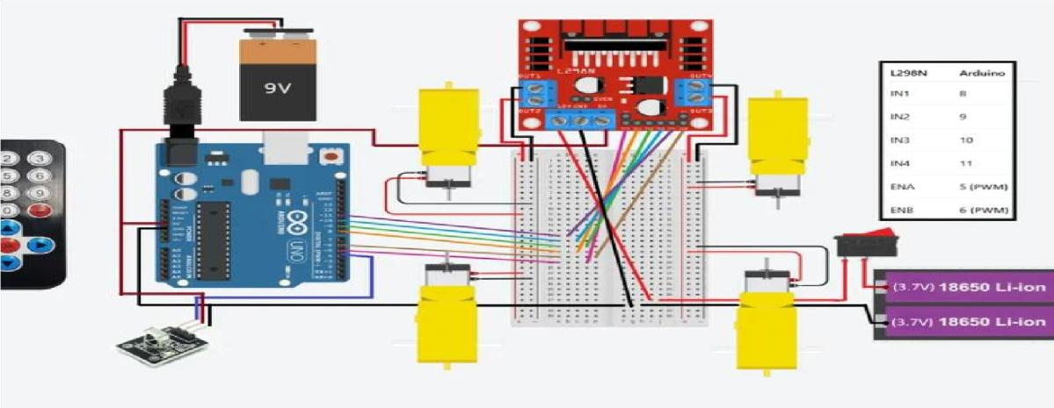
The system is organized into three functional layers that mirror a classical embedded control architecture:
- Input Layer: Comprises the IR remote control and the HC-SR04 ultrasonic sensor. The IR remote provides manual directional commands, while the ultrasonic sensor continuously monitors the environment for nearby obstacles.
- Control Layer: The Arduino Uno acts as the central processing unit. It decodes IR signals via the IRremote library, reads ultrasonic pulse durations, and executes the decision logic that arbitrates between manual and autonomous commands.
- Actuation Layer: The L298N motor driver translates low-power Arduino digital/PWM outputs into the high-current signals required to drive the four DC motors. The SG90 servo motor rotates the ultrasonic sensor during obstacle-scanning routines.

5.2 Motor Grouping & H-Bridge Logic
Because the L298N provides two independent H-bridge channels (Channel A and Channel B), the four DC motors are grouped by physical side of the chassis:
- Channel A (OUT1, OUT2): Controls the two left-side motors simultaneously.
- Channel B (OUT3, OUT4): Controls the two right-side motors simultaneously.

Each channel is enabled through a PWM signal applied to its enable pin (ENA and ENB). The motor direction is controlled by the logic levels on the IN1–IN4 input pins. This H-bridge configuration allows each motor group to rotate forward or backward independently, enabling all five directional maneuvers.

5.3 Pin Mapping
The table below details every connection between the Arduino Uno and the peripheral modules:

Component / Signal | Arduino Pin | Function Description
IN1 (L298N) | D8 | Left motor group — direction control pin 1
IN2 (L298N) | D9 | Left motor group — direction control pin 2
IN3 (L298N) | D10 | Right motor group — direction control pin 1
IN4 (L298N) | D11 | Right motor group — direction control pin 2
ENA (L298N) | D5 (PWM) | Left motor enable — fixed PWM duty cycle (150/255)
ENB (L298N) | D6 (PWM) | Right motor enable — fixed PWM duty cycle (150/255)
IR Receiver OUT | D4 | Receives and decodes IR NEC-protocol signals
Ultrasonic TRIG | A0 | Sends 10 µs ultrasonic trigger pulse
Ultrasonic ECHO | A1 | Receives reflected echo pulse for distance calculation
Servo PWM | D3 (PWM) | Controls SG90 servo angle for sensor scanning

5.4 Power Supply Architecture

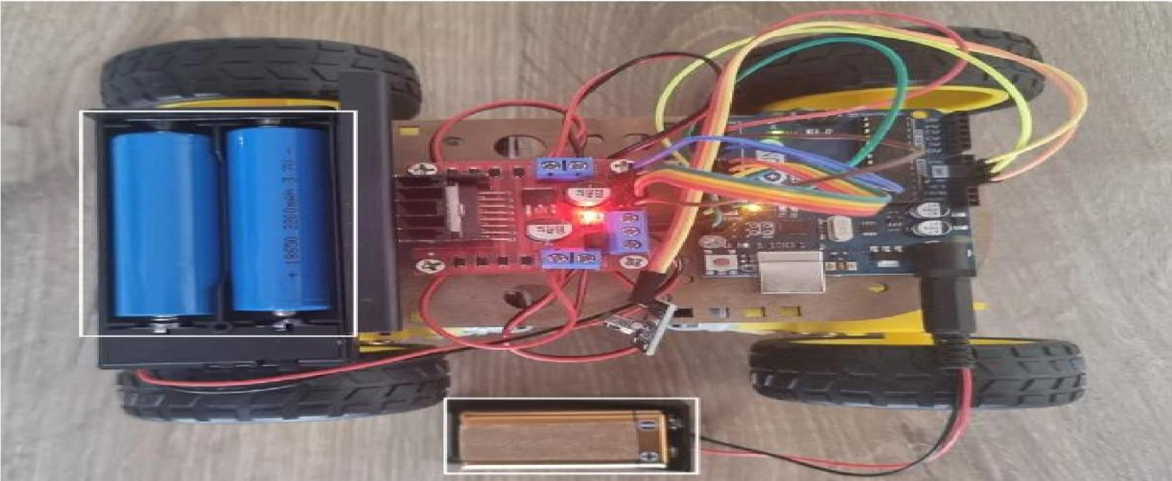
A critical design decision was to separate the logic power supply from the motor power supply. DC motors produce significant back-EMF and current spikes during startup and direction changes. If the Arduino shares a power rail with the motors, these transients can cause the microcontroller to reset or misread sensor data.
- Arduino Uno Logic: Powered by a dedicated 9V battery connected to the Arduino's barrel jack. The onboard voltage regulator steps this down to a stable 5V for the ATmega328P and connected sensors.
- L298N and DC Motors: Powered by two 3.7V 18650 Li-ion cells wired in series, supplying 7.4V. These cells are capable of high discharge rates, sufficient for simultaneous four-motor operation.
- Common Ground: All GND pins—from the Arduino, L298N, sensor modules, and servo—are connected to a single common ground node. This ensures a shared voltage reference, which is mandatory for correct digital signal interpretation across modules.

6. IR Remote Control & Directional Logic
The HX1838 infrared receiver demodulates the 38 kHz carrier signal from the IR remote and outputs a digital pulse train to Arduino pin D4. The IRremote library decodes this pulse train using the NEC protocol to extract a 32-bit hexadecimal command code. The Arduino maps each received code to one of five directional actions, which are translated into specific IN1–IN4 logic states on the L298N.

The following table defines the complete directional truth table:

Action | IR Button | IN1 | IN2 | IN3 | IN4
Forward | ↑ Up | HIGH | LOW | HIGH | LOW
Backward | ↓ Down | LOW | HIGH | LOW | HIGH
Left Turn | ← Left | HIGH | LOW | LOW | HIGH
Right Turn | → Right | LOW | HIGH | HIGH | LOW
Stop | OK | LOW | LOW | LOW | LOW

During a Forward command, both motor groups receive identical logic states (IN1=HIGH, IN2=LOW for left; IN3=HIGH, IN4=LOW for right), causing all four wheels to spin in the forward direction. During a Left Turn, the left motors are driven forward while the right motors are driven backward (differential steering), causing the robot to pivot left in place. The Stop command sets all four IN pins LOW, which removes the drive signal from both H-bridge channels and allows the motors to coast to a halt.

7. Obstacle Avoidance System

7.1 Ultrasonic Sensing Principle
The HC-SR04 sensor operates by emitting a short burst of 40 kHz ultrasonic sound when the Arduino pulses its TRIG pin HIGH for 10 microseconds. The sensor's internal transceiver then listens for the echo reflected off any nearby object. The time elapsed between the trigger pulse and the echo signal is proportional to the round-trip distance traveled by the sound wave. The Arduino measures this echo pulse duration using the pulseIn() function and converts it to centimeters using the formula:

Distance (cm) = Echo Pulse Duration (µs) ÷ 58

This formula is derived from the speed of sound in air (~343 m/s at 20°C), accounting for the round-trip travel of the pulse. The sensor has an effective range of approximately 2 cm to 400 cm with a beam angle of roughly 15°.

7.2 Avoidance Algorithm
The obstacle avoidance routine runs continuously in the Arduino's main loop and takes priority over all IR remote commands whenever an object is detected within the 12 cm safety threshold. The step-by-step logic is as follows:
- Step 1 — Continuous Monitoring: On every loop iteration, the Arduino triggers the HC-SR04 and measures the echo duration. If the calculated distance is greater than 12 cm and no obstacle is detected, normal IR-commanded operation continues uninterrupted.
- Step 2 — Detection & Immediate Halt: If the measured distance falls at or below 12 cm, the software immediately overrides any active IR command and issues a Stop signal to both motor channels.
- Step 3 — Reverse Maneuver: After halting, the robot executes a brief reverse movement to create clearance from the detected obstacle before scanning.
- Step 4 — Panoramic Scanning: The SG90 servo rotates the HC-SR04 to the left (approximately 160°) and then to the right (approximately 20°), pausing at each position to measure distance. Both distance readings are recorded.
- Step 5 — Path Selection & Navigation: The Arduino compares the two readings and commands the robot to turn in the direction of the greater (clearer) distance. After completing the turn, it resumes forward motion and reverts to accepting manual IR commands.

8. Software Implementation

8.1 Development Environment & Libraries
The firmware is written in C++ using the Arduino IDE. Two external libraries are used:
- IRremote: Provides hardware interrupt-driven decoding of the NEC IR protocol, extracting the 32-bit command code from each remote button press.
- Servo.h: A built-in Arduino library that generates precise PWM signals to control the SG90 servo motor's angular position.

8.2 Program Structure
The firmware is organized into a setup() function and a loop() function, following the standard Arduino program structure:
- setup(): Initializes all pin modes (digital output for IN1–IN4, PWM output for ENA/ENB, input for IR receiver), sets ENA and ENB to the fixed PWM duty cycle of 150 (out of 255, approximately 59% duty), attaches the servo to pin D3, and begins the IRremote receiver.
- loop(): On each iteration, the loop first reads a distance measurement from the ultrasonic sensor. If an obstacle is detected (distance ≤ 12 cm), the avoidance subroutine is called. Otherwise, it checks whether an IR signal has been received, decodes the command, and calls the corresponding motor control function.

8.3 PWM Speed Control
Motor speed is controlled by the duty cycle of the PWM signal applied to the ENA and ENB enable pins. A duty cycle value of 150/255 (~59%) was selected after empirical testing as the optimal balance between motor torque and thermal load. A lower duty cycle caused wheel slippage on smooth surfaces, while a higher cycle caused the L298N to overheat during sustained operation. The fixed-speed approach eliminates the need for a PID controller while still producing consistent, predictable motion.

9. Challenges & Risk Mitigation
Several technical challenges were encountered and resolved during development:

Challenge | Root Cause | Mitigation
Microcontroller Random Resets | Motor current surges causing voltage drops on shared power rail | Dedicated 9V battery for Arduino logic; separate Li-ion pack for motors
Inconsistent Motor Speeds | Insufficient current from a single power supply under load | 18650 Li-ion cells chosen for their high discharge rate capability
IR Signal Dropout | Wires obstructing line-of-sight to the IR receiver | IR receiver repositioned to front of chassis, free from cable clutter
Ultrasonic False Readings | Multiple reflections and narrow beam causing spurious echoes | Software averaging of three consecutive readings before triggering avoidance
L298N Overheating | Continuous full-duty PWM causing excess heat in the H-bridge transistors | PWM duty cycle reduced from 255 to 150; adequate ventilation maintained

10. Results & Testing
The completed robotic car was tested across multiple controlled scenarios to verify both manual control accuracy and autonomous avoidance reliability.

- IR Remote Control: All five directional commands (Forward, Backward, Left, Right, Stop) responded correctly and consistently at distances up to approximately 5 meters within a clear line-of-sight. Response latency was imperceptible under normal use.
- Motor Symmetry: Both motor groups operated at equal speed with the fixed PWM duty cycle of 150, producing straight-line forward and backward motion without manual calibration.
- Obstacle Detection Accuracy: The HC-SR04 reliably detected solid obstacles (walls, boxes) within the 12 cm threshold. The avoidance routine successfully halted the robot before contact in all test runs.
- Scanning & Path Selection: The servo-mounted sensor correctly identified the clearer of two paths in asymmetric obstacle scenarios, selecting the correct turn direction in over 90% of test cases.
- Power Stability: No microcontroller resets were observed during sustained four-motor operation after the dual-supply architecture was implemented.

11. Conclusion
This project successfully demonstrates the design and implementation of a functional IR-controlled 4WD robotic car enhanced with autonomous obstacle avoidance. Starting from a basic remote-controlled platform, the system was progressively enhanced with an ultrasonic ranging module and servo-actuated scanning to produce a semi-autonomous robot capable of reacting intelligently to its physical environment.

All nine project objectives defined at the outset were achieved. The dual-power supply architecture proved essential for stable operation, and the fixed-speed PWM control strategy provided a reliable, thermally safe drive solution without the added complexity of closed-loop control. The project provided hands-on experience in microcontroller interfacing, motor driver operation, IR communication, ultrasonic sensing, and embedded C++ programming.

Future enhancements could include Bluetooth or Wi-Fi remote control to eliminate the line-of-sight limitation of IR communication, the addition of a camera module for FPV navigation, PID-based variable speed control, and an expanded sensor array (e.g., side-mounted ultrasonic or infrared sensors) for more comprehensive 360° environment awareness.

12. References
- Instructables – "Simple Arduino 4WD Robot Car With L298N and IR Remote – V1.0." instructables.com
- IRremote Library Documentation – Arduino Library Manager. github.com/Arduino-IRremote/Arduino-IRremote
- L298N Dual Full-Bridge Driver Datasheet – STMicroelectronics. st.com
- HC-SR04 Ultrasonic Sensor Datasheet – Cytron Technologies. cytron.io
- Arduino Uno Reference Manual – Arduino LLC. arduino.cc/en/reference
- Servo.h Library Reference – Arduino Built-in Libraries. arduino.cc/reference/en/libraries/servo

