Scenario:

Albio University is a large uni which has two campuses situated 20 miles apart. The university students and staff are distributed in 4 facilities, of health and science, Business, Engineering/Computing and Art/Design. Each staff member has a PC and students have access to PCs in the lab.

Requirements:

1 – Create a network topology with the main components to support the following:  
Main Campus:

* Building A: Administrative staff in the departments of management, HR, & Finance. The admin staff Pcs are distributed in the building offices and it is expected that they will share some networking equipment. Hint: Use of VLANs is expected here.) The faculty of business is also situated In this building.
* Building B : Faculty of Engineering and Computing and Faculty of Art and Design.
* Building C : Students lab and IT Department. The IT department hosts the university web server and other servers.
* There is also an email server hosted externally on the cloud.

2 – Smaller Campus – Faculty of Health and sciences (Staff and student labs are situated on different floors)

Configuration guidelines

* You will be expected to configure the core devices and few end devices to provide end to end connectivity and access to the internal servers and external servers.
* Each department is expected to be on its own separate network.
* RiPv2 will be used to provide routing for the routersin the internal network and static routing for external server.
* The devices in building A will be expected to acquire dynamic IP Adrresses from router-based DHCP server

Tasks:

Task 1 : Your task is to plan, design, and prototype the network topology for Albions Uni network.

Task 2 – Configure appropriate settings to achieve connectivity.

Task 3 -

Explanatioin –

To make the connection between cloud router and main router as serial dce, we need to physically add a HWIC-2T module. Turn off router, add the module and turn it on. The serial connection should appear as below.

Configurations:

1 – Each department is expected to have its own network. So we will assign accordingly. So starting from left most department that is admin I will assign Vlan 10 and 192.168.1.0/24, then HR will have Vlan 20 and 192.168.2.0/24. So on and so forth.

The routers will have /30 networks. Refer to the diagram for the exact network.

Step 1 – Turn on the router's interfaces since they are administratively down by default. If you wanna see which interfaces are down, go to the rotuers cli and enter “do show ip interfaces brief”.

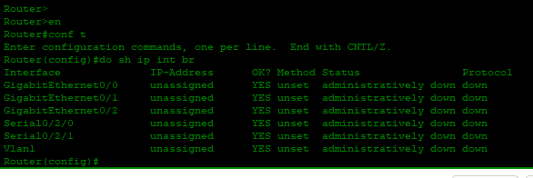

This router is our main campus router, int g0/0 and the other two serial interfaces are In use so we will only turn them on.

We do the same for all other routers.

**Step 2 –**

Enable clock rate on the correct serial dce cables. In order to know which interfaces need it, hover over the red line that connects the two routers and see which interface has a clock sign on it.

Commands – int serial “interface number”, followed by clock rate 64000

**Step – 3**

Configuring Vlans.

I configured vlans on all but will show commands for just vlan 10.

Interface range f0/1-24

Switchport mode access

Switchport access vlan 10

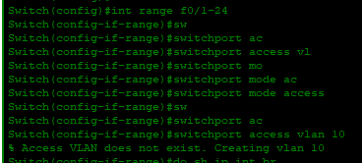

Additionally, I also renamed the vlans to their respective department. Simply type vlan followed by vlan number, and in the next command use name “name”.

We must also add each interface of the switch in main campus to the departments respective vlan.

We can see above the interface is f0/2, so it will be conncted to vlan 10.

Commands will be

Int f0/2, sw mode access, sw access vlan 10

Note- where we have the layer 3 switch and the other switch, we need to add the respective Vlans.

For instance here

Int g1/0/2 should be connected with VLAN 90, and the other int with VLAN 100.

Trunk config

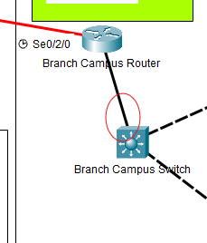

This will be trunk. Do the same for the other router.

See the below image to understand which interface will be assigned ip addresses, which will have trunk config, and which will be used for inter-vlan routing.

Configuring ip addresses on serial interfaces of routers.

On main campus routers serial interfaces we will configure for interface se0/0/1 and se 0/0/0.

The interfaces we left will be used for inter-vlan routing.

The cloud router is connected to a server on the other end so we will configure ip address for both.

Server config.

We need to assign the ip address to server via static method.

Now we configure inter-vlan routing

Branch campus router.

Commands for vlan 90 and 100. On router gig 0/0 interface

I took the first ip address of the subnet. This will be used as the default fateway on the rouer for that vlan.

We will also configure DHCP server to let the end devices choose their ip addresses.

Do the same for other branches.

Configuring RIP

We need if we want the devices connected to the main branch router to communication with the devices in the branch network.

The branch campus router is connected to 3 networks, so rip will advertise those 3 networks.

Commands

Router rip

Version 2

Network “network here”

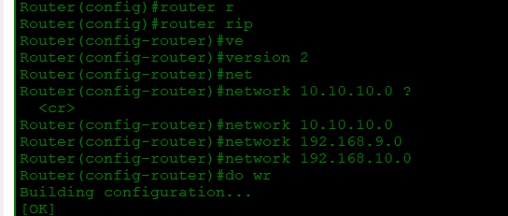

For the campus router, it’s the same but the conneceted networks are more,