Codebook for beers

Autogenerated data summary from dataMaid

2018-10-13 17:34:56

# Data report overview

The dataset examined has the following dimensions:

|  |  |
| --- | --- |
| Feature | Result |
| Number of observations | 2410 |
| Number of variables | 7 |

# Codebook summary table

|  |  |  |  |  |  |
| --- | --- | --- | --- | --- | --- |
| Label | Variable | Class | # unique values | Missing | Description |
|  | **Name** | factor | 2305 | 0.00 % |  |
|  | **Beer_ID** | integer | 2410 | 0.00 % |  |
|  | **ABV** | numeric | 75 | 2.57 % |  |
|  | **IBU** | integer | 108 | 41.70 % |  |
|  | **Brewery_id** | integer | 558 | 0.00 % |  |
|  | **Style** | factor | 100 | 0.00 % |  |
|  | **Ounces** | numeric | 7 | 0.00 % |  |

# Variable list

## Name

|  |  |
| --- | --- |
| Feature | Result |
| Variable type | factor |
| Number of missing obs. | 0 (0 %) |
| Number of unique values | 2305 |
| Mode | “Nonstop Hef Hop” |
| Reference category | #001 Golden Amber Lager |

## Beer_ID

|  |  |
| --- | --- |
| Feature | Result |
| Variable type | integer |
| Number of missing obs. | 0 (0 %) |
| Number of unique values | 2410 |
| Median | 1453.5 |
| 1st and 3rd quartiles | 808.25; 2075.75 |
| Min. and max. | 1; 2692 |

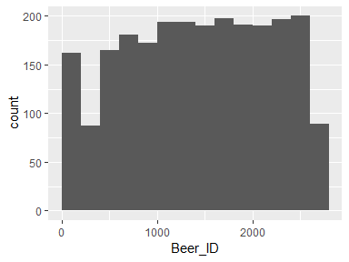

## ABV

|  |  |
| --- | --- |
| Feature | Result |
| Variable type | numeric |
| Number of missing obs. | 62 (2.57 %) |
| Number of unique values | 74 |
| Median | 0.06 |
| 1st and 3rd quartiles | 0.05; 0.07 |
| Min. and max. | 0; 0.13 |

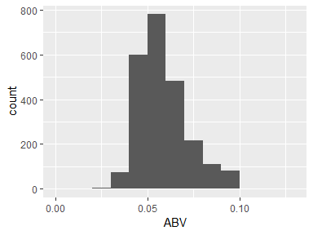

## IBU

|  |  |
| --- | --- |
| Feature | Result |
| Variable type | integer |
| Number of missing obs. | 1005 (41.7 %) |
| Number of unique values | 107 |
| Median | 35 |
| 1st and 3rd quartiles | 21; 64 |
| Min. and max. | 4; 138 |

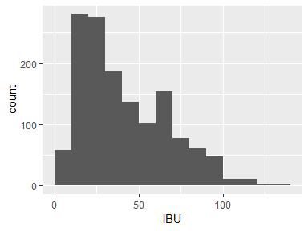

## Brewery_id

|  |  |
| --- | --- |
| Feature | Result |
| Variable type | integer |
| Number of missing obs. | 0 (0 %) |
| Number of unique values | 558 |
| Median | 206 |
| 1st and 3rd quartiles | 94; 367 |
| Min. and max. | 1; 558 |

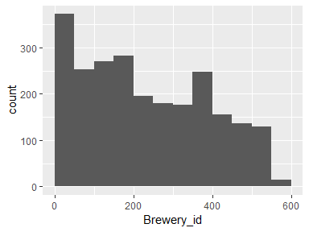

## Style

|  |  |
| --- | --- |
| Feature | Result |
| Variable type | factor |
| Number of missing obs. | 0 (0 %) |
| Number of unique values | 100 |
| Mode | “American IPA” |
| Reference category |  |

## Ounces

|  |  |
| --- | --- |
| Feature | Result |
| Variable type | numeric |
| Number of missing obs. | 0 (0 %) |
| Number of unique values | 7 |
| Median | 12 |
| 1st and 3rd quartiles | 12; 16 |
| Min. and max. | 8.4; 32 |

