Codebook for breweries

Team (Satish, Tyler, Thotho)

2018-10-13 17:50:10

# Data report overview

The dataset examined has the following dimensions:

|  |  |
| --- | --- |
| Feature | Result |
| Number of observations | 558 |
| Number of variables | 4 |

# Codebook summary table

|  |  |  |  |  |  |
| --- | --- | --- | --- | --- | --- |
| Label | Variable | Class | # unique values | Missing | Description |
|  | **Brew_ID** | integer | 558 | 0.00 % | Unique identifier of the brewery |
|  | **Name** | factor | 551 | 0.00 % | Name of the brewery |
|  | **City** | factor | 384 | 0.00 % | City where the brewery is located |
|  | **State** | factor | 51 | 0.00 % | U.S. State where the brewery is located |

# Variable list

## Brew_ID

|  |  |
| --- | --- |
| Feature | Result |
| Variable type | integer |
| Number of missing obs. | 0 (0 %) |
| Number of unique values | 558 |
| Median | 279.5 |
| 1st and 3rd quartiles | 140.25; 418.75 |
| Min. and max. | 1; 558 |

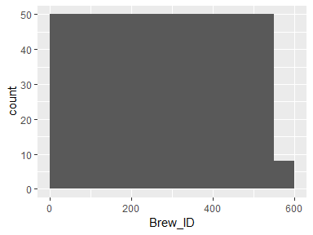

## Name

|  |  |
| --- | --- |
| Feature | Result |
| Variable type | factor |
| Number of missing obs. | 0 (0 %) |
| Number of unique values | 551 |
| Mode | “Blackrocks Brewery” |
| Reference category | 10 Barrel Brewing Company |

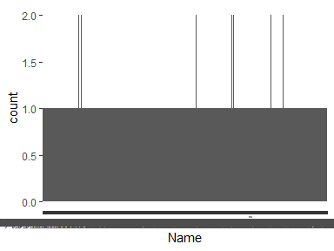

## City

|  |  |
| --- | --- |
| Feature | Result |
| Variable type | factor |
| Number of missing obs. | 0 (0 %) |
| Number of unique values | 384 |
| Mode | “Portland” |
| Reference category | Abingdon |

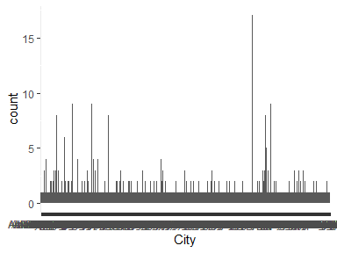

## State

|  |  |
| --- | --- |
| Feature | Result |
| Variable type | factor |
| Number of missing obs. | 0 (0 %) |
| Number of unique values | 51 |
| Mode | " CO" |
| Reference category | AK |

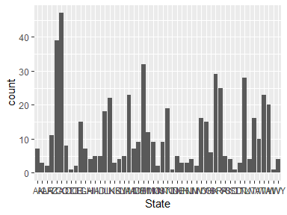

* Observed factor levels: " AK", " AL", " AR", " AZ", " CA", " CO", " CT", " DC", " DE", " FL", " GA", " HI", " IA", " ID", " IL", " IN", " KS", " KY", " LA", " MA", " MD", " ME", " MI", " MN", " MO", " MS", " MT", " NC", " ND", " NE", " NH", " NJ", " NM", " NV", " NY", " OH", " OK", " OR", " PA", " RI", " SC", " SD", " TN", " TX", " UT", " VA", " VT", " WA", " WI", " WV", " WY".