# Basket Ball Pro

This package is compatible with Unity 2018.2.4 or above.

# Overview

This package is a fully fledged basketball game with 4 different game modes, In App purchases, Unity and Admob Ads, Facebook Leaderboard and Invite, Share system for iOS and Android, complete unlocking mechanism for hoops and balls unlock on the basis of score and crowns, Spin wheel system and hourly reward system. This help you launch a game with almost no coding required. The game is very simple, easy and addictive to play. User plays the game and earn score and combos give them crowns, these score and crowns helps it to unlock more hoops and balls. User can earn coins and can also buy them from in App purchases. User will also get coins bonus every 30 minutes. The object is to earn more and more score and crowns to stand high on Leaderboard. The Leaderboard is implemented with Facebook Score API. The simple editor menu helps you enable or disable features.

* Feature needs to be enabled after buying respective packages

# Features List:

This asset includes following features.

* Complete game with source code
* Amazing UI, Animation and Sounds
* Free coins Bonus every 30 Minute
* Fully optimized for Mobile, Web and Desktop
* Unity Ads and Google Admob Interstitial Ads
* Unity IAP for all supported platforms
* Editor Support to configure things as per your liking
* Custom Hourly Reward SDK is In place
* Bad Review Protector comes for free
* Facebook Package needs to enable from Settings
* Custom Re-skin Service available
* Get Game Bench Native Share <http://u3d.as/1j90> To enable Feature
* Get Game Bench Animated Splash Screen <http://u3d.as/1h4i> to enable Feature

# Getting Started:

Simply Open the scene named “game” from the “BasketBallPro” directory after importing the package. You may want to add the scene in your build setting for testing on a physical device by going into Unity File> Build Settings Menu.

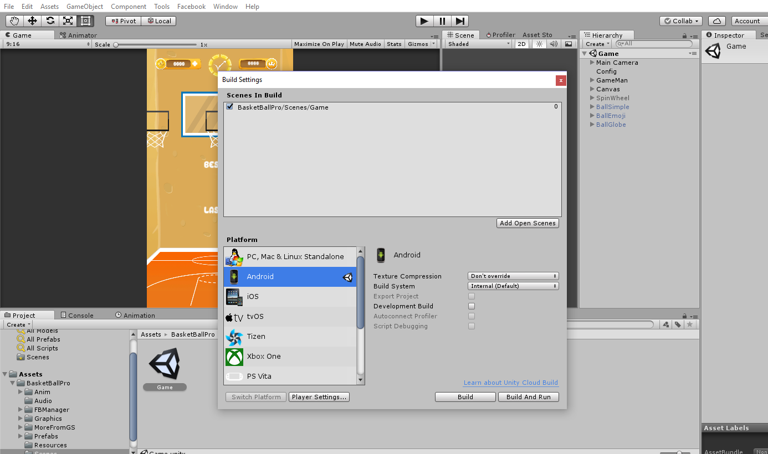

You can enable or disable features by going to the editor menu that also helps you in contacting us through email in case you have any queries or want to order further features and support.

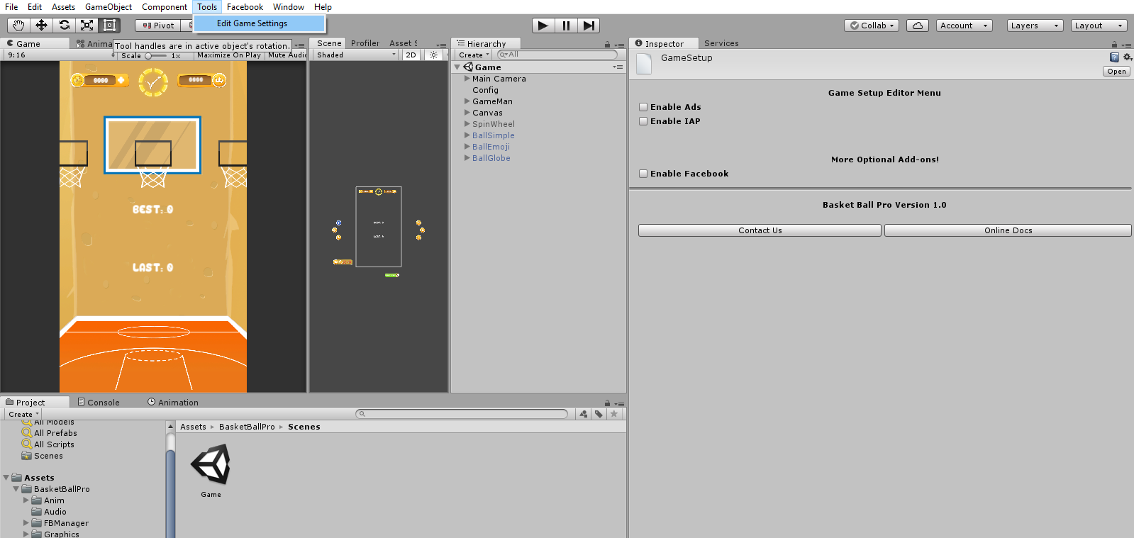

## Additional Features:

This package doesn’t equip with some other GameBench packages. You’ll need to buy and import the Bad Review Protector, asynchronous scene loader and GS Native share, whereas the Hourly spin system, Facebook invite and leaderboard, spin wheel and bad review protector is enabled and comes out of the box with this package.

For Enabling In App purchases : First check the box from the Game’s Editor menu and then from Unity’s Menu Window select Services and login in with your unity account and enable in App purchase.

For Enabling Ads:

For Ads, just check the box from the Game’s Editor menu and enable Ads from Unity’s Menu Window> Services. You may need to login with Unity Account for Unity Ads. For Admob settings simple download Unity Admob SDK from <https://github.com/googleads/googleads-mobile-unity/releases>

Now you need to import sdk and put your iOS and Android interstitial Ad Ids.

Game Bench Facebook package is already included in the project and you just need to import the official Facebook SDK for Unity, also GameBench Bad Review Protector is in place so no extra steps are needed. You may want to have a custom animated splash (after made with Unity splash – for Unity Free) and can also buy native share to enable from our asset store page.

# Help and Support

The code is minimal and self-explanatory with comments so you can easily understand it and further customize it if. Contact if you need additional help:

Email: [info.gamebench@gmail.com](mailto:info.gamebench@gmail.com)

Facebook: <https://www.facebook.com/Game-Bench-240598019929708/>

Unity Connect: <https://connect.unity.com/u/5b56f21603b00200199bb25a>