**Cheat sheet examples:**

Contents

pinMode 2

digitalRead 3

digitalWrite 4

delay 5

if 6

else 7

for 8

serial.print 9

analogRead 10

analogWrite 11

While 12

Queries 13

Equals 14

And 15

or 16

# pinMode

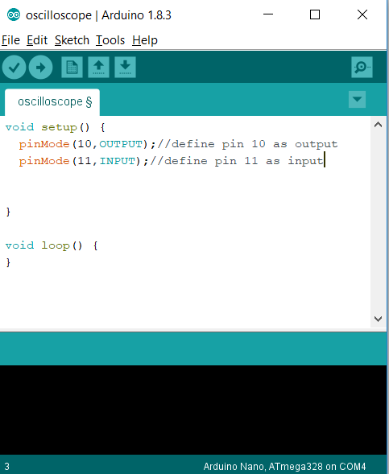

# digitalRead

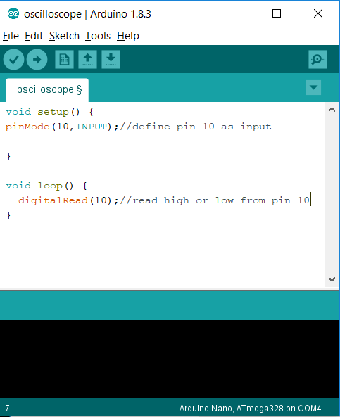

# digitalWrite

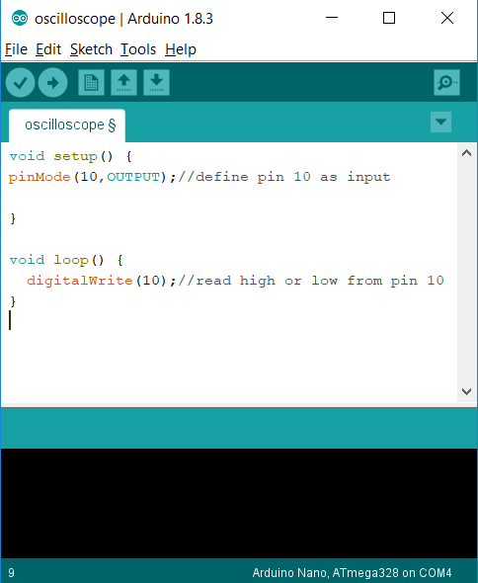

# delay

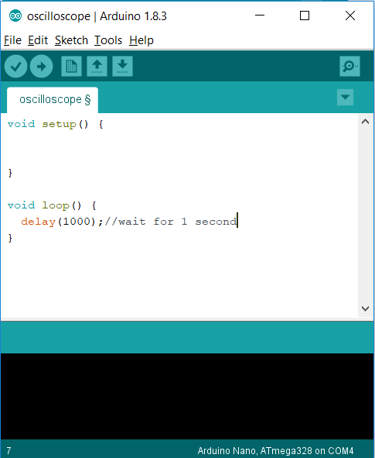

# if

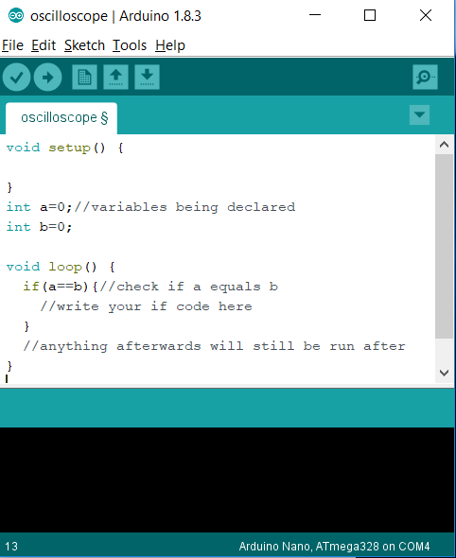

# else

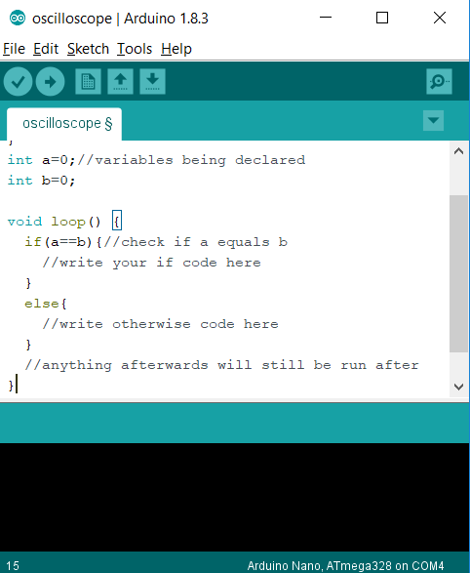

# for

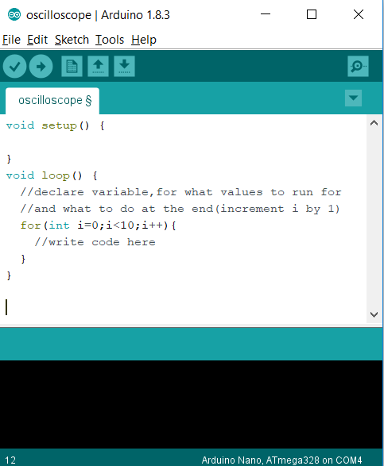

# serial.print

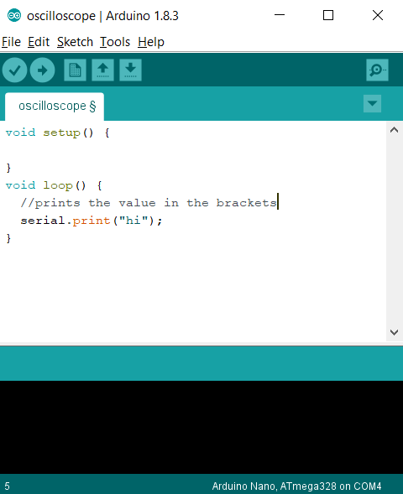

# Serial.print

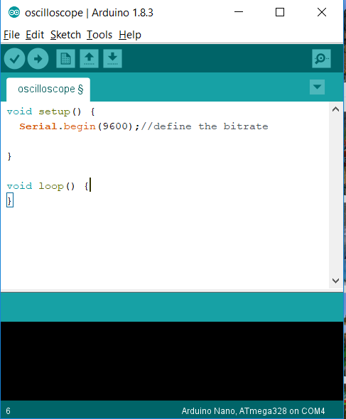

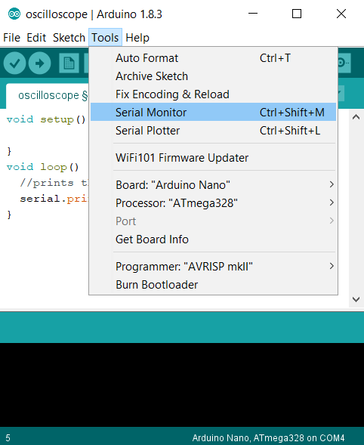

# analogRead

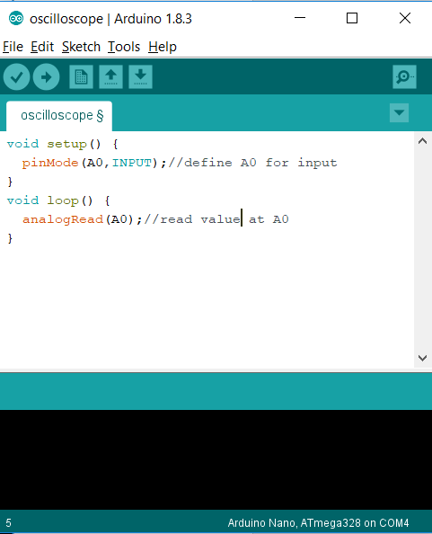

You don’t need to initialise for analogue pins!

# analogWrite

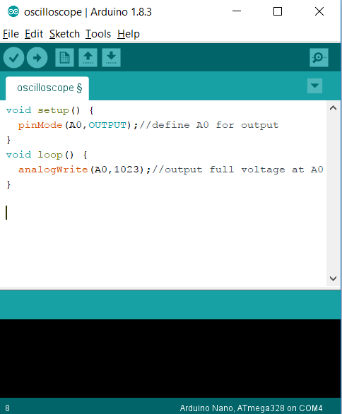

You don’t need to initialise for analogue pins!

# While

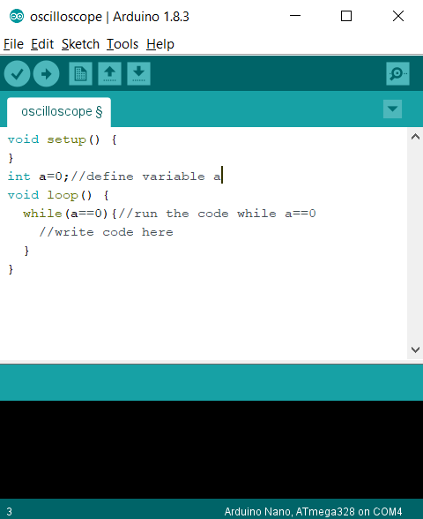

# Queries

## Equals

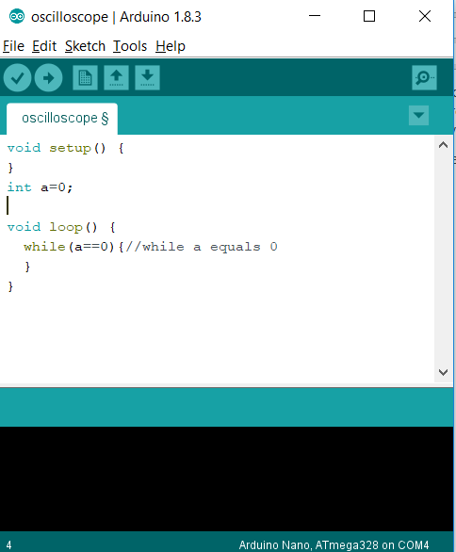

## And

## 

## Or

