Introduction
Background:
In this lab we were given two black boxes with no way of directly identifying what component inside is other thank knowing it was a capacitor or a inductor. We had access to general basic electronic measurement equipment and knew that one of the components was a resistor.
Aims:
To an average degree of accuracy find the value of the components inside the black boxes via external measurements.

Theory
Laws and equations:
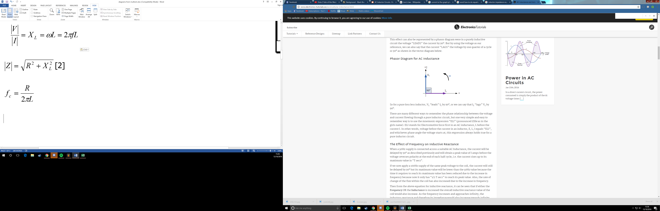
An inductors voltage drop is directly proportional to the rate of change of current flowing across [1].
An alternating current passing through a wire creates a magnetic field which interacts with the current through the wire opposing the motion increasing the reactance (resistance).

Due to the fact the voltage is directly proportional to the rate of change of current flowing through the wire and following lenz’s law the voltage creates a field that is opposing the change that created it creating a phase difference of pi/2 with the current lagging behind voltage. Diagrammed as such:
V
I

Method
Description:
First of all we define the boxes randomly as box 1 and box 2.We measure the resistance of both boxes on dc power, immediately we can tell if we have a capacitor or an inductor depending on if there is a component with infinite resistance. We then connect the boxes in series with the function generator starting with a sine wave of voltage 1Vpp and a frequency of 100 Hz. We ground the oscilloscope to the negative of the circuit and measure the voltage wave across both and then only the second black box. After this repeat incrementing frequency in reasonable steps.
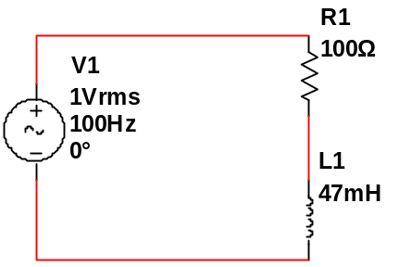
Circuit diagrams:

[3]
Results
Measured (12/10/16)
f(Hz) | V(i)(V) | V(m)(V) | Gain
100 | 1.38 | 0.10 | 0.072
200 | 1.38 | 0.10 | 0.072
500 | 1.39 | 0.10 | 0.072
1,000 | 1.39 | 0.12 | 0.086
2,000 | 1.39 | 0.14 | 0.101
5,000 | 1.45 | 0.24 | 0.166
10,000 | 1.45 | 0.42 | 0.290
20,000 | 1.51 | 0.76 | 0.503
50,000 | 1.75 | 1.43 | 0.817
100,000 | 1.95 | 1.83 | 0.938
Extras:
700 | 1.37 | 0.11 | 0.080
1,500 | 1.38 | 0.13 | 0.094
3,000 | 1.38 | 0.17 | 0.123
6,500 | 1.39 | 0.28 | 0.201
15,000 | 1.43 | 0.37 | 0.259
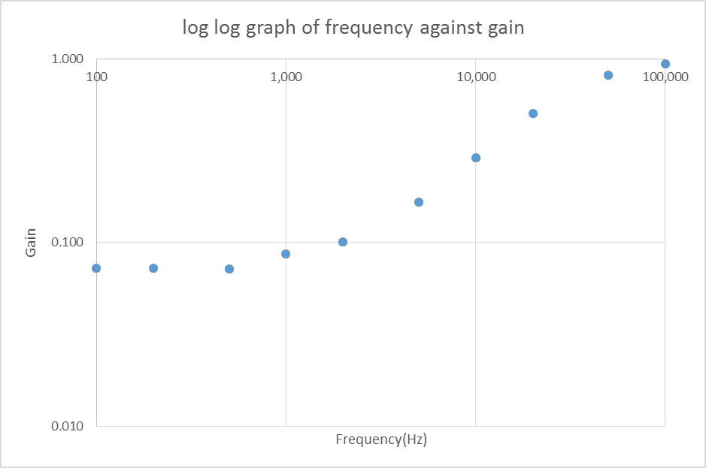

In this graph there is a curve at the beginning and end of the graph with a linear sequence joining the two, with large gaps it is hard to tell where this linear cut off is and so more results were taken. Because the graph curves upwards and we know we have a resistor and a inductor in that order. Due to the value of the resistor bein 100 ohm which is quite small for measuring an inductor value the curves are interacting over a large frequency meaning the linear section is smaller and harder to measure impacting my calulations accuracy.
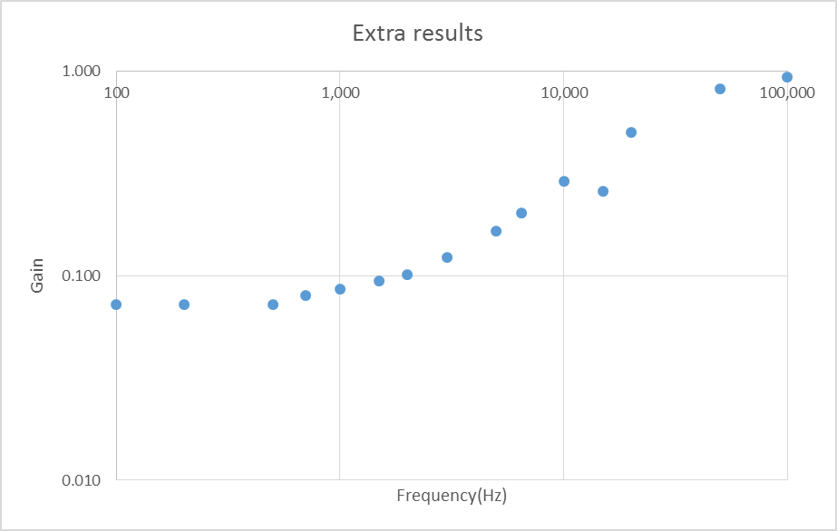

In this next graph we added some extra results and straight away the first thing we see is the blatant anomaly, I could use calculations to find out if this is an anomaly but at this point there isn’t much benefit of keeping it due to the un necessary high precision of my calculation. We do start to see the function in a bit more light now though.
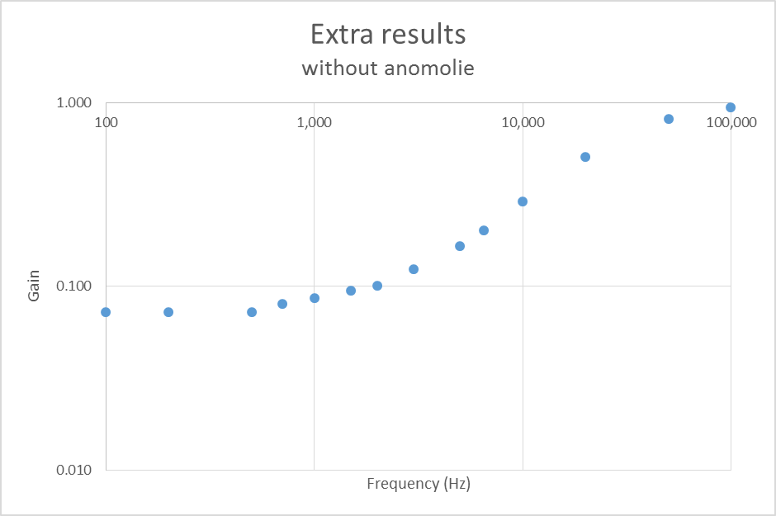

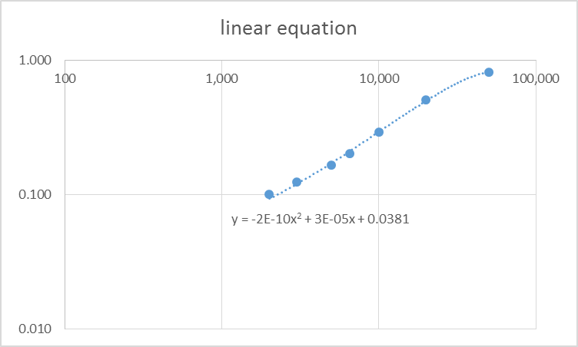
Without the anomolie in the graph I find It now much easier to see the shape of the graph and at what point the cut off is, unfortunately this anomolie is neer the cut off point and so in heinsight it would’ve been usefull to take double or tripple measurements just so we have a value for this.

Next I decided to take away the curve section of the graph and let software try to make an equation to fit these and the closest is marked above, this mathod allows me to then map the equation and measure where the frequency cut off is (gain =1) I could also find it out mathematically. You can see that at the top point the equation starts to round off and so I expect my answer here to be a tad too high and for the final inductance result too low.
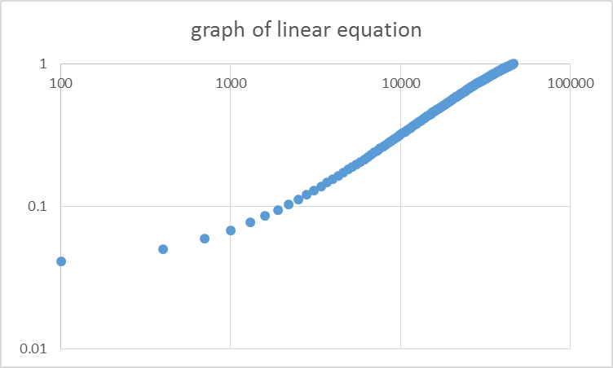

Personally I trust my own work more than a computer and so I am going to use the value off my graph of 3.75E4 which is remarkably different to that that the equation gives us.
Calculations:
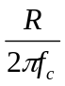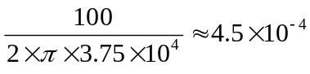
Discussion
Errors:
Tolerance – The tolerance of the device
Magnetic field – the magnetic fields in the room interacting with that of the inductor
Equipment – The uncertainty in the function generated and the tools used to measure that function.
Unaccounted resistance – The resistance in wires and connections unaccounted for
Graph reading – lack of linear section making it difficult to measure
Conclusion
The resistance of the inductor is 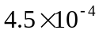and due to the large variance in values for the frequency cut off I believe a uncertainty of around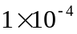is fair and so are finally quoting a value of 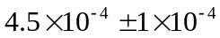, this as inductor values means that this could be 36, 39, 43 ,47 or 51mH most likely being 43 or 47 mH.
Reference list
[1] - http://www.allaboutcircuits.com/textbook/alternating-current/chpt-3/ac-inductor-circuits/ (13/10/16)
[2] - http://www.electronics-tutorials.ws/accircuits/ac-inductance.html (13/10/16)
[3] – Circuit diagrams drawn using multisim

