**Software Requirements Specification**

**For**

**Airline Management System Version 2.0 approved**

**Prepared by:**

**Hammad Hassan (64567)**

**Ezan Siddiqui (13620)**

**KIET**

**22-March-2023**

***Software Requirements Specification for <AMS> Page ii***

**Table of Contents**

**Table of Contents.......................................................................................................................... ii Revision History............................................................................................................................ ii 1. Introduction..............................................................................................................................1**

1.1 Purpose............................................................................................................................................. 1 1.2 Project Scope ................................................................................................................................... 1 1.3 References........................................................................................................................................ 1

**2. Overall Description..................................................................................................................1** 2.1 Product Overview ............................................................................................................................ 1 2.2 Product Description ......................................................................................................................... 1 2.3 User Classes and Characteristics ..................................................................................................... 2 2.4 Operating Environment.................................................................................................................... 2 2.5 Assumptions and Dependencies ...................................................................................................... 2

**3. External Requirements............................................................................................................3** 3.1 User Interfaces................................................................................................................................. 3 3.2 Hardware Requirements................................................................................................................... 3 3.3 Software Requirements.................................................................................................................... 3

**4. Other Nonfunctional Requirements.......................................................................................3** 4.1 Performance Requirements.............................................................................................................. 3 4.2 Safety Requirements........................................................................................................................ 3

**5. System Design...........................................................................................................................4** 5.1 Module Description ......................................................................................................................... 4 5.2 Software System Attributes ............................................................................................................. 4

**6. Work Flow Diagrams…………………………………………………………………………..……...6** 6.1 Use Case Diagram………………………………………………………………………………….6 6.2 Activity Diagram…………………………………………………………………………………...7

**7. DESIGNS & FORM OUTPUT……………………...………………………………………………...8** 7.1 LOGIN……………...……………………………………………………………………………….8 7.2 OUTPUT FLOW…..…………………………….……………………………………………….....8 7.3 n-TIER ARCHITECTURE……………………….………………………………………………...12

7.4 SECOND INSTANCE WORKFLOW…………….……………………………………………….13

**Revision History**

| **Name** | **Date** | **Reason For Changes** | **Version** |
| --- | --- | --- | --- |
| EZAN SIDDIQUI |  | 07-06-2023 INCLUDATION OF OUTPUTS & WORKFLOW | 2.0 |
|  |  |  |  |

**Software Requirements Specification for (AMS) Page1 1. Introduction**

**1.1 Purpose**

The purpose of this document is to elaborate the software requirements which will enable us to build an online system to ease the airline management. This document is useful for the airline management team.

**1.2 Project Scope**

The system allows the airline passenger to search for flights that are available between the two travel cities, namely the “Departure city” and “Arrival city” for a particular departure and arrival dates. Thesystem displays all the flight’s details such as flight no, name, price and duration of journey etc.

**1.3 References**

Software Requirement Specification from the internet.

**2. Overall Description**

**2.1 Project Overview**

Airline Management System contains the details about flight schedules and its fare tariffs, passenger reservations and ticket records. Air Alliance operates flights to 3 destinations in Pakistan namely Karachi, Islamabad and Lahore.

**2.2 Project Description**

Airline Management System will hold flight schedules and its fare tariffs, passenger reservations and ticket records. It saves time as it allows online procedure as users no longer to wait in a queue to book the flights. It is automatically generated by the server. Admin is the main authority who can do addition, deletion, and modification of flights if required. The project has been planned to be having the view of distributed architecture, with centralized storage of the database. The application for the storage of the datahas been planned. Using the constructs of Database sql and all the user interfaces have been designed usingthe Microsoft Visual Studio C#. The database connectivity is planned using the “SQL Connection” methodology. The standards of security and data protective mechanism have been given a big choice for proper usage. The application takes care of different modules and their associated reports, which are produced as per the applicable strategies and standards that are put forwarded by the administrative staff. 10 The entire project has been developed keeping in view of the distributed client server computing technology, in mind. The user interfaces are browser specific to give distributed accessibility for the overall system. The internal database has been selected as Database SQL. The Airline Management System project is an implementation of a general Airline Ticketing website like Orbits, which helps the customers to search the availability and prices of various airline tickets, along with the different packages available with the reservations. This project also covers various features like online registration of the users, modifying the

**Software Requirements Specification for (AMS) Page2**

Details of the website by the management staff or administrator of the website, by adding, deleting or modifying the customer details, flights or packages information. In general, this website would be designed to perform like any other airline ticketing website available online.

**2.3 User Classes and Characteristics**

Users of the system should be able to retrieve flight information between two given cities with the given date/time of travel from the database. The system will support two types of user privileges, Customer, and Admin. Customers will have access to customer functions, and the admin will have access to both customer and flight management functions. The customer should be able to do the following functions:

*•* Make a new reservation

*•* One-way

*•* Flexible Date/time

*•* Confirmation

*•* Cancel an existing reservation

*•* View his itinerary

Similarly, the Admin should have following management functionalities

*•* Get all customers who have seats reserved on a given flight.

*•* Get all flights for a given airport.

*•* View flight schedule.

*•* Get all flights whose arrival and departure times are on time/delayed.

*•* Calculate total sales for a given flight.

ADMINISTRATIVE

*•* Add/Delete a flight

*•* Add a new airport

*•* Update fare for flights.

*•* Add a new flight leg instance.

*•* Update departure/arrival times for flight leg instances.

Each flight has a limited number of available seats. There are a number of flights, which depart from or arrive at different cities on different dates and time.

**2.4 Operating Environment**

The normal and special operations required by the user such as:

∙ The various modes of operations in the user organization

∙ Periods of interactive operations and periods of unattended operations

∙ Data processing support functions

∙ Backup and recovery operations.

**2.5 Assumptions and Dependencies**

The Software needs the following third party products-

∙ Microsoft Visual Studio for development of project.

∙ MySQL for database.

Although basic password authentication and role based security mechanisms will be used To protect system from unauthorized access. Redundant Database is setup as the role of backup Database.

**Software Requirements Specification for (AMS) Page3 3. External Requirements**

**3.1 User Interface**

The application will have a user friendly and menu based interface.

**3.2 Hardware Requirements**

Describe the logical and physical characteristics of each interface between the software product and the hardware components of the system. This may include the supported device types, the nature of the data andcontrol interactions between the software and the hardware, and communication protocols to be used.

**Hardware**: Intel(R) Core(TM) i3, i5, i7-75000U CPU

**Software**: Visual Studio (after-2017 / SQL 2008)

**3.3 Software Requirements**

Describe the connections between this product and other specific software components (name and version), including databases, operating systems, tools, libraries, and integrated commercial components. Identify the data items or messages coming into the system and going out and describe the purpose of each. Describe the services needed and the nature of communications. Refer to documents that describe detailed application programming interface protocols. Identify data that will be shared across software components.If the data sharing mechanism must be implemented in a specific way (for example, use of a global data area in a multitasking operating system), specify this as an implementation constraint.

**4. Other Nonfunctional Requirements**

**4.1 Performance Requirements**

This subsection specifies numerical requirements placed on the software or on the human interaction with the software, as a whole. Numerical requirements will include:

∙ 300 terminals will be supported at a time

∙ Only text information will be supported.

**4.2 Safety Requirements**

If there is extensive damage to a wide portion of the database due to catastrophic failure, such as a disk crash, the recovery method restores a past copy of the database that was backed up to archival storage (typically tape) and reconstructs a more current state by reapplying or redoing the operations of committed transactions from the backed up log, up to the time of failure.

**Software Requirements Specification for (AMS) Page4 5. System Design**

**5.1 Module Description**

The list of modules incorporated with “AIRLINE RESERVATION SYSTEM “is as follows:

**Registration module**

After registering with us the passenger can logon to his/her own account and can viewall flight details such as Timings, Prices, Availability of seats and can book the ticket with unique ticket id and gives its personal details. Once Passenger registered with us can book any number of tickets.

**Administrative module**

Administrative module is provided for the sake of administrators to manage the site and update the content at regular intervals, the major operations included in this module are: ∙ Create and maintain airline schedule, fare and timings of the Flight.

∙ View the passenger list.

∙ View the available seats in the flights.

∙ Updating the flight schedule and timings and fare.

**Passenger module**

This module is meant for passengers, where a user logging into his/her owns account will view this panel. The major operations included in this module were

∙ View all airline schedules, timings, fare details and seats availability.

∙ Book for the tickets.

∙ View the ticket.

**5.2 Software System Attributes**

There are a number of attributes of software that can serve as requirements. It is

important that required attributes by specified so that their achievement can be

objectively verified. The following items provide a partial list of examples. These are also known as non-functional requirements or quality attributes.

These are characteristics the system must possess, but that pervade (or cross-cut) the design. These requirements have to be testable just like the functional requirements.

It’s easy to start philosophizing here, but keep it specific.

**Reliability**

It means the extent to which program performs with required precision. The website developed should be extremely reliable and secure so that information about any questions etc. is not leaked. The system shall not be down more than 2 times in a year.

**Availability**

Checking that the system always has something to function and always pop up error messages in case of component failure. In that case the error messages appear when something goes wrong so to prevail availability problems.

**Software Requirements Specification for (AMS) Page5**

**Security**

The security requirements deal with the primarily security. The software should be handled only by the administrator and authorized users. Only the administrator has right to assign permissions like creatingnew accounts and generating password. Specific requirements in this area could include the need to: ∙ Utilize certain cryptographic techniques

∙ Keep specific log or history data sets

∙ Assign certain functions to different modules 32

∙ Restrict communications between some areas of the program

∙ Check data integrity for critical variable.

**Maintability**

The application is to be designed so that it is easily maintained. Also it should allow incorporating new requirements in any module of system. Backups for database are available.

**Portability**

The software is a windows form based application and is built in C# and My SQL. So it is platform independent and is independent of OS. The application will be easily portable on any window based system

**Software Requirements Specification for (AMS) Page6**

**6. WORKFLOW DIAGRAMS**

**6.1 USE CASE DIAGRAM**

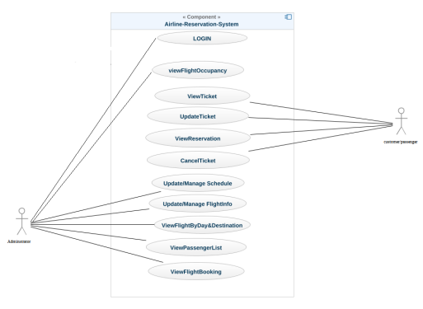

**Software Requirements Specification for (AMS) Page7**

**6.2 ACTIVITY DIAGRAM**

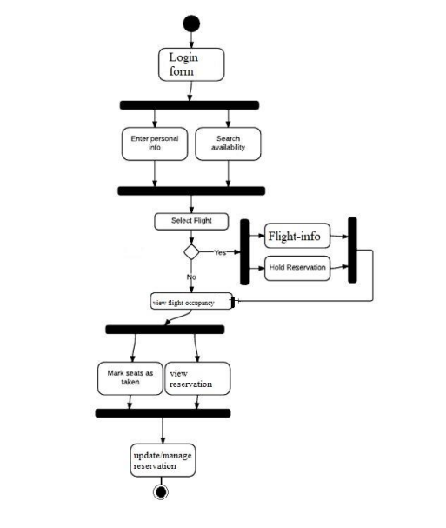

**Software Requirements Specification for (AMS) Page8**

**7. DESIGNS & FORM OUTPUT**

**7.1 LOGIN ADMIN**

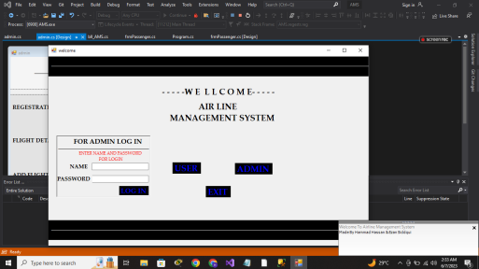

**7.2 OUTPUT FLOW**

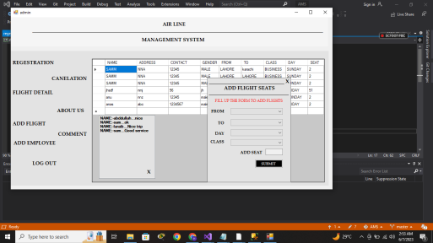

**Software Requirements Specification for (AMS) Page9**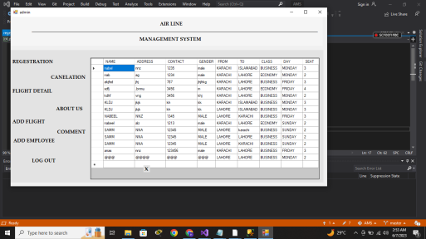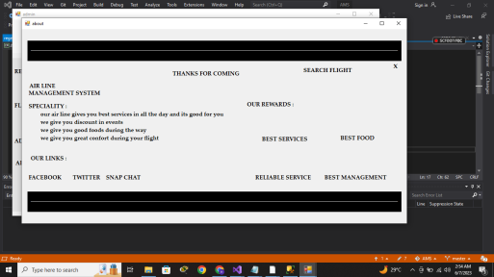

**Software Requirements Specification for (AMS) Page10**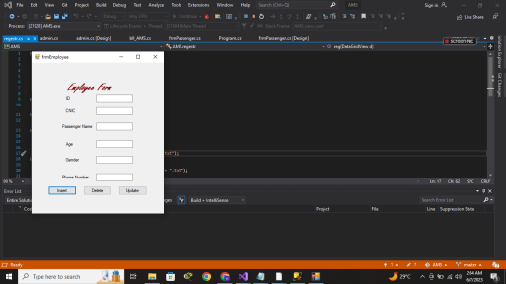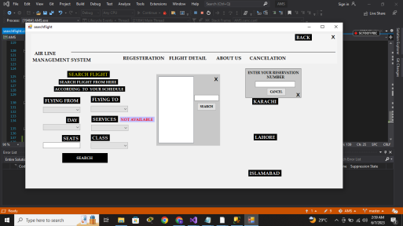

**Software Requirements Specification for (AMS) Page11**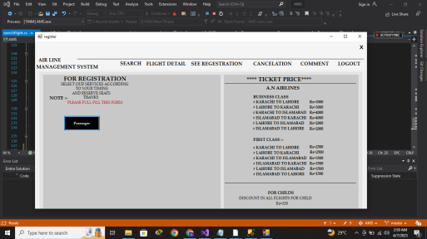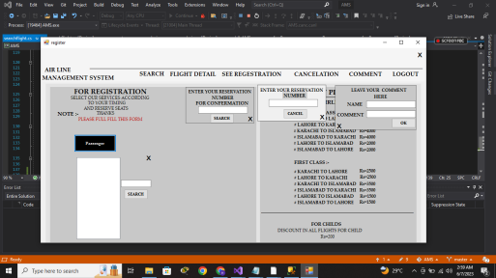

**Software Requirements Specification for (AMS) Page12 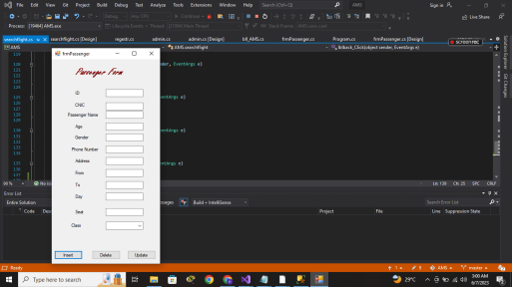7.3 N-TIER ARCHITECTURE**

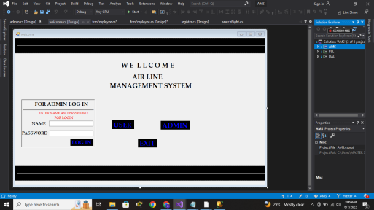

**Software Requirements Specification for (AMS) Page13**

**7.4 SECOND INSTANCE WORKFLOW**

