
SRE PROJECT
PHASE 3

May 2, 2026
HAMNA MARYIAM
24F-3063

Phase 3: Requirements Analysis & Modeling

REQUIREMENTS:
Functional requirements:
Functional requirements define the specific behaviors and functions the system must perform to satisfy user and stakeholder goals.
REQUIREMENT ID | FUNCTIONAL REQUIREMENT
FR-01 | The system shall allow customers to register and log in to the system.
FR-02 | The system shall allow technicians to register and log in to the system.
FR-03 | The system shall allow customers to search for technicians based on service type (e.g., electrician, plumber).
FR-04 | The system shall display detailed technician profiles including work experience, skills, background, and services offered.
FR-05 | The system shall allow customers to view and select technicians based on their profiles.
FR-06 | The system shall allow customers to save preferred technicians for future use.
FR-07 | The system shall maintain a history of previously hired technicians and completed jobs.
FR-08 | The system shall allow customers to request services by providing job details.
FR-09 | The system shall provide estimated cost before confirming a booking based on the job description.
FR-10 | The system shall support flexible pricing where cost may vary depending on the complexity of the work.
FR-11 | The system shall allow customers to compare multiple technicians based on pricing and details.
FR-12 | The system shall allow customers to book technicians for specific dates and time slots.
FR-13 | The system shall display technician availability to customers before booking.
FR-14 | The system shall allow technicians to set and update their availability schedule.
FR-15 | The system shall allow technicians to set their working hours and preferred working areas.
FR-16 | The system shall allow technicians to accept or reject service requests.
FR-17 | The system shall provide an emergency repair request option for urgent situations.
FR-18 | The system shall prioritize emergency requests and assign available technicians accordingly.
FR-19 | The system shall send notifications for important updates such as booking confirmation and status changes.
FR-20 | The system shall allow customers and technicians to communicate through an in-system messaging feature.
FR-21 | The system shall allow customers to track the status of their service requests (pending, ongoing, completed).
FR-22 | The system shall maintain a record of all past jobs and allow users to view them.
FR-23 | The system shall provide summaries or records of repair work and related expenses.
FR-24 | The system shall allow technicians to manage multiple job requests.
FR-25 | The system shall allow technicians to view job details before accepting requests.
FR-26 | The system shall include a rating and review mechanism for technicians.
FR-27 | The system shall provide a verification mechanism (e.g., badge) for technicians.
FR-28 | The system shall ensure customer authentication to reduce fake or invalid requests.
FR-29 | The system shall allow admin to verify technician profiles.
FR-30 | The system shall allow admin to manage users and technician accounts.
FR-31 | The system shall allow admin to handle complaints and resolve disputes.
FR-32 | The system shall allow admin to monitor system activities and bookings.

Non-Functional requirements:
Non-functional requirements describe quality attributes, constraints, and operational standards the system must conform to.
REQUIREMENT ID | CATEGORY | NON-FUNCTIONAL REQUIREMENT
NFR-01 | Usability | The system should be easy to use with simple and clear steps.
NFR-02 | Accessibility | The system should be accessible through both mobile devices and web browsers.
NFR-03 | Performance | The system should provide fast response time during search and booking operations.
NFR-04 | Scalability | The system should handle multiple users simultaneously without performance issues.
NFR-05 | Reliability | The system should ensure reliability and consistent system availability.
NFR-06 | Privacy | The system should protect user data and maintain privacy.
NFR-07 | Security | The system should provide secure authentication for users.
NFR-08 | Flexibility | The system should support flexible pricing instead of strictly fixed rates.
NFR-09 | Usability | The system should provide only relevant and important notifications to avoid disturbance.
NFR-10 | Maintainability | The system should be maintainable and easy to update.

Requirements Analysis Checklist:
Requirements are validated across four dimensions: Necessity (serves stakeholder/business goals), Consistency (no contradictions with other requirements), Completeness (no missing services or constraints), and Feasibility (achievable within budget and schedule).
REQUIREMENT ID | NECESSITY | CONSISTENCY | COMPLETENESS | FEASIBILITY
FR-01 | YES | YES | YES | YES
FR-02 | YES | YES | YES | YES
FR-03 | YES | YES | YES | YES
FR-04 | YES | YES | YES | YES
FR-05 | YES | YES | YES | YES
FR-06 | YES | YES | YES | YES
FR-07 | YES | YES | YES | YES
FR-08 | YES | YES | YES | YES
FR-09 | YES | YES | YES | YES
FR-10 | YES | YES | YES | YES
FR-11 | YES | YES | YES | YES
FR-12 | YES | YES | YES | YES
FR-13 | YES | YES | YES | YES
FR-14 | YES | YES | YES | YES
FR-15 | YES | YES | YES | YES
FR-16 | YES | YES | YES | YES
FR-17 | YES | YES | YES | YES
FR-18 | YES | YES | YES | YES
FR-19 | YES | YES | YES | YES
FR-20 | YES | YES | YES | YES
FR-21 | YES | YES | YES | YES
FR-22 | YES | YES | YES | YES
FR-23 | YES | YES | YES | YES
FR-24 | YES | YES | YES | YES
FR-25 | YES | YES | YES | YES
FR-26 | YES | YES | YES | YES
FR-27 | YES | YES | YES | YES
FR-28 | YES | YES | YES | YES
FR-29 | YES | YES | YES | YES
FR-30 | YES | YES | YES | YES
FR-31 | YES | YES | YES | YES
FR-32 | YES | YES | YES | YES
NFR-01 | YES | YES | YES | YES
NFR-02 | YES | YES | YES | YES
NFR-03 | YES | YES | YES | YES
NFR-04 | YES | YES | YES | YES
NFR-05 | YES | YES | YES | YES
NFR-06 | YES | YES | YES | YES
NFR-07 | YES | YES | YES | YES
NFR-08 | YES | YES | YES | YES
NFR-09 | YES | YES | YES | YES
NFR-10 | YES | YES | YES | YES
Conflicts, interactions and ambiguities:
Conflict:
- FR-16 grants technicians the right to accept or reject any request. FR-18 mandates that emergency requests be prioritized and assigned. These directly conflict that the emergency assignment may override a technician's rejection right. Resolution: define a system-level policy that emergency requests have a mandatory acceptance window before automatic reassignment.
Ambiguity:
- FR-09 provides an estimated cost while FR-10 allows flexible/variable pricing. The accuracy and binding nature of the estimate is not defined. Resolution: clarify that FR-09 estimate is advisory (not a fixed quote) and FR-10 governs final pricing.
- FR-27 defines the verification badge as a feature; FR-29 defines the admin process to grant it. Neither specifies criteria for verification. Resolution: define verification criteria (e.g., ID check, license upload).
- Both relate to technician schedule settings. FR-14 covers availability slots; FR-15 covers working hours and areas. The boundary between them needs clarification to avoid duplicate data entry.
Overlap:
- Both describe storing past job records. The distinction is unclear. Resolution: FR-07 covers the customer-facing job history view; FR-22 is the underlying data record system.
- NFR-08 requires flexible pricing support while FR-09 requires estimated cost display. These overlap; both should reference the same pricing engine to stay consistent.

Interaction table:
The requirements interaction matrix is a 42×42 table covering all 32 functional requirements (FR-01 to FR-32) and 10 non-functional requirements (NFR-01 to NFR-10). Due to its size, the full matrix is provided as a separate Excel file: 24F-3063_Interaction_Matrix.xlsx
Matrix encoding conventions:
- 1 (Conflict): the two requirements directly contradict each other
- 1000 (Overlap): the two requirements share data, functionality, or depend on each other
- 0 (Independent): no significant relationship between the two requirements
- — (diagonal) Self-reference: a requirement does not interact with itself
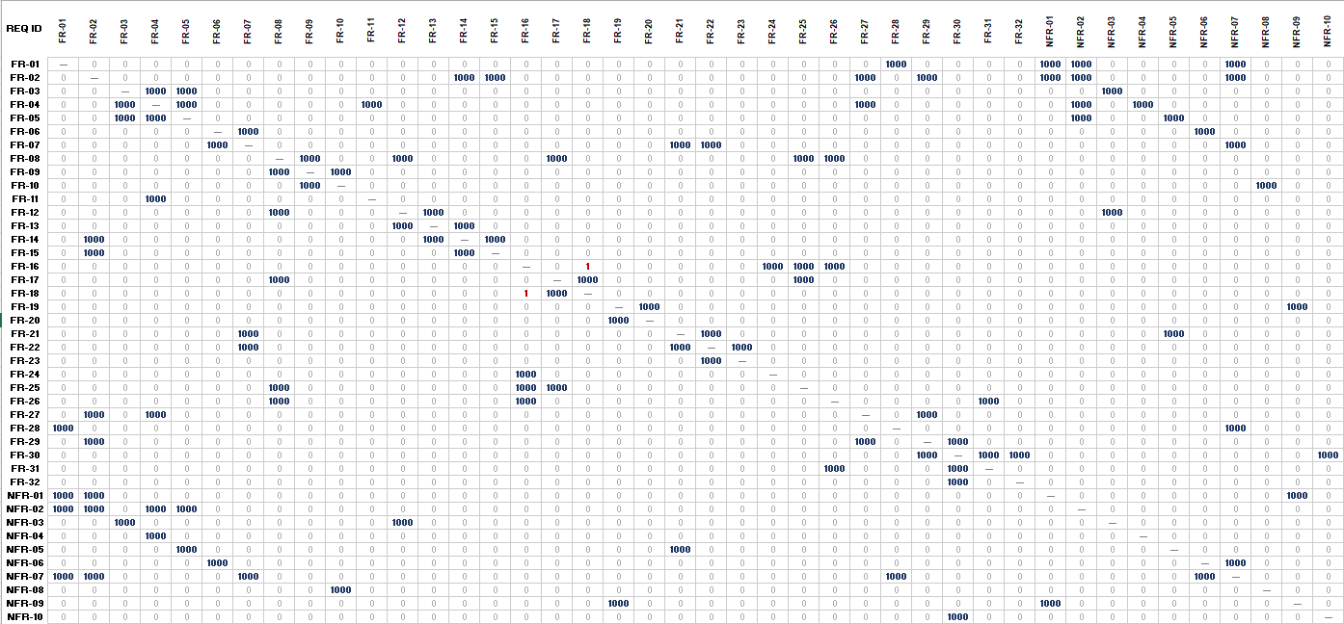

Requirement Prioritization:
All 42 requirements are prioritized using the MoSCoW technique based on stakeholder importance, system criticality, and implementation feasibility.

REQ. ID | REQUIREMENT | MOSCOW PRIORITY
FR-01 | Customer Registration & Login | Must
FR-02 | Technician Registration & Login | Must
FR-03 | Search Technicians by Service Type | Must
FR-04 | Display Technician Profile | Must
FR-05 | View & Select Technicians | Must
FR-06 | Save Preferred Technicians | Could
FR-07 | Job Hiring History | Could
FR-08 | Submit Service Request | Must
FR-09 | View Estimated Cost Before Booking | Should
FR-10 | Flexible Pricing Support | Should
FR-11 | Compare Multiple Technicians | Should
FR-12 | Book Technician for Date & Time Slot | Must
FR-13 | Display Technician Availability | Must
FR-14 | Technician Sets & Updates Availability | Must
FR-15 | Set Working Hours & Preferred Areas | Should
FR-16 | Accept or Reject Service Requests | Must
FR-17 | Emergency Repair Request Option | Must
FR-18 | Prioritize & Assign Emergency Requests | Must
FR-19 | Send Booking & Status Notifications | Must
FR-20 | In-System Messaging | Should
FR-21 | Track Service Request Status | Must
FR-22 | Record of Past Jobs | Should
FR-23 | Repair Summaries & Expense Records | Could
FR-24 | Technician Manages Multiple Job Requests | Should
FR-25 | Technician Views Job Details Before Accepting | Should
FR-26 | Rating & Review Mechanism | Should
FR-27 | Technician Verification Badge | Must
FR-28 | Customer Authentication | Must
FR-29 | Admin Verifies Technician Profiles | Must
FR-30 | Admin Manages User & Technician Accounts | Must
FR-31 | Admin Handles Complaints & Disputes | Should
FR-32 | Admin Monitors System Activities | Should
NFR-01 | Simple & Clear Interface | Must
NFR-02 | Mobile & Web | Must
NFR-03 | Fast Response Time | Should
NFR-04 | Multiple Simultaneous Users | Should
NFR-05 | Consistent Availability | Should
NFR-06 | Data Protection | Must
NFR-07 | Secure Authentication | Must
NFR-08 | Flexible Pricing System | Should
NFR-09 | Relevant Notifications Only | Should
NFR-10 | Easy to Update | Could

Prioritization notes:
- MUST requirements are non-negotiable for system launch. Without them, the core system cannot function.
- SHOULD requirements add significant value and are expected by stakeholders, but the system can launch without them initially.
- COULD requirements are desirable enhancements that improve user experience but are low-risk to defer.
- WON'T requirements are explicitly out of scope for this release (e.g., payment gateway, GPS tracking, AI recommendations, multi-language support).
- All 42 requirements (FR-01–FR-32 and NFR-01–NFR-10) are categorized; there are no WON'T items among the stated requirements, all stated requirements are achievable within the project scope.

Use Case Diagram:
The use case diagram models the interactions between three actors and the system. Primary actors (Customer, Technician) initiate use cases. The secondary actor (Admin) manages and oversees the system.
Actors:
- Customer (Primary Actor): Initiates bookings, searches, reviews, messages.
- Technician (Primary Actor): Manages availability, accepts/rejects jobs, messages.
- Admin (Secondary Actor): Verifies profiles, manages accounts, resolves disputes, monitors.

Relationships Used:
- <<include>>: The base use case unconditionally includes the behavior of another use case (e.g., Submit Service Request always includes View Estimated Cost).
- <<extend>>: The extending use case optionally adds behavior to the base use case under certain conditions (e.g., Compare Technicians extends Search Technicians when the customer wants to compare).
- Generalization: Not used in this diagram as actors and use cases do not have parent-child specialization relationships in this system.

Diagram:
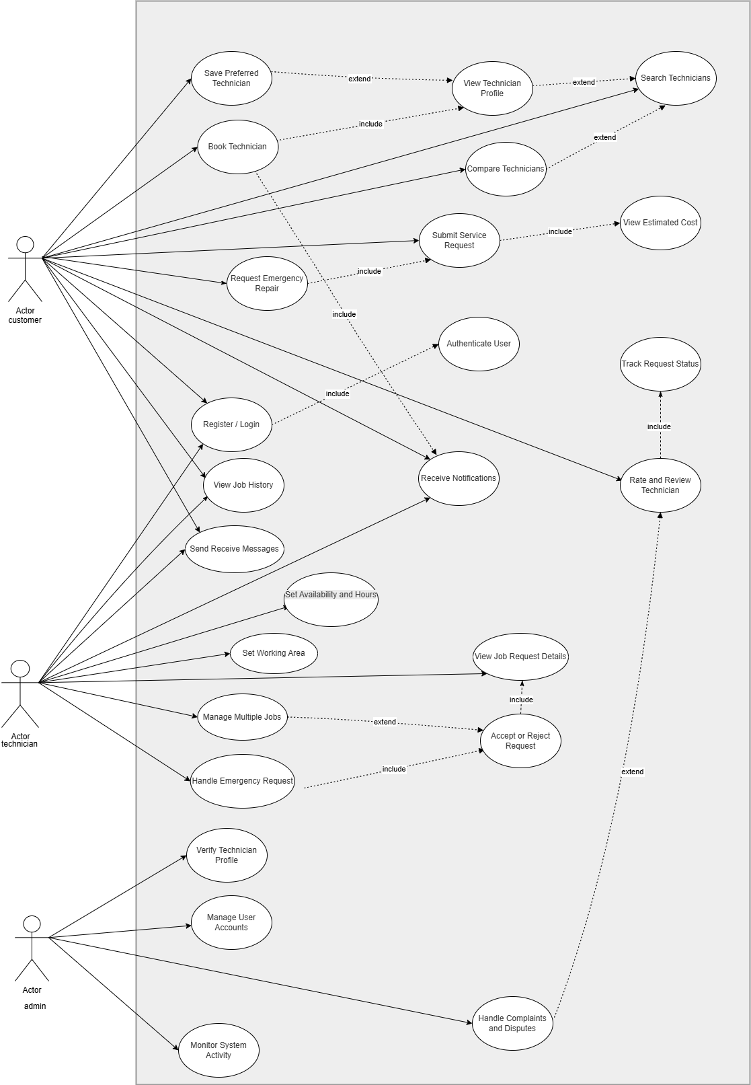

User stories:
User stories follow the standard format: As a [actor], I want to [goal] so that [reason/benefit]. Stories cover all three actors: Customer, Technician, and Admin.
ID | Actor | Feature | User Story
US-01 | Customer | Register & Login | As a customer, I want to register and log in so that I can access the system and book repair services.
US-02 | Customer | Search Technicians | As a customer, I want to search for technicians by service type so that I can find the right professional for my repair.
US-03 | Customer | View Technician Profile | As a customer, I want to view a technician's full profile so that I can make an informed decision before hiring.
US-04 | Customer | Compare Technicians | As a customer, I want to compare multiple technicians side by side so that I can choose the best option based on price and rating.
US-05 | Customer | Save Preferred Technician | As a customer, I want to save a preferred technician so that I can quickly rebook them in the future.
US-06 | Customer | Submit Service Request | As a customer, I want to submit a service request with job details so that a technician can understand and respond to my repair need.
US-07 | Customer | View Estimated Cost | As a customer, I want to see an estimated cost before confirming a booking so that I can plan my budget.
US-08 | Customer | Book Technician | As a customer, I want to book a technician for a specific date and time so that the repair is done at my convenience.
US-09 | Customer | Emergency Repair Request | As a customer, I want to submit an emergency repair request so that I can receive urgent help without delay.
US-10 | Customer | Track Request Status | As a customer, I want to track my service request status (pending, ongoing, completed) so that I know what is happening with my booking.
US-11 | Customer | View Job History | As a customer, I want to view my past jobs and expenses so that I can track the services I have used.
US-12 | Customer | Message Technician | As a customer, I want to message the technician through the app so that I can clarify job details without sharing my personal contact.
US-13 | Customer | Rate & Review | As a customer, I want to rate and review a technician after job completion so that other customers can benefit from my experience.
US-14 | Technician | Register & Login | As a technician, I want to register and log in so that I can create my profile and start receiving job requests.
US-15 | Technician | Set Availability | As a technician, I want to set my daily availability and working hours so that customers can only book me when I am free.
US-16 | Technician | Set Working Area | As a technician, I want to define my preferred working areas so that I only receive requests within my service zone.
US-17 | Technician | View Job Details | As a technician, I want to view full job details before responding so that I can decide if the job matches my skills and schedule.
US-18 | Technician | Accept or Reject Request | As a technician, I want to accept or reject incoming job requests so that I have full control over the work I take on.
US-19 | Technician | Manage Multiple Jobs | As a technician, I want to manage multiple active jobs so that I can organize my workday efficiently.
US-20 | Technician | Handle Emergency Jobs | As a technician, I want to be notified of emergency requests so that I can respond quickly to urgent customer needs.
US-21 | Technician | Message Customer | As a technician, I want to message the customer through the app so that I can confirm location and job requirements.
US-22 | Technician | View Job History | As a technician, I want to view my completed job history so that I can track my work and past earnings.
US-23 | Technician | Receive Notifications | As a technician, I want to receive notifications for new job requests and status updates so that I never miss an opportunity.
US-24 | Technician | Get Verified Badge | As a technician, I want to get a verified badge on my profile so that customers trust me and I receive more bookings.
US-25 | Admin | Verify Technician | As an admin, I want to verify technician profiles so that only qualified technicians are listed on the platform.
US-26 | Admin | Manage Accounts | As an admin, I want to manage customer and technician accounts so that I can suspend or remove accounts that violate platform rules.
US-27 | Admin | Resolve Complaints | As an admin, I want to handle complaints and disputes so that platform trust and user satisfaction are maintained.
US-28 | Admin | Monitor System | As an admin, I want to monitor system activities and bookings so that I can ensure smooth operation and detect issues early.

Data flow diagrams (DFD):
DFDs are constructed notation: external entities are represented as sharp rectangles, processes as rounded rectangles with a process number, and data stores as open-ended parallel-line rectangles (D1, D2…). Two DFDs are provided: the Context Diagram (Level 1) and Level 0.
DFD notations:

Symbol | Description
External Entity | A person, system, or organization outside the system boundary that inputs or receives data
Process | A function that transforms input data into output data; labeled with number and name
Data Store | A repository where data is stored; labeled D1, D2, etc.
Data Flow | Movement of data between entities, processes, and stores; labeled with data name

DFD CONTEXT LEVEL:
The context diagram shows the entire system as a single process (Process 0). External entities (Customer, Technician, Admin) are positioned around it. No data stores appear at this level only data flows between entities and the system.

DIAGRAM:
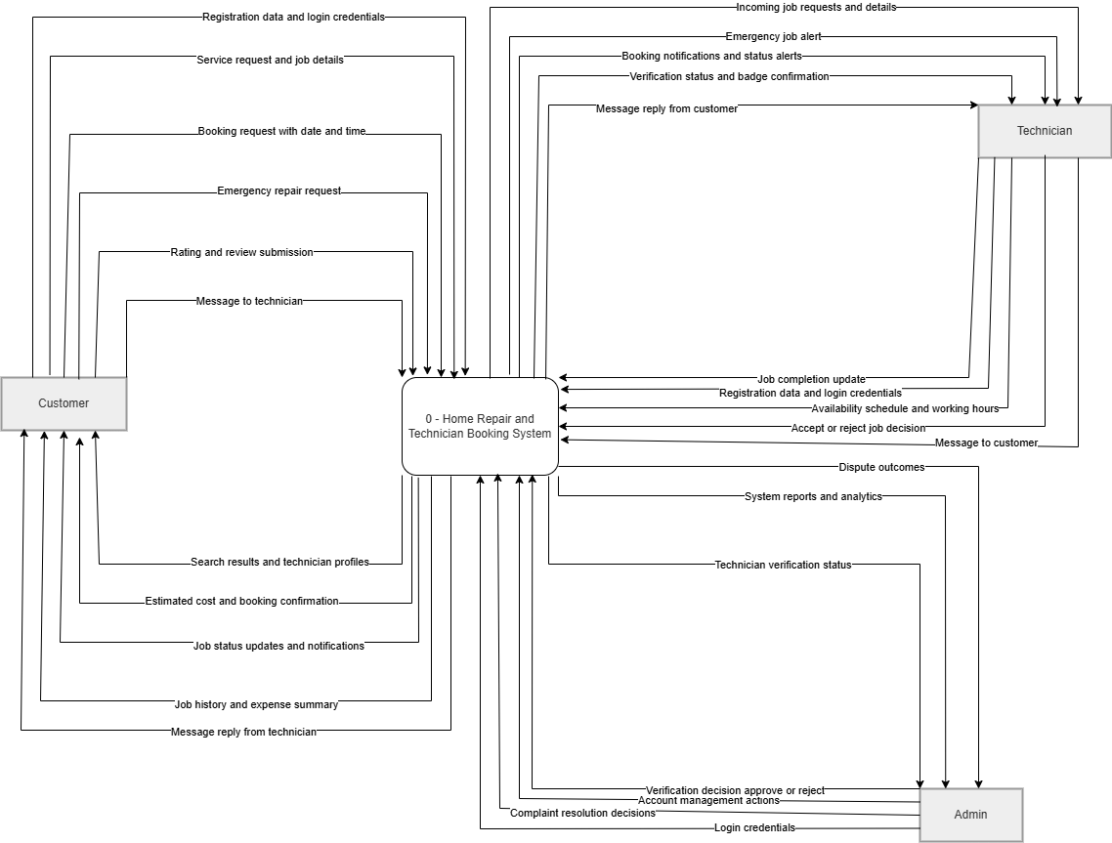

DFD LEVEL 0:
Level 0 decomposes the system into its 10 major processes. Processes are shown in the center of the diagram. External entities appear on the outside. Data stores are shown between processes that share them. All significant data flows are labeled.
Process | Name | Description
1.0 | User Authentication | Validates credentials for customers, technicians, and admin. Reads/writes D1 (User Data).
2.0 | Technician Search & Profile | Processes search queries, returns filtered technician profiles. Reads D2 (Technician Profiles).
3.0 | Booking Management | Handles service requests, availability checks, date/time booking. Reads/writes D3 and D4.
4.0 | Cost Estimation | Calculates estimated job cost from job description. Uses D5 (Pricing Data).
5.0 | Emergency Request Handling | Flags urgent requests, assigns available technicians. Reads D4, writes D3, triggers P6.
6.0 | Notification Service | Sends booking/status/emergency alerts. Triggered by P3, P5, P8. Writes D9.
7.0 | Messaging | Facilitates in-app communication. Reads/writes D6 (Messages).
8.0 | Job Tracking & History | Updates real-time job status, maintains job records. Reads/writes D7 and D3. Triggers P6.
9.0 | Rating & Review | Collects post-job ratings and reviews. Writes D8, updates D2.
10.0 | Admin Management | Profile verification, account management, complaint resolution, monitoring. Reads all stores. Writes D10.

Store | Name | Contents
D1 | User Data | Customer and technician accounts, credentials, profile info, preferences
D2 | Technician Profiles | Skills, experience, services offered, verification status, verified badge, ratings
D3 | Booking Data | All service requests, booking status (pending/ongoing/completed), timestamps, job IDs
D4 | Availability Data | Technician schedules, working hours, available time slots, working areas
D5 | Pricing Data | Service-based pricing rules and cost estimation parameters
D6 | Messages | In-app chat logs between customers and technicians
D7 | Job History | Completed job records linked to customers and technicians, expense summaries
D8 | Reviews | Star ratings and text reviews linked to jobs, technicians, and customers
D9 | Notification Log | Sent notifications with timestamps, recipients, and event types
D10 | Admin Logs | Audit trails, monitoring data, complaint records, account action history

DIAGRAM:

