Assignment 08

Title: Secure Coding Practices

CYL4001

Secure Software Design Lab

Submitted by: Hamna Ejaz
Roll number: 22i-1645
Date: October 27th, 2025

Table of Contents
Task 1 & 2: Secure Input Handling & Use Parameterized Queries 3
Phase 1: Vulnerability Testing (Current Code) 3
Phase 2: Applying Secure Input Handling (WTForms) 5
Phase 3: Post-Fix Testing (Secure Code) 5
Task 3: Session Management and CSRF Protection 7
Phase 1: Vulnerability Testing (Pre-Fix Status) 7
Phase 2: Applying Fixes (Secure Configuration) 7
Phase 3: Post-Fix Testing (Verification) 8
Task 4: Secure Error Handling 8
Phase 1: Vulnerability Testing (Current Code) 8
Phase 2: Applying Secure Fixes 11
Phase 3: Post-Fix Testing (Secure Code) 12
Task 5: Secure Password Storage (Flask-Bcrypt) 13
Phase 1: Pre-Fix Testing (Vulnerability Check) 13
Phase 2: Applying the Flask-Bcrypt Fix 14
Phase 3: Post-Fix Testing (Verification) 15

Task 1 & 2: Secure Input Handling & Use Parameterized Queries

Phase 1: Vulnerability Testing (Current Code)
1. Test for SQL Injection Vulnerability
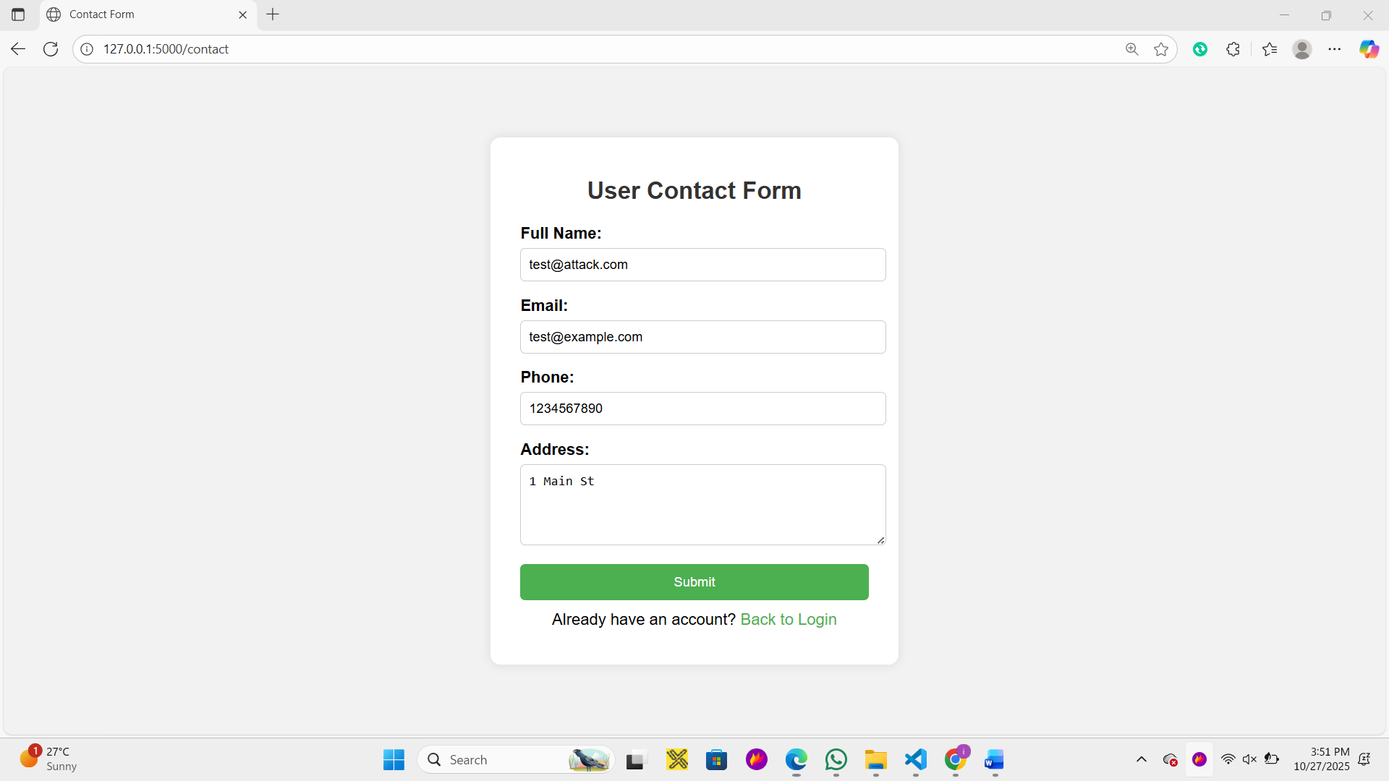

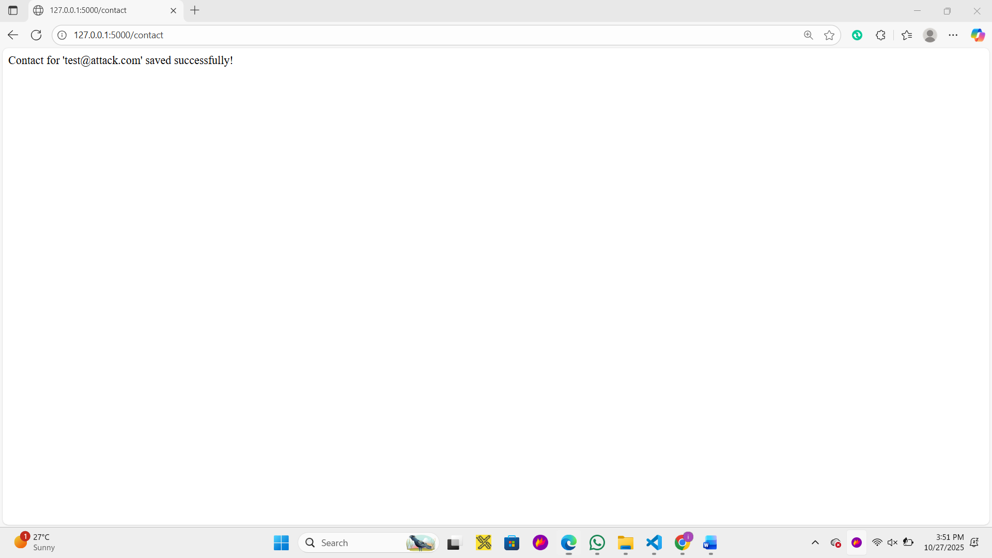

2. Test for XSS (Cross-Site Scripting) Vulnerability
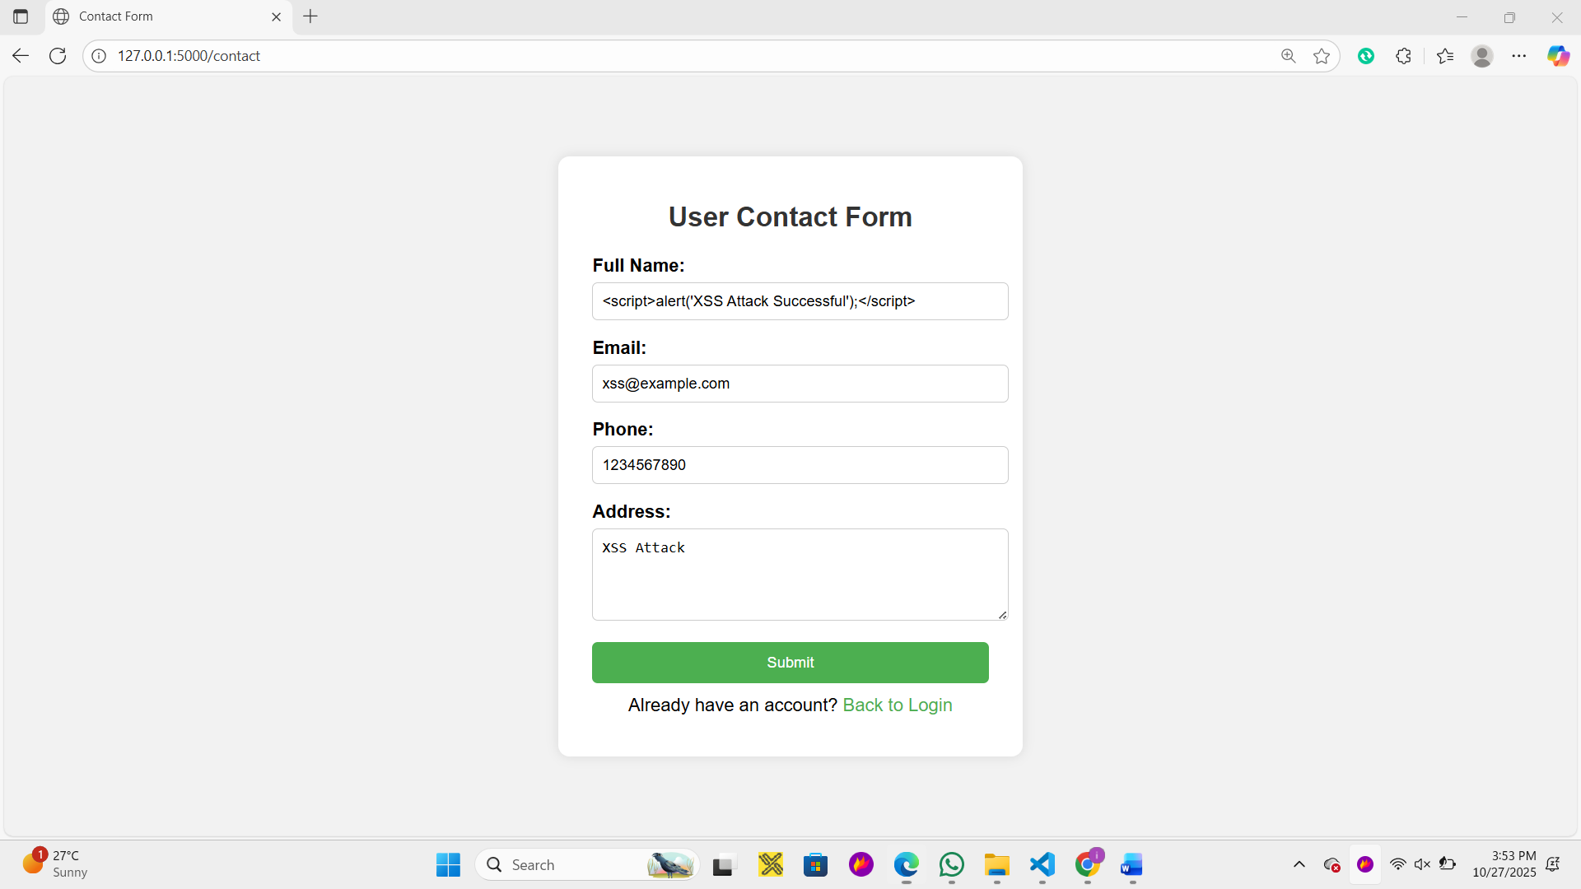

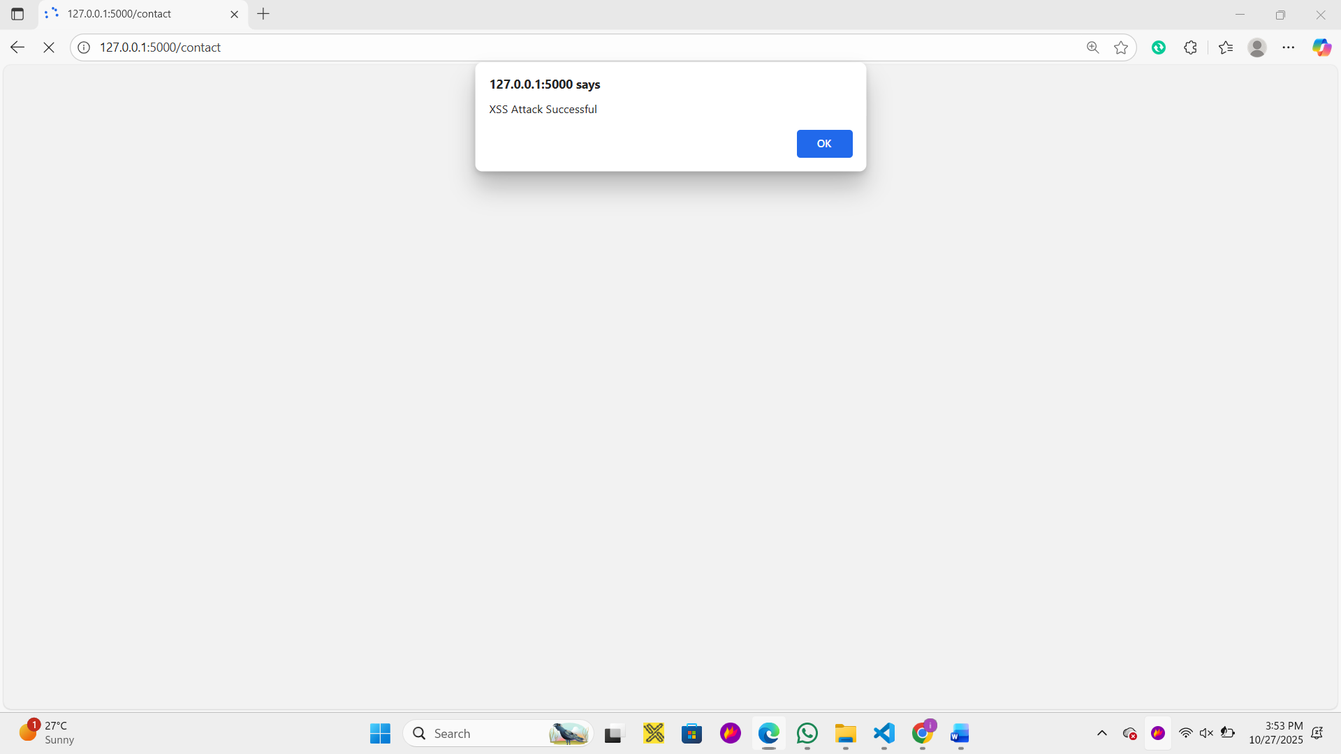

Phase 2: Applying Secure Input Handling (WTForms)
Step 1: Install WTForms
First, you need to install the Flask-WTF extension (pip install Flask-WTF)
Step 2: Update app.py
Modify your app.py to import WTForms, define form classes, and update the routes to use the forms for validation and data retrieval.
Key Changes:
- Import necessary classes from flask_wtf and wtforms.
- Define RegistrationForm and ContactForm with appropriate validators.
- Update the /login and /contact routes to instantiate the forms and validate submissions using form.validate_on_submit().
- Update the routes to pass the form object to the templates.
Step 3: Update login.html and contact.html
The HTML forms must be updated to use WTForms' helper functions to render fields, include validation messages, and automatically add the CSRF token (a crucial security feature).
Step 4: Add success.html Template
Create a new simple template to handle the successful submission redirection safely.

Phase 3: Post-Fix Testing (Secure Code)

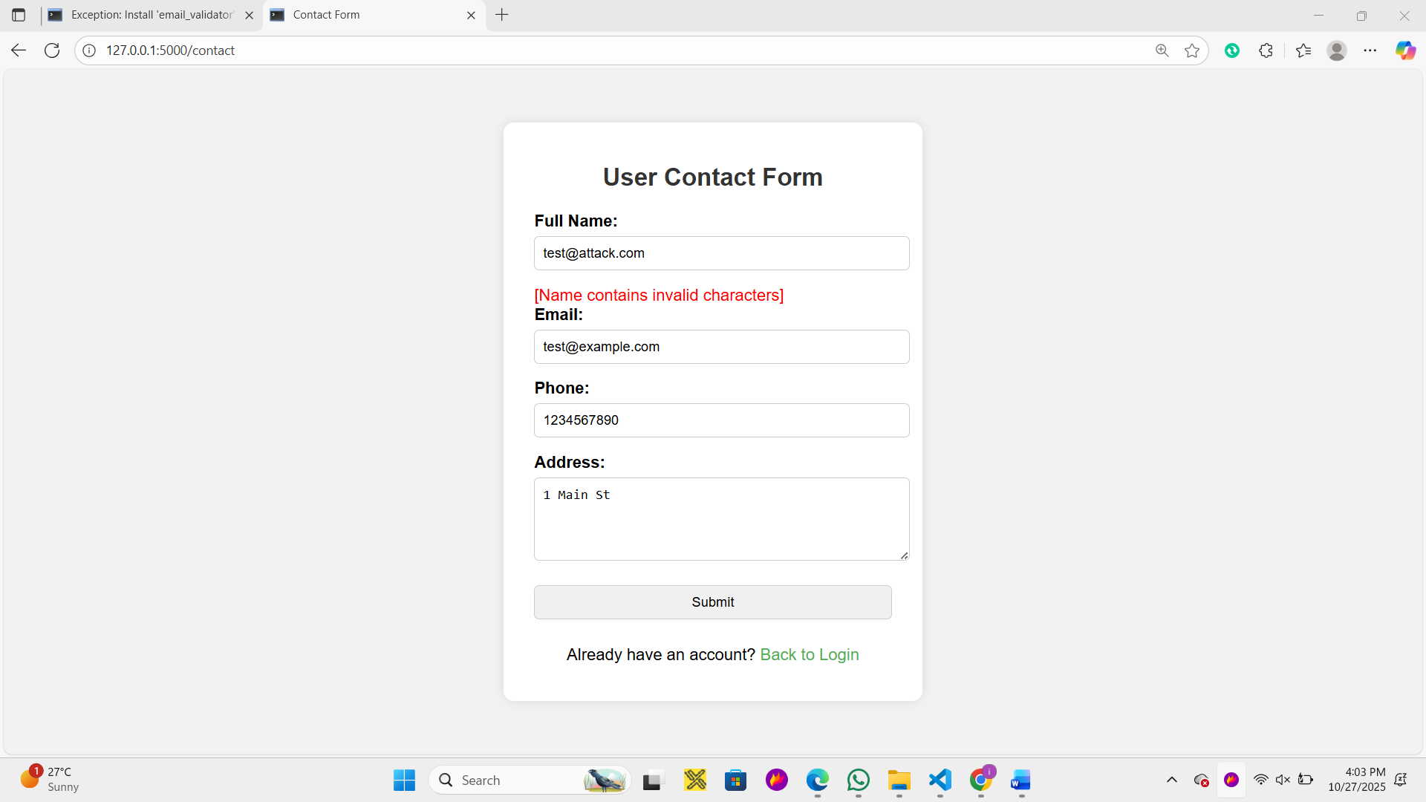
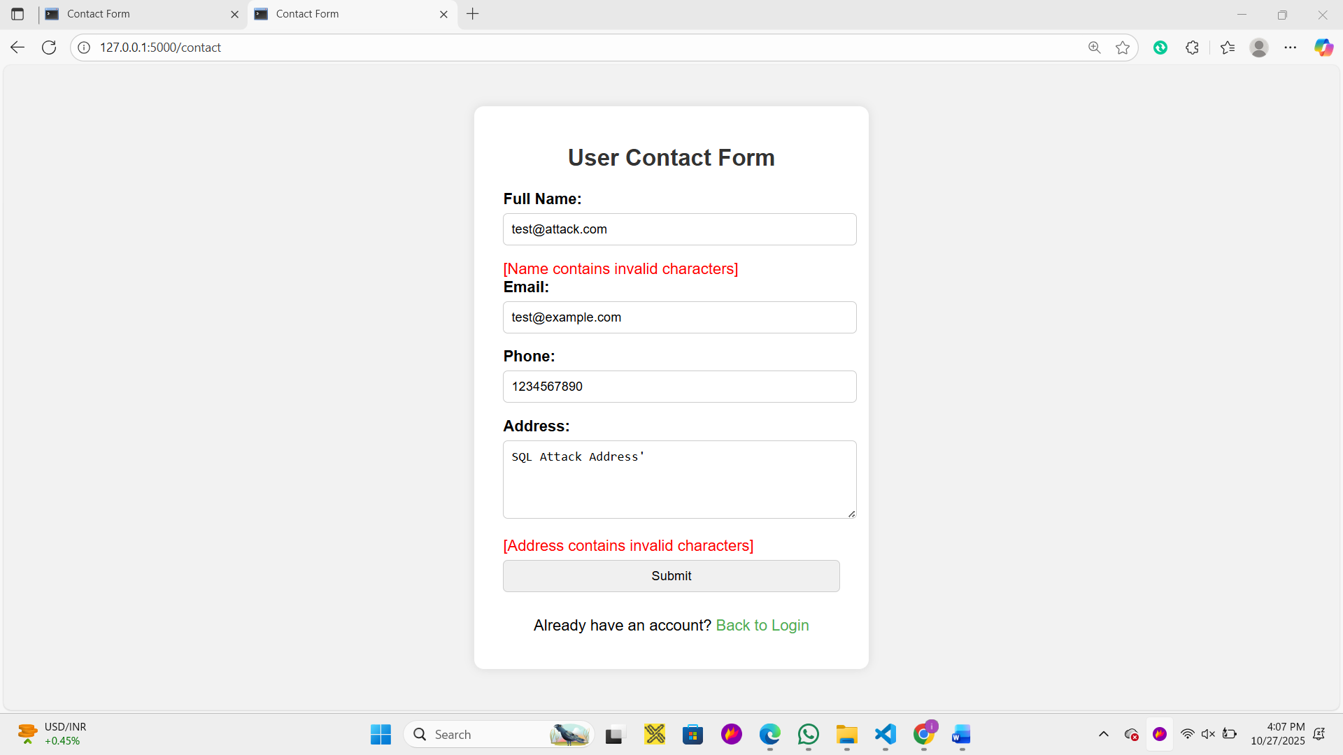

Task 3: Session Management and CSRF Protection

Phase 1: Vulnerability Testing (Pre-Fix Status)
The forms were already protected against CSRF via the hidden token provided by Flask-WTF. However, testing revealed the session management was insecure by default:
- Session Cookie: The session cookie was set without the crucial Secure and SameSite flags.
- Vulnerability: As shown in the pre-fix test (referencing the screenshot of the Developer Tools), the Secure and SameSite fields were blank, meaning the cookie could be transmitted over insecure HTTP and was vulnerable to certain types of CSRF attacks and session hijacking.
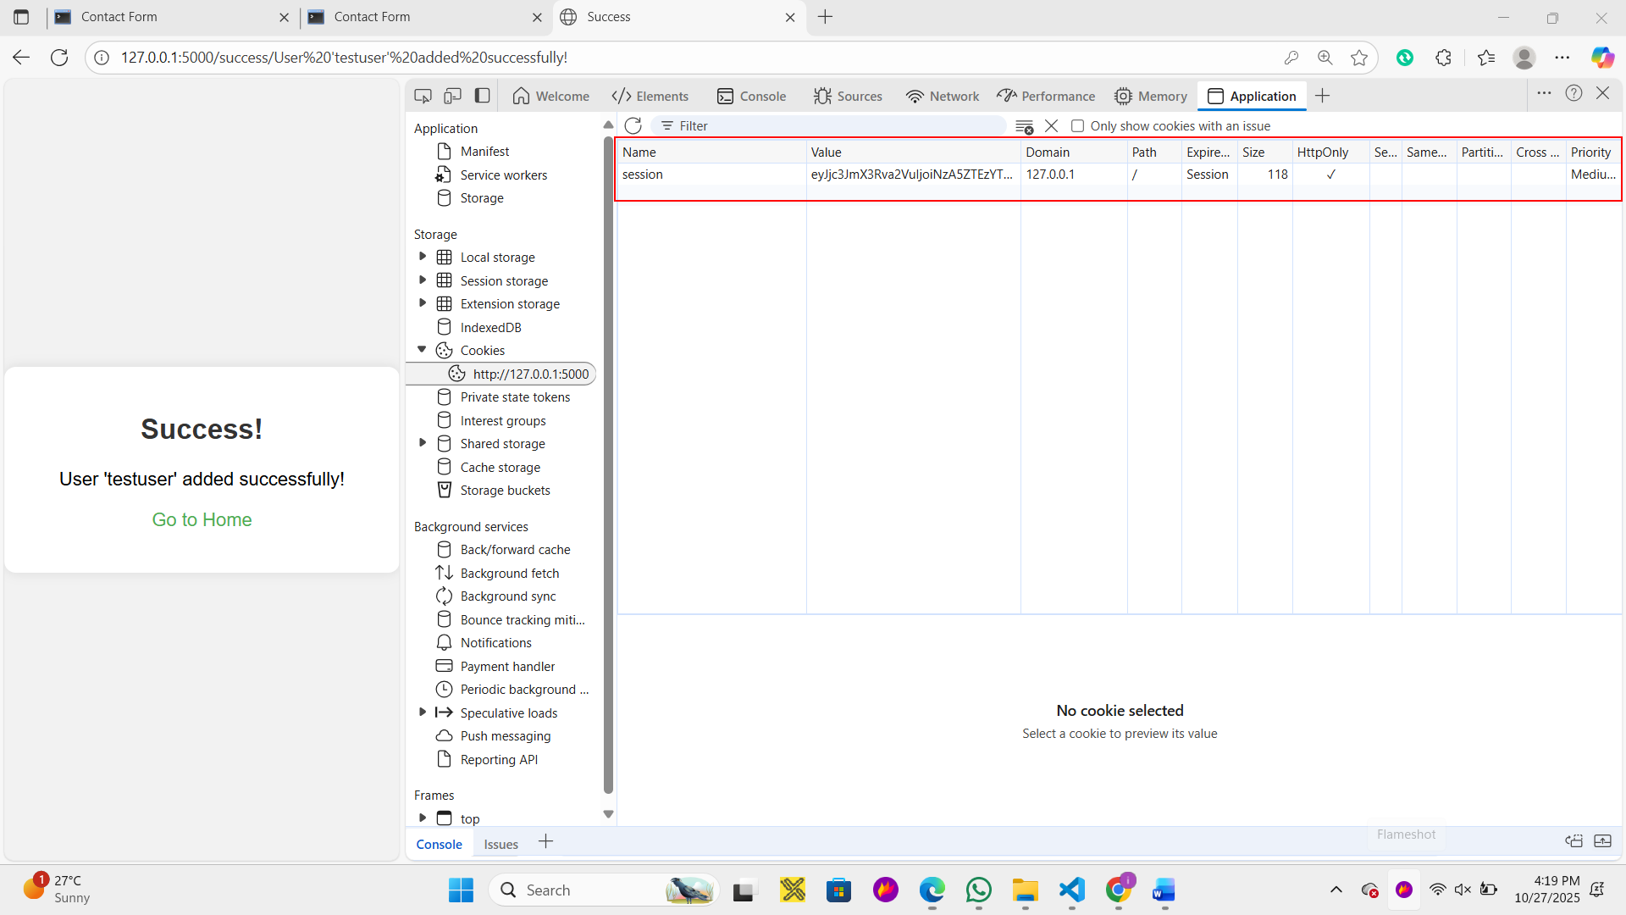

Phase 2: Applying Fixes (Secure Configuration)
The following security configurations were added to app.config in app.py to ensure robust session management:
Configuration | Value | Purpose
SESSION_COOKIE_SECURE | True | Enforces HTTPS for cookie transmission
SESSION_COOKIE_HTTPONLY | True | Prevents client-side script access (Defense against XSS).
SESSION_COOKIE_SAMESITE | Lax | Mitigates CSRF by restricting cross-site cookie transmission
PERMANENT_SESSION_LIFETIME | 3600 | Sets session expiry to 1 hour

Phase 3: Post-Fix Testing (Verification)
Post-fix testing confirmed that the new security configurations are active:
- HttpOnly: Confirmed to be checked.
- SameSite: Confirmed to be set to Lax.
- Secure Flag Behavior: When attempting to log in on the insecure http://127.0.0.1:5000 test server, the browser correctly refused to set the session cookie, demonstrating that the SESSION_COOKIE_SECURE = True flag is active and preventing the cookie from being used over an insecure channel.
Conclusion: Both CSRF protection (via Flask-WTF token) and secure session cookie configuration are now correctly implemented.
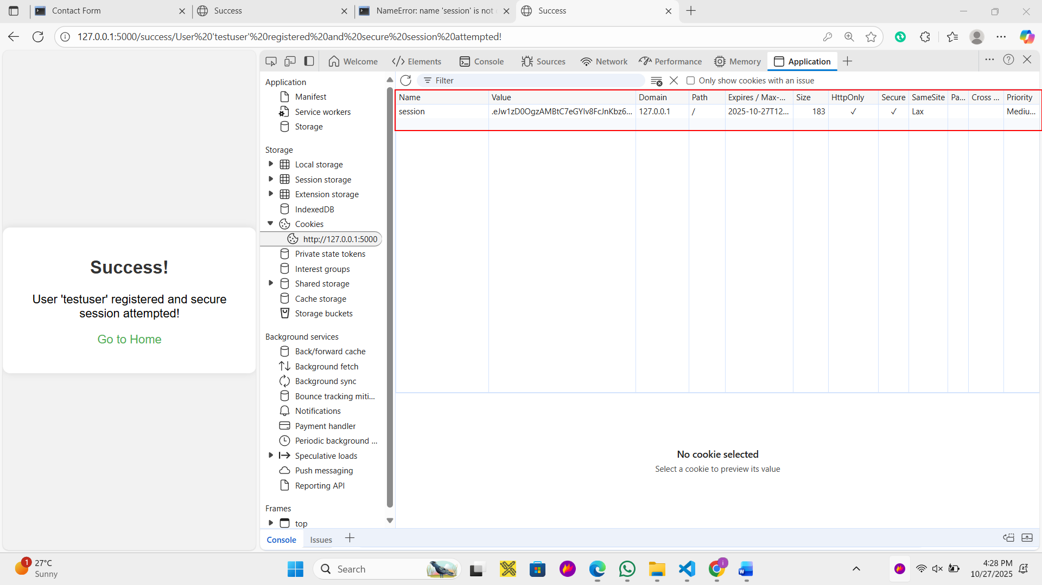

Task 4: Secure Error Handling

Phase 1: Vulnerability Testing (Current Code)
By default, Flask (especially when running in debug=True) provides highly verbose error pages that contain detailed stack traces, environment variables, and snippets of your source code. This is a severe security risk.
1. Testing for Verbose 404 (Not Found) Errors
- Run the Flask Application: Ensure your current app.py is running.
- Access a Non-Existent Route: Navigate your browser to a URL that does not exist in your application, such as: http://127.0.0.1:5000/check
- Observe the Result:
  - If debug=True is still set in app.py, Flask might give you a slightly generic "Not Found" error, but it won't be styled like your custom pages.
  - If debug=False (production mode), Flask will show a generic, unstyled "Not Found" page, which is better but still unhelpful to the user.
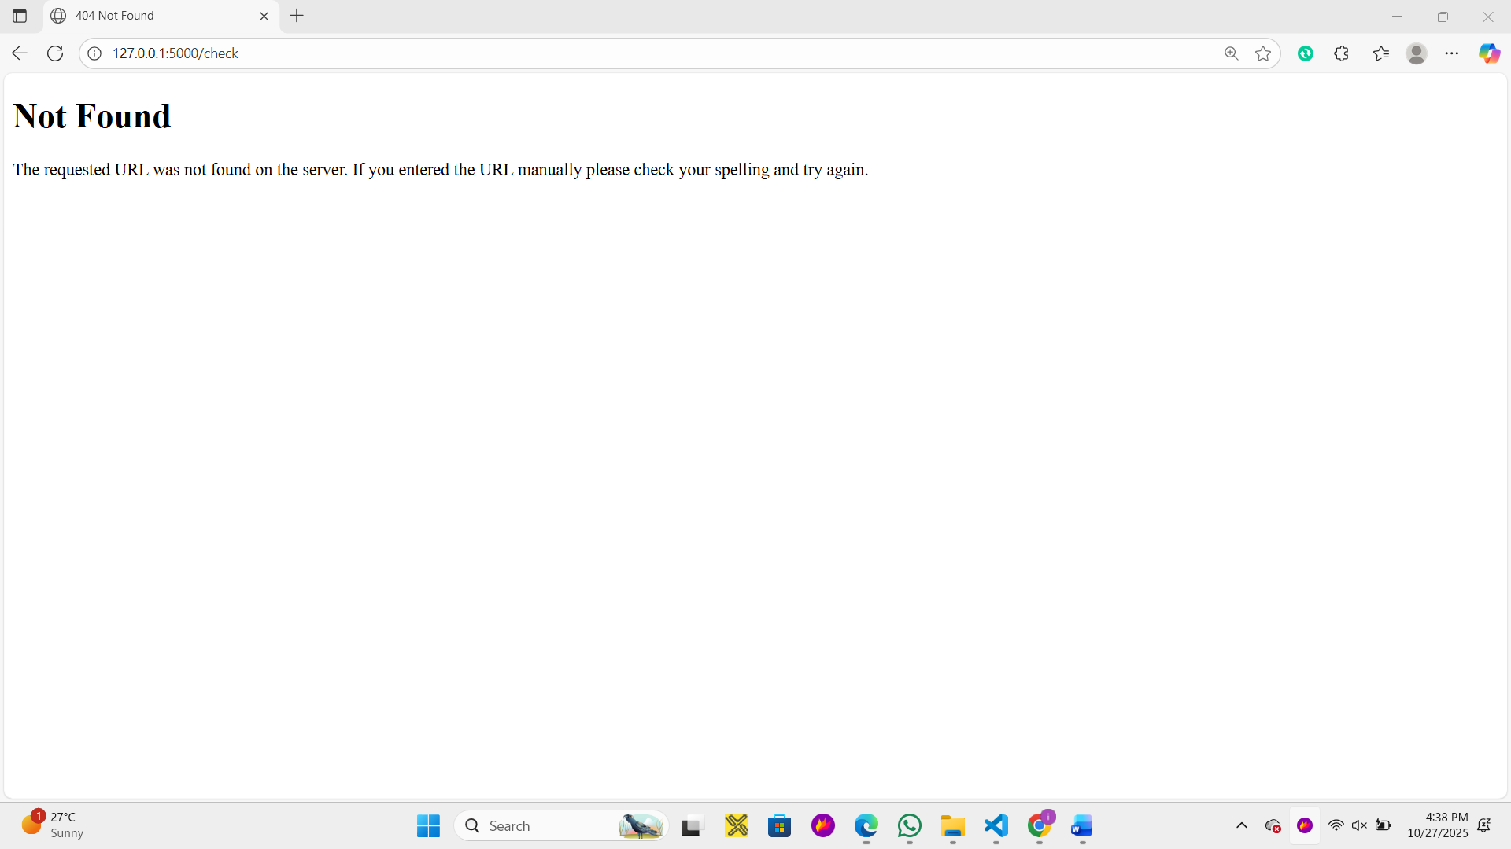

2. Testing for Verbose 500 (Internal Server) Errors
We need to intentionally introduce an error in a route to trigger a 500. We will temporarily modify the /contact route.
- Modify app.py (Temporarily): Open app.py and modify the /contact route before restarting Flask. Add a line that guarantees an error (e.g., trying to divide by zero or access an undefined variable).
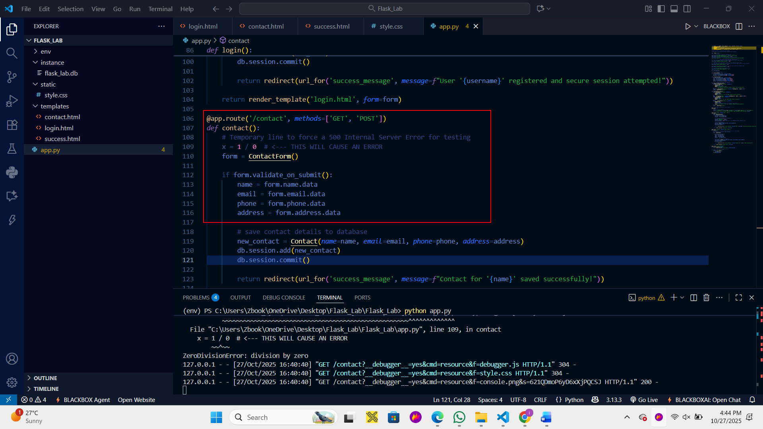

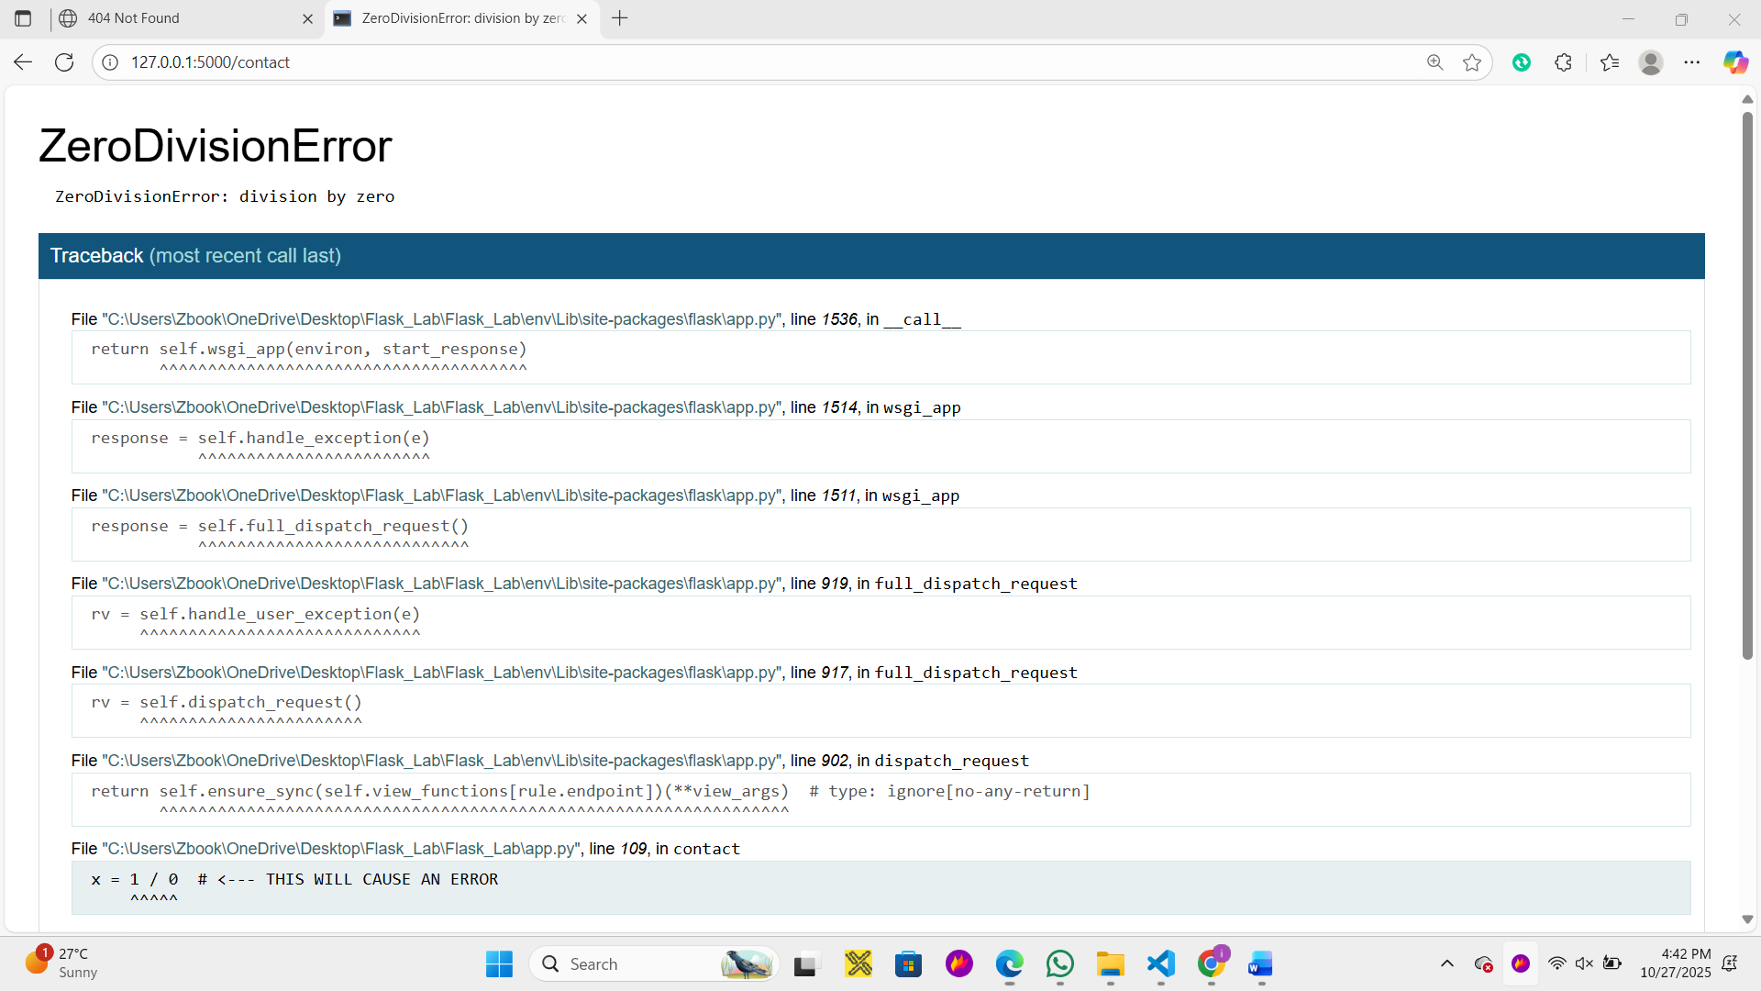

- Restart Flask: The change requires a restart.
- Trigger the Error: Access the contact page: http://127.0.0.1:5000/contact
- Observe the Result :
- Flask's default debug error page will appear. This page typically displays a full Python stack trace, file paths (including your local file path like C:\Users\Zbook\...), and snippets of your source code.
Revert app.py (Crucial): Remove the line x = 1 / 0 from the /contact route immediately after taking the screenshot, and restart Flask to ensure your application works correctly again.

Phase 2: Applying Secure Fixes
The fix is to define custom handler functions in app.py for common HTTP errors (like 404 and 500) that render generic, styled, and non-disclosing templates.
Step 1: Create Custom Error Templates
We need a generic, styled template (error.html) that can be used for all custom error pages, ensuring it uses the existing style.css.
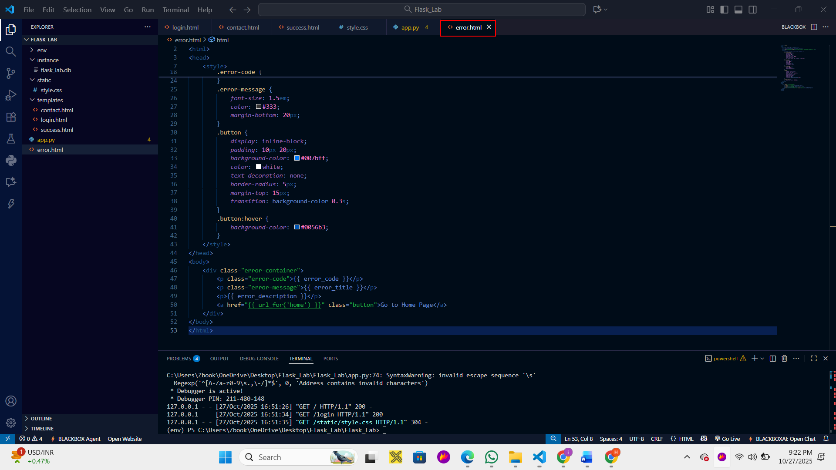

Step 2: Implement Custom Error Handlers in app.py
Update app.py by adding the handler functions after your route definitions.

Phase 3: Post-Fix Testing (Secure Code)
1. Test for Secure 404 Errors
- Restart Flask: Ensure the new app.py and error.html are active.
- Access the Non-Existent Route: http://127.0.0.1:5000/ this-route-does-not-exist
- Observe the Result: You should now see your customized, styled 404 page showing only the error code and message, with no stack traces or file paths.
2. Test for Secure 500 Errors
- Modify app.py (Temporarily): Re-introduce the error to the /contact route:
3. Trigger the Error: Access the contact page: http://127.0.0.1:5000/contact
4. Observe the Result and Take a Screenshot:
- Even with debug=True, your custom 500 handler should intercept the error.
- You will see your customized, generic 500 error page.
- Take a screenshot of this custom, non-disclosing 500 error page. This screenshot is your proof that sensitive information is protected.
5. Revert app.py: Remove the line x = 1 / 0 and restart Flask to finalize the task.
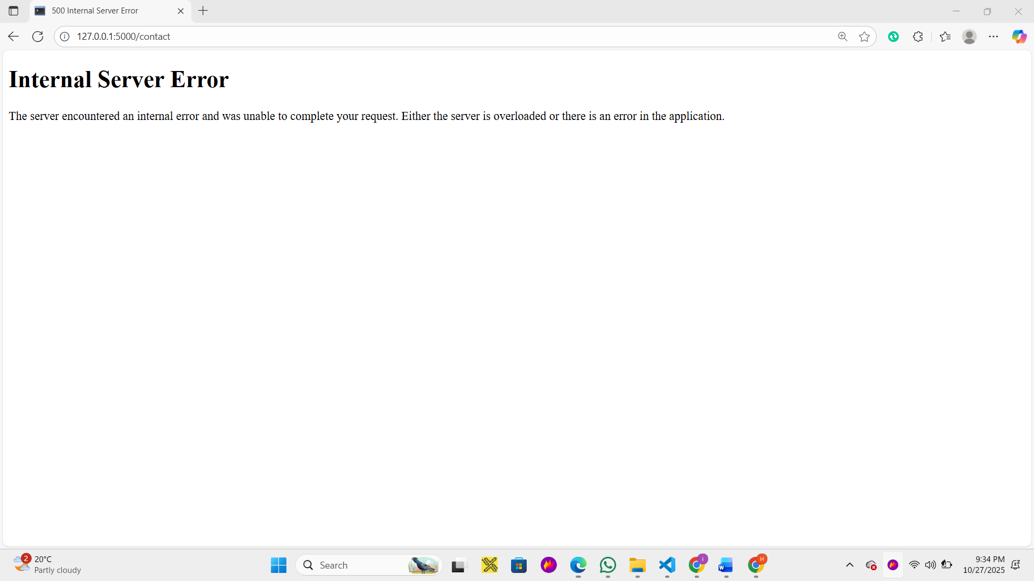

Task 5: Secure Password Storage (Flask-Bcrypt)

Phase 1: Pre-Fix Testing (Vulnerability Check)
The goal is to prove that the current User table stores passwords as plain text. Since we are using an SQLite file (flask_lab.db), we need to insert a user and then check the database file directly.
Step 1.1: Insert a Test User (Unsecured)
- Ensure your current app.py is running.
- Access the Registration/Login Page: Go to http://127.0.0.1:5000/login
- Register a New User:
  - Username: testuser
  - Password: password123
- You should see the "Success!" page confirming the user was registered.
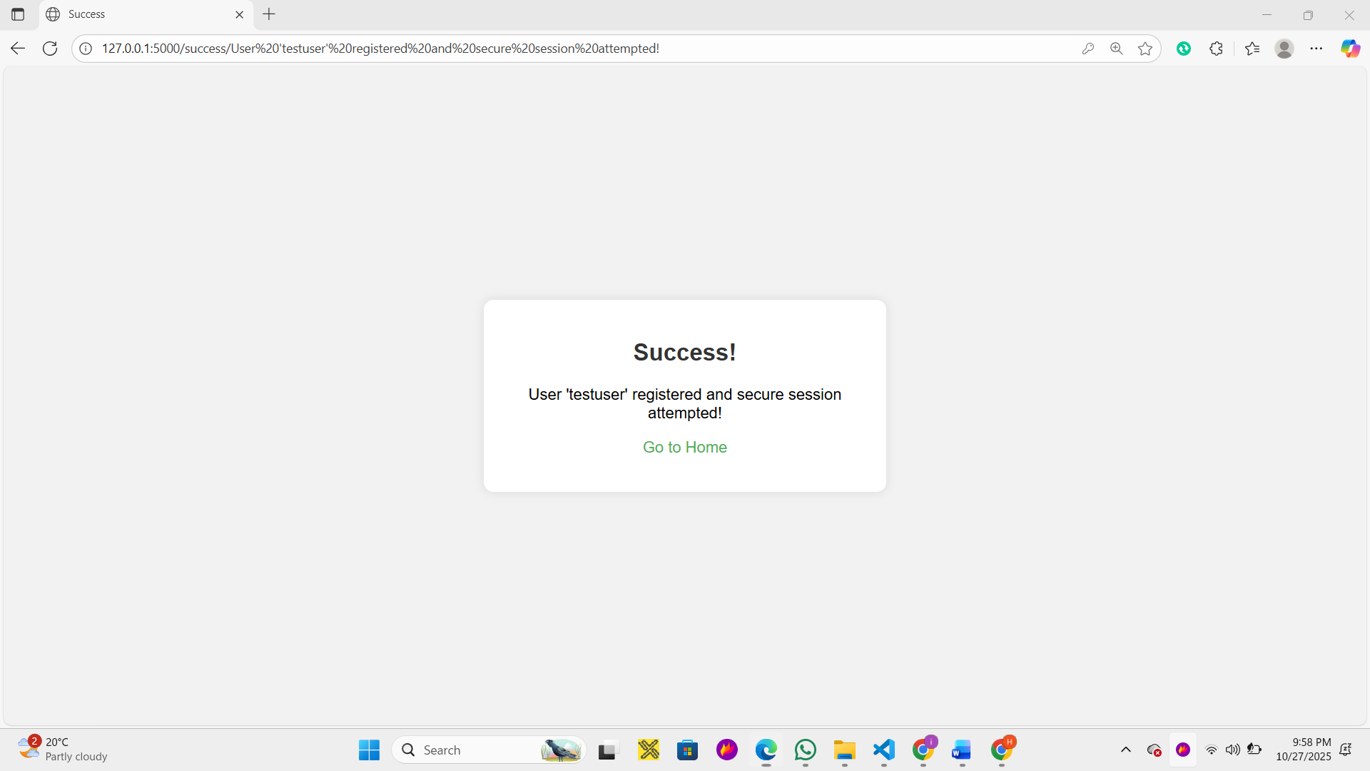

Step 1.2: Take Screenshot of Database (Vulnerability Proof)
- Open the SQLite database file: You will need a tool like DB Browser for SQLite (or a similar tool that can read SQLite files) to open the flask_lab.db file generated by your Flask app.
- Inspect the user table: Find the record for testuser.
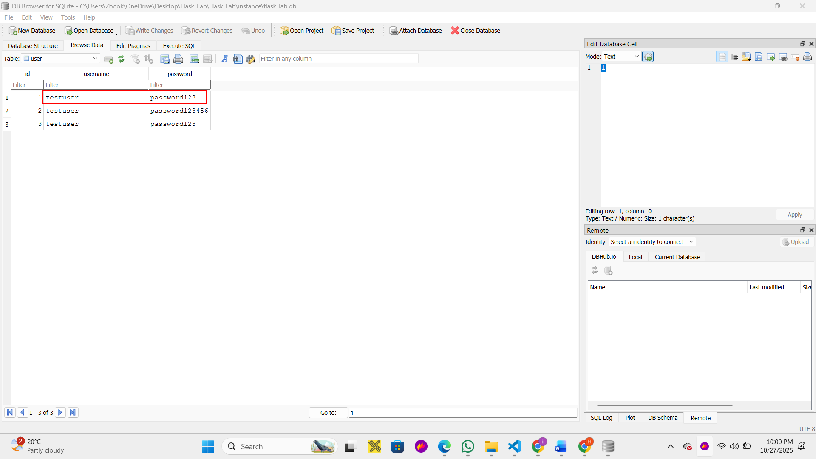

Phase 2: Applying the Flask-Bcrypt Fix
The fix involves installing the package, initializing it in app.py, and updating the registration logic.
Step 2.1: Install Flask-Bcrypt (Manual Instruction)
In terminal/command prompt, run the following command pip install Flask-Bcrypt
Step 2.2: Update app.py
I will now update your app.py to use Flask-Bcrypt. This involves:
- Importing and initializing Bcrypt.
- Updating the User model to store a longer password hash.
- Updating the /login route to hash the password before saving it.
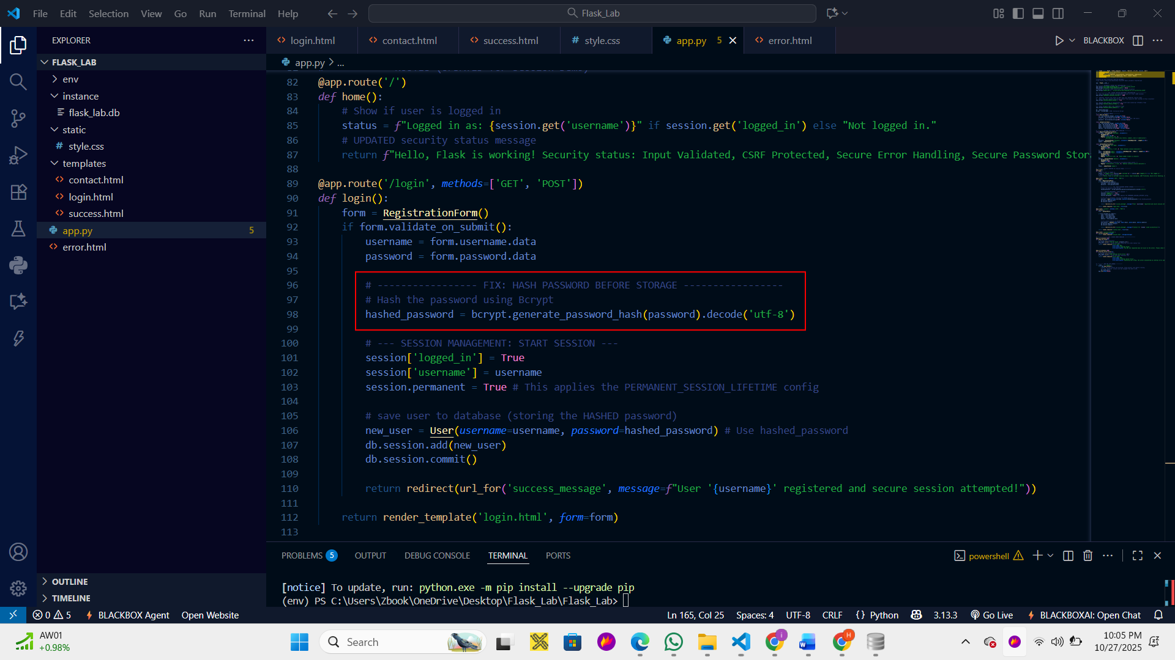

Phase 3: Post-Fix Testing (Verification)
Step 3.1: Insert a New Test User (Secured)
- Stop and restart your Flask app.
- Access the Registration/Login Page: Go to http://127.0.0.1:5000/login
- Register a New User:
  - Username: final
  - Password: finalpass
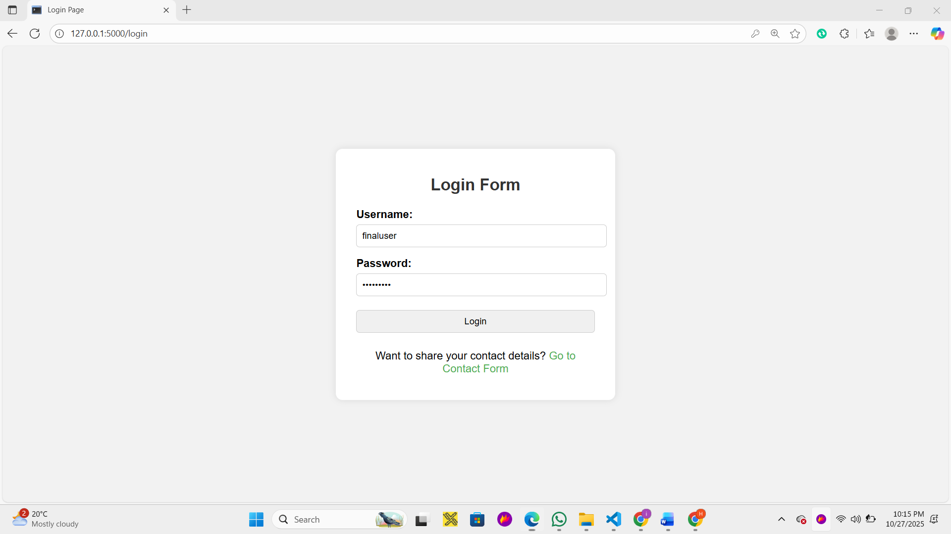

Step 3.2: Take Screenshot of Database (Verification Proof)
- Open the SQLite database file (flask_lab.db) again using your DB Browser tool.
- Inspect the user table.
- Find the record for secureuser.
