Contents
Abstract 3
1. Introduction 3
2. Restaurant Profiles and Positioning 3
3. Digital Marketing Channels and Strategies 6
4. Content and Promotion Strategies Analysis 8
4.1. Visual Content and Brand Alignment 8
4.2. Promotional Tactics and Messaging 9
4.2.1: Price & Value Positioning 9
4.2.2: Community and Customer Voice 9
4.2.3: Influencer Ecosystem & Digital Credibility 10
4.3. Alignment with Target Audience 10
4.3.1 Family vs. Youth Appeal 10
4.3.2 Sophistication vs. Mass-Market Positioning 11
4.3.3 Digital Experience vs. Physical Experience Attraction 11
4.4. Analysis of Instagram and Facebook audiences 13
Instagram Followers: 13
Facebook Followers: 14
5. Menu and Food Insights. 14
5.1 Online Menu Presentation 14
5.2 Marketing of Cuisine & Dietary Preferences 15
6. Conclusion and Recommendations 16
6.1. Summary of Key Digital Takeaways 16
6.2. Actionable Recommendations 17
Appendix 19
Conclusion 20
References 21

Abstract
This report looks at the digital marketing strategies of five top Pakistani restaurant brands: Cheezious, Al-Khan, Butt Karahi, Arcadian, and Cafe Zouk. It examines how these restaurants use online platforms to shape their brand, connect with customers, and build trust in a competitive food industry. The analysis includes pricing and value strategies, community involvement, influencer networks, audience connection, and the balance between digital and physical experiences.
The findings show that Cheezious and Al-Khan excel with value-based promotions and family appeal. Arcadian and Café Zouk concentrate on premium experiences and careful branding, while Butt Karahi emphasizes cultural heritage and authenticity. Each brand’s approach reflects its market position, ranging from fast-food accessibility to luxury dining experiences. Overall, the report emphasizes that consistent engagement, storytelling, and partnerships with influencers are crucial for restaurants to stay visible and trustworthy in the digital marketplace.

1. Introduction
Pakistan's restaurant industry faces a highly competitive and fast-moving market. Consumer habits change quickly, and there is a growing reliance on digital platforms. Traditionally, the industry focused on location and word of mouth. However, it has evolved. Online marketing is now crucial for brand awareness, customer acquisition, and retention. Food ordering apps, social media, and online reviews are not just extra tools; they are essential for running a restaurant.
This report aims to analyze the digital marketing strategies of five different local restaurants in Pakistan: a Desi Food restaurant, a fast food chain, a casual dining buffet, a fine dining restaurant, and a specialty coffee brand. By examining their online presence, content strategies, and promotional activities, the research seeks to understand how each restaurant uses digital channels to connect with its target market. It will also provide insights and practical recommendations for improving digital engagement.

2. Restaurant Profiles and Positioning
This section provides a profile of the five selected restaurants. It describes their market position and the target audience.
2.1. Butt Karahi
Category | Details
Type | Desi / Traditional Pakistani Cuisine Restaurant
Positioning | Butt Karahi is a local Pakistani restaurant that serves authentic karahi, a type of curry, along with other desi dishes. It has several branches in Lahore. The restaurant focuses on serving fresh, tasty, and affordable food, particularly its butter chicken and mutton karahi.  Its main strategies involve highlighting its background as a traditional street food vendor. Butt Karahi offers a lively and relaxed dining atmosphere, sometimes with outdoor seating. The restaurant aims to make its dishes a must-try for both tourists and locals.  Additionally, it emphasizes the "Lahori essence" through popular items like mutton and chicken karahi. These dishes are made using traditional methods that enhance their flavors, as noted in reviews on TripAdvisor.
Target Audience | - Families  - Groups of friends  - Traditional food lovers  - Price-conscious diners  - Late-night eaters  - Tourists and expatriates
Online Presence | - Website: https://buttkarahi.online/ buttkarahi.online+2buttkarahi.online+2  - Instagram: @buttkarahipakistan Instagram+1  - YouTube review: Butt Karahi Food review | Hype is real or not  - Facebook Page: https://www.facebook.com/OfficialButtKarahi/  - Food delivery via Foodpanda: https://www.foodpanda.pk/restaurant/d8el/butt-karahi-lakshmi-chowk  - LinkedIn: https://www.linkedin.com/company/butt-karahi/
2.2. Cheezious
Category | Details
Type | Fast Food / Quick Service Restaurant
Positioning | The Ultimate Cheesy Comfort, Cheezious is the place for delicious, cheesy comfort food. It uses high-quality ingredients at reasonable prices. It differs from typical burger chains by offering various cheese flavors and special sauces.
Target Audience | - Families  - Young adults and students  - Office workers and professionals  - Middle-income consumers  - Online delivery customers
Online Presence | - Website( https://cheezious.com/),  - Instagram: @cheeziouspakistan,  - YouTube review: Cheezious Pizza Taste Test and Review in Lahore,  - Facebook Page: https://www.facebook.com/Cheezious/  - Food delivery via Foodpanda (Pakistan listing): Cheezious on Foodpanda
2.3. Al Khan Restaurant (Lahore)
Category | Details
Type | Multi-Cuisine Restaurant/ Heritage Dining
Positioning | Al Khan Restaurant stands out as a fine dining spot that showcases traditional cooking. It offers a unique and high-quality dining experience with a mix of various global cuisines, including Pakistani, Chinese, and Continental. The restaurant caters to families and friends looking for a cozy setting, featuring a blend of modern and traditional decor. It serves both lunch and dinner and provides amenities like free Wi-Fi and online payment options. The restaurant aims to be a trusted name rooted in a legacy of flavor, quality, and excellent hospitality.
Target Audience | - Families  - Couples  - Singles  - Groups
Online Presence | - Website (https://www.alkhan.com.pk/about),  - Presence on Instagram (https://www.instagram.com/alkhanpk/?hl=en),  - Facebook (https://web.facebook.com/alkhanrestaurant/)
2.4. Arcadian (Lahore)
Category | Details
Type | Fine Dining / High-End Bistro
Positioning | It positions itself as a high-end restaurant that offers a mix of Classic Asian and Continental/French Italian cuisine. Although labeled as 'Fine Dining', its presence in places like Packages Mall suggests it provides modern dining, emphasizing special menu items and gourmet presentation.
Target Audience | - Young Professionals  - Affluent Couples  - Gourmet Food Enthusiasts  - customers prioritizing modern dining and high-quality ingredients.
Initial Online Presence | - Website: https://arcadiancafe.com  - Instagram: https://www.instagram.com/arcadiancafe/?hl=en  - Facebook: https://www.facebook.com/arcadiancafe
2.5. Cafe Zouk
Category | Details
Type | Specialty Cuisine / Coffee House
Positioning | Positioned as a premium Canadian coffee house chain, it emphasizes quality drinks and a welcoming atmosphere, creating a "Third Place." The goal is to stand out from competitors through diverse product offerings and a unique brand experience.
Target Audience | - Students  - Young adults  - Professionals (work/study-friendly)  - Café-goers / social groups
Initial Online Presence | - Website: https://www.cafezouk.com  - Instagram: https://www.instagram.com/cafezouklahore/?hl=en  - Facebook: https://www.facebook.com/CafeZoukLahore

3. Digital Marketing Channels and Strategies
Restaurant | Digital Platforms | Frequency of Posts and Content (Observation) | Analysis and Key Findings
Butt Karahi | Social media:  - Instagram  - Facebook  - LinkedIn  Ordering and delivery:  - Mobile Apps  - Food Delivery Platforms  - Website  - Direct Phone Service | Facebook and Instagram updates happen regularly, usually around three to four times a week. Most of these updates include food pictures, reels, and deals. Updates on platforms like LinkedIn and the website are less frequent, often appearing after weeks or months. | Analysis:  Butt Karahi has some activity on Facebook and Instagram. They mainly post food images and special deals. The posting is inconsistent, but it tends to increase on weekends and holidays.  Key Findings:  The brand's most engaging content consists of real images of food and customer reviews. This content gets more engagement on Facebook and Instagram, but less on platforms like TikTok and the website.
Cheezious | Social media:  - Facebook  - Instagram  - TikTok  - YouTube  - LinkedIn  Ordering and delivery:  - Official Website  - Foodpanda  - Cheetay | Posts are shared regularly, usually several times a week. About 80% of the content features images of food, including close-ups and reels, while 20% is for promotions or events. | Analysis:  Cheezious sees a lot of interaction with its deals and new menu posts. In contrast, regular food posts receive moderate interaction.  Key Finding:  They are concentrating on regular posts and useful content to attract quick orders and budget-conscious customers.
AL-KHAN | Social media:  - Facebook  - Instagram  Ordering and delivery:  - Official Website  - Foodpanda  - Mobile App | Posts come out fairly often. They usually feature weekly menu highlights and high-tea promotions. The content mainly shows wide shots of buffet spreads, the elegant interior decor, and short video tours that highlight the restaurant’s atmosphere and fine dining experience. | Analysis:  Engagement is moderate. Many comments ask users to "tag a friend" on posts about group dining and high-tea offers.  Key Finding:  The restaurant effectively promotes its range and atmosphere. It focuses on showcasing the benefits of its large buffet and high-quality dining to draw in families and groups.
Arcadian | Social media:  - Instagram (Arcadian Cafe)  - Facebook  Ordering and delivery:  - Official Website  - Foodpanda  - Their Mobile App | Moderate posting frequency focuses on professional food photography. The content showcases premium dishes, elegant plating, and atmosphere, with some influencer-style posts. There is limited activity outside of Instagram and Facebook. | Analysis:  Arcadian gets regular engagement, especially on posts featuring high-quality dishes and beautiful presentation. Most interaction comes from likes, with fewer comments. This shows a selective fine-dining audience that values quality visuals more than frequent promotions.  Key Findings:  The brand has a refined, high-end digital image. Engagement is moderate but significant, attracting customers who enjoy luxury dining and gourmet food content.
Cafe Zouk | Social media:  - Facebook  - Instagram  Ordering and delivery:  - Official Website  - Direct Phone Service | Posting frequency is steady. There are regular updates and stories. The content primarily focuses on seasonal drinks, cozy café vibes, and lifestyle shots of customers working or relaxing. Sometimes, there are promotions and features of new items, but most posts are limited to the main social platforms. | Analysis:  Café Zouk sees consistent engagement. This is especially true for Instagram stories, lifestyle posts, and photos of people enjoying the café's atmosphere. Content that focuses on coffee and the cozy vibe performs better than basic product posts.  Key Findings:  Their digital strategy focuses on café culture, which includes comfort, socializing, and a work or study environment. This approach attracts young professionals and students who appreciate ambiance and experience in addition to their coffee.

4. Content and Promotion Strategies Analysis

4.1. Visual Content and Brand Alignment
- Butt Karahi: The visual style of Butt Karahi focuses on authenticity and tradition. The rich, warm-toned images show sizzling karahi dishes, smoky tandoors, and people enjoying meals together. Close-up shots of mutton and chicken karahi are especially striking. They allow viewers to see the texture, freshness, and local flavors. Occasionally, video reels capture the live cooking process, which adds to the brand’s appeal. The visuals reflect Butt Karahi’s identity as a heritage Lahori food brand rooted in desi culture and communal dining. Each post reinforces the restaurant’s image as a source of taste, tradition, and local pride.
- Cheezious: The visual style of Cheezious is bright, colorful, and clear. Close-up photos and videos showcase the melty cheese, juicy fillings, and texture of the food. The main focus is on the product itself, making viewers crave the food immediately rather than a formal dining experience. Food imagery reinforces Cheezious' identity as "The Ultimate Cheesy Comfort" by highlighting value, hearty portions, and indulgence.
- Al Khan: In terms of content, Al Khan mainly creates food-focused visual posts. These posts feature big, appealing images of the final plated dishes to attract viewers to the restaurant. The Facebook and Instagram posts are generally the same and are shared at the same time to keep the brand consistent. The restaurant also produces short reels and posters that highlight their food or the ambiance, often focusing on special or festive events. These visuals are well-designed, colorful, and aim to grab attention.
- Arcadian: The visual style of Arcadian Café is refined and attractive. It highlights premium dining through clean, high-quality, and modern images. Most posts feature clear images that display sophisticated plating with gourmet dishes. They also capture a luxurious restaurant atmosphere, characterized by warm lighting and polished table settings. The content typically includes close-ups of international cuisine, desserts, and beverages, maintaining the brand's commitment to quality and fine dining. The images are sleek, minimal, and tasteful, focusing on taste rather than quantity or overly bright promotions.
- Cafe Zouk: Cafe Zouk Coffee shares content and style inspired by cozy cafe atmospheres and a lifestyle approach. Posts usually feature warm colors, latte art, desserts, and show people enjoying coffee while working or socializing in a coffee shop. They emphasize the comfort level, the vibe of coffee shop culture, and a relaxed modern coffee experience. Occasionally, promotional content is included, blending seamlessly into the aesthetic of the cafe posts. This strategy helps to reinforce ZOUK's image as stylish, comfortable, and perfect for socializing, studying, or enjoying a specialty coffee.

4.2. Promotional Tactics and Messaging

4.2.1: Price & Value Positioning
Brand | Pricing Strategy Identity | Key Promo Style
Cheezious | “Value Hero” | Combo deals, discounted bundles, and offers aimed at students.
Al-Khan | “Family Value Builder” | Hi-tea promotions, group platters, seasonal offers.
Butt Karahi | “Cultural Value Anchor” | Occasional festive promotions rely on reputation rather than pricing.
Arcadian | “Premium Dining” | Subtle seasonal menus. Luxury pricing stays the same.
Café Zouk | “Experience-Based Pricing” | Rare discounts, the atmosphere, and café culture are the draws.
Insight:
Value-based brands like Cheezious and Al-Khan compete on cost. Premium cafés and fine dining restaurants such as Arcadian and Zouk never offer discounts, as that would harm their brand value. Butt Karahi takes a different approach, focusing more on its heritage rather than on discounts.

4.2.2: Community and Customer Voice
Category | Brands | Engagement Style
Community-Led | Cheezious, Café Zouk | Reposts, user-generated content, polls, student culture, and hangout culture
Low-Touch Community | Al-Khan, Butt Karahi | Customer presence is sometimes noticeable. Food visuals take center stage.
Controlled and curated | Arcadian | Polished feed, minimal UGC. Brand tone is more important than customer content.
Insight:
User-generated content enhances relevance and retention for brands that target youth demographics (Cheezious, Zouk). Arcadian safeguards its luxury factor by moderating user-generated content to feature the best posts and limit 'normie' audience voice on social media.

4.2.3: Influencer Ecosystem & Digital Credibility
Brand | Approach | What It Signals
Arcadian | Strong influencer partnerships | Build appeal and reputation.
Al-Khan, Butt Karahi | Event-based influencer pushes | Visibility increases during campaigns.
Cheezious, Café Zouk | Selective collaborations | Authenticity and a natural feel are prioritized.

4.3. Alignment with Target Audience

4.3.1 Family vs. Youth Appeal
Restaurant | Target Audience Focus | Key Indicators
Cheezious | Targets youth but serves families also | Fun colors, memes, cheesy reels, student deals, and late-night snacking.
Arcadian Café | Young professionals, couples, and families who enjoy dining outside | Elegant plating, a premium atmosphere, and a mix of western and fusion cuisine.
Al-Khan | Families & casual dine-in crowd | Hi-Tea deals, family platters, festive buffets.
Butt Karahi | Traditional family diners & food-lover groups | Desi focus, live karahi cooking, group servings, and cultural authenticity.
Cafe Zouk | Young adults, café lovers, students & professionals | Coffee culture, a cozy dine-in vibe, and a lifestyle and work-friendly atmosphere.
Insight:
Cheezious and Arcadian attract young people, students, and active social media users. Butt Karahi is popular with families and those who love traditional food. Al-Khan has a family-friendly image, while Cafe Zouk appeals to young professionals and café goers seeking a cozy place to eat and enjoy coffee.

4.3.2 Sophistication vs. Mass-Market Positioning
Restaurant | Brand Position | Messaging Style
Cheezious | Mass-market, youth-focused brand | Comfort food, large portions, a fun vibe, mouth-watering images, and great deals.
Arcadian Café | Premium casual, sophisticated dining | Elegant plating, casual dining, luxurious atmosphere.
Al-Khan | Semi-premium family dining | Buffet and high-tea options, festive meals, and cultural dining attract interest.
Butt Karahi | Traditional mass appeal. Heritage brand. | Authentic desi cooking, live tawa or karahi, and traditional food pride.
Cafe Zouk | Modern urban cafe, premium casual | Coffee culture, a cozy lifestyle aesthetic, and a modern dining atmosphere.
Insight:
Cheezious is promoted as an affordable and indulgent fast-food choice for young people. Arcadian and Café Zouk offer refined dining experiences, featuring appealing visuals and high-quality dishes in the upscale casual category. Butt Karahi showcases traditional cuisine, while Al-Khan is well-suited for semi-premium family dining, offering buffets and emphasizing family culture.

4.3.3 Digital Experience vs. Physical Experience Attraction
Restaurant | Digital Focus | Physical Experience Focus
Cheezious | Trendy reels, posts aimed at young people, and regular deals | Fast food is convenient. It’s great for late-night meals and hanging out with friends.
Arcadian Café | Elegant food visuals, premium ambience storytelling | Fine dining setup, romantic dinners, high-quality presentation.
Al-Khan | Buffet promotions, festive updates, and family-focused visuals. | Family gatherings, live buffet, and high-tea experience
Butt Karahi | Live karahi cooking videos, real desi reels. | Smoky tandoor, live traditional cooking, group desi dining.
Café Zouk | Coffee lifestyle reels, cozy café content, and a student-friendly tone. | Café culture, a place to study or work, and quality coffee dining.

Insight
Digital focus differs from brand to brand. Cheezious mainly operates online, targeting a youth-driven purpose. Butt Karahi and Café Zouk both create memorable dining experiences in person, focusing on ambiance and live cooking. Arcadian combines a strong digital presence with a high-end dine-in experience. Al-Khan relies on buffet culture to attract family visits, which is backed by festive digital posts.

4.4. Analysis of audiences

Instagram Followers:
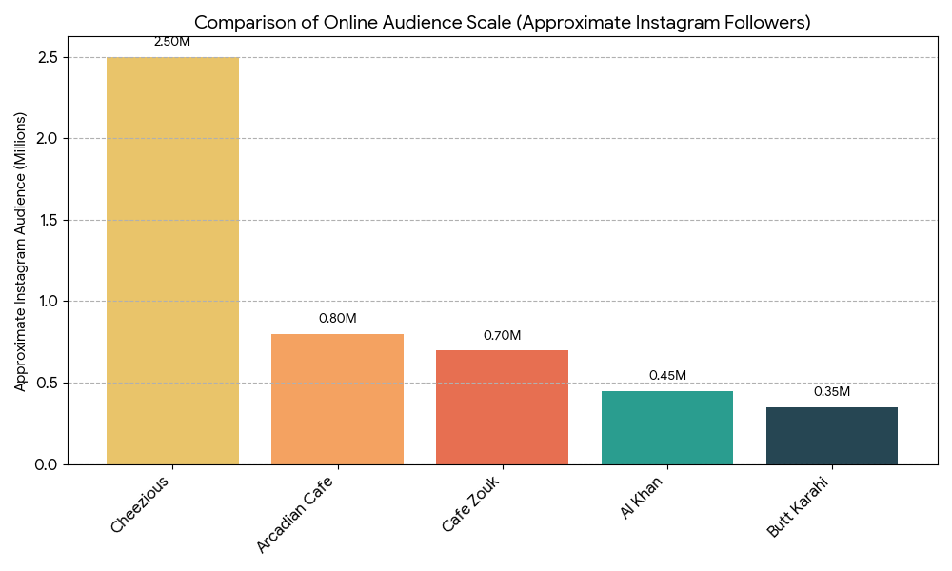

Facebook Followers:
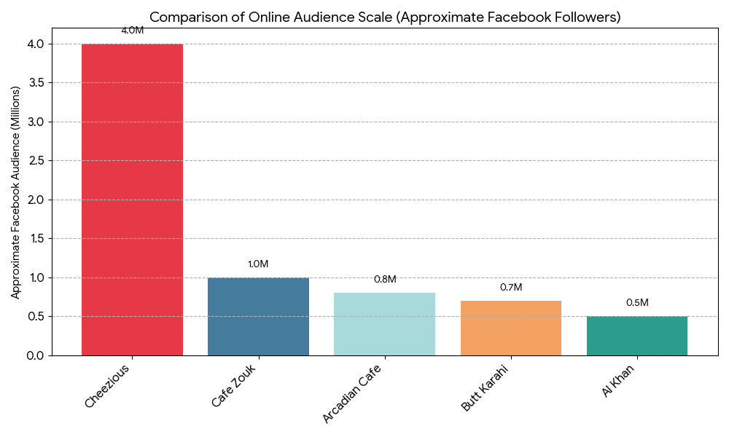

Website Visitors:
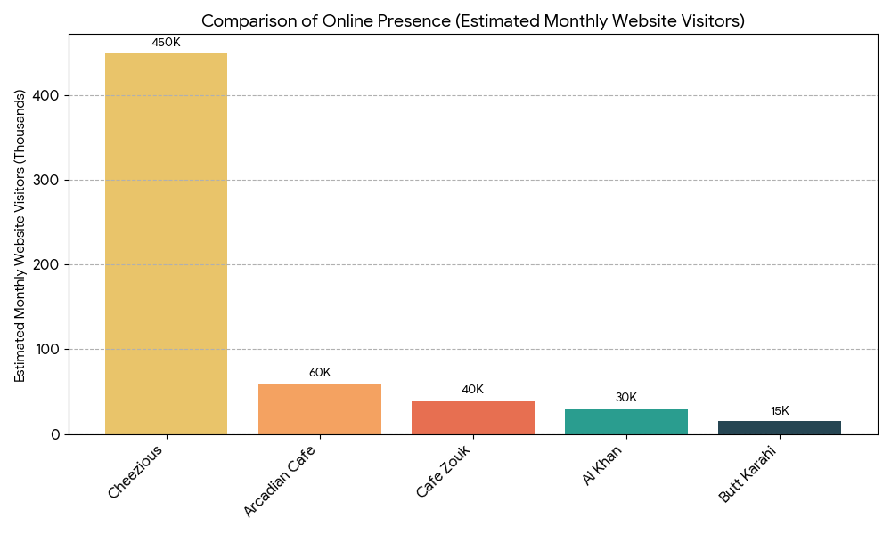

5. Menu and Food Insights.

5.1 Online Menu Presentation
Butt Karahi
- Ease of Access: The Menu is mostly shared through images and reels. It is not as organized or interactive online.
- Specialties Highlighted: Mutton and chicken karahi, tawa items, BBQ. The food visuals highlight authenticity and live cooking.
Cheezious
- Ease of Access: Very easy to use on the app and delivery platforms. The mobile-friendly interface shows prices, combos, and deals clearly.
- Specialties Highlighted: Crown Pizza, Bazinga Burger, loaded fries, and cheesy items are shown with appealing images and combo deals.
Al-Khan
- Ease of Access: Menus are available on the website and social media pages. It also provides details for the high tea and buffet menus.
- Specialties Highlighted: Hi-tea platters, BBQ, Pakistani food, and family meals are featured prominently. They attract diners in groups.
Arcadian Café
- Ease of Access: User-friendly website menu with structured categories, such as entrée, mains, and desserts. It relies less on delivery apps and more on the brand website.
- Specialties Highlighted: Continental and Asian fusion, steaks, pasta, and plated desserts. The restaurant focuses on high-quality food presentation to create a fine-dining atmosphere.
Cafe Zouk
- Ease of Access: Menu available on the website and delivery apps.
- Specialties Highlighted: Coffee drinks, pasta, sandwiches, and desserts. A lifestyle café experience.

5.2 Marketing of Cuisine & Dietary Preferences
Butt Karahi
- Cuisine Focus: Pure desi/Lahori traditional dishes.
- Dietary Focus: Rich, traditional flavors; no diet-conscious marketing.
Cheezious
- Cuisine Focus: Western fast-food — pizzas, burgers, sandwiches, fries, wraps.
- Dietary Focus: No strong promotion of healthy, low-calorie, vegan, or gluten-free foods; emphasizes indulgence & cheese.
Al-Khan
- Cuisine Focus: Pakistani, BBQ, continental & hi-tea buffets.
- Dietary Focus: Buffet-style means variety, but no special emphasis on health or dietary-specific menus.
Arcadian
- Cuisine Focus: Multi-cuisine premium dining — continental, Asian fusion, desserts.
- Dietary Focus: Limited emphasis on healthy tags, but upscale plating suggests quality & ingredient consideration.
Cafe Zouk
- Cuisine Focus: Modern café & continental — sandwiches, pasta, steaks, salads, desserts, premium coffee.
- Dietary Focus: Occasionally highlights lighter items like salads & grilled meals, but primary emphasis is taste & café lifestyle rather than diet health.

6. Conclusion and Recommendations

6.1. Summary of Key Digital Takeaways
BUTT KARAHI
- Success Factors: Strong brand recall comes from a traditional food identity and a loyal local audience. Food pictures and the cultural tone resonate with people who love desi dining and family groups.
- Observed Gaps: Limited modern branding and storytelling, inconsistent posting, and fewer interactive posts. There is less use of influencer marketing and weak customer engagement in comments.
CHEEZIOUS
- Success Factors: Appealing food images and regular good deals attract young people and families. This leads to quick orders and strong engagement.
- Observed Gaps: Limited customer interaction. Replies to comments and reviews are rare. The content focuses mainly on deals, with less storytelling and a stronger emphasis on customer experience.
AL KHAN
- Success Factors: An elegant brand tone, consistent posting, showing high-quality food, and being present on key platforms build trust. Content focused on dine-in experiences appeals to families and groups.
- Observed Gaps: Online engagement is limited. Storytelling, behind-the-scenes content, and influencer collaborations are few. There is room to improve the delivery-based communication and reels strategy.
ARCADIAN
- Success Factors: Premium decor and appealing food visuals showcase an upscale dining experience. Consistent social media posts and high-quality photography draw in a young, elite corporate audience.
- Observed Gaps: Low engagement on posts, limited customer interaction, and a lack of relatable or fun content create challenges. There is less focus on offers and online delivery promotions compared to competitors.
CAFE ZOUK
- Success Factors: Modern and cozy brand vibe with stylish food and coffee visuals. It appeals to young professionals and café lovers. A premium dine-in experience improves brand perception.
- Observed Gaps: There is very limited variety in content. We need more lifestyle videos, reels, and barista-focused content. Interaction with followers is low, and there are fewer campaigns or customer-generated materials.

6.2. Actionable Recommendations
Restaurant | Recommendation for Enhanced Digital Engagement
Butt Karahi | - Create and manage an official TikTok account to reach younger audiences.  - Increase activity on less-used platforms like the official website and LinkedIn.  - Use the website fully to share updates, offers, and menu highlights.  - Use location tags and local hashtags for wider social media reach.  - Maintain consistent content across all outlets.  - Use promotional and engagement posts along with food visuals.  - Collaborate with local food influencers or micro-food bloggers.  - Offer discounts to attract and keep customers.  - Improve response and engagement with followers.
Cheezious | - Launch new limited-time flavors and combos.  - Engage followers through polls and challenges.  - Create unique content for each platform.  - Share behind-the-scenes kitchen clips.  - Improve response time to customer feedback.  - Work with food influencers for greater reach.
Al-Khan | - Offer discounts on all cuisines, not just sweets.  - Improve delivery speed and reliability.  - Share short recipe or food-making videos, not just final dishes.  - Create unique content for each platform, like Instagram and Facebook.  - Use more social media platforms, such as TikTok, Threads, and X, for a wider reach.  - Promote healthy meal options and work with more influencers, ads.
Arcadian | - Expand digital activity beyond Instagram and Facebook  - Introduce Interactive and User-Generated Campaigns  - Optimize Influencer Collaborations for Storytelling  - Integrate Seasonal Campaigns and Thematic Menus  - Improve the Digital Ordering Experience  - Appeal to Emotion through Narration  - Maintain Brand Consistency Across All Branches  - Highlight the Health-Conscious and Contemporary Dining Options  - Refine Posting Schedule and Engagement Strategy  - Strengthen Public Relations and Corporate Partnerships
Café Zouk | - Expand digital presence through short-form video content.  - Improve user-generated content and community engagement.  - Collaborate with micro-influencers and student ambassadors.  - Introduce seasonal and limited-edition menu items.  - Highlight cafe lifestyle and work-friendly ambiance.  - Develop a loyalty and rewards program.  - Promote sustainability and ethical sourcing.  - Enhance website and online ordering experience.

Appendix
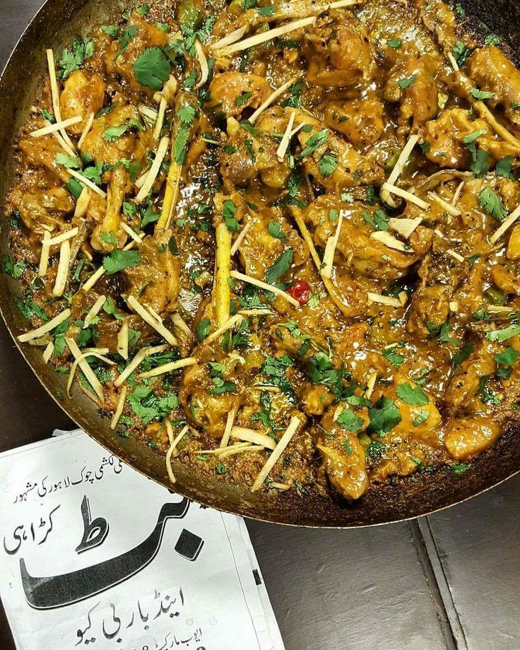
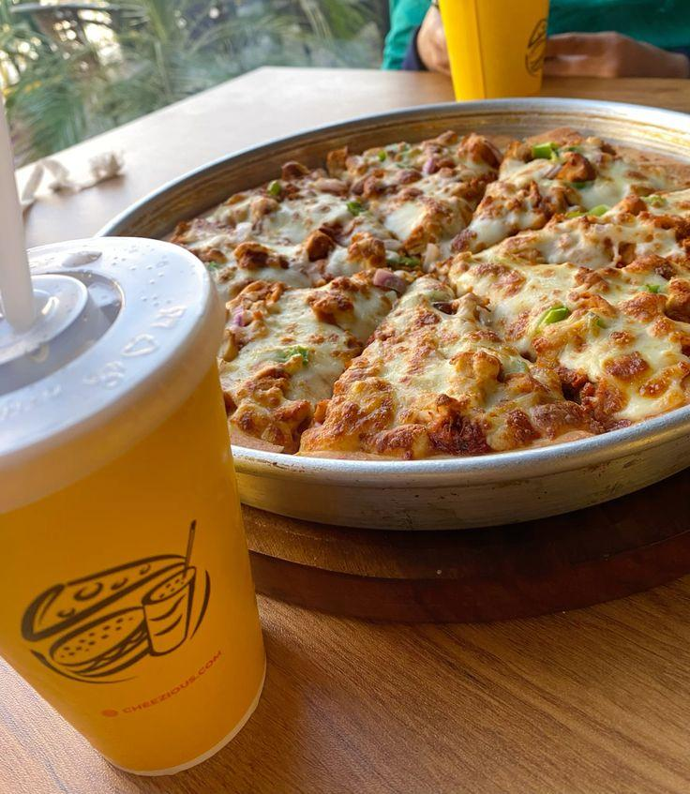
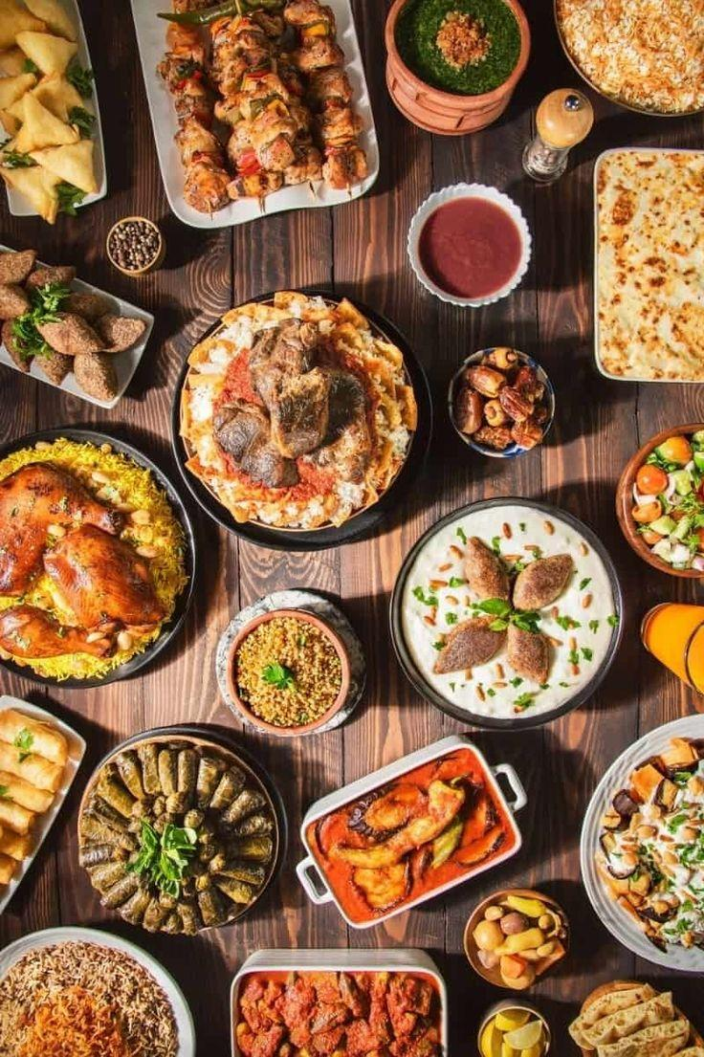
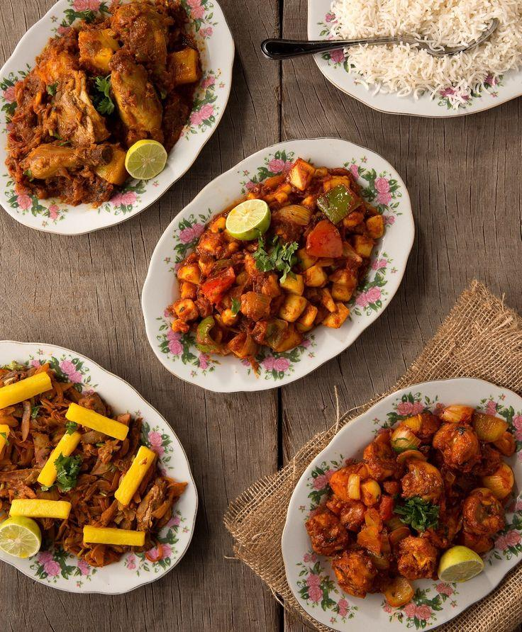
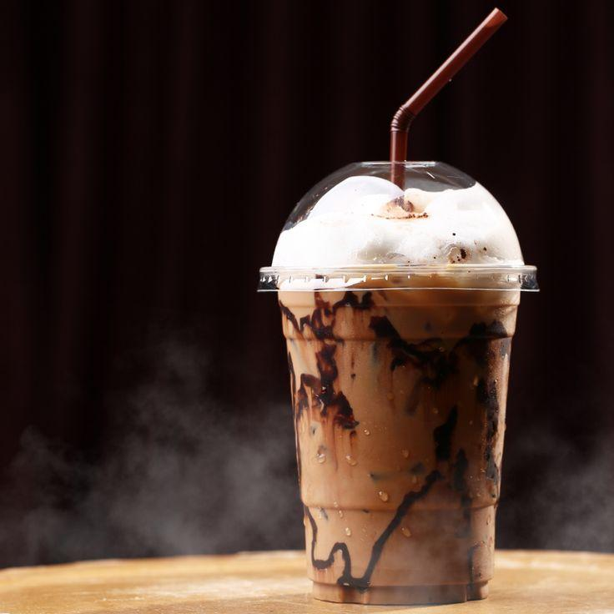

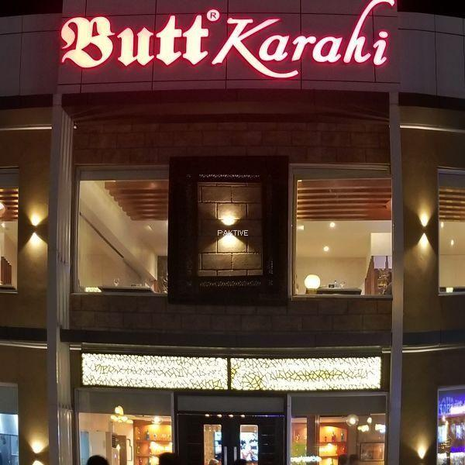
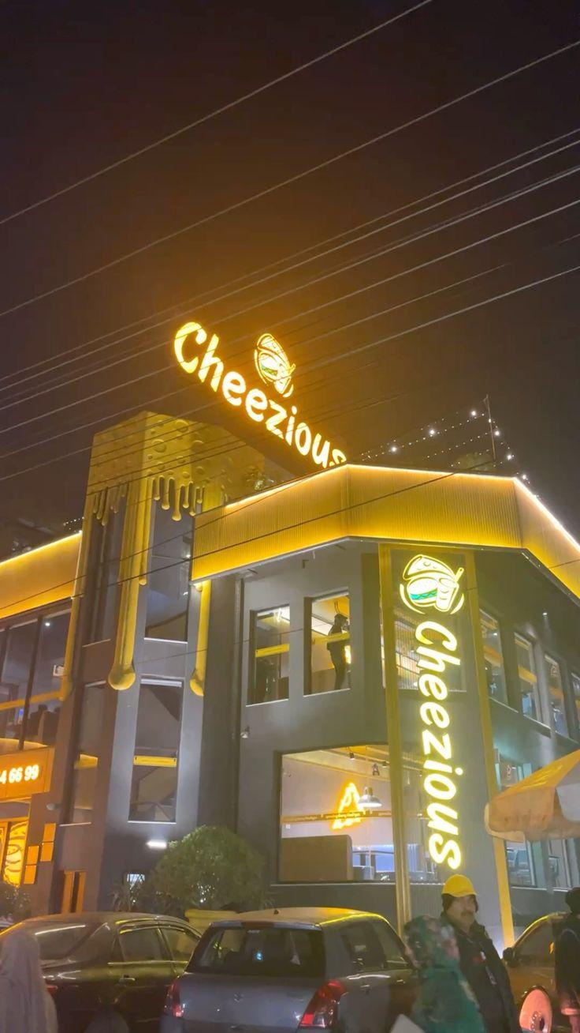
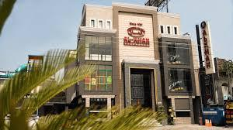
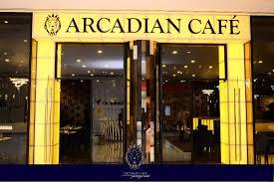
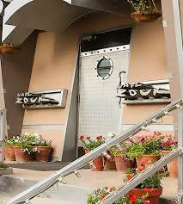

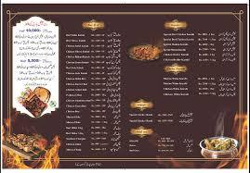
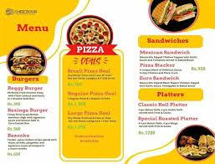
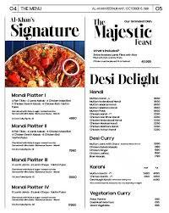
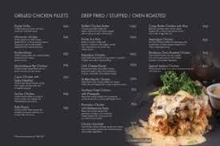
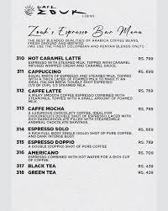

Conclusion
The digital transformation of Pakistan’s restaurant industry has changed how brands communicate, compete, and connect with customers. Each restaurant in this report shows a different approach based on its identity and target market. Cheezious grabs the attention of young people with affordable options and creative visuals, but it needs to create stronger engagement beyond posts about deals. Al-Khan does well with its family-oriented promotions and buffet culture, but it should reach a wider audience by using newer digital platforms. Butt Karahi is recognized for its authentic desi identity and traditional appeal, but it could benefit from greater consistency and partnerships with influencers to update its digital presence. Arcadian Café has a polished, premium image that attracts high-end diners, but it could improve relatability by increasing user interaction and using emotional storytelling. Café Zouk effectively promotes the café culture and lifestyle branding, but it can build customer loyalty through rewards programs and messages about sustainability.
Overall, the analysis shows that the most successful restaurants are those that mix authenticity, creativity, and digital interaction in their marketing. In a time when online influence drives consumer decisions, restaurants must move beyond just promotions to storytelling. They need to build relationships, create communities, and offer brand experiences that go beyond the dining table.

References
Café Zouk
- Café Zouk. (n.d.-a). Café Zouk official website. https://www.cafezouk.com/ Accessed October 29, 2025. [21]
- Café Zouk. (n.d.-b). Order online page. https://cafezouk.com/order-online.html Accessed October 29, 2025. [5]
- Café Zouk Lahore. (2021, November 16). Experience the height of flavour and taste. | Rocket Chicken [Status update]. Facebook. https://www.facebook.com/CafeZoukLahore/posts/4486085031510540 / Accessed October 29, 2025. [5][14]
- Café Zouk Lahore. (n.d.). A timeless classic done right | Pepper Steak [Status update]. Facebook. https://www.facebook.com/CafeZoukLahore/posts/1164073245749868/ Accessed October 29, 2025. [4]
- Café Zouk Lahore. (n.d.). Stuffed Chicken Breast | Serving Lunch & Dinner… [Photo post]. Facebook. https://www.facebook.com/photo.php?fbid=4853299711455735&id=210227812429638&set=a.226761277442958 Accessed October 29, 2025. [8]
- Café Zouk Lahore. (n.d.). Here comes our Duxelle Chicken… [Status update]. Facebook. https://www.facebook.com/CafeZoukLahore/posts/here-comes-our-duxelle-chicken-tgifintroducing-online-ordering-for-your-convenie/2970623859723339/ Accessed October 29, 2025. [1]
- Café Zouk Lahore. (n.d.). This Chicken Caspian with scrumptious pesto pasta… [Status update]. Facebook. https://www.facebook.com/CafeZoukLahore/posts/3324212634364458/ Accessed October 29, 2025. [24]
- Café Zouk Lahore. (n.d.). Zouk’s exclusive bank card discounts… [Status update]. Facebook. https://www.facebook.com/CafeZoukLahore/posts/1089963149827545/ Accessed October 29, 2025. [19]
- Café Zouk Lahore. (n.d.). A mother’s love is forever… [Photo post]. Facebook. https://m.facebook.com/CafeZoukLahore/photos/a-mothers-love-is-forever-celebrate-its-magic-this-mothers-day-with-a-warm-delic/1102406355249891/ Accessed October 29, 2025. [10]
- Café Zouk (Lahore). (n.d.). Instagram profile and posts. Instagram. https://www.instagram.com/cafezouklahore/ Accessed October 29, 2025. [23]
- Café Zouk (Lahore). (n.d.). Crispy, golden, and bursting with flavour… [Post]. Instagram. https://www.instagram.com/p/DJBVE8FPlS3/ Accessed October 29, 2025.
- Café Zouk (Lahore). (n.d.). For those who like it hot… [Post]. Instagram. https://www.instagram.com/p/DNKlTCYuoNg/ Accessed October 29, 2025. [9]
- TripAdvisor. (n.d.). Café Zouk — Reviews and ranking. https://www.tripadvisor.com/Restaurant_Review-g295413-d801704-Reviews-Cafe_Zouk-Lahore_Punjab_Province.html Accessed October 29, 2025. [11]
- Wanderlog. (n.d.). Café Zouk — Reviews, ratings, details. https://wanderlog.com/place/details/2670113/caf%C3%A9-zouk Accessed October 29, 2025. [13] .
Butt Karahi
- https://buttkarahi.online/
- https://www.facebook.com/OfficialButtKarahi/
- https://www.foodpanda.pk/restaurant/d8el/butt-karahi-lakshmi-chowk
- https://pricepro.pk/butt-karahi/
- https://www.tripadvisor.com/Restaurant_Review-g295413-d7243327-Reviews-Butt_Karahi_Tikka-Lahore_Punjab_Province.html
- https://butt-karahi-1.wheree.com/
- https://www.google.com/search?q=target+audience+of+Butt+Karahi+Lahore+restaurant

- https://www.google.com/search?q=Visual+Content+and+Brand+Alignment+Butt+Karahi

- https://www.google.com/search?q=Visual+Content+and+Brand+Alignment+Butt+Karahi
Cheezious
- https://cheezious.com/
- https://www.facebook.com/Cheezious/
- https://www.infozonepk.com/2024/10/08/cheezious-makes-history-with-pakistans-largest-pizza-diner-opened-in-lahore/
- https://cheeziouslahore.com/cheezious-menu-lahore/
- https://www.facebook.com/groups/dineandshare
- https://www.tripadvisor.com/Restaurant_Review-g304030-d26836533-Reviews-Cheezious_Pizza-Faisalabad_Punjab_Province.html
- https://thecheeziousmenus.com/
- https://www.studocu.com/row/document/riphah-international-university/ms-accounting-and-finance/pestle-analysis-of-cheezious-pakistan-ayesha/85073095
- https://www.scribd.com/presentation/673470849/Cheezious-Pakistans-Delicious-Fast-Food-Brand-1
- https://kimola.com/reports/unlock-insights-with-cheezious-customer-feedback-analysis-google-business-lahore-pakistan-145410
- https://badarmunir.com/projects/casestudy-cheezious-metaads/
Al Khan Restaurant
- https://www.alkhan.com.pk/about
- https://web.facebook.com/alkhanrestaurant/
- https://www.instagram.com/p/C6_whr8tTUJ/?hl=en
Arcadian
- https://arcadiancafe.com
- https://www.facebook.com/arcadiancafe
- https://www.instagram.com/arcadiancafe/?hl=en

Audience Analysis
- https://backlinko.com/tools/website-traffic-checker
- https://contentsquare.com/guides/website-tracking/compare-traffic/

