LAB EXPERIMENT 6
Online Cake Ordering System

SUBJECT CODE | CSA4306
SUBJECT NAME | INTERNET PROGRAMMING
NAME | HAMRUDHA J
REG NO | 192411266
EXPERIMENTS | 6

Experiment 6: Online Cake Ordering System

Question
The online cake ordering system allows users to browse a variety of cakes by category, flavor, and occasion, complete with detailed descriptions and images. Users can register, log in, and manage their orders through a personal dashboard. The ordering process includes selecting a cake, customizing options like size and message, entering delivery details, and making secure payments via an integrated payment gateway. Admins can manage cake inventory, track orders, and handle user accounts through an admin panel. Users receive order confirmation emails and can track delivery status. The website is fully responsive, providing a seamless shopping experience on all devices. Buy a Cake is a portal which allows admin in developing counters to advertise and sell their cake. This would permit rural communities to make their wares available to the rest of the world. The proposed system is to develop the website for cake store. User can buy the nearby cake available in app. An E Com App is a portal which allows admin in developing products to promote and sell their goods. This would permit rural communities to make their wares available to the rest of the world.

Aim
To design and develop a responsive online cake ordering website that lets users browse cakes by category, customise size and message, place orders with delivery details and payment, and lets the admin manage cake inventory and orders.

Software / Tools Required
HTML5, CSS3 and JavaScript; any text editor (VS Code / Notepad++); a web browser (Google Chrome).

Algorithm
1. Start.
2. Create a folder for the project and a file index.html.
3. Design the common header (BuyACake) and the navigation bar using HTML.
4. Create one section (page) for each module: Home, Register, Login, Cakes, Customize, Cart, Checkout, Track Order, Admin Panel.
5. Design forms with labels, text fields, drop-down lists and buttons for user input.
6. Apply CSS for the layout, colours, cards, tables and responsive grid.
7. Write JavaScript functions to switch between pages, validate and submit forms, search and filter items, and manage the shopping cart.
8. Open index.html in the browser, test every page and verify the output.
9. Stop.

Program (index.html)
<!DOCTYPE html>
<html lang="en">
<head>
<meta charset="UTF-8">
<meta name="viewport" content="width=device-width, initial-scale=1">
<title>BuyACake - Online Cake Ordering System</title>
<style>
:root{--c:#d6336c}
*{box-sizing:border-box;margin:0;font-family:'Segoe UI',Arial,sans-serif}
body{background:#f4f5f7;color:#212529}
header{background:var(--c);color:#fff;padding:14px 28px;display:flex;justify-content:space-between;align-items:center}
header h1{font-size:24px}
nav{background:#fff;padding:0 20px;display:flex;flex-wrap:wrap;box-shadow:0 2px 4px #0001}
nav a{padding:12px 13px;cursor:pointer;font-size:14px;color:#495057;border-bottom:3px solid transparent}
nav a.on,nav a:hover{color:var(--c);border-color:var(--c)}
main{max-width:1000px;margin:20px auto;padding:0 16px;min-height:420px}
.page{display:none}.page.active{display:block}
h2{margin-bottom:14px;color:var(--c)}
h3{margin:14px 0 8px}
.hero{background:linear-gradient(120deg,var(--c),#212529);color:#fff;border-radius:12px;padding:38px;margin-bottom:20px}
.hero h2{color:#fff;font-size:30px}
.grid{display:grid;grid-template-columns:repeat(auto-fill,minmax(200px,1fr));gap:16px;margin-bottom:16px}
.card{background:#fff;border-radius:10px;padding:16px;box-shadow:0 1px 5px #0002}
.card .ic{font-size:44px}
.card p{font-size:13px;color:#555;margin:4px 0}
.price{color:var(--c);font-weight:700}
.btn{background:var(--c);color:#fff;border:0;padding:9px 16px;border-radius:6px;cursor:pointer;margin-top:8px;font-size:14px}
.btn.alt{background:#868e96}
form,.box{background:#fff;padding:20px;border-radius:10px;box-shadow:0 1px 5px #0002;max-width:560px;margin-bottom:16px}
label{display:block;margin:10px 0 4px;font-size:14px;font-weight:600}
input,select,textarea{width:100%;padding:8px;border:1px solid #ced4da;border-radius:6px;font-size:14px}
table{width:100%;border-collapse:collapse;background:#fff;border-radius:10px;overflow:hidden;box-shadow:0 1px 5px #0002;margin-bottom:16px}
th{background:var(--c);color:#fff;text-align:left}
th,td{padding:10px;border-bottom:1px solid #eee;font-size:14px}
.stats{display:flex;gap:16px;margin-bottom:16px}
.stat{flex:1;background:#fff;border-radius:10px;padding:16px;text-align:center;box-shadow:0 1px 5px #0002}
.stat b{display:block;font-size:26px;color:var(--c)}
.tag{background:#e9ecef;border-radius:12px;padding:3px 10px;font-size:12px}
.ok{background:#d3f9d8;color:#2b8a3e}.wait{background:#fff3bf;color:#e67700}.bad{background:#ffe3e3;color:#c92a2a}
.map{height:240px;border-radius:10px;background:repeating-linear-gradient(45deg,#dff3e3,#dff3e3 20px,#cfe8d5 20px,#cfe8d5 40px);position:relative;margin-bottom:12px;cursor:crosshair;overflow:hidden}
.pin{position:absolute;font-size:26px;transform:translate(-50%,-100%)}
.bar{height:22px;background:var(--c);border-radius:4px;color:#fff;font-size:12px;padding:2px 8px}
.qr{display:grid;grid-template-columns:repeat(15,12px);gap:0;width:180px;border:8px solid #fff;box-shadow:0 1px 5px #0002}
.qr i{width:12px;height:12px;background:#fff}.qr i.k{background:#000}
#toast{position:fixed;bottom:24px;right:24px;background:#212529;color:#fff;padding:12px 20px;border-radius:8px;display:none}
footer{text-align:center;padding:16px;font-size:12px;color:#868e96}
</style>
</head>
<body>
<header><h1>🎂 BuyACake</h1><span>Fresh cakes at your doorstep</span></header>
<nav>
<a data-p="home" onclick="show('home')">Home</a>
<a data-p="register" onclick="show('register')">Register</a>
<a data-p="login" onclick="show('login')">Login</a>
<a data-p="cakes" onclick="show('cakes')">Cakes</a>
<a data-p="custom" onclick="show('custom')">Customize</a>
<a data-p="cart" onclick="show('cart')">Cart</a>
<a data-p="checkout" onclick="show('checkout')">Checkout</a>
<a data-p="track" onclick="show('track')">Track Order</a>
<a data-p="admin" onclick="show('admin')">Admin Panel</a>
</nav>
<main>
<section class="page" id="home">
<div class="hero"><h2>Order Fresh Cakes Online</h2><p>Browse by category, flavour and occasion. Delivered nearby, fresh and on time.</p><button class="btn" style="background:#fff;color:#212529" onclick="show('cakes')">Browse Cakes</button></div><div class="grid" id="cards">
<div class="card" data-c=""><div class="ic">🎉</div><b>Birthday</b><p>24 cakes</p></div>
<div class="card" data-c=""><div class="ic">💑</div><b>Anniversary</b><p>12 cakes</p></div>
<div class="card" data-c=""><div class="ic">💒</div><b>Wedding</b><p>8 cakes</p></div>
<div class="card" data-c=""><div class="ic">🥚</div><b>Eggless</b><p>15 cakes</p></div>
</div><div class="stats"><div class="stat"><b>60+</b>Cakes</div><div class="stat"><b>1200</b>Happy Customers</div><div class="stat"><b>4.8</b>Rating</div></div>
</section>
<section class="page" id="register">
<h2>Register</h2>
<form data-msg="Registration successful" data-go="login">
<label>Full Name</label><input type="text" placeholder="Enter full name" required>
<label>Email</label><input type="email" placeholder="Enter email" required>
<label>Mobile</label><input type="tel" placeholder="Enter mobile" required>
<label>City</label><input type="text" placeholder="Enter city" required>
<label>Password</label><input type="password" placeholder="Enter password" required>
<button class="btn">Create Account</button>
</form>
</section>
<section class="page" id="login">
<h2>Login</h2>
<form data-msg="Login successful" data-go="cakes">
<label>Role</label><select><option>User</option><option>Admin</option></select>
<label>Email</label><input type="email" placeholder="Enter email" required>
<label>Password</label><input type="password" placeholder="Enter password" required>
<button class="btn">Login</button>
</form>
</section>
<section class="page" id="cakes">
<h2>Cakes</h2>
<input placeholder="Search cakes..." onkeyup="filt(this,'#cards .card')" style="max-width:320px;margin-bottom:10px;display:inline-block">
<select onchange="catf(this.value,'#cards .card')" style="max-width:200px;margin-left:8px;display:inline-block"><option>All</option><option>Birthday</option><option>Anniversary</option><option>Wedding</option><option>Eggless</option></select>
<div class="grid" id="cards">
<div class="card" data-c="Birthday"><div class="ic">🎂</div><b>Black Forest</b><p>Chocolate sponge, cream, cherries</p><div class="price">Rs. 450</div><button class="btn" onclick="add('Black Forest',450)">Add to Cart</button></div>
<div class="card" data-c="Birthday"><div class="ic">🍫</div><b>Chocolate Truffle</b><p>Rich dark chocolate ganache</p><div class="price">Rs. 550</div><button class="btn" onclick="add('Chocolate Truffle',550)">Add to Cart</button></div>
<div class="card" data-c="Anniversary"><div class="ic">❤️</div><b>Red Velvet</b><p>Cream cheese frosting</p><div class="price">Rs. 650</div><button class="btn" onclick="add('Red Velvet',650)">Add to Cart</button></div>
<div class="card" data-c="Birthday"><div class="ic">🍮</div><b>Butterscotch</b><p>Crunchy caramel praline</p><div class="price">Rs. 480</div><button class="btn" onclick="add('Butterscotch',480)">Add to Cart</button></div>
<div class="card" data-c="Eggless"><div class="ic">🍍</div><b>Pineapple</b><p>Fresh fruit and whipped cream</p><div class="price">Rs. 420</div><button class="btn" onclick="add('Pineapple',420)">Add to Cart</button></div>
<div class="card" data-c="Wedding"><div class="ic">💍</div><b>Wedding Tier</b><p>Three-tier fondant cake</p><div class="price">Rs. 2500</div><button class="btn" onclick="add('Wedding Tier',2500)">Add to Cart</button></div>
</div>
</section>
<section class="page" id="custom">
<h2>Customize</h2>
<form data-msg="Customization saved" data-go="cart">
<label>Cake</label><select><option>Black Forest</option><option>Chocolate Truffle</option><option>Red Velvet</option><option>Butterscotch</option></select>
<label>Size</label><select><option>500 g</option><option>1 kg</option><option>2 kg</option><option>3 kg</option></select>
<label>Flavour</label><select><option>Chocolate</option><option>Vanilla</option><option>Strawberry</option></select>
<label>Message on Cake</label><input type="text" placeholder="Enter message on cake" required>
<label>Delivery Date</label><input type="date" placeholder="Enter delivery date" required>
<button class="btn">Save Customization</button>
</form>
</section>
<section class="page" id="cart">
<h2>Cart</h2>
<table><tr><th>Item</th><th>Price</th><th>Action</th></tr><tbody id="cartBody"></tbody></table>
<div class="box"><b>Total: <span id="total">Rs. 0</span></b><br>
<button class="btn" onclick="show('checkout')">Proceed to Checkout</button></div>
</section>
<section class="page" id="checkout">
<h2>Checkout</h2>
<form data-msg="Order placed! Confirmation sent to your email" data-go="track">
<label>Receiver Name</label><input type="text" placeholder="Enter receiver name" required>
<label>Delivery Address</label><textarea rows="3" required></textarea>
<label>Phone</label><input type="tel" placeholder="Enter phone" required>
<label>Delivery Time</label><select><option>10 AM - 12 PM</option><option>12 PM - 3 PM</option><option>3 PM - 6 PM</option></select>
<label>Payment</label><select><option>UPI</option><option>Credit/Debit Card</option><option>Net Banking</option><option>Cash on Delivery</option></select>
<button class="btn">Place Order</button>
</form>
</section>
<section class="page" id="track">
<h2>Track Order</h2>
<table>
<tr><th>Order ID</th><th>Cake</th><th>Date</th><th>Status</th></tr>
<tr><td>#C101</td><td>Black Forest 1 kg</td><td>12-Nov</td><td><span class="tag ok">Delivered</span></td></tr>
<tr><td>#C102</td><td>Red Velvet 500 g</td><td>14-Nov</td><td><span class="tag wait">Out for delivery</span></td></tr>
<tr><td>#C103</td><td>Wedding Tier</td><td>20-Nov</td><td><span class="tag wait">Baking</span></td></tr>
</table>
</section>
<section class="page" id="admin">
<h2>Admin Panel</h2>
<div class="stats"><div class="stat"><b>60</b>Cakes</div><div class="stat"><b>18</b>Orders Today</div><div class="stat"><b>Rs. 24,500</b>Revenue</div></div><table>
<tr><th>Cake</th><th>Stock</th><th>Price</th><th>Action</th></tr>
<tr><td>Black Forest</td><td>25</td><td>Rs. 450</td><td><button class="btn">Edit</button> <button class="btn alt">Delete</button></td></tr>
<tr><td>Red Velvet</td><td>12</td><td>Rs. 650</td><td><button class="btn">Edit</button> <button class="btn alt">Delete</button></td></tr>
<tr><td>Pineapple</td><td>30</td><td>Rs. 420</td><td><button class="btn">Edit</button> <button class="btn alt">Delete</button></td></tr>
</table><h3>Add New Cake</h3>
<form data-msg="New cake added">
<label>Cake Name</label><input type="text" placeholder="Enter cake name" required>
<label>Price</label><input type="number" placeholder="Enter price" required>
<label>Stock</label><input type="number" placeholder="Enter stock" required>
<button class="btn">Add Cake</button>
</form>
</section>
</main>
<footer>Internet Programming Lab (CSA4306) - Online Cake Ordering System</footer>
<div id="toast"></div>
<script>
function show(id){document.querySelectorAll('.page').forEach(p=>p.classList.toggle('active',p.id===id));
document.querySelectorAll('nav a').forEach(a=>a.classList.toggle('on',a.dataset.p===id));window.scrollTo(0,0)}
function toast(m){const t=document.getElementById('toast');t.textContent=m;t.style.display='block';setTimeout(()=>t.style.display='none',2200)}
document.addEventListener('submit',e=>{e.preventDefault();toast(e.target.dataset.msg||'Saved successfully');if(e.target.dataset.go)show(e.target.dataset.go)});
function filt(inp,sel){const v=inp.value.toLowerCase();document.querySelectorAll(sel).forEach(r=>r.style.display=r.textContent.toLowerCase().includes(v)?'':'none')}
function catf(v,sel){document.querySelectorAll(sel).forEach(r=>r.style.display=(v=='All'||r.dataset.c==v)?'':'none')}
let cart=[];
function add(n,p){cart.push({n,p});toast(n+' added to cart');draw()}
function del(i){cart.splice(i,1);draw()}
function draw(){const b=document.getElementById('cartBody');let t=0;
b.innerHTML=cart.length?cart.map((c,i)=>{t+=c.p;return `<tr><td>${c.n}</td><td>Rs. ${c.p}</td><td><button class="btn alt" onclick="del(${i})">Remove</button></td></tr>`}).join(''):'<tr><td colspan="3">Your cart is empty</td></tr>';
document.getElementById('total').textContent='Rs. '+t}
show('home');
</script>
</body>
</html>

Output
Fig. 6.1 Home Page
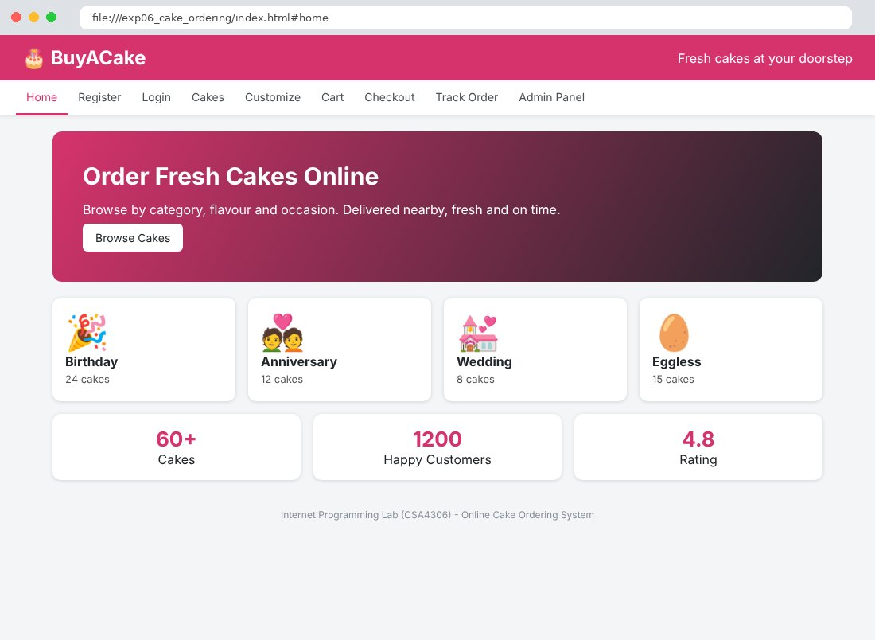
Fig. 6.2 Register Page
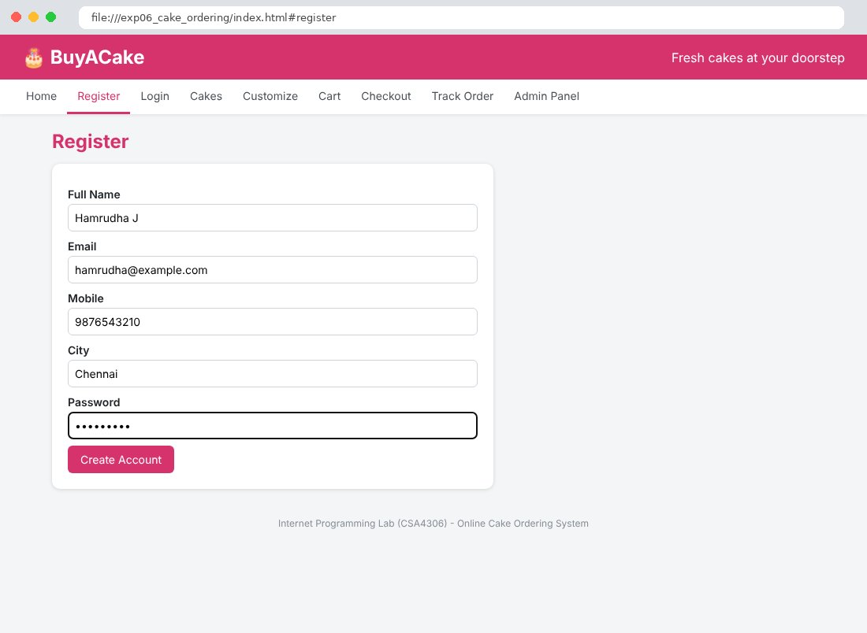
Fig. 6.3 Login Page
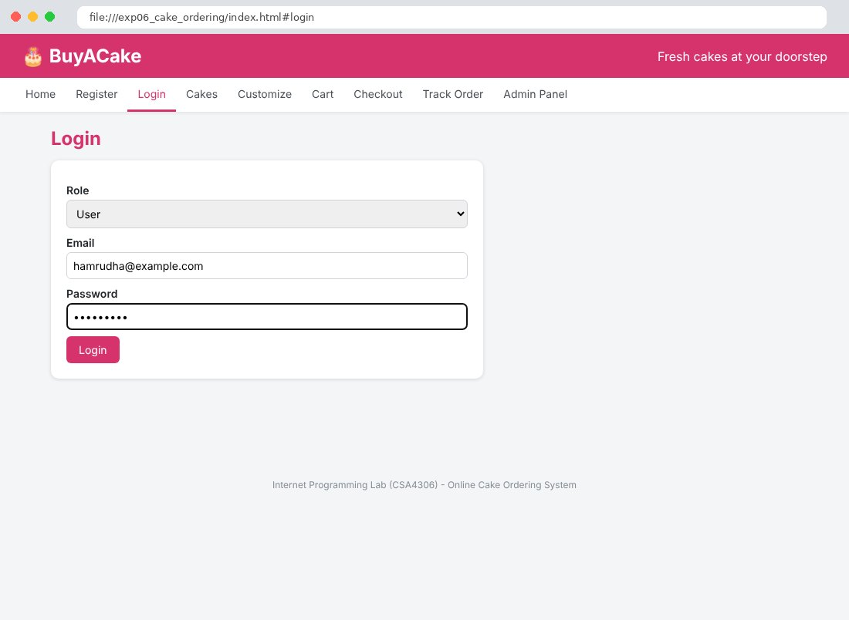
Fig. 6.4 Cakes Page
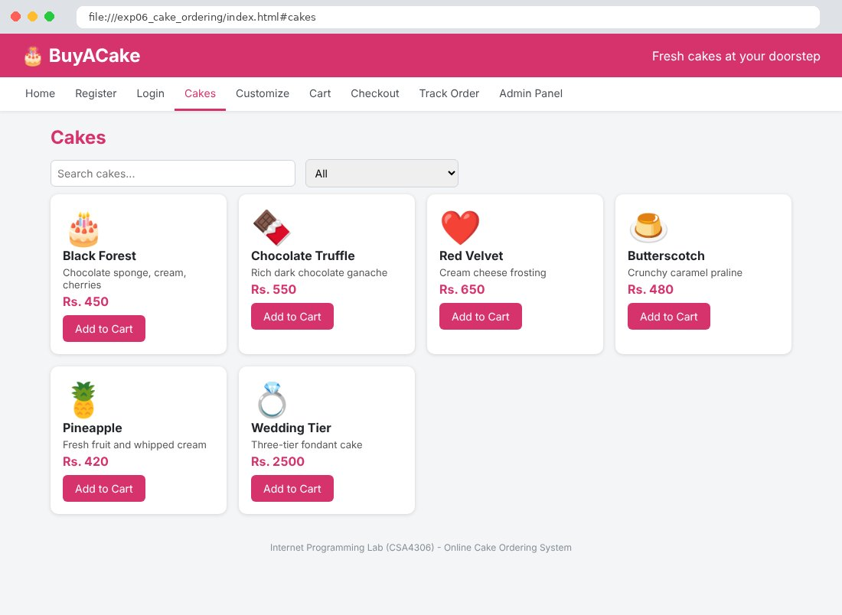
Fig. 6.5 Customize Page
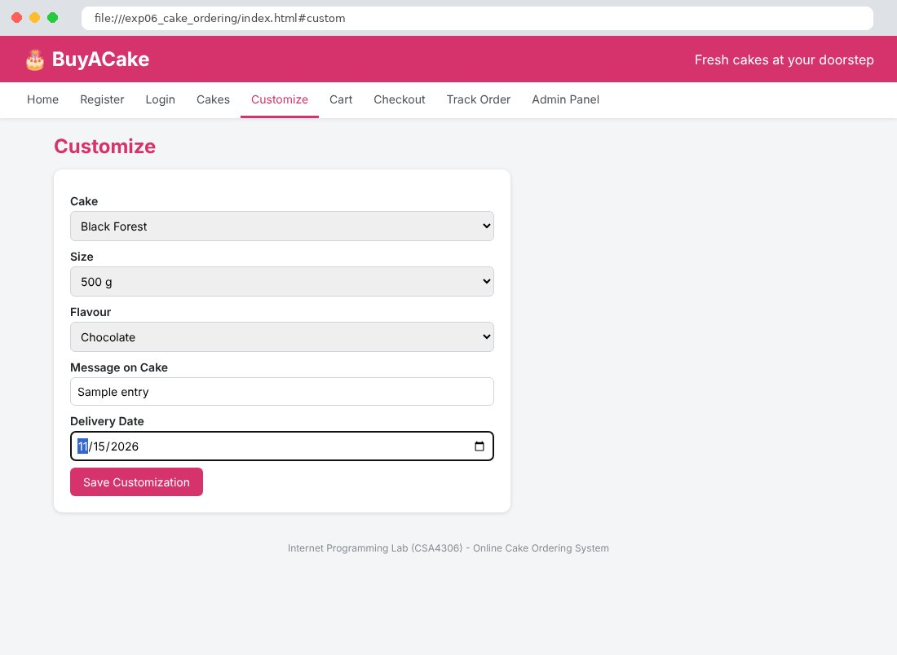
Fig. 6.6 Cart Page
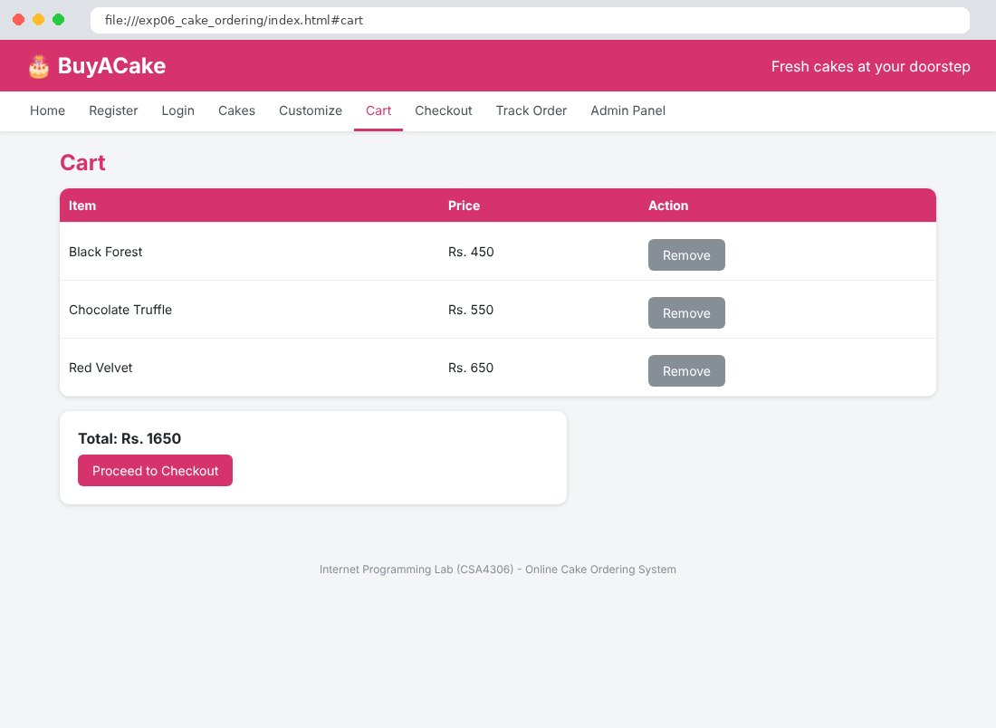
Fig. 6.7 Checkout Page
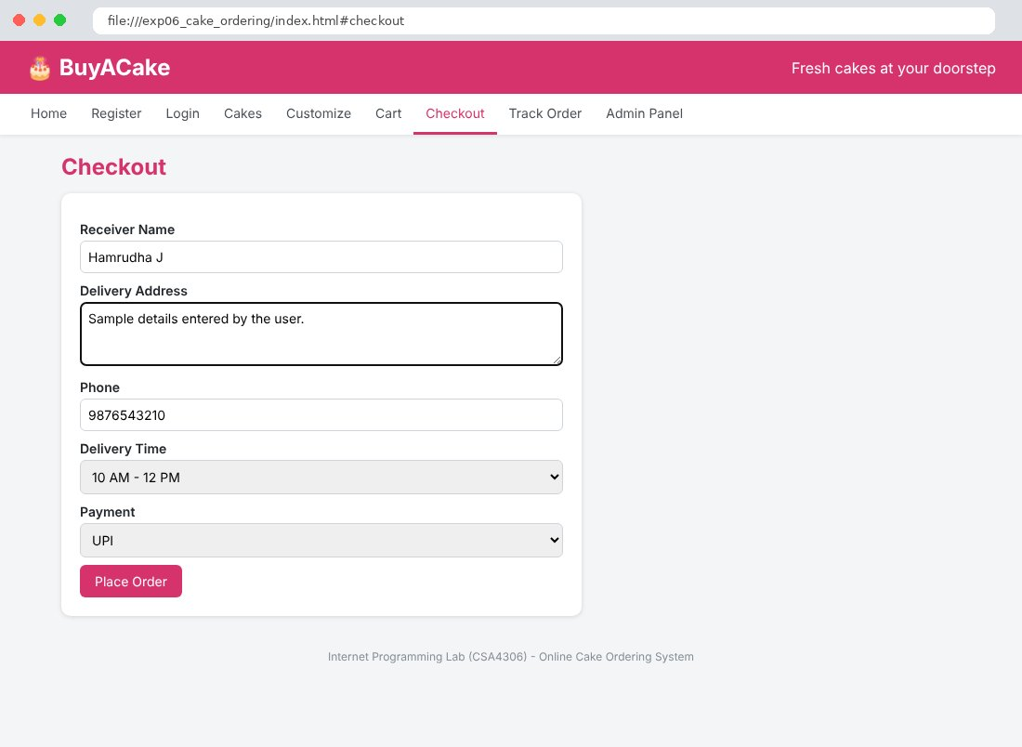
Fig. 6.8 Track Order Page
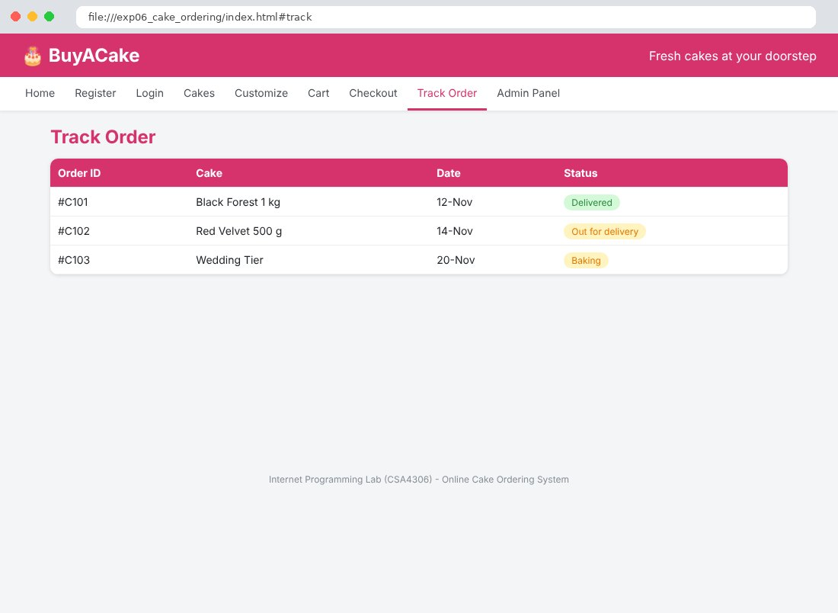
Fig. 6.9 Admin Panel Page
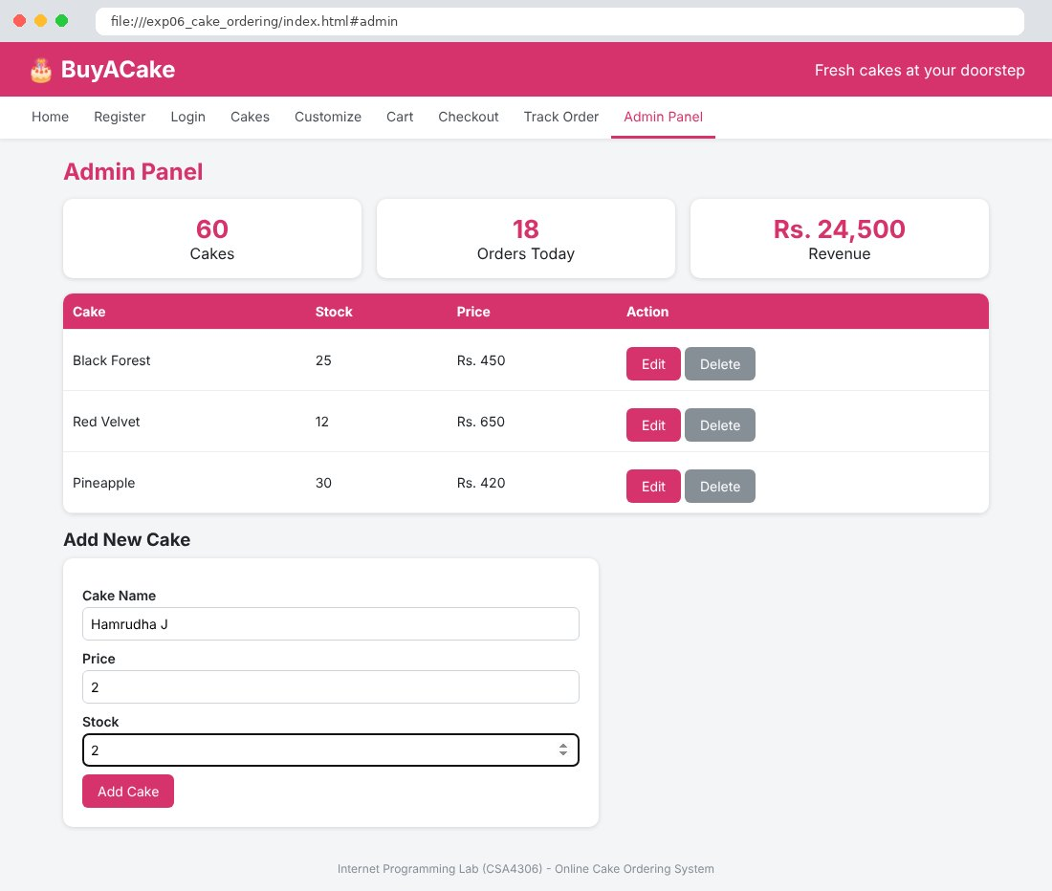

Result
Thus the Online Cake Ordering System website was designed and developed using HTML, CSS and JavaScript, and the output was verified successfully.

