LAB EXPERIMENT 7
Online Beauty Parlour Appointment Booking

SUBJECT CODE | CSA4306
SUBJECT NAME | INTERNET PROGRAMMING
NAME | HAMRUDHA J
REG NO | 192411266
EXPERIMENTS | 6 to 20

Experiment 7: Online Beauty Parlour Appointment Booking

Question
The online beauty parlour appointment booking system allows users to browse available services, view stylist profiles, and check appointment slots in real-time. Users can register, log in, and manage their appointments through a personal dashboard. The booking process includes selecting services, choosing a stylist, selecting a date and time, and making secure payments via an integrated payment gateway. Admins can manage service offerings, stylist schedules, and user accounts through a comprehensive admin panel. Users receive appointment confirmation emails and reminders, with the option to reschedule or cancel appointments through their dashboard. The website is fully responsive, ensuring an optimal experience on all devices. This website helps customers to search for any beauty parlour and book appointments as they preferable date and time.
- Have reservations calendar
- Create, edit, and cancel reservations
- Lockout unavailable hours
- Get the crucial information for each date on the calendar Customers’ personal account page
- Upcoming reservations
- Reservations history
- Personal data
- Salon manager and staff member in order to control and manage reservations.
- Upcoming reservations
- Reservations calendar
- Add reservation
- Edit reservations
- Send an SMS or call to the customer
- customers leave feedback about their experiences and learn from their suggestions.
- Accept online payments as a whole payment or as a partial deposit with Stripe or PayPal or with one of the available payments
- Require full payment or a deposit
- Accept PayPal or Stripe
- Automatic cancellation of unpaid reservations
- We have more than twenty different payments platforms integration add-ons

Aim
To develop a beauty parlour appointment booking website with a reservations calendar, service and stylist selection, payment (full or deposit), customer account pages, and a manager panel for managing reservations and feedback.

Software / Tools Required
HTML5, CSS3 and JavaScript; any text editor (VS Code / Notepad++); a web browser (Google Chrome).

Algorithm
1. Start.
2. Create a folder for the project and a file index.html.
3. Design the common header (GlamBook) and the navigation bar using HTML.
4. Create one section (page) for each module: Home, Login / Register, Services & Stylists, Book Appointment, Reservations Calendar, My Account, Manager Panel, Feedback.
5. Design forms with labels, text fields, drop-down lists and buttons for user input.
6. Apply CSS for the layout, colours, cards, tables and responsive grid.
7. Write JavaScript functions to switch between pages, validate and submit forms, search and filter items.
8. Open index.html in the browser, test every page and verify the output.
9. Stop.

Program (index.html)
<!DOCTYPE html>
<html lang="en">
<head>
<meta charset="UTF-8">
<meta name="viewport" content="width=device-width, initial-scale=1">
<title>GlamBook - Online Beauty Parlour Appointment Booking</title>
<style>
:root{--c:#b5179e}
*{box-sizing:border-box;margin:0;font-family:'Segoe UI',Arial,sans-serif}
body{background:#f4f5f7;color:#212529}
header{background:var(--c);color:#fff;padding:14px 28px;display:flex;justify-content:space-between;align-items:center}
header h1{font-size:24px}
nav{background:#fff;padding:0 20px;display:flex;flex-wrap:wrap;box-shadow:0 2px 4px #0001}
nav a{padding:12px 13px;cursor:pointer;font-size:14px;color:#495057;border-bottom:3px solid transparent}
nav a.on,nav a:hover{color:var(--c);border-color:var(--c)}
main{max-width:1000px;margin:20px auto;padding:0 16px;min-height:420px}
.page{display:none}.page.active{display:block}
h2{margin-bottom:14px;color:var(--c)}
h3{margin:14px 0 8px}
.hero{background:linear-gradient(120deg,var(--c),#212529);color:#fff;border-radius:12px;padding:38px;margin-bottom:20px}
.hero h2{color:#fff;font-size:30px}
.grid{display:grid;grid-template-columns:repeat(auto-fill,minmax(200px,1fr));gap:16px;margin-bottom:16px}
.card{background:#fff;border-radius:10px;padding:16px;box-shadow:0 1px 5px #0002}
.card .ic{font-size:44px}
.card p{font-size:13px;color:#555;margin:4px 0}
.price{color:var(--c);font-weight:700}
.btn{background:var(--c);color:#fff;border:0;padding:9px 16px;border-radius:6px;cursor:pointer;margin-top:8px;font-size:14px}
.btn.alt{background:#868e96}
form,.box{background:#fff;padding:20px;border-radius:10px;box-shadow:0 1px 5px #0002;max-width:560px;margin-bottom:16px}
label{display:block;margin:10px 0 4px;font-size:14px;font-weight:600}
input,select,textarea{width:100%;padding:8px;border:1px solid #ced4da;border-radius:6px;font-size:14px}
table{width:100%;border-collapse:collapse;background:#fff;border-radius:10px;overflow:hidden;box-shadow:0 1px 5px #0002;margin-bottom:16px}
th{background:var(--c);color:#fff;text-align:left}
th,td{padding:10px;border-bottom:1px solid #eee;font-size:14px}
.stats{display:flex;gap:16px;margin-bottom:16px}
.stat{flex:1;background:#fff;border-radius:10px;padding:16px;text-align:center;box-shadow:0 1px 5px #0002}
.stat b{display:block;font-size:26px;color:var(--c)}
.tag{background:#e9ecef;border-radius:12px;padding:3px 10px;font-size:12px}
.ok{background:#d3f9d8;color:#2b8a3e}.wait{background:#fff3bf;color:#e67700}.bad{background:#ffe3e3;color:#c92a2a}
.map{height:240px;border-radius:10px;background:repeating-linear-gradient(45deg,#dff3e3,#dff3e3 20px,#cfe8d5 20px,#cfe8d5 40px);position:relative;margin-bottom:12px;cursor:crosshair;overflow:hidden}
.pin{position:absolute;font-size:26px;transform:translate(-50%,-100%)}
.bar{height:22px;background:var(--c);border-radius:4px;color:#fff;font-size:12px;padding:2px 8px}
.qr{display:grid;grid-template-columns:repeat(15,12px);gap:0;width:180px;border:8px solid #fff;box-shadow:0 1px 5px #0002}
.qr i{width:12px;height:12px;background:#fff}.qr i.k{background:#000}
#toast{position:fixed;bottom:24px;right:24px;background:#212529;color:#fff;padding:12px 20px;border-radius:8px;display:none}
footer{text-align:center;padding:16px;font-size:12px;color:#868e96}
</style>
</head>
<body>
<header><h1>💇 GlamBook</h1><span>Look good. Book easy.</span></header>
<nav>
<a data-p="home" onclick="show('home')">Home</a>
<a data-p="login" onclick="show('login')">Login / Register</a>
<a data-p="services" onclick="show('services')">Services & Stylists</a>
<a data-p="book" onclick="show('book')">Book Appointment</a>
<a data-p="calendar" onclick="show('calendar')">Reservations Calendar</a>
<a data-p="account" onclick="show('account')">My Account</a>
<a data-p="manager" onclick="show('manager')">Manager Panel</a>
<a data-p="feedback" onclick="show('feedback')">Feedback</a>
</nav>
<main>
<section class="page" id="home">
<div class="hero"><h2>Book Your Beauty Appointment</h2><p>Choose a service, pick a stylist and reserve your slot in seconds.</p><button class="btn" style="background:#fff;color:#212529" onclick="show('book')">Book Now</button></div><div class="grid" id="cards">
<div class="card" data-c=""><div class="ic">💇</div><b>Hair Cut</b><p>Rs. 300 · 45 min</p></div>
<div class="card" data-c=""><div class="ic">💅</div><b>Manicure</b><p>Rs. 500 · 60 min</p></div>
<div class="card" data-c=""><div class="ic">💆</div><b>Facial</b><p>Rs. 900 · 75 min</p></div>
<div class="card" data-c=""><div class="ic">👰</div><b>Bridal Makeup</b><p>Rs. 8000 · 3 hrs</p></div>
</div>
</section>
<section class="page" id="login">
<h2>Login / Register</h2>
<form data-msg="Welcome to GlamBook" data-go="book">
<label>Name</label><input type="text" placeholder="Enter name" required>
<label>Email</label><input type="email" placeholder="Enter email" required>
<label>Mobile</label><input type="tel" placeholder="Enter mobile" required>
<label>Password</label><input type="password" placeholder="Enter password" required>
<button class="btn">Register / Login</button>
</form>
</section>
<section class="page" id="services">
<h2>Services & Stylists</h2>
<input placeholder="Search service or stylist..." onkeyup="filt(this,'#cards .card')" style="max-width:320px;margin-bottom:10px;display:inline-block">
<div class="grid" id="cards">
<div class="card" data-c=""><div class="ic">👩‍🎨</div><b>Anita</b><p>Hair specialist · 8 yrs</p></div>
<div class="card" data-c=""><div class="ic">🧑‍🎨</div><b>Ravi</b><p>Colour expert · 6 yrs</p></div>
<div class="card" data-c=""><div class="ic">👩‍🔬</div><b>Meena</b><p>Skin & facial · 10 yrs</p></div>
<div class="card" data-c=""><div class="ic">💄</div><b>Priya</b><p>Bridal makeup · 7 yrs</p></div>
</div>
</section>
<section class="page" id="book">
<h2>Book Appointment</h2>
<form data-msg="Appointment booked. Confirmation sent" data-go="account">
<label>Service</label><select><option>Hair Cut</option><option>Manicure</option><option>Facial</option><option>Bridal Makeup</option></select>
<label>Stylist</label><select><option>Anita</option><option>Ravi</option><option>Meena</option><option>Priya</option></select>
<label>Date</label><input type="date" placeholder="Enter date" required>
<label>Time Slot</label><select><option>10:00 AM</option><option>11:00 AM</option><option>12:00 PM</option><option>2:00 PM</option><option>4:00 PM</option></select>
<label>Payment</label><select><option>Full Payment (Stripe)</option><option>Partial Deposit (PayPal)</option></select>
<button class="btn">Confirm & Pay</button>
</form>
</section>
<section class="page" id="calendar">
<h2>Reservations Calendar</h2>
<table>
<tr><th>Time</th><th>Mon</th><th>Tue</th><th>Wed</th><th>Thu</th><th>Fri</th></tr>
<tr><td>10:00</td><td><span class="tag bad">Booked</span></td><td>Free</td><td><span class="tag bad">Booked</span></td><td>Free</td><td>Free</td></tr>
<tr><td>11:00</td><td>Free</td><td><span class="tag bad">Booked</span></td><td>Free</td><td><span class="tag wait">Blocked</span></td><td>Free</td></tr>
<tr><td>12:00</td><td>Free</td><td>Free</td><td><span class="tag bad">Booked</span></td><td>Free</td><td><span class="tag bad">Booked</span></td></tr>
<tr><td>14:00</td><td><span class="tag bad">Booked</span></td><td>Free</td><td>Free</td><td>Free</td><td>Free</td></tr>
</table>
</section>
<section class="page" id="account">
<h2>My Account</h2>
<div class="stats"><div class="stat"><b>2</b>Upcoming</div><div class="stat"><b>9</b>Past Visits</div></div><table>
<tr><th>Date</th><th>Service</th><th>Stylist</th><th>Status</th><th>Action</th></tr>
<tr><td>18-Nov</td><td>Facial</td><td>Meena</td><td><span class="tag wait">Upcoming</span></td><td><button class="btn">Reschedule</button> <button class="btn alt">Cancel</button></td></tr>
<tr><td>02-Nov</td><td>Hair Cut</td><td>Anita</td><td><span class="tag ok">Completed</span></td><td>-</td></tr>
<tr><td>10-Oct</td><td>Manicure</td><td>Priya</td><td><span class="tag ok">Completed</span></td><td>-</td></tr>
</table>
</section>
<section class="page" id="manager">
<h2>Manager Panel</h2>
<table>
<tr><th>Customer</th><th>Service</th><th>Date & Time</th><th>Action</th></tr>
<tr><td>Divya</td><td>Hair Cut</td><td>18-Nov 10:00</td><td><button class="btn">Edit</button> <button class="btn alt">Send SMS</button></td></tr>
<tr><td>Kavin</td><td>Facial</td><td>18-Nov 11:00</td><td><button class="btn">Edit</button> <button class="btn alt">Send SMS</button></td></tr>
</table><h3>Add Reservation</h3>
<form data-msg="Reservation added">
<label>Customer</label><input type="text" placeholder="Enter customer" required>
<label>Service</label><select><option>Hair Cut</option><option>Manicure</option><option>Facial</option></select>
<label>Date</label><input type="date" placeholder="Enter date" required>
<button class="btn">Add Reservation</button>
</form>
</section>
<section class="page" id="feedback">
<h2>Feedback</h2>
<form data-msg="Thank you for your feedback">
<label>Name</label><input type="text" placeholder="Enter name" required>
<label>Rating</label><select><option>5 - Excellent</option><option>4 - Good</option><option>3 - Average</option><option>2 - Poor</option></select>
<label>Comments</label><textarea rows="3" required></textarea>
<button class="btn">Submit Feedback</button>
</form>
</section>
</main>
<footer>Internet Programming Lab (CSA4306) - Online Beauty Parlour Appointment Booking</footer>
<div id="toast"></div>
<script>
function show(id){document.querySelectorAll('.page').forEach(p=>p.classList.toggle('active',p.id===id));
document.querySelectorAll('nav a').forEach(a=>a.classList.toggle('on',a.dataset.p===id));window.scrollTo(0,0)}
function toast(m){const t=document.getElementById('toast');t.textContent=m;t.style.display='block';setTimeout(()=>t.style.display='none',2200)}
document.addEventListener('submit',e=>{e.preventDefault();toast(e.target.dataset.msg||'Saved successfully');if(e.target.dataset.go)show(e.target.dataset.go)});
function filt(inp,sel){const v=inp.value.toLowerCase();document.querySelectorAll(sel).forEach(r=>r.style.display=r.textContent.toLowerCase().includes(v)?'':'none')}
function catf(v,sel){document.querySelectorAll(sel).forEach(r=>r.style.display=(v=='All'||r.dataset.c==v)?'':'none')}
show('home');
</script>
</body>
</html>

Output
Fig. 7.1 Home Page
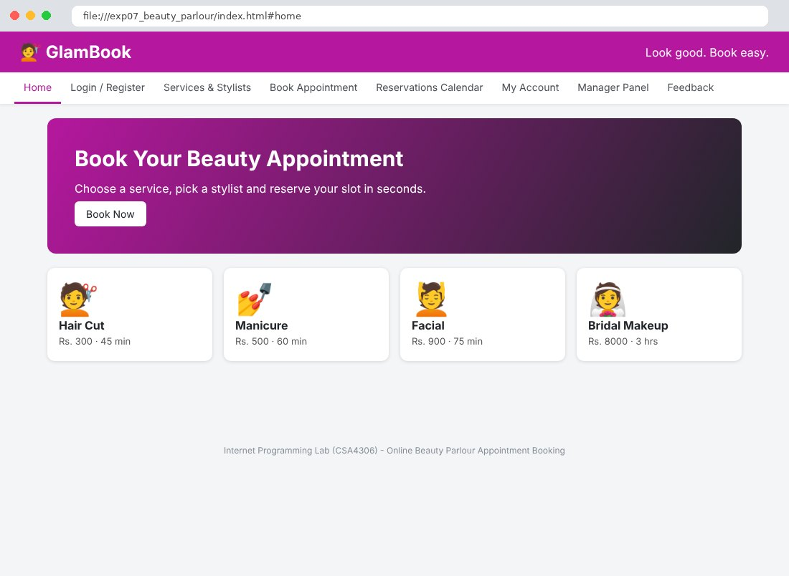
Fig. 7.2 Login / Register Page
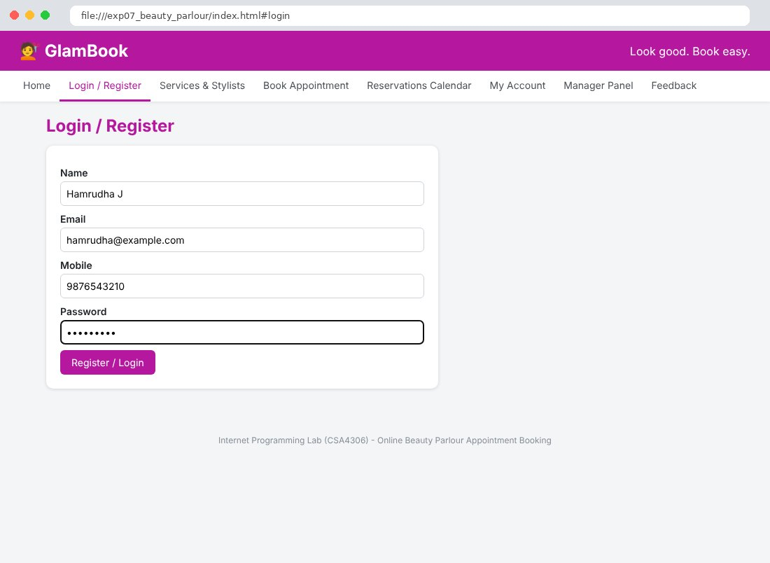
Fig. 7.3 Services & Stylists Page
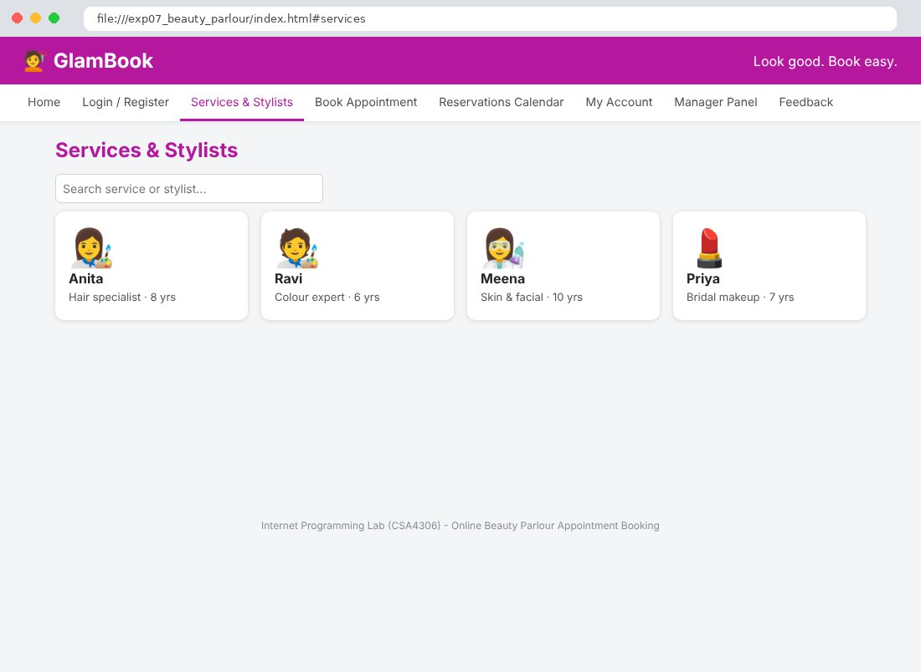
Fig. 7.4 Book Appointment Page
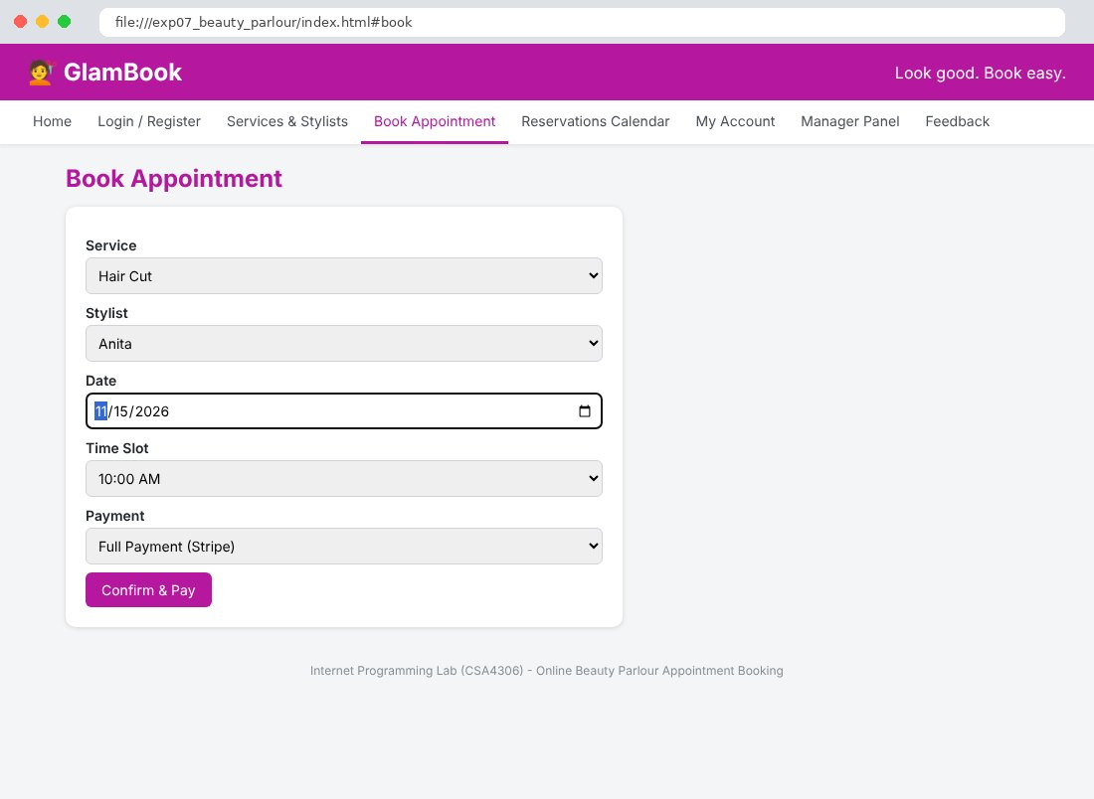
Fig. 7.5 Reservations Calendar Page
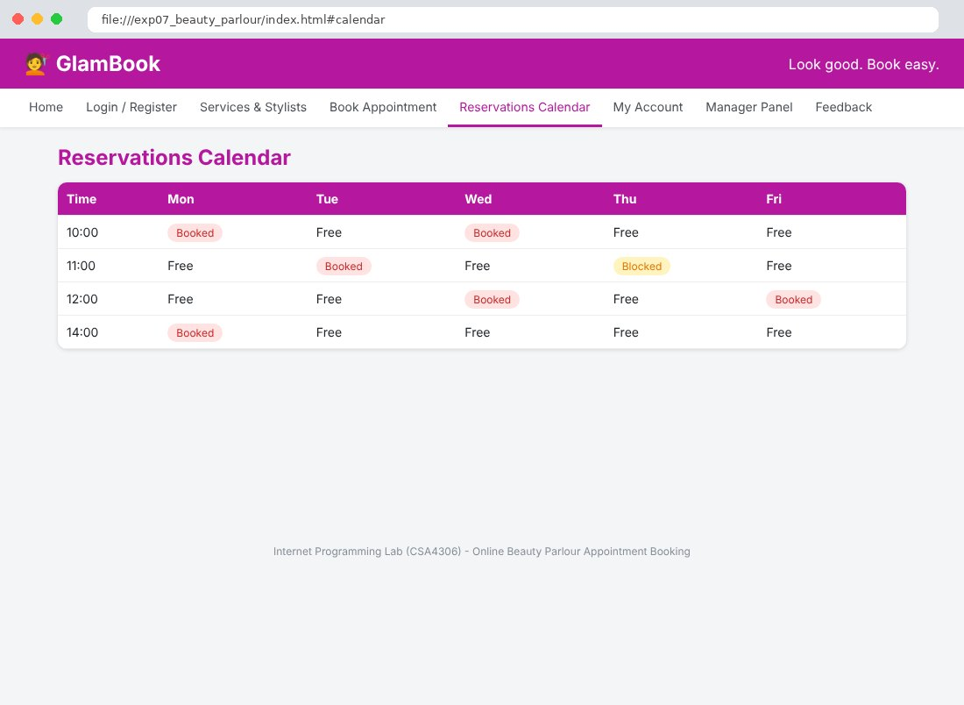
Fig. 7.6 My Account Page
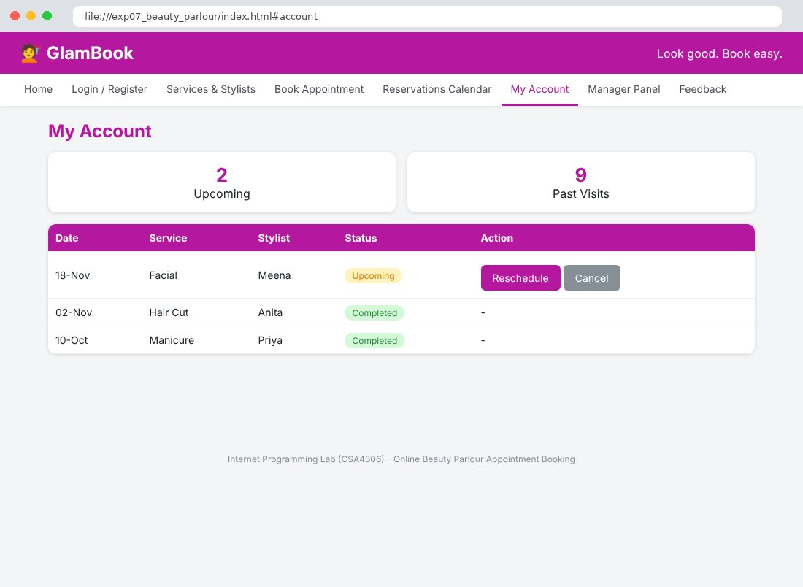
Fig. 7.7 Manager Panel Page
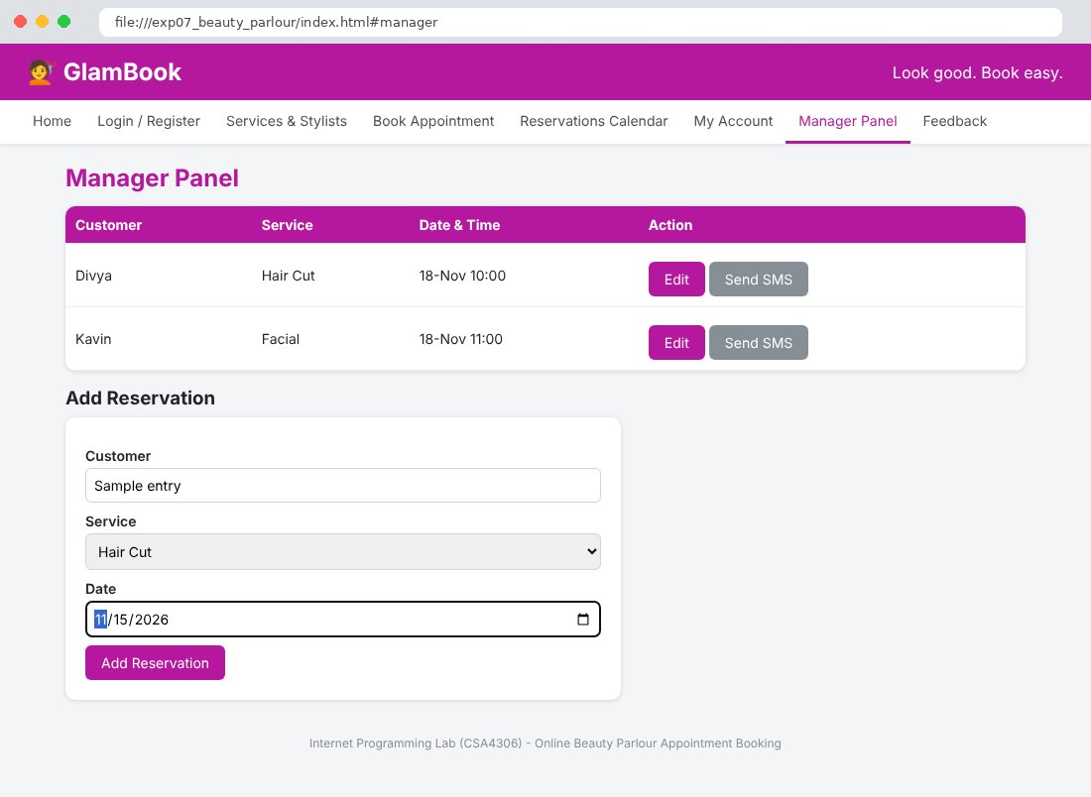
Fig. 7.8 Feedback Page
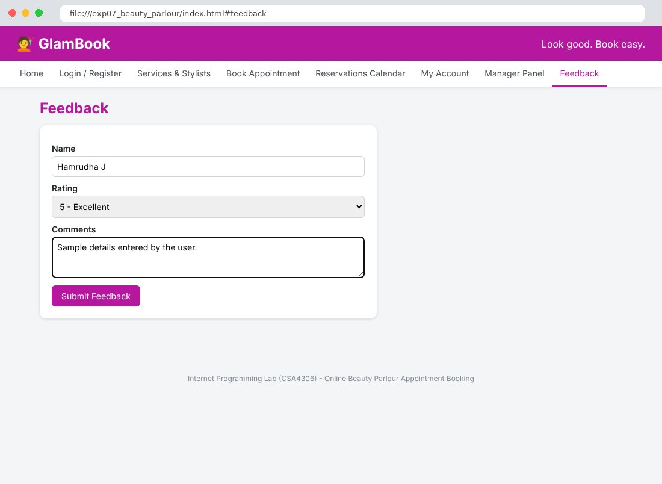

Result
Thus the Online Beauty Parlour Appointment Booking website was designed and developed using HTML, CSS and JavaScript, and the output was verified successfully.

