LAB EXPERIMENT 8
Online Hospital Appointment Booking

SUBJECT CODE | CSA4306
SUBJECT NAME | INTERNET PROGRAMMING
NAME | HAMRUDHA J
REG NO | 192411266
EXPERIMENTS | 6 to 20

Experiment 8: Online Hospital Appointment Booking

Question
In an effort to streamline the appointment process and enhance patient experience, MedCare Hospital has developed an online appointment booking system. This platform allows patients to book appointments with doctors from various specialties at their convenience. Key functionalities include user registration and login, browsing available doctors and appointment slots, booking and canceling appointments, and receiving appointment reminders via email or SMS. Patients can also view their appointment history and update their personal details. The system ensures data security and compliance with healthcare regulations to protect patient information. This online service aims to reduce wait times, minimize paperwork, and provide a seamless experience for patients and healthcare providers alike. This website helps the patient to search any hospital and book appointments as they prefer.
- Search Module
- Appointment Booking
- Check-in form Submitting
- Appointment management
- Schedule a timing
- Past appointment Management
Admin Features
- Manage appointments
- Manage doctors
- View Appointments statistics
- Rating Details
Patient Features
- Signup/Login.
- Can choose and book an appointment at the flexible time and date.
- Can search for doctor according to specialty and location.
- Can write reviews about the doctor and can select doctors according to other user feedback.
- Can access all previous check-in details and medical past appointment
User
- User Registration
- User Login
- Search Location wise
- View Hosptial list
- Book Appointment
- View status
- View google map for single hospital
Hospital
- Hospital Registration
- Hosptial login
- Create hostpital details
- Update details
- Update location

Aim
To develop an online hospital appointment booking website where patients search doctors by specialty and location, book and manage appointments, view status and reviews, and hospitals and admins manage doctors and appointments.

Software / Tools Required
HTML5, CSS3 and JavaScript; any text editor (VS Code / Notepad++); a web browser (Google Chrome).

Algorithm
1. Start.
2. Create a folder for the project and a file index.html.
3. Design the common header (MedCare Hospital) and the navigation bar using HTML.
4. Create one section (page) for each module: Home, Signup / Login, Search Doctors, Book Appointment, Appointment Status, Hospitals & Map, Hospital / Admin, Reviews.
5. Design forms with labels, text fields, drop-down lists and buttons for user input.
6. Apply CSS for the layout, colours, cards, tables and responsive grid.
7. Write JavaScript functions to switch between pages, validate and submit forms, search and filter items.
8. Open index.html in the browser, test every page and verify the output.
9. Stop.

Program (index.html)
<!DOCTYPE html>
<html lang="en">
<head>
<meta charset="UTF-8">
<meta name="viewport" content="width=device-width, initial-scale=1">
<title>MedCare Hospital - Online Hospital Appointment Booking</title>
<style>
:root{--c:#0b7285}
*{box-sizing:border-box;margin:0;font-family:'Segoe UI',Arial,sans-serif}
body{background:#f4f5f7;color:#212529}
header{background:var(--c);color:#fff;padding:14px 28px;display:flex;justify-content:space-between;align-items:center}
header h1{font-size:24px}
nav{background:#fff;padding:0 20px;display:flex;flex-wrap:wrap;box-shadow:0 2px 4px #0001}
nav a{padding:12px 13px;cursor:pointer;font-size:14px;color:#495057;border-bottom:3px solid transparent}
nav a.on,nav a:hover{color:var(--c);border-color:var(--c)}
main{max-width:1000px;margin:20px auto;padding:0 16px;min-height:420px}
.page{display:none}.page.active{display:block}
h2{margin-bottom:14px;color:var(--c)}
h3{margin:14px 0 8px}
.hero{background:linear-gradient(120deg,var(--c),#212529);color:#fff;border-radius:12px;padding:38px;margin-bottom:20px}
.hero h2{color:#fff;font-size:30px}
.grid{display:grid;grid-template-columns:repeat(auto-fill,minmax(200px,1fr));gap:16px;margin-bottom:16px}
.card{background:#fff;border-radius:10px;padding:16px;box-shadow:0 1px 5px #0002}
.card .ic{font-size:44px}
.card p{font-size:13px;color:#555;margin:4px 0}
.price{color:var(--c);font-weight:700}
.btn{background:var(--c);color:#fff;border:0;padding:9px 16px;border-radius:6px;cursor:pointer;margin-top:8px;font-size:14px}
.btn.alt{background:#868e96}
form,.box{background:#fff;padding:20px;border-radius:10px;box-shadow:0 1px 5px #0002;max-width:560px;margin-bottom:16px}
label{display:block;margin:10px 0 4px;font-size:14px;font-weight:600}
input,select,textarea{width:100%;padding:8px;border:1px solid #ced4da;border-radius:6px;font-size:14px}
table{width:100%;border-collapse:collapse;background:#fff;border-radius:10px;overflow:hidden;box-shadow:0 1px 5px #0002;margin-bottom:16px}
th{background:var(--c);color:#fff;text-align:left}
th,td{padding:10px;border-bottom:1px solid #eee;font-size:14px}
.stats{display:flex;gap:16px;margin-bottom:16px}
.stat{flex:1;background:#fff;border-radius:10px;padding:16px;text-align:center;box-shadow:0 1px 5px #0002}
.stat b{display:block;font-size:26px;color:var(--c)}
.tag{background:#e9ecef;border-radius:12px;padding:3px 10px;font-size:12px}
.ok{background:#d3f9d8;color:#2b8a3e}.wait{background:#fff3bf;color:#e67700}.bad{background:#ffe3e3;color:#c92a2a}
.map{height:240px;border-radius:10px;background:repeating-linear-gradient(45deg,#dff3e3,#dff3e3 20px,#cfe8d5 20px,#cfe8d5 40px);position:relative;margin-bottom:12px;cursor:crosshair;overflow:hidden}
.pin{position:absolute;font-size:26px;transform:translate(-50%,-100%)}
.bar{height:22px;background:var(--c);border-radius:4px;color:#fff;font-size:12px;padding:2px 8px}
.qr{display:grid;grid-template-columns:repeat(15,12px);gap:0;width:180px;border:8px solid #fff;box-shadow:0 1px 5px #0002}
.qr i{width:12px;height:12px;background:#fff}.qr i.k{background:#000}
#toast{position:fixed;bottom:24px;right:24px;background:#212529;color:#fff;padding:12px 20px;border-radius:8px;display:none}
footer{text-align:center;padding:16px;font-size:12px;color:#868e96}
</style>
</head>
<body>
<header><h1>🏥 MedCare Hospital</h1><span>Care that comes first</span></header>
<nav>
<a data-p="home" onclick="show('home')">Home</a>
<a data-p="login" onclick="show('login')">Signup / Login</a>
<a data-p="search" onclick="show('search')">Search Doctors</a>
<a data-p="book" onclick="show('book')">Book Appointment</a>
<a data-p="status" onclick="show('status')">Appointment Status</a>
<a data-p="hospitals" onclick="show('hospitals')">Hospitals & Map</a>
<a data-p="hospadmin" onclick="show('hospadmin')">Hospital / Admin</a>
<a data-p="reviews" onclick="show('reviews')">Reviews</a>
</nav>
<main>
<section class="page" id="home">
<div class="hero"><h2>Book a Doctor Appointment</h2><p>Search by specialty or location and choose a time that suits you.</p><button class="btn" style="background:#fff;color:#212529" onclick="show('search')">Find a Doctor</button></div><div class="stats"><div class="stat"><b>120</b>Doctors</div><div class="stat"><b>25</b>Specialties</div><div class="stat"><b>4.7</b>Avg Rating</div></div>
</section>
<section class="page" id="login">
<h2>Signup / Login</h2>
<form data-msg="Login successful" data-go="search">
<label>Role</label><select><option>Patient</option><option>Hospital</option><option>Admin</option></select>
<label>Name</label><input type="text" placeholder="Enter name" required>
<label>Email</label><input type="email" placeholder="Enter email" required>
<label>Password</label><input type="password" placeholder="Enter password" required>
<button class="btn">Continue</button>
</form>
</section>
<section class="page" id="search">
<h2>Search Doctors</h2>
<input placeholder="Search specialty or doctor..." onkeyup="filt(this,'#cards .card')" style="max-width:320px;margin-bottom:10px;display:inline-block">
<select onchange="catf(this.value,'#cards .card')" style="max-width:200px;margin-left:8px;display:inline-block"><option>All</option><option>Chennai</option><option>Madurai</option><option>Coimbatore</option></select>
<div class="grid" id="cards">
<div class="card" data-c="Chennai"><div class="ic">👨‍⚕️</div><b>Dr. Arun</b><p>Cardiologist · Chennai</p><div class="price">⭐ 4.8</div><button class="btn" onclick="show('book')">Book</button></div>
<div class="card" data-c="Madurai"><div class="ic">👩‍⚕️</div><b>Dr. Lakshmi</b><p>Dermatologist · Madurai</p><div class="price">⭐ 4.6</div><button class="btn" onclick="show('book')">Book</button></div>
<div class="card" data-c="Chennai"><div class="ic">👨‍⚕️</div><b>Dr. Imran</b><p>Orthopedic · Chennai</p><div class="price">⭐ 4.5</div><button class="btn" onclick="show('book')">Book</button></div>
<div class="card" data-c="Coimbatore"><div class="ic">👩‍⚕️</div><b>Dr. Sneha</b><p>Pediatrician · Coimbatore</p><div class="price">⭐ 4.9</div><button class="btn" onclick="show('book')">Book</button></div>
</div>
</section>
<section class="page" id="book">
<h2>Book Appointment</h2>
<form data-msg="Appointment booked. Reminder will be sent" data-go="status">
<label>Doctor</label><select><option>Dr. Arun</option><option>Dr. Lakshmi</option><option>Dr. Imran</option><option>Dr. Sneha</option></select>
<label>Date</label><input type="date" placeholder="Enter date" required>
<label>Time</label><select><option>09:00 AM</option><option>10:30 AM</option><option>12:00 PM</option><option>04:00 PM</option></select>
<label>Reason for visit</label><textarea rows="3" required></textarea>
<button class="btn">Book Appointment</button>
</form>
</section>
<section class="page" id="status">
<h2>Appointment Status</h2>
<table>
<tr><th>Doctor</th><th>Date</th><th>Time</th><th>Status</th><th>Action</th></tr>
<tr><td>Dr. Arun</td><td>20-Nov</td><td>10:30 AM</td><td><span class="tag ok">Confirmed</span></td><td><button class="btn alt">Cancel</button></td></tr>
<tr><td>Dr. Sneha</td><td>25-Nov</td><td>09:00 AM</td><td><span class="tag wait">Pending</span></td><td><button class="btn alt">Cancel</button></td></tr>
<tr><td>Dr. Imran</td><td>05-Oct</td><td>04:00 PM</td><td><span class="tag ok">Completed</span></td><td>-</td></tr>
</table>
</section>
<section class="page" id="hospitals">
<h2>Hospitals & Map</h2>
<table>
<tr><th>Hospital</th><th>Location</th><th>Beds</th></tr>
<tr><td>MedCare Central</td><td>Chennai</td><td>250</td></tr>
<tr><td>MedCare Annex</td><td>Madurai</td><td>120</td></tr>
</table><div class="map" style="pointer-events:none"><span class="pin" style="left:40%;top:60%">📍</span><span class="pin" style="left:70%;top:40%">📍</span></div><p>Map view of hospital location (Google Map can be embedded using an iframe).</p>
</section>
<section class="page" id="hospadmin">
<h2>Hospital / Admin</h2>
<div class="stats"><div class="stat"><b>48</b>Appointments Today</div><div class="stat"><b>120</b>Doctors</div><div class="stat"><b>4.7</b>Rating</div></div><table>
<tr><th>Doctor</th><th>Specialty</th><th>Action</th></tr>
<tr><td>Dr. Arun</td><td>Cardiology</td><td><button class="btn">Update</button></td></tr>
<tr><td>Dr. Lakshmi</td><td>Dermatology</td><td><button class="btn">Update</button></td></tr>
</table><h3>Create / Update Hospital Details</h3>
<form data-msg="Hospital details updated">
<label>Hospital Name</label><input type="text" placeholder="Enter hospital name" required>
<label>Location</label><input type="text" placeholder="Enter location" required>
<label>Latitude</label><input type="text" placeholder="Enter latitude" required>
<label>Longitude</label><input type="text" placeholder="Enter longitude" required>
<button class="btn">Update Hospital Details</button>
</form>
</section>
<section class="page" id="reviews">
<h2>Reviews</h2>
<form data-msg="Review posted">
<label>Doctor</label><select><option>Dr. Arun</option><option>Dr. Lakshmi</option><option>Dr. Imran</option><option>Dr. Sneha</option></select>
<label>Rating</label><select><option>5</option><option>4</option><option>3</option><option>2</option><option>1</option></select>
<label>Review</label><textarea rows="3" required></textarea>
<button class="btn">Post Review</button>
</form>
</section>
</main>
<footer>Internet Programming Lab (CSA4306) - Online Hospital Appointment Booking</footer>
<div id="toast"></div>
<script>
function show(id){document.querySelectorAll('.page').forEach(p=>p.classList.toggle('active',p.id===id));
document.querySelectorAll('nav a').forEach(a=>a.classList.toggle('on',a.dataset.p===id));window.scrollTo(0,0)}
function toast(m){const t=document.getElementById('toast');t.textContent=m;t.style.display='block';setTimeout(()=>t.style.display='none',2200)}
document.addEventListener('submit',e=>{e.preventDefault();toast(e.target.dataset.msg||'Saved successfully');if(e.target.dataset.go)show(e.target.dataset.go)});
function filt(inp,sel){const v=inp.value.toLowerCase();document.querySelectorAll(sel).forEach(r=>r.style.display=r.textContent.toLowerCase().includes(v)?'':'none')}
function catf(v,sel){document.querySelectorAll(sel).forEach(r=>r.style.display=(v=='All'||r.dataset.c==v)?'':'none')}
show('home');
</script>
</body>
</html>

Output
Fig. 8.1 Home Page
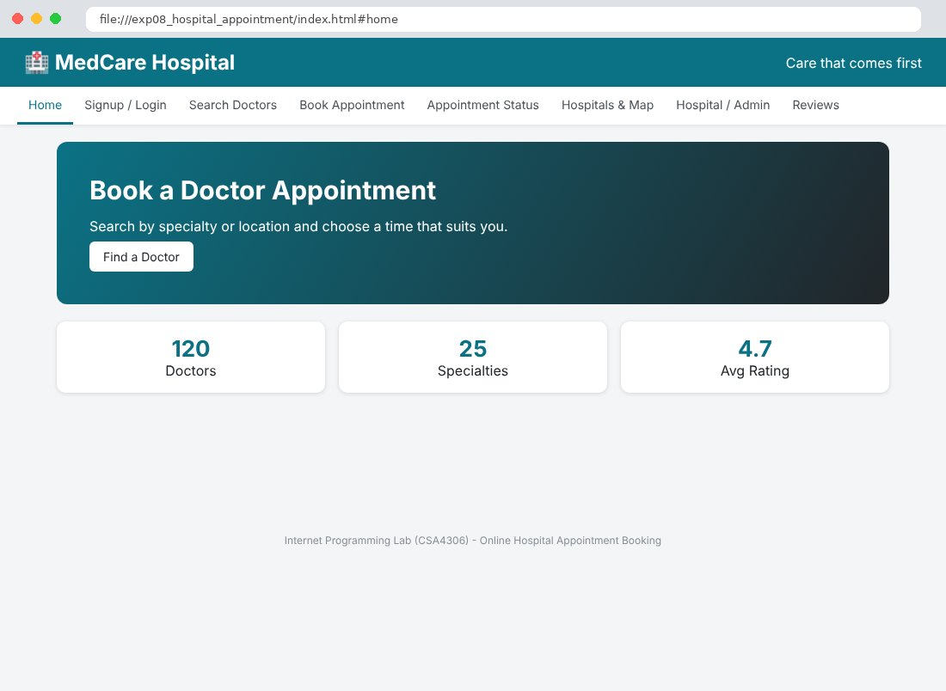
Fig. 8.2 Signup / Login Page
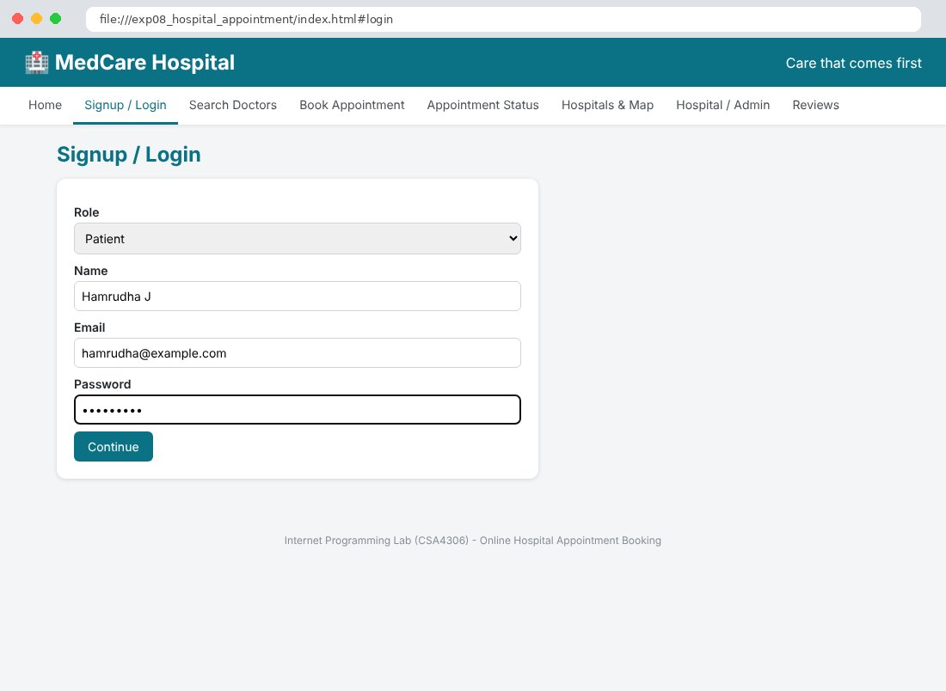
Fig. 8.3 Search Doctors Page
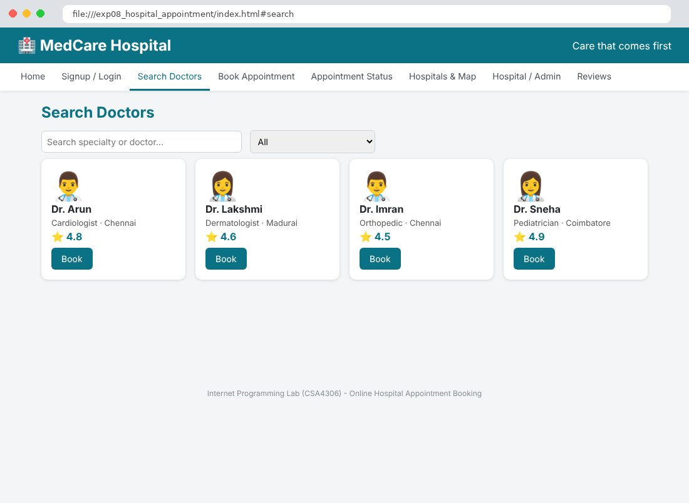
Fig. 8.4 Book Appointment Page
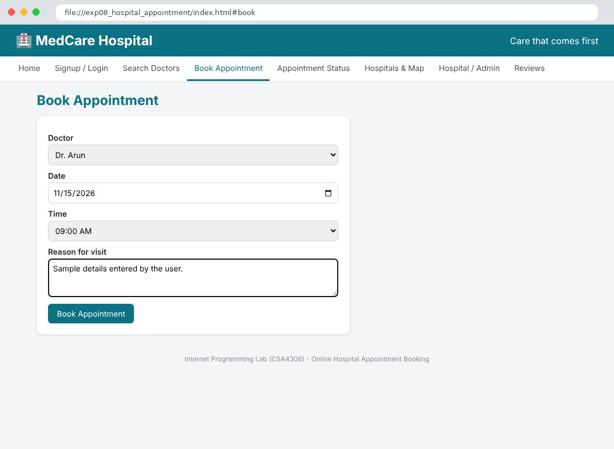
Fig. 8.5 Appointment Status Page
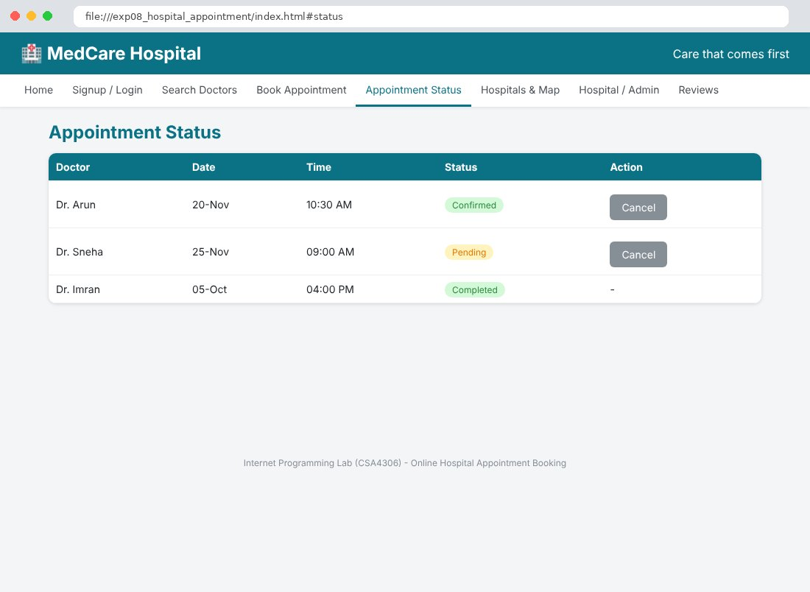
Fig. 8.6 Hospitals & Map Page
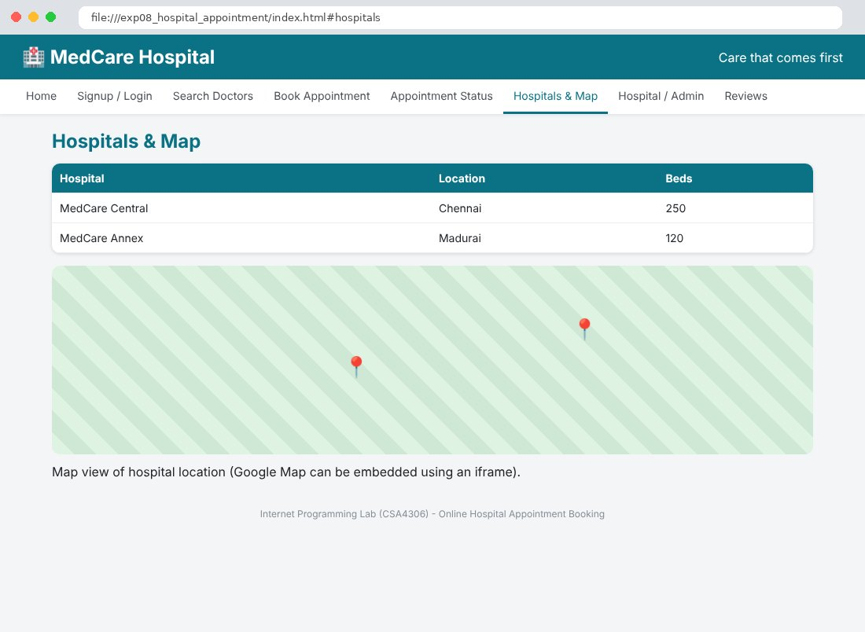
Fig. 8.7 Hospital / Admin Page
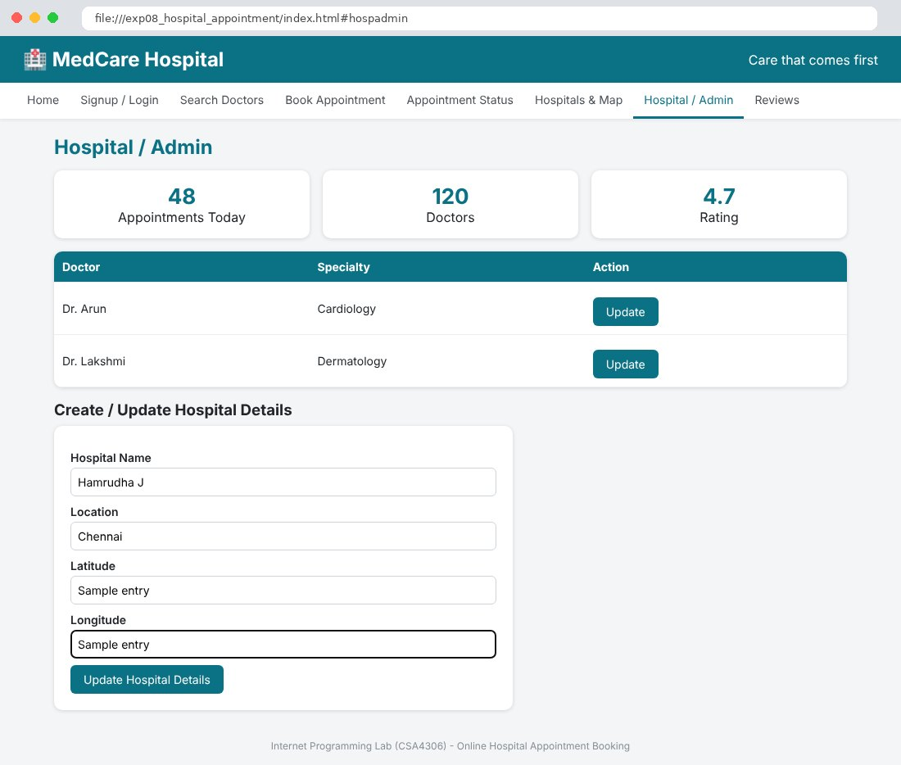
Fig. 8.8 Reviews Page
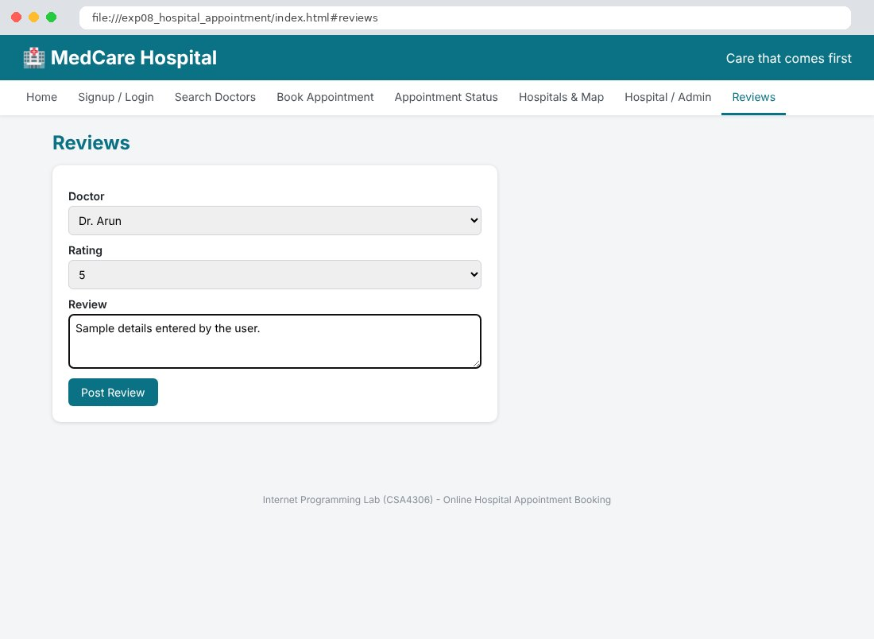

Result
Thus the Online Hospital Appointment Booking website was designed and developed using HTML, CSS and JavaScript, and the output was verified successfully.

