LAB EXPERIMENT 9
TechSavvy Online Gadget Store

SUBJECT CODE | CSA4306
SUBJECT NAME | INTERNET PROGRAMMING
NAME | HAMRUDHA J
REG NO | 192411266
EXPERIMENTS | 6 to 20

Experiment 9: TechSavvy Online Gadget Store

Question
TechSavvy, a leading retailer of electronic gadgets, has launched an online shopping platform to provide customers with a seamless and convenient shopping experience. The website features a wide range of products, including smartphones, laptops, tablets, and accessories, all categorized for easy browsing. Key functionalities include user registration and login, product search and filtering, detailed product descriptions and reviews, secure payment options, and order tracking. Customers can add items to their cart, create wish lists, and receive personalized recommendations based on their browsing and purchase history. The platform also offers exclusive online discounts and promotions, ensuring customers get the best deals on the latest gadgets.The core of an online shop is the product catalogue and the cart. The users browse products which are grouped in categories and add the desired ones to the cart. Next, there is transaction handling, which in its simplest form consists in the order being sent via e-mail to the seller, but most often it takes the whole buying process through separate order statuses.
- Products should be logically categorized, with the most popular categories listed first.Display all the available categories for shopping on the home page.
- Display all the subcategories on the home page, that are associated with any particular item.
- Admin has the authority to add new particulars to the items list whenever needed.
- Permission to the administrator to remove items, anytime.
- Allows the admin to modify the price of each item, whenever required or felt like.
- Admin has the authority to update the description of each item.
- Permission to the admin to view information about each customer who checkouts the items list.
Use Cases
- Visit a site
- Login
- Search for Items
- Check Availability of Items
- Add Items to Shopping Cart
- Edit Items in the Shopping Cart
- remove Items from the Shopping Cart
- Check out the Shopping Cart
- Check Order Status
- Browse Order History
- Display Item Details
- Logout
- Leave a site

Aim
To develop an e-commerce website for electronic gadgets with logically categorised products, search and filter, shopping cart, checkout, order status and history, and an admin panel for managing items, prices and customer information.

Software / Tools Required
HTML5, CSS3 and JavaScript; any text editor (VS Code / Notepad++); a web browser (Google Chrome).

Algorithm
1. Start.
2. Create a folder for the project and a file index.html.
3. Design the common header (TechSavvy) and the navigation bar using HTML.
4. Create one section (page) for each module: Home, Login / Register, Products, Item Details, Shopping Cart, Checkout, Order Status & History, Admin.
5. Design forms with labels, text fields, drop-down lists and buttons for user input.
6. Apply CSS for the layout, colours, cards, tables and responsive grid.
7. Write JavaScript functions to switch between pages, validate and submit forms, search and filter items, and manage the shopping cart.
8. Open index.html in the browser, test every page and verify the output.
9. Stop.

Program (index.html)
<!DOCTYPE html>
<html lang="en">
<head>
<meta charset="UTF-8">
<meta name="viewport" content="width=device-width, initial-scale=1">
<title>TechSavvy - TechSavvy Online Gadget Store</title>
<style>
:root{--c:#364fc7}
*{box-sizing:border-box;margin:0;font-family:'Segoe UI',Arial,sans-serif}
body{background:#f4f5f7;color:#212529}
header{background:var(--c);color:#fff;padding:14px 28px;display:flex;justify-content:space-between;align-items:center}
header h1{font-size:24px}
nav{background:#fff;padding:0 20px;display:flex;flex-wrap:wrap;box-shadow:0 2px 4px #0001}
nav a{padding:12px 13px;cursor:pointer;font-size:14px;color:#495057;border-bottom:3px solid transparent}
nav a.on,nav a:hover{color:var(--c);border-color:var(--c)}
main{max-width:1000px;margin:20px auto;padding:0 16px;min-height:420px}
.page{display:none}.page.active{display:block}
h2{margin-bottom:14px;color:var(--c)}
h3{margin:14px 0 8px}
.hero{background:linear-gradient(120deg,var(--c),#212529);color:#fff;border-radius:12px;padding:38px;margin-bottom:20px}
.hero h2{color:#fff;font-size:30px}
.grid{display:grid;grid-template-columns:repeat(auto-fill,minmax(200px,1fr));gap:16px;margin-bottom:16px}
.card{background:#fff;border-radius:10px;padding:16px;box-shadow:0 1px 5px #0002}
.card .ic{font-size:44px}
.card p{font-size:13px;color:#555;margin:4px 0}
.price{color:var(--c);font-weight:700}
.btn{background:var(--c);color:#fff;border:0;padding:9px 16px;border-radius:6px;cursor:pointer;margin-top:8px;font-size:14px}
.btn.alt{background:#868e96}
form,.box{background:#fff;padding:20px;border-radius:10px;box-shadow:0 1px 5px #0002;max-width:560px;margin-bottom:16px}
label{display:block;margin:10px 0 4px;font-size:14px;font-weight:600}
input,select,textarea{width:100%;padding:8px;border:1px solid #ced4da;border-radius:6px;font-size:14px}
table{width:100%;border-collapse:collapse;background:#fff;border-radius:10px;overflow:hidden;box-shadow:0 1px 5px #0002;margin-bottom:16px}
th{background:var(--c);color:#fff;text-align:left}
th,td{padding:10px;border-bottom:1px solid #eee;font-size:14px}
.stats{display:flex;gap:16px;margin-bottom:16px}
.stat{flex:1;background:#fff;border-radius:10px;padding:16px;text-align:center;box-shadow:0 1px 5px #0002}
.stat b{display:block;font-size:26px;color:var(--c)}
.tag{background:#e9ecef;border-radius:12px;padding:3px 10px;font-size:12px}
.ok{background:#d3f9d8;color:#2b8a3e}.wait{background:#fff3bf;color:#e67700}.bad{background:#ffe3e3;color:#c92a2a}
.map{height:240px;border-radius:10px;background:repeating-linear-gradient(45deg,#dff3e3,#dff3e3 20px,#cfe8d5 20px,#cfe8d5 40px);position:relative;margin-bottom:12px;cursor:crosshair;overflow:hidden}
.pin{position:absolute;font-size:26px;transform:translate(-50%,-100%)}
.bar{height:22px;background:var(--c);border-radius:4px;color:#fff;font-size:12px;padding:2px 8px}
.qr{display:grid;grid-template-columns:repeat(15,12px);gap:0;width:180px;border:8px solid #fff;box-shadow:0 1px 5px #0002}
.qr i{width:12px;height:12px;background:#fff}.qr i.k{background:#000}
#toast{position:fixed;bottom:24px;right:24px;background:#212529;color:#fff;padding:12px 20px;border-radius:8px;display:none}
footer{text-align:center;padding:16px;font-size:12px;color:#868e96}
</style>
</head>
<body>
<header><h1>💻 TechSavvy</h1><span>Latest gadgets, best deals</span></header>
<nav>
<a data-p="home" onclick="show('home')">Home</a>
<a data-p="login" onclick="show('login')">Login / Register</a>
<a data-p="products" onclick="show('products')">Products</a>
<a data-p="details" onclick="show('details')">Item Details</a>
<a data-p="cart" onclick="show('cart')">Shopping Cart</a>
<a data-p="checkout" onclick="show('checkout')">Checkout</a>
<a data-p="orders" onclick="show('orders')">Order Status & History</a>
<a data-p="admin" onclick="show('admin')">Admin</a>
</nav>
<main>
<section class="page" id="home">
<div class="hero"><h2>Latest Gadgets. Best Prices.</h2><p>Smartphones, laptops, tablets and accessories with exclusive online discounts.</p><button class="btn" style="background:#fff;color:#212529" onclick="show('products')">Shop Now</button></div><div class="grid" id="cards">
<div class="card" data-c=""><div class="ic">📱</div><b>Smartphones</b><p>Android, iOS</p></div>
<div class="card" data-c=""><div class="ic">💻</div><b>Laptops</b><p>Gaming, Business</p></div>
<div class="card" data-c=""><div class="ic">📲</div><b>Tablets</b><p>Study, Work</p></div>
<div class="card" data-c=""><div class="ic">🎧</div><b>Accessories</b><p>Audio, Wearables</p></div>
</div><h3>Popular Subcategories</h3><p>Smartphones: 5G Phones, Budget Phones · Laptops: Gaming, Ultrabooks · Accessories: Earbuds, Chargers, Watches</p>
</section>
<section class="page" id="login">
<h2>Login / Register</h2>
<form data-msg="Welcome to TechSavvy" data-go="products">
<label>Name</label><input type="text" placeholder="Enter name" required>
<label>Email</label><input type="email" placeholder="Enter email" required>
<label>Password</label><input type="password" placeholder="Enter password" required>
<button class="btn">Login / Register</button>
</form>
</section>
<section class="page" id="products">
<h2>Products</h2>
<input placeholder="Search products..." onkeyup="filt(this,'#cards .card')" style="max-width:320px;margin-bottom:10px;display:inline-block">
<select onchange="catf(this.value,'#cards .card')" style="max-width:200px;margin-left:8px;display:inline-block"><option>All</option><option>Smartphones</option><option>Laptops</option><option>Tablets</option><option>Accessories</option></select>
<div class="grid" id="cards">
<div class="card" data-c="Smartphones"><div class="ic">📱</div><b>SmartPhone X</b><p>6.5" AMOLED, 128 GB</p><div class="price">Rs. 24999</div><button class="btn" onclick="add('SmartPhone X',24999)">Add to Cart</button></div>
<div class="card" data-c="Laptops"><div class="ic">💻</div><b>UltraBook 14</b><p>i5, 16 GB RAM, 512 GB SSD</p><div class="price">Rs. 58999</div><button class="btn" onclick="add('UltraBook 14',58999)">Add to Cart</button></div>
<div class="card" data-c="Tablets"><div class="ic">📲</div><b>Tab Pro 11</b><p>11" display, 8 GB RAM</p><div class="price">Rs. 27999</div><button class="btn" onclick="add('Tab Pro 11',27999)">Add to Cart</button></div>
<div class="card" data-c="Accessories"><div class="ic">🎧</div><b>Noise Buds</b><p>Wireless earbuds</p><div class="price">Rs. 1999</div><button class="btn" onclick="add('Noise Buds',1999)">Add to Cart</button></div>
<div class="card" data-c="Accessories"><div class="ic">⌚</div><b>Smart Watch</b><p>Heart-rate, GPS</p><div class="price">Rs. 3499</div><button class="btn" onclick="add('Smart Watch',3499)">Add to Cart</button></div>
<div class="card" data-c="Accessories"><div class="ic">🖱️</div><b>Gaming Mouse</b><p>RGB, 12000 DPI</p><div class="price">Rs. 999</div><button class="btn" onclick="add('Gaming Mouse',999)">Add to Cart</button></div>
</div>
</section>
<section class="page" id="details">
<h2>Item Details</h2>
<div class="stats"><div class="stat"><b>Rs. 24999</b>Price</div><div class="stat"><b>In Stock</b>Availability</div><div class="stat"><b>4.5/5</b>Rating</div></div><div class="box"><h3>📱 SmartPhone X</h3><p>6.5" AMOLED display, 8 GB RAM, 128 GB storage, 50 MP camera, 5000 mAh battery.</p><p><b>Reviews:</b> "Great display and battery" - Arun (5/5); "Value for money" - Priya (4/5)</p><button class="btn" onclick="add('SmartPhone X',24999)">Add to Cart</button> <button class="btn alt">Add to Wishlist</button></div>
</section>
<section class="page" id="cart">
<h2>Shopping Cart</h2>
<table><tr><th>Item</th><th>Price</th><th>Action</th></tr><tbody id="cartBody"></tbody></table>
<div class="box"><b>Total: <span id="total">Rs. 0</span></b><br>
<button class="btn" onclick="show('checkout')">Proceed to Checkout</button></div>
</section>
<section class="page" id="checkout">
<h2>Checkout</h2>
<form data-msg="Order placed successfully" data-go="orders">
<label>Full Name</label><input type="text" placeholder="Enter full name" required>
<label>Shipping Address</label><textarea rows="3" required></textarea>
<label>Phone</label><input type="tel" placeholder="Enter phone" required>
<label>Payment</label><select><option>UPI</option><option>Card</option><option>Net Banking</option><option>Cash on Delivery</option></select>
<button class="btn">Place Order</button>
</form>
</section>
<section class="page" id="orders">
<h2>Order Status & History</h2>
<table>
<tr><th>Order</th><th>Item</th><th>Date</th><th>Status</th></tr>
<tr><td>#T501</td><td>SmartPhone X</td><td>10-Nov</td><td><span class="tag wait">Shipped</span></td></tr>
<tr><td>#T488</td><td>Noise Buds</td><td>28-Oct</td><td><span class="tag ok">Delivered</span></td></tr>
<tr><td>#T455</td><td>Gaming Mouse</td><td>02-Oct</td><td><span class="tag ok">Delivered</span></td></tr>
</table>
</section>
<section class="page" id="admin">
<h2>Admin</h2>
<div class="stats"><div class="stat"><b>240</b>Products</div><div class="stat"><b>36</b>Orders</div><div class="stat"><b>Rs. 3.2 L</b>Sales</div></div><table>
<tr><th>Product</th><th>Price</th><th>Action</th></tr>
<tr><td>SmartPhone X</td><td>Rs. 24999</td><td><button class="btn">Update Price</button> <button class="btn alt">Remove</button></td></tr>
<tr><td>UltraBook 14</td><td>Rs. 58999</td><td><button class="btn">Update Price</button> <button class="btn alt">Remove</button></td></tr>
</table><h3>Add / Update Item</h3>
<form data-msg="Product added">
<label>Product Name</label><input type="text" placeholder="Enter product name" required>
<label>Category</label><select><option>Smartphones</option><option>Laptops</option><option>Tablets</option><option>Accessories</option></select>
<label>Price</label><input type="number" placeholder="Enter price" required>
<label>Description</label><textarea rows="3" required></textarea>
<button class="btn">Add Product</button>
</form><table>
<tr><th>Customer</th><th>Items</th><th>Total</th></tr>
<tr><td>Hamrudha</td><td>SmartPhone X</td><td>Rs. 24999</td></tr>
<tr><td>Karthik</td><td>Noise Buds</td><td>Rs. 1999</td></tr>
</table>
</section>
</main>
<footer>Internet Programming Lab (CSA4306) - TechSavvy Online Gadget Store</footer>
<div id="toast"></div>
<script>
function show(id){document.querySelectorAll('.page').forEach(p=>p.classList.toggle('active',p.id===id));
document.querySelectorAll('nav a').forEach(a=>a.classList.toggle('on',a.dataset.p===id));window.scrollTo(0,0)}
function toast(m){const t=document.getElementById('toast');t.textContent=m;t.style.display='block';setTimeout(()=>t.style.display='none',2200)}
document.addEventListener('submit',e=>{e.preventDefault();toast(e.target.dataset.msg||'Saved successfully');if(e.target.dataset.go)show(e.target.dataset.go)});
function filt(inp,sel){const v=inp.value.toLowerCase();document.querySelectorAll(sel).forEach(r=>r.style.display=r.textContent.toLowerCase().includes(v)?'':'none')}
function catf(v,sel){document.querySelectorAll(sel).forEach(r=>r.style.display=(v=='All'||r.dataset.c==v)?'':'none')}
let cart=[];
function add(n,p){cart.push({n,p});toast(n+' added to cart');draw()}
function del(i){cart.splice(i,1);draw()}
function draw(){const b=document.getElementById('cartBody');let t=0;
b.innerHTML=cart.length?cart.map((c,i)=>{t+=c.p;return `<tr><td>${c.n}</td><td>Rs. ${c.p}</td><td><button class="btn alt" onclick="del(${i})">Remove</button></td></tr>`}).join(''):'<tr><td colspan="3">Your cart is empty</td></tr>';
document.getElementById('total').textContent='Rs. '+t}
show('home');
</script>
</body>
</html>

Output
Fig. 9.1 Home Page
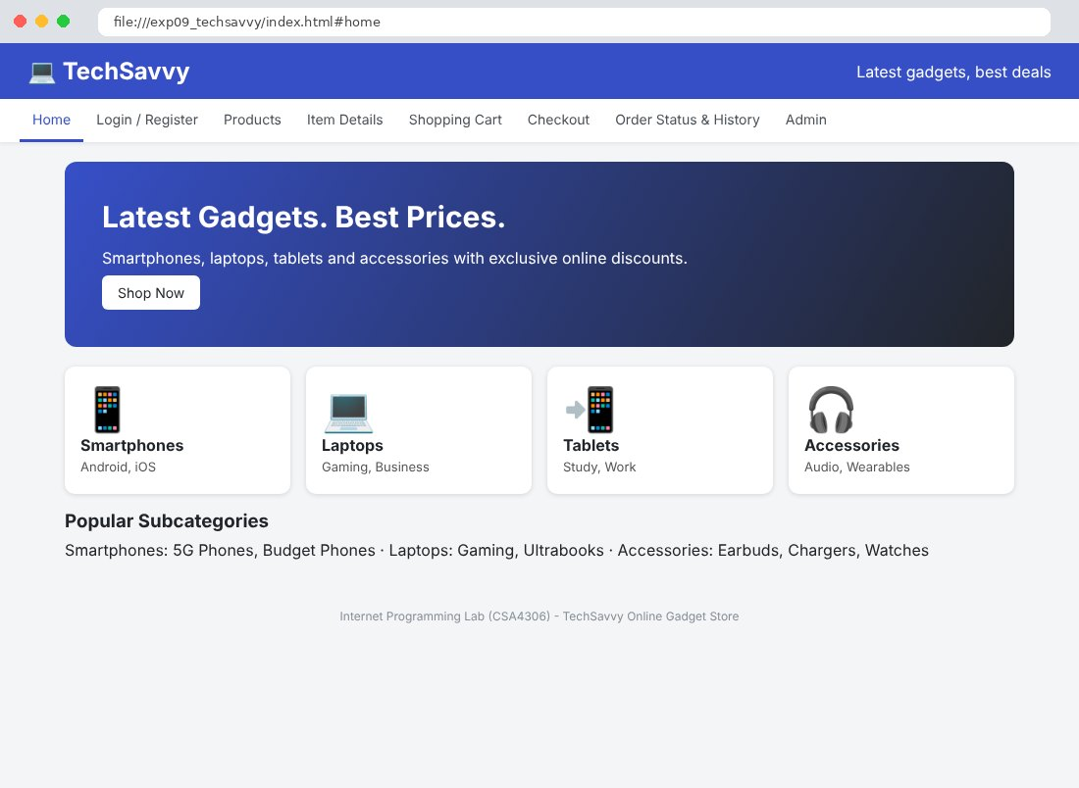
Fig. 9.2 Login / Register Page
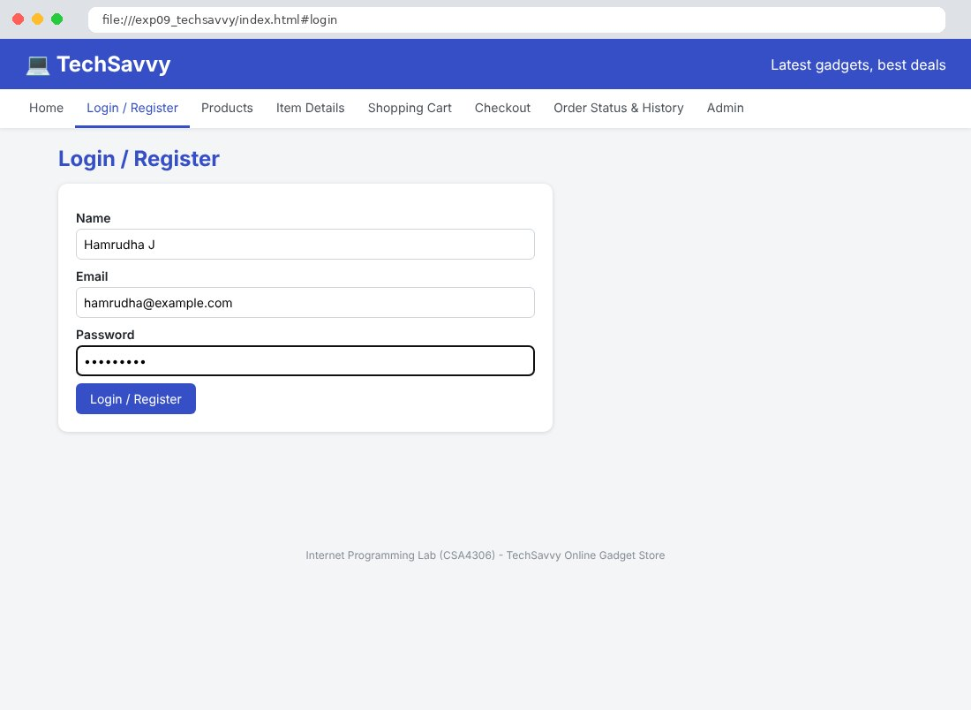
Fig. 9.3 Products Page
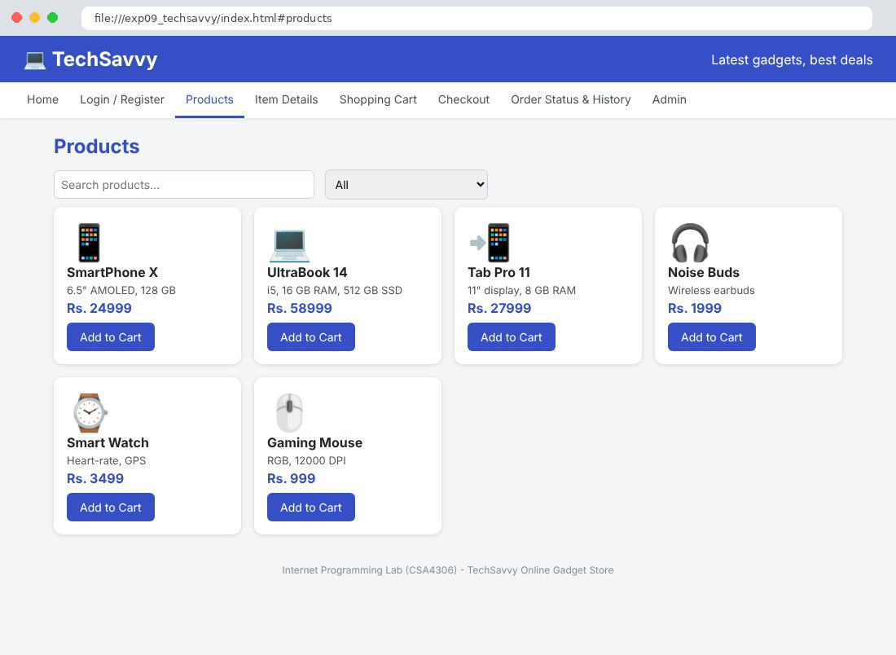
Fig. 9.4 Item Details Page
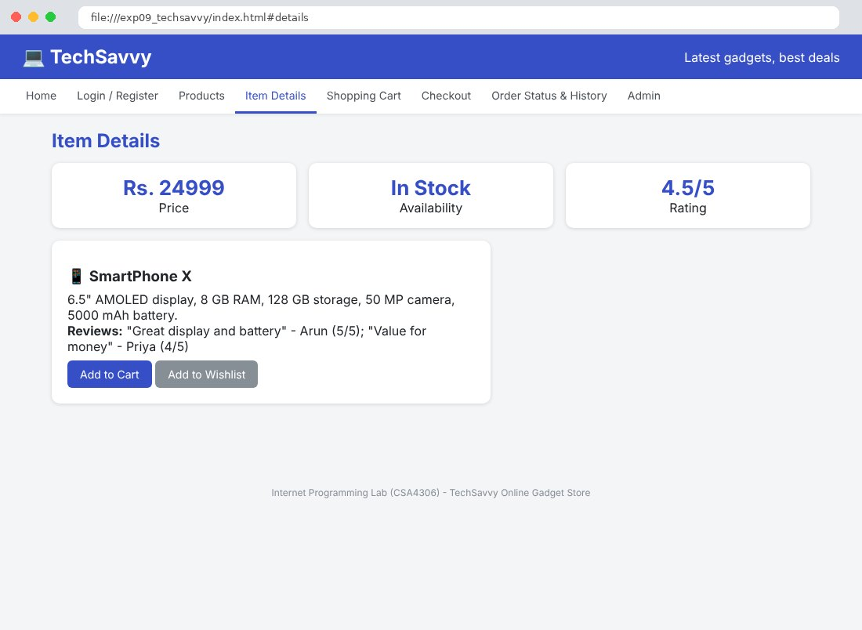
Fig. 9.5 Shopping Cart Page
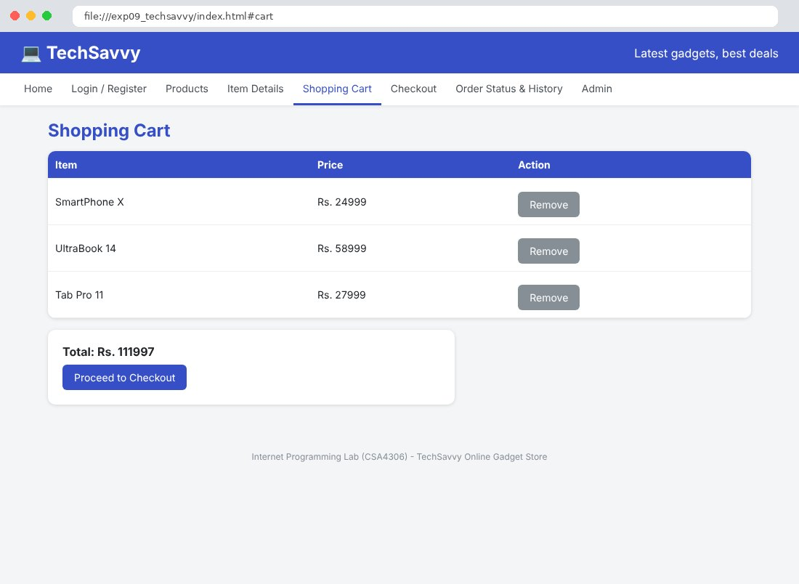
Fig. 9.6 Checkout Page
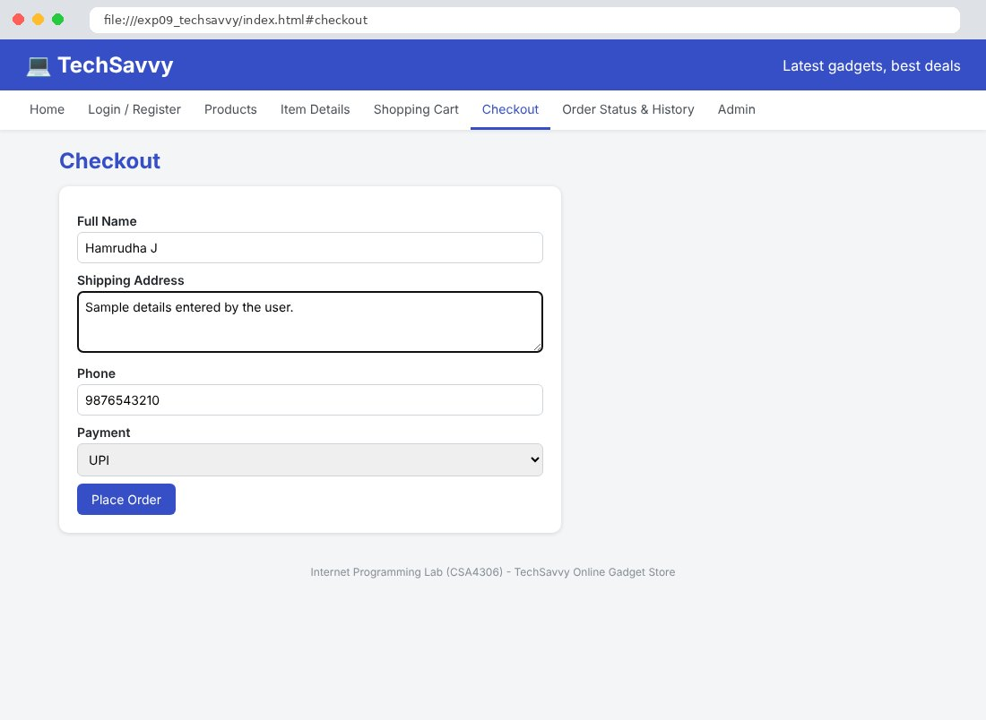
Fig. 9.7 Order Status & History Page
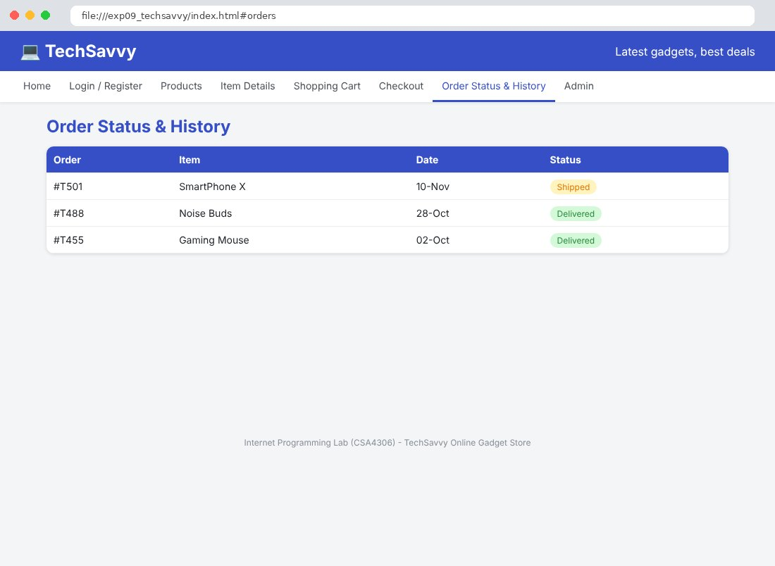
Fig. 9.8 Admin Page
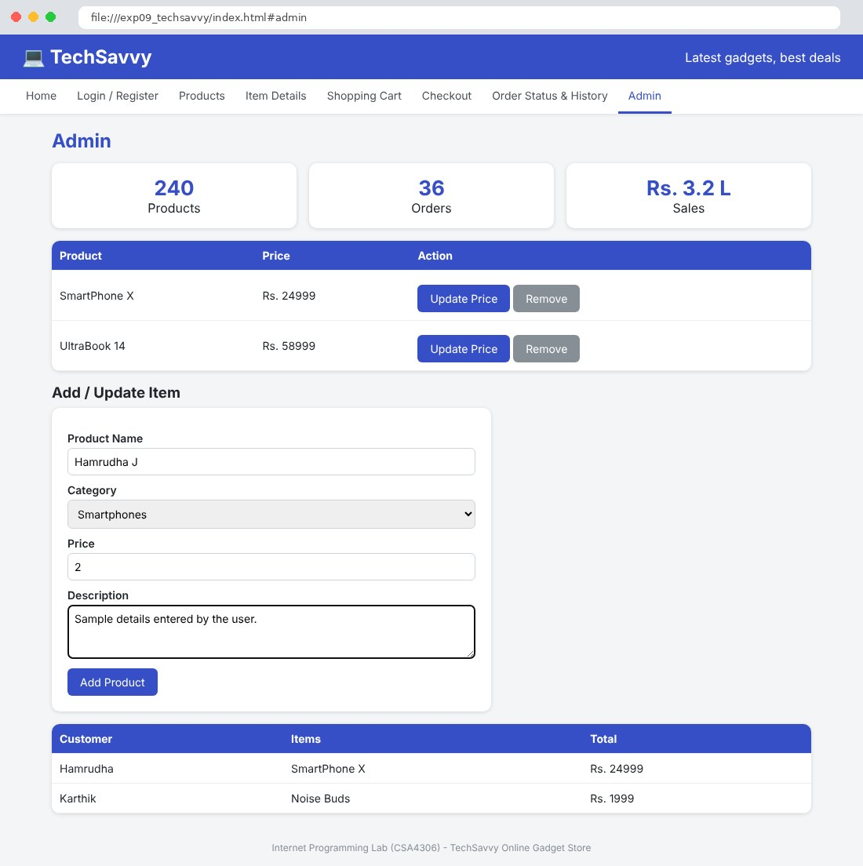

Result
Thus the TechSavvy Online Gadget Store website was designed and developed using HTML, CSS and JavaScript, and the output was verified successfully.

