LAB EXPERIMENT 10
StyleHub Online Fashion Store

SUBJECT CODE | CSA4306
SUBJECT NAME | INTERNET PROGRAMMING
NAME | HAMRUDHA J
REG NO | 192411266
EXPERIMENTS | 6 to 20

Experiment 10: StyleHub Online Fashion Store

Question
StyleHub, a premier online fashion retailer, introduces its comprehensive e-commerce platform designed to cater to fashion enthusiasts. The website offers an extensive collection of clothing, footwear, and accessories for men, women, and children, with categories such as casual wear, formal attire, and seasonal collections. Key functionalities include user registration and login, advanced search and filtering options, detailed product descriptions with high-resolution images, customer reviews, and size guides. The platform supports secure payment methods, order tracking, and an easy return and exchange policy. Customers can create wish lists, receive personalized style recommendations, and enjoy exclusive online discounts and flash sales. StyleHub aims to provide a seamless and enjoyable shopping experience, keeping users up-to-date with the latest fashion trends.The core of an online shop is the product catalogue and the cart. The users browse products which are grouped in categories and add the desired ones to the cart. Next, there is transaction handling, which in its simplest form consists in the order being sent via e-mail to the seller, but most often it takes the whole buying process through separate order statuses.
- The key to helping customers find the products they need quickly is to offer a user- friendly navigation system.
- Products should be logically categorized, with the most popular categories listed first.
- Display all the available categories for shopping on the home page.
- Display all the subcategories on the home page, that are associated with any particular item.
- Admin has the authority to add new particulars to the items list whenever needed.
- Permission to the administrator to remove items, anytime.
- Allows the admin to modify the price of each item, whenever required or felt like.
- Admin has the authority to update the description of each item.
- Permission to the admin to view information about each customer who checkouts the items list.
Use Cases
- 2. Visit a site
- Login
- Search for Items
- Check Availability of Items
- Add Items to Shopping Cart
- Edit Items in the Shopping Cart
- remove Items from the Shopping Cart
- Check out the Shopping Cart
- Check Order Status
- Browse Order History
- Display Item Details
- Logout
- Leave a site

Aim
To develop an online fashion e-commerce website with easy navigation, categories and subcategories, product search and filter, cart and checkout, order tracking, and an admin panel for item and customer management.

Software / Tools Required
HTML5, CSS3 and JavaScript; any text editor (VS Code / Notepad++); a web browser (Google Chrome).

Algorithm
1. Start.
2. Create a folder for the project and a file index.html.
3. Design the common header (StyleHub) and the navigation bar using HTML.
4. Create one section (page) for each module: Home, Login / Register, Products, Item Details, Shopping Cart, Checkout, Order History, Admin.
5. Design forms with labels, text fields, drop-down lists and buttons for user input.
6. Apply CSS for the layout, colours, cards, tables and responsive grid.
7. Write JavaScript functions to switch between pages, validate and submit forms, search and filter items, and manage the shopping cart.
8. Open index.html in the browser, test every page and verify the output.
9. Stop.

Program (index.html)
<!DOCTYPE html>
<html lang="en">
<head>
<meta charset="UTF-8">
<meta name="viewport" content="width=device-width, initial-scale=1">
<title>StyleHub - StyleHub Online Fashion Store</title>
<style>
:root{--c:#c2255c}
*{box-sizing:border-box;margin:0;font-family:'Segoe UI',Arial,sans-serif}
body{background:#f4f5f7;color:#212529}
header{background:var(--c);color:#fff;padding:14px 28px;display:flex;justify-content:space-between;align-items:center}
header h1{font-size:24px}
nav{background:#fff;padding:0 20px;display:flex;flex-wrap:wrap;box-shadow:0 2px 4px #0001}
nav a{padding:12px 13px;cursor:pointer;font-size:14px;color:#495057;border-bottom:3px solid transparent}
nav a.on,nav a:hover{color:var(--c);border-color:var(--c)}
main{max-width:1000px;margin:20px auto;padding:0 16px;min-height:420px}
.page{display:none}.page.active{display:block}
h2{margin-bottom:14px;color:var(--c)}
h3{margin:14px 0 8px}
.hero{background:linear-gradient(120deg,var(--c),#212529);color:#fff;border-radius:12px;padding:38px;margin-bottom:20px}
.hero h2{color:#fff;font-size:30px}
.grid{display:grid;grid-template-columns:repeat(auto-fill,minmax(200px,1fr));gap:16px;margin-bottom:16px}
.card{background:#fff;border-radius:10px;padding:16px;box-shadow:0 1px 5px #0002}
.card .ic{font-size:44px}
.card p{font-size:13px;color:#555;margin:4px 0}
.price{color:var(--c);font-weight:700}
.btn{background:var(--c);color:#fff;border:0;padding:9px 16px;border-radius:6px;cursor:pointer;margin-top:8px;font-size:14px}
.btn.alt{background:#868e96}
form,.box{background:#fff;padding:20px;border-radius:10px;box-shadow:0 1px 5px #0002;max-width:560px;margin-bottom:16px}
label{display:block;margin:10px 0 4px;font-size:14px;font-weight:600}
input,select,textarea{width:100%;padding:8px;border:1px solid #ced4da;border-radius:6px;font-size:14px}
table{width:100%;border-collapse:collapse;background:#fff;border-radius:10px;overflow:hidden;box-shadow:0 1px 5px #0002;margin-bottom:16px}
th{background:var(--c);color:#fff;text-align:left}
th,td{padding:10px;border-bottom:1px solid #eee;font-size:14px}
.stats{display:flex;gap:16px;margin-bottom:16px}
.stat{flex:1;background:#fff;border-radius:10px;padding:16px;text-align:center;box-shadow:0 1px 5px #0002}
.stat b{display:block;font-size:26px;color:var(--c)}
.tag{background:#e9ecef;border-radius:12px;padding:3px 10px;font-size:12px}
.ok{background:#d3f9d8;color:#2b8a3e}.wait{background:#fff3bf;color:#e67700}.bad{background:#ffe3e3;color:#c92a2a}
.map{height:240px;border-radius:10px;background:repeating-linear-gradient(45deg,#dff3e3,#dff3e3 20px,#cfe8d5 20px,#cfe8d5 40px);position:relative;margin-bottom:12px;cursor:crosshair;overflow:hidden}
.pin{position:absolute;font-size:26px;transform:translate(-50%,-100%)}
.bar{height:22px;background:var(--c);border-radius:4px;color:#fff;font-size:12px;padding:2px 8px}
.qr{display:grid;grid-template-columns:repeat(15,12px);gap:0;width:180px;border:8px solid #fff;box-shadow:0 1px 5px #0002}
.qr i{width:12px;height:12px;background:#fff}.qr i.k{background:#000}
#toast{position:fixed;bottom:24px;right:24px;background:#212529;color:#fff;padding:12px 20px;border-radius:8px;display:none}
footer{text-align:center;padding:16px;font-size:12px;color:#868e96}
</style>
</head>
<body>
<header><h1>👗 StyleHub</h1><span>Wear your style</span></header>
<nav>
<a data-p="home" onclick="show('home')">Home</a>
<a data-p="login" onclick="show('login')">Login / Register</a>
<a data-p="products" onclick="show('products')">Products</a>
<a data-p="details" onclick="show('details')">Item Details</a>
<a data-p="cart" onclick="show('cart')">Shopping Cart</a>
<a data-p="checkout" onclick="show('checkout')">Checkout</a>
<a data-p="orders" onclick="show('orders')">Order History</a>
<a data-p="admin" onclick="show('admin')">Admin</a>
</nav>
<main>
<section class="page" id="home">
<div class="hero"><h2>New Season Collection</h2><p>Clothing, footwear and accessories for men, women and kids.</p><button class="btn" style="background:#fff;color:#212529" onclick="show('products')">Shop Collection</button></div><div class="grid" id="cards">
<div class="card" data-c=""><div class="ic">👨</div><b>Men</b><p>Casual, Formal</p></div>
<div class="card" data-c=""><div class="ic">👩</div><b>Women</b><p>Ethnic, Western</p></div>
<div class="card" data-c=""><div class="ic">🧒</div><b>Kids</b><p>Boys, Girls</p></div>
<div class="card" data-c=""><div class="ic">👟</div><b>Footwear</b><p>Sports, Party</p></div>
</div>
</section>
<section class="page" id="login">
<h2>Login / Register</h2>
<form data-msg="Welcome to StyleHub" data-go="products">
<label>Name</label><input type="text" placeholder="Enter name" required>
<label>Email</label><input type="email" placeholder="Enter email" required>
<label>Password</label><input type="password" placeholder="Enter password" required>
<button class="btn">Login / Register</button>
</form>
</section>
<section class="page" id="products">
<h2>Products</h2>
<input placeholder="Search clothes..." onkeyup="filt(this,'#cards .card')" style="max-width:320px;margin-bottom:10px;display:inline-block">
<select onchange="catf(this.value,'#cards .card')" style="max-width:200px;margin-left:8px;display:inline-block"><option>All</option><option>Men</option><option>Women</option><option>Kids</option><option>Footwear</option></select>
<div class="grid" id="cards">
<div class="card" data-c="Men"><div class="ic">👕</div><b>Casual Shirt</b><p>Cotton, slim fit</p><div class="price">Rs. 899</div><button class="btn" onclick="add('Casual Shirt',899)">Add to Cart</button></div>
<div class="card" data-c="Men"><div class="ic">👔</div><b>Formal Blazer</b><p>Navy, tailored</p><div class="price">Rs. 3499</div><button class="btn" onclick="add('Formal Blazer',3499)">Add to Cart</button></div>
<div class="card" data-c="Women"><div class="ic">👗</div><b>Floral Dress</b><p>Summer collection</p><div class="price">Rs. 1599</div><button class="btn" onclick="add('Floral Dress',1599)">Add to Cart</button></div>
<div class="card" data-c="Women"><div class="ic">👠</div><b>Heels</b><p>Party wear</p><div class="price">Rs. 1299</div><button class="btn" onclick="add('Heels',1299)">Add to Cart</button></div>
<div class="card" data-c="Kids"><div class="ic">🧒</div><b>Kids Hoodie</b><p>Soft fleece</p><div class="price">Rs. 799</div><button class="btn" onclick="add('Kids Hoodie',799)">Add to Cart</button></div>
<div class="card" data-c="Footwear"><div class="ic">👟</div><b>Sneakers</b><p>Everyday comfort</p><div class="price">Rs. 1999</div><button class="btn" onclick="add('Sneakers',1999)">Add to Cart</button></div>
</div>
</section>
<section class="page" id="details">
<h2>Item Details</h2>
<h3>Casual Shirt - Rs. 899</h3>
<form data-msg="Item added to cart" data-go="cart">
<label>Size</label><select><option>S</option><option>M</option><option>L</option><option>XL</option></select>
<label>Colour</label><select><option>Blue</option><option>Black</option><option>White</option><option>Red</option></select>
<label>Quantity</label><input type="number" placeholder="Enter quantity" required>
<button class="btn">Add to Cart</button>
</form>
</section>
<section class="page" id="cart">
<h2>Shopping Cart</h2>
<table><tr><th>Item</th><th>Price</th><th>Action</th></tr><tbody id="cartBody"></tbody></table>
<div class="box"><b>Total: <span id="total">Rs. 0</span></b><br>
<button class="btn" onclick="show('checkout')">Proceed to Checkout</button></div>
</section>
<section class="page" id="checkout">
<h2>Checkout</h2>
<form data-msg="Order placed" data-go="orders">
<label>Full Name</label><input type="text" placeholder="Enter full name" required>
<label>Address</label><textarea rows="3" required></textarea>
<label>Phone</label><input type="tel" placeholder="Enter phone" required>
<label>Payment</label><select><option>UPI</option><option>Card</option><option>Cash on Delivery</option></select>
<button class="btn">Place Order</button>
</form>
</section>
<section class="page" id="orders">
<h2>Order History</h2>
<table>
<tr><th>Order</th><th>Item</th><th>Date</th><th>Status</th></tr>
<tr><td>#S210</td><td>Floral Dress</td><td>09-Nov</td><td><span class="tag wait">Packed</span></td></tr>
<tr><td>#S198</td><td>Sneakers</td><td>30-Oct</td><td><span class="tag ok">Delivered</span></td></tr>
</table>
</section>
<section class="page" id="admin">
<h2>Admin</h2>
<div class="stats"><div class="stat"><b>240</b>Products</div><div class="stat"><b>36</b>Orders</div><div class="stat"><b>Rs. 3.2 L</b>Sales</div></div><table>
<tr><th>Product</th><th>Price</th><th>Action</th></tr>
<tr><td>SmartPhone X</td><td>Rs. 24999</td><td><button class="btn">Update Price</button> <button class="btn alt">Remove</button></td></tr>
<tr><td>UltraBook 14</td><td>Rs. 58999</td><td><button class="btn">Update Price</button> <button class="btn alt">Remove</button></td></tr>
</table><h3>Add / Update Item</h3>
<form data-msg="Product added">
<label>Product Name</label><input type="text" placeholder="Enter product name" required>
<label>Category</label><select><option>Smartphones</option><option>Laptops</option><option>Tablets</option><option>Accessories</option></select>
<label>Price</label><input type="number" placeholder="Enter price" required>
<label>Description</label><textarea rows="3" required></textarea>
<button class="btn">Add Product</button>
</form><table>
<tr><th>Customer</th><th>Items</th><th>Total</th></tr>
<tr><td>Hamrudha</td><td>SmartPhone X</td><td>Rs. 24999</td></tr>
<tr><td>Karthik</td><td>Noise Buds</td><td>Rs. 1999</td></tr>
</table>
</section>
</main>
<footer>Internet Programming Lab (CSA4306) - StyleHub Online Fashion Store</footer>
<div id="toast"></div>
<script>
function show(id){document.querySelectorAll('.page').forEach(p=>p.classList.toggle('active',p.id===id));
document.querySelectorAll('nav a').forEach(a=>a.classList.toggle('on',a.dataset.p===id));window.scrollTo(0,0)}
function toast(m){const t=document.getElementById('toast');t.textContent=m;t.style.display='block';setTimeout(()=>t.style.display='none',2200)}
document.addEventListener('submit',e=>{e.preventDefault();toast(e.target.dataset.msg||'Saved successfully');if(e.target.dataset.go)show(e.target.dataset.go)});
function filt(inp,sel){const v=inp.value.toLowerCase();document.querySelectorAll(sel).forEach(r=>r.style.display=r.textContent.toLowerCase().includes(v)?'':'none')}
function catf(v,sel){document.querySelectorAll(sel).forEach(r=>r.style.display=(v=='All'||r.dataset.c==v)?'':'none')}
let cart=[];
function add(n,p){cart.push({n,p});toast(n+' added to cart');draw()}
function del(i){cart.splice(i,1);draw()}
function draw(){const b=document.getElementById('cartBody');let t=0;
b.innerHTML=cart.length?cart.map((c,i)=>{t+=c.p;return `<tr><td>${c.n}</td><td>Rs. ${c.p}</td><td><button class="btn alt" onclick="del(${i})">Remove</button></td></tr>`}).join(''):'<tr><td colspan="3">Your cart is empty</td></tr>';
document.getElementById('total').textContent='Rs. '+t}
show('home');
</script>
</body>
</html>

Output
Fig. 10.1 Home Page
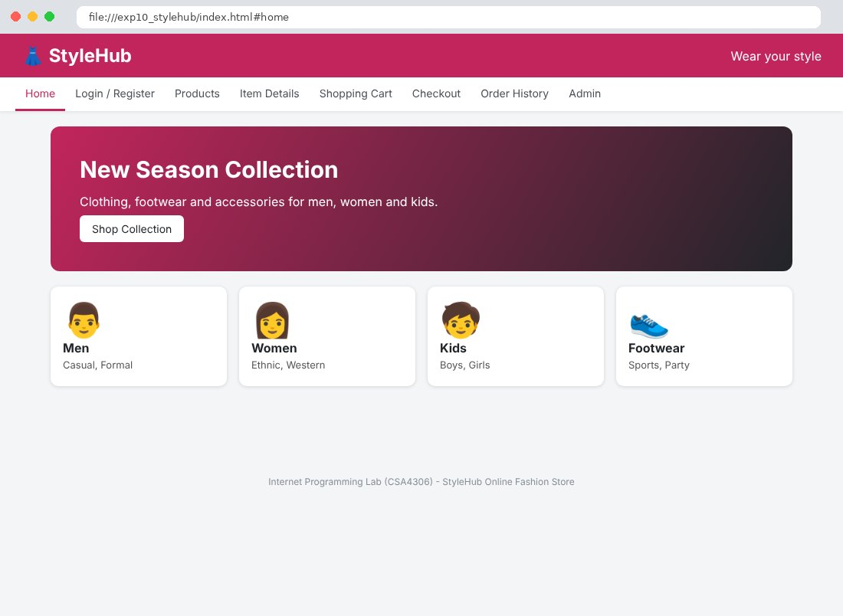
Fig. 10.2 Login / Register Page
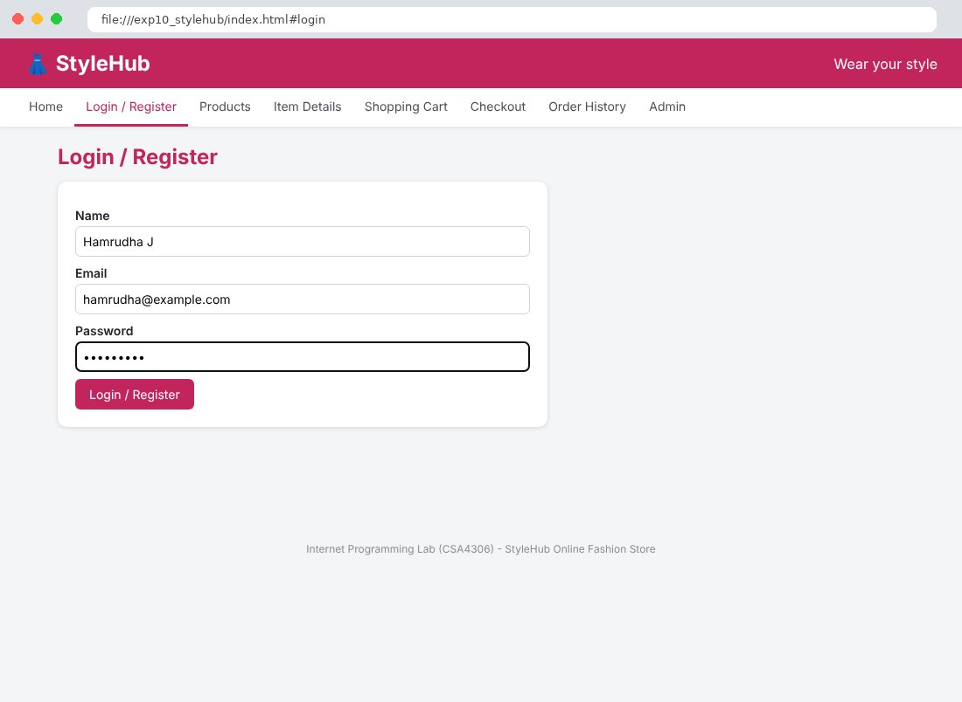
Fig. 10.3 Products Page
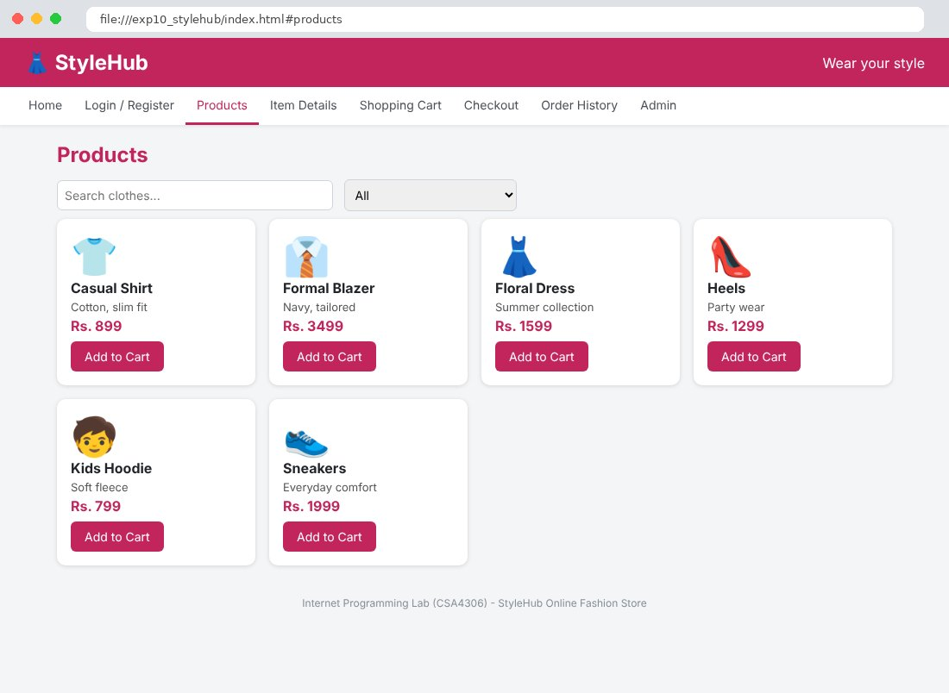
Fig. 10.4 Item Details Page
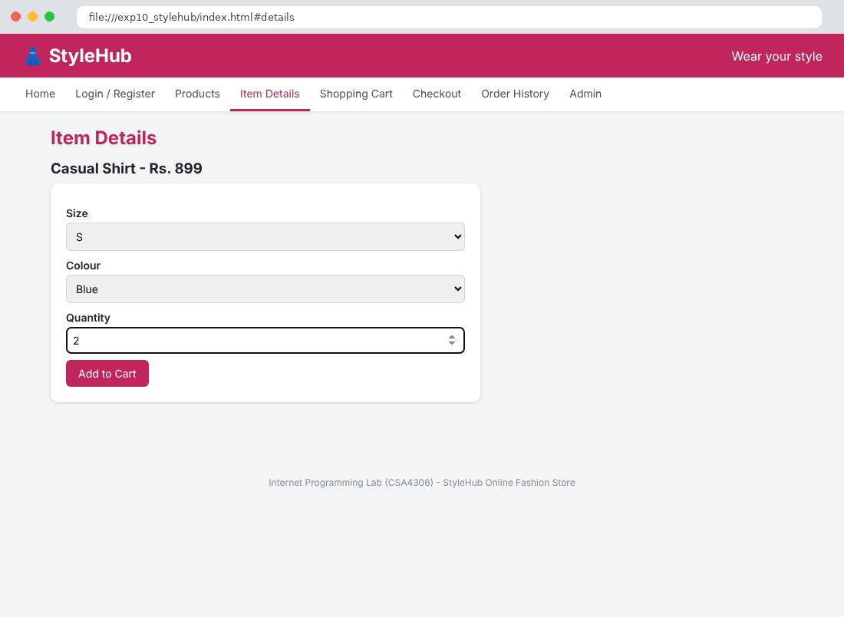
Fig. 10.5 Shopping Cart Page
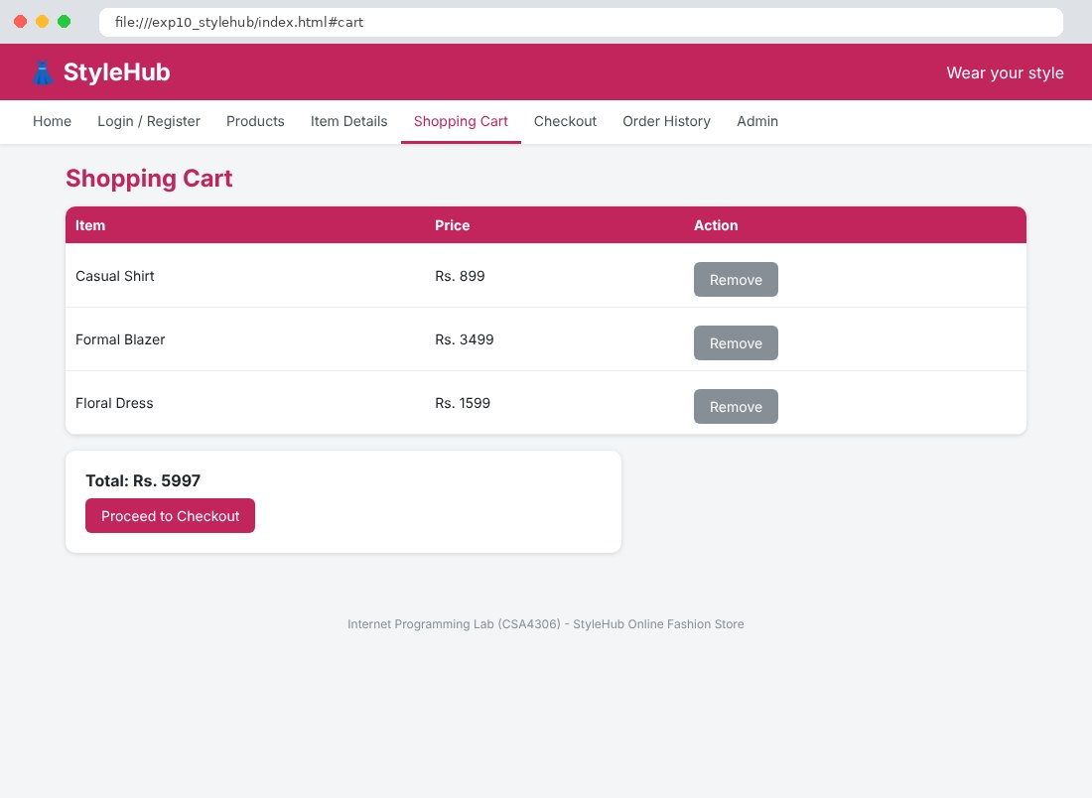
Fig. 10.6 Checkout Page
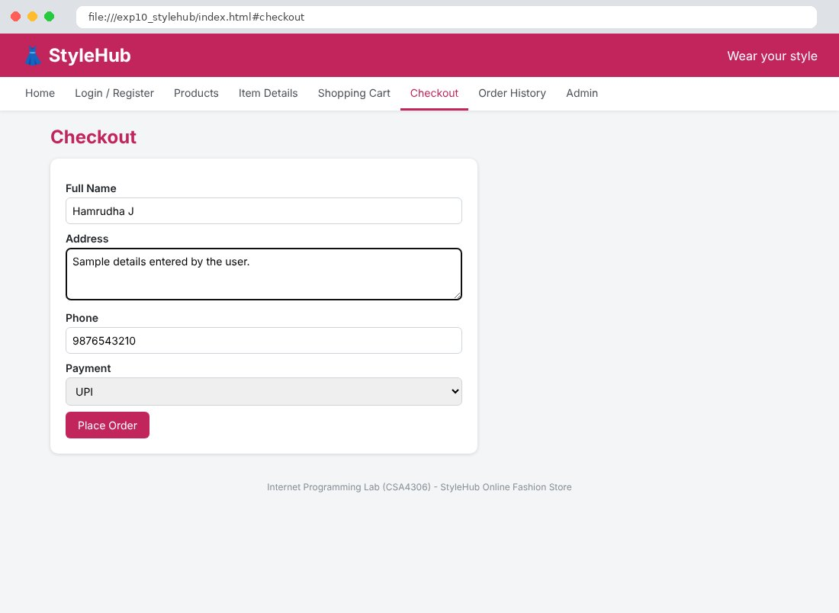
Fig. 10.7 Order History Page
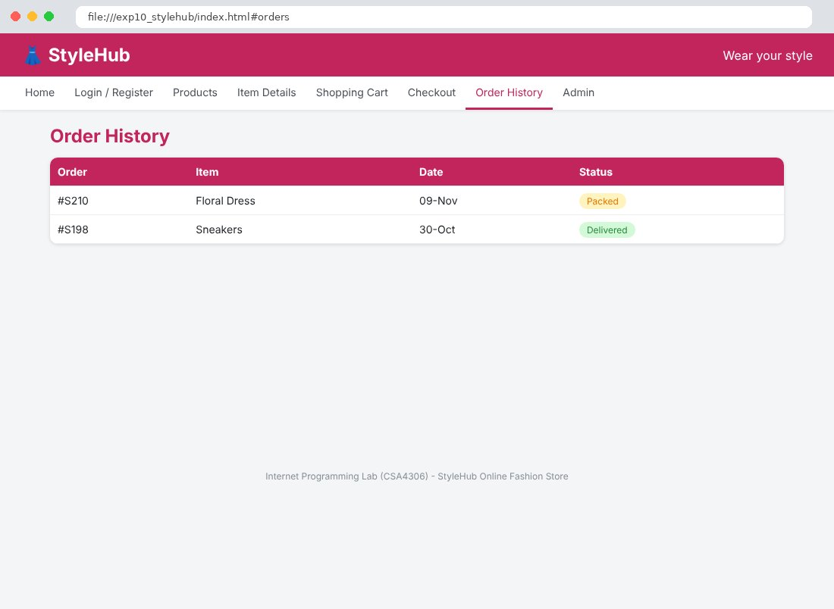
Fig. 10.8 Admin Page
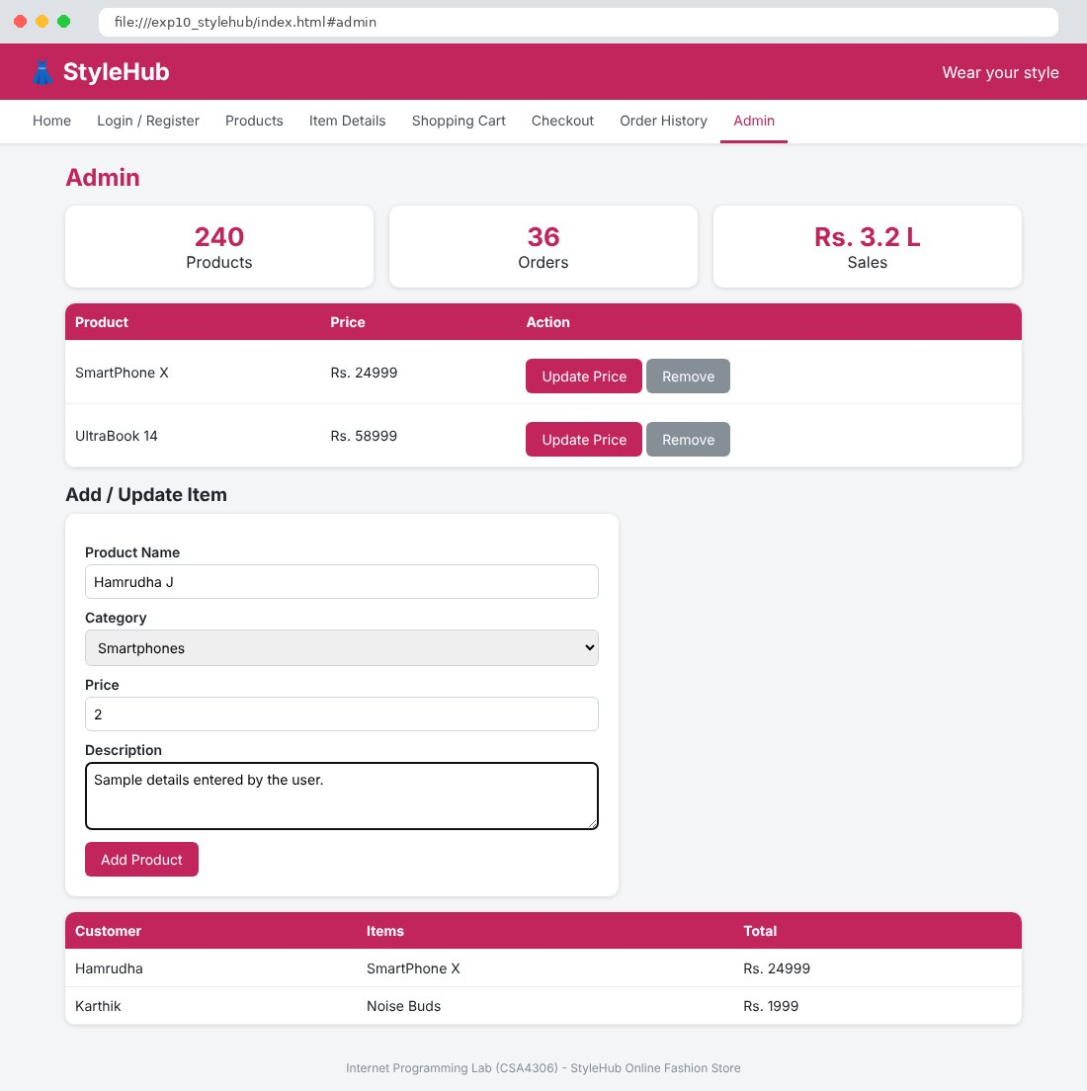

Result
Thus the StyleHub Online Fashion Store website was designed and developed using HTML, CSS and JavaScript, and the output was verified successfully.

