LAB EXPERIMENT 11
Home Finder Real Estate Portal

SUBJECT CODE | CSA4306
SUBJECT NAME | INTERNET PROGRAMMING
NAME | HAMRUDHA J
REG NO | 192411266
EXPERIMENTS | 6 to 20

Experiment 11: Home Finder Real Estate Portal

Question
Home Finder, an innovative online real estate platform, is designed to simplify the property search and transaction process for buyers, sellers, and renters. The website features a comprehensive database of residential and commercial properties, with advanced search filters for location, price, type, and amenities. Key functionalities include user registration and login, detailed property listings with high-quality images and virtual tours, and interactive maps to explore neighborhood features. Users can schedule property viewings, save favorite listings, and receive notifications for new or updated properties matching their criteria. The platform also offers tools for property valuation, mortgage calculators, and direct communication with real estate agents. Home Finder aims to make the property search process efficient and transparent, providing users with valuable. This website helps the user to search and book lands/houses in their required area in their budget.
- Provide a login page for buyers and store their username and password in the database and can save the search criteria for the buyers.
- Helps the buyers to use the same search criteria rather than creating a new criterion every time the buyer performs the search.
- Add more advertisements on the website or links to another website.
- Add agent and company search functionality.
- Displaying the search results on Google Maps and locating the area where the property listing is located.
- It should be friendly and pretty
- Store and give details of properties
- Maintain record of customers visited the website

Aim
To develop an online real estate website where buyers can log in, search properties with filters, save search criteria, view results on a map, search agents and companies, and where property details and visitor records are maintained.

Software / Tools Required
HTML5, CSS3 and JavaScript; any text editor (VS Code / Notepad++); a web browser (Google Chrome).

Algorithm
1. Start.
2. Create a folder for the project and a file index.html.
3. Design the common header (Home Finder) and the navigation bar using HTML.
4. Create one section (page) for each module: Home, Buyer Login, Search Results, Property Details, Saved Searches, Agents & Companies, Admin.
5. Design forms with labels, text fields, drop-down lists and buttons for user input.
6. Apply CSS for the layout, colours, cards, tables and responsive grid.
7. Write JavaScript functions to switch between pages, validate and submit forms, search and filter items.
8. Open index.html in the browser, test every page and verify the output.
9. Stop.

Program (index.html)
<!DOCTYPE html>
<html lang="en">
<head>
<meta charset="UTF-8">
<meta name="viewport" content="width=device-width, initial-scale=1">
<title>Home Finder - Home Finder Real Estate Portal</title>
<style>
:root{--c:#2b8a3e}
*{box-sizing:border-box;margin:0;font-family:'Segoe UI',Arial,sans-serif}
body{background:#f4f5f7;color:#212529}
header{background:var(--c);color:#fff;padding:14px 28px;display:flex;justify-content:space-between;align-items:center}
header h1{font-size:24px}
nav{background:#fff;padding:0 20px;display:flex;flex-wrap:wrap;box-shadow:0 2px 4px #0001}
nav a{padding:12px 13px;cursor:pointer;font-size:14px;color:#495057;border-bottom:3px solid transparent}
nav a.on,nav a:hover{color:var(--c);border-color:var(--c)}
main{max-width:1000px;margin:20px auto;padding:0 16px;min-height:420px}
.page{display:none}.page.active{display:block}
h2{margin-bottom:14px;color:var(--c)}
h3{margin:14px 0 8px}
.hero{background:linear-gradient(120deg,var(--c),#212529);color:#fff;border-radius:12px;padding:38px;margin-bottom:20px}
.hero h2{color:#fff;font-size:30px}
.grid{display:grid;grid-template-columns:repeat(auto-fill,minmax(200px,1fr));gap:16px;margin-bottom:16px}
.card{background:#fff;border-radius:10px;padding:16px;box-shadow:0 1px 5px #0002}
.card .ic{font-size:44px}
.card p{font-size:13px;color:#555;margin:4px 0}
.price{color:var(--c);font-weight:700}
.btn{background:var(--c);color:#fff;border:0;padding:9px 16px;border-radius:6px;cursor:pointer;margin-top:8px;font-size:14px}
.btn.alt{background:#868e96}
form,.box{background:#fff;padding:20px;border-radius:10px;box-shadow:0 1px 5px #0002;max-width:560px;margin-bottom:16px}
label{display:block;margin:10px 0 4px;font-size:14px;font-weight:600}
input,select,textarea{width:100%;padding:8px;border:1px solid #ced4da;border-radius:6px;font-size:14px}
table{width:100%;border-collapse:collapse;background:#fff;border-radius:10px;overflow:hidden;box-shadow:0 1px 5px #0002;margin-bottom:16px}
th{background:var(--c);color:#fff;text-align:left}
th,td{padding:10px;border-bottom:1px solid #eee;font-size:14px}
.stats{display:flex;gap:16px;margin-bottom:16px}
.stat{flex:1;background:#fff;border-radius:10px;padding:16px;text-align:center;box-shadow:0 1px 5px #0002}
.stat b{display:block;font-size:26px;color:var(--c)}
.tag{background:#e9ecef;border-radius:12px;padding:3px 10px;font-size:12px}
.ok{background:#d3f9d8;color:#2b8a3e}.wait{background:#fff3bf;color:#e67700}.bad{background:#ffe3e3;color:#c92a2a}
.map{height:240px;border-radius:10px;background:repeating-linear-gradient(45deg,#dff3e3,#dff3e3 20px,#cfe8d5 20px,#cfe8d5 40px);position:relative;margin-bottom:12px;cursor:crosshair;overflow:hidden}
.pin{position:absolute;font-size:26px;transform:translate(-50%,-100%)}
.bar{height:22px;background:var(--c);border-radius:4px;color:#fff;font-size:12px;padding:2px 8px}
.qr{display:grid;grid-template-columns:repeat(15,12px);gap:0;width:180px;border:8px solid #fff;box-shadow:0 1px 5px #0002}
.qr i{width:12px;height:12px;background:#fff}.qr i.k{background:#000}
#toast{position:fixed;bottom:24px;right:24px;background:#212529;color:#fff;padding:12px 20px;border-radius:8px;display:none}
footer{text-align:center;padding:16px;font-size:12px;color:#868e96}
</style>
</head>
<body>
<header><h1>🏠 Home Finder</h1><span>Find your dream property</span></header>
<nav>
<a data-p="home" onclick="show('home')">Home</a>
<a data-p="login" onclick="show('login')">Buyer Login</a>
<a data-p="results" onclick="show('results')">Search Results</a>
<a data-p="details" onclick="show('details')">Property Details</a>
<a data-p="saved" onclick="show('saved')">Saved Searches</a>
<a data-p="agents" onclick="show('agents')">Agents & Companies</a>
<a data-p="admin" onclick="show('admin')">Admin</a>
</nav>
<main>
<section class="page" id="home">
<div class="hero"><h2>Find Your Dream Home</h2><p>Search residential and commercial properties by location, price and type.</p><button class="btn" style="background:#fff;color:#212529" onclick="show('results')">Search Properties</button></div><form data-msg="Showing matching properties" data-go="results">
<label>Location</label><input type="text" placeholder="Enter location" required>
<label>Type</label><select><option>House</option><option>Apartment</option><option>Commercial</option></select>
<label>Max Price</label><select><option>Rs. 50 L</option><option>Rs. 1 Cr</option><option>Rs. 2 Cr</option></select>
<button class="btn">Search</button>
</form>
</section>
<section class="page" id="login">
<h2>Buyer Login</h2>
<form data-msg="Login successful" data-go="results">
<label>Username</label><input type="text" placeholder="Enter username" required>
<label>Password</label><input type="password" placeholder="Enter password" required>
<button class="btn">Login</button>
</form>
</section>
<section class="page" id="results">
<h2>Search Results</h2>
<input placeholder="Search location..." onkeyup="filt(this,'#cards .card')" style="max-width:320px;margin-bottom:10px;display:inline-block">
<select onchange="catf(this.value,'#cards .card')" style="max-width:200px;margin-left:8px;display:inline-block"><option>All</option><option>House</option><option>Apartment</option><option>Commercial</option></select>
<div class="grid" id="cards">
<div class="card" data-c="House"><div class="ic">🏠</div><b>3BHK Villa</b><p>Anna Nagar, Chennai</p><div class="price">Rs. 1.2 Cr</div><button class="btn" onclick="show('details')">View Details</button></div>
<div class="card" data-c="Apartment"><div class="ic">🏢</div><b>2BHK Apartment</b><p>OMR, Chennai</p><div class="price">Rs. 65 L</div><button class="btn" onclick="show('details')">View Details</button></div>
<div class="card" data-c="Commercial"><div class="ic">🏬</div><b>Shop Space</b><p>T. Nagar, Chennai</p><div class="price">Rs. 90 L</div><button class="btn" onclick="show('details')">View Details</button></div>
<div class="card" data-c="House"><div class="ic">🏡</div><b>Independent House</b><p>Madurai</p><div class="price">Rs. 48 L</div><button class="btn" onclick="show('details')">View Details</button></div>
</div><div class="map" style="pointer-events:none"><span class="pin" style="left:30%;top:55%">📍</span><span class="pin" style="left:55%;top:35%">📍</span><span class="pin" style="left:75%;top:65%">📍</span></div><p>Search results are marked on the map (Google Maps integration).</p>
</section>
<section class="page" id="details">
<h2>Property Details</h2>
<div class="stats"><div class="stat"><b>Rs. 1.2 Cr</b>Price</div><div class="stat"><b>3 BHK</b>Type</div><div class="stat"><b>1800 sqft</b>Area</div></div><div class="box"><h3>🏠 3BHK Villa - Anna Nagar</h3><p>Gated community, 24x7 security, car parking, garden, near metro and schools.</p><p><b>Agent:</b> Ramesh Properties · 98765 43210</p><button class="btn" onclick="toast('Enquiry sent to agent')">Contact Agent</button></div>
</section>
<section class="page" id="saved">
<h2>Saved Searches</h2>
<table>
<tr><th>Criteria</th><th>Saved On</th><th>Action</th></tr>
<tr><td>House, Chennai, up to Rs. 1 Cr</td><td>05-Nov</td><td><button class="btn">Use Again</button></td></tr>
<tr><td>Apartment, OMR, up to Rs. 70 L</td><td>01-Nov</td><td><button class="btn">Use Again</button></td></tr>
</table><h3>Save New Criteria</h3>
<form data-msg="Search criteria saved">
<label>Location</label><input type="text" placeholder="Enter location" required>
<label>Type</label><select><option>House</option><option>Apartment</option><option>Commercial</option></select>
<label>Budget</label><input type="text" placeholder="Enter budget" required>
<button class="btn">Save Search Criteria</button>
</form>
</section>
<section class="page" id="agents">
<h2>Agents & Companies</h2>
<input placeholder="Search agent or company..." onkeyup="filt(this,'#cards .card')" style="max-width:320px;margin-bottom:10px;display:inline-block">
<div class="grid" id="cards">
<div class="card" data-c=""><div class="ic">🧑‍💼</div><b>Ramesh Properties</b><p>Chennai · 120 listings</p></div>
<div class="card" data-c=""><div class="ic">🏢</div><b>Urban Nest Realty</b><p>Madurai · 80 listings</p></div>
<div class="card" data-c=""><div class="ic">🧑‍💼</div><b>Sana Estates</b><p>Coimbatore · 45 listings</p></div>
</div>
</section>
<section class="page" id="admin">
<h2>Admin</h2>
<div class="stats"><div class="stat"><b>320</b>Properties</div><div class="stat"><b>1,480</b>Visitors</div><div class="stat"><b>45</b>Agents</div></div><h3>Add Property</h3>
<form data-msg="Property added">
<label>Title</label><input type="text" placeholder="Enter title" required>
<label>Location</label><input type="text" placeholder="Enter location" required>
<label>Price</label><input type="text" placeholder="Enter price" required>
<label>Type</label><select><option>House</option><option>Apartment</option><option>Commercial</option></select>
<button class="btn">Add Property</button>
</form><table>
<tr><th>Visitor</th><th>Visited On</th><th>Page</th></tr>
<tr><td>Arun</td><td>06-Nov</td><td>Search Results</td></tr>
<tr><td>Divya</td><td>06-Nov</td><td>Property Details</td></tr>
</table>
</section>
</main>
<footer>Internet Programming Lab (CSA4306) - Home Finder Real Estate Portal</footer>
<div id="toast"></div>
<script>
function show(id){document.querySelectorAll('.page').forEach(p=>p.classList.toggle('active',p.id===id));
document.querySelectorAll('nav a').forEach(a=>a.classList.toggle('on',a.dataset.p===id));window.scrollTo(0,0)}
function toast(m){const t=document.getElementById('toast');t.textContent=m;t.style.display='block';setTimeout(()=>t.style.display='none',2200)}
document.addEventListener('submit',e=>{e.preventDefault();toast(e.target.dataset.msg||'Saved successfully');if(e.target.dataset.go)show(e.target.dataset.go)});
function filt(inp,sel){const v=inp.value.toLowerCase();document.querySelectorAll(sel).forEach(r=>r.style.display=r.textContent.toLowerCase().includes(v)?'':'none')}
function catf(v,sel){document.querySelectorAll(sel).forEach(r=>r.style.display=(v=='All'||r.dataset.c==v)?'':'none')}
show('home');
</script>
</body>
</html>

Output
Fig. 11.1 Home Page
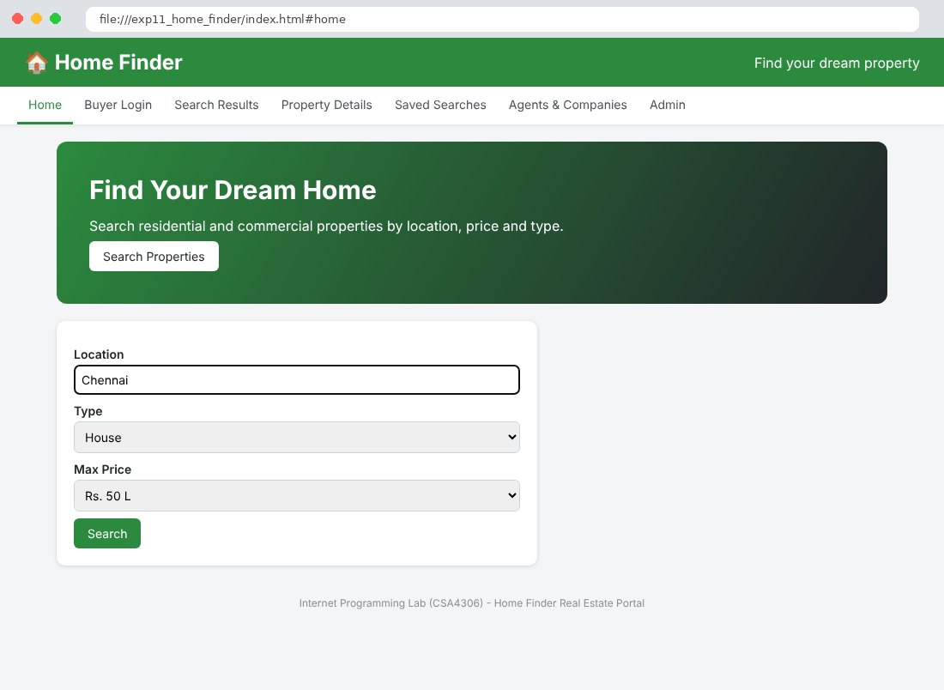
Fig. 11.2 Buyer Login Page
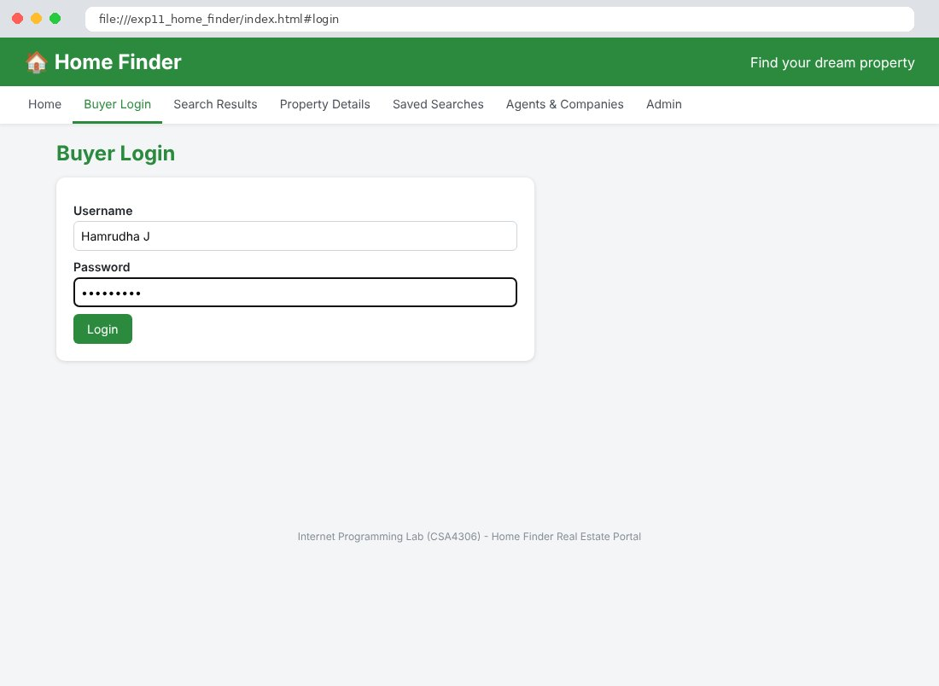
Fig. 11.3 Search Results Page
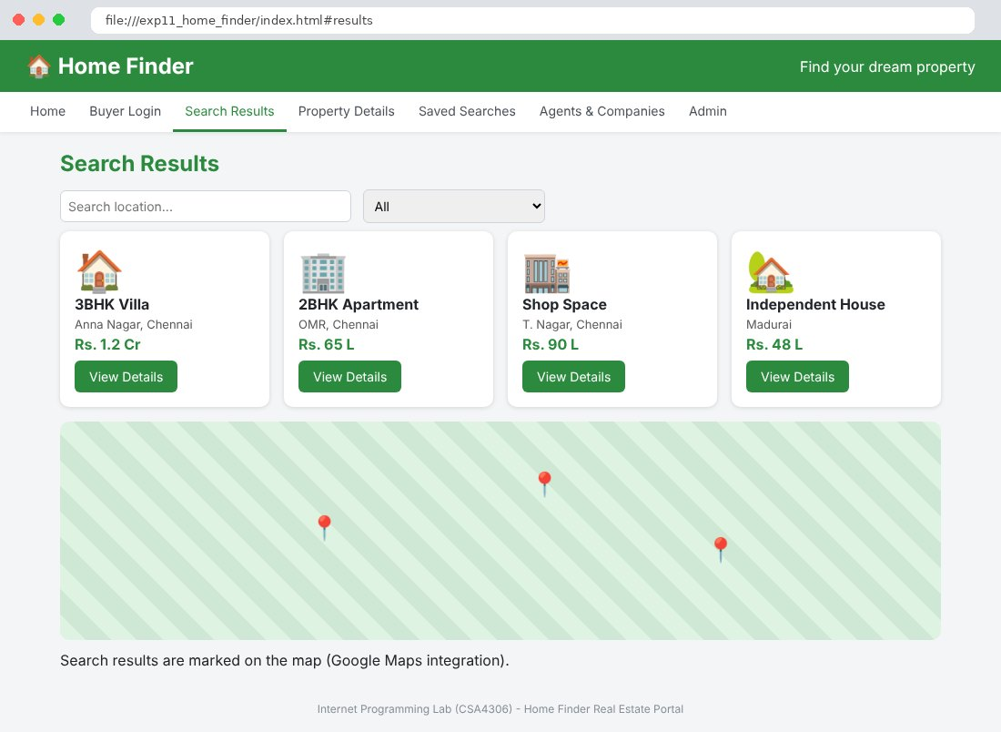
Fig. 11.4 Property Details Page
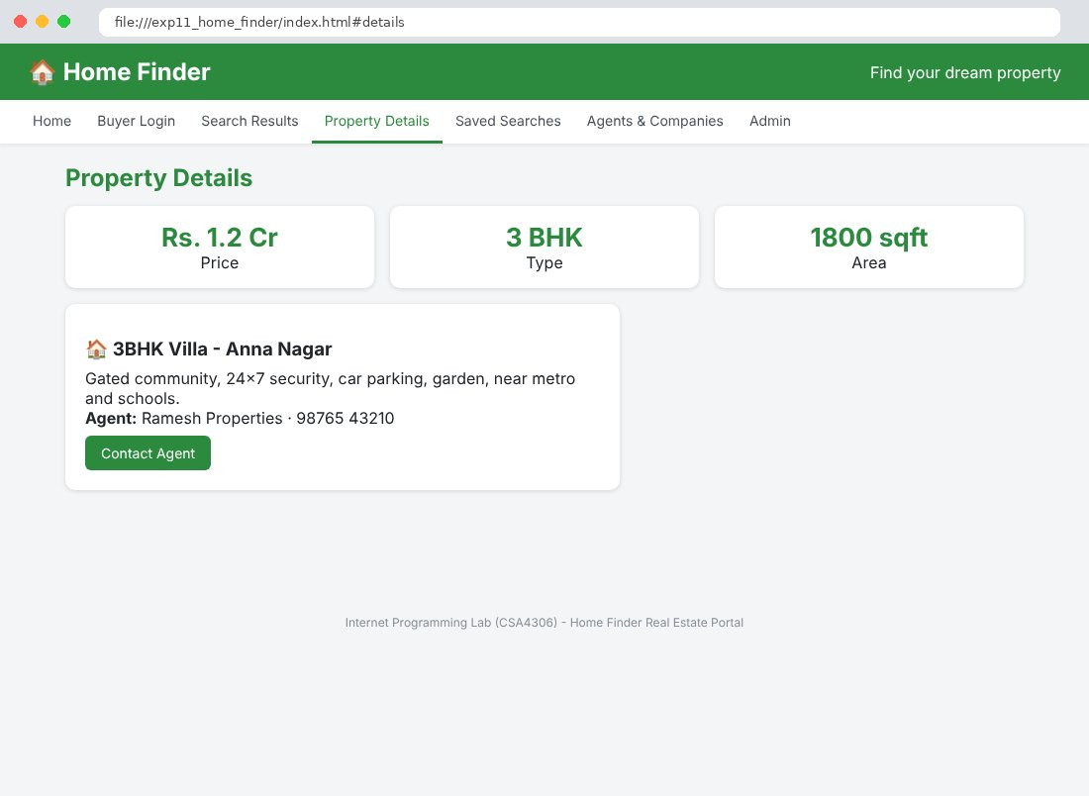
Fig. 11.5 Saved Searches Page
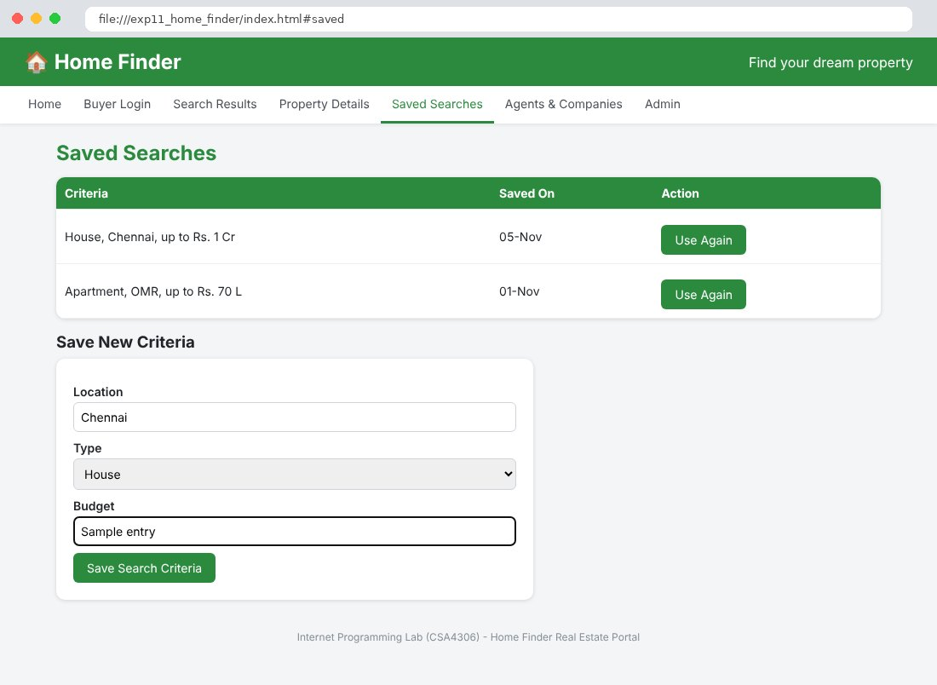
Fig. 11.6 Agents & Companies Page
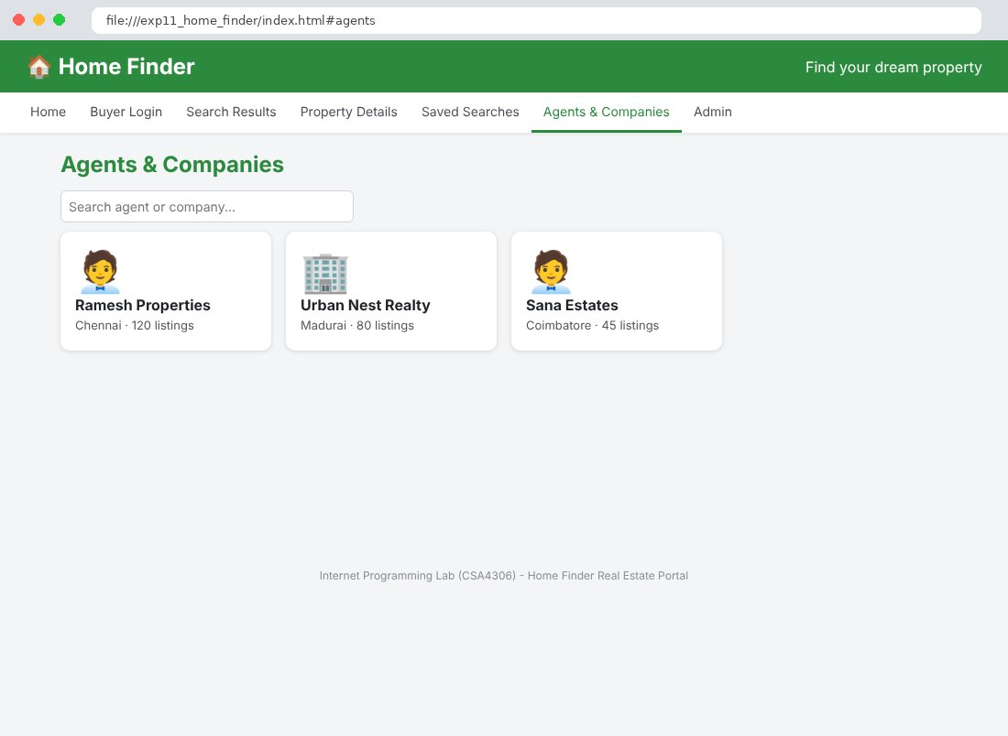
Fig. 11.7 Admin Page
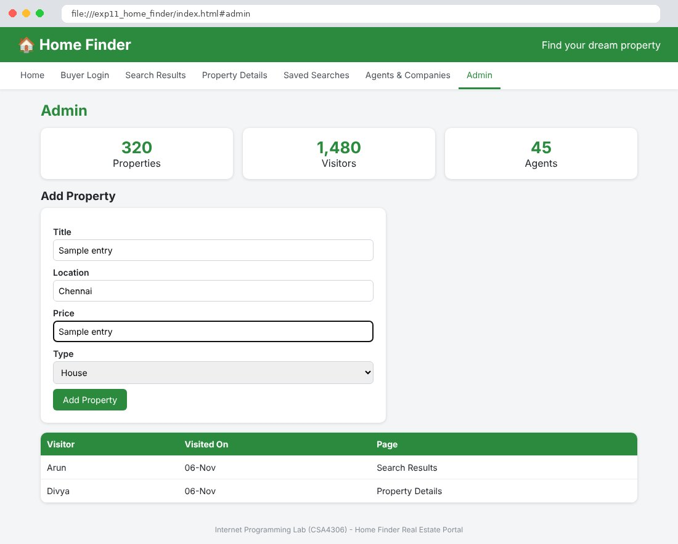

Result
Thus the Home Finder Real Estate Portal website was designed and developed using HTML, CSS and JavaScript, and the output was verified successfully.

