LAB EXPERIMENT 12
InsureEasy Insurance Management

SUBJECT CODE | CSA4306
SUBJECT NAME | INTERNET PROGRAMMING
NAME | HAMRUDHA J
REG NO | 192411266
EXPERIMENTS | 6 to 20

Experiment 12: InsureEasy Insurance Management

Question
InsureEasy, a cutting-edge online insurance management platform, is designed to streamline the insurance process for users. The website allows customers to easily compare and purchase various insurance policies, including health, auto, and home insurance. Key functionalities include user registration and login, a policy comparison tool, detailed policy descriptions, and secure online applications. Users can view and manage their existing policies, make premium payments, and file claims through an intuitive dashboard. The platform also provides personalized recommendations based on user profiles and needs, and sends automated reminders for policy renewals and upcoming payments. InsureEasy aims to enhance user convenience and provide comprehensive support for all insurance-related needs.This system maintains information of managers who can deal with agents and customers. In existing system, the manual procedure is followed where records are used to maintain data which is a time taking process and requires manpower and calculating commissions dues. Etc are done manually. This system is where agents send SMS alerts to the policyholder to remind them before and exceed the data of due.
Admin
- Login
- Approve Agent login
- View all agent details
Agents
- Register
- Login
- Create Customer
- Manager Customer Details
- Manage Policy Details
- Send SMS Alert
User
- Login
- Manage policy details
- Get sms alert

Aim
To develop an online insurance management website with policy comparison, online application, admin approval of agents, agent management of customers and policies, SMS alerts, and a user dashboard.

Software / Tools Required
HTML5, CSS3 and JavaScript; any text editor (VS Code / Notepad++); a web browser (Google Chrome).

Algorithm
1. Start.
2. Create a folder for the project and a file index.html.
3. Design the common header (InsureEasy) and the navigation bar using HTML.
4. Create one section (page) for each module: Home, Login, Compare Policies, Apply Online, Admin, Agent Panel, My Policies.
5. Design forms with labels, text fields, drop-down lists and buttons for user input.
6. Apply CSS for the layout, colours, cards, tables and responsive grid.
7. Write JavaScript functions to switch between pages, validate and submit forms, search and filter items.
8. Open index.html in the browser, test every page and verify the output.
9. Stop.

Program (index.html)
<!DOCTYPE html>
<html lang="en">
<head>
<meta charset="UTF-8">
<meta name="viewport" content="width=device-width, initial-scale=1">
<title>InsureEasy - InsureEasy Insurance Management</title>
<style>
:root{--c:#1971c2}
*{box-sizing:border-box;margin:0;font-family:'Segoe UI',Arial,sans-serif}
body{background:#f4f5f7;color:#212529}
header{background:var(--c);color:#fff;padding:14px 28px;display:flex;justify-content:space-between;align-items:center}
header h1{font-size:24px}
nav{background:#fff;padding:0 20px;display:flex;flex-wrap:wrap;box-shadow:0 2px 4px #0001}
nav a{padding:12px 13px;cursor:pointer;font-size:14px;color:#495057;border-bottom:3px solid transparent}
nav a.on,nav a:hover{color:var(--c);border-color:var(--c)}
main{max-width:1000px;margin:20px auto;padding:0 16px;min-height:420px}
.page{display:none}.page.active{display:block}
h2{margin-bottom:14px;color:var(--c)}
h3{margin:14px 0 8px}
.hero{background:linear-gradient(120deg,var(--c),#212529);color:#fff;border-radius:12px;padding:38px;margin-bottom:20px}
.hero h2{color:#fff;font-size:30px}
.grid{display:grid;grid-template-columns:repeat(auto-fill,minmax(200px,1fr));gap:16px;margin-bottom:16px}
.card{background:#fff;border-radius:10px;padding:16px;box-shadow:0 1px 5px #0002}
.card .ic{font-size:44px}
.card p{font-size:13px;color:#555;margin:4px 0}
.price{color:var(--c);font-weight:700}
.btn{background:var(--c);color:#fff;border:0;padding:9px 16px;border-radius:6px;cursor:pointer;margin-top:8px;font-size:14px}
.btn.alt{background:#868e96}
form,.box{background:#fff;padding:20px;border-radius:10px;box-shadow:0 1px 5px #0002;max-width:560px;margin-bottom:16px}
label{display:block;margin:10px 0 4px;font-size:14px;font-weight:600}
input,select,textarea{width:100%;padding:8px;border:1px solid #ced4da;border-radius:6px;font-size:14px}
table{width:100%;border-collapse:collapse;background:#fff;border-radius:10px;overflow:hidden;box-shadow:0 1px 5px #0002;margin-bottom:16px}
th{background:var(--c);color:#fff;text-align:left}
th,td{padding:10px;border-bottom:1px solid #eee;font-size:14px}
.stats{display:flex;gap:16px;margin-bottom:16px}
.stat{flex:1;background:#fff;border-radius:10px;padding:16px;text-align:center;box-shadow:0 1px 5px #0002}
.stat b{display:block;font-size:26px;color:var(--c)}
.tag{background:#e9ecef;border-radius:12px;padding:3px 10px;font-size:12px}
.ok{background:#d3f9d8;color:#2b8a3e}.wait{background:#fff3bf;color:#e67700}.bad{background:#ffe3e3;color:#c92a2a}
.map{height:240px;border-radius:10px;background:repeating-linear-gradient(45deg,#dff3e3,#dff3e3 20px,#cfe8d5 20px,#cfe8d5 40px);position:relative;margin-bottom:12px;cursor:crosshair;overflow:hidden}
.pin{position:absolute;font-size:26px;transform:translate(-50%,-100%)}
.bar{height:22px;background:var(--c);border-radius:4px;color:#fff;font-size:12px;padding:2px 8px}
.qr{display:grid;grid-template-columns:repeat(15,12px);gap:0;width:180px;border:8px solid #fff;box-shadow:0 1px 5px #0002}
.qr i{width:12px;height:12px;background:#fff}.qr i.k{background:#000}
#toast{position:fixed;bottom:24px;right:24px;background:#212529;color:#fff;padding:12px 20px;border-radius:8px;display:none}
footer{text-align:center;padding:16px;font-size:12px;color:#868e96}
</style>
</head>
<body>
<header><h1>🛡️ InsureEasy</h1><span>Protection made easy</span></header>
<nav>
<a data-p="home" onclick="show('home')">Home</a>
<a data-p="login" onclick="show('login')">Login</a>
<a data-p="policies" onclick="show('policies')">Compare Policies</a>
<a data-p="apply" onclick="show('apply')">Apply Online</a>
<a data-p="admin" onclick="show('admin')">Admin</a>
<a data-p="agent" onclick="show('agent')">Agent Panel</a>
<a data-p="dashboard" onclick="show('dashboard')">My Policies</a>
</nav>
<main>
<section class="page" id="home">
<div class="hero"><h2>Compare & Buy Insurance Online</h2><p>Health, auto and home insurance policies at the best premium.</p><button class="btn" style="background:#fff;color:#212529" onclick="show('policies')">Compare Policies</button></div><div class="grid" id="cards">
<div class="card" data-c=""><div class="ic">❤️</div><b>Health</b><p>From Rs. 450/mo</p></div>
<div class="card" data-c=""><div class="ic">🚗</div><b>Auto</b><p>From Rs. 300/mo</p></div>
<div class="card" data-c=""><div class="ic">🏠</div><b>Home</b><p>From Rs. 200/mo</p></div>
</div>
</section>
<section class="page" id="login">
<h2>Login</h2>
<form data-msg="Login successful" data-go="policies">
<label>Role</label><select><option>Admin</option><option>Agent</option><option>User</option></select>
<label>Username</label><input type="text" placeholder="Enter username" required>
<label>Password</label><input type="password" placeholder="Enter password" required>
<button class="btn">Login</button>
</form>
</section>
<section class="page" id="policies">
<h2>Compare Policies</h2>
<input placeholder="Search policy..." onkeyup="filt(this,'#tb789 tr')" style="max-width:320px;margin-bottom:10px">
<table id="tb789">
<tr><th>Policy</th><th>Type</th><th>Cover</th><th>Premium / yr</th><th>Action</th></tr>
<tr><td>Health Shield</td><td>Health</td><td>Rs. 5 L</td><td>Rs. 6,500</td><td><button class="btn" onclick="show('apply')">Apply</button></td></tr>
<tr><td>Family Care</td><td>Health</td><td>Rs. 10 L</td><td>Rs. 11,200</td><td><button class="btn" onclick="show('apply')">Apply</button></td></tr>
<tr><td>DriveSafe</td><td>Auto</td><td>Rs. 3 L</td><td>Rs. 3,900</td><td><button class="btn" onclick="show('apply')">Apply</button></td></tr>
<tr><td>HomeGuard</td><td>Home</td><td>Rs. 20 L</td><td>Rs. 4,800</td><td><button class="btn" onclick="show('apply')">Apply</button></td></tr>
</table>
</section>
<section class="page" id="apply">
<h2>Apply Online</h2>
<form data-msg="Application submitted" data-go="dashboard">
<label>Policy</label><select><option>Health Shield</option><option>Family Care</option><option>DriveSafe</option><option>HomeGuard</option></select>
<label>Full Name</label><input type="text" placeholder="Enter full name" required>
<label>Date of Birth</label><input type="date" placeholder="Enter date of birth" required>
<label>Mobile</label><input type="tel" placeholder="Enter mobile" required>
<label>Nominee</label><input type="text" placeholder="Enter nominee" required>
<button class="btn">Submit Application</button>
</form>
</section>
<section class="page" id="admin">
<h2>Admin</h2>
<table>
<tr><th>Agent</th><th>City</th><th>Status</th><th>Action</th></tr>
<tr><td>Suresh</td><td>Chennai</td><td><span class="tag wait">Pending</span></td><td><button class="btn">Approve</button></td></tr>
<tr><td>Nisha</td><td>Madurai</td><td><span class="tag ok">Approved</span></td><td>-</td></tr>
<tr><td>Rajan</td><td>Trichy</td><td><span class="tag wait">Pending</span></td><td><button class="btn">Approve</button></td></tr>
</table>
</section>
<section class="page" id="agent">
<h2>Agent Panel</h2>
<h3>Create Customer</h3>
<form data-msg="Customer created">
<label>Customer Name</label><input type="text" placeholder="Enter customer name" required>
<label>Mobile</label><input type="tel" placeholder="Enter mobile" required>
<label>Policy</label><select><option>Health Shield</option><option>Family Care</option><option>DriveSafe</option><option>HomeGuard</option></select>
<button class="btn">Create Customer</button>
</form><table>
<tr><th>Customer</th><th>Policy</th><th>Due Date</th><th>Action</th></tr>
<tr><td>Hamrudha</td><td>Health Shield</td><td>15-Dec</td><td><button class="btn">Send SMS Alert</button></td></tr>
<tr><td>Karthik</td><td>DriveSafe</td><td>02-Jan</td><td><button class="btn">Send SMS Alert</button></td></tr>
</table>
</section>
<section class="page" id="dashboard">
<h2>My Policies</h2>
<table>
<tr><th>Policy</th><th>Start</th><th>Expiry</th><th>Status</th></tr>
<tr><td>Health Shield</td><td>15-Dec-2025</td><td>14-Dec-2026</td><td><span class="tag ok">Active</span></td></tr>
<tr><td>DriveSafe</td><td>02-Jan-2026</td><td>01-Jan-2027</td><td><span class="tag ok">Active</span></td></tr>
</table><div class="box"><b>SMS Alert:</b> Your Health Shield premium is due on 15-Dec. Pay now to avoid lapse.</div>
</section>
</main>
<footer>Internet Programming Lab (CSA4306) - InsureEasy Insurance Management</footer>
<div id="toast"></div>
<script>
function show(id){document.querySelectorAll('.page').forEach(p=>p.classList.toggle('active',p.id===id));
document.querySelectorAll('nav a').forEach(a=>a.classList.toggle('on',a.dataset.p===id));window.scrollTo(0,0)}
function toast(m){const t=document.getElementById('toast');t.textContent=m;t.style.display='block';setTimeout(()=>t.style.display='none',2200)}
document.addEventListener('submit',e=>{e.preventDefault();toast(e.target.dataset.msg||'Saved successfully');if(e.target.dataset.go)show(e.target.dataset.go)});
function filt(inp,sel){const v=inp.value.toLowerCase();document.querySelectorAll(sel).forEach(r=>r.style.display=r.textContent.toLowerCase().includes(v)?'':'none')}
function catf(v,sel){document.querySelectorAll(sel).forEach(r=>r.style.display=(v=='All'||r.dataset.c==v)?'':'none')}
show('home');
</script>
</body>
</html>

Output
Fig. 12.1 Home Page
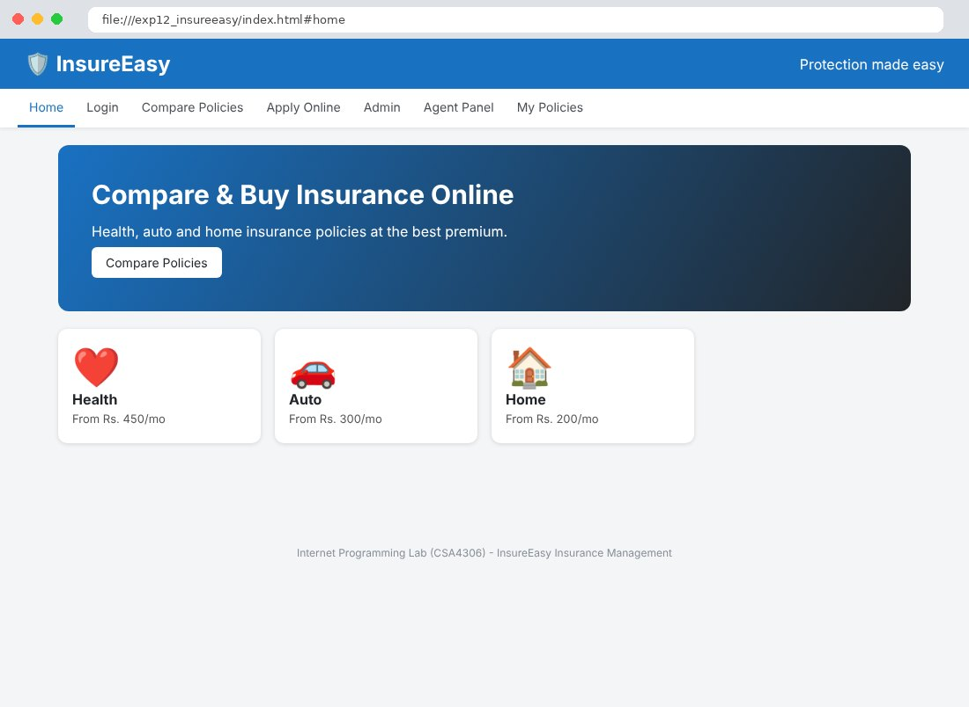
Fig. 12.2 Login Page
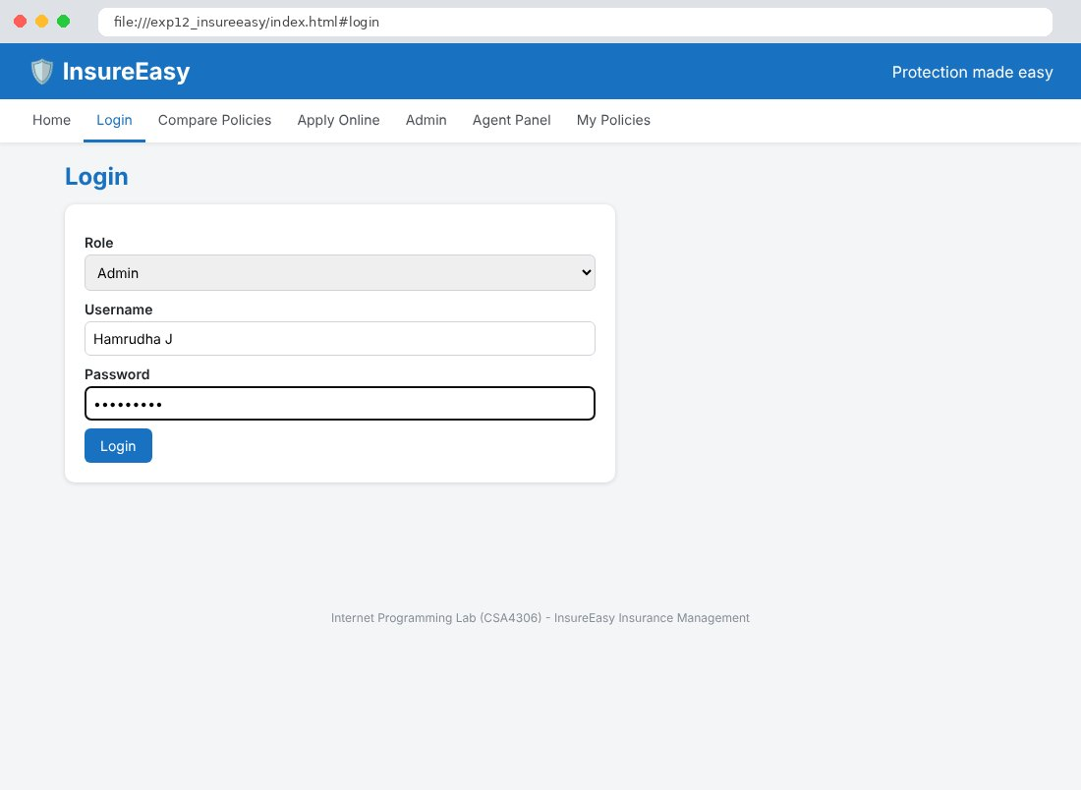
Fig. 12.3 Compare Policies Page
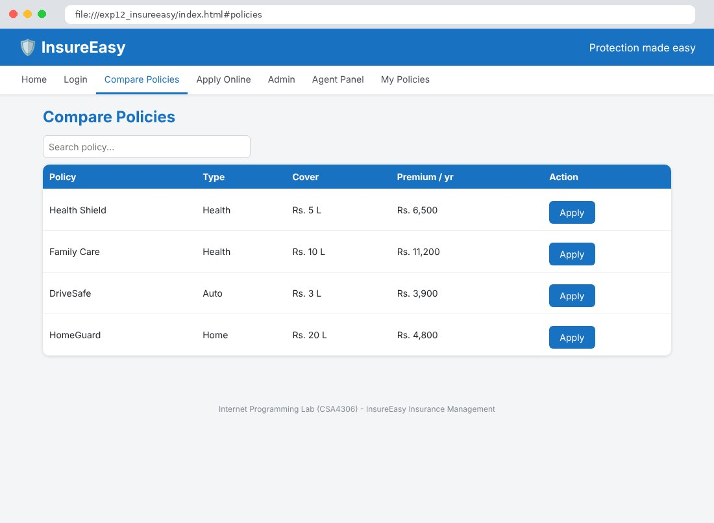
Fig. 12.4 Apply Online Page
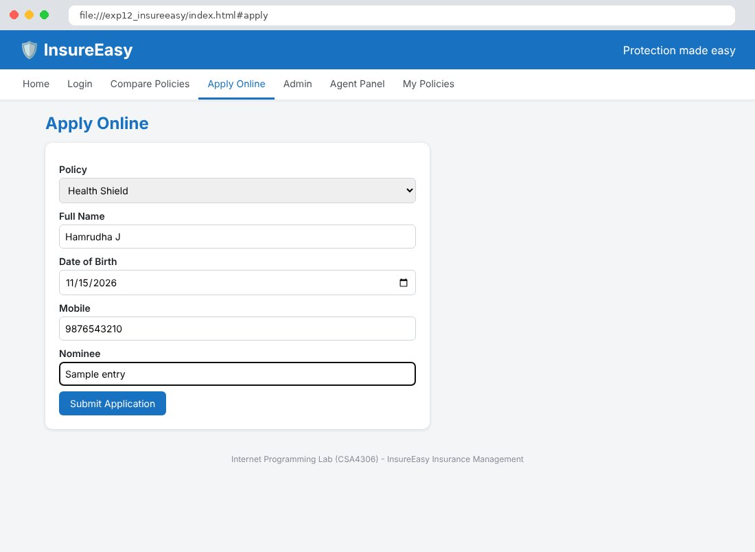
Fig. 12.5 Admin Page
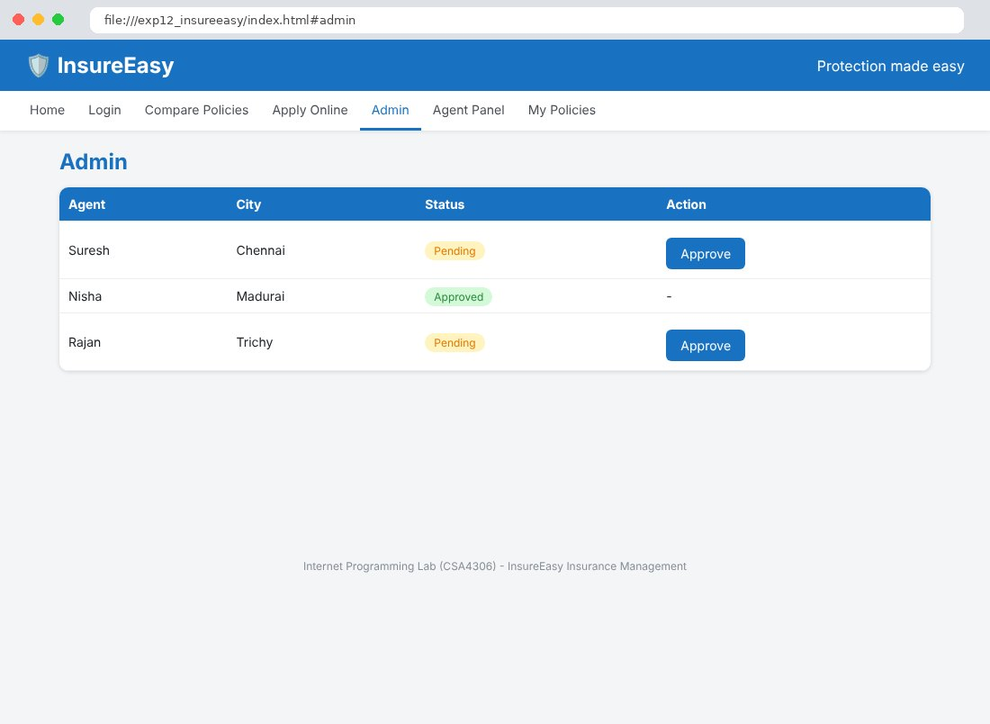
Fig. 12.6 Agent Panel Page
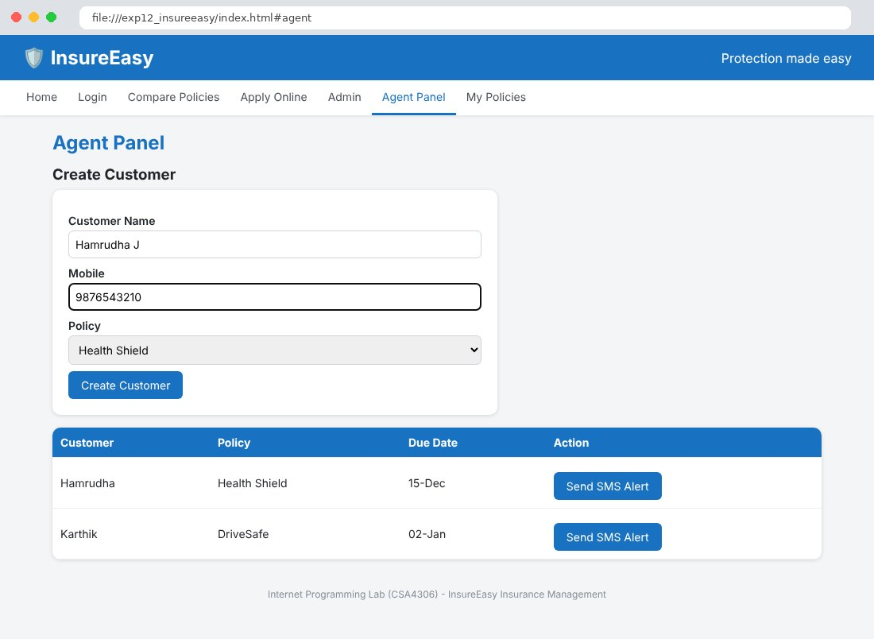
Fig. 12.7 My Policies Page
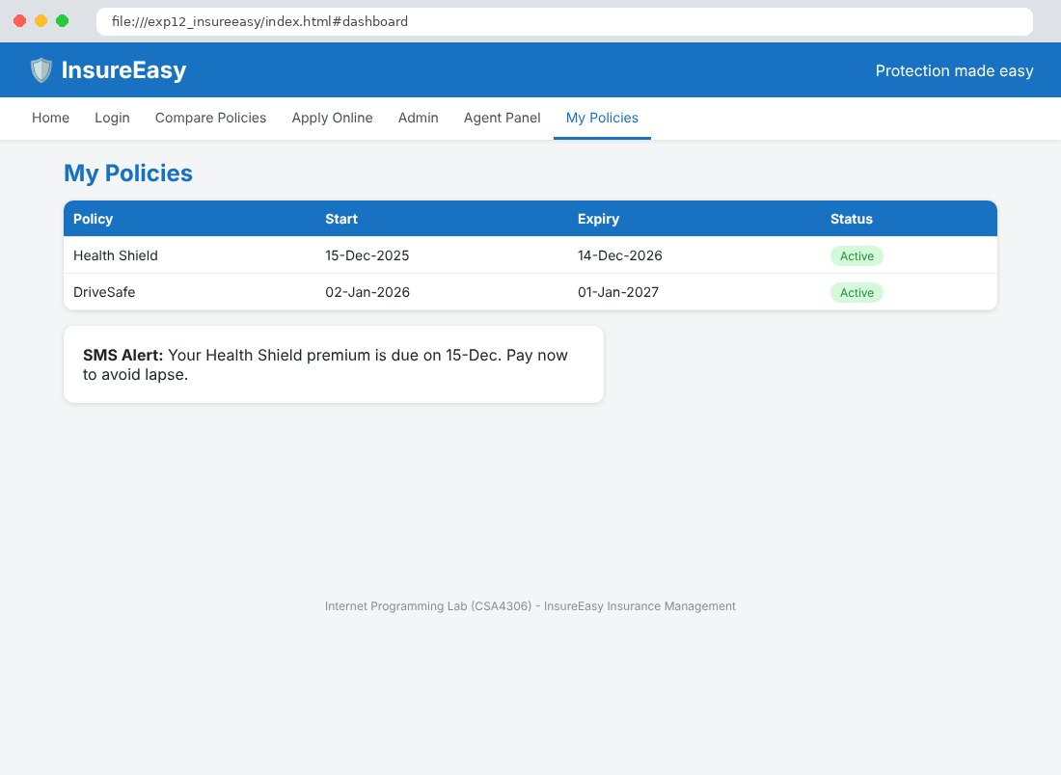

Result
Thus the InsureEasy Insurance Management website was designed and developed using HTML, CSS and JavaScript, and the output was verified successfully.

