LAB EXPERIMENT 13
BlossomGifts Online Flower and Gift Shop

SUBJECT CODE | CSA4306
SUBJECT NAME | INTERNET PROGRAMMING
NAME | HAMRUDHA J
REG NO | 192411266
EXPERIMENTS | 6 to 20

Experiment 13: BlossomGifts Online Flower and Gift Shop

Question
BlossomGifts, a user-friendly online platform, offers a seamless experience for ordering flowers and gifts for any occasion. The website features a diverse selection of floral arrangements, gift baskets, and personalized gifts, all organized by occasion, recipient, and price range. Key functionalities include user registration and login, a customizable order system with options for delivery dates and times, and detailed product descriptions with high-quality images. Customers can track their orders in real-time, schedule future deliveries, and receive order confirmations via email or SMS. The platform also supports secure payment methods and provides special promotions and discounts for loyal customers. BlossomGifts aims to make sending thoughtful gifts and flowers easy and convenient, ensuring timely delivery and customer satisfaction.
- The key to helping customers find the products they need quickly is to offer a user- friendly navigation system.
- Products should be logically categorized, with the most popular categories listed first.
- Display all the available categories for shopping on the home page.
- Display all the subcategories on the home page, that are associated with any particular item.
- Admin has the authority to add new particulars to the items list whenever needed.
- Permission to the administrator to remove items, anytime.
- Allows the admin to modify the price of each item, whenever required or felt like.
- Permission to the admin to view information about each customer who checkouts the items list.
Use Cases

Aim
To develop an online flower and gift ordering website organised by occasion, recipient and price, with customisable orders, delivery date and time scheduling, order tracking, and an admin panel for managing items and customer details.

Software / Tools Required
HTML5, CSS3 and JavaScript; any text editor (VS Code / Notepad++); a web browser (Google Chrome).

Algorithm
1. Start.
2. Create a folder for the project and a file index.html.
3. Design the common header (BlossomGifts) and the navigation bar using HTML.
4. Create one section (page) for each module: Home, Login / Register, Products, Customize & Schedule, Cart, Checkout, Track Order, Admin.
5. Design forms with labels, text fields, drop-down lists and buttons for user input.
6. Apply CSS for the layout, colours, cards, tables and responsive grid.
7. Write JavaScript functions to switch between pages, validate and submit forms, search and filter items, and manage the shopping cart.
8. Open index.html in the browser, test every page and verify the output.
9. Stop.

Program (index.html)
<!DOCTYPE html>
<html lang="en">
<head>
<meta charset="UTF-8">
<meta name="viewport" content="width=device-width, initial-scale=1">
<title>BlossomGifts - BlossomGifts Online Flower and Gift Shop</title>
<style>
:root{--c:#e64980}
*{box-sizing:border-box;margin:0;font-family:'Segoe UI',Arial,sans-serif}
body{background:#f4f5f7;color:#212529}
header{background:var(--c);color:#fff;padding:14px 28px;display:flex;justify-content:space-between;align-items:center}
header h1{font-size:24px}
nav{background:#fff;padding:0 20px;display:flex;flex-wrap:wrap;box-shadow:0 2px 4px #0001}
nav a{padding:12px 13px;cursor:pointer;font-size:14px;color:#495057;border-bottom:3px solid transparent}
nav a.on,nav a:hover{color:var(--c);border-color:var(--c)}
main{max-width:1000px;margin:20px auto;padding:0 16px;min-height:420px}
.page{display:none}.page.active{display:block}
h2{margin-bottom:14px;color:var(--c)}
h3{margin:14px 0 8px}
.hero{background:linear-gradient(120deg,var(--c),#212529);color:#fff;border-radius:12px;padding:38px;margin-bottom:20px}
.hero h2{color:#fff;font-size:30px}
.grid{display:grid;grid-template-columns:repeat(auto-fill,minmax(200px,1fr));gap:16px;margin-bottom:16px}
.card{background:#fff;border-radius:10px;padding:16px;box-shadow:0 1px 5px #0002}
.card .ic{font-size:44px}
.card p{font-size:13px;color:#555;margin:4px 0}
.price{color:var(--c);font-weight:700}
.btn{background:var(--c);color:#fff;border:0;padding:9px 16px;border-radius:6px;cursor:pointer;margin-top:8px;font-size:14px}
.btn.alt{background:#868e96}
form,.box{background:#fff;padding:20px;border-radius:10px;box-shadow:0 1px 5px #0002;max-width:560px;margin-bottom:16px}
label{display:block;margin:10px 0 4px;font-size:14px;font-weight:600}
input,select,textarea{width:100%;padding:8px;border:1px solid #ced4da;border-radius:6px;font-size:14px}
table{width:100%;border-collapse:collapse;background:#fff;border-radius:10px;overflow:hidden;box-shadow:0 1px 5px #0002;margin-bottom:16px}
th{background:var(--c);color:#fff;text-align:left}
th,td{padding:10px;border-bottom:1px solid #eee;font-size:14px}
.stats{display:flex;gap:16px;margin-bottom:16px}
.stat{flex:1;background:#fff;border-radius:10px;padding:16px;text-align:center;box-shadow:0 1px 5px #0002}
.stat b{display:block;font-size:26px;color:var(--c)}
.tag{background:#e9ecef;border-radius:12px;padding:3px 10px;font-size:12px}
.ok{background:#d3f9d8;color:#2b8a3e}.wait{background:#fff3bf;color:#e67700}.bad{background:#ffe3e3;color:#c92a2a}
.map{height:240px;border-radius:10px;background:repeating-linear-gradient(45deg,#dff3e3,#dff3e3 20px,#cfe8d5 20px,#cfe8d5 40px);position:relative;margin-bottom:12px;cursor:crosshair;overflow:hidden}
.pin{position:absolute;font-size:26px;transform:translate(-50%,-100%)}
.bar{height:22px;background:var(--c);border-radius:4px;color:#fff;font-size:12px;padding:2px 8px}
.qr{display:grid;grid-template-columns:repeat(15,12px);gap:0;width:180px;border:8px solid #fff;box-shadow:0 1px 5px #0002}
.qr i{width:12px;height:12px;background:#fff}.qr i.k{background:#000}
#toast{position:fixed;bottom:24px;right:24px;background:#212529;color:#fff;padding:12px 20px;border-radius:8px;display:none}
footer{text-align:center;padding:16px;font-size:12px;color:#868e96}
</style>
</head>
<body>
<header><h1>🌸 BlossomGifts</h1><span>Say it with flowers</span></header>
<nav>
<a data-p="home" onclick="show('home')">Home</a>
<a data-p="login" onclick="show('login')">Login / Register</a>
<a data-p="products" onclick="show('products')">Products</a>
<a data-p="custom" onclick="show('custom')">Customize & Schedule</a>
<a data-p="cart" onclick="show('cart')">Cart</a>
<a data-p="checkout" onclick="show('checkout')">Checkout</a>
<a data-p="track" onclick="show('track')">Track Order</a>
<a data-p="admin" onclick="show('admin')">Admin</a>
</nav>
<main>
<section class="page" id="home">
<div class="hero"><h2>Flowers & Gifts for Every Occasion</h2><p>Fresh bouquets, gift baskets and personalised gifts delivered on time.</p><button class="btn" style="background:#fff;color:#212529" onclick="show('products')">Shop Now</button></div><div class="grid" id="cards">
<div class="card" data-c=""><div class="ic">🎂</div><b>Birthday</b><p>40 gifts</p></div>
<div class="card" data-c=""><div class="ic">💑</div><b>Anniversary</b><p>35 gifts</p></div>
<div class="card" data-c=""><div class="ic">🪔</div><b>Festival</b><p>28 gifts</p></div>
<div class="card" data-c=""><div class="ic">💐</div><b>Get Well</b><p>15 gifts</p></div>
</div>
</section>
<section class="page" id="login">
<h2>Login / Register</h2>
<form data-msg="Welcome to BlossomGifts" data-go="products">
<label>Name</label><input type="text" placeholder="Enter name" required>
<label>Email</label><input type="email" placeholder="Enter email" required>
<label>Mobile</label><input type="tel" placeholder="Enter mobile" required>
<label>Password</label><input type="password" placeholder="Enter password" required>
<button class="btn">Login / Register</button>
</form>
</section>
<section class="page" id="products">
<h2>Products</h2>
<input placeholder="Search gifts..." onkeyup="filt(this,'#cards .card')" style="max-width:320px;margin-bottom:10px;display:inline-block">
<select onchange="catf(this.value,'#cards .card')" style="max-width:200px;margin-left:8px;display:inline-block"><option>All</option><option>Birthday</option><option>Anniversary</option><option>Festival</option></select>
<div class="grid" id="cards">
<div class="card" data-c="Anniversary"><div class="ic">💐</div><b>Red Rose Bouquet</b><p>12 fresh roses</p><div class="price">Rs. 799</div><button class="btn" onclick="add('Red Rose Bouquet',799)">Add to Cart</button></div>
<div class="card" data-c="Birthday"><div class="ic">🌻</div><b>Sunflower Bunch</b><p>10 sunflowers</p><div class="price">Rs. 649</div><button class="btn" onclick="add('Sunflower Bunch',649)">Add to Cart</button></div>
<div class="card" data-c="Festival"><div class="ic">🧺</div><b>Gift Basket</b><p>Chocolates, flowers, card</p><div class="price">Rs. 1499</div><button class="btn" onclick="add('Gift Basket',1499)">Add to Cart</button></div>
<div class="card" data-c="Anniversary"><div class="ic">🧸</div><b>Teddy & Roses</b><p>Soft toy with bouquet</p><div class="price">Rs. 1199</div><button class="btn" onclick="add('Teddy & Roses',1199)">Add to Cart</button></div>
<div class="card" data-c="Birthday"><div class="ic">🎁</div><b>Personalised Mug</b><p>Photo + name print</p><div class="price">Rs. 399</div><button class="btn" onclick="add('Personalised Mug',399)">Add to Cart</button></div>
<div class="card" data-c="Festival"><div class="ic">🌷</div><b>Tulip Arrangement</b><p>15 mixed tulips</p><div class="price">Rs. 999</div><button class="btn" onclick="add('Tulip Arrangement',999)">Add to Cart</button></div>
</div>
</section>
<section class="page" id="custom">
<h2>Customize & Schedule</h2>
<form data-msg="Delivery scheduled" data-go="cart">
<label>Product</label><select><option>Red Rose Bouquet</option><option>Sunflower Bunch</option><option>Gift Basket</option><option>Teddy & Roses</option></select>
<label>Greeting Message</label><input type="text" placeholder="Enter greeting message" required>
<label>Delivery Date</label><input type="date" placeholder="Enter delivery date" required>
<label>Delivery Time</label><select><option>9 AM - 12 PM</option><option>12 PM - 4 PM</option><option>4 PM - 8 PM</option></select>
<label>Recipient Name</label><input type="text" placeholder="Enter recipient name" required>
<label>Recipient Address</label><textarea rows="3" required></textarea>
<button class="btn">Save Order Details</button>
</form>
</section>
<section class="page" id="cart">
<h2>Cart</h2>
<table><tr><th>Item</th><th>Price</th><th>Action</th></tr><tbody id="cartBody"></tbody></table>
<div class="box"><b>Total: <span id="total">Rs. 0</span></b><br>
<button class="btn" onclick="show('checkout')">Proceed to Checkout</button></div>
</section>
<section class="page" id="checkout">
<h2>Checkout</h2>
<form data-msg="Order confirmed. Confirmation sent" data-go="track">
<label>Coupon Code</label><input type="text" placeholder="Enter coupon code" required>
<label>Payment</label><select><option>UPI</option><option>Card</option><option>Net Banking</option><option>Cash on Delivery</option></select>
<label>Notify me by</label><select><option>Email</option><option>SMS</option></select>
<button class="btn">Pay & Confirm</button>
</form>
</section>
<section class="page" id="track">
<h2>Track Order</h2>
<table>
<tr><th>Order</th><th>Item</th><th>Delivery</th><th>Status</th></tr>
<tr><td>#B301</td><td>Red Rose Bouquet</td><td>14-Nov</td><td><span class="tag wait">Out for delivery</span></td></tr>
<tr><td>#B290</td><td>Gift Basket</td><td>02-Nov</td><td><span class="tag ok">Delivered</span></td></tr>
</table>
</section>
<section class="page" id="admin">
<h2>Admin</h2>
<table>
<tr><th>Item</th><th>Price</th><th>Action</th></tr>
<tr><td>Red Rose Bouquet</td><td>Rs. 799</td><td><button class="btn">Edit Price</button> <button class="btn alt">Remove</button></td></tr>
<tr><td>Gift Basket</td><td>Rs. 1499</td><td><button class="btn">Edit Price</button> <button class="btn alt">Remove</button></td></tr>
</table><h3>Add New Item</h3>
<form data-msg="Item added">
<label>Item Name</label><input type="text" placeholder="Enter item name" required>
<label>Price</label><input type="number" placeholder="Enter price" required>
<button class="btn">Add Item</button>
</form><table>
<tr><th>Customer</th><th>Order</th><th>Phone</th></tr>
<tr><td>Divya</td><td>#B301</td><td>98400 11223</td></tr>
<tr><td>Arun</td><td>#B290</td><td>98410 33445</td></tr>
</table>
</section>
</main>
<footer>Internet Programming Lab (CSA4306) - BlossomGifts Online Flower and Gift Shop</footer>
<div id="toast"></div>
<script>
function show(id){document.querySelectorAll('.page').forEach(p=>p.classList.toggle('active',p.id===id));
document.querySelectorAll('nav a').forEach(a=>a.classList.toggle('on',a.dataset.p===id));window.scrollTo(0,0)}
function toast(m){const t=document.getElementById('toast');t.textContent=m;t.style.display='block';setTimeout(()=>t.style.display='none',2200)}
document.addEventListener('submit',e=>{e.preventDefault();toast(e.target.dataset.msg||'Saved successfully');if(e.target.dataset.go)show(e.target.dataset.go)});
function filt(inp,sel){const v=inp.value.toLowerCase();document.querySelectorAll(sel).forEach(r=>r.style.display=r.textContent.toLowerCase().includes(v)?'':'none')}
function catf(v,sel){document.querySelectorAll(sel).forEach(r=>r.style.display=(v=='All'||r.dataset.c==v)?'':'none')}
let cart=[];
function add(n,p){cart.push({n,p});toast(n+' added to cart');draw()}
function del(i){cart.splice(i,1);draw()}
function draw(){const b=document.getElementById('cartBody');let t=0;
b.innerHTML=cart.length?cart.map((c,i)=>{t+=c.p;return `<tr><td>${c.n}</td><td>Rs. ${c.p}</td><td><button class="btn alt" onclick="del(${i})">Remove</button></td></tr>`}).join(''):'<tr><td colspan="3">Your cart is empty</td></tr>';
document.getElementById('total').textContent='Rs. '+t}
show('home');
</script>
</body>
</html>

Output
Fig. 13.1 Home Page
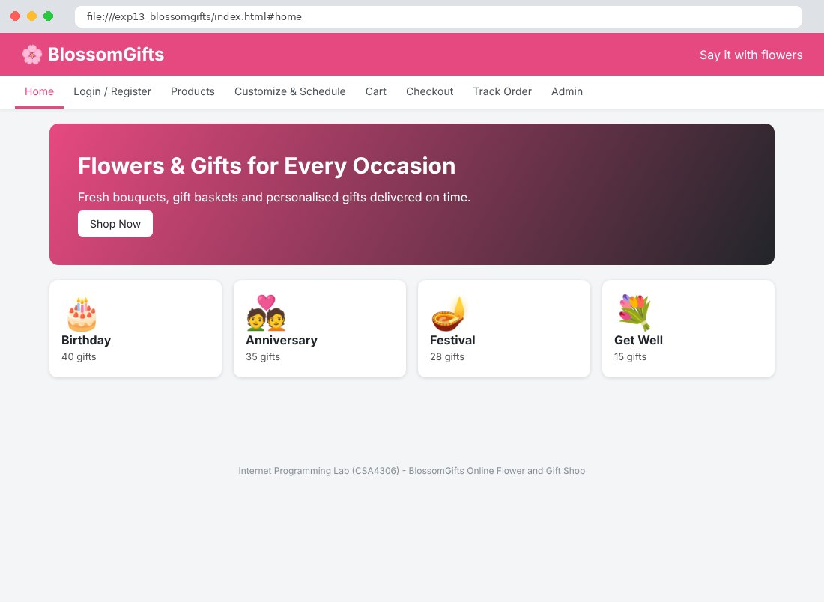
Fig. 13.2 Login / Register Page
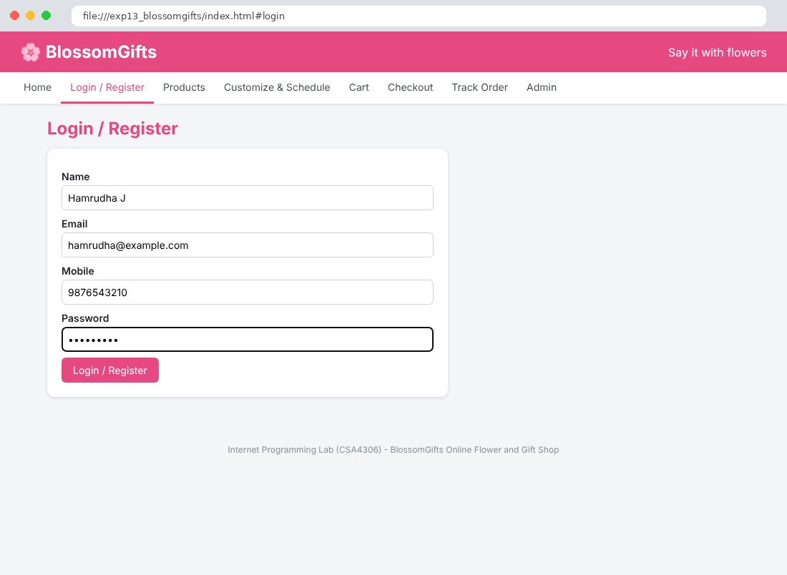
Fig. 13.3 Products Page
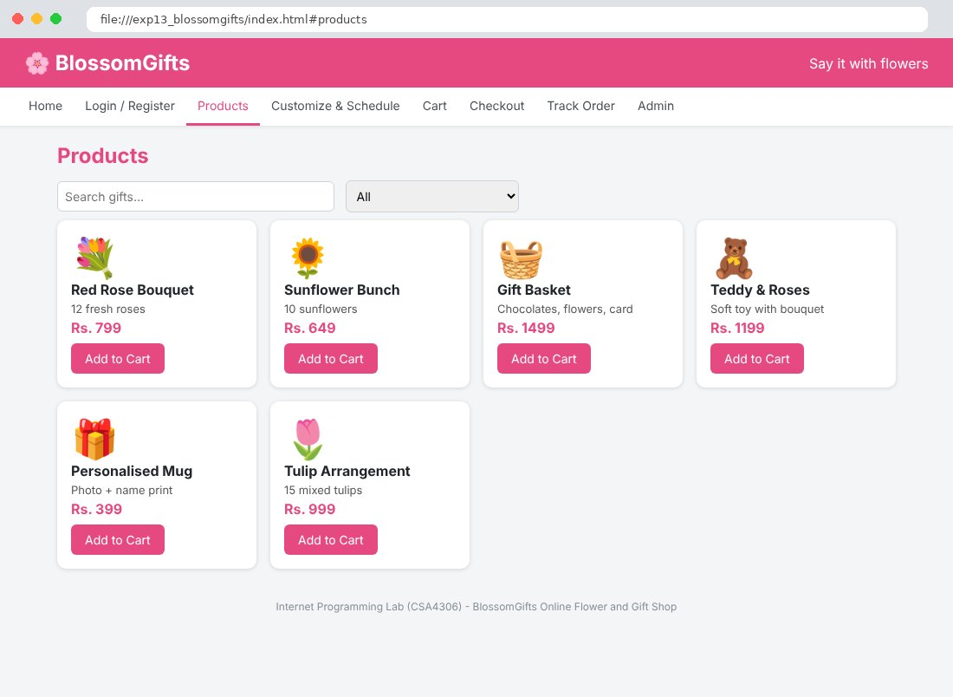
Fig. 13.4 Customize & Schedule Page
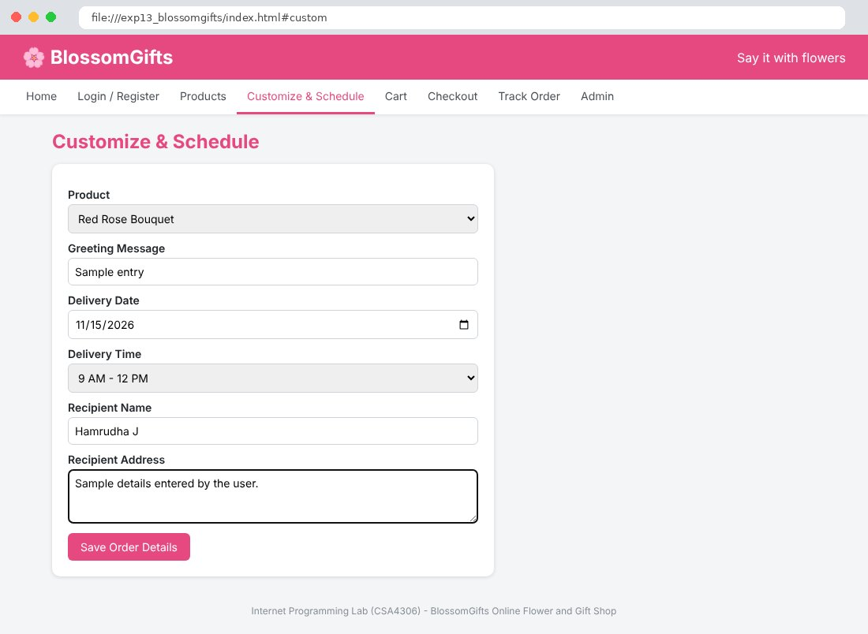
Fig. 13.5 Cart Page
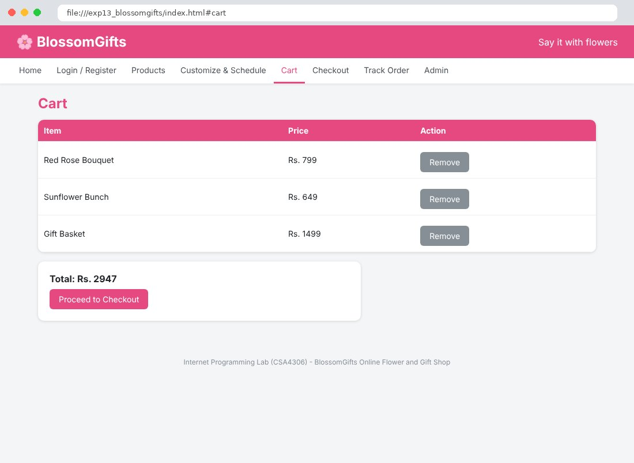
Fig. 13.6 Checkout Page
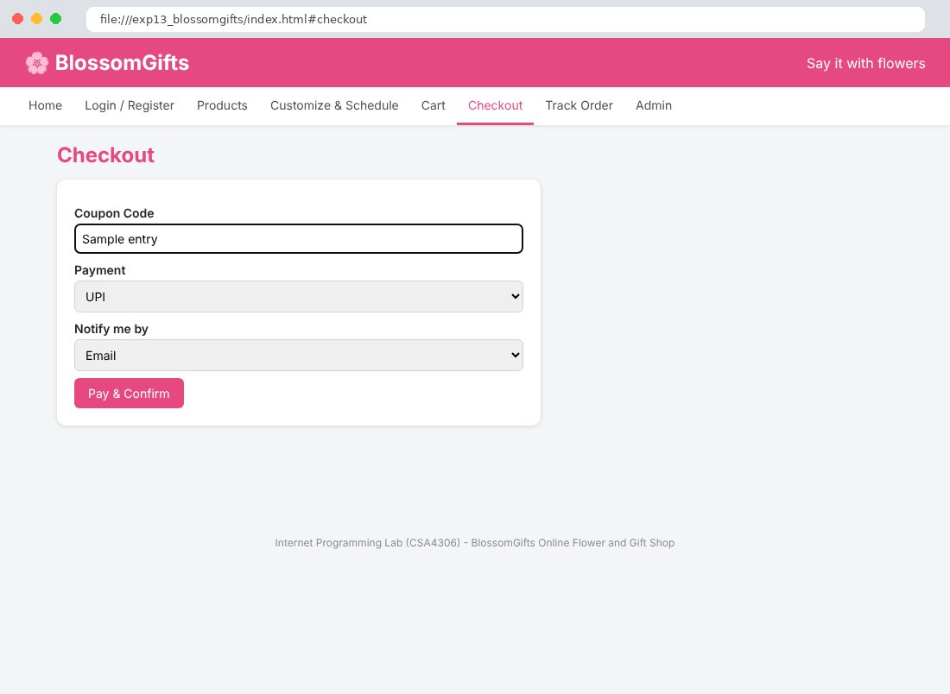
Fig. 13.7 Track Order Page
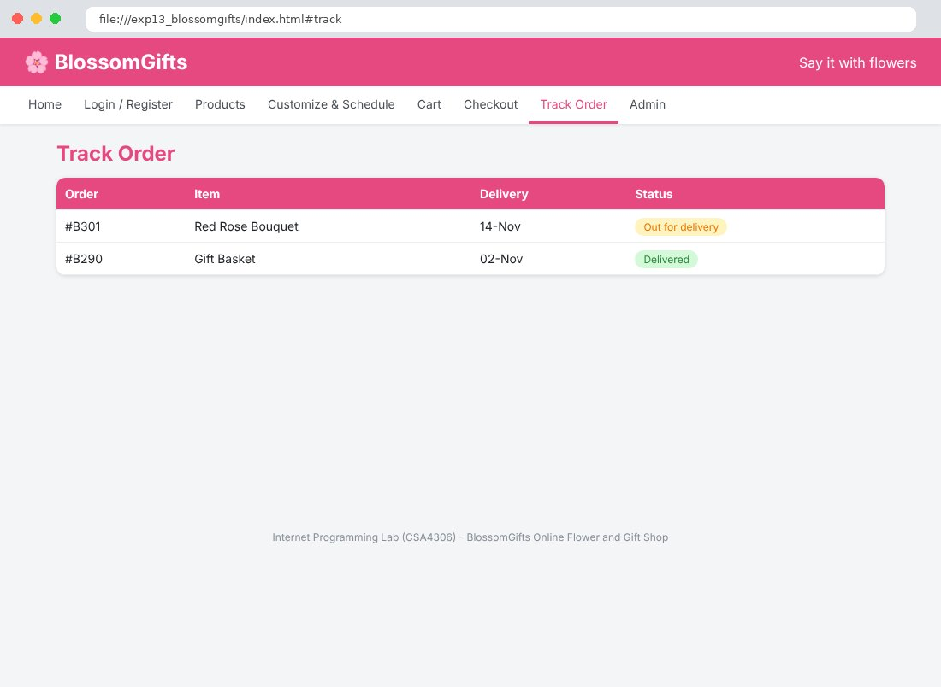
Fig. 13.8 Admin Page
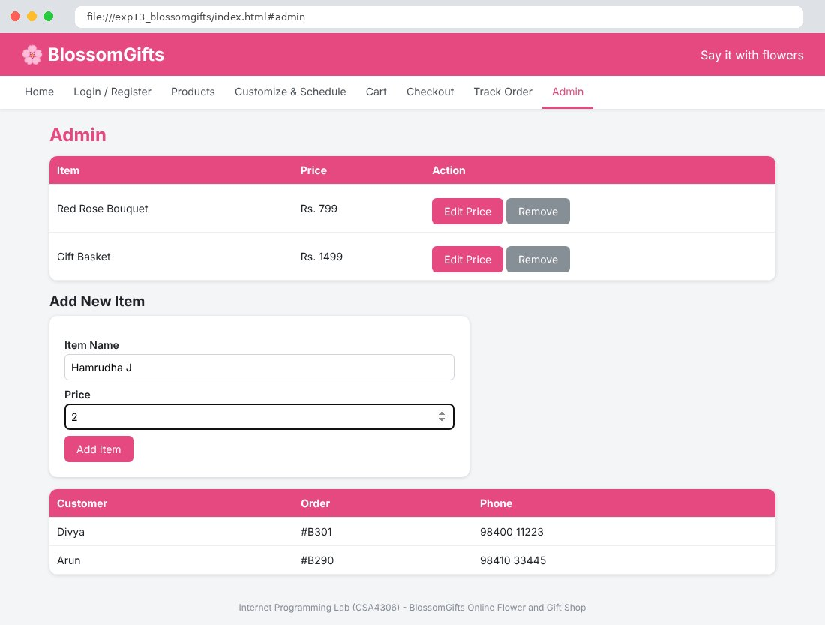

Result
Thus the BlossomGifts Online Flower and Gift Shop website was designed and developed using HTML, CSS and JavaScript, and the output was verified successfully.

