LAB EXPERIMENT 14
ReNewMarket Second-hand Marketplace

SUBJECT CODE | CSA4306
SUBJECT NAME | INTERNET PROGRAMMING
NAME | HAMRUDHA J
REG NO | 192411266
EXPERIMENTS | 6 to 20

Experiment 14: ReNewMarket Second-hand Marketplace

Question
ReNewMarket, a dynamic online marketplace, connects buyers and sellers of second-hand goods with ease. The website features a broad range of categories, including electronics, furniture, clothing, and collectibles. Key functionalities include user registration and login, a user-friendly listing creation tool for sellers, and advanced search and filtering options for buyers. Listings include detailed descriptions, photos, and pricing information, with the option to negotiate prices directly with sellers. Users can track their transactions, leave feedback, and manage their favorite items and notifications. The platform also provides secure payment options and a simple process for arranging item pick-ups or deliveries. ReNewMarket aims to provide a reliable and convenient space for exchanging pre-loved items while promoting sustainability
User Management
- The system login successfully and the network connection is working.
- The administrator set login account and password.
- Editing User
- Deleting User
Category Management
- Add category information.
- Delete category information
Commodity Management
- Editing Commodity
- deleting Commodity
Order Management
- Change logistics status: (Shipped/ Received)
- Delete Order

Aim
To develop an online marketplace for second-hand goods with user login, listing creation, search and filter, price negotiation, transaction tracking, feedback, and an admin panel for user, category, commodity and order management.

Software / Tools Required
HTML5, CSS3 and JavaScript; any text editor (VS Code / Notepad++); a web browser (Google Chrome).

Algorithm
1. Start.
2. Create a folder for the project and a file index.html.
3. Design the common header (ReNewMarket) and the navigation bar using HTML.
4. Create one section (page) for each module: Home, Login / Register, Listings, Item & Negotiate, Create Listing, My Transactions, Admin Panel.
5. Design forms with labels, text fields, drop-down lists and buttons for user input.
6. Apply CSS for the layout, colours, cards, tables and responsive grid.
7. Write JavaScript functions to switch between pages, validate and submit forms, search and filter items.
8. Open index.html in the browser, test every page and verify the output.
9. Stop.

Program (index.html)
<!DOCTYPE html>
<html lang="en">
<head>
<meta charset="UTF-8">
<meta name="viewport" content="width=device-width, initial-scale=1">
<title>ReNewMarket - ReNewMarket Second-hand Marketplace</title>
<style>
:root{--c:#2f9e44}
*{box-sizing:border-box;margin:0;font-family:'Segoe UI',Arial,sans-serif}
body{background:#f4f5f7;color:#212529}
header{background:var(--c);color:#fff;padding:14px 28px;display:flex;justify-content:space-between;align-items:center}
header h1{font-size:24px}
nav{background:#fff;padding:0 20px;display:flex;flex-wrap:wrap;box-shadow:0 2px 4px #0001}
nav a{padding:12px 13px;cursor:pointer;font-size:14px;color:#495057;border-bottom:3px solid transparent}
nav a.on,nav a:hover{color:var(--c);border-color:var(--c)}
main{max-width:1000px;margin:20px auto;padding:0 16px;min-height:420px}
.page{display:none}.page.active{display:block}
h2{margin-bottom:14px;color:var(--c)}
h3{margin:14px 0 8px}
.hero{background:linear-gradient(120deg,var(--c),#212529);color:#fff;border-radius:12px;padding:38px;margin-bottom:20px}
.hero h2{color:#fff;font-size:30px}
.grid{display:grid;grid-template-columns:repeat(auto-fill,minmax(200px,1fr));gap:16px;margin-bottom:16px}
.card{background:#fff;border-radius:10px;padding:16px;box-shadow:0 1px 5px #0002}
.card .ic{font-size:44px}
.card p{font-size:13px;color:#555;margin:4px 0}
.price{color:var(--c);font-weight:700}
.btn{background:var(--c);color:#fff;border:0;padding:9px 16px;border-radius:6px;cursor:pointer;margin-top:8px;font-size:14px}
.btn.alt{background:#868e96}
form,.box{background:#fff;padding:20px;border-radius:10px;box-shadow:0 1px 5px #0002;max-width:560px;margin-bottom:16px}
label{display:block;margin:10px 0 4px;font-size:14px;font-weight:600}
input,select,textarea{width:100%;padding:8px;border:1px solid #ced4da;border-radius:6px;font-size:14px}
table{width:100%;border-collapse:collapse;background:#fff;border-radius:10px;overflow:hidden;box-shadow:0 1px 5px #0002;margin-bottom:16px}
th{background:var(--c);color:#fff;text-align:left}
th,td{padding:10px;border-bottom:1px solid #eee;font-size:14px}
.stats{display:flex;gap:16px;margin-bottom:16px}
.stat{flex:1;background:#fff;border-radius:10px;padding:16px;text-align:center;box-shadow:0 1px 5px #0002}
.stat b{display:block;font-size:26px;color:var(--c)}
.tag{background:#e9ecef;border-radius:12px;padding:3px 10px;font-size:12px}
.ok{background:#d3f9d8;color:#2b8a3e}.wait{background:#fff3bf;color:#e67700}.bad{background:#ffe3e3;color:#c92a2a}
.map{height:240px;border-radius:10px;background:repeating-linear-gradient(45deg,#dff3e3,#dff3e3 20px,#cfe8d5 20px,#cfe8d5 40px);position:relative;margin-bottom:12px;cursor:crosshair;overflow:hidden}
.pin{position:absolute;font-size:26px;transform:translate(-50%,-100%)}
.bar{height:22px;background:var(--c);border-radius:4px;color:#fff;font-size:12px;padding:2px 8px}
.qr{display:grid;grid-template-columns:repeat(15,12px);gap:0;width:180px;border:8px solid #fff;box-shadow:0 1px 5px #0002}
.qr i{width:12px;height:12px;background:#fff}.qr i.k{background:#000}
#toast{position:fixed;bottom:24px;right:24px;background:#212529;color:#fff;padding:12px 20px;border-radius:8px;display:none}
footer{text-align:center;padding:16px;font-size:12px;color:#868e96}
</style>
</head>
<body>
<header><h1>♻️ ReNewMarket</h1><span>Buy. Sell. Reuse.</span></header>
<nav>
<a data-p="home" onclick="show('home')">Home</a>
<a data-p="login" onclick="show('login')">Login / Register</a>
<a data-p="listings" onclick="show('listings')">Listings</a>
<a data-p="item" onclick="show('item')">Item & Negotiate</a>
<a data-p="sell" onclick="show('sell')">Create Listing</a>
<a data-p="trans" onclick="show('trans')">My Transactions</a>
<a data-p="admin" onclick="show('admin')">Admin Panel</a>
</nav>
<main>
<section class="page" id="home">
<div class="hero"><h2>Give Old Things a New Home</h2><p>Buy and sell electronics, furniture, clothing and collectibles.</p><button class="btn" style="background:#fff;color:#212529" onclick="show('listings')">Browse Listings</button></div><div class="grid" id="cards">
<div class="card" data-c=""><div class="ic">📺</div><b>Electronics</b><p>120 items</p></div>
<div class="card" data-c=""><div class="ic">🛋️</div><b>Furniture</b><p>85 items</p></div>
<div class="card" data-c=""><div class="ic">🧥</div><b>Clothing</b><p>60 items</p></div>
<div class="card" data-c=""><div class="ic">🪙</div><b>Collectibles</b><p>30 items</p></div>
</div>
</section>
<section class="page" id="login">
<h2>Login / Register</h2>
<form data-msg="Login successful" data-go="listings">
<label>Name</label><input type="text" placeholder="Enter name" required>
<label>Email</label><input type="email" placeholder="Enter email" required>
<label>Password</label><input type="password" placeholder="Enter password" required>
<button class="btn">Login / Register</button>
</form>
</section>
<section class="page" id="listings">
<h2>Listings</h2>
<input placeholder="Search items..." onkeyup="filt(this,'#cards .card')" style="max-width:320px;margin-bottom:10px;display:inline-block">
<select onchange="catf(this.value,'#cards .card')" style="max-width:200px;margin-left:8px;display:inline-block"><option>All</option><option>Electronics</option><option>Furniture</option><option>Clothing</option><option>Collectibles</option></select>
<div class="grid" id="cards">
<div class="card" data-c="Electronics"><div class="ic">📺</div><b>LED TV 32"</b><p>2 years old, good condition</p><div class="price">Rs. 8500</div><button class="btn" onclick="show('item')">View</button></div>
<div class="card" data-c="Furniture"><div class="ic">🛋️</div><b>Sofa Set</b><p>3+1+1, teak wood</p><div class="price">Rs. 12000</div><button class="btn" onclick="show('item')">View</button></div>
<div class="card" data-c="Clothing"><div class="ic">🧥</div><b>Leather Jacket</b><p>Size M, lightly used</p><div class="price">Rs. 1800</div><button class="btn" onclick="show('item')">View</button></div>
<div class="card" data-c="Collectibles"><div class="ic">🪙</div><b>Old Coins</b><p>Collectors set of 25</p><div class="price">Rs. 3000</div><button class="btn" onclick="show('item')">View</button></div>
<div class="card" data-c="Electronics"><div class="ic">💻</div><b>Used Laptop</b><p>i5, 8 GB, 256 SSD</p><div class="price">Rs. 17500</div><button class="btn" onclick="show('item')">View</button></div>
<div class="card" data-c="Furniture"><div class="ic">🪑</div><b>Study Table</b><p>Wooden with drawers</p><div class="price">Rs. 2500</div><button class="btn" onclick="show('item')">View</button></div>
</div>
</section>
<section class="page" id="item">
<h2>Item & Negotiate</h2>
<div class="stats"><div class="stat"><b>Rs. 8500</b>Asking Price</div><div class="stat"><b>Chennai</b>Location</div><div class="stat"><b>Good</b>Condition</div></div><div class="box"><h3>📺 LED TV 32"</h3><p>Seller: Karthik · Used for 2 years, remote and box included.</p></div><form data-msg="Offer sent to seller">
<label>Your Offer (Rs.)</label><input type="number" placeholder="Enter your offer (rs.)" required>
<label>Message to Seller</label><textarea rows="3" required></textarea>
<button class="btn">Send Offer</button>
</form>
</section>
<section class="page" id="sell">
<h2>Create Listing</h2>
<form data-msg="Listing posted successfully">
<label>Title</label><input type="text" placeholder="Enter title" required>
<label>Category</label><select><option>Electronics</option><option>Furniture</option><option>Clothing</option><option>Collectibles</option></select>
<label>Price</label><input type="number" placeholder="Enter price" required>
<label>Description</label><textarea rows="3" required></textarea>
<label>Photos</label><input type="file">
<button class="btn">Post Listing</button>
</form>
</section>
<section class="page" id="trans">
<h2>My Transactions</h2>
<table>
<tr><th>Item</th><th>With</th><th>Amount</th><th>Status</th><th>Feedback</th></tr>
<tr><td>LED TV 32"</td><td>Karthik</td><td>Rs. 8000</td><td><span class="tag ok">Completed</span></td><td>⭐⭐⭐⭐⭐</td></tr>
<tr><td>Study Table</td><td>Meena</td><td>Rs. 2300</td><td><span class="tag wait">In Transit</span></td><td><button class="btn">Leave Feedback</button></td></tr>
</table>
</section>
<section class="page" id="admin">
<h2>Admin Panel</h2>
<table>
<tr><th>User</th><th>Email</th><th>Action</th></tr>
<tr><td>Karthik</td><td>karthik@mail.com</td><td><button class="btn">Edit</button> <button class="btn alt">Delete</button></td></tr>
<tr><td>Meena</td><td>meena@mail.com</td><td><button class="btn">Edit</button> <button class="btn alt">Delete</button></td></tr>
</table><h3>Category Management</h3>
<form data-msg="Category added">
<label>Category Name</label><input type="text" placeholder="Enter category name" required>
<button class="btn">Add Category</button>
</form><table>
<tr><th>Order</th><th>Item</th><th>Logistics Status</th><th>Action</th></tr>
<tr><td>#R12</td><td>LED TV 32"</td><td><span class="tag wait">Shipped</span></td><td><button class="btn">Mark Received</button> <button class="btn alt">Delete</button></td></tr>
<tr><td>#R11</td><td>Sofa Set</td><td><span class="tag ok">Received</span></td><td><button class="btn alt">Delete</button></td></tr>
</table>
</section>
</main>
<footer>Internet Programming Lab (CSA4306) - ReNewMarket Second-hand Marketplace</footer>
<div id="toast"></div>
<script>
function show(id){document.querySelectorAll('.page').forEach(p=>p.classList.toggle('active',p.id===id));
document.querySelectorAll('nav a').forEach(a=>a.classList.toggle('on',a.dataset.p===id));window.scrollTo(0,0)}
function toast(m){const t=document.getElementById('toast');t.textContent=m;t.style.display='block';setTimeout(()=>t.style.display='none',2200)}
document.addEventListener('submit',e=>{e.preventDefault();toast(e.target.dataset.msg||'Saved successfully');if(e.target.dataset.go)show(e.target.dataset.go)});
function filt(inp,sel){const v=inp.value.toLowerCase();document.querySelectorAll(sel).forEach(r=>r.style.display=r.textContent.toLowerCase().includes(v)?'':'none')}
function catf(v,sel){document.querySelectorAll(sel).forEach(r=>r.style.display=(v=='All'||r.dataset.c==v)?'':'none')}
show('home');
</script>
</body>
</html>

Output
Fig. 14.1 Home Page
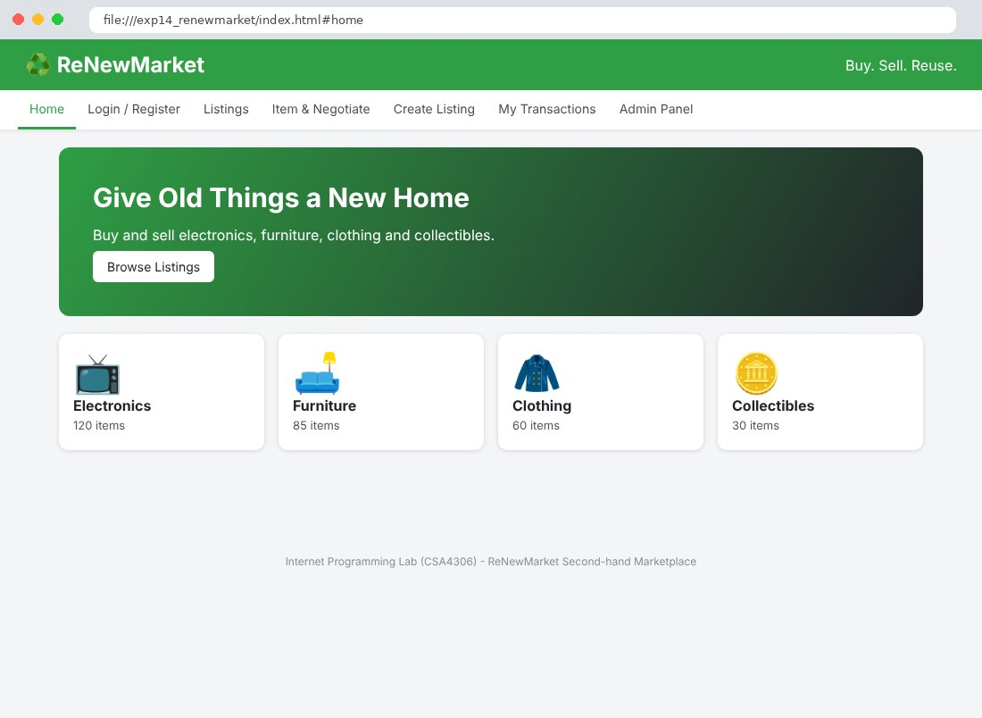
Fig. 14.2 Login / Register Page
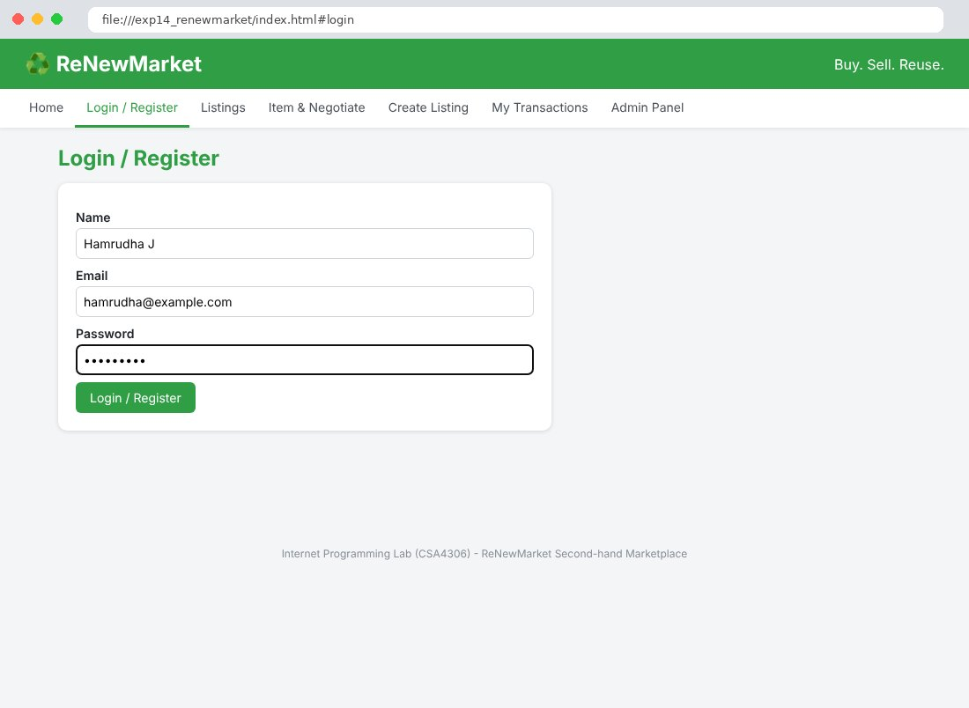
Fig. 14.3 Listings Page
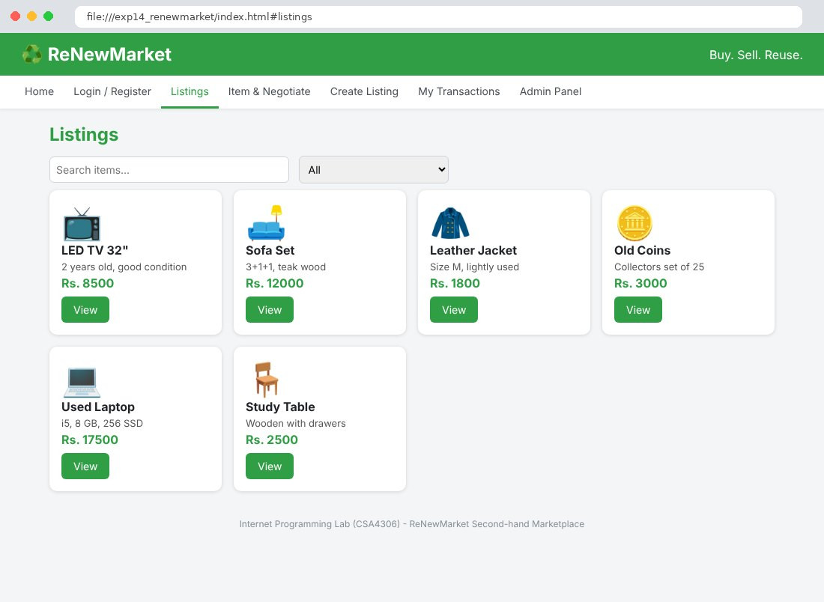
Fig. 14.4 Item & Negotiate Page
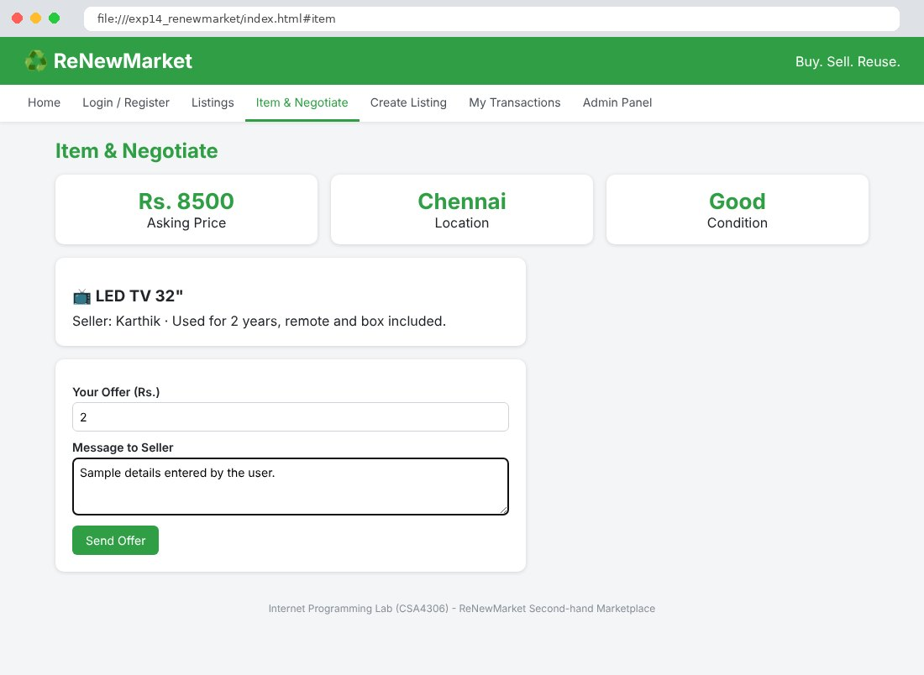
Fig. 14.5 Create Listing Page
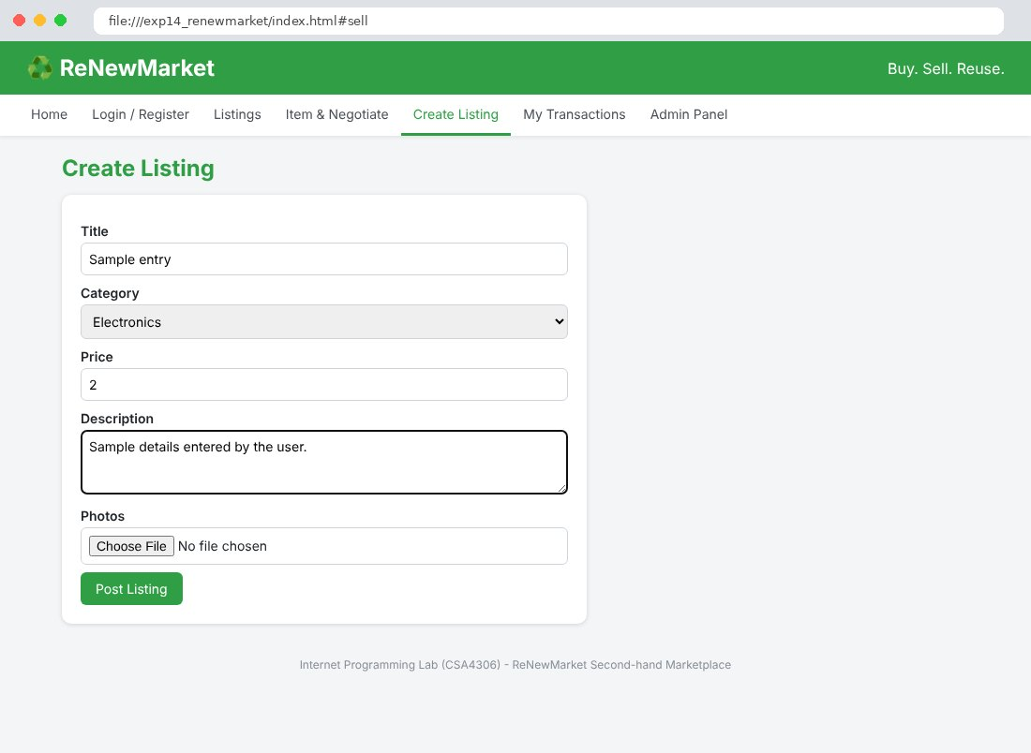
Fig. 14.6 My Transactions Page
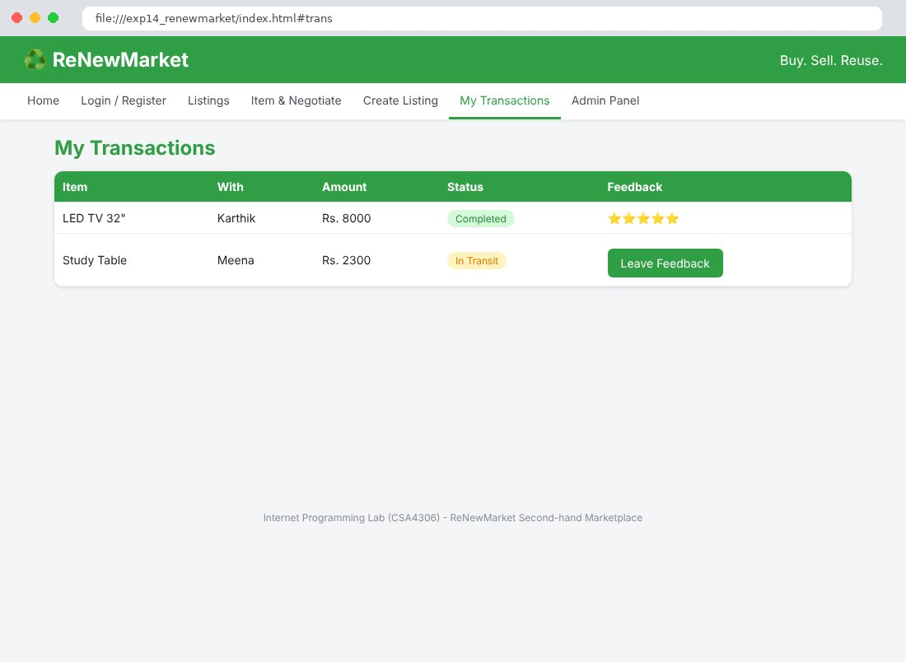
Fig. 14.7 Admin Panel Page
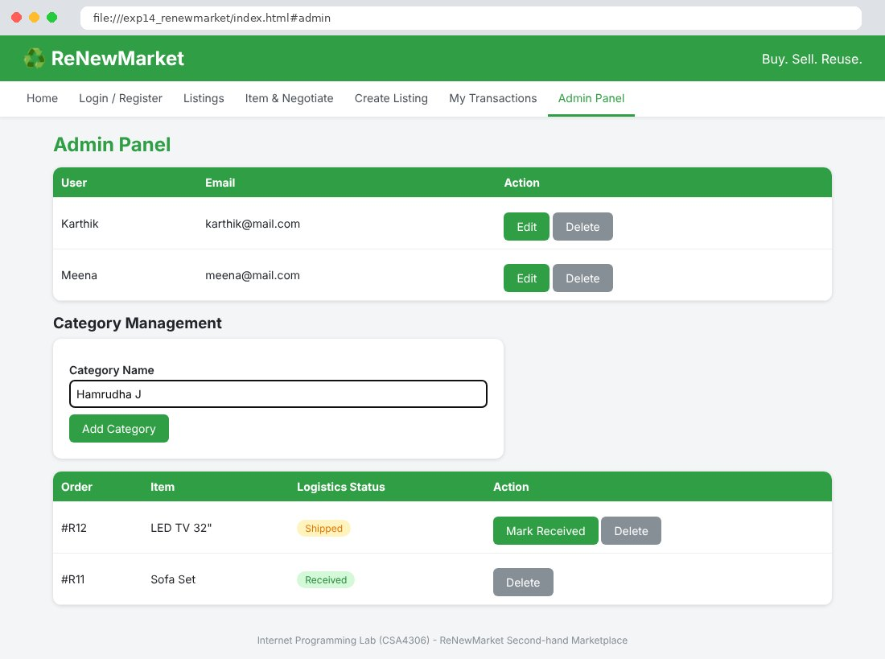

Result
Thus the ReNewMarket Second-hand Marketplace website was designed and developed using HTML, CSS and JavaScript, and the output was verified successfully.

