LAB EXPERIMENT 15
EasyToll Online Toll Payment System

SUBJECT CODE | CSA4306
SUBJECT NAME | INTERNET PROGRAMMING
NAME | HAMRUDHA J
REG NO | 192411266
EXPERIMENTS | 6 to 20

Experiment 15: EasyToll Online Toll Payment System

Question
EasyToll, an advanced online toll payment system, simplifies the process of managing toll fees for drivers. The website allows users to register and log in to access their toll account, where they can view and pay outstanding toll charges from various toll gates. Key functionalities include real-time toll balance updates, automatic payment options, and the ability to add or update vehicle details. Users can view detailed transaction history, set up recurring payments for frequent routes, and receive notifications for upcoming toll charges. The platform also supports secure payment methods and provides a user-friendly interface for managing toll accounts and reviewing payment summaries. EasyToll aims to enhance the convenience of toll payments and reduce wait times at toll booths, This website should help the user to pay toll in advance therefore not to wait in queue while travelling.
Admin:
- Login
- Manage User & Toll pass
- Manage Toll login
- Approve toll pass
- Generate QR Code
- Create Toll details
User:
- Register
- Login
- Add Money – eWallet
- Buy Toll eTicket
- Apply New toll pass
- Renewal toll pass
- Apply Toll pass
- Get QR Code for Toll pass
Toll Gate User :
- Login
- Scan QR
- Verify toll pass ID
- Verify Toll ticket
- Update toll location

Aim
To develop an online toll payment system where users register, add money to an e-wallet, buy toll e-tickets, apply and renew toll passes and get a QR code, admin approves passes, and toll gate staff scan and verify passes and tickets.

Software / Tools Required
HTML5, CSS3 and JavaScript; any text editor (VS Code / Notepad++); a web browser (Google Chrome).

Algorithm
1. Start.
2. Create a folder for the project and a file index.html.
3. Design the common header (EasyToll) and the navigation bar using HTML.
4. Create one section (page) for each module: Home, Register / Login, e-Wallet, Buy Toll e-Ticket, Apply / Renew Pass, Admin Panel, Toll Gate Scan.
5. Design forms with labels, text fields, drop-down lists and buttons for user input.
6. Apply CSS for the layout, colours, cards, tables and responsive grid.
7. Write JavaScript functions to switch between pages, validate and submit forms, search and filter items.
8. Open index.html in the browser, test every page and verify the output.
9. Stop.

Program (index.html)
<!DOCTYPE html>
<html lang="en">
<head>
<meta charset="UTF-8">
<meta name="viewport" content="width=device-width, initial-scale=1">
<title>EasyToll - EasyToll Online Toll Payment System</title>
<style>
:root{--c:#e8590c}
*{box-sizing:border-box;margin:0;font-family:'Segoe UI',Arial,sans-serif}
body{background:#f4f5f7;color:#212529}
header{background:var(--c);color:#fff;padding:14px 28px;display:flex;justify-content:space-between;align-items:center}
header h1{font-size:24px}
nav{background:#fff;padding:0 20px;display:flex;flex-wrap:wrap;box-shadow:0 2px 4px #0001}
nav a{padding:12px 13px;cursor:pointer;font-size:14px;color:#495057;border-bottom:3px solid transparent}
nav a.on,nav a:hover{color:var(--c);border-color:var(--c)}
main{max-width:1000px;margin:20px auto;padding:0 16px;min-height:420px}
.page{display:none}.page.active{display:block}
h2{margin-bottom:14px;color:var(--c)}
h3{margin:14px 0 8px}
.hero{background:linear-gradient(120deg,var(--c),#212529);color:#fff;border-radius:12px;padding:38px;margin-bottom:20px}
.hero h2{color:#fff;font-size:30px}
.grid{display:grid;grid-template-columns:repeat(auto-fill,minmax(200px,1fr));gap:16px;margin-bottom:16px}
.card{background:#fff;border-radius:10px;padding:16px;box-shadow:0 1px 5px #0002}
.card .ic{font-size:44px}
.card p{font-size:13px;color:#555;margin:4px 0}
.price{color:var(--c);font-weight:700}
.btn{background:var(--c);color:#fff;border:0;padding:9px 16px;border-radius:6px;cursor:pointer;margin-top:8px;font-size:14px}
.btn.alt{background:#868e96}
form,.box{background:#fff;padding:20px;border-radius:10px;box-shadow:0 1px 5px #0002;max-width:560px;margin-bottom:16px}
label{display:block;margin:10px 0 4px;font-size:14px;font-weight:600}
input,select,textarea{width:100%;padding:8px;border:1px solid #ced4da;border-radius:6px;font-size:14px}
table{width:100%;border-collapse:collapse;background:#fff;border-radius:10px;overflow:hidden;box-shadow:0 1px 5px #0002;margin-bottom:16px}
th{background:var(--c);color:#fff;text-align:left}
th,td{padding:10px;border-bottom:1px solid #eee;font-size:14px}
.stats{display:flex;gap:16px;margin-bottom:16px}
.stat{flex:1;background:#fff;border-radius:10px;padding:16px;text-align:center;box-shadow:0 1px 5px #0002}
.stat b{display:block;font-size:26px;color:var(--c)}
.tag{background:#e9ecef;border-radius:12px;padding:3px 10px;font-size:12px}
.ok{background:#d3f9d8;color:#2b8a3e}.wait{background:#fff3bf;color:#e67700}.bad{background:#ffe3e3;color:#c92a2a}
.map{height:240px;border-radius:10px;background:repeating-linear-gradient(45deg,#dff3e3,#dff3e3 20px,#cfe8d5 20px,#cfe8d5 40px);position:relative;margin-bottom:12px;cursor:crosshair;overflow:hidden}
.pin{position:absolute;font-size:26px;transform:translate(-50%,-100%)}
.bar{height:22px;background:var(--c);border-radius:4px;color:#fff;font-size:12px;padding:2px 8px}
.qr{display:grid;grid-template-columns:repeat(15,12px);gap:0;width:180px;border:8px solid #fff;box-shadow:0 1px 5px #0002}
.qr i{width:12px;height:12px;background:#fff}.qr i.k{background:#000}
#toast{position:fixed;bottom:24px;right:24px;background:#212529;color:#fff;padding:12px 20px;border-radius:8px;display:none}
footer{text-align:center;padding:16px;font-size:12px;color:#868e96}
</style>
</head>
<body>
<header><h1>🛣️ EasyToll</h1><span>Pay toll, skip the queue</span></header>
<nav>
<a data-p="home" onclick="show('home')">Home</a>
<a data-p="login" onclick="show('login')">Register / Login</a>
<a data-p="wallet" onclick="show('wallet')">e-Wallet</a>
<a data-p="ticket" onclick="show('ticket')">Buy Toll e-Ticket</a>
<a data-p="pass" onclick="show('pass')">Apply / Renew Pass</a>
<a data-p="admin" onclick="show('admin')">Admin Panel</a>
<a data-p="gate" onclick="show('gate')">Toll Gate Scan</a>
</nav>
<main>
<section class="page" id="home">
<div class="hero"><h2>Smart Toll Payment</h2><p>Pay tolls from your e-wallet, buy e-tickets and get a QR toll pass.</p><button class="btn" style="background:#fff;color:#212529" onclick="show('wallet')">Open Wallet</button></div><div class="stats"><div class="stat"><b>Rs. 850</b>Wallet Balance</div><div class="stat"><b>2</b>Active Passes</div><div class="stat"><b>14</b>Trips this month</div></div>
</section>
<section class="page" id="login">
<h2>Register / Login</h2>
<form data-msg="Login successful" data-go="wallet">
<label>Role</label><select><option>User</option><option>Admin</option><option>Toll Gate User</option></select>
<label>Name</label><input type="text" placeholder="Enter name" required>
<label>Mobile</label><input type="tel" placeholder="Enter mobile" required>
<label>Password</label><input type="password" placeholder="Enter password" required>
<button class="btn">Login</button>
</form>
</section>
<section class="page" id="wallet">
<h2>e-Wallet</h2>
<div class="stats"><div class="stat"><b>Rs. 850</b>Balance</div></div><form data-msg="Money added to e-wallet">
<label>Amount (Rs.)</label><input type="number" placeholder="Enter amount (rs.)" required>
<label>Payment</label><select><option>UPI</option><option>Card</option><option>Net Banking</option></select>
<button class="btn">Add Money</button>
</form>
</section>
<section class="page" id="ticket">
<h2>Buy Toll e-Ticket</h2>
<form data-msg="e-Ticket purchased">
<label>Vehicle No</label><input type="text" placeholder="Enter vehicle no" required>
<label>Vehicle Type</label><select><option>Car</option><option>Van</option><option>Bus</option><option>Truck</option></select>
<label>Toll Gate</label><select><option>Chennai Bypass</option><option>Vandalur</option><option>Sriperumbudur</option></select>
<label>Journey</label><select><option>Single</option><option>Return</option><option>Monthly</option></select>
<button class="btn">Buy e-Ticket</button>
</form>
</section>
<section class="page" id="pass">
<h2>Apply / Renew Pass</h2>
<form data-msg="Application submitted for approval">
<label>Vehicle No</label><input type="text" placeholder="Enter vehicle no" required>
<label>Owner Name</label><input type="text" placeholder="Enter owner name" required>
<label>Pass Type</label><select><option>New Pass</option><option>Renewal</option></select>
<label>Duration</label><select><option>1 Month</option><option>3 Months</option><option>1 Year</option></select>
<label>Upload RC Book</label><input type="file">
<button class="btn">Submit Application</button>
</form><h3>My QR Toll Pass</h3><div class="qr" id="qr1"></div>
</section>
<section class="page" id="admin">
<h2>Admin Panel</h2>
<table>
<tr><th>Vehicle</th><th>Owner</th><th>Pass</th><th>Status</th><th>Action</th></tr>
<tr><td>TN 01 AB 1234</td><td>Hamrudha</td><td>1 Year</td><td><span class="tag wait">Pending</span></td><td><button class="btn">Approve</button></td></tr>
<tr><td>TN 09 CD 5678</td><td>Karthik</td><td>1 Month</td><td><span class="tag ok">Approved</span></td><td><button class="btn">Generate QR</button></td></tr>
</table><h3>Create Toll Details</h3>
<form data-msg="Toll details created">
<label>Toll Gate Name</label><input type="text" placeholder="Enter toll gate name" required>
<label>Location</label><input type="text" placeholder="Enter location" required>
<label>Fare (Rs.)</label><input type="number" placeholder="Enter fare (rs.)" required>
<button class="btn">Create Toll Details</button>
</form>
</section>
<section class="page" id="gate">
<h2>Toll Gate Scan</h2>
<h3>Scan QR & Verify</h3>
<form data-msg="Pass verified: VALID">
<label>Scan / Enter Pass ID</label><input type="text" placeholder="Enter scan / enter pass id" required>
<button class="btn">Verify Pass</button>
</form><div class="qr" id="qr2"></div><p style="margin-top:10px">Status: <span class="tag ok">Valid pass - Barrier open</span></p><form data-msg="Location updated">
<label>Toll Location</label><input type="text" placeholder="Enter toll location" required>
<button class="btn">Update Toll Location</button>
</form>
</section>
</main>
<footer>Internet Programming Lab (CSA4306) - EasyToll Online Toll Payment System</footer>
<div id="toast"></div>
<script>
function show(id){document.querySelectorAll('.page').forEach(p=>p.classList.toggle('active',p.id===id));
document.querySelectorAll('nav a').forEach(a=>a.classList.toggle('on',a.dataset.p===id));window.scrollTo(0,0)}
function toast(m){const t=document.getElementById('toast');t.textContent=m;t.style.display='block';setTimeout(()=>t.style.display='none',2200)}
document.addEventListener('submit',e=>{e.preventDefault();toast(e.target.dataset.msg||'Saved successfully');if(e.target.dataset.go)show(e.target.dataset.go)});
function filt(inp,sel){const v=inp.value.toLowerCase();document.querySelectorAll(sel).forEach(r=>r.style.display=r.textContent.toLowerCase().includes(v)?'':'none')}
function catf(v,sel){document.querySelectorAll(sel).forEach(r=>r.style.display=(v=='All'||r.dataset.c==v)?'':'none')}
function qr(id,seed){const q=document.getElementById(id);let s=seed,h='';
for(let i=0;i<225;i++){s=(s*1103515245+12345)%2147483648;const r=Math.floor(i/15),c=i%15;
const f=(r<5&&c<5)||(r<5&&c>9)||(r>9&&c<5);h+='<i class="'+((f?(r%4!=1&&r%4!=3||c%4==0||c==4):s%3==0)?'k':'')+'"></i>'}q.innerHTML=h}
show('home');qr('qr1',7);qr('qr2',7)
</script>
</body>
</html>

Output
Fig. 15.1 Home Page
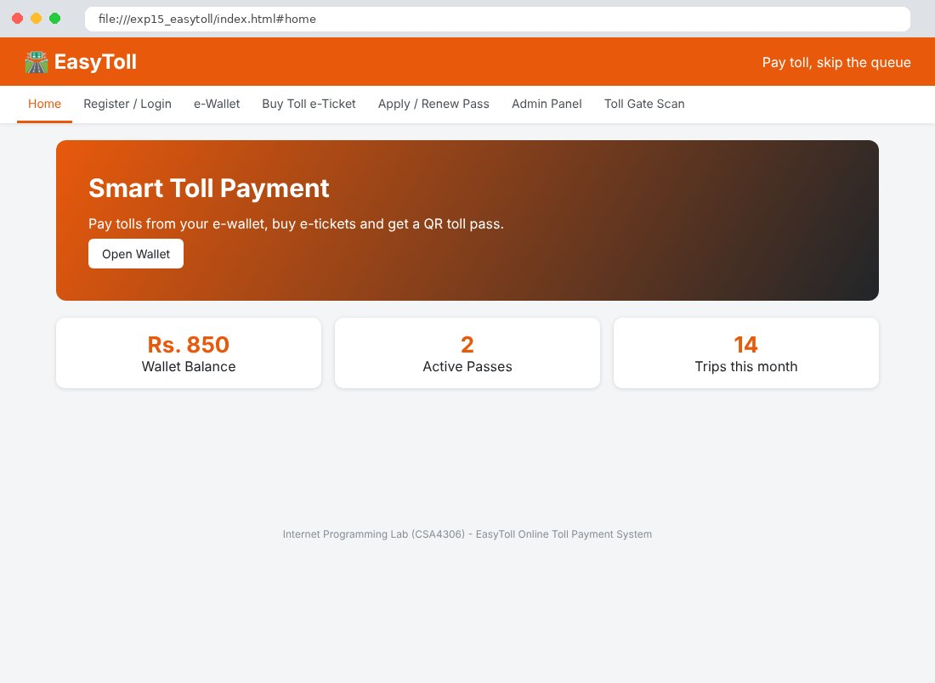
Fig. 15.2 Register / Login Page
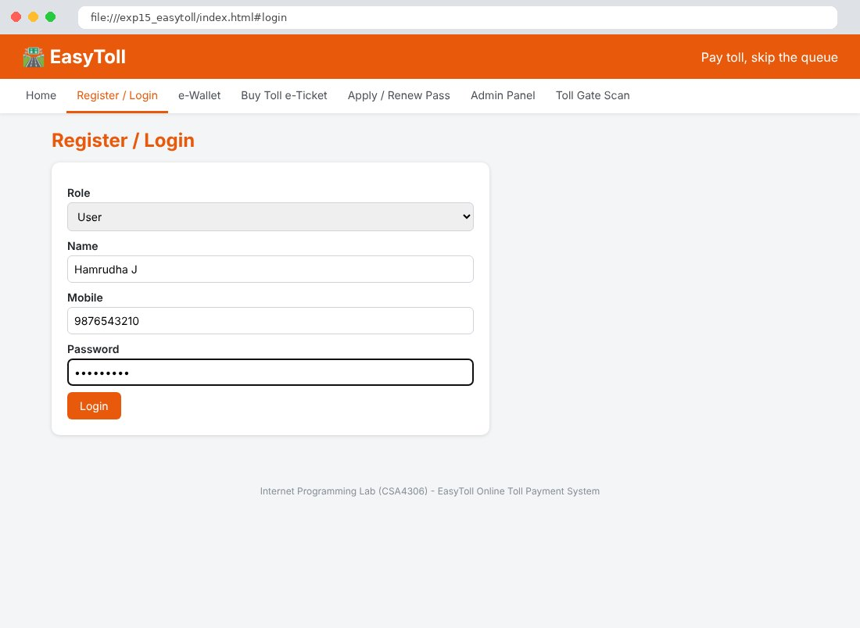
Fig. 15.3 e-Wallet Page
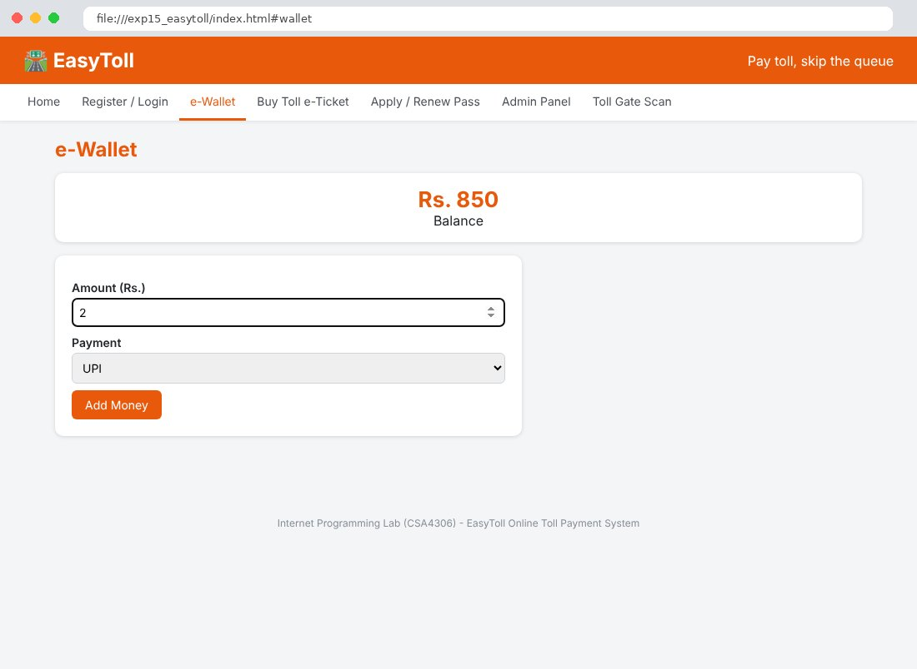
Fig. 15.4 Buy Toll e-Ticket Page
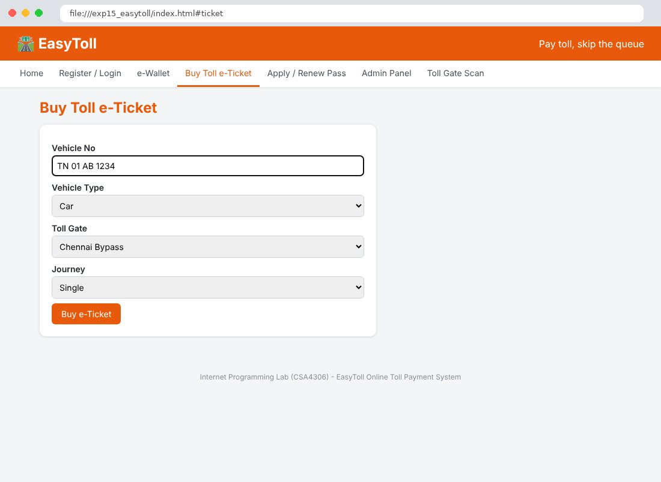
Fig. 15.5 Apply / Renew Pass Page
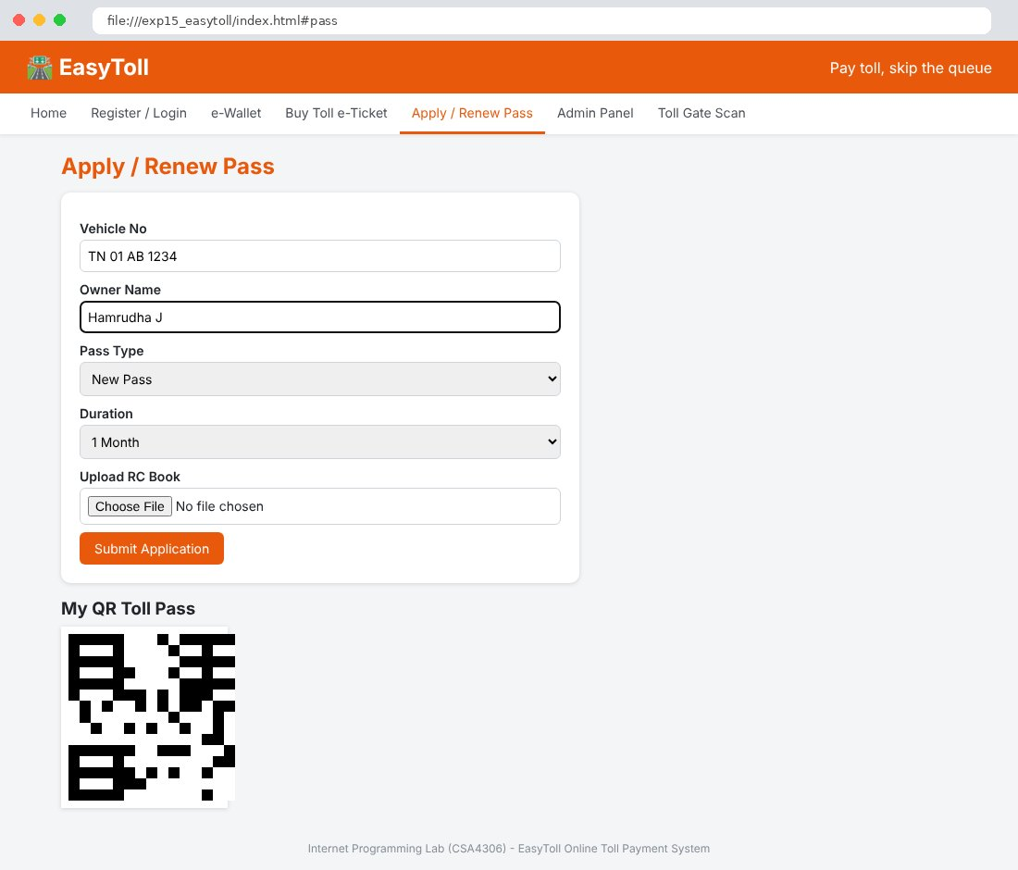
Fig. 15.6 Admin Panel Page
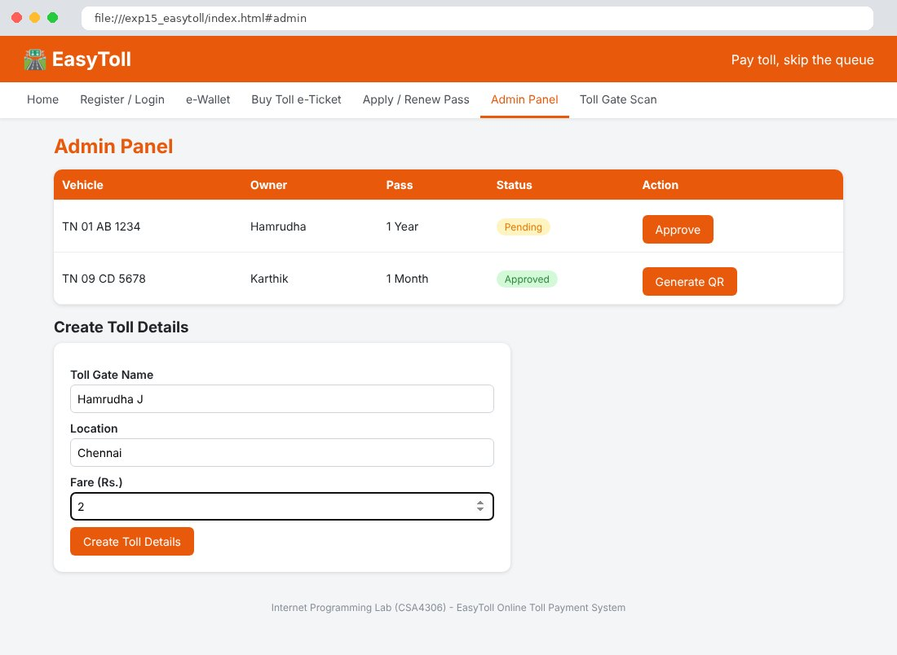
Fig. 15.7 Toll Gate Scan Page
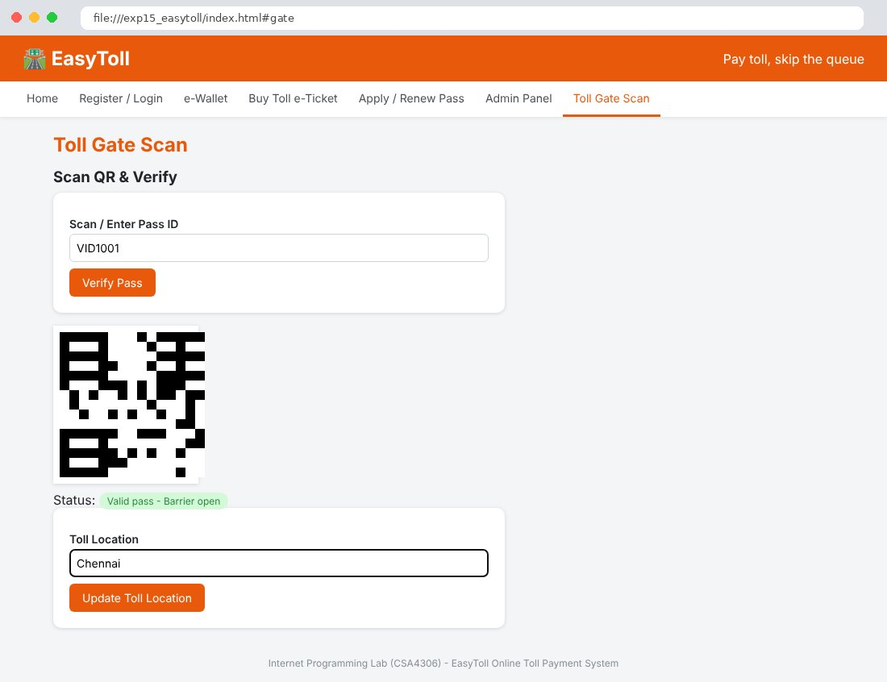

Result
Thus the EasyToll Online Toll Payment System website was designed and developed using HTML, CSS and JavaScript, and the output was verified successfully.

