LAB EXPERIMENT 16
ComplainEase Online Complaint Management

SUBJECT CODE | CSA4306
SUBJECT NAME | INTERNET PROGRAMMING
NAME | HAMRUDHA J
REG NO | 192411266
EXPERIMENTS | 6 to 20

Experiment 16: ComplainEase Online Complaint Management

Question
ComplainEase is a robust online platform designed to streamline the process of registering and managing complaints. The website allows users to easily submit complaints by filling out a detailed form that includes categories, descriptions, and supporting documents. Key functionalities include user registration and login, real-time complaint tracking, and status updates via email or SMS. Users can view their complaint history, receive feedback from resolution teams, and provide additional information or evidence if needed. The platform also includes a search feature for browsing common issues and solutions, and a dashboard for managing and resolving complaints efficiently. ComplainEase aims to improve responsiveness and transparency in handling user grievances, ensuring a smooth and effective resolution process.
USER
- Login
- Register
- Post Complaint
- Location Mark in Google Map
- View complaint status
- Feedback
- Get Admin Contact details
OFFICER
- Register
- Login
- View Complaint
- Update status
- Update proof of work
ADMIN
- Generate id & password for officer
- The administrator has full-fledged rights over the OES.
- Can create/delete an account.
- Can view the accounts.
- Can change the password.
- Can hide any kind of features from both of users.
- Insert the information of available on OES. Can access all the accounts of the officer.

Aim
To develop a complaint registration and management website where users post complaints with map location, track status and give feedback, officers update status and proof of work, and the admin generates officer credentials and manages accounts.

Software / Tools Required
HTML5, CSS3 and JavaScript; any text editor (VS Code / Notepad++); a web browser (Google Chrome).

Algorithm
1. Start.
2. Create a folder for the project and a file index.html.
3. Design the common header (ComplainEase) and the navigation bar using HTML.
4. Create one section (page) for each module: Home, Login / Register, Post Complaint, Complaint Status, Feedback & Contact, Officer Panel, Admin Panel.
5. Design forms with labels, text fields, drop-down lists and buttons for user input.
6. Apply CSS for the layout, colours, cards, tables and responsive grid.
7. Write JavaScript functions to switch between pages, validate and submit forms, search and filter items, and mark the location on the map.
8. Open index.html in the browser, test every page and verify the output.
9. Stop.

Program (index.html)
<!DOCTYPE html>
<html lang="en">
<head>
<meta charset="UTF-8">
<meta name="viewport" content="width=device-width, initial-scale=1">
<title>ComplainEase - ComplainEase Online Complaint Management</title>
<style>
:root{--c:#7048e8}
*{box-sizing:border-box;margin:0;font-family:'Segoe UI',Arial,sans-serif}
body{background:#f4f5f7;color:#212529}
header{background:var(--c);color:#fff;padding:14px 28px;display:flex;justify-content:space-between;align-items:center}
header h1{font-size:24px}
nav{background:#fff;padding:0 20px;display:flex;flex-wrap:wrap;box-shadow:0 2px 4px #0001}
nav a{padding:12px 13px;cursor:pointer;font-size:14px;color:#495057;border-bottom:3px solid transparent}
nav a.on,nav a:hover{color:var(--c);border-color:var(--c)}
main{max-width:1000px;margin:20px auto;padding:0 16px;min-height:420px}
.page{display:none}.page.active{display:block}
h2{margin-bottom:14px;color:var(--c)}
h3{margin:14px 0 8px}
.hero{background:linear-gradient(120deg,var(--c),#212529);color:#fff;border-radius:12px;padding:38px;margin-bottom:20px}
.hero h2{color:#fff;font-size:30px}
.grid{display:grid;grid-template-columns:repeat(auto-fill,minmax(200px,1fr));gap:16px;margin-bottom:16px}
.card{background:#fff;border-radius:10px;padding:16px;box-shadow:0 1px 5px #0002}
.card .ic{font-size:44px}
.card p{font-size:13px;color:#555;margin:4px 0}
.price{color:var(--c);font-weight:700}
.btn{background:var(--c);color:#fff;border:0;padding:9px 16px;border-radius:6px;cursor:pointer;margin-top:8px;font-size:14px}
.btn.alt{background:#868e96}
form,.box{background:#fff;padding:20px;border-radius:10px;box-shadow:0 1px 5px #0002;max-width:560px;margin-bottom:16px}
label{display:block;margin:10px 0 4px;font-size:14px;font-weight:600}
input,select,textarea{width:100%;padding:8px;border:1px solid #ced4da;border-radius:6px;font-size:14px}
table{width:100%;border-collapse:collapse;background:#fff;border-radius:10px;overflow:hidden;box-shadow:0 1px 5px #0002;margin-bottom:16px}
th{background:var(--c);color:#fff;text-align:left}
th,td{padding:10px;border-bottom:1px solid #eee;font-size:14px}
.stats{display:flex;gap:16px;margin-bottom:16px}
.stat{flex:1;background:#fff;border-radius:10px;padding:16px;text-align:center;box-shadow:0 1px 5px #0002}
.stat b{display:block;font-size:26px;color:var(--c)}
.tag{background:#e9ecef;border-radius:12px;padding:3px 10px;font-size:12px}
.ok{background:#d3f9d8;color:#2b8a3e}.wait{background:#fff3bf;color:#e67700}.bad{background:#ffe3e3;color:#c92a2a}
.map{height:240px;border-radius:10px;background:repeating-linear-gradient(45deg,#dff3e3,#dff3e3 20px,#cfe8d5 20px,#cfe8d5 40px);position:relative;margin-bottom:12px;cursor:crosshair;overflow:hidden}
.pin{position:absolute;font-size:26px;transform:translate(-50%,-100%)}
.bar{height:22px;background:var(--c);border-radius:4px;color:#fff;font-size:12px;padding:2px 8px}
.qr{display:grid;grid-template-columns:repeat(15,12px);gap:0;width:180px;border:8px solid #fff;box-shadow:0 1px 5px #0002}
.qr i{width:12px;height:12px;background:#fff}.qr i.k{background:#000}
#toast{position:fixed;bottom:24px;right:24px;background:#212529;color:#fff;padding:12px 20px;border-radius:8px;display:none}
footer{text-align:center;padding:16px;font-size:12px;color:#868e96}
</style>
</head>
<body>
<header><h1>📣 ComplainEase</h1><span>Your voice, our action</span></header>
<nav>
<a data-p="home" onclick="show('home')">Home</a>
<a data-p="login" onclick="show('login')">Login / Register</a>
<a data-p="post" onclick="show('post')">Post Complaint</a>
<a data-p="status" onclick="show('status')">Complaint Status</a>
<a data-p="feedback" onclick="show('feedback')">Feedback & Contact</a>
<a data-p="officer" onclick="show('officer')">Officer Panel</a>
<a data-p="admin" onclick="show('admin')">Admin Panel</a>
</nav>
<main>
<section class="page" id="home">
<div class="hero"><h2>Register Your Complaint Online</h2><p>Report civic issues, mark the location on the map and track progress.</p><button class="btn" style="background:#fff;color:#212529" onclick="show('post')">Post Complaint</button></div><div class="stats"><div class="stat"><b>1,250</b>Complaints</div><div class="stat"><b>1,040</b>Resolved</div><div class="stat"><b>83%</b>Resolution Rate</div></div>
</section>
<section class="page" id="login">
<h2>Login / Register</h2>
<form data-msg="Login successful" data-go="post">
<label>Role</label><select><option>User</option><option>Officer</option><option>Admin</option></select>
<label>Name</label><input type="text" placeholder="Enter name" required>
<label>Email</label><input type="email" placeholder="Enter email" required>
<label>Password</label><input type="password" placeholder="Enter password" required>
<button class="btn">Login</button>
</form>
</section>
<section class="page" id="post">
<h2>Post Complaint</h2>
<div class="map" onclick="pin(event)"></div>
<form data-msg="Complaint registered. ID: CMP1051" data-go="status">
<label>Category</label><select><option>Road</option><option>Water</option><option>Electricity</option><option>Sanitation</option></select>
<label>Description</label><textarea rows="3" required></textarea>
<label>Supporting Document</label><input type="file">
<label>Location (click map to mark)</label><input id="loc" placeholder="Click on the map to mark location" required>
<button class="btn">Submit Complaint</button>
</form>
</section>
<section class="page" id="status">
<h2>Complaint Status</h2>
<table>
<tr><th>ID</th><th>Category</th><th>Date</th><th>Status</th></tr>
<tr><td>CMP1051</td><td>Road</td><td>10-Nov</td><td><span class="tag wait">Registered</span></td></tr>
<tr><td>CMP1032</td><td>Water</td><td>02-Nov</td><td><span class="tag wait">In Progress</span></td></tr>
<tr><td>CMP1010</td><td>Electricity</td><td>20-Oct</td><td><span class="tag ok">Resolved</span></td></tr>
</table>
</section>
<section class="page" id="feedback">
<h2>Feedback & Contact</h2>
<form data-msg="Thank you for your feedback">
<label>Complaint ID</label><input type="text" placeholder="Enter complaint id" required>
<label>Rating</label><select><option>5 - Very Satisfied</option><option>4 - Satisfied</option><option>3 - Neutral</option><option>2 - Dissatisfied</option></select>
<label>Feedback</label><textarea rows="3" required></textarea>
<button class="btn">Send Feedback</button>
</form><div class="box"><b>Admin Contact:</b> admin@complainease.in · 044-2345 6789</div>
</section>
<section class="page" id="officer">
<h2>Officer Panel</h2>
<table>
<tr><th>ID</th><th>Category</th><th>Location</th><th>Status</th><th>Action</th></tr>
<tr><td>CMP1051</td><td>Road</td><td>Anna Nagar</td><td><span class="tag wait">Registered</span></td><td><button class="btn">Update Status</button></td></tr>
<tr><td>CMP1032</td><td>Water</td><td>Adyar</td><td><span class="tag wait">In Progress</span></td><td><button class="btn">Update Status</button></td></tr>
</table><h3>Update Status & Proof</h3>
<form data-msg="Status and proof updated">
<label>Complaint ID</label><input type="text" placeholder="Enter complaint id" required>
<label>Status</label><select><option>In Progress</option><option>Resolved</option></select>
<label>Proof of Work</label><input type="file">
<button class="btn">Update</button>
</form>
</section>
<section class="page" id="admin">
<h2>Admin Panel</h2>
<h3>Generate Officer Login</h3>
<form data-msg="Officer ID: OFF204, Password sent">
<label>Officer Name</label><input type="text" placeholder="Enter officer name" required>
<label>Department</label><select><option>Roads</option><option>Water</option><option>Electricity</option></select>
<button class="btn">Generate ID & Password</button>
</form><table>
<tr><th>Account</th><th>Role</th><th>Action</th></tr>
<tr><td>OFF201</td><td>Officer</td><td><button class="btn">Change Password</button> <button class="btn alt">Delete</button></td></tr>
<tr><td>USR880</td><td>User</td><td><button class="btn">View</button> <button class="btn alt">Delete</button></td></tr>
</table>
</section>
</main>
<footer>Internet Programming Lab (CSA4306) - ComplainEase Online Complaint Management</footer>
<div id="toast"></div>
<script>
function show(id){document.querySelectorAll('.page').forEach(p=>p.classList.toggle('active',p.id===id));
document.querySelectorAll('nav a').forEach(a=>a.classList.toggle('on',a.dataset.p===id));window.scrollTo(0,0)}
function toast(m){const t=document.getElementById('toast');t.textContent=m;t.style.display='block';setTimeout(()=>t.style.display='none',2200)}
document.addEventListener('submit',e=>{e.preventDefault();toast(e.target.dataset.msg||'Saved successfully');if(e.target.dataset.go)show(e.target.dataset.go)});
function filt(inp,sel){const v=inp.value.toLowerCase();document.querySelectorAll(sel).forEach(r=>r.style.display=r.textContent.toLowerCase().includes(v)?'':'none')}
function catf(v,sel){document.querySelectorAll(sel).forEach(r=>r.style.display=(v=='All'||r.dataset.c==v)?'':'none')}
function pin(e){const m=e.currentTarget,r=m.getBoundingClientRect(),x=e.clientX-r.left,y=e.clientY-r.top;
m.querySelectorAll('.pin').forEach(p=>p.remove());const p=document.createElement('span');p.className='pin';p.textContent='\u{1F4CD}';
p.style.left=x+'px';p.style.top=y+'px';m.appendChild(p);
document.getElementById('loc').value=(13.0+y/1000).toFixed(4)+', '+(80.0+x/1000).toFixed(4)}
show('home');
</script>
</body>
</html>

Output
Fig. 16.1 Home Page
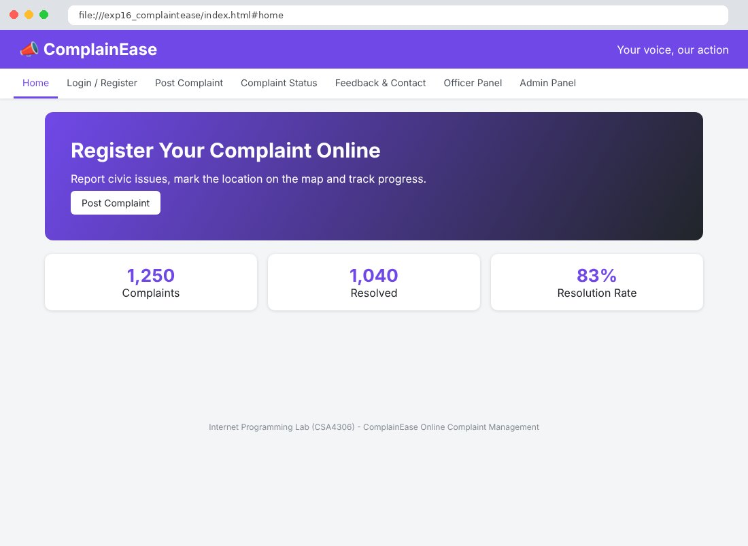
Fig. 16.2 Login / Register Page
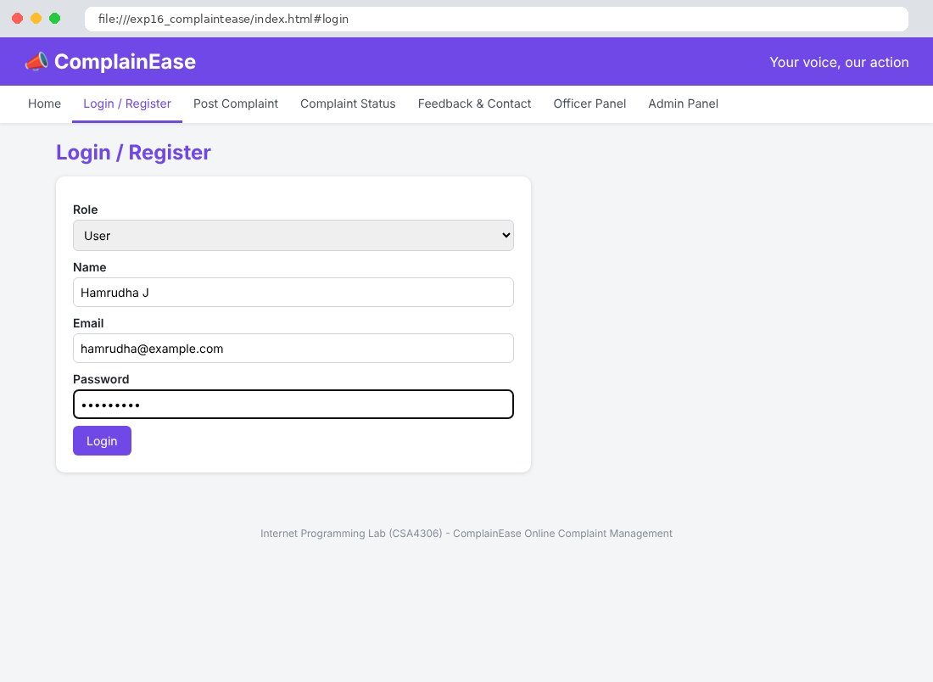
Fig. 16.3 Post Complaint Page
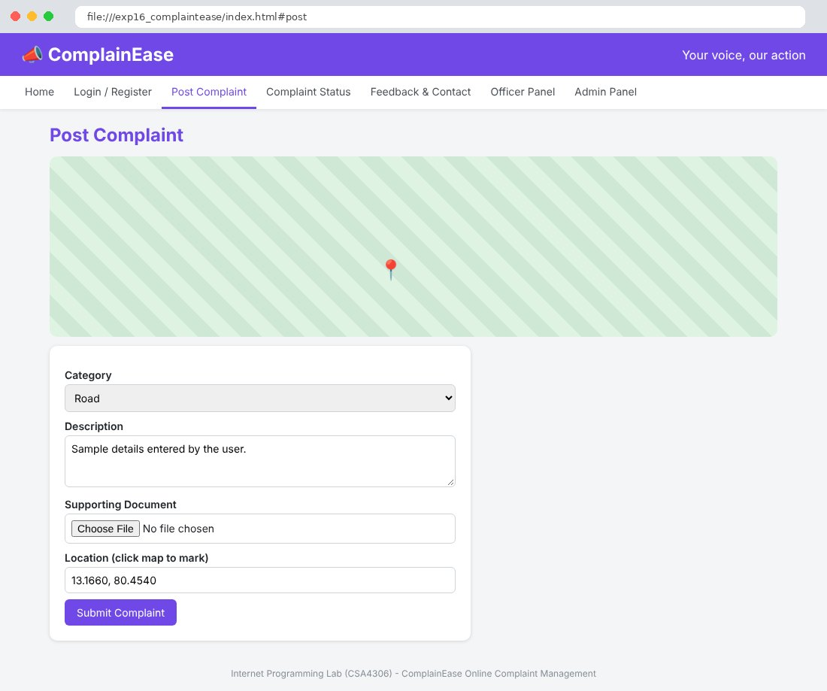
Fig. 16.4 Complaint Status Page
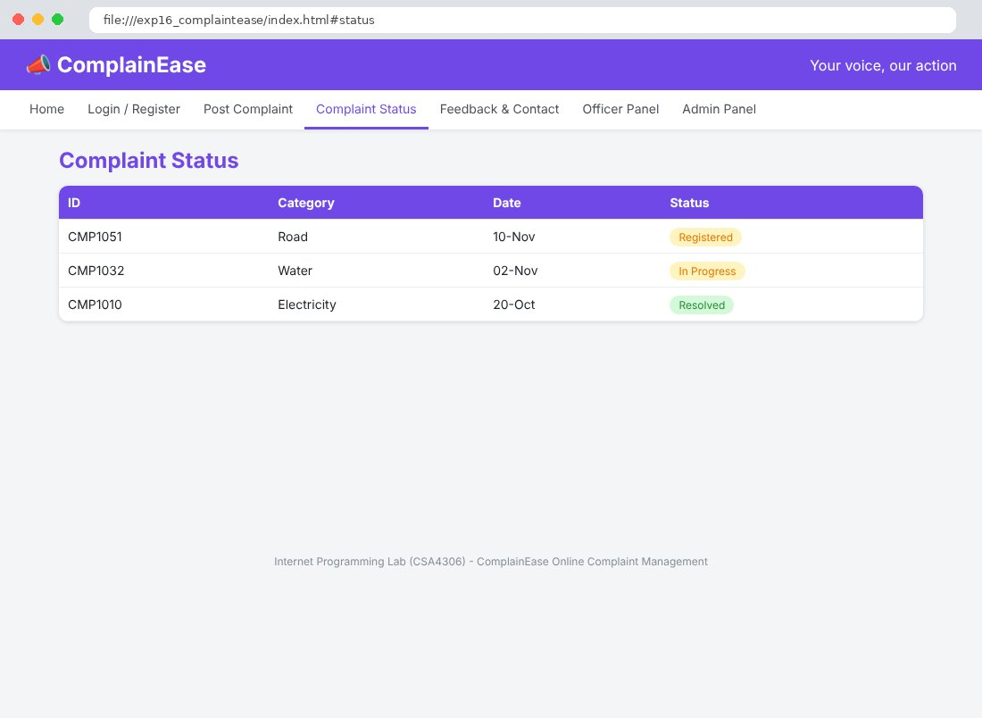
Fig. 16.5 Feedback & Contact Page
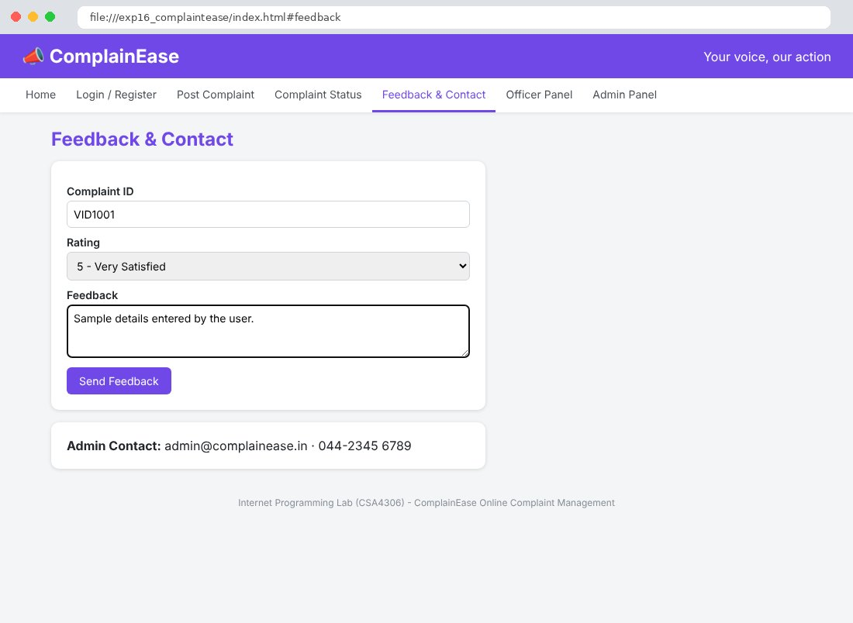
Fig. 16.6 Officer Panel Page
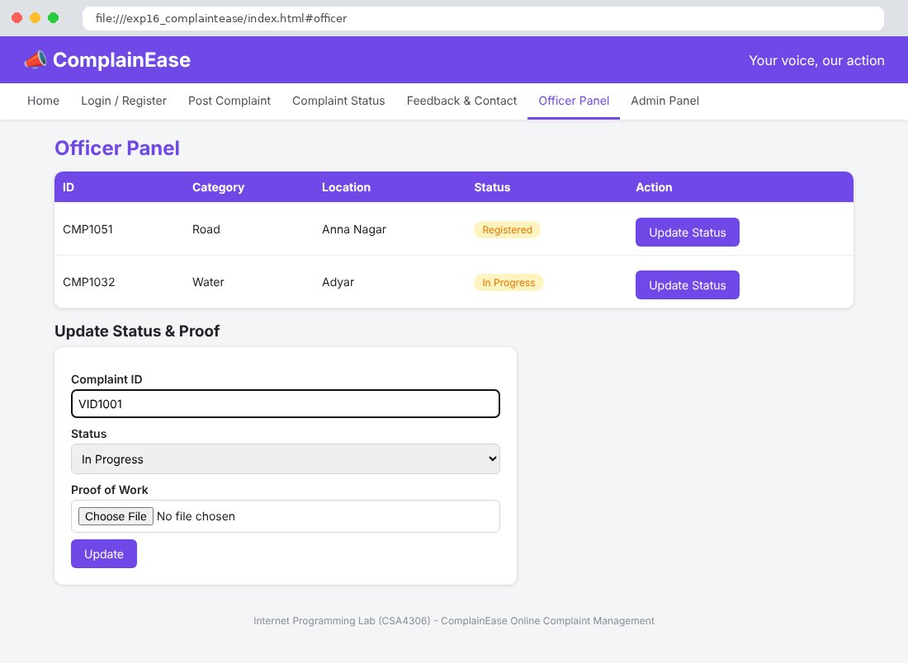
Fig. 16.7 Admin Panel Page
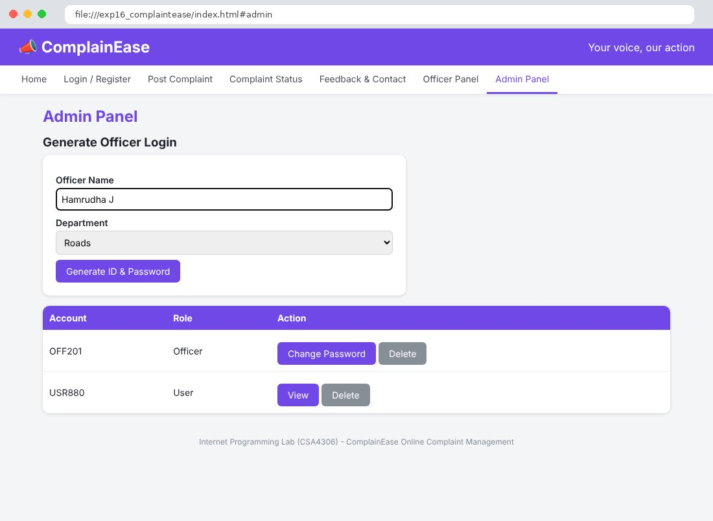

Result
Thus the ComplainEase Online Complaint Management website was designed and developed using HTML, CSS and JavaScript, and the output was verified successfully.

