LAB EXPERIMENT 17
VoteOnline E-Voting System

SUBJECT CODE | CSA4306
SUBJECT NAME | INTERNET PROGRAMMING
NAME | HAMRUDHA J
REG NO | 192411266
EXPERIMENTS | 6 to 20

Experiment 17: VoteOnline E-Voting System

Question
VoteOnline is a secure and user-friendly e-voting platform designed to facilitate and streamline the voting process for elections. The website allows registered voters to log in and cast their votes remotely, ensuring a seamless voting experience. Key functionalities include user authentication with multi-factor verification, a list of candidates or referendum options with detailed information, and a simple, intuitive voting interface. Voters can view their voting history, receive confirmation of their submitted votes, and track the progress of the election in real-time. The platform also provides secure data encryption to protect voter information and ensures compliance with electoral regulations. VoteOnline aims to make the voting process more accessible, efficient, and transparent, reducing barriers to participation and enhancing election integrity
Admin
- Create Election Candidate
- Allocate election Data with Candidate
- Allocate user to election wards
- Create Voter List
- Import Voter List
- View & update Voter List
- Get Election Results
USER
- Login using Voter ID
- OTP Login Verification
- Get OTP for Voting
- Select Candidate
- Submit Vote

Aim
To develop a secure online voting website where voters log in using Voter ID and OTP verification, select a candidate and submit their vote, and the admin creates candidates, manages voter lists and views election results.

Software / Tools Required
HTML5, CSS3 and JavaScript; any text editor (VS Code / Notepad++); a web browser (Google Chrome).

Algorithm
1. Start.
2. Create a folder for the project and a file index.html.
3. Design the common header (VoteOnline) and the navigation bar using HTML.
4. Create one section (page) for each module: Home, Voter Login, OTP Verification, Select Candidate, Vote Confirmation, Admin Panel, Election Results.
5. Design forms with labels, text fields, drop-down lists and buttons for user input.
6. Apply CSS for the layout, colours, cards, tables and responsive grid.
7. Write JavaScript functions to switch between pages, validate and submit forms, search and filter items.
8. Open index.html in the browser, test every page and verify the output.
9. Stop.

Program (index.html)
<!DOCTYPE html>
<html lang="en">
<head>
<meta charset="UTF-8">
<meta name="viewport" content="width=device-width, initial-scale=1">
<title>VoteOnline - VoteOnline E-Voting System</title>
<style>
:root{--c:#1c7ed6}
*{box-sizing:border-box;margin:0;font-family:'Segoe UI',Arial,sans-serif}
body{background:#f4f5f7;color:#212529}
header{background:var(--c);color:#fff;padding:14px 28px;display:flex;justify-content:space-between;align-items:center}
header h1{font-size:24px}
nav{background:#fff;padding:0 20px;display:flex;flex-wrap:wrap;box-shadow:0 2px 4px #0001}
nav a{padding:12px 13px;cursor:pointer;font-size:14px;color:#495057;border-bottom:3px solid transparent}
nav a.on,nav a:hover{color:var(--c);border-color:var(--c)}
main{max-width:1000px;margin:20px auto;padding:0 16px;min-height:420px}
.page{display:none}.page.active{display:block}
h2{margin-bottom:14px;color:var(--c)}
h3{margin:14px 0 8px}
.hero{background:linear-gradient(120deg,var(--c),#212529);color:#fff;border-radius:12px;padding:38px;margin-bottom:20px}
.hero h2{color:#fff;font-size:30px}
.grid{display:grid;grid-template-columns:repeat(auto-fill,minmax(200px,1fr));gap:16px;margin-bottom:16px}
.card{background:#fff;border-radius:10px;padding:16px;box-shadow:0 1px 5px #0002}
.card .ic{font-size:44px}
.card p{font-size:13px;color:#555;margin:4px 0}
.price{color:var(--c);font-weight:700}
.btn{background:var(--c);color:#fff;border:0;padding:9px 16px;border-radius:6px;cursor:pointer;margin-top:8px;font-size:14px}
.btn.alt{background:#868e96}
form,.box{background:#fff;padding:20px;border-radius:10px;box-shadow:0 1px 5px #0002;max-width:560px;margin-bottom:16px}
label{display:block;margin:10px 0 4px;font-size:14px;font-weight:600}
input,select,textarea{width:100%;padding:8px;border:1px solid #ced4da;border-radius:6px;font-size:14px}
table{width:100%;border-collapse:collapse;background:#fff;border-radius:10px;overflow:hidden;box-shadow:0 1px 5px #0002;margin-bottom:16px}
th{background:var(--c);color:#fff;text-align:left}
th,td{padding:10px;border-bottom:1px solid #eee;font-size:14px}
.stats{display:flex;gap:16px;margin-bottom:16px}
.stat{flex:1;background:#fff;border-radius:10px;padding:16px;text-align:center;box-shadow:0 1px 5px #0002}
.stat b{display:block;font-size:26px;color:var(--c)}
.tag{background:#e9ecef;border-radius:12px;padding:3px 10px;font-size:12px}
.ok{background:#d3f9d8;color:#2b8a3e}.wait{background:#fff3bf;color:#e67700}.bad{background:#ffe3e3;color:#c92a2a}
.map{height:240px;border-radius:10px;background:repeating-linear-gradient(45deg,#dff3e3,#dff3e3 20px,#cfe8d5 20px,#cfe8d5 40px);position:relative;margin-bottom:12px;cursor:crosshair;overflow:hidden}
.pin{position:absolute;font-size:26px;transform:translate(-50%,-100%)}
.bar{height:22px;background:var(--c);border-radius:4px;color:#fff;font-size:12px;padding:2px 8px}
.qr{display:grid;grid-template-columns:repeat(15,12px);gap:0;width:180px;border:8px solid #fff;box-shadow:0 1px 5px #0002}
.qr i{width:12px;height:12px;background:#fff}.qr i.k{background:#000}
#toast{position:fixed;bottom:24px;right:24px;background:#212529;color:#fff;padding:12px 20px;border-radius:8px;display:none}
footer{text-align:center;padding:16px;font-size:12px;color:#868e96}
</style>
</head>
<body>
<header><h1>🗳️ VoteOnline</h1><span>Secure. Simple. Digital.</span></header>
<nav>
<a data-p="home" onclick="show('home')">Home</a>
<a data-p="login" onclick="show('login')">Voter Login</a>
<a data-p="otp" onclick="show('otp')">OTP Verification</a>
<a data-p="vote" onclick="show('vote')">Select Candidate</a>
<a data-p="done" onclick="show('done')">Vote Confirmation</a>
<a data-p="admin" onclick="show('admin')">Admin Panel</a>
<a data-p="results" onclick="show('results')">Election Results</a>
</nav>
<main>
<section class="page" id="home">
<div class="hero"><h2>Cast Your Vote Online</h2><p>Secure remote voting with Voter ID and OTP verification.</p><button class="btn" style="background:#fff;color:#212529" onclick="show('login')">Voter Login</button></div><div class="stats"><div class="stat"><b>12,500</b>Registered Voters</div><div class="stat"><b>8,430</b>Votes Cast</div><div class="stat"><b>67%</b>Turnout</div></div>
</section>
<section class="page" id="login">
<h2>Voter Login</h2>
<form data-msg="Voter ID verified" data-go="otp">
<label>Voter ID</label><input type="text" placeholder="Enter voter id" required>
<label>Password</label><input type="password" placeholder="Enter password" required>
<button class="btn">Login</button>
</form>
</section>
<section class="page" id="otp">
<h2>OTP Verification</h2>
<h3>Enter the 4-digit OTP sent to your mobile</h3>
<form data-msg="OTP verified" data-go="vote">
<label>Enter OTP</label><input type="text" placeholder="Enter enter otp" required>
<button class="btn">Verify OTP</button>
</form><button class="btn alt" onclick="otp()">Get OTP</button>
</section>
<section class="page" id="vote">
<h2>Select Candidate</h2>
<div class="grid" id="cards">
<div class="card" data-c=""><div class="ic">🧑‍💼</div><b>Arjun Kumar</b><p>Party A</p><button class="btn" onclick="pick(this.parentNode.querySelector('b').textContent)">Select</button></div>
<div class="card" data-c=""><div class="ic">👩‍💼</div><b>Meera Devi</b><p>Party B</p><button class="btn" onclick="pick(this.parentNode.querySelector('b').textContent)">Select</button></div>
<div class="card" data-c=""><div class="ic">🧑‍💼</div><b>Rahim Khan</b><p>Party C</p><button class="btn" onclick="pick(this.parentNode.querySelector('b').textContent)">Select</button></div>
<div class="card" data-c=""><div class="ic">👩‍💼</div><b>Sheela Rao</b><p>Independent</p><button class="btn" onclick="pick(this.parentNode.querySelector('b').textContent)">Select</button></div>
</div><div class="box">Selected candidate: <b id="sel">None</b><br><button class="btn" onclick="toast('Vote submitted successfully');show('done')">Submit Vote</button></div>
</section>
<section class="page" id="done">
<h2>Vote Confirmation</h2>
<div class="box"><h3>✅ Your vote has been recorded</h3><p>Receipt No: VOT-2026-084301</p><p>Thank you for taking part in the election. You cannot vote again.</p></div>
</section>
<section class="page" id="admin">
<h2>Admin Panel</h2>
<h3>Create Election Candidate</h3>
<form data-msg="Candidate created">
<label>Candidate Name</label><input type="text" placeholder="Enter candidate name" required>
<label>Party</label><input type="text" placeholder="Enter party" required>
<label>Ward</label><select><option>Ward 1</option><option>Ward 2</option><option>Ward 3</option></select>
<button class="btn">Create Candidate</button>
</form><form data-msg="Voter list imported">
<label>Import Voter List (CSV)</label><input type="file">
<button class="btn">Import</button>
</form><table>
<tr><th>Voter ID</th><th>Name</th><th>Ward</th><th>Action</th></tr>
<tr><td>VID1001</td><td>Hamrudha</td><td>Ward 1</td><td><button class="btn">Update</button></td></tr>
<tr><td>VID1002</td><td>Karthik</td><td>Ward 2</td><td><button class="btn">Update</button></td></tr>
</table>
</section>
<section class="page" id="results">
<h2>Election Results</h2>
<div class="box" style="max-width:none"><p>Arjun Kumar</p><div class="bar" style="width:62%">3,420</div><p>Meera Devi</p><div class="bar" style="width:50%">2,760</div><p>Rahim Khan</p><div class="bar" style="width:28%">1,540</div><p>Sheela Rao</p><div class="bar" style="width:12%">710</div></div>
</section>
</main>
<footer>Internet Programming Lab (CSA4306) - VoteOnline E-Voting System</footer>
<div id="toast"></div>
<script>
function show(id){document.querySelectorAll('.page').forEach(p=>p.classList.toggle('active',p.id===id));
document.querySelectorAll('nav a').forEach(a=>a.classList.toggle('on',a.dataset.p===id));window.scrollTo(0,0)}
function toast(m){const t=document.getElementById('toast');t.textContent=m;t.style.display='block';setTimeout(()=>t.style.display='none',2200)}
document.addEventListener('submit',e=>{e.preventDefault();toast(e.target.dataset.msg||'Saved successfully');if(e.target.dataset.go)show(e.target.dataset.go)});
function filt(inp,sel){const v=inp.value.toLowerCase();document.querySelectorAll(sel).forEach(r=>r.style.display=r.textContent.toLowerCase().includes(v)?'':'none')}
function catf(v,sel){document.querySelectorAll(sel).forEach(r=>r.style.display=(v=='All'||r.dataset.c==v)?'':'none')}
function pick(n){document.getElementById('sel').textContent=n}
function otp(){toast('Demo OTP sent: 4 8 2 1')}
show('home');
</script>
</body>
</html>

Output
Fig. 17.1 Home Page
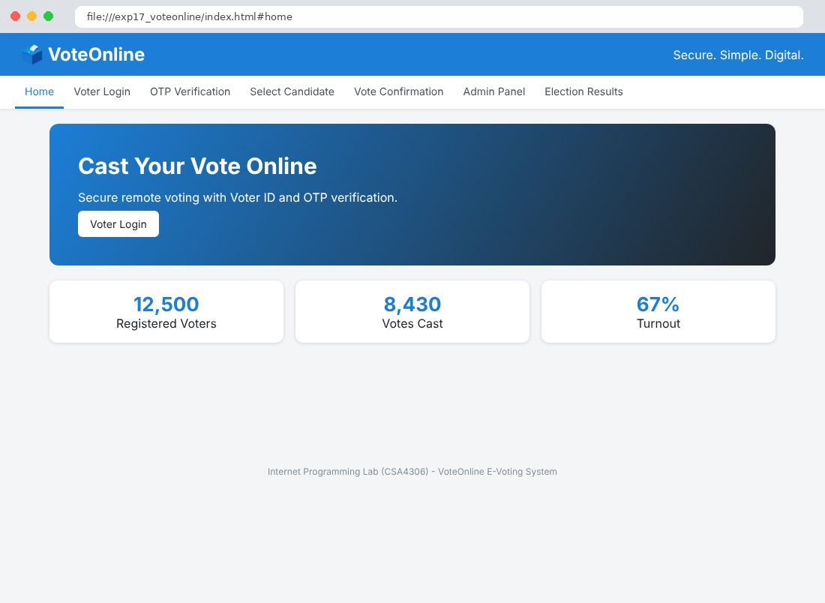
Fig. 17.2 Voter Login Page
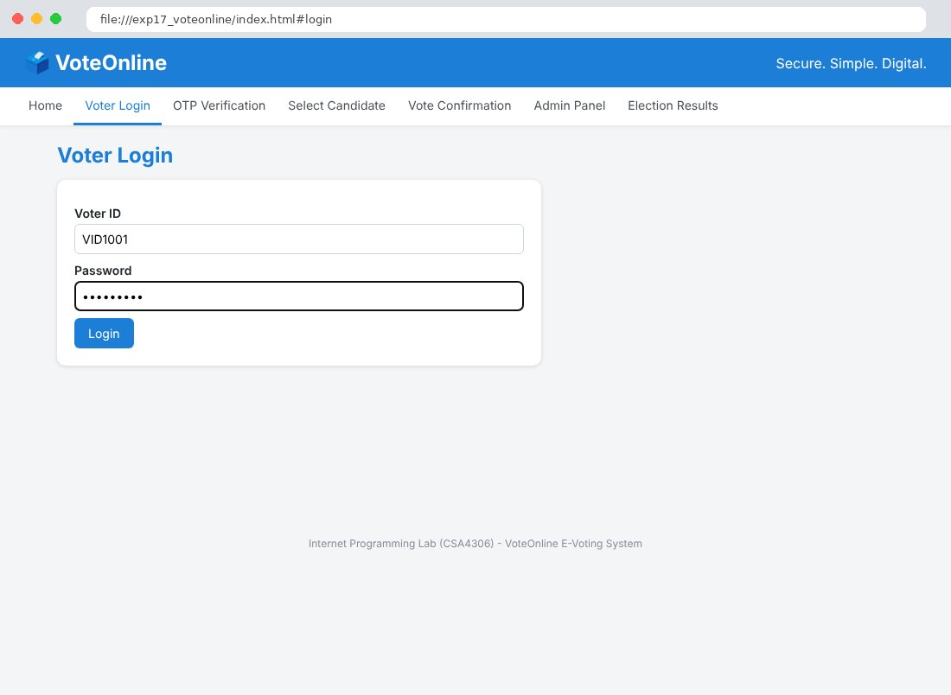
Fig. 17.3 OTP Verification Page
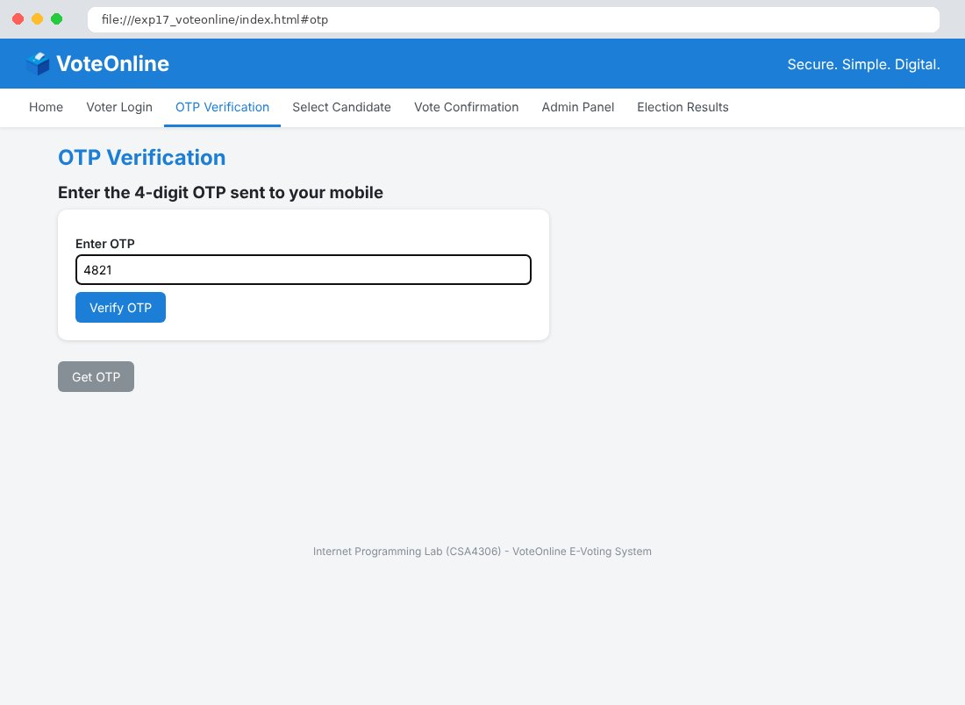
Fig. 17.4 Select Candidate Page
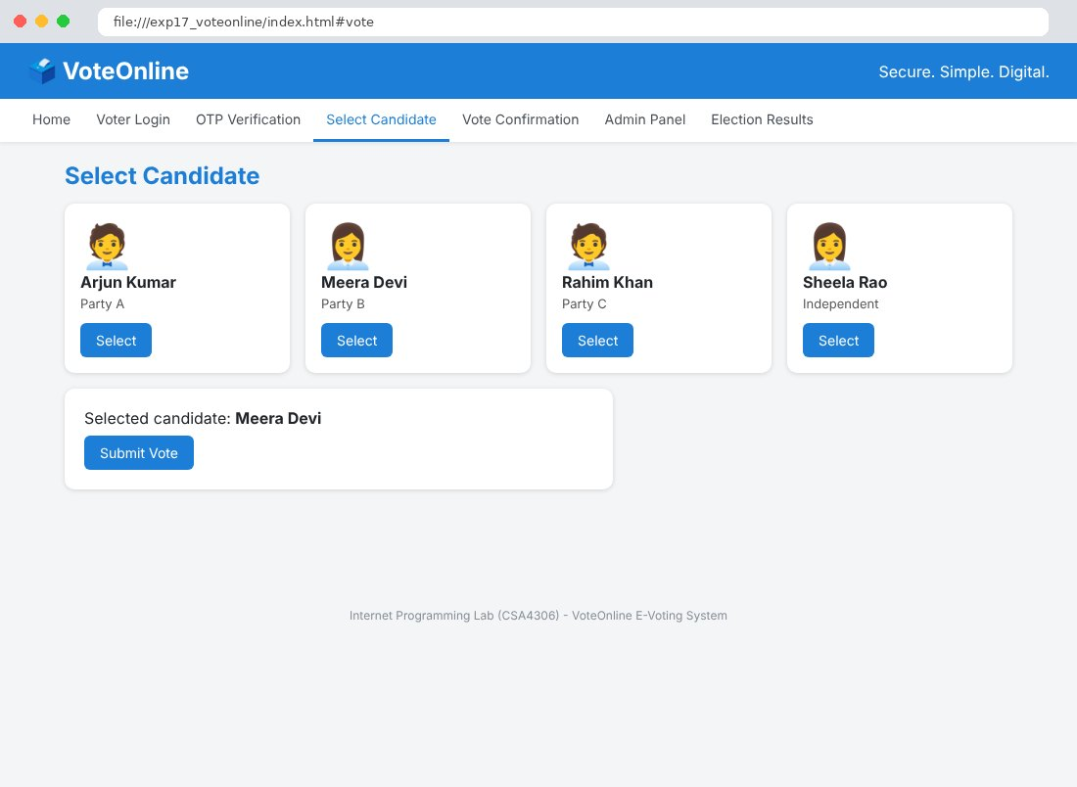
Fig. 17.5 Vote Confirmation Page
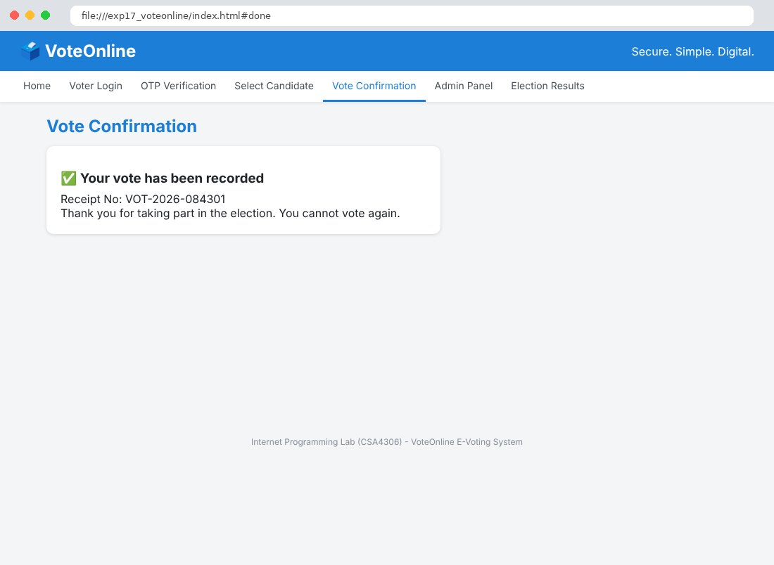
Fig. 17.6 Admin Panel Page
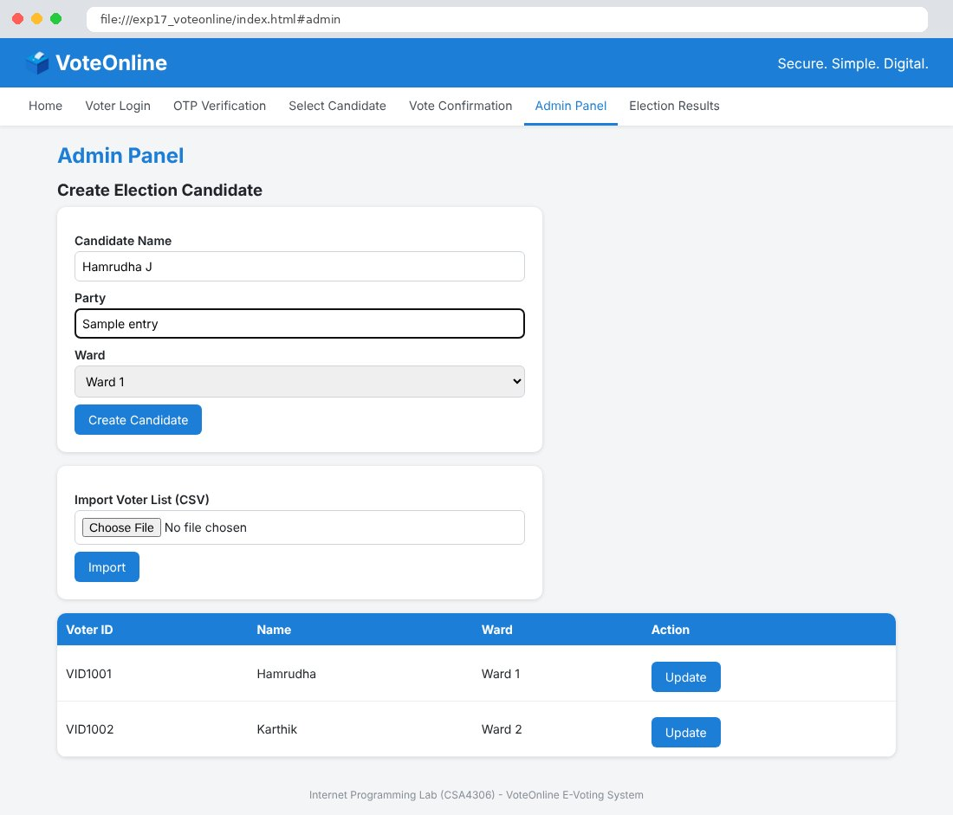
Fig. 17.7 Election Results Page
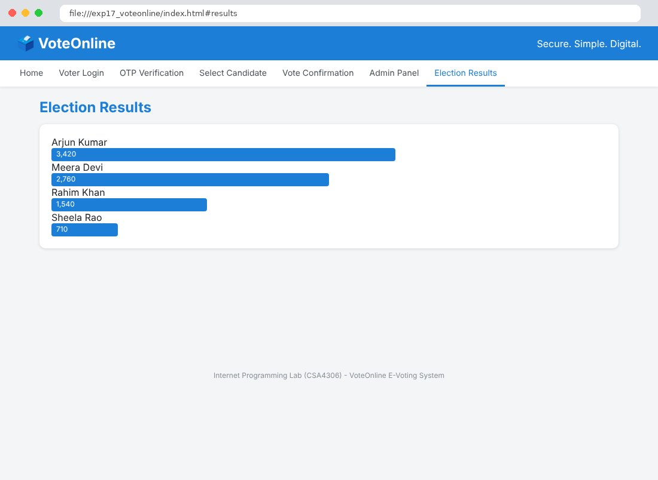

Result
Thus the VoteOnline E-Voting System website was designed and developed using HTML, CSS and JavaScript, and the output was verified successfully.

