LAB EXPERIMENT 18
AgriMart Online Agri Products Store

SUBJECT CODE | CSA4306
SUBJECT NAME | INTERNET PROGRAMMING
NAME | HAMRUDHA J
REG NO | 192411266
EXPERIMENTS | 6 to 20

Experiment 18: AgriMart Online Agri Products Store

Question
AgriMart is a comprehensive online platform catering to farmers and agricultural enthusiasts with a wide range of products and services. The website features categories such as seeds, fertilizers, pesticides, farming equipment, and tools. Key functionalities include user registration and login, product search and filtering, detailed product descriptions, and high-resolution images. Customers can place orders directly, track their shipments, and access personalized recommendations based on their purchase history. The platform also offers secure payment options and customer support for product inquiries and order issues. AgriMart aims to provide a convenient and efficient shopping experience, helping users access essential agricultural supplies and resources with ease.’
FARMER
- Login
- Register
- OTP Verification
- Manage Orders
- Update order Status
- Add Product
- Update/Delete product
- Upload images
- My Sales
- Update Shipping Status
- Logout
PUBLIC
- Register
- Login
- OTP Verification
- My Account
- Manage Wallet Balance
- View product details
- Search product
- Add to cart
- Edit/Delete Cart
- Add/Edit Shipping Address
- Order Product
- My Order status
- View Shipping Status

Aim
To develop an online agricultural products website where public users register with OTP, search and buy seeds, fertilizers, pesticides and equipment, track orders and shipping, and farmers manage their products, orders and sales.

Software / Tools Required
HTML5, CSS3 and JavaScript; any text editor (VS Code / Notepad++); a web browser (Google Chrome).

Algorithm
1. Start.
2. Create a folder for the project and a file index.html.
3. Design the common header (AgriMart) and the navigation bar using HTML.
4. Create one section (page) for each module: Home, Login / Register, OTP Verification, Products, Cart, Shipping Address, My Orders & Shipping, Farmer Panel.
5. Design forms with labels, text fields, drop-down lists and buttons for user input.
6. Apply CSS for the layout, colours, cards, tables and responsive grid.
7. Write JavaScript functions to switch between pages, validate and submit forms, search and filter items, and manage the shopping cart.
8. Open index.html in the browser, test every page and verify the output.
9. Stop.

Program (index.html)
<!DOCTYPE html>
<html lang="en">
<head>
<meta charset="UTF-8">
<meta name="viewport" content="width=device-width, initial-scale=1">
<title>AgriMart - AgriMart Online Agri Products Store</title>
<style>
:root{--c:#5c940d}
*{box-sizing:border-box;margin:0;font-family:'Segoe UI',Arial,sans-serif}
body{background:#f4f5f7;color:#212529}
header{background:var(--c);color:#fff;padding:14px 28px;display:flex;justify-content:space-between;align-items:center}
header h1{font-size:24px}
nav{background:#fff;padding:0 20px;display:flex;flex-wrap:wrap;box-shadow:0 2px 4px #0001}
nav a{padding:12px 13px;cursor:pointer;font-size:14px;color:#495057;border-bottom:3px solid transparent}
nav a.on,nav a:hover{color:var(--c);border-color:var(--c)}
main{max-width:1000px;margin:20px auto;padding:0 16px;min-height:420px}
.page{display:none}.page.active{display:block}
h2{margin-bottom:14px;color:var(--c)}
h3{margin:14px 0 8px}
.hero{background:linear-gradient(120deg,var(--c),#212529);color:#fff;border-radius:12px;padding:38px;margin-bottom:20px}
.hero h2{color:#fff;font-size:30px}
.grid{display:grid;grid-template-columns:repeat(auto-fill,minmax(200px,1fr));gap:16px;margin-bottom:16px}
.card{background:#fff;border-radius:10px;padding:16px;box-shadow:0 1px 5px #0002}
.card .ic{font-size:44px}
.card p{font-size:13px;color:#555;margin:4px 0}
.price{color:var(--c);font-weight:700}
.btn{background:var(--c);color:#fff;border:0;padding:9px 16px;border-radius:6px;cursor:pointer;margin-top:8px;font-size:14px}
.btn.alt{background:#868e96}
form,.box{background:#fff;padding:20px;border-radius:10px;box-shadow:0 1px 5px #0002;max-width:560px;margin-bottom:16px}
label{display:block;margin:10px 0 4px;font-size:14px;font-weight:600}
input,select,textarea{width:100%;padding:8px;border:1px solid #ced4da;border-radius:6px;font-size:14px}
table{width:100%;border-collapse:collapse;background:#fff;border-radius:10px;overflow:hidden;box-shadow:0 1px 5px #0002;margin-bottom:16px}
th{background:var(--c);color:#fff;text-align:left}
th,td{padding:10px;border-bottom:1px solid #eee;font-size:14px}
.stats{display:flex;gap:16px;margin-bottom:16px}
.stat{flex:1;background:#fff;border-radius:10px;padding:16px;text-align:center;box-shadow:0 1px 5px #0002}
.stat b{display:block;font-size:26px;color:var(--c)}
.tag{background:#e9ecef;border-radius:12px;padding:3px 10px;font-size:12px}
.ok{background:#d3f9d8;color:#2b8a3e}.wait{background:#fff3bf;color:#e67700}.bad{background:#ffe3e3;color:#c92a2a}
.map{height:240px;border-radius:10px;background:repeating-linear-gradient(45deg,#dff3e3,#dff3e3 20px,#cfe8d5 20px,#cfe8d5 40px);position:relative;margin-bottom:12px;cursor:crosshair;overflow:hidden}
.pin{position:absolute;font-size:26px;transform:translate(-50%,-100%)}
.bar{height:22px;background:var(--c);border-radius:4px;color:#fff;font-size:12px;padding:2px 8px}
.qr{display:grid;grid-template-columns:repeat(15,12px);gap:0;width:180px;border:8px solid #fff;box-shadow:0 1px 5px #0002}
.qr i{width:12px;height:12px;background:#fff}.qr i.k{background:#000}
#toast{position:fixed;bottom:24px;right:24px;background:#212529;color:#fff;padding:12px 20px;border-radius:8px;display:none}
footer{text-align:center;padding:16px;font-size:12px;color:#868e96}
</style>
</head>
<body>
<header><h1>🌾 AgriMart</h1><span>Everything for the farm</span></header>
<nav>
<a data-p="home" onclick="show('home')">Home</a>
<a data-p="login" onclick="show('login')">Login / Register</a>
<a data-p="otp" onclick="show('otp')">OTP Verification</a>
<a data-p="products" onclick="show('products')">Products</a>
<a data-p="cart" onclick="show('cart')">Cart</a>
<a data-p="address" onclick="show('address')">Shipping Address</a>
<a data-p="orders" onclick="show('orders')">My Orders & Shipping</a>
<a data-p="farmer" onclick="show('farmer')">Farmer Panel</a>
</nav>
<main>
<section class="page" id="home">
<div class="hero"><h2>Quality Farm Inputs Delivered</h2><p>Seeds, fertilizers, pesticides, equipment and tools at fair prices.</p><button class="btn" style="background:#fff;color:#212529" onclick="show('products')">Shop Now</button></div><div class="grid" id="cards">
<div class="card" data-c=""><div class="ic">🌱</div><b>Seeds</b><p>80 items</p></div>
<div class="card" data-c=""><div class="ic">🧪</div><b>Fertilizers</b><p>45 items</p></div>
<div class="card" data-c=""><div class="ic">🐛</div><b>Pesticides</b><p>30 items</p></div>
<div class="card" data-c=""><div class="ic">🚜</div><b>Equipment</b><p>25 items</p></div>
</div>
</section>
<section class="page" id="login">
<h2>Login / Register</h2>
<form data-msg="OTP sent to your mobile" data-go="otp">
<label>Role</label><select><option>Public</option><option>Farmer</option></select>
<label>Name</label><input type="text" placeholder="Enter name" required>
<label>Mobile</label><input type="tel" placeholder="Enter mobile" required>
<label>Password</label><input type="password" placeholder="Enter password" required>
<button class="btn">Login / Register</button>
</form>
</section>
<section class="page" id="otp">
<h2>OTP Verification</h2>
<form data-msg="OTP verified" data-go="products">
<label>Enter OTP</label><input type="text" placeholder="Enter enter otp" required>
<button class="btn">Verify</button>
</form>
</section>
<section class="page" id="products">
<h2>Products</h2>
<input placeholder="Search products..." onkeyup="filt(this,'#cards .card')" style="max-width:320px;margin-bottom:10px;display:inline-block">
<select onchange="catf(this.value,'#cards .card')" style="max-width:200px;margin-left:8px;display:inline-block"><option>All</option><option>Seeds</option><option>Fertilizers</option><option>Pesticides</option><option>Equipment</option><option>Tools</option></select>
<div class="grid" id="cards">
<div class="card" data-c="Seeds"><div class="ic">🌱</div><b>Hybrid Tomato Seeds</b><p>High yield, 50 g</p><div class="price">Rs. 120</div><button class="btn" onclick="add('Hybrid Tomato Seeds',120)">Add to Cart</button></div>
<div class="card" data-c="Fertilizers"><div class="ic">🧪</div><b>NPK Fertilizer</b><p>50 kg bag</p><div class="price">Rs. 1450</div><button class="btn" onclick="add('NPK Fertilizer',1450)">Add to Cart</button></div>
<div class="card" data-c="Pesticides"><div class="ic">🐛</div><b>Neem Pesticide</b><p>1 litre organic</p><div class="price">Rs. 380</div><button class="btn" onclick="add('Neem Pesticide',380)">Add to Cart</button></div>
<div class="card" data-c="Equipment"><div class="ic">🚜</div><b>Hand Tractor</b><p>Power tiller 7 HP</p><div class="price">Rs. 68000</div><button class="btn" onclick="add('Hand Tractor',68000)">Add to Cart</button></div>
<div class="card" data-c="Tools"><div class="ic">🔧</div><b>Garden Tool Set</b><p>5-piece steel set</p><div class="price">Rs. 650</div><button class="btn" onclick="add('Garden Tool Set',650)">Add to Cart</button></div>
<div class="card" data-c="Seeds"><div class="ic">🌾</div><b>Paddy Seeds</b><p>Certified, 5 kg</p><div class="price">Rs. 420</div><button class="btn" onclick="add('Paddy Seeds',420)">Add to Cart</button></div>
</div>
</section>
<section class="page" id="cart">
<h2>Cart</h2>
<table><tr><th>Item</th><th>Price</th><th>Action</th></tr><tbody id="cartBody"></tbody></table>
<div class="box"><b>Total: <span id="total">Rs. 0</span></b><br>
<button class="btn" onclick="show('address')">Proceed to Checkout</button></div>
</section>
<section class="page" id="address">
<h2>Shipping Address</h2>
<form data-msg="Order placed" data-go="orders">
<label>Name</label><input type="text" placeholder="Enter name" required>
<label>Address</label><textarea rows="3" required></textarea>
<label>Pincode</label><input type="text" placeholder="Enter pincode" required>
<label>Phone</label><input type="tel" placeholder="Enter phone" required>
<label>Payment</label><select><option>Wallet</option><option>UPI</option><option>Cash on Delivery</option></select>
<button class="btn">Order Product</button>
</form>
</section>
<section class="page" id="orders">
<h2>My Orders & Shipping</h2>
<table>
<tr><th>Order</th><th>Product</th><th>Date</th><th>Shipping Status</th></tr>
<tr><td>#A71</td><td>NPK Fertilizer</td><td>11-Nov</td><td><span class="tag wait">Shipped</span></td></tr>
<tr><td>#A64</td><td>Paddy Seeds</td><td>03-Nov</td><td><span class="tag ok">Delivered</span></td></tr>
</table><div class="stats"><div class="stat"><b>Rs. 2,300</b>Wallet Balance</div></div>
</section>
<section class="page" id="farmer">
<h2>Farmer Panel</h2>
<div class="stats"><div class="stat"><b>24</b>Products</div><div class="stat"><b>9</b>Orders</div><div class="stat"><b>Rs. 42,000</b>My Sales</div></div><h3>Add Product</h3>
<form data-msg="Product added">
<label>Product Name</label><input type="text" placeholder="Enter product name" required>
<label>Category</label><select><option>Seeds</option><option>Fertilizers</option><option>Pesticides</option><option>Equipment</option><option>Tools</option></select>
<label>Price</label><input type="number" placeholder="Enter price" required>
<label>Image</label><input type="file">
<button class="btn">Add Product</button>
</form><table>
<tr><th>Order</th><th>Product</th><th>Shipping</th><th>Action</th></tr>
<tr><td>#A71</td><td>NPK Fertilizer</td><td><span class="tag wait">Packed</span></td><td><button class="btn">Update Shipping</button></td></tr>
<tr><td>#A64</td><td>Paddy Seeds</td><td><span class="tag wait">Shipped</span></td><td><button class="btn">Update Shipping</button></td></tr>
</table>
</section>
</main>
<footer>Internet Programming Lab (CSA4306) - AgriMart Online Agri Products Store</footer>
<div id="toast"></div>
<script>
function show(id){document.querySelectorAll('.page').forEach(p=>p.classList.toggle('active',p.id===id));
document.querySelectorAll('nav a').forEach(a=>a.classList.toggle('on',a.dataset.p===id));window.scrollTo(0,0)}
function toast(m){const t=document.getElementById('toast');t.textContent=m;t.style.display='block';setTimeout(()=>t.style.display='none',2200)}
document.addEventListener('submit',e=>{e.preventDefault();toast(e.target.dataset.msg||'Saved successfully');if(e.target.dataset.go)show(e.target.dataset.go)});
function filt(inp,sel){const v=inp.value.toLowerCase();document.querySelectorAll(sel).forEach(r=>r.style.display=r.textContent.toLowerCase().includes(v)?'':'none')}
function catf(v,sel){document.querySelectorAll(sel).forEach(r=>r.style.display=(v=='All'||r.dataset.c==v)?'':'none')}
let cart=[];
function add(n,p){cart.push({n,p});toast(n+' added to cart');draw()}
function del(i){cart.splice(i,1);draw()}
function draw(){const b=document.getElementById('cartBody');let t=0;
b.innerHTML=cart.length?cart.map((c,i)=>{t+=c.p;return `<tr><td>${c.n}</td><td>Rs. ${c.p}</td><td><button class="btn alt" onclick="del(${i})">Remove</button></td></tr>`}).join(''):'<tr><td colspan="3">Your cart is empty</td></tr>';
document.getElementById('total').textContent='Rs. '+t}
show('home');
</script>
</body>
</html>

Output
Fig. 18.1 Home Page
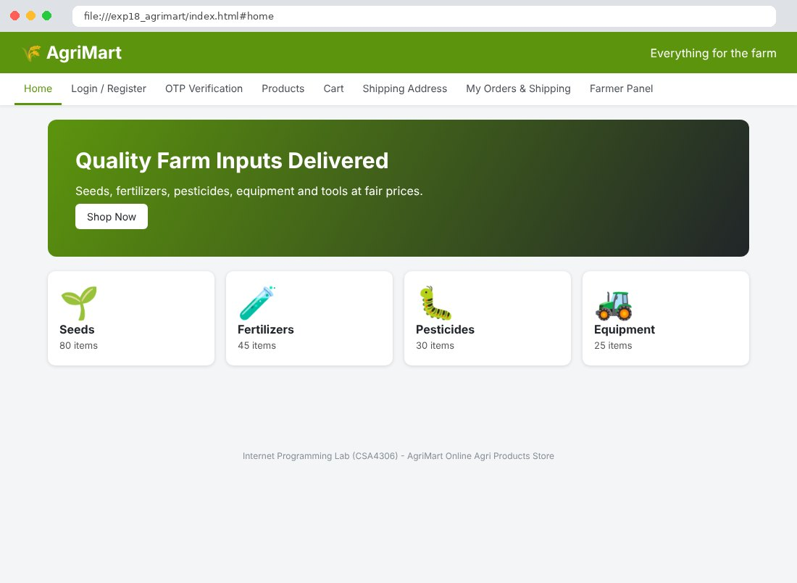
Fig. 18.2 Login / Register Page
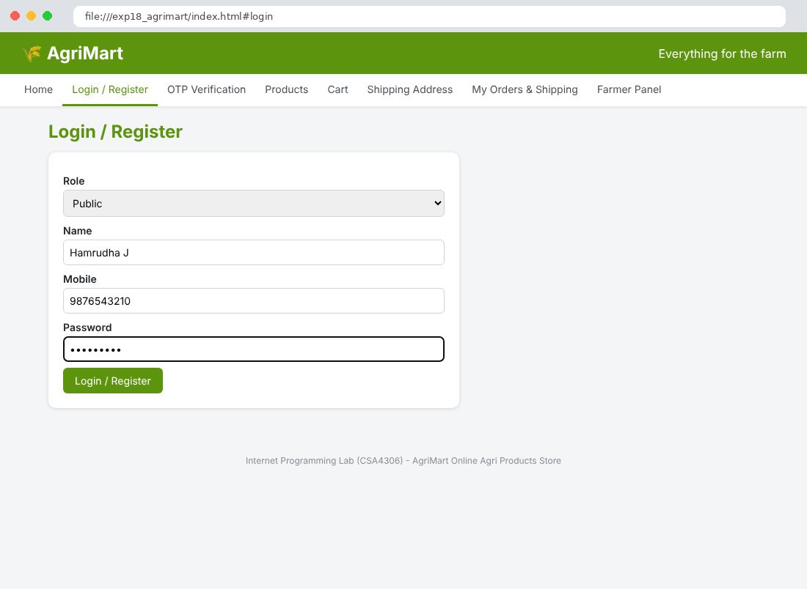
Fig. 18.3 OTP Verification Page
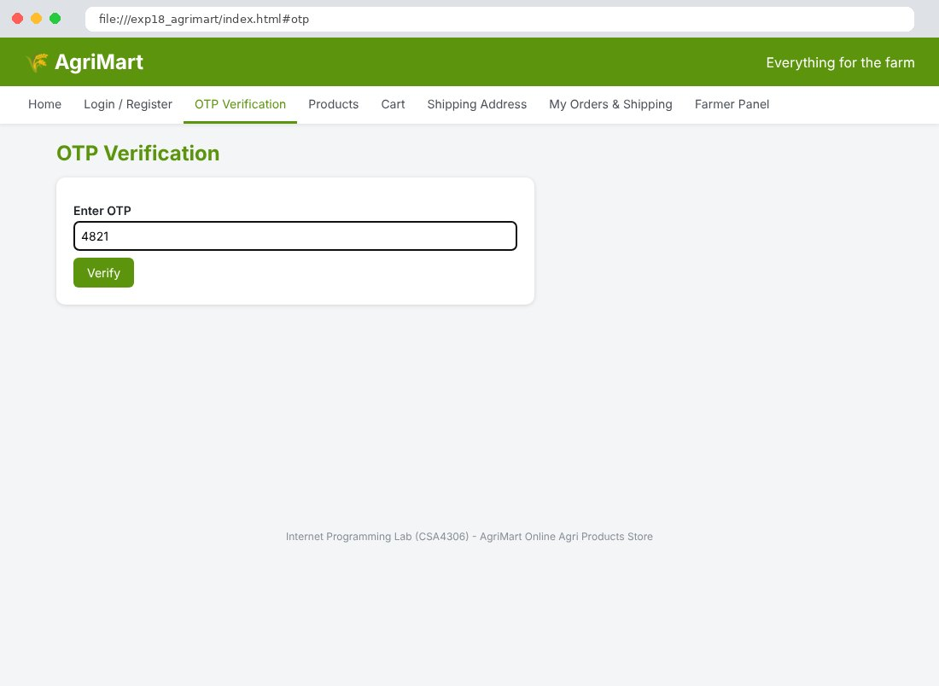
Fig. 18.4 Products Page
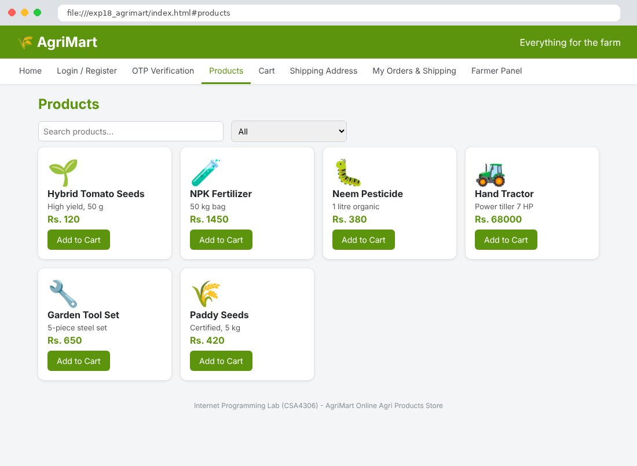
Fig. 18.5 Cart Page
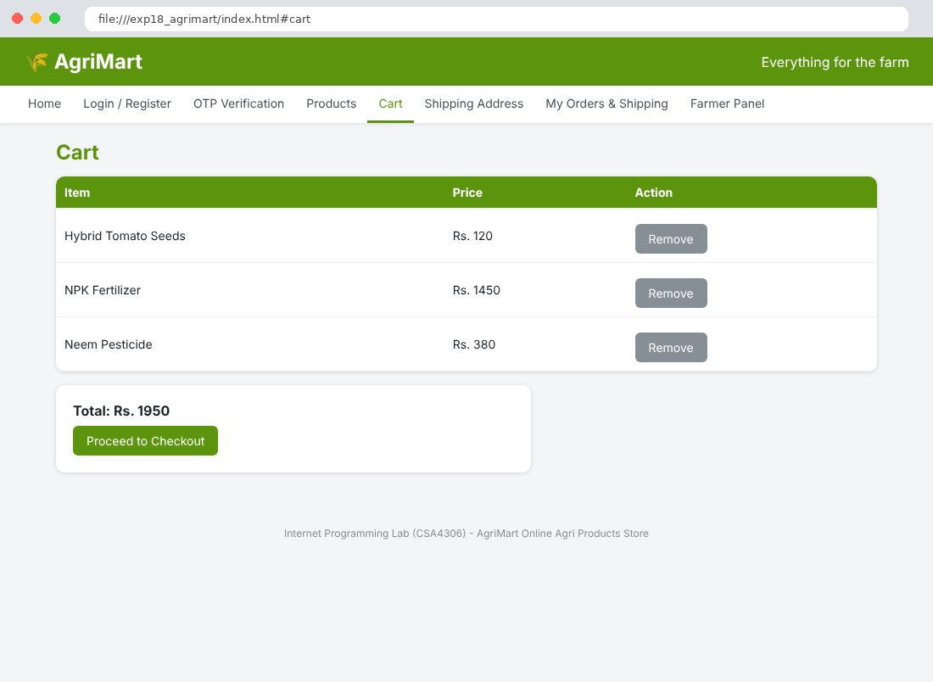
Fig. 18.6 Shipping Address Page
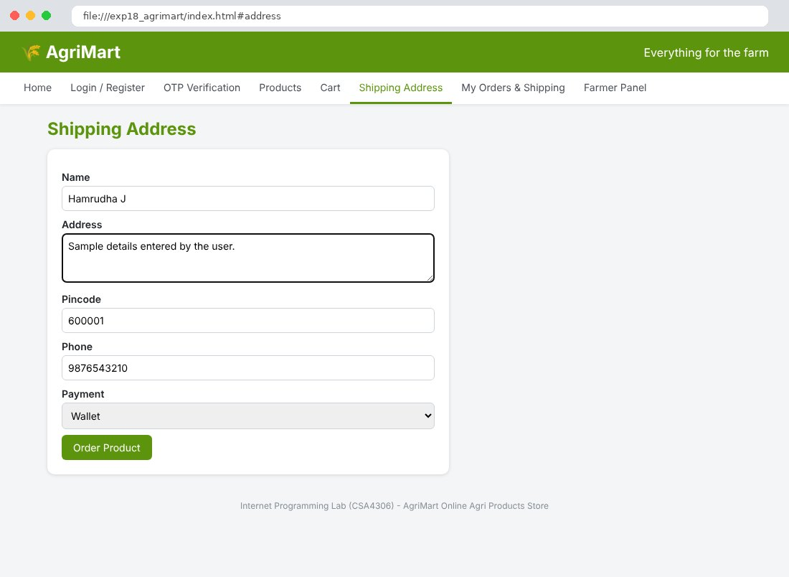
Fig. 18.7 My Orders & Shipping Page
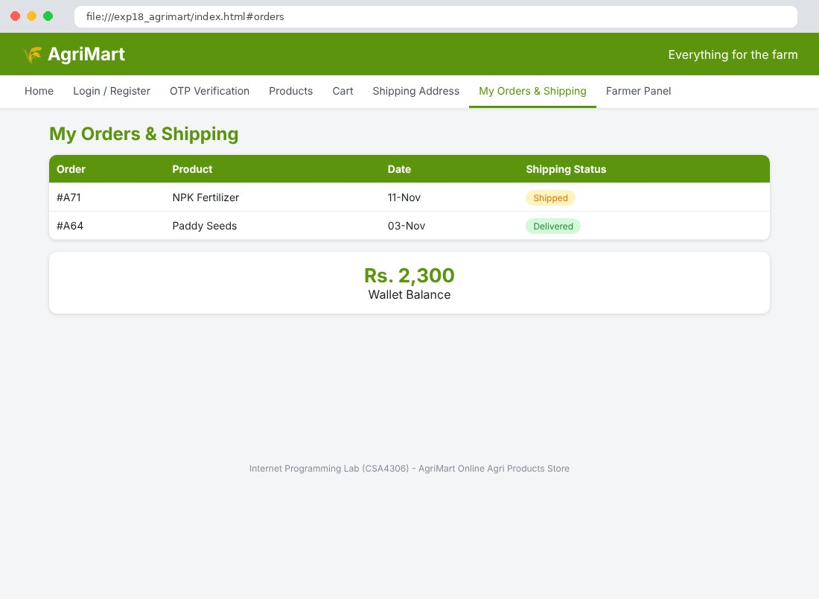
Fig. 18.8 Farmer Panel Page
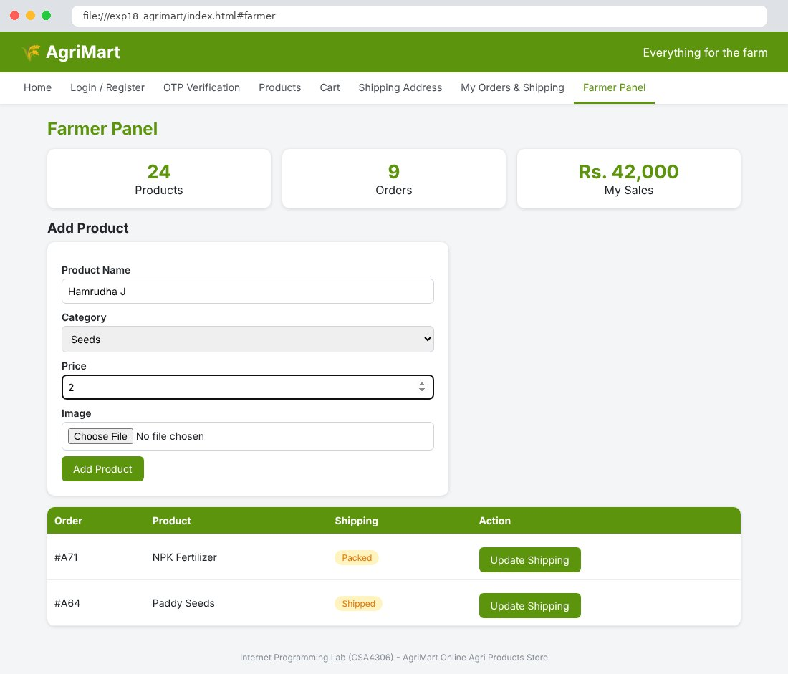

Result
Thus the AgriMart Online Agri Products Store website was designed and developed using HTML, CSS and JavaScript, and the output was verified successfully.

