LAB EXPERIMENT 19
VetCure Animal Disease Consultation System

SUBJECT CODE | CSA4306
SUBJECT NAME | INTERNET PROGRAMMING
NAME | HAMRUDHA J
REG NO | 192411266
EXPERIMENTS | 6 to 20

Experiment 19: VetCure Animal Disease Consultation System

Question
The farmer must send his animal’s signs and symptoms to doctor in video, audio, images or text form. The doctor will receive the farmer’s requests and respond. The user’s data will be automatically added to the database. The farmer has to register first and has to subscribe. A farmer will freely subscribe to Govt. CVHs. He must pay a fee if he will subscribe to the private clinic’s doctor. There will be two payment gateways for the farmers, bank transfer (Doctor will provide his bank information while creating his profile) and easy paisa. Doctors will provide their bank details for payments. He can also provide easy paisa account details. There will be images of influenced animals with basic diseases and their prescriptions. Based on recorded data, the system can perform an analysis that which disease attacks on pets mostly in a specific area.
USER
- Register
- Login
- Post Complaint
- My Complaint Status
- View Vetcure details
- View News
- View Doctor
- View Report
- Post Feedback
- Make Payment
- My Profile
Doctor
- Register
- Login
- View Complaint
- Post Solution
- Manage Cure
- Manage news
- View user Details
- View Payment Details
- Feedback Details

Aim
To develop an online animal healthcare website where farmers register, post animal symptoms as text, image, audio or video, get solutions from doctors, view cures, news and reports, make payments, and doctors manage complaints, cures, news and payments.

Software / Tools Required
HTML5, CSS3 and JavaScript; any text editor (VS Code / Notepad++); a web browser (Google Chrome).

Algorithm
1. Start.
2. Create a folder for the project and a file index.html.
3. Design the common header (VetCure) and the navigation bar using HTML.
4. Create one section (page) for each module: Home, Register / Login, Post Complaint, My Complaint Status, Doctors, Cure, News & Report, Payment & Feedback, Doctor Panel.
5. Design forms with labels, text fields, drop-down lists and buttons for user input.
6. Apply CSS for the layout, colours, cards, tables and responsive grid.
7. Write JavaScript functions to switch between pages, validate and submit forms, search and filter items.
8. Open index.html in the browser, test every page and verify the output.
9. Stop.

Program (index.html)
<!DOCTYPE html>
<html lang="en">
<head>
<meta charset="UTF-8">
<meta name="viewport" content="width=device-width, initial-scale=1">
<title>VetCure - VetCure Animal Disease Consultation System</title>
<style>
:root{--c:#0ca678}
*{box-sizing:border-box;margin:0;font-family:'Segoe UI',Arial,sans-serif}
body{background:#f4f5f7;color:#212529}
header{background:var(--c);color:#fff;padding:14px 28px;display:flex;justify-content:space-between;align-items:center}
header h1{font-size:24px}
nav{background:#fff;padding:0 20px;display:flex;flex-wrap:wrap;box-shadow:0 2px 4px #0001}
nav a{padding:12px 13px;cursor:pointer;font-size:14px;color:#495057;border-bottom:3px solid transparent}
nav a.on,nav a:hover{color:var(--c);border-color:var(--c)}
main{max-width:1000px;margin:20px auto;padding:0 16px;min-height:420px}
.page{display:none}.page.active{display:block}
h2{margin-bottom:14px;color:var(--c)}
h3{margin:14px 0 8px}
.hero{background:linear-gradient(120deg,var(--c),#212529);color:#fff;border-radius:12px;padding:38px;margin-bottom:20px}
.hero h2{color:#fff;font-size:30px}
.grid{display:grid;grid-template-columns:repeat(auto-fill,minmax(200px,1fr));gap:16px;margin-bottom:16px}
.card{background:#fff;border-radius:10px;padding:16px;box-shadow:0 1px 5px #0002}
.card .ic{font-size:44px}
.card p{font-size:13px;color:#555;margin:4px 0}
.price{color:var(--c);font-weight:700}
.btn{background:var(--c);color:#fff;border:0;padding:9px 16px;border-radius:6px;cursor:pointer;margin-top:8px;font-size:14px}
.btn.alt{background:#868e96}
form,.box{background:#fff;padding:20px;border-radius:10px;box-shadow:0 1px 5px #0002;max-width:560px;margin-bottom:16px}
label{display:block;margin:10px 0 4px;font-size:14px;font-weight:600}
input,select,textarea{width:100%;padding:8px;border:1px solid #ced4da;border-radius:6px;font-size:14px}
table{width:100%;border-collapse:collapse;background:#fff;border-radius:10px;overflow:hidden;box-shadow:0 1px 5px #0002;margin-bottom:16px}
th{background:var(--c);color:#fff;text-align:left}
th,td{padding:10px;border-bottom:1px solid #eee;font-size:14px}
.stats{display:flex;gap:16px;margin-bottom:16px}
.stat{flex:1;background:#fff;border-radius:10px;padding:16px;text-align:center;box-shadow:0 1px 5px #0002}
.stat b{display:block;font-size:26px;color:var(--c)}
.tag{background:#e9ecef;border-radius:12px;padding:3px 10px;font-size:12px}
.ok{background:#d3f9d8;color:#2b8a3e}.wait{background:#fff3bf;color:#e67700}.bad{background:#ffe3e3;color:#c92a2a}
.map{height:240px;border-radius:10px;background:repeating-linear-gradient(45deg,#dff3e3,#dff3e3 20px,#cfe8d5 20px,#cfe8d5 40px);position:relative;margin-bottom:12px;cursor:crosshair;overflow:hidden}
.pin{position:absolute;font-size:26px;transform:translate(-50%,-100%)}
.bar{height:22px;background:var(--c);border-radius:4px;color:#fff;font-size:12px;padding:2px 8px}
.qr{display:grid;grid-template-columns:repeat(15,12px);gap:0;width:180px;border:8px solid #fff;box-shadow:0 1px 5px #0002}
.qr i{width:12px;height:12px;background:#fff}.qr i.k{background:#000}
#toast{position:fixed;bottom:24px;right:24px;background:#212529;color:#fff;padding:12px 20px;border-radius:8px;display:none}
footer{text-align:center;padding:16px;font-size:12px;color:#868e96}
</style>
</head>
<body>
<header><h1>🐄 VetCure</h1><span>Care for every animal</span></header>
<nav>
<a data-p="home" onclick="show('home')">Home</a>
<a data-p="login" onclick="show('login')">Register / Login</a>
<a data-p="post" onclick="show('post')">Post Complaint</a>
<a data-p="status" onclick="show('status')">My Complaint Status</a>
<a data-p="doctors" onclick="show('doctors')">Doctors</a>
<a data-p="cure" onclick="show('cure')">Cure, News & Report</a>
<a data-p="pay" onclick="show('pay')">Payment & Feedback</a>
<a data-p="doctor" onclick="show('doctor')">Doctor Panel</a>
</nav>
<main>
<section class="page" id="home">
<div class="hero"><h2>Online Veterinary Consultation</h2><p>Send your animal's symptoms and get expert advice from doctors.</p><button class="btn" style="background:#fff;color:#212529" onclick="show('post')">Post Complaint</button></div><div class="stats"><div class="stat"><b>85</b>Doctors</div><div class="stat"><b>3,200</b>Cases Solved</div><div class="stat"><b>12</b>Govt. CVH Hospitals</div></div>
</section>
<section class="page" id="login">
<h2>Register / Login</h2>
<form data-msg="Login successful" data-go="post">
<label>Role</label><select><option>User</option><option>Doctor</option></select>
<label>Name</label><input type="text" placeholder="Enter name" required>
<label>Mobile</label><input type="tel" placeholder="Enter mobile" required>
<label>Password</label><input type="password" placeholder="Enter password" required>
<button class="btn">Login</button>
</form>
</section>
<section class="page" id="post">
<h2>Post Complaint</h2>
<form data-msg="Complaint sent to doctor" data-go="status">
<label>Animal</label><select><option>Cow</option><option>Buffalo</option><option>Goat</option><option>Sheep</option><option>Hen</option></select>
<label>Symptoms</label><textarea rows="3" required></textarea>
<label>Upload Image / Audio / Video</label><input type="file">
<button class="btn">Post Complaint</button>
</form>
</section>
<section class="page" id="status">
<h2>My Complaint Status</h2>
<table>
<tr><th>ID</th><th>Animal</th><th>Date</th><th>Status</th><th>Doctor Solution</th></tr>
<tr><td>V101</td><td>Cow</td><td>10-Nov</td><td><span class="tag ok">Solved</span></td><td>Give antibiotic, rest for 3 days</td></tr>
<tr><td>V102</td><td>Goat</td><td>12-Nov</td><td><span class="tag wait">Pending</span></td><td>-</td></tr>
</table>
</section>
<section class="page" id="doctors">
<h2>Doctors</h2>
<input placeholder="Search doctor..." onkeyup="filt(this,'#cards .card')" style="max-width:320px;margin-bottom:10px;display:inline-block">
<div class="grid" id="cards">
<div class="card" data-c=""><div class="ic">👨‍⚕️</div><b>Dr. Ganesh</b><p>Govt. CVH Salem</p><div class="price">Free</div></div>
<div class="card" data-c=""><div class="ic">👩‍⚕️</div><b>Dr. Revathi</b><p>Private Clinic, Erode</p><div class="price">Rs. 300/consult</div></div>
<div class="card" data-c=""><div class="ic">👨‍⚕️</div><b>Dr. Kumar</b><p>Govt. CVH Namakkal</p><div class="price">Free</div></div>
</div>
</section>
<section class="page" id="cure">
<h2>Cure, News & Report</h2>
<table>
<tr><th>Disease</th><th>Animal</th><th>Cure</th></tr>
<tr><td>Foot and Mouth</td><td>Cow</td><td>Vaccination + antiseptic wash</td></tr>
<tr><td>Mastitis</td><td>Buffalo</td><td>Antibiotic course + hygiene</td></tr>
<tr><td>Pox</td><td>Goat</td><td>Isolation + supportive care</td></tr>
</table><div class="box"><b>News:</b> Free vaccination camp on 20-Nov at Salem CVH.<br><b>Report:</b> Foot and Mouth disease is most reported in Salem this month.</div>
</section>
<section class="page" id="pay">
<h2>Payment & Feedback</h2>
<form data-msg="Payment successful">
<label>Doctor</label><select><option>Dr. Revathi</option><option>Dr. Ganesh</option></select>
<label>Method</label><select><option>Bank Transfer</option><option>EasyPaisa</option></select>
<label>Amount (Rs.)</label><input type="number" placeholder="Enter amount (rs.)" required>
<button class="btn">Make Payment</button>
</form><form data-msg="Feedback posted">
<label>Feedback</label><textarea rows="3" required></textarea>
<button class="btn">Post Feedback</button>
</form>
</section>
<section class="page" id="doctor">
<h2>Doctor Panel</h2>
<table>
<tr><th>ID</th><th>Animal</th><th>Symptoms</th><th>Action</th></tr>
<tr><td>V102</td><td>Goat</td><td>Cough and fever</td><td><button class="btn">Post Solution</button></td></tr>
<tr><td>V103</td><td>Hen</td><td>Not eating</td><td><button class="btn">Post Solution</button></td></tr>
</table><h3>Post Solution</h3>
<form data-msg="Solution posted">
<label>Complaint ID</label><input type="text" placeholder="Enter complaint id" required>
<label>Solution</label><textarea rows="3" required></textarea>
<button class="btn">Post Solution</button>
</form><h3>Manage News</h3>
<form data-msg="News published">
<label>News Title</label><input type="text" placeholder="Enter news title" required>
<label>Details</label><textarea rows="3" required></textarea>
<button class="btn">Publish News</button>
</form>
</section>
</main>
<footer>Internet Programming Lab (CSA4306) - VetCure Animal Disease Consultation System</footer>
<div id="toast"></div>
<script>
function show(id){document.querySelectorAll('.page').forEach(p=>p.classList.toggle('active',p.id===id));
document.querySelectorAll('nav a').forEach(a=>a.classList.toggle('on',a.dataset.p===id));window.scrollTo(0,0)}
function toast(m){const t=document.getElementById('toast');t.textContent=m;t.style.display='block';setTimeout(()=>t.style.display='none',2200)}
document.addEventListener('submit',e=>{e.preventDefault();toast(e.target.dataset.msg||'Saved successfully');if(e.target.dataset.go)show(e.target.dataset.go)});
function filt(inp,sel){const v=inp.value.toLowerCase();document.querySelectorAll(sel).forEach(r=>r.style.display=r.textContent.toLowerCase().includes(v)?'':'none')}
function catf(v,sel){document.querySelectorAll(sel).forEach(r=>r.style.display=(v=='All'||r.dataset.c==v)?'':'none')}
show('home');
</script>
</body>
</html>

Output
Fig. 19.1 Home Page
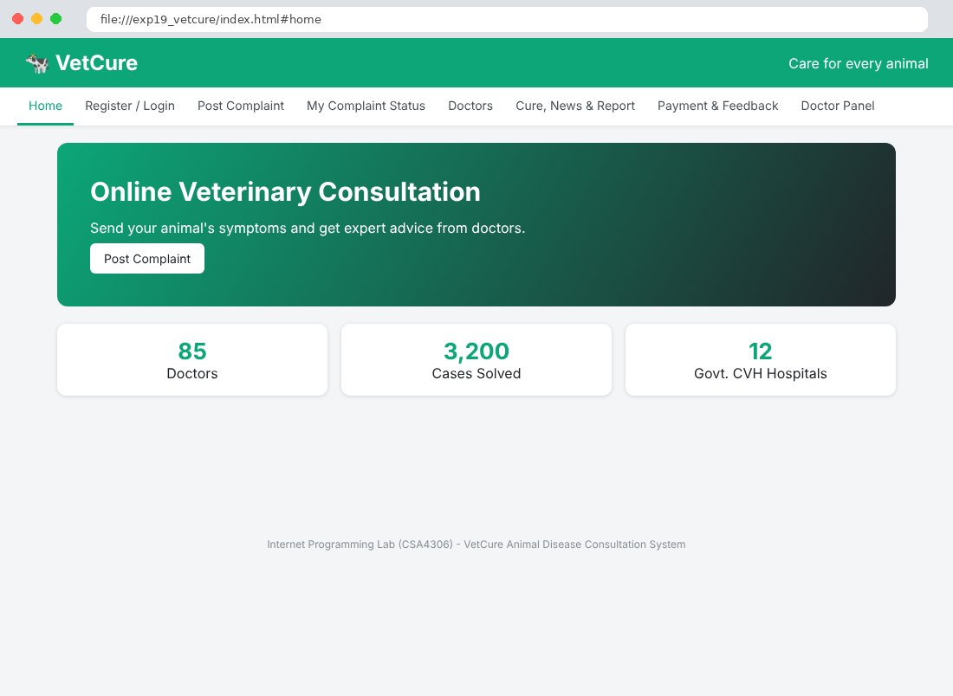
Fig. 19.2 Register / Login Page
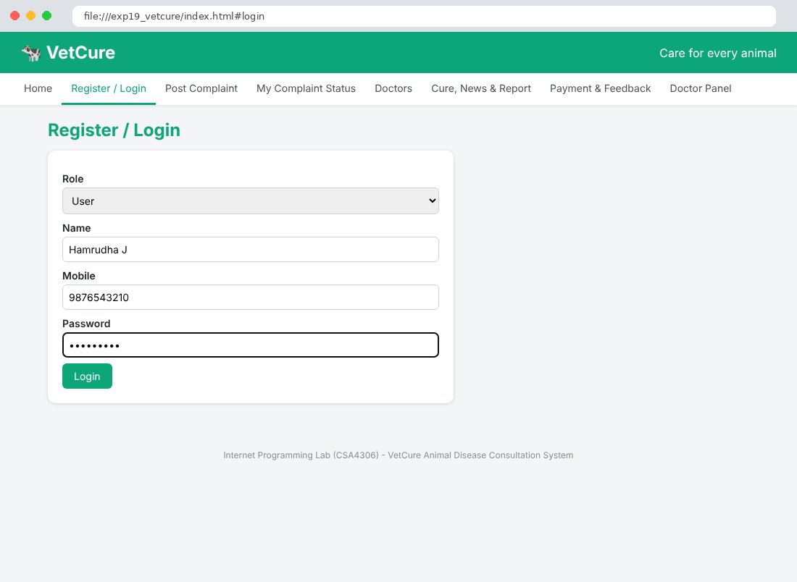
Fig. 19.3 Post Complaint Page
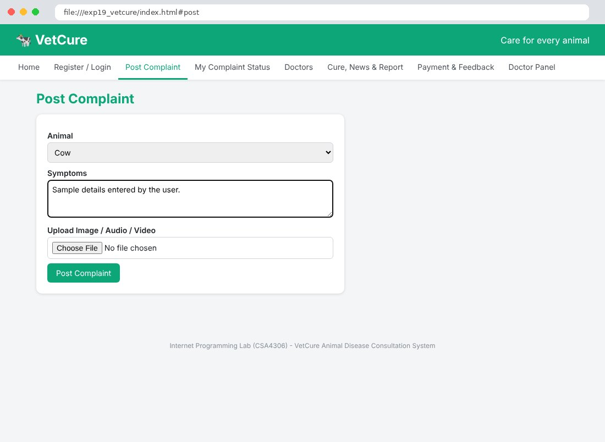
Fig. 19.4 My Complaint Status Page
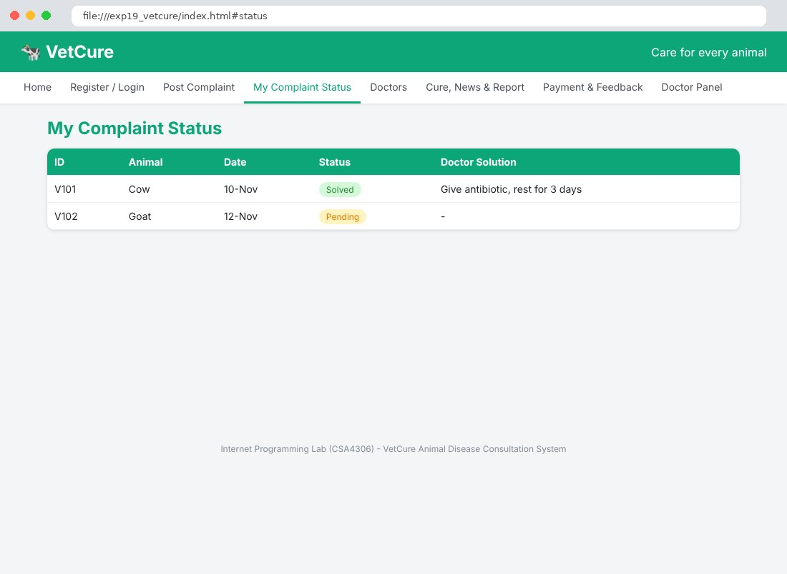
Fig. 19.5 Doctors Page
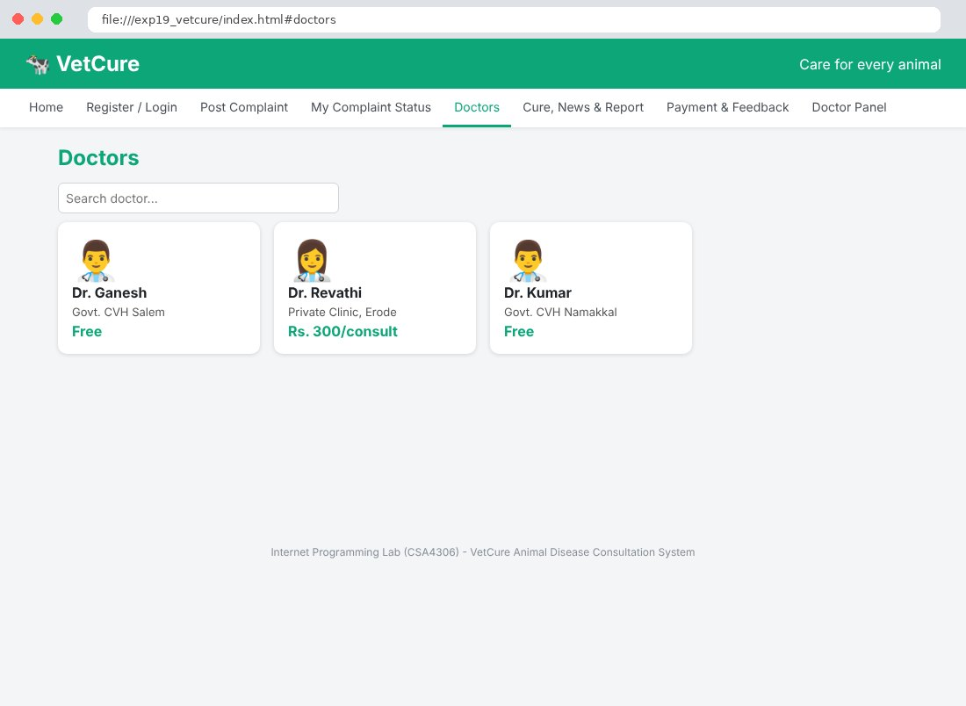
Fig. 19.6 Cure, News & Report Page
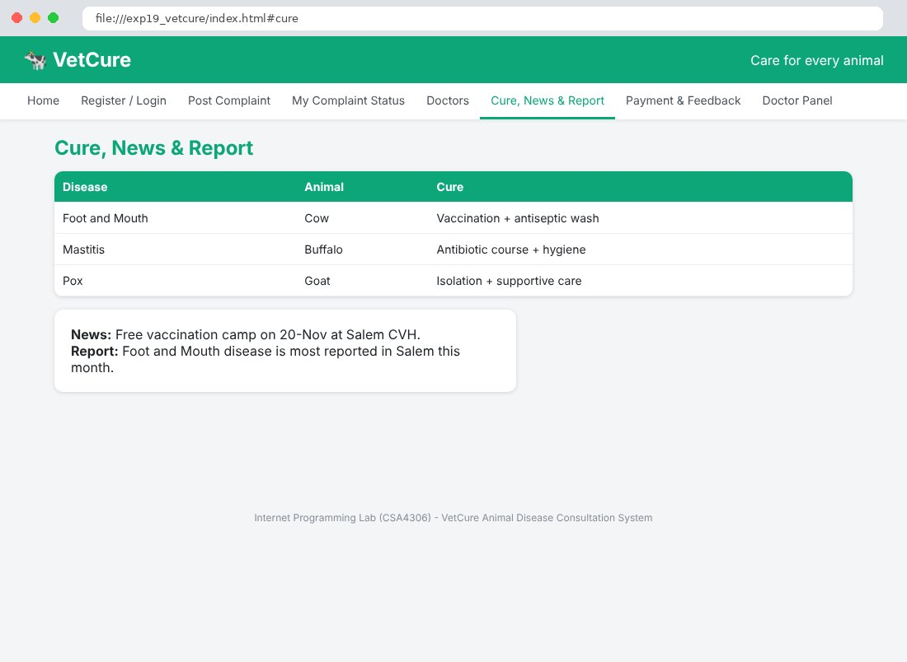
Fig. 19.7 Payment & Feedback Page
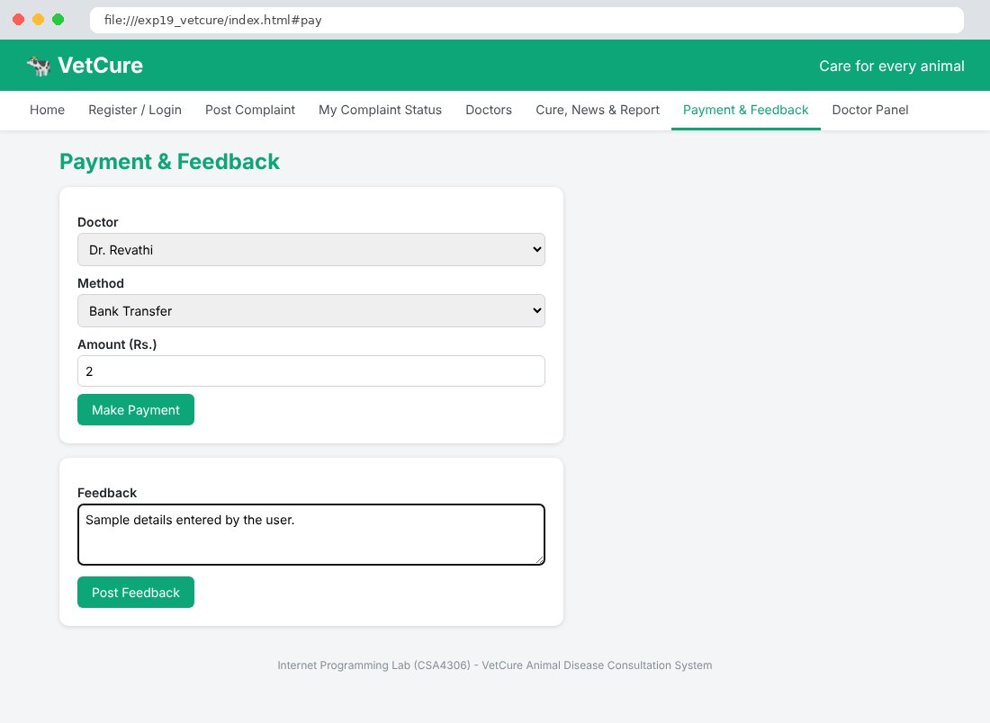
Fig. 19.8 Doctor Panel Page
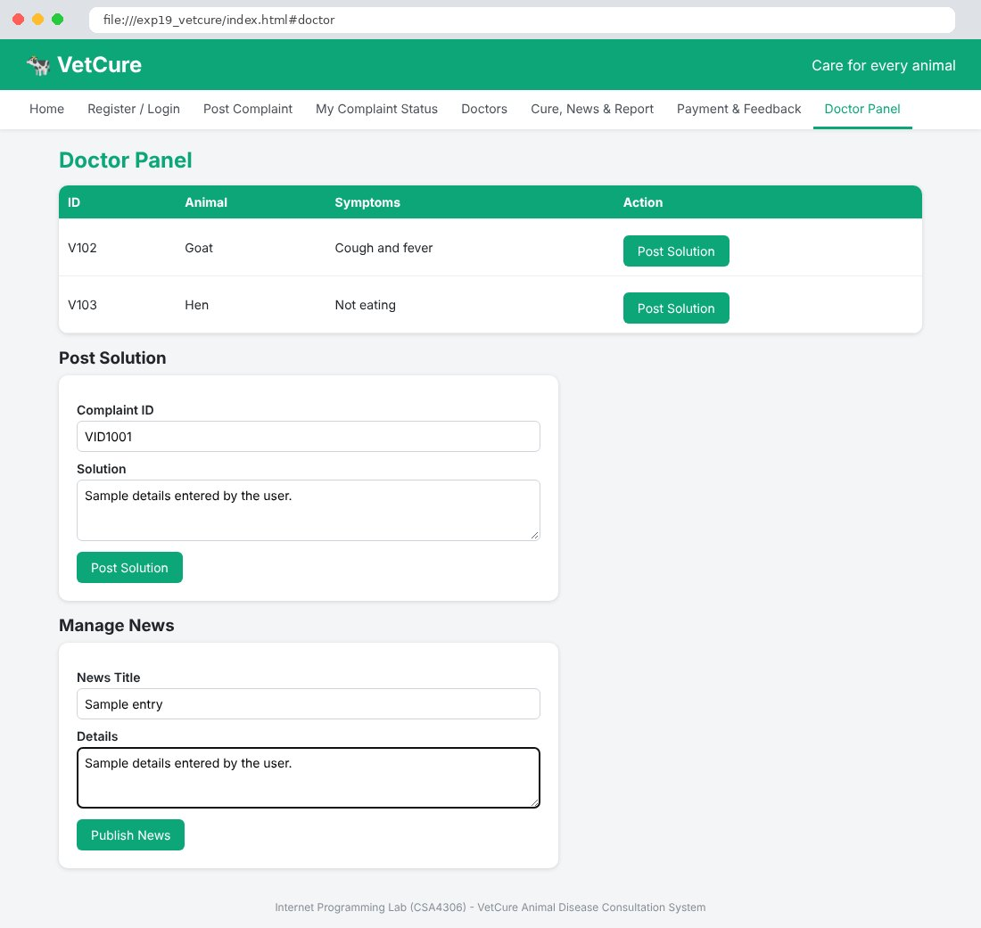

Result
Thus the VetCure Animal Disease Consultation System website was designed and developed using HTML, CSS and JavaScript, and the output was verified successfully.

