LAB EXPERIMENT 20
RentRide Online Vehicle Rental System

SUBJECT CODE | CSA4306
SUBJECT NAME | INTERNET PROGRAMMING
NAME | HAMRUDHA J
REG NO | 192411266
EXPERIMENTS | 6 to 20

Experiment 20: RentRide Online Vehicle Rental System

Question
RentRide is a modern online platform designed for convenient vehicle rentals. The website allows users to browse a diverse fleet of vehicles, including cars, trucks, and SUVs, based on their needs and preferences. Key functionalities include user registration and login, a search feature with filters for vehicle type, rental duration, and location, and detailed vehicle descriptions with photos and pricing. Customers can book vehicles, manage their reservations, and view rental history through a personalized dashboard. The platform supports secure payment methods, provides real-time booking confirmations, and offers 24/7 customer support for any rental issues. RentRide aims to simplify the vehicle rental process, ensuring a seamless and efficient experience for users.Key Features
- Search Module
- Appointment Booking
- Check-in form Submitting
- Appointment management
- Schedule a timing
- Past appointment Management
- Reviews Admin
- Login
- Add Vehicle
- Manage Vehicle details
- Type, Price, Etc
- Manage Booking details
- Approve User Booking
- My profile User
- Register
- Login
- Search Vehicle details
- Select Vehicle & Make Booking
- Name, Customer No, Address, Type
- View Booking Status
- My profile

Aim
To develop an online vehicle rental website where users register, search vehicles with filters, make bookings with customer details, view booking status and profile, and the admin adds vehicles, manages vehicle and booking details and approves bookings.

Software / Tools Required
HTML5, CSS3 and JavaScript; any text editor (VS Code / Notepad++); a web browser (Google Chrome).

Algorithm
1. Start.
2. Create a folder for the project and a file index.html.
3. Design the common header (RentRide) and the navigation bar using HTML.
4. Create one section (page) for each module: Home, Register / Login, Vehicles, Make Booking, Booking Status, My Profile, Admin Panel.
5. Design forms with labels, text fields, drop-down lists and buttons for user input.
6. Apply CSS for the layout, colours, cards, tables and responsive grid.
7. Write JavaScript functions to switch between pages, validate and submit forms, search and filter items.
8. Open index.html in the browser, test every page and verify the output.
9. Stop.

Program (index.html)
<!DOCTYPE html>
<html lang="en">
<head>
<meta charset="UTF-8">
<meta name="viewport" content="width=device-width, initial-scale=1">
<title>RentRide - RentRide Online Vehicle Rental System</title>
<style>
:root{--c:#f08c00}
*{box-sizing:border-box;margin:0;font-family:'Segoe UI',Arial,sans-serif}
body{background:#f4f5f7;color:#212529}
header{background:var(--c);color:#fff;padding:14px 28px;display:flex;justify-content:space-between;align-items:center}
header h1{font-size:24px}
nav{background:#fff;padding:0 20px;display:flex;flex-wrap:wrap;box-shadow:0 2px 4px #0001}
nav a{padding:12px 13px;cursor:pointer;font-size:14px;color:#495057;border-bottom:3px solid transparent}
nav a.on,nav a:hover{color:var(--c);border-color:var(--c)}
main{max-width:1000px;margin:20px auto;padding:0 16px;min-height:420px}
.page{display:none}.page.active{display:block}
h2{margin-bottom:14px;color:var(--c)}
h3{margin:14px 0 8px}
.hero{background:linear-gradient(120deg,var(--c),#212529);color:#fff;border-radius:12px;padding:38px;margin-bottom:20px}
.hero h2{color:#fff;font-size:30px}
.grid{display:grid;grid-template-columns:repeat(auto-fill,minmax(200px,1fr));gap:16px;margin-bottom:16px}
.card{background:#fff;border-radius:10px;padding:16px;box-shadow:0 1px 5px #0002}
.card .ic{font-size:44px}
.card p{font-size:13px;color:#555;margin:4px 0}
.price{color:var(--c);font-weight:700}
.btn{background:var(--c);color:#fff;border:0;padding:9px 16px;border-radius:6px;cursor:pointer;margin-top:8px;font-size:14px}
.btn.alt{background:#868e96}
form,.box{background:#fff;padding:20px;border-radius:10px;box-shadow:0 1px 5px #0002;max-width:560px;margin-bottom:16px}
label{display:block;margin:10px 0 4px;font-size:14px;font-weight:600}
input,select,textarea{width:100%;padding:8px;border:1px solid #ced4da;border-radius:6px;font-size:14px}
table{width:100%;border-collapse:collapse;background:#fff;border-radius:10px;overflow:hidden;box-shadow:0 1px 5px #0002;margin-bottom:16px}
th{background:var(--c);color:#fff;text-align:left}
th,td{padding:10px;border-bottom:1px solid #eee;font-size:14px}
.stats{display:flex;gap:16px;margin-bottom:16px}
.stat{flex:1;background:#fff;border-radius:10px;padding:16px;text-align:center;box-shadow:0 1px 5px #0002}
.stat b{display:block;font-size:26px;color:var(--c)}
.tag{background:#e9ecef;border-radius:12px;padding:3px 10px;font-size:12px}
.ok{background:#d3f9d8;color:#2b8a3e}.wait{background:#fff3bf;color:#e67700}.bad{background:#ffe3e3;color:#c92a2a}
.map{height:240px;border-radius:10px;background:repeating-linear-gradient(45deg,#dff3e3,#dff3e3 20px,#cfe8d5 20px,#cfe8d5 40px);position:relative;margin-bottom:12px;cursor:crosshair;overflow:hidden}
.pin{position:absolute;font-size:26px;transform:translate(-50%,-100%)}
.bar{height:22px;background:var(--c);border-radius:4px;color:#fff;font-size:12px;padding:2px 8px}
.qr{display:grid;grid-template-columns:repeat(15,12px);gap:0;width:180px;border:8px solid #fff;box-shadow:0 1px 5px #0002}
.qr i{width:12px;height:12px;background:#fff}.qr i.k{background:#000}
#toast{position:fixed;bottom:24px;right:24px;background:#212529;color:#fff;padding:12px 20px;border-radius:8px;display:none}
footer{text-align:center;padding:16px;font-size:12px;color:#868e96}
</style>
</head>
<body>
<header><h1>🚗 RentRide</h1><span>Rent a ride, hit the road</span></header>
<nav>
<a data-p="home" onclick="show('home')">Home</a>
<a data-p="login" onclick="show('login')">Register / Login</a>
<a data-p="vehicles" onclick="show('vehicles')">Vehicles</a>
<a data-p="booking" onclick="show('booking')">Make Booking</a>
<a data-p="status" onclick="show('status')">Booking Status</a>
<a data-p="profile" onclick="show('profile')">My Profile</a>
<a data-p="admin" onclick="show('admin')">Admin Panel</a>
</nav>
<main>
<section class="page" id="home">
<div class="hero"><h2>Rent the Perfect Vehicle</h2><p>Cars, trucks and SUVs with transparent pricing and 24/7 support.</p><button class="btn" style="background:#fff;color:#212529" onclick="show('vehicles')">Search Vehicles</button></div><form data-msg="Showing available vehicles" data-go="vehicles">
<label>Location</label><select><option>Chennai</option><option>Madurai</option><option>Coimbatore</option></select>
<label>Vehicle Type</label><select><option>Car</option><option>SUV</option><option>Truck</option></select>
<label>Pick-up Date</label><input type="date" placeholder="Enter pick-up date" required>
<label>Days</label><input type="number" placeholder="Enter days" required>
<button class="btn">Search</button>
</form>
</section>
<section class="page" id="login">
<h2>Register / Login</h2>
<form data-msg="Login successful" data-go="vehicles">
<label>Role</label><select><option>User</option><option>Admin</option></select>
<label>Name</label><input type="text" placeholder="Enter name" required>
<label>Email</label><input type="email" placeholder="Enter email" required>
<label>Password</label><input type="password" placeholder="Enter password" required>
<button class="btn">Login</button>
</form>
</section>
<section class="page" id="vehicles">
<h2>Vehicles</h2>
<input placeholder="Search vehicle..." onkeyup="filt(this,'#cards .card')" style="max-width:320px;margin-bottom:10px;display:inline-block">
<select onchange="catf(this.value,'#cards .card')" style="max-width:200px;margin-left:8px;display:inline-block"><option>All</option><option>Car</option><option>SUV</option><option>Truck</option></select>
<div class="grid" id="cards">
<div class="card" data-c="Car"><div class="ic">🚗</div><b>Hyundai i20</b><p>Hatchback · 5 seats</p><div class="price">Rs. 1800 / day</div><button class="btn" onclick="show('booking')">Book Now</button></div>
<div class="card" data-c="SUV"><div class="ic">🚙</div><b>Toyota Fortuner</b><p>SUV · 7 seats</p><div class="price">Rs. 4500 / day</div><button class="btn" onclick="show('booking')">Book Now</button></div>
<div class="card" data-c="Truck"><div class="ic">🚚</div><b>Tata Ace</b><p>Mini truck · 750 kg</p><div class="price">Rs. 2200 / day</div><button class="btn" onclick="show('booking')">Book Now</button></div>
<div class="card" data-c="Car"><div class="ic">🚗</div><b>Honda City</b><p>Sedan · 5 seats</p><div class="price">Rs. 2400 / day</div><button class="btn" onclick="show('booking')">Book Now</button></div>
<div class="card" data-c="SUV"><div class="ic">🚙</div><b>Mahindra Thar</b><p>SUV · 4 seats</p><div class="price">Rs. 3500 / day</div><button class="btn" onclick="show('booking')">Book Now</button></div>
</div>
</section>
<section class="page" id="booking">
<h2>Make Booking</h2>
<form data-msg="Booking request sent. Confirmation sent" data-go="status">
<label>Vehicle</label><select><option>Hyundai i20</option><option>Toyota Fortuner</option><option>Tata Ace</option><option>Honda City</option><option>Mahindra Thar</option></select>
<label>Name</label><input type="text" placeholder="Enter name" required>
<label>Customer No</label><input type="tel" placeholder="Enter customer no" required>
<label>Address</label><textarea rows="3" required></textarea>
<label>Type</label><select><option>Self Drive</option><option>With Driver</option></select>
<label>From</label><input type="date" placeholder="Enter from" required>
<label>To</label><input type="date" placeholder="Enter to" required>
<button class="btn">Confirm Booking</button>
</form>
</section>
<section class="page" id="status">
<h2>Booking Status</h2>
<table>
<tr><th>Booking</th><th>Vehicle</th><th>Dates</th><th>Amount</th><th>Status</th></tr>
<tr><td>RB301</td><td>Hyundai i20</td><td>15-18 Nov</td><td>Rs. 5,400</td><td><span class="tag ok">Approved</span></td></tr>
<tr><td>RB302</td><td>Toyota Fortuner</td><td>25-26 Nov</td><td>Rs. 9,000</td><td><span class="tag wait">Waiting approval</span></td></tr>
<tr><td>RB280</td><td>Honda City</td><td>02-03 Oct</td><td>Rs. 4,800</td><td><span class="tag ok">Completed</span></td></tr>
</table>
</section>
<section class="page" id="profile">
<h2>My Profile</h2>
<form data-msg="Profile updated">
<label>Name</label><input type="text" placeholder="Enter name" required>
<label>Mobile</label><input type="tel" placeholder="Enter mobile" required>
<label>Email</label><input type="email" placeholder="Enter email" required>
<label>Address</label><textarea rows="3" required></textarea>
<button class="btn">Update Profile</button>
</form>
</section>
<section class="page" id="admin">
<h2>Admin Panel</h2>
<div class="stats"><div class="stat"><b>48</b>Vehicles</div><div class="stat"><b>12</b>Pending Bookings</div></div><h3>Add Vehicle</h3>
<form data-msg="Vehicle added">
<label>Vehicle Name</label><input type="text" placeholder="Enter vehicle name" required>
<label>Type</label><select><option>Car</option><option>SUV</option><option>Truck</option></select>
<label>Price per day</label><input type="number" placeholder="Enter price per day" required>
<button class="btn">Add Vehicle</button>
</form><table>
<tr><th>Booking</th><th>Customer</th><th>Vehicle</th><th>Action</th></tr>
<tr><td>RB302</td><td>Hamrudha</td><td>Toyota Fortuner</td><td><button class="btn">Approve</button> <button class="btn alt">Reject</button></td></tr>
<tr><td>RB303</td><td>Karthik</td><td>Tata Ace</td><td><button class="btn">Approve</button> <button class="btn alt">Reject</button></td></tr>
</table>
</section>
</main>
<footer>Internet Programming Lab (CSA4306) - RentRide Online Vehicle Rental System</footer>
<div id="toast"></div>
<script>
function show(id){document.querySelectorAll('.page').forEach(p=>p.classList.toggle('active',p.id===id));
document.querySelectorAll('nav a').forEach(a=>a.classList.toggle('on',a.dataset.p===id));window.scrollTo(0,0)}
function toast(m){const t=document.getElementById('toast');t.textContent=m;t.style.display='block';setTimeout(()=>t.style.display='none',2200)}
document.addEventListener('submit',e=>{e.preventDefault();toast(e.target.dataset.msg||'Saved successfully');if(e.target.dataset.go)show(e.target.dataset.go)});
function filt(inp,sel){const v=inp.value.toLowerCase();document.querySelectorAll(sel).forEach(r=>r.style.display=r.textContent.toLowerCase().includes(v)?'':'none')}
function catf(v,sel){document.querySelectorAll(sel).forEach(r=>r.style.display=(v=='All'||r.dataset.c==v)?'':'none')}
show('home');
</script>
</body>
</html>

Output
Fig. 20.1 Home Page
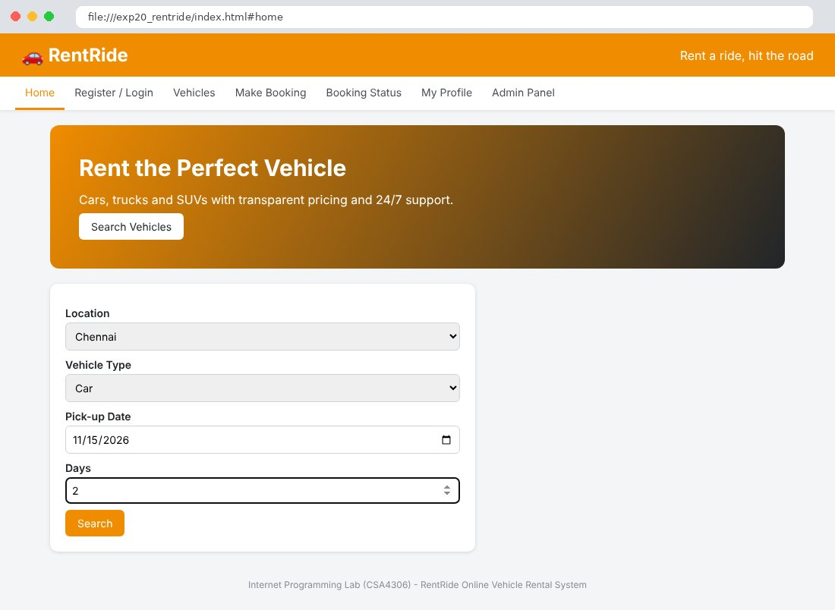
Fig. 20.2 Register / Login Page
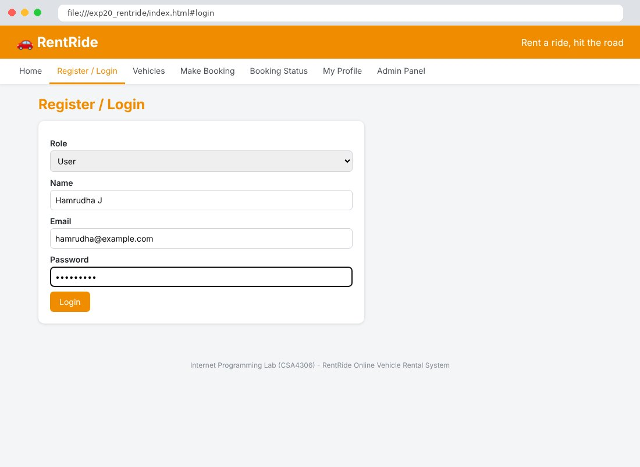
Fig. 20.3 Vehicles Page
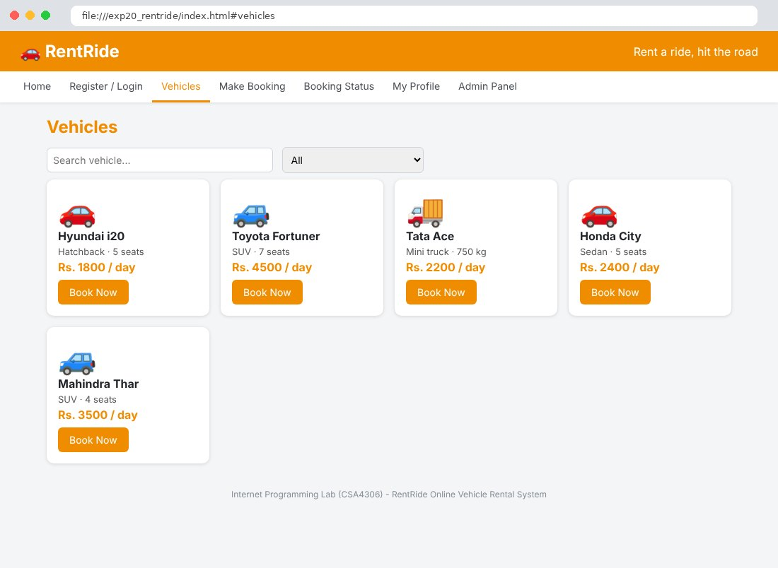
Fig. 20.4 Make Booking Page
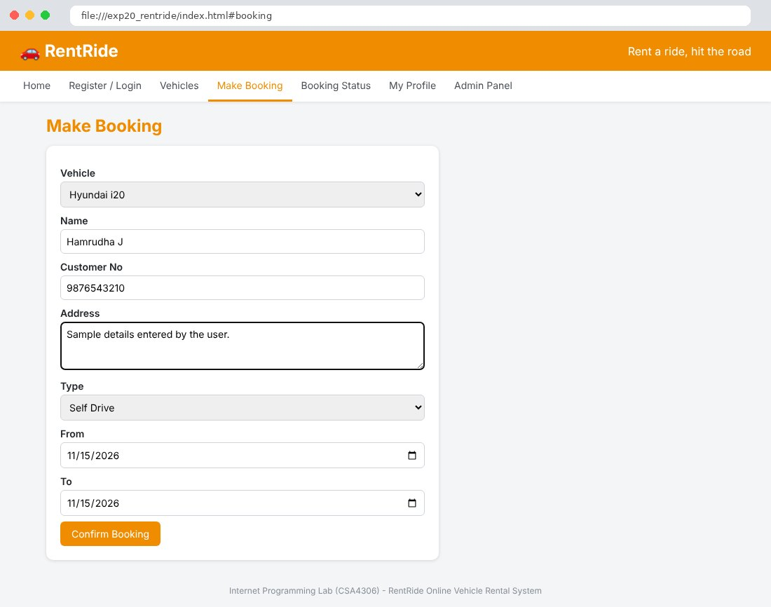
Fig. 20.5 Booking Status Page
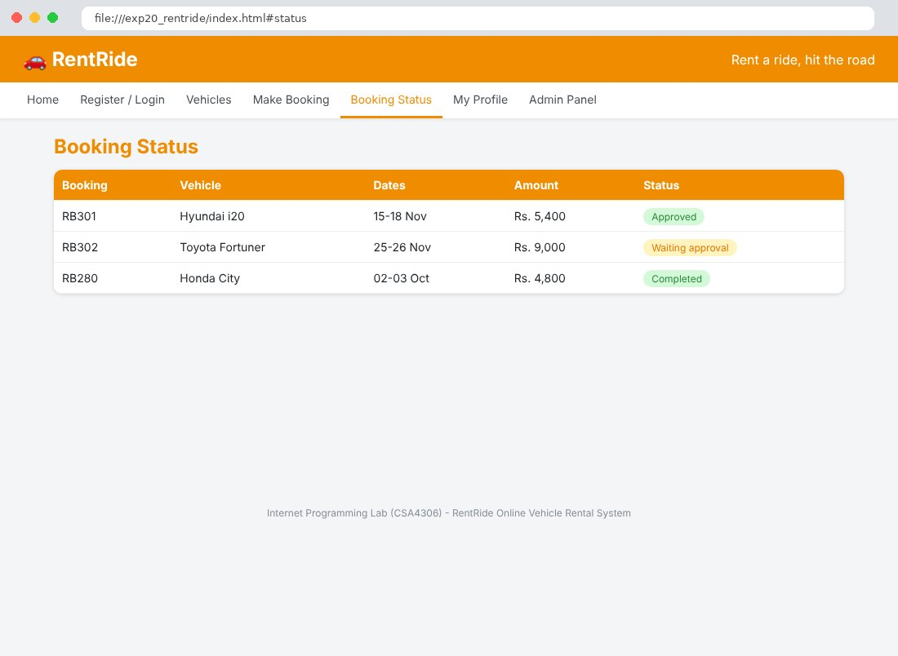
Fig. 20.6 My Profile Page
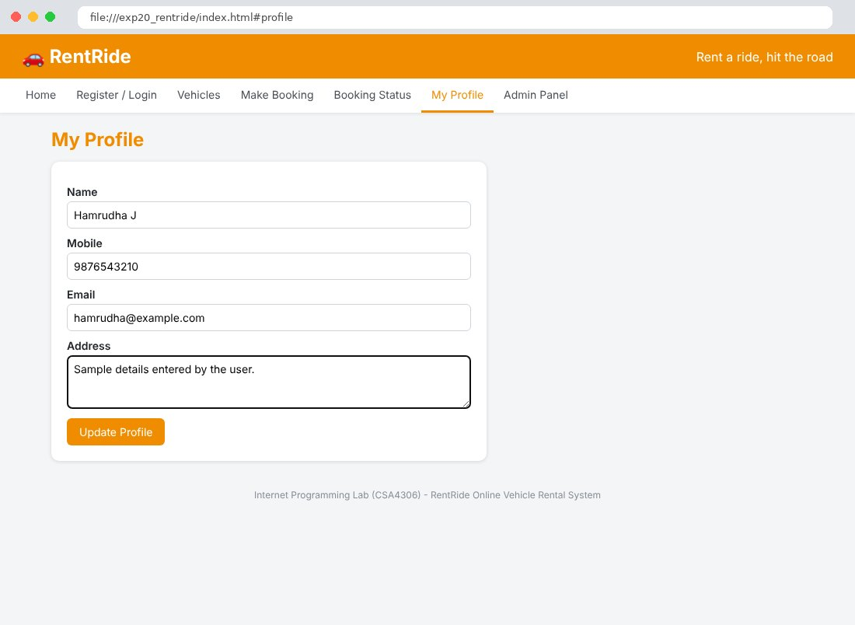
Fig. 20.7 Admin Panel Page
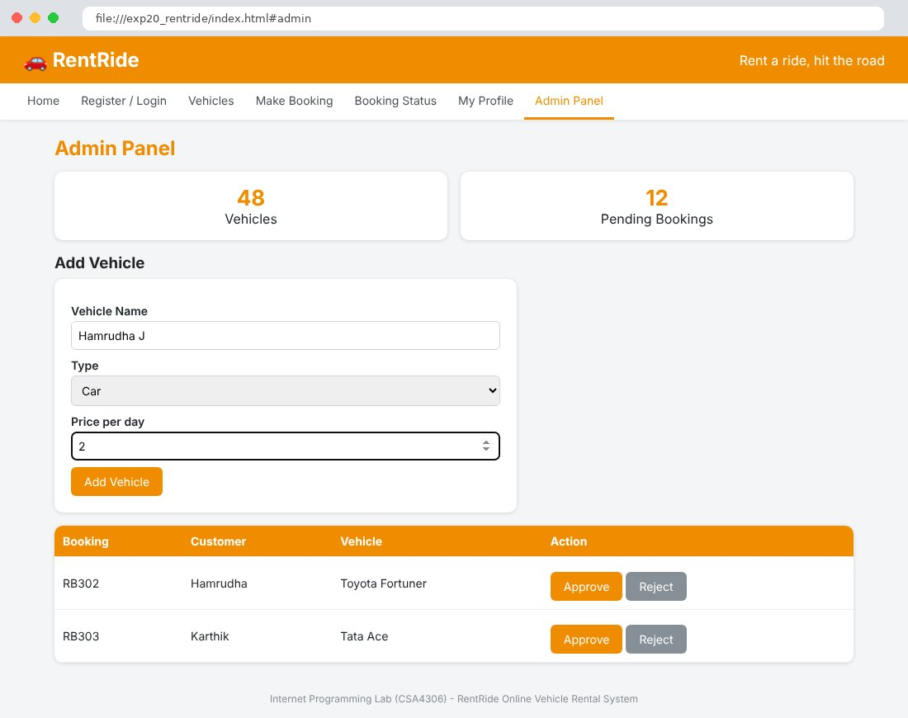

Result
Thus the RentRide Online Vehicle Rental System website was designed and developed using HTML, CSS and JavaScript, and the output was verified successfully.

