**WEEK 6**

**Superset ID-6396692**

**1.REACT JS-HOL**

**App.js**

import React from 'react';

function App() {

return (

<div>

<h1>welcome to the first session of React</h1>

</div>

);

}

export default App;

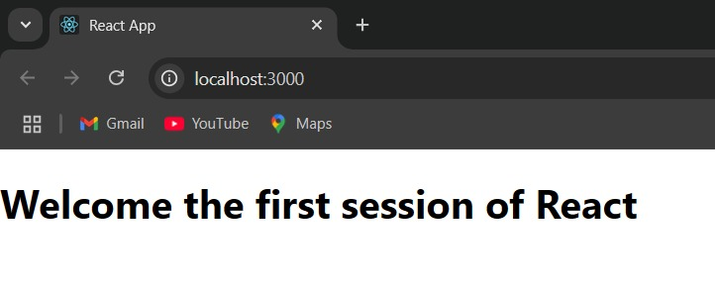

**2.REACT JS-HOL**

**src**

**Components**

**Home.js**

import React, { Component } from 'react';

class Home extends Component {

  render() {

    return (

      <div>

        <h3>Welcome to Home Page of Student Management Portal</h3>

      </div>

    );

  }

}

export default Home;

**About.js**

import React, {Component} from 'react';

class About extends Component{

    render(){

        return(

        <div>

        <h3>Welcome to the About Page of Student Management Portal</h3>

        </div>

        );

    }

}

export default About;

**Contact.js**

import React, {Component} from 'react';

class Contact extends Component{

    render(){

        return(

        <div>

        <h3>Welcome to the Contact Page of Student Management Portal</h3>

        </div>

        );

    }

}

export default Contact;

**App.js**

import React from 'react';

import Home from './Components/Home';

import About from './Components/About';

import Contact from './Components/Contact';

function App() {

  return (

    <div *className*="App">

      <Home />

      <About />

      <Contact />

    </div>

  );

}

export default App;

**OUTPUT**

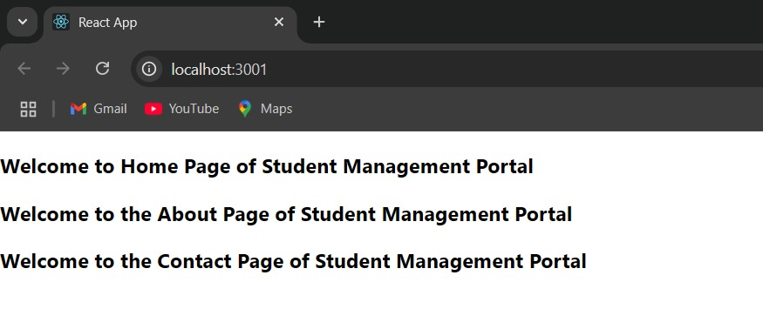

**3. REACT JS-HOL**

**src/components/CalculateScore.js**

import React from 'react';

import '../Stylesheets/mystyle.css';

function CalculateScore({ *name*, *school*, *total*, *goal* }) {

  const average = *total* / *goal*;

  return (

    <div *className*="score-box">

      <h2>Student Score Details</h2>

      <p><strong>Name:</strong> {*name*}</p>

      <p><strong>School:</strong> {*school*}</p>

      <p><strong>Total Marks:</strong> {*total*}</p>

      <p><strong>Number of Subjects:</strong> {*goal*}</p>

      <p><strong>Average Score:</strong> {average.toFixed(2)}</p>

    </div>

  );

}

export default CalculateScore;

**src/Stylesheets/mystyle.css**

.score-box {

  width: 400px;

  margin: 30px auto;

  padding: 20px;

  border: 2px solid #4caf50;

  border-radius: 10px;

  background-color: #f0f8ff;

  font-family: Arial, sans-serif;

  box-shadow: 0px 0px 10px rgba(0,0,0,0.1);

}

.score-box h2 {

  color: #4caf50;

  text-align: center;

}

**App.js**

import React from 'react';

import './App.css';

import CalculateScore from './Components/CalculateScore';

function App() {

  return (

    <div *className*="App">

      <CalculateScore

*name*="Cognizant"

*school*="Cognizant Academy"

*total*={465}

*goal*={5}

      />

    </div>

  );

}

export default App;

**OUPUT:**

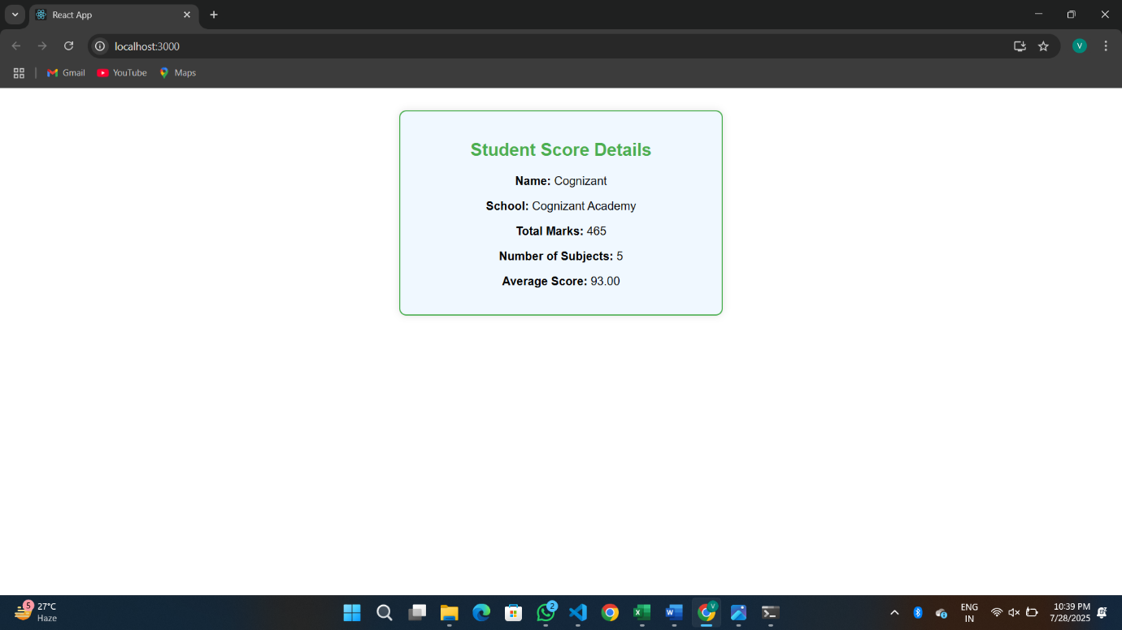

**4. REACT JS-HOL**

**Src**

**Post.js**

class Post{

    constructor(*id*, *title*, *body*){

        this.id=*id*;

        this.title=*title*;

        this.body=*body*;

    }

}

export default Post;

**Posts.js**

import React, { Component } from 'react';

import Post from './Post';

class Posts extends Component {

  constructor(*props*) {

*super*(*props*);

    this.state = {

      posts: [],

      hasError: false,

    };

  }

  loadPosts = async () => {

    try {

      const response = await fetch('https://jsonplaceholder.typicode.com/posts');

      const data = await response.json();

      const postList = data.map(*post* => new Post(*post*.userId, *post*.id, *post*.title, *post*.body));

      this.setState({ posts: postList });

    } catch (error) {

      this.setState({ hasError: true });

      alert('Error while fetching posts: ' + error.message);

    }

  };

  componentDidMount() {

    this.loadPosts();

  }

  componentDidCatch(*error*, *info*) {

    this.setState({ hasError: true });

    alert("An error occurred in Posts component: " + *error*.toString());

    console.error("Error info:", *info*);

  }

  render() {

    if (this.state.hasError) {

      return <h2>Something went wrong while loading posts.</h2>;

    }

    return (

      <div *style*={{ padding: '20px' }}>

        <h1>Blog Posts</h1>

        {this.state.posts.slice(0, 10).map(*post* => (

          <div *key*={*post*.id} *style*={{ marginBottom: '20px' }}>

            <h2>{*post*.title}</h2>

            <p>{*post*.body}</p>

          </div>

        ))}

      </div>

    );

  }

}

export default Posts;

**App.js**

import React from 'react';

import './App.css';

import Posts from './Posts';

function App() {

  return (

    <div *className*="App">

      <Posts />

    </div>

  );

}

export default App;

**OUPUT:**

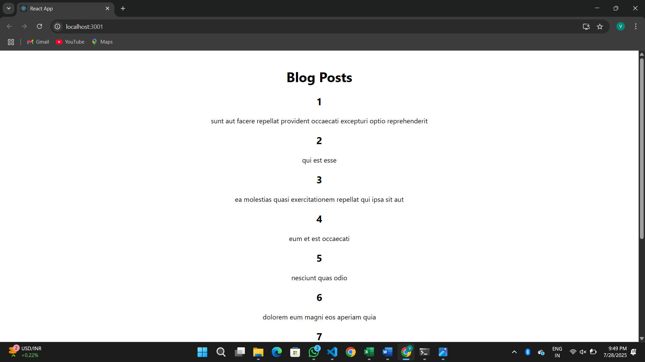

**5. REACT JS-HOL**

**CohortDetails.module.css**

**.**box {

width: 300px;

display: inline-block;

margin: 10px;

padding: 10px 20px;

border: 1px solid black;

border-radius: 10px;

vertical-align: top;

}

dt {

font-weight: 500;

}

**CohortDetails.js**

import React from 'react';

import styles from './CohortDetails.module.css';

function CohortDetails({ name, status, startDate, coach, trainer }) {

return (

<div className={styles.box}>

<h3 style={{ color: status === 'Ongoing' ? 'green' : 'blue' }}>{name}</h3>

<dl>

<dt>Started On</dt>

<dd>{startDate}</dd>

<dt>Current Status</dt>

<dd>{status}</dd>

<dt>Coach</dt>

<dd>{coach}</dd>

<dt>Trainer</dt>

<dd>{trainer}</dd>

</dl>

</div>

);

}

export default CohortDetails;

**App.js**

import React from 'react';

import CohortDetails from './components/CohortDetails';

function App() {

const cohortList = [

{

name: 'INTADMDF10 - .NET FSD',

status: 'Scheduled',

startDate: '22-Feb-2022',

coach: 'Aathma',

trainer: 'Jojo Jose',

},

{

name: 'ADM21JF014 - Java FSD',

status: 'Ongoing',

startDate: '10-Sep-2021',

coach: 'Apoorv',

trainer: 'Elisa Smith',

},

{

name: 'CDBJF21025 - Java FSD',

status: 'Ongoing',

startDate: '24-Dec-2021',

coach: 'Aathma',

trainer: 'John Doe',

},

];

return (

<div style={{ padding: '20px' }}>

<h2>Cohorts Details</h2>

{cohortList.map((cohort, index) => (

<CohortDetails

key={index}

name={cohort.name}

status={cohort.status}

startDate={cohort.startDate}

coach={cohort.coach}

trainer={cohort.trainer}

/>

))}

</div>

);

}

export default App;

**OUTPUT:**



