Name : Hams Ali

- What is the topic of your final project?
library system

- Who is the intended audience?
Librarians: The primary users of the system who manage the library's collection, handle patron transactions, and perform administrative tasks such as adding, updating, and removing books from the catalog.

- Provide a summary of the functionalities of your project.
  - Book Management:
  - Add, edit, and remove books from the library's collection.
  - Track details such as title, author, ID_Book,, and availability status.
  - Manage multiple copies of the same book.
  - Patron Management:
  - Register new library members (patrons) and maintain patron records.
  - Track patron information including name, contact details, and borrowing history.

UML

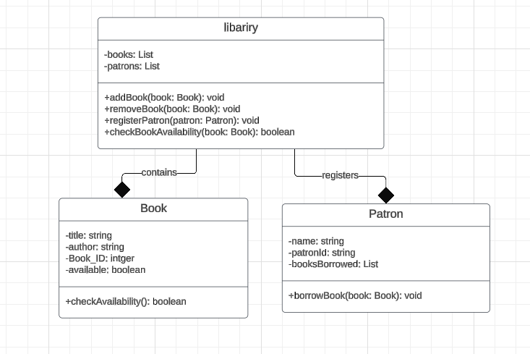

Secreen Shootes:

LOGIN
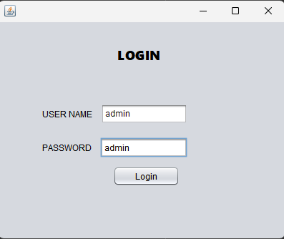
Dashboard
D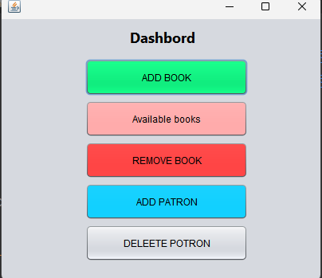

Add Book
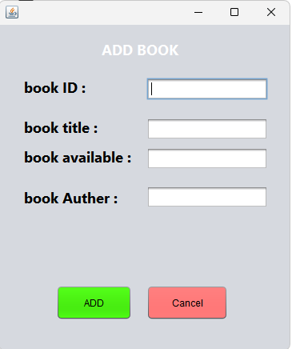

Avalbel Book
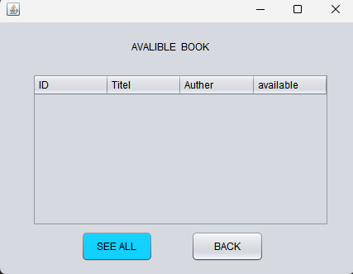

Add Book after click SEE ALL

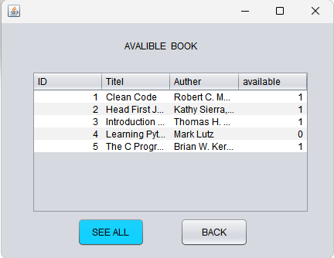

DELETE BOOK
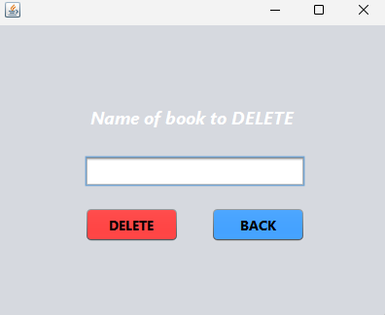

ADD NEW PATRON TO DATABASE

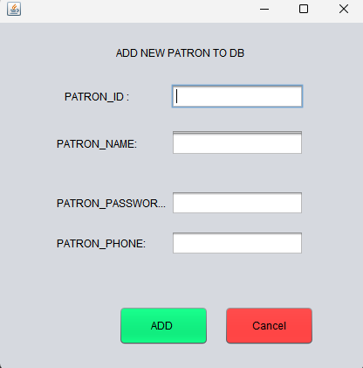

DELETE Book
