Seafood website Project

Your group members?
3 members
Hams Aljohani
Sara Imran
Sahar Albardawil

What is the topic of your final project?
A restaurant website through which the user can order and from the website through the menu that contains the products.

Who is the intended audience?
The target audience or people are those who love seafood and sweets

brief summary of the functionalities of your project:
First, the customer enters the HOME (Seafood.php) page, from which he will move to the rest of the pages. After that, he will move to the login.php page. If he does not have an account, he will open a new account through the Singup.php page. After registration, the customer will be transferred to the menu page, through which he can choose meals and others, and after he chooses the meals. He will click on the bill button to see the Bill payment.

FRONT-END
What is the total page count?
7 pages (admin.php, bill.php, book.php, Contact.php, login.php, Menu.php, seafood.php, signup.php)

names of any external stylesheet used in this project:
main.css

CSS libraries/frameworks used in this project:
Bootstrap

JavaScript libraries/frameworks used in this project:
N/A

How does your project meet the Interactivity requirement?
Interactive Menu:
- We have Implement a dynamic and visually appealing menu that allows users to view different categories of seafood dishes.
- We have Include high-quality images, descriptions, and prices for each dish.
- we have Add interactive elements like hover effects, animations, or pop-ups to make the menu visually engaging.

Online Ordering System:
- we made Integrate an online ordering system that enables customers to place orders directly through the website.

- we have Provide a user-friendly interface for selecting dishes, specifying quantities, and customizing orders.
Responsive Design:
- User-friendly on all devices.

BACK-END

Attach a screenshot of the final database diagram:

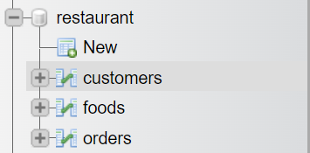
This image for the all table in database

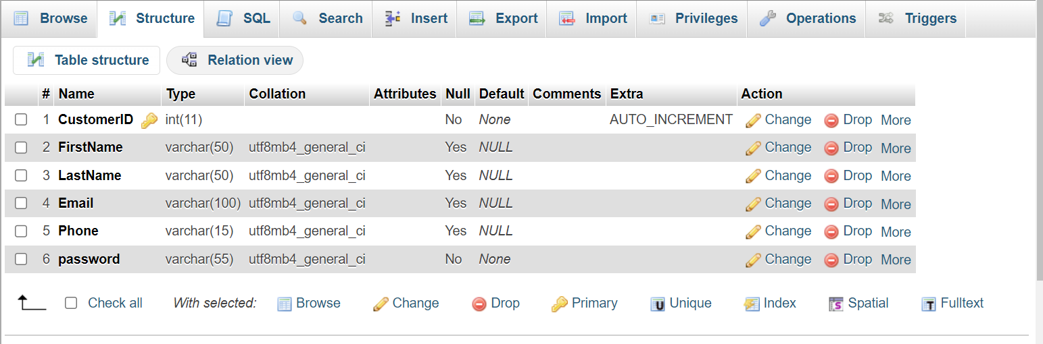
This structure for customers TABLE

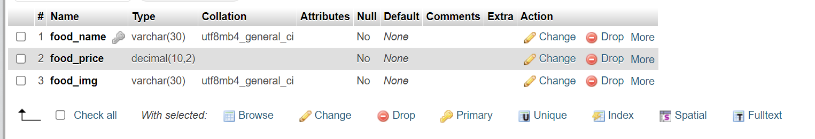
This structure for foods TABLE

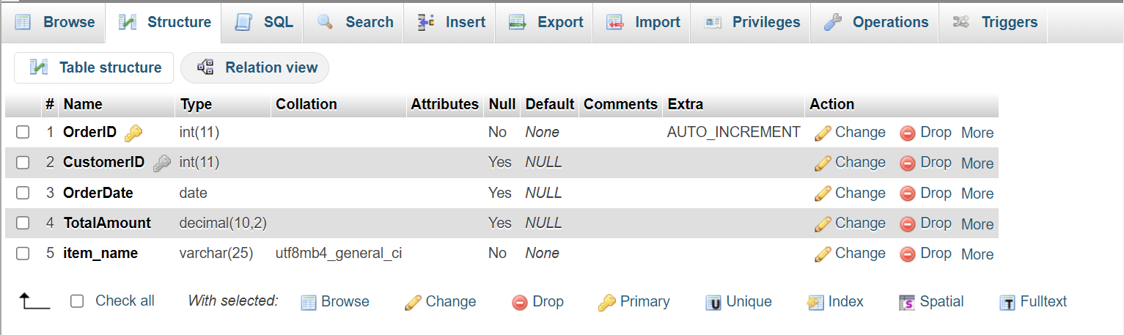
This structure for orders TABLE

project do you insert a record to the database (the 'C' in CRUD)?
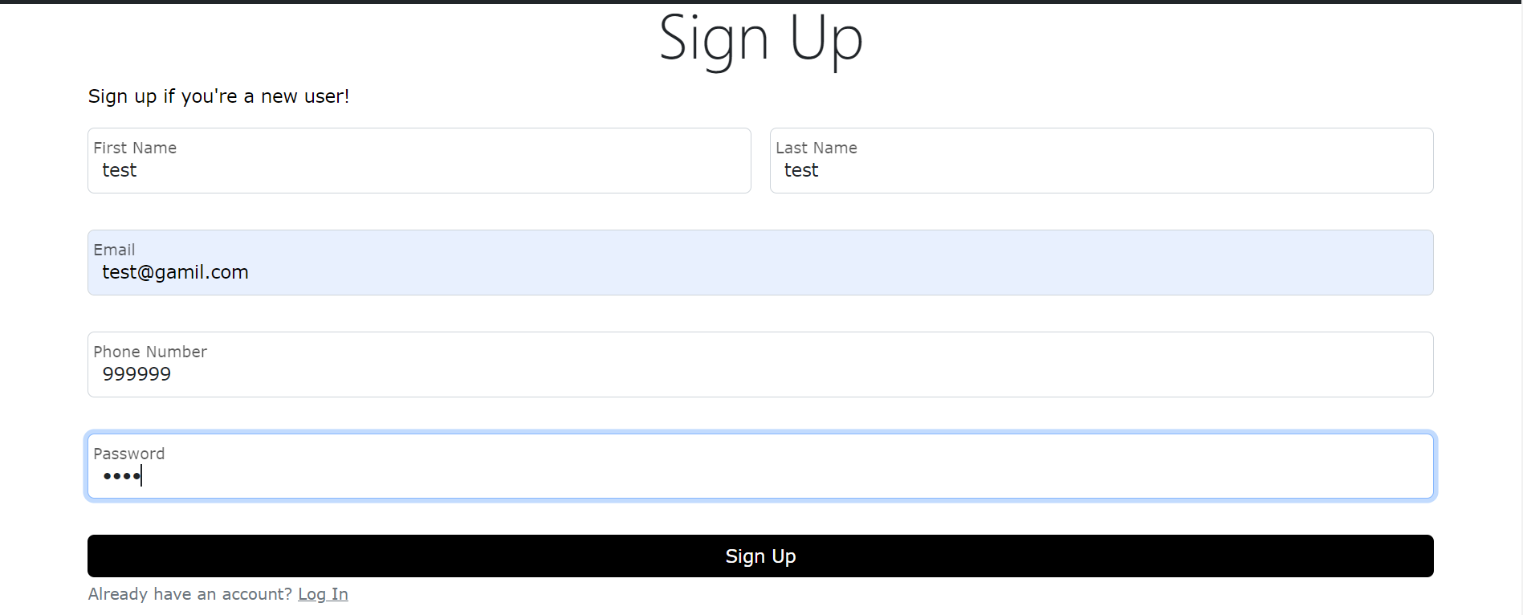

When the fields are filled in correctly, a new row will be added in the Customers table the code for this :

if (isset($_POST['signup']) and !empty($_POST['firstname'] and !empty($_POST['lastname']) and !empty($_POST['phonenumber']) and !empty($_POST['email']))) {
$firstname = $_POST['firstname'];
$lastname = $_POST['lastname'];
$email = $_POST['email'];
$PhoneNumber = $_POST['phonenumber'];
$password = $_POST['password'];
$query = $conaction->prepare("INSERT INTO customers(FirstName, LastName, Email , Phone, password) VALUES ( '$firstname', '$lastname', '$email', '$PhoneNumber', SHA1('$password'))");
$query->execute();

project do you search and display record(s) from the database (the 'R' in CRUD)?
We implement that is three time :

One in booking table (book.php)
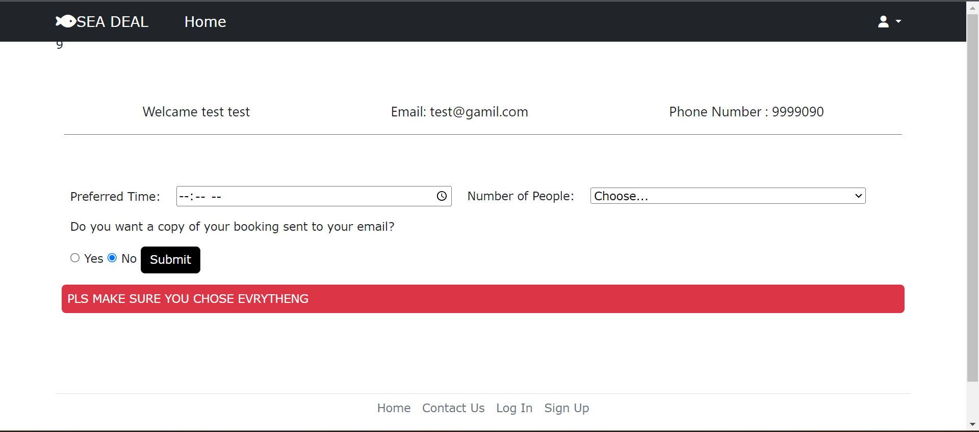
Here we learn about the customer data by reading from the customer table, and the data is displayed in the specified places.

Second in Menu.php
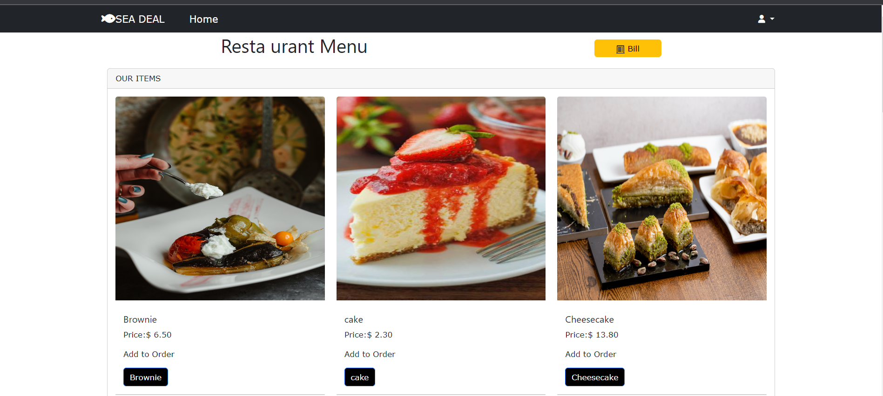
On this page, all products come from the foods table, which contains the names of the pictures, the name of the product, and the price this the code

<?php
include("db.php");
// Display Appetizers with images
$food_table = $conaction->prepare("SELECT * FROM foods");
$food_table->execute();
$data_food_table = $food_table->fetchAll();
foreach ($data_food_table as $item) { ?>

project do you update and existing record(s) the database (the 'U' in CRUD)?
N/A

project do you delete existing record(s) from the database (the 'D' in CRUD)?
We have that in admin.php
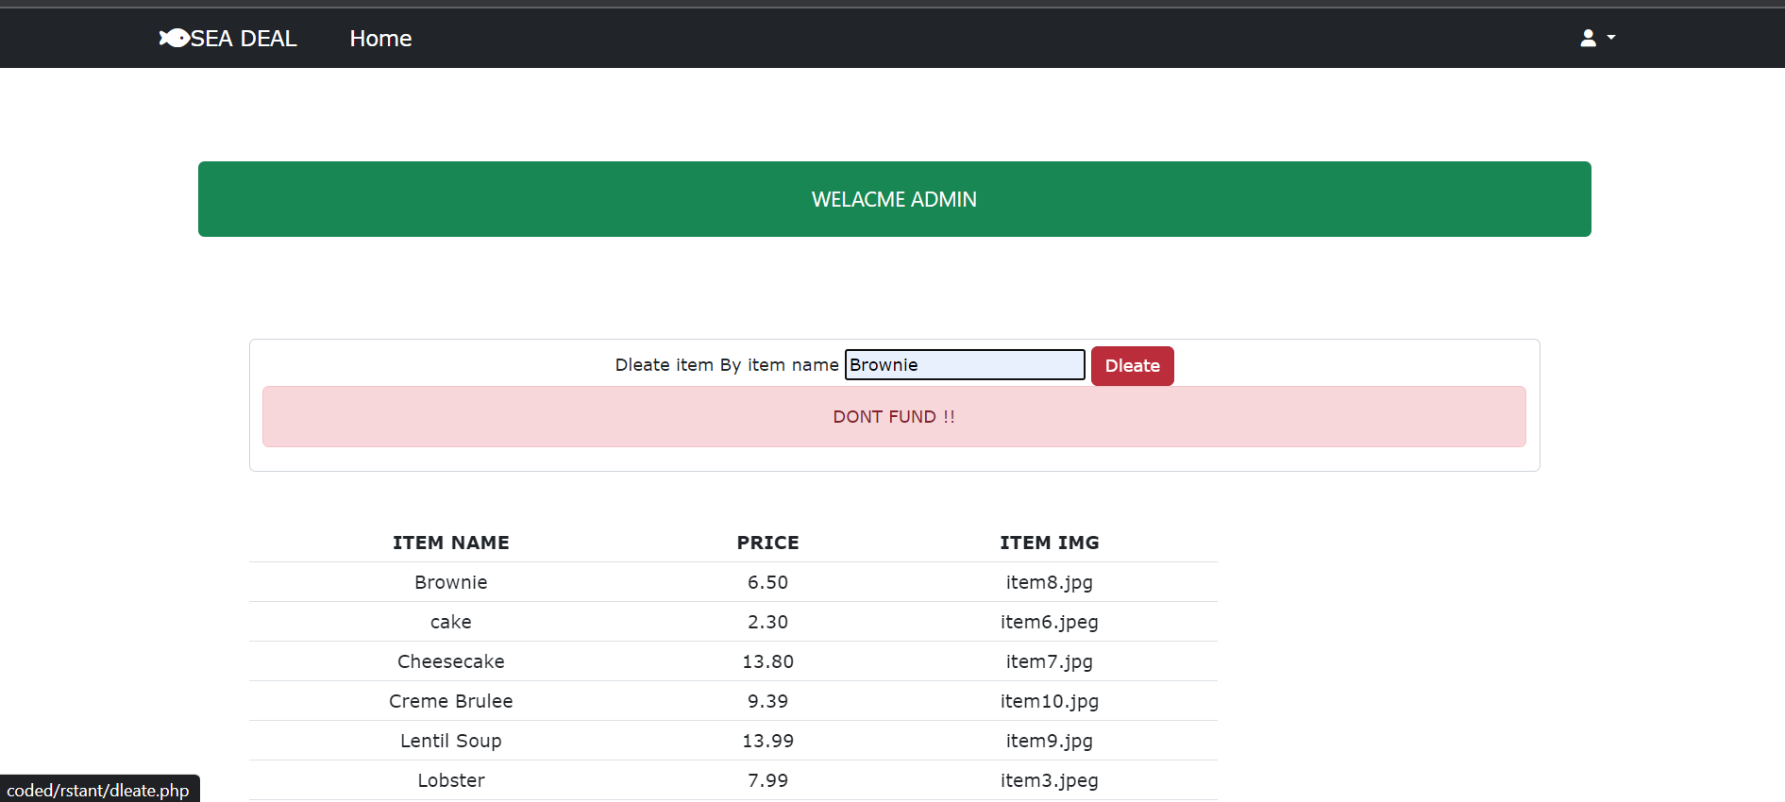

Here, when the product name is entered and delete is pressed, the product is deleted from the Foods table Foods
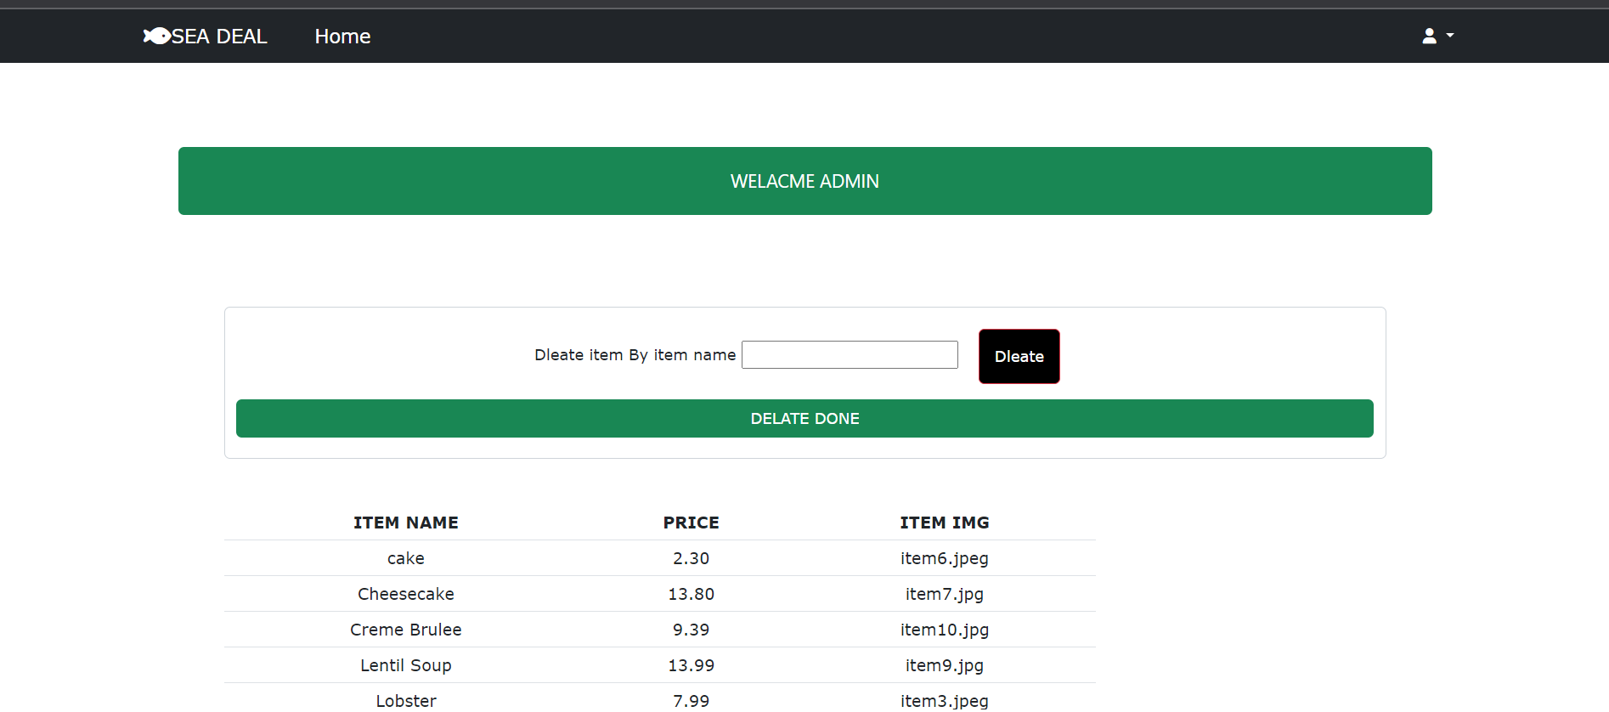

project requires any admin credentials (i.e. only admin users can access a certain page)

To enter the admin page the admin user when login as admin and the password admin
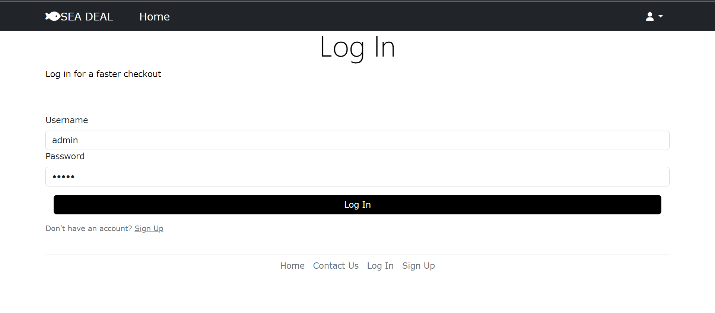

other information that you think the grader/instructor should know when grading your final
One of the important pieces of information is that there is a relationship between the Orders table and the Customers table and between the Customers table and the Orders table

