Home Lab Project Log
Windows Server 2022 | Active Directory | DNS | Group Policy | Microsoft 365
Hamsa Dahir | IT Support & Platform Engineering | June 2026

A record of tasks completed while building a home lab using Windows Server 2022, Active Directory, Group Policy and ServiceNow. The goal was to get hands-on experience with the tools used in IT support and platform engineering roles.

01 | Configure Static IP Address on Windows Server  Networking | TCP/IPv4

Set a static IP address on the server so it always has the same address on the network. This is required before promoting it to a Domain Controller.
Steps
- Pressed Windows + R and typed ncpa.cpl then pressed Enter to open Network Connections
- Right-clicked the Ethernet adapter and selected Properties
- Double-clicked Internet Protocol Version 4 (TCP/IPv4)
- Selected Use the following IP address and filled in the details below
- Selected Use the following DNS server addresses and entered the DNS settings
- Clicked OK then closed the Ethernet Properties window
Settings Applied
- IP Address: 192.168.1.60
- Subnet Mask: 255.255.255.0
- Default Gateway: 192.168.1.1
- Preferred DNS: 192.168.1.60 (points to itself as it will run DNS)
- Alternate DNS: 8.8.8.8
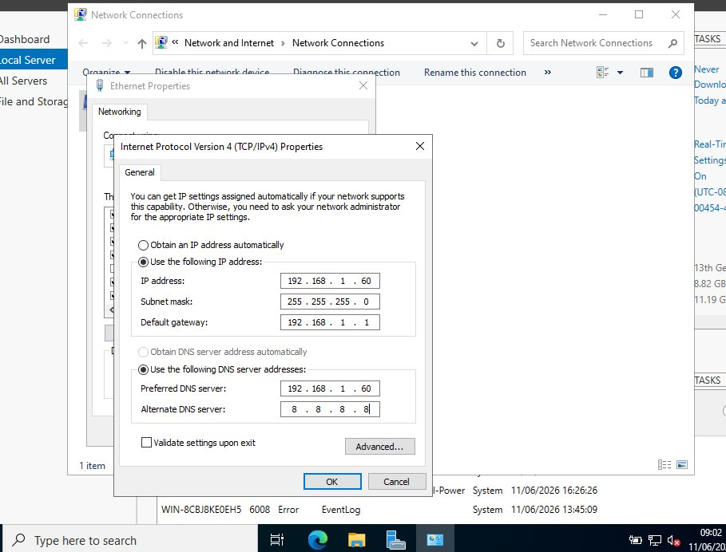
Fig 1 - Static IPv4 address configured on Windows Server 2022
Why This Matters
A Domain Controller needs a static IP so other machines can always find it. If the IP keeps changing, domain joins and DNS lookups will fail. The server points to itself for DNS because it will be running the DNS role for the domain.

02 | Install AD DS and DNS, Promote Server to Domain Controller  Active Directory | DNS | Server Roles

Used Server Manager to install the AD DS and DNS roles, then promoted the server to a Domain Controller for a new domain called mylab.local.
Steps
- Opened Server Manager and clicked Manage then Add Roles and Features
- Selected Role-based or feature-based installation and clicked Next
- Selected the local server and clicked Next
- Ticked Active Directory Domain Services and DNS Server from the roles list
- Clicked Add Features when prompted then clicked Next through to Install
- After installation completed, clicked the notification flag and selected Promote this server to a domain controller
- Selected Add a new forest and entered the root domain name: mylab.local
- Set the Directory Services Restore Mode (DSRM) password and clicked Next through the wizard
- Clicked Install and waited for the server to restart automatically
- Server rebooted and logged back in as MYLAB\Administrator confirming the promotion was successful
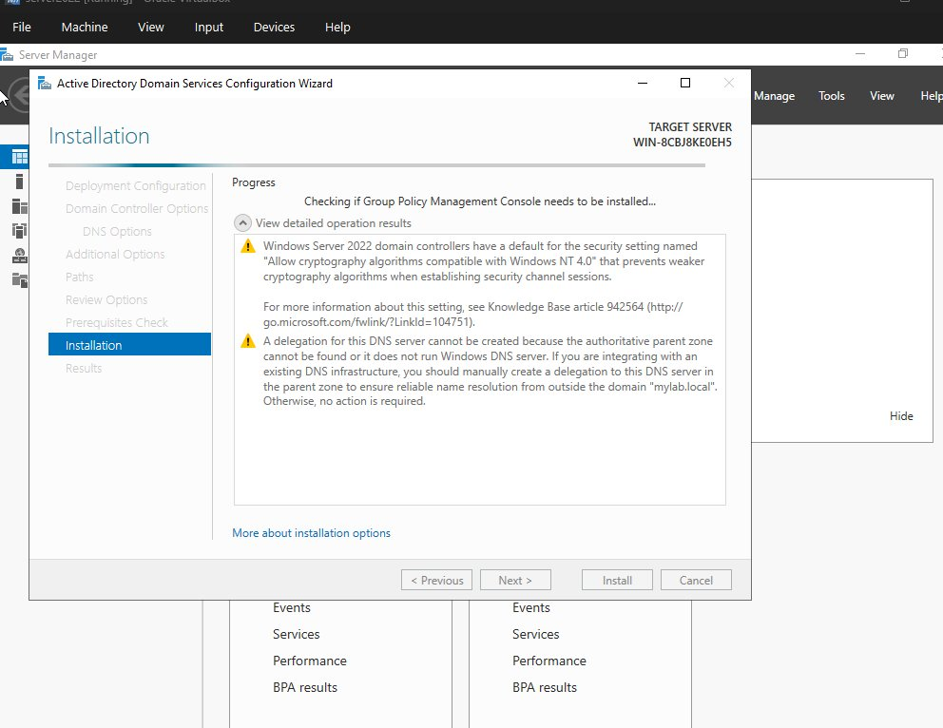
Fig 2 - AD DS Configuration Wizard during installation
Why This Matters
Promoting the server to a Domain Controller is the foundation of the whole lab. AD DS manages authentication for all users and computers, and DNS makes sure internal names like mylab.local resolve correctly.

03 | Join a Windows 10 PC to the Domain  Active Directory | Domain Join

Joined a Windows 10 machine to mylab.local and verified it appeared in Active Directory Users and Computers on the server.
Steps on the Windows 10 Machine
- Right-clicked the Start button and selected System
- Clicked Rename this PC (advanced) to open System Properties
- Clicked Change under Computer Name/Domain Changes
- Selected Domain and typed mylab.local then clicked OK
- Entered Domain Admin username and password when prompted
- Clicked OK on the welcome message and restarted the machine
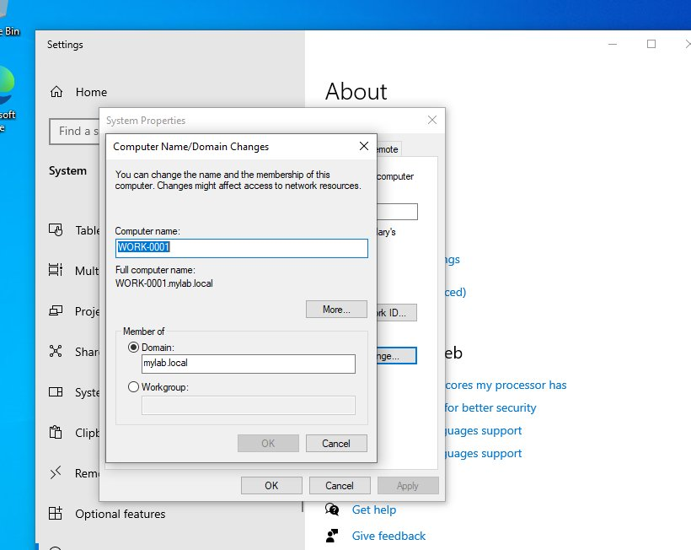
Fig 3 - Windows 10 System Properties showing WORK-0001 joined to mylab.local
Verified on the Server
- Opened Active Directory Users and Computers (ADUC) on the Domain Controller
- Expanded mylab.local and clicked the Computers container
- WORK-0001 appeared in the list confirming the domain join was successful
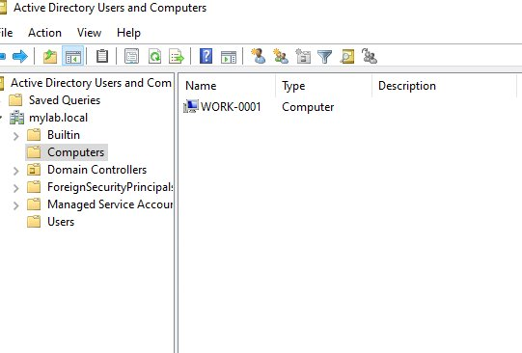
Fig 4 - ADUC showing WORK-0001 in the Computers container

Why This Matters
Once a PC is joined to the domain it is managed centrally. Group Policies and user permissions set in AD apply to it automatically, and any domain user can log in without needing a local account on that machine.

04 | Create an Organisational Unit and User Account in Active Directory  Active Directory | User Management

Created an Organisational Unit (OU) for HR and then added a new user account inside it. OUs are used to organise users and computers in AD so policies can be targeted at specific departments.
Steps to Create the OU
- Opened Active Directory Users and Computers (ADUC) from Server Manager or by typing dsa.msc in the Run box
- Right-clicked on mylab.local in the left panel
- Selected New then Organisational Unit
- Typed HR as the name and clicked OK
- The HR OU appeared under mylab.local in the tree
Steps to Create the User
- Right-clicked the HR OU and selected New then User
- Entered First name: Priya, Last name: Nair, Full name: Priya Nair
- Set the User logon name to pnair and the domain to mylab.local then clicked Next
- Set a temporary password and ticked User must change password at next logon
- Clicked Next then Finish to create the account
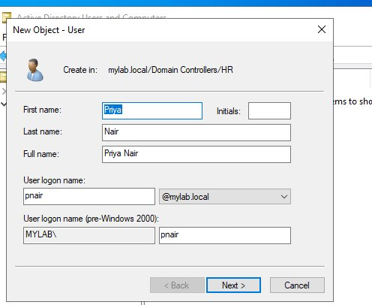
Fig 5 - Creating user Priya Nair in the HR OU
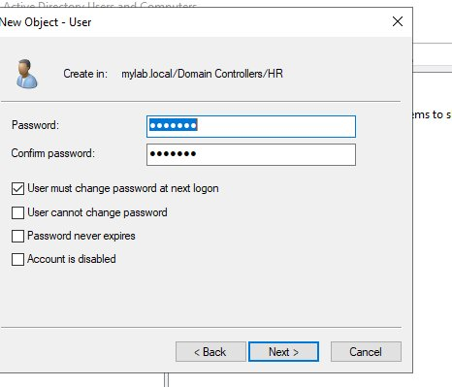
Fig 6 - Password settings applied to the new user account

Why This Matters
Placing the account in the HR OU means any HR Group Policies apply to it automatically. Forcing a password change at first login means the admin never knows the user's actual password.

05 | Create a Security Group and Assign Admin Privileges  Active Directory | Security Groups

Created a security group called tech support, added it to Domain Admins to give it elevated privileges, then added the user cobu man to the group so they inherited admin rights through membership.
Steps to Create the OU and Group
- Opened ADUC and right-clicked mylab.local
- Selected New then Organisational Unit and named it Tech Support
- Right-clicked the Tech Support OU and selected New then Group
- Named the group tech support, set Group scope to Global and Group type to Security then clicked OK
Steps to Assign Admin Privileges to the Group
- Right-clicked the tech support group and selected Properties
- Clicked the Member Of tab then clicked Add
- Typed Domain Admins and clicked OK to add the group to Domain Admins
Steps to Create the User and Add to Group
- Right-clicked the Tech Support OU and selected New then User
- Created the user account for cobu man
- Right-clicked the tech support group and selected Properties
- Clicked the Members tab then clicked Add
- Typed cobu man and clicked OK to add them to the group
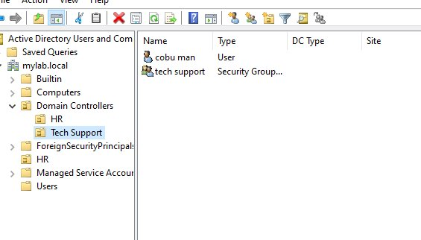
Fig 7 - Tech Support OU showing cobu man and the tech support security group

Why This Matters
Admin rights should always be assigned to groups, not individual users. If cobu man leaves, removing them from the group instantly removes their privileges without touching anything else.

06 | Set Up Tiered Support Groups Using Least Privilege  Active Directory | Security Groups | Least Privilege

Built a tiered IT support structure with three security groups inside the Tech Support OU, each representing a different level of access. A user was created and assigned to each tier.
Steps to Create the Groups
- Opened ADUC and expanded the Tech Support OU
- Right-clicked the Tech Support OU and created two sub-OUs named Groups and Users to keep things organised
- Right-clicked the Groups OU and selected New then Group
- Created 1st line support with Group scope Global and type Security, clicked OK
- Repeated the same steps to create 2nd line support and 3rd line group
Steps to Create Users and Assign to Groups
- Right-clicked the Users OU and selected New then User
- Created John Smith and set his logon name, then right-clicked the 1st line support group, selected Properties, Members tab, and added John Smith
- Created Sarah Jones the same way and added her to 2nd line support
- Created Marcus Log and added him to 3rd line group
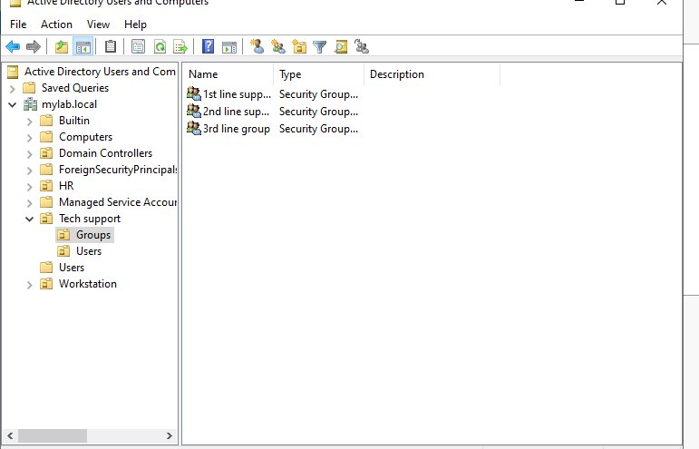
Fig 8 - Groups OU showing the three tiered security groups
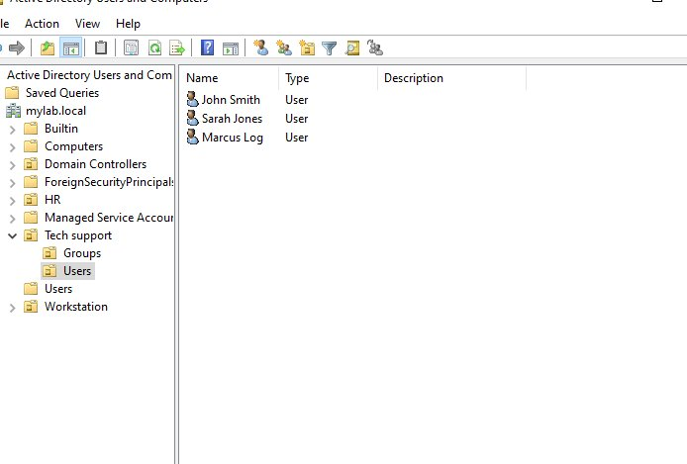
Fig 9 - Users OU showing the three support staff accounts

Why This Matters
Least privilege means users only get the access they need for their role. A 1st line agent does not need the same permissions as a senior engineer. Using groups makes this easy to manage as people change roles.

07 | Raise, Resolve and Close a ServiceNow Incident  ServiceNow | ITSM | Active Directory

A user called to say they could not log in to their workstation. Logged the incident in ServiceNow, fixed the issue in Active Directory, then closed the ticket.
Steps to Set Up ServiceNow
- Signed up for a free ServiceNow Developer Instance at developer.servicenow.com
- Logged in and navigated to the Incidents module under Service Desk in the left menu
- Familiarised with the incident queue showing all open tickets
Steps to Log the Incident
- Clicked New to create a new incident
- Set Caller to Emily Carter, Category to Inquiry/Help, Channel to Phone
- Entered Short description: workstation Locked out
- Entered Description: She said she cannot log in to her workstation. It needs resetting
- Set Urgency to 3 Low and assigned to Help Desk group then saved the ticket
Steps to Resolve the Issue
- Went to ADUC on the Domain Controller and searched for Emily Carter's account
- Right-clicked her account and saw it was disabled
- Clicked Enable Account to restore her login access
- Returned to ServiceNow and opened the ticket
- Changed State to Resolved and filled in the Resolution Information tab
- Clicked Resolve to close the ticket
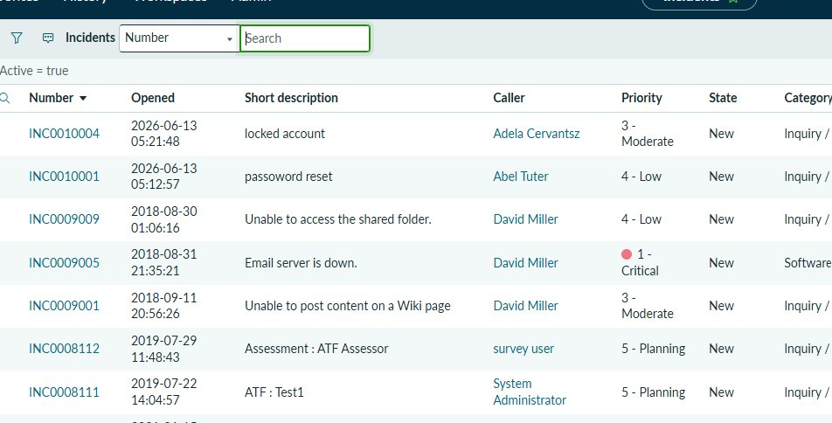
Fig 10 - ServiceNow incident queue showing INC0010005
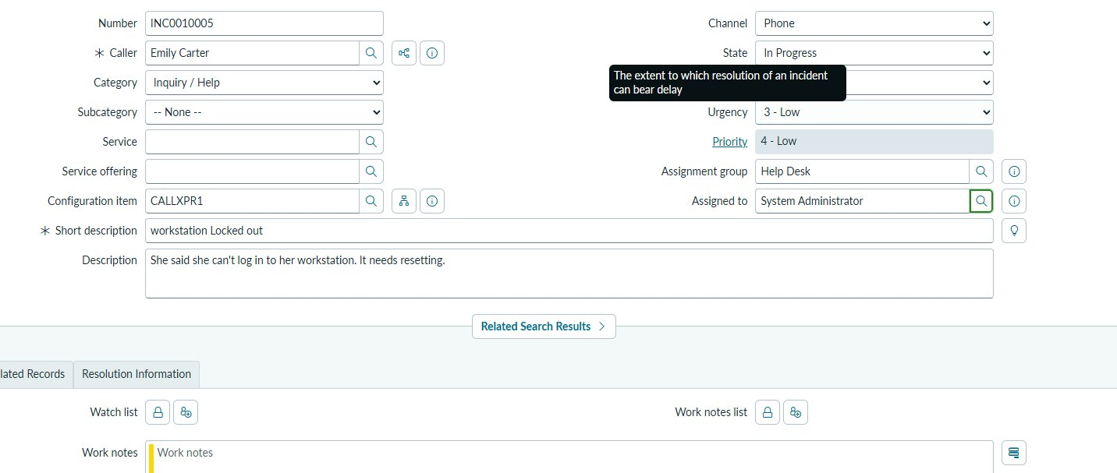
Fig 11 - ServiceNow ticket form showing the incident details
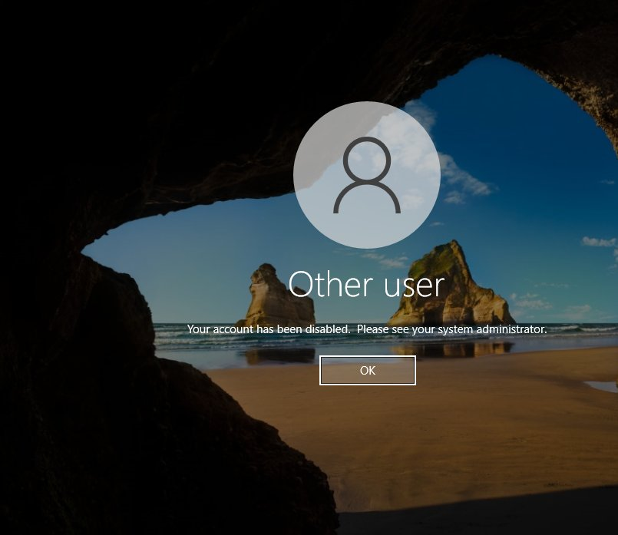
Fig 12 - The error Emily saw when trying to log in
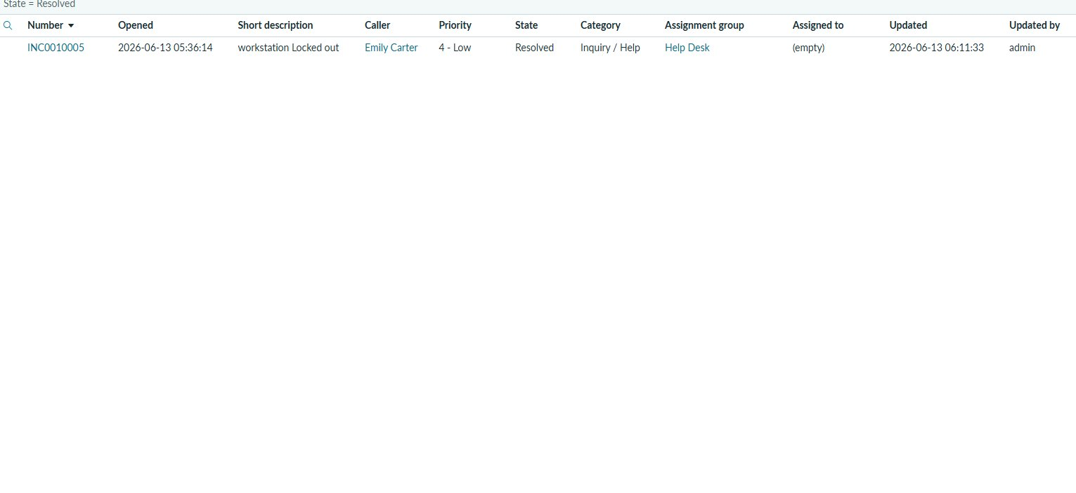
Fig 13 - INC0010005 marked as Resolved in ServiceNow

Why This Matters
This covers the full ITIL incident lifecycle from logging through to closure. ServiceNow is the most widely used ITSM platform in enterprise environments and being able to work a ticket end to end is a core 1st line support skill.

08 | Troubleshoot Trust Relationship Between Workstation and Domain Failed  Active Directory | Troubleshooting

User Daniel Hughes received the error 'The trust relationship between this workstation and the primary domain failed' when trying to log in. Diagnosed and resolved the issue.
Cause
Each domain-joined PC has a machine account in AD with a password that rotates every 30 days. If the PC is offline too long or restored from a snapshot, that password falls out of sync with the DC and breaks the trust.
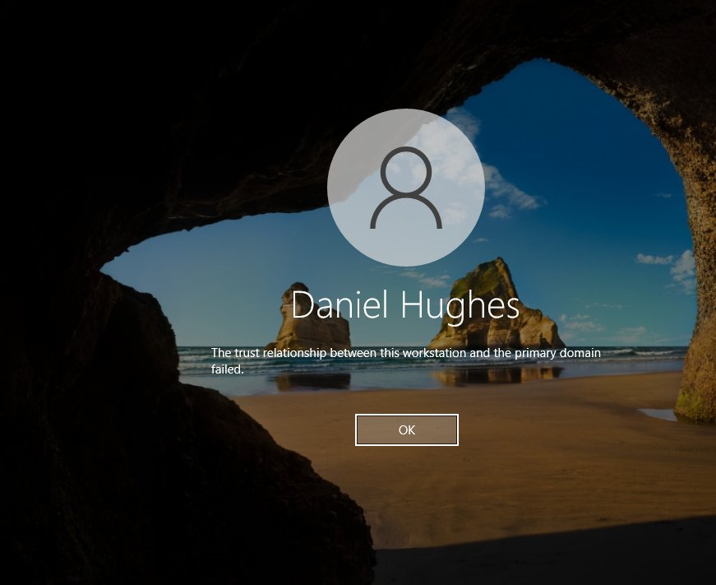
Fig 14 - Trust relationship error on the Windows 10 login screen
Steps to Fix
- At the Windows 10 login screen, clicked Other user and logged in with the local admin account instead of the domain account
- Opened PowerShell as Administrator by right-clicking the Start button and selecting Windows PowerShell (Admin)
- Typed the following command and pressed Enter: Test-ComputerSecureChannel -Repair -Credential (Get-Credential)
- A credentials box appeared, entered the Domain Admin username and password then clicked OK
- PowerShell returned True confirming the secure channel was reset successfully
- Alternative method if PowerShell did not work: opened ADUC on the DC, right-clicked the computer object for the affected machine and selected Reset Account
- Restarted the workstation and confirmed Daniel Hughes could log in with domain credentials

Why This Matters
This is a common error in environments with VMs or machines that go offline for long periods. Knowing how to fix it via PowerShell or ADUC is useful for any 1st or 2nd line support role.

09 | GPO: Enforce Screensaver Timeout on HR Users  Group Policy | Security

Created a GPO called Screensaver policy, configured a screensaver timeout setting, and linked it to the HR OU so it applies to all HR users automatically.
Steps to Create and Configure the GPO
- Opened Group Policy Management from Server Manager under Tools
- Expanded Forest, Domains, mylab.local then right-clicked the HR OU
- Selected Create a GPO in this domain and link it here
- Named the GPO Screensaver policy and clicked OK
- Right-clicked the new GPO and selected Edit to open Group Policy Management Editor
- Navigated to User Configuration, Policies, Administrative Templates, Control Panel, Personalisation
- Double-clicked Screen saver timeout and selected Enabled
- Set the timeout value in seconds then clicked Apply and OK
- Closed the editor, the policy was now active and linked to the HR OU
Policy Details
- GPO name: Screensaver policy
- Setting: Screen saver timeout
- Linked to: HR OU (mylab.local/HR)
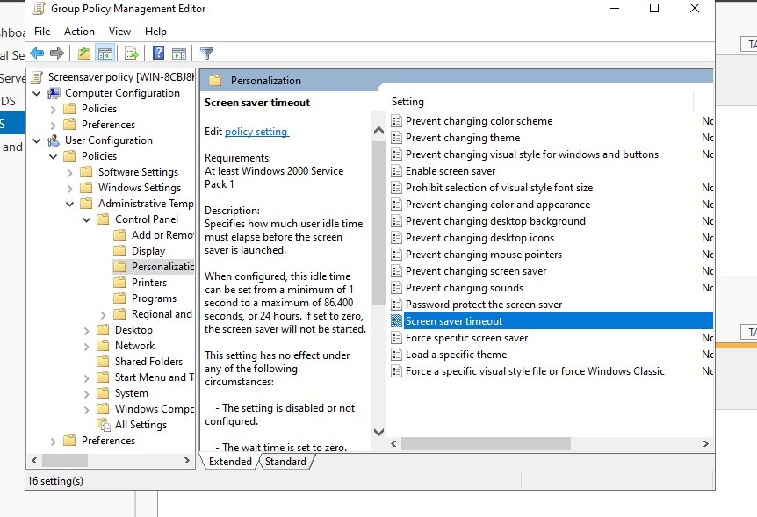
Fig 15 - Screen saver timeout setting in Group Policy Management Editor
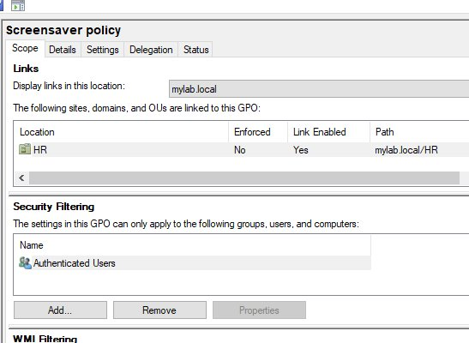
Fig 16 - Screensaver policy linked to the HR OU

Why This Matters
Linking the GPO to the HR OU means only HR users are affected. A screensaver lockout is a standard security control used to prevent unauthorised access to idle workstations.

10 | GPO: Block USB and Removable Storage on Workstations  Group Policy | Security | Data Loss Prevention

Created a GPO called Disable USB driver, enabled the setting to deny all removable storage access, and linked it to the Workstation OU to apply across all company PCs.
Steps
- Opened Group Policy Management from Server Manager under Tools
- Right-clicked the Workstation OU and selected Create a GPO in this domain and link it here
- Named the GPO Disable USB driver and clicked OK
- Right-clicked the GPO and selected Edit
- Navigated to Computer Configuration, Policies, Administrative Templates, System, Removable Storage Access
- Double-clicked All Removable Storage classes: Deny all access and selected Enabled
- Clicked Apply then OK and closed the editor
- Confirmed the GPO appeared as linked and enabled in the Workstation OU
Policy Details
- GPO name: Disable USB driver
- Setting: All Removable Storage classes: Deny all access
- Status: Enabled
- Linked to: Workstation OU
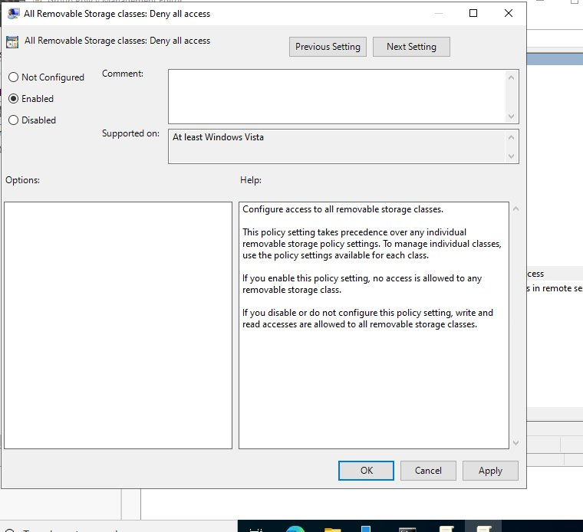
Fig 17 - Removable storage access denied setting enabled in GPO
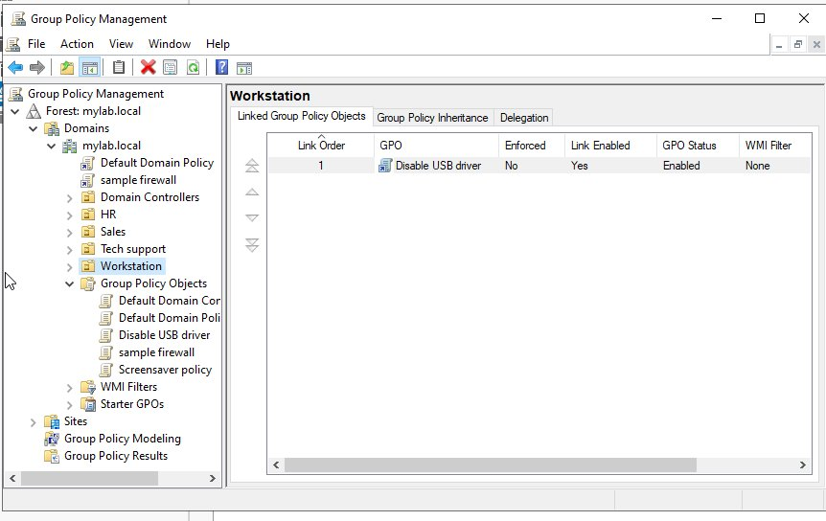
Fig 18 - Disable USB driver GPO linked to the Workstation OU

Why This Matters
Blocking removable storage prevents users copying sensitive data to USB drives or introducing malware. Applying it at OU level means it enforces on every PC in that OU without any per-machine configuration.

11 | Create a Shared Folder with NTFS Permissions and Map as Network Drive  File Server | NTFS | Network Drive Mapping

Created an HR folder on the Domain Controller, restricted access using NTFS permissions tied to the HR Users AD group, then mapped it as a network drive on the Windows 10 client.
Steps to Create and Share the Folder
- On the Domain Controller, opened File Explorer and went to the C: drive
- Right-clicked and selected New, Folder and named it HR
- Right-clicked the HR folder and selected Properties then clicked the Sharing tab
- Clicked Advanced Sharing, ticked Share this folder and set the share name
- Clicked Permissions and added the HR Users group with Read and Change permissions
- Clicked OK to apply the share settings
Steps to Set NTFS Permissions
- Clicked the Security tab in the HR folder Properties
- Clicked Edit then Add and typed HR Users then clicked Check Names and OK
- Selected the HR Users group and ticked the permissions needed then clicked Apply and OK
Steps to Map the Drive on Windows 10
- On the Windows 10 client, opened File Explorer and clicked This PC
- Clicked the Computer tab at the top and selected Map network drive
- Selected drive letter H: and entered the network path to the HR folder on the server
- Ticked Reconnect at sign-in so the drive maps automatically every time the user logs in
- Clicked Finish and the HR file drive appeared under Network Locations
Permissions Applied
- SYSTEM: Full control
- HR Users (MYLAB\HR Users): Read and write access
- Administrators: Full control
- Anyone not listed is denied access
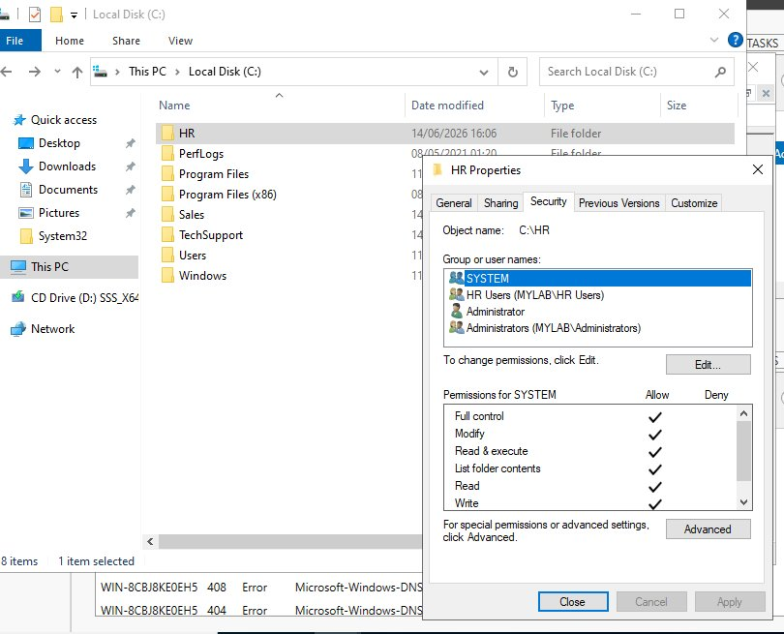
Fig 19 - HR folder NTFS permissions showing HR Users group access
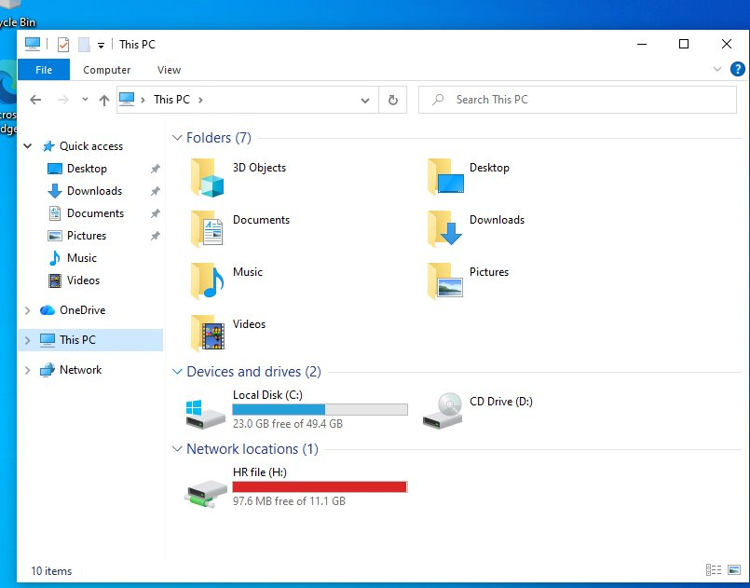
Fig 20 - Windows 10 showing the HR folder mapped as network drive H:

Why This Matters
Assigning permissions to the HR Users group keeps things manageable. New HR staff just need to be added to the group to get access. The mapped drive appears automatically at login, which is how departmental drives work in any company.

12 | Configure Password Policy and Account Lockout in Default Domain Policy  Group Policy | Security | Password Policy

Edited the Default Domain Policy to enforce password complexity and account lockout rules that apply automatically to every user on the domain.
Steps to Configure Password Policy
- Opened Group Policy Management from Server Manager under Tools
- Expanded Forest, Domains, mylab.local and right-clicked Default Domain Policy then selected Edit
- Navigated to Computer Configuration, Policies, Windows Settings, Security Settings, Account Policies, Password Policy
- Double-clicked Enforce password history and set it to 10 passwords then clicked OK
- Double-clicked Maximum password age and set it to 90 days then clicked OK
- Double-clicked Minimum password age and set it to 1 day then clicked OK
- Double-clicked Minimum password length and set it to 7 characters then clicked OK
- Double-clicked Password must meet complexity requirements and selected Enabled then clicked OK
Steps to Configure Account Lockout Policy
- In the same editor, navigated to Account Policies then Account Lockout Policy
- Double-clicked Account lockout threshold and set it to 5 invalid attempts then clicked OK
- Windows automatically suggested values for the other settings, clicked OK to accept them
- Confirmed Account lockout duration was set to 30 minutes
- Confirmed Reset account lockout counter after was set to 15 minutes
Settings Applied
- Password history: 10 passwords remembered
- Maximum age: 90 days
- Minimum length: 7 characters
- Complexity requirements: Enabled
- Lockout threshold: 5 invalid attempts
- Lockout duration: 30 minutes
- Reset counter after: 15 minutes
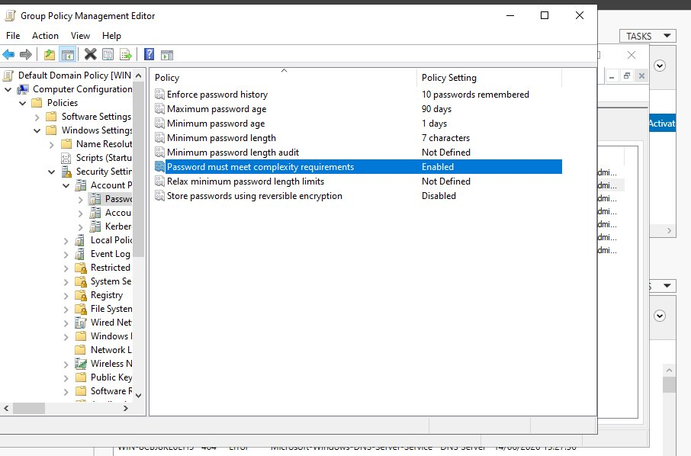
Fig 21 - Password policy settings in the Default Domain Policy
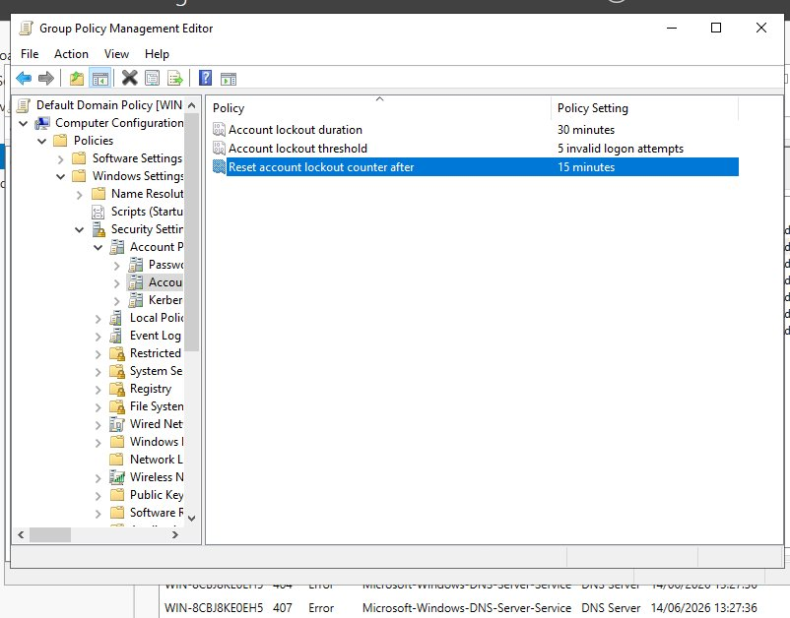
Fig 22 - Account lockout settings in the Default Domain Policy

Why This Matters
Complexity requirements stop users setting weak passwords. The lockout policy means an account locks after 5 wrong attempts, making brute force attacks impractical. Both policies apply to every user on the domain through the Default Domain Policy.

Microsoft 365 Administration
Microsoft 365 Admin Centre | Entra ID | Exchange Online | Intune

13 | Create Users in Microsoft 365 Admin Centre  Microsoft 365 | User Management | Licensing

Created users in the Microsoft 365 Admin Centre using two methods — manually adding a single user and using a user template for the Sales team.
Steps to Create a User Manually
- Went to admin.microsoft.com and signed in as the global admin
- Clicked Users in the left menu then selected Active users
- Clicked Add a user at the top
- Entered First name: Ryan, Last name: Mitchell, Display name: Ryan Mitchell
- Set the username to Mryan and selected the domain hamzadahir2.onmicrosoft.com
- Left Automatically create a password ticked and ticked Require this user to change their password when they first sign in
- Clicked Next, assigned Microsoft 365 Business Standard licence, clicked Next then Finish adding
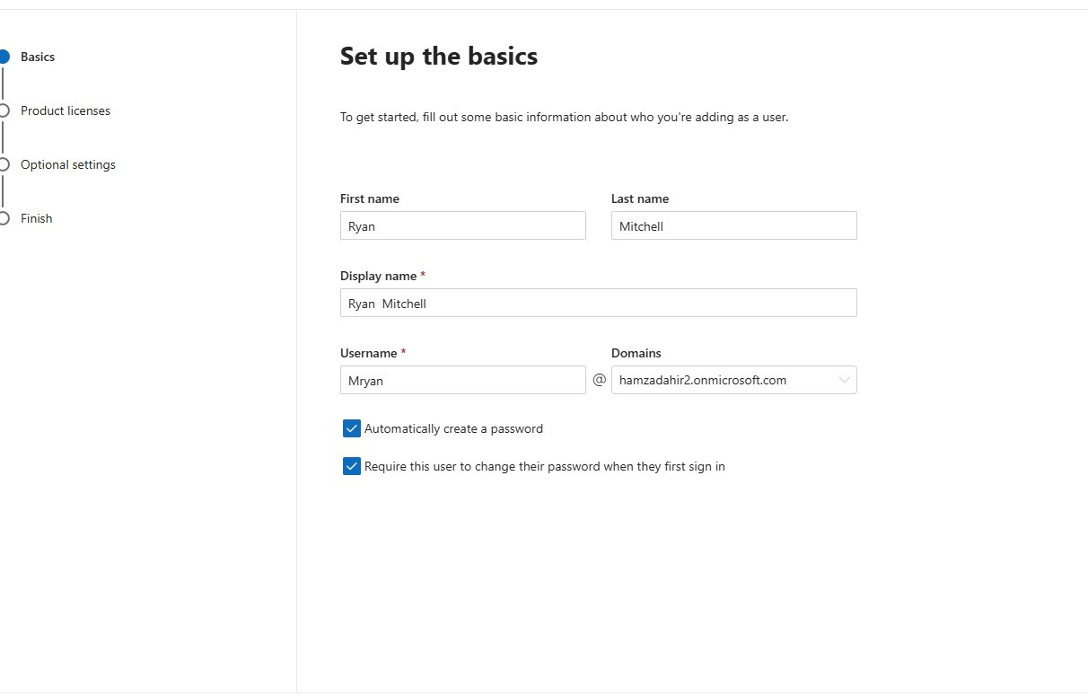
Fig 23 - Creating user Ryan Mitchell in the Microsoft 365 Admin Centre
Steps to Create a User Template
- In the Admin Centre clicked Users then User templates
- Clicked Add a template and entered the name as Sales with a description
- Set the domain to hamzadahir2.onmicrosoft.com and configured password settings
- Assigned Microsoft 365 Business Standard licence to the template
- Reviewed all settings on the final screen and clicked Create template
- Template published and available for onboarding new sales staff quickly
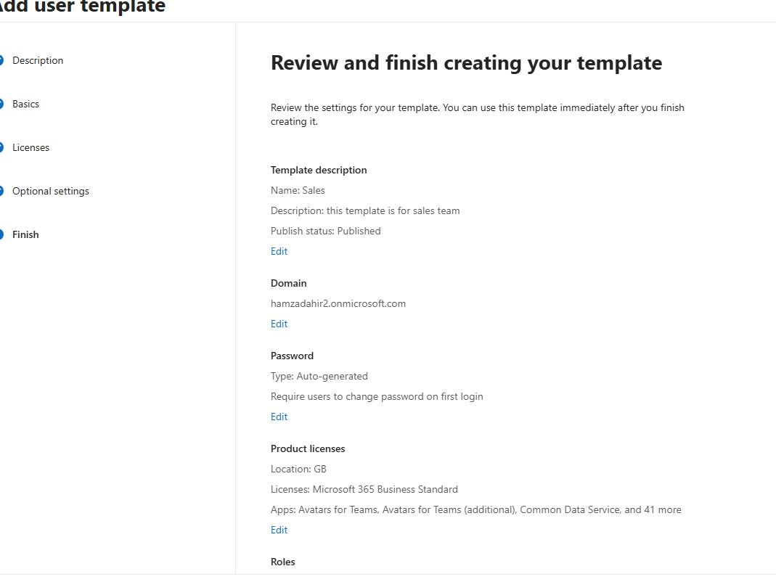
Fig 24 - Sales user template review page showing licence and password settings

Why This Matters
Templates save time when onboarding a whole team. Every user created from the template gets the same licence and settings automatically.

14 | Create a Microsoft 365 Group and Add Members  Microsoft 365 | Groups | Collaboration

Created a Microsoft 365 group called HR, set an owner, added members and configured the group settings.
Steps
- In the Admin Centre clicked Teams and groups then Active teams and groups
- Clicked Add a group and selected Microsoft 365 as the group type then clicked Next
- Entered the group name as HR and added a description then clicked Next
- Assigned an owner for the group and clicked Next
- Added HR users as members by searching their names and clicking Add then Next
- Configured whether external senders could email the group on the Settings page
- Clicked Create group then Close once created
- The HR group appeared in the Active teams and groups list within a few minutes
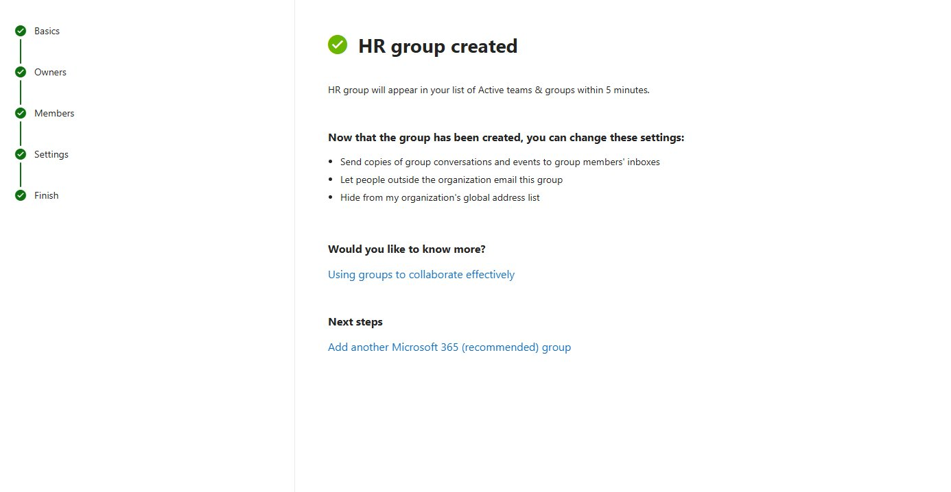
Fig 25 - HR group successfully created in Microsoft 365 Admin Centre

Why This Matters
A single Microsoft 365 group gives members shared access to a mailbox, Teams channel, SharePoint site and calendar all at once.

15 | Verify Group Access Controls Across Mailbox, Teams and SharePoint  Microsoft 365 | Access Control | Permissions Testing

Tested the Sales group permissions by logging in as a group member and as a non-member to confirm access was controlled correctly.
Steps to Test as a Group Member
- Opened a private browser window and went to outlook.office.com
- Signed in as Laura Bennett (Blaura@hamzadahir2.onmicrosoft.com)
- Checked the inbox and received the Sales Team welcome email confirming membership
- The shared Sales mailbox appeared in the left panel under her personal mailbox
- Navigated to the Sales SharePoint site and confirmed she had full access
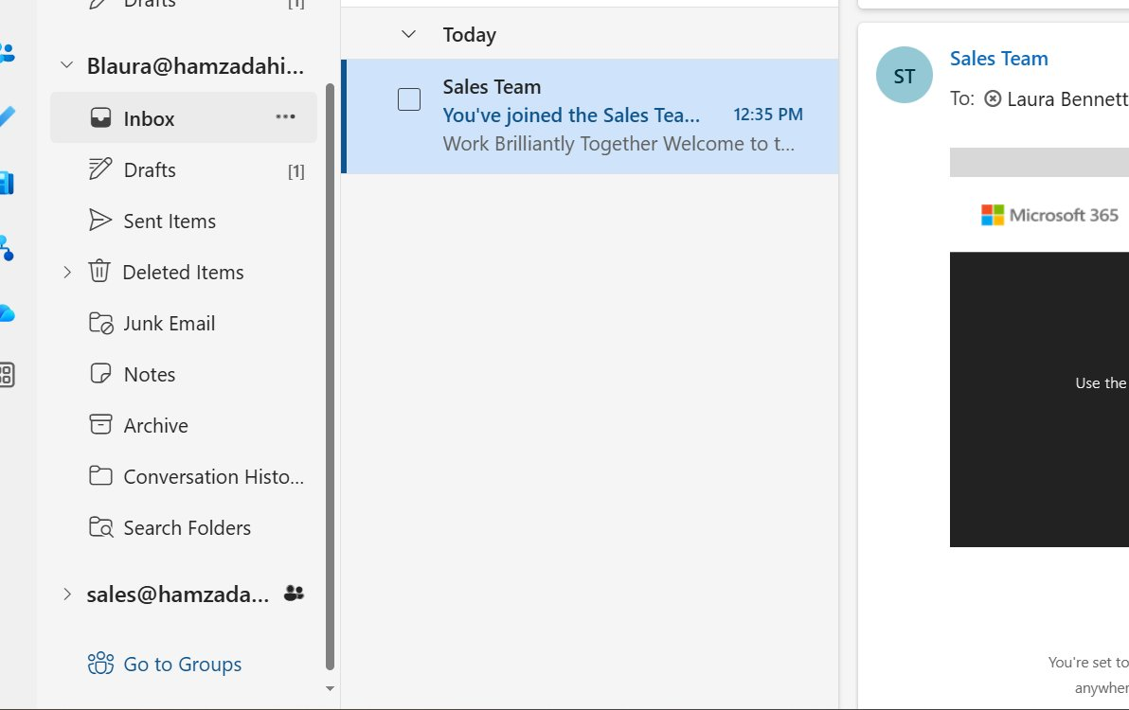
Fig 26 - Laura Bennett's inbox showing the Sales Team welcome email and shared mailbox
Steps to Test as a Non-Member
- Opened another private browser window and signed in as a user not in the Sales group
- Attempted to navigate directly to the Sales SharePoint site URL
- Received the You need access page confirming the user was blocked
- Confirmed the user could request access but could not view any content
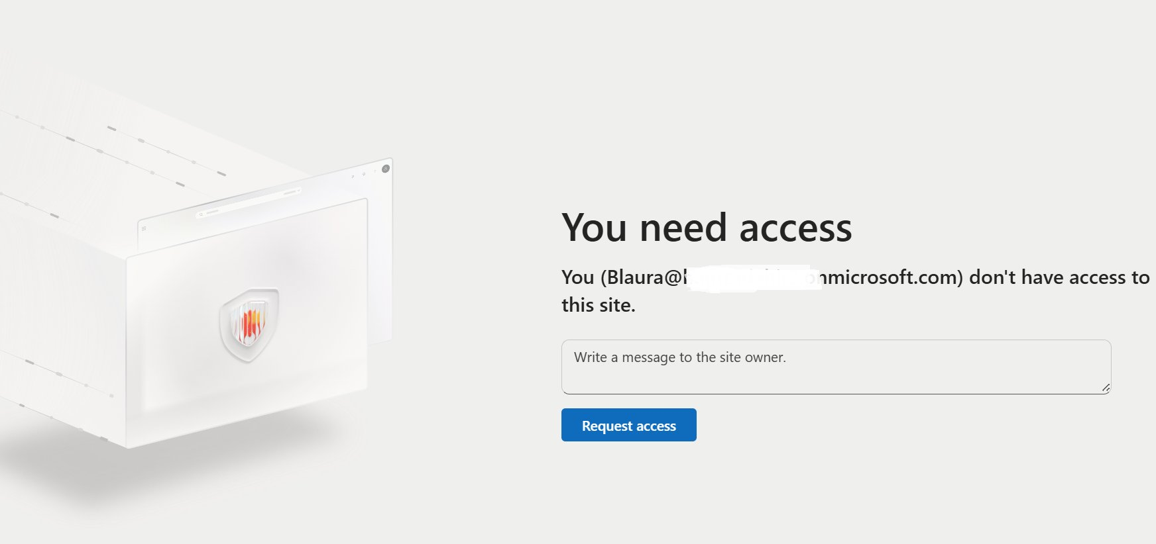
Fig 27 - Access denied page confirming non-members cannot access the Sales site

Why This Matters
Testing as both a member and non-member confirms permissions are working and departments are kept separate.

16 | Create a Distribution List and Set Up Automatic Replies  Exchange Online | Distribution Lists | Mailbox Management

Created a company-wide distribution list and configured an automatic out of office reply on behalf of a user.
Steps to Create the Distribution List
- In the Admin Centre clicked Teams and groups then Active teams and groups
- Clicked the Distribution list tab at the top then clicked Add a group
- Selected Distribution as the type, named it Allmembers and set the group email address
- Added all company users as members and clicked Create
- The Allmembers distribution list appeared and was ready to use
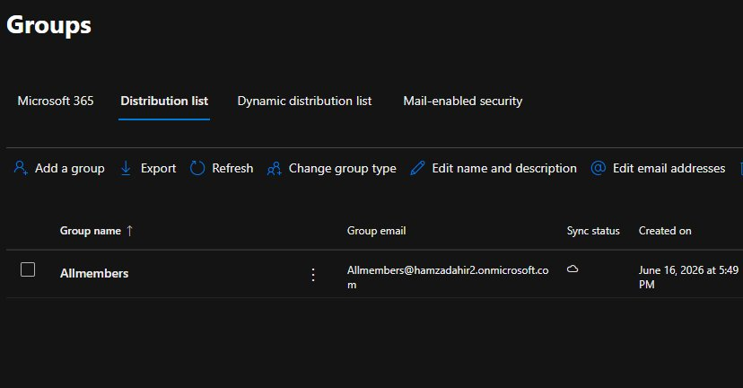
Fig 28 - Allmembers distribution list created in the Microsoft 365 Admin Centre
Steps to Set Up Automatic Replies
- In the Admin Centre clicked Users then Active users and selected the user
- Clicked the Mail tab and then clicked Manage automatic replies
- Toggled Automatic replies to On
- Ticked Send replies only during this time period and set the start date to 16/06/2026 and end date to 17/06/2026
- Typed the internal reply message and ticked Send automatic replies to senders outside this organization
- Selected Reply to all senders and typed the external reply message then clicked Save
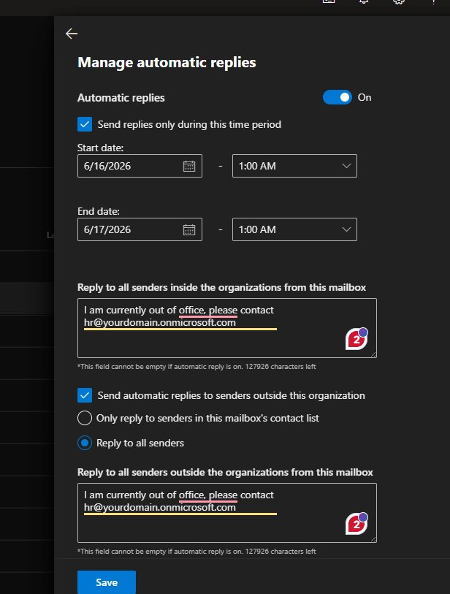
Fig 29 - Automatic replies configured with internal and external messages

Why This Matters
Setting automatic replies on behalf of a user is a common helpdesk task when someone is off sick and forgot to set it themselves.

17 | Configure Email Forwarding Between Users  Exchange Online | Mailbox Management

Set up email forwarding on a user's mailbox so all incoming emails are automatically redirected to Ryan Mitchell.
Steps
- In the Admin Centre clicked Users then Active users and selected the user to forward from
- Clicked the Mail tab and scrolled down to Email forwarding then clicked Manage email forwarding
- Toggled Forward all emails sent to this mailbox to On
- Selected Forward to an internal email address and searched for Ryan Mitchell
- Left Deliver message to both mailboxes unticked so emails go to Ryan only
- Clicked Save to apply the forwarding rule
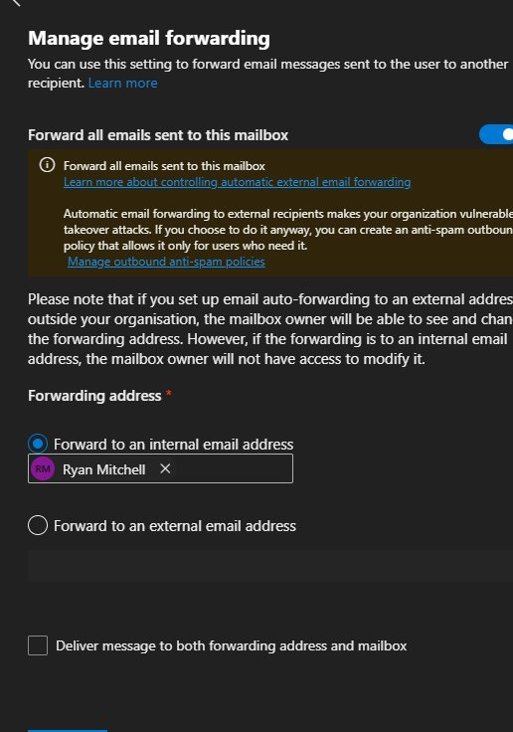
Fig 30 - Email forwarding configured to redirect all emails to Ryan Mitchell

Why This Matters
Email forwarding is used when someone leaves or changes role. Forwarding internally is more secure than forwarding to an external address.

18 | Resolve a SharePoint Access Ticket by Fixing Group Membership  ServiceNow | Microsoft 365 | Permissions Troubleshooting

Ryan Mitchell could not access a SharePoint site he needed. Logged the ticket, diagnosed the cause as missing group membership, fixed it and closed the ticket.
Steps to Log the Incident in ServiceNow
- Opened ServiceNow and navigated to Service Desk then Incidents
- Clicked New and set Caller to Emily Carter, Category to Inquiry/Help, Service to IT Services
- Entered Short description: Staff Member Unable to Access SharePoint Site
- Filled in the full description of the issue and set Priority to 4 Low then saved
Steps to Diagnose
- Opened the Microsoft 365 Admin Centre and went to Teams and groups
- Opened the Sales group and clicked the Members tab
- Confirmed Ryan Mitchell was not listed as a member
- Tested by signing in as Ryan and navigating to the Sales SharePoint site
- Received the You need access page confirming the diagnosis
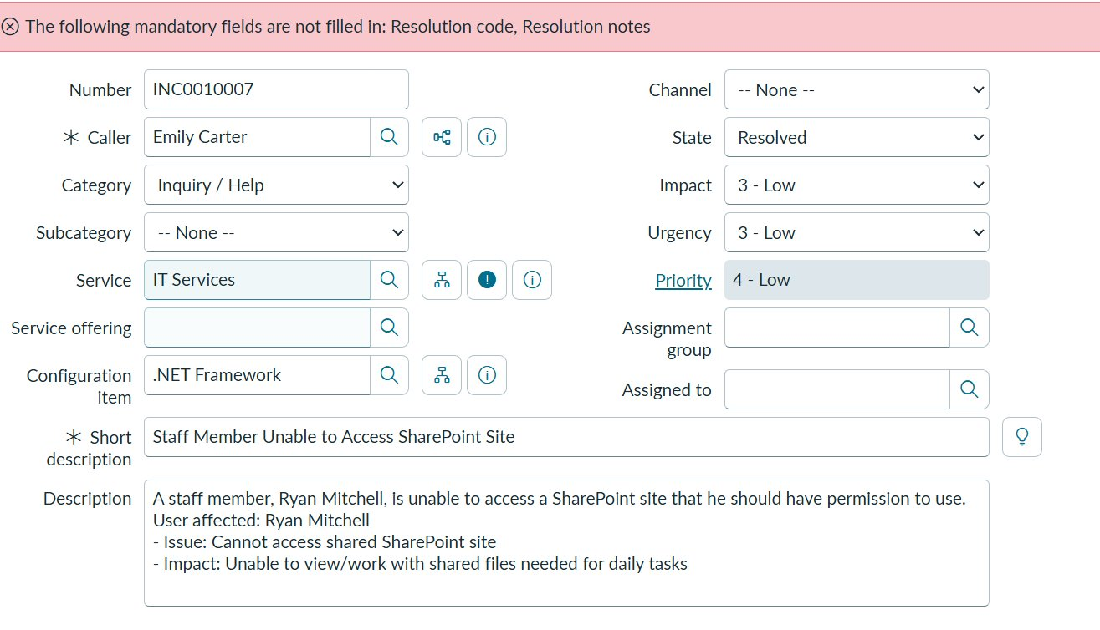
Fig 31 - ServiceNow incident INC0010007 logged with full details
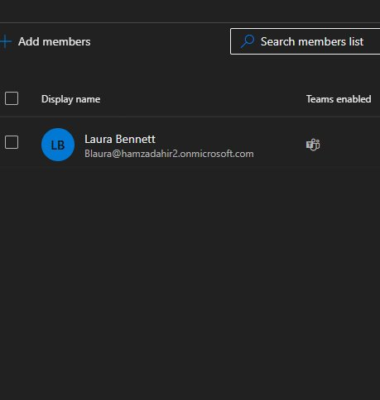
Fig 32 - Sales group showing only Laura Bennett, confirming Ryan was missing
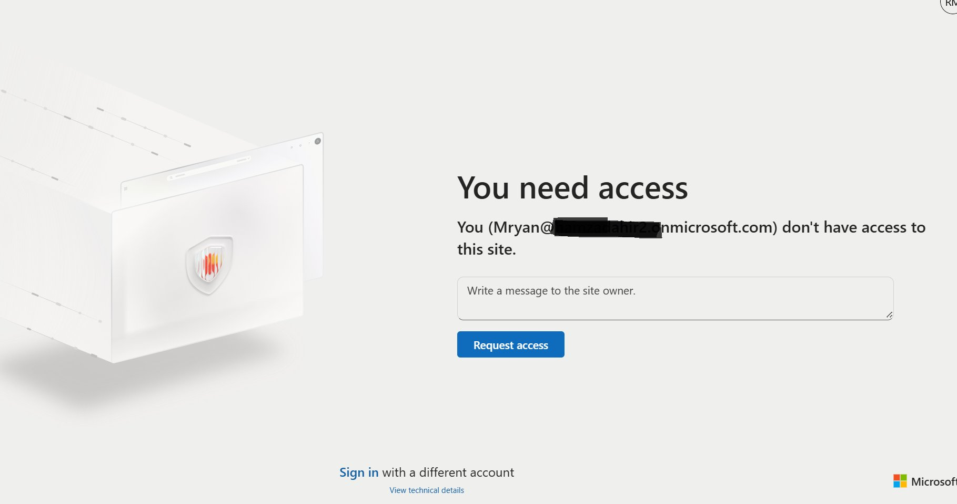
Fig 33 - Access denied page confirming Ryan Mitchell did not have site access
Steps to Fix and Close
- In the Sales group Members tab clicked Add members and searched for Ryan Mitchell
- Selected Ryan and clicked Add to add him to the group
- Waited a few minutes then confirmed Ryan could access the SharePoint site
- Returned to ServiceNow, opened the ticket and clicked Resolution Information tab
- Set Resolution code to Resolved by change and entered resolution notes explaining the fix
- Clicked Resolve to close the ticket
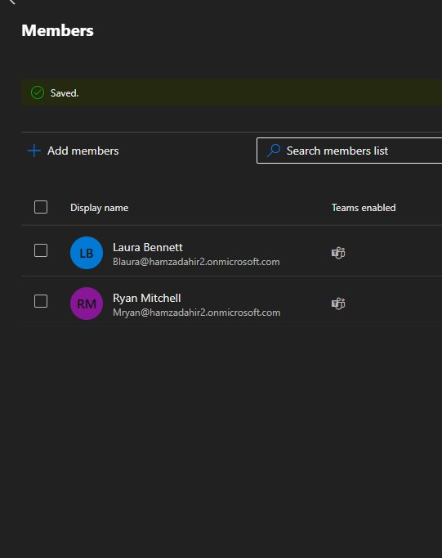
Fig 34 - Sales group members updated to include Ryan Mitchell
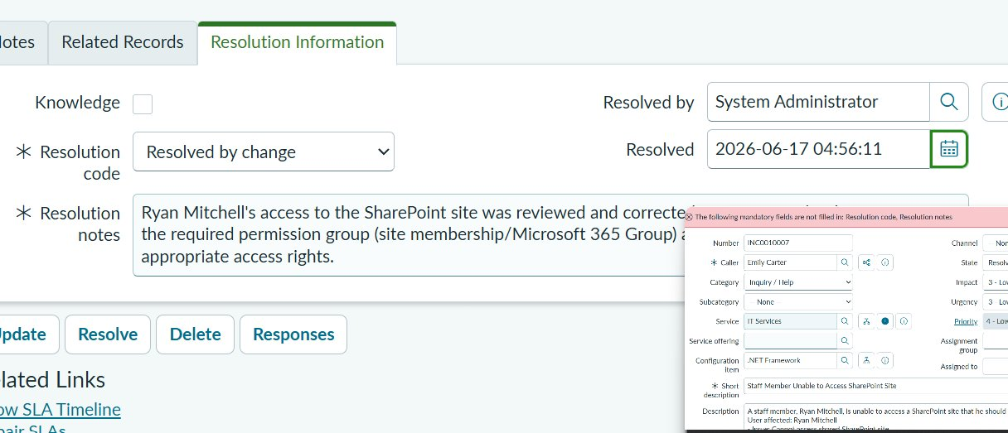
Fig 35 - Ticket resolved with resolution notes recorded

Why This Matters
Diagnosing by testing as the affected user, fixing the root cause and documenting it properly in the ticket are the steps expected of any support engineer.

19 | Recover a Deleted File from the Second-Stage Recycle Bin  SharePoint | OneDrive | File Recovery

A user deleted files from OneDrive and emptied their recycle bin. Recovered the files using the SharePoint second-stage recycle bin.
Steps
- Opened the user's OneDrive in a browser and clicked Recycle bin in the left panel
- The files were not there as the user had already emptied the recycle bin
- Scrolled to the bottom of the recycle bin page and clicked Check the second-stage recycle bin
- The second-stage recycle bin opened showing all recently deleted files
- Ticked the files to recover: Document.docx, test doc.docx and Document1.docx
- Clicked Restore at the top and confirmed the action
- Navigated back to OneDrive and confirmed the files were restored to their original location
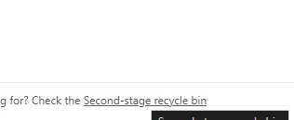
Fig 36 - Link to the second-stage recycle bin when a file is missing from the normal one
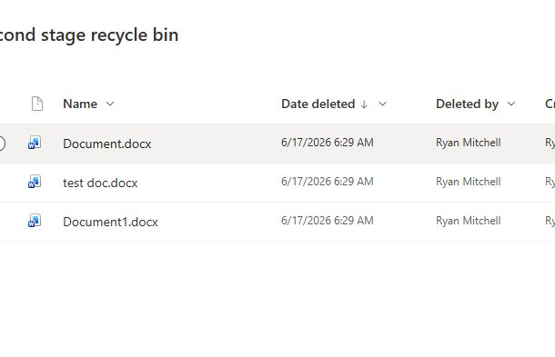
Fig 37 - Second-stage recycle bin showing deleted files ready to restore

Why This Matters
OneDrive and SharePoint have two stages of recycle bin so files can often be recovered even after a user thinks they are permanently deleted.

More tasks will be added as the lab progresses | Hamsa Dahir | June 2026

