Technical Design Document

Shopping List Project – Team N2

# Version History

|  |  |  |
| --- | --- | --- |
| **Date** | **Author** | **Description** |
| 2016/05/15 | Jared Wooten | Initial Creation |
| 2016/09/19 | Team N2 | SOW Clarifications |
|  |  |  |

# Acronyms

|  |  |
| --- | --- |
| **Acronym** | **Definition** |
| SOW | Statement of Work |
|  |  |
|  |  |
|  |  |
|  |  |
|  |  |

# References

1. SOW

# Table of Contents

1 Version History 2

2 Acronyms 2

3 References 2

4 Table of Contents 3

5 Introduction 4

6 Scope 4

7 Technical Architecture 5

7.1 Use Cases 5

8 Technical Design 5

8.1 Design Constraints 6

8.2 Data Model 6

8.3 User Interface 7

9 Platform Specific Technical Information 11

# Introduction

The purpose of this document is to expand upon the SOW [1] and define the technical architecture and high level design required to fulfill project scope. Anything not included in this document is considered out of scope and may incur additional time and costs.

<Now introduce this project in a few short paragraphs. Assume that you’re communicating to both the customer and the coders / fellow designers on this project. The customer loves to know that you understand their business and vision. And, the better we can propagate that vision to fellow designers & coders, the better they’ll be able to do their job.>

A great outline to follow is:

A blurb about the customer and why they came to EFC

A blurb about the overall project

A high level summary of what is in the SOW

# Scope

This document is structured as follows:

* Technical Architecture
* Technical Design
* Platform Specific Technical Information

# Technical Architecture

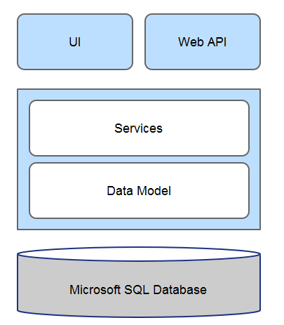

**MSSQL Database**: This component is the database where backend data will be stored. The database will be Microsoft SQL Server hosted on Azure.

**Data Model**: This component is the data model that represents the database tables. See section 8.2 Data Model.

**Services**: This component is the assembly that encapsulates the business logic of the app.

**UI**: This component is the main UI of the app defined as an MVC web application. See section 8.3 User Interface.

**Web API:** This component exposes some aspects of the app to external users. It is defined as a Web API 2 web application.

## Use Cases

<This section is optional and should only be used for high level, architecturally significant use cases>

### Login Page

### Shopping List CRUD Pages

# Technical Design

## Design Constraints

<This section should contain constraining factors to design. I would restate supported OS / Browsers etc here from the SOW, and any other over-arching constraints (like ADA compliant, etc.).>

## Data Model

The Data Model will use a Code First strategy with Data Migrations enabled to facilitate ease of deployment end incremental database development.

### Framework Entities

These are auto-generated by the Identity Framework (AspNetUser, AspNetRole, etc.).

### ShoppingList

|  |  |  |
| --- | --- | --- |
| Id (key) | Int | Unique Id |
| UserId (foreign key) | Int | Relates to a User |
| Name | String | Name of shopping list |
| Color | String | Color to display text as (hex value) |
| CreatedUtc | DateTimeOffset | Utc created date |
| ModifiedUtc | DateTimeOffset | Utc modified date |

### ShoppingListItem

|  |  |  |
| --- | --- | --- |
| Id (key) | Int | Unique Id |
| ShoppingListId (foreign key) | Int | Relates to a ShoppingList |
| Contents | String | Description of item to shop for |
| Priority | Int (Enum) | One of several enumerated values: “ Wait”, “Soon”, and “Now” |
| IsChecked | Bool | Checked items are purchased/complete |
| CreatedUtc | DateTimeOffset | Utc created date |
| ModifiedUtc | DateTimeOffset | Utc modified date |

### Note

|  |  |  |
| --- | --- | --- |
| Id (key) | Int | Unique Id |
| ShoppingListItemId (foreign key) | Int | Relates to a ShoppingListItem |
| Body | String |  |
| CreatedUtc | DateTimeOffset | Utc created date |
| ModifiedUtc | DateTimeOffset | Utc modified date |

## User Interface

Mockups of the main pages of the app.

### Shopping List – List page

This page lists all shopping lists for the logged in user and has the following functions available:

* Add New List
* (per list item) View List
* (per list item) Delete List

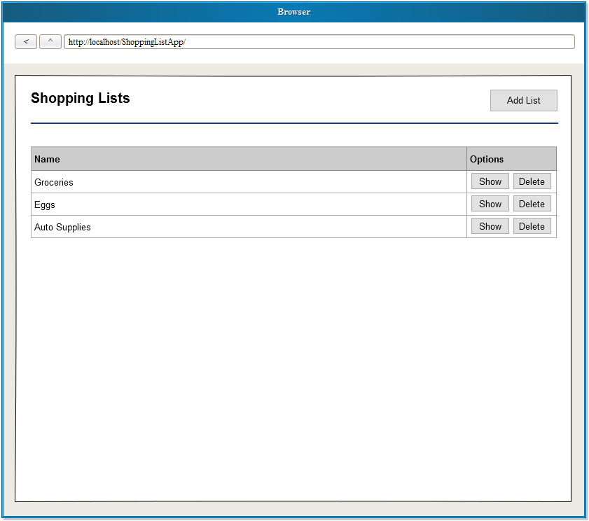

### Shopping List – Add page

This page is for adding a new shopping list.

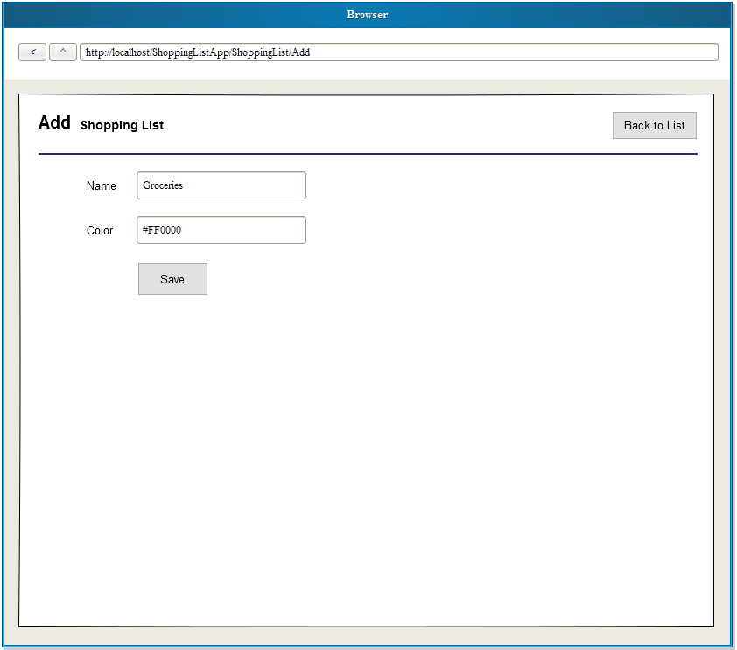

### Shopping List - Show page

This page lists all shopping list items for the logged in user as well as the following functions:

* Add New Item
* Clear Checked Items
* Sort Items
* Page Items
* (Per list item) Check Off Item
* (Per list item) Add Note to Item
* (Per list item) Delete Item

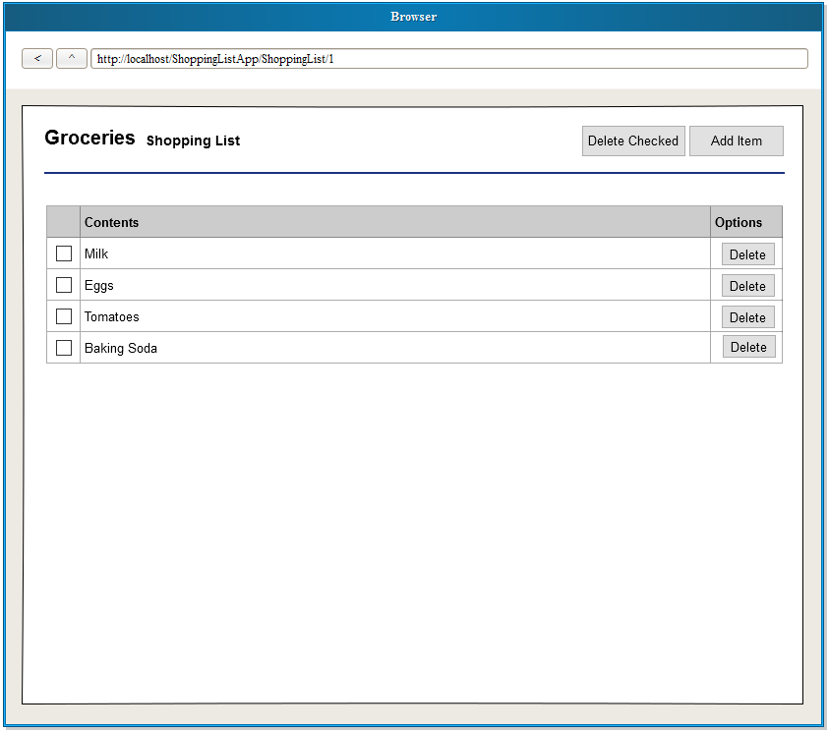

### Shopping List Item - Add page

This page is for adding a new shopping list item.

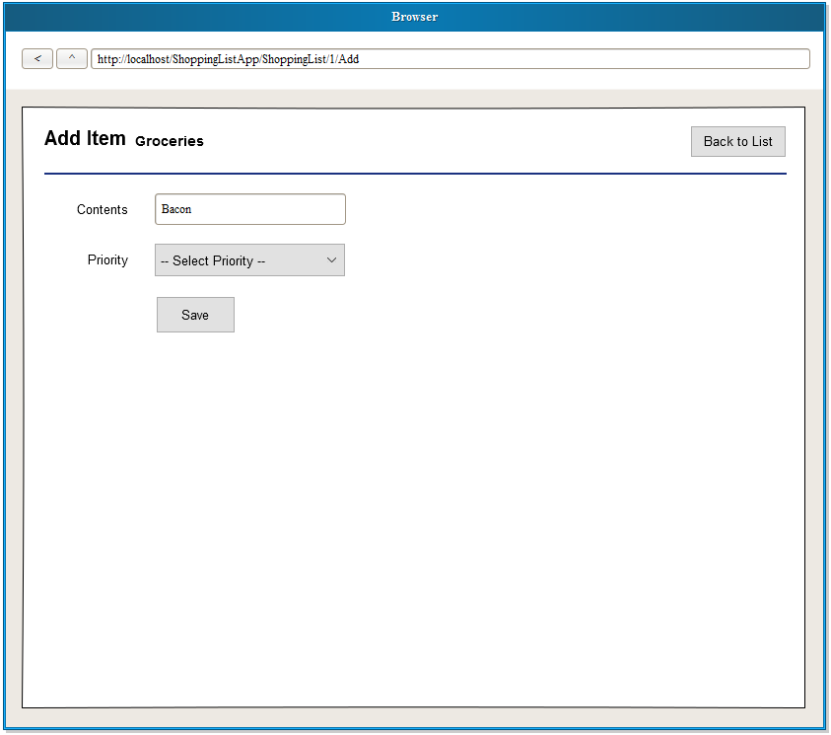

# Platform Specific Technical Information

<each technical lead can tailor the design doc from here down>