FACTORY REALLOCATION AND SHIPPING OPTIMIZATION RECOMMENDATION SYSTEM FOR NASSAU CANDY DISTRIBUTOR

Internship Project Report

Submitted By:
N.J.Hamshalekha

M.Sc. Information Technology
Business Analyst Intern

Submitted To:
Unified Mentor Private Limited
Business Analyst Internship Program

Internship Duration: 3 Months
Year: 2025 - 2026

ABSTRACT
The creation of a Factory Reallocation and Shipping Optimization Recommendation System for Nassau Candy Distributor is the main goal of this project. The objective is to use data analytics and predictive modeling techniques to support better business decision-making, optimize factory allocation, and increase shipping efficiency.
The project analyzes performance trends and produces insightful recommendations using business data, including sales, gross profit, ship mode, product details, region, and cost. Exploratory Data Analysis (EDA) was carried out to understand trends, product performance, and regional sales behavior.
Business performance was predicted using machine learning models like Gradient Boosting Regressor, Random Forest Regressor, and Linear Regression. The project also incorporates scenario simulation, recommendation logic, and route and product clustering to compare current and suggested business outcomes.
A Streamlit dashboard was created to offer real-time analytics, product filtering, recommendation insights, and business impact visualization. The end result enhances operational effectiveness and profitability while promoting wise decision-making.

INTRODUCTION
The logistics and distribution sector is crucial for ensuring goods are delivered effectively and economically. Operational optimization is a critical need for Nassau Candy Distributor, which manages various products, shipping methods, and regional distribution processes.
Inefficient shipping routes, poor factory allocation, and high operating costs can reduce profitability and customer satisfaction in large-scale distribution systems. To address these challenges, businesses increasingly rely on machine learning, business analytics, and data-driven decision-making systems.
This project aims to develop a Factory Reallocation and Shipping Optimization Recommendation System for Nassau Candy Distributor. The system analyzes product sales, shipping trends, regional performance, gross profit, and operating expenses to identify optimization opportunities and enhance decision-making.
Exploratory Data Analysis (EDA) techniques were used to examine business patterns and trends in the dataset. Predictive machine learning models such as Linear Regression, Random Forest Regressor, and Gradient Boosting Regressor were applied to forecast business performance and compare model effectiveness.
To further support business optimization, recommendation logic, scenario simulation, and route and product clustering were incorporated. Additionally, a Streamlit dashboard was developed to provide an interactive interface for data filtering, generating business insights, and monitoring product performance.

PROBLEM STATEMENT AND OBJECTIVES
PROBLEM STATEMENT:
Nassau Candy Distributor manages a sizable distribution network that includes a variety of products, shipping options, regional operations, and cost factors. Inefficient factory allocation, high shipping costs, and improper product distribution can all reduce operational efficiency and profitability. To improve performance and business outcomes, businesses need an intelligent recommendation system that analyzes business data and provides optimized factory allocation and shipping recommendations.

PROJECT OBJECTIVES:
- To use Exploratory Data Analysis (EDA) to examine Nassau Candy Distributor's business data.
- To identify trends in product and regional performance.
- To develop predictive models using Gradient Boosting Regressor, Random Forest Regressor, and Linear Regression.
- To evaluate machine learning model performance with RMSE, MAE, and R² Score.
- To identify performance similarities through route and product clustering.
- To simulate business scenarios and compare actual performance with recommended outcomes.
- To create an interactive Streamlit dashboard for analytics, filtering, and recommendation visualization.
- To enhance operational efficiency and profitability through optimized recommendations.

DATASET DESCRIPTION
DATASET COLUMNS:
1. Order ID – Unique identification number for each order.

2. Order Date – Date on which the order was placed.

3. Ship Date – Date on which the product was shipped.

4. Ship Mode – Shipping method used for product delivery.

5. Customer ID – Unique customer identification.

6. Country or Region – Region where the order belongs.

7. City – Customer city information.

8. State or Province – State or province details.

9. Postal Code – Postal code of customer location.

10. Division – Business division information.

11. Region – Distribution region information.

12. Product ID – Unique product identification number.

13. Product Name – Name of the product.

14. Sales – Revenue generated from sales.

15. Units – Quantity of products sold.

16. Gross Profit – Profit earned from business operations.

17. Cost – Operational or product cost information.

PURPOSE OF DATASET:
The dataset was used to examine product performance, shipping effectiveness, regional business trends, and profitability. It also facilitates predictive modeling, clustering, scenario simulation, and recommendation generation to enhance operational efficiency and business decision-making.

METHODOLOGY
The project's methodology includes data collection, pre-processing, exploratory data analysis, predictive modeling, clustering, scenario simulation, recommendation generation, and dashboard development. Various business analytics and machine learning techniques were applied to enhance operational efficiency and support better business decision-making.

- DATA COLLECTION AND DATA PREPARATION:
The dataset was collected in CSV format and imported into Python for analysis. Data preparation was carried out to make the dataset suitable for predictive modeling and analytics. Numerical data such as sales, gross profit, units, and cost were normalized, while categorical variables like ship mode, region, and division were encoded into machine-readable numerical values.
- EXPLORATORY DATA ANALYSIS (EDA) WAS PERFORMED:
Exploratory Data Analysis (EDA) was conducted to identify patterns, trends, and relationships within the business dataset. Summary statistics, correlation analysis, pivot tables, and visual graphs were used to analyze product performance, sales trends, profitability, and regional business behavior.
- PREDICTIVE MODELING:
Machine learning techniques were applied to predict business performance and assess model effectiveness. Three predictive models were used:
• Linear Regression
• Random Forest Regressor
• Gradient Boosting Regressor
These models were trained and evaluated using business-related variables such as sales, cost, units, ship mode, and region.
- MODEL EVALUATION:
The predictive models were evaluated using Mean Absolute Error (MAE), Root Mean Squared Error (RMSE), and R² Score. The Random Forest Regressor demonstrated the best performance, achieving the highest prediction accuracy and the lowest error values.

- ROUTE AND PRODUCT CLUSTERING:
Clustering techniques grouped products and regions based on sales, units sold, and gross profit. This analysis identified performance similarities and opportunities for business optimization.
- SCENARIO SIMULATION AND RECOMMENDATION LOGIC:
Scenario simulation was conducted to compare current business performance with recommended optimization outcomes. Recommendation logic was used to rank products and identify opportunities for business improvement based on their impact on sales and profitability.
- STREAMLIT DASHBOARD DEVELOPMENT:
An interactive Streamlit dashboard was created to visualize product performance, regional analysis, recommendation insights, KPI metrics, and optimization scenarios. Its filters and performance monitoring features support effective business decision-making.

RESULTS AND MODEL PERFORMANCE
The predictive models developed in this project were evaluated using performance metrics such as Mean Absolute Error (MAE), Root Mean Squared Error (RMSE), and R² Score. These metrics were used to compare the effectiveness and prediction accuracy of the implemented machine learning models.

- MODEL PERFORMANCE RESULTS:

- Linear Regression
MAE: 0.0644
RMSE: 0.1495
R² Score: 0.9725
The Linear Regression model achieved good predictive performance and explained a high percentage of variance in business outcomes.
- Random Forest Regressor
MAE: 0.0013
RMSE: 0.0167
R² Score: 0.9996
The Random Forest Regressor produced the best performance among all models with the lowest prediction error and highest accuracy. This model showed excellent capability in predicting business performance and was selected as the best-performing model.
- Gradient Boosting Regressor
MAE: 0.0317
RMSE: 0.0513
R² Score: 0.9968
The Gradient Boosting Regressor also produced strong predictive performance with high accuracy and low prediction error.

- PERFORMANCE COMPARISION
The comparison of predictive models indicates that the Random Forest Regressor achieved the highest R² Score and the lowest MAE and RMSE values. Therefore, it was selected as the most effective predictive model for business optimization and recommendation generation in this project.
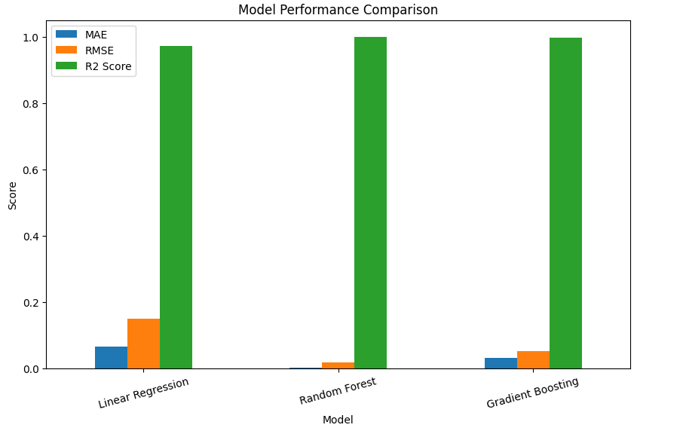
FIGURE 1: MODEL PERFORMANCE COMPARISON

ROUTE AND PRODUCT CLUSTERING AND SCENARIO SIMULATION RESULTS

- ROUTE AND PRODUCT CLUSTERING
Route and product clustering analysis was performed to group products and regions based on business performance indicators such as sales, units sold, and gross profit. Clustering techniques helped identify performance similarities among product-region combinations and provided meaningful insights into business optimization opportunities.

The clustering results enabled identification of high-performing and low-performing product combinations across regions. This analysis supports business decision-making by highlighting areas where optimization and strategic improvements may improve operational performance and profitability.

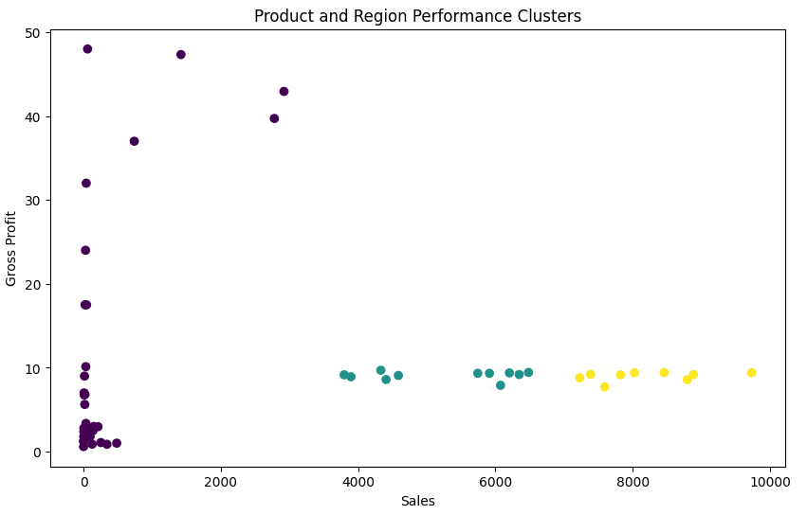
FIGURE 2: ROUTE AND PRODUCT CLUSTERING ANALYSIS

- SCENARIO SIMULATION RESULTS
Scenario simulation was performed to compare current business performance with recommended optimization outcomes. The simulation estimated business improvements by comparing current sales and gross profit values with projected performance after implementing recommendation logic.

The comparison showed that optimized recommendations may improve sales performance and profitability while supporting better operational efficiency. Scenario simulation provides businesses with a better understanding of possible future outcomes and assists in strategic planning and decision-making.

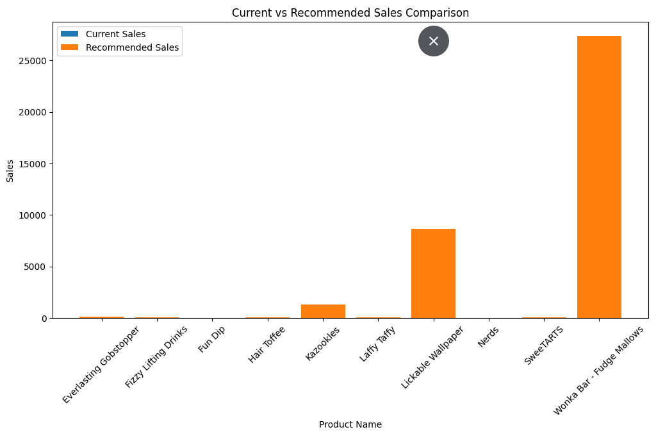

FIGURE 3: CURRENT VS RECOMMENDED PERFORMANCE COMPARISON

- KEY FINDINGS

- Product-region combinations showed different levels of business performance.
- Clustering analysis helped identify optimization opportunities.
- Scenario simulation indicated improvement in sales and gross profit after recommendation implementation.
- Recommendation logic supported business optimization and improved decision-making.
STREAMLIT DASHBOARD RESULTS

An interactive Streamlit dashboard was developed to support business analysis and optimization for Nassau Candy Distributor. The dashboard provides product-level insights, regional filtering, shipping mode analysis, KPI monitoring, and recommendation visualization.

The dashboard allows users to interact with business data through filters such as product selection, region selection, and shipping mode selection. KPI metrics including total sales, units sold, and gross profit were included to improve monitoring and business understanding.

The dashboard also supports recommendation analysis, risk and impact visualization, optimization priority settings, and what-if scenario analysis for better decision-making.

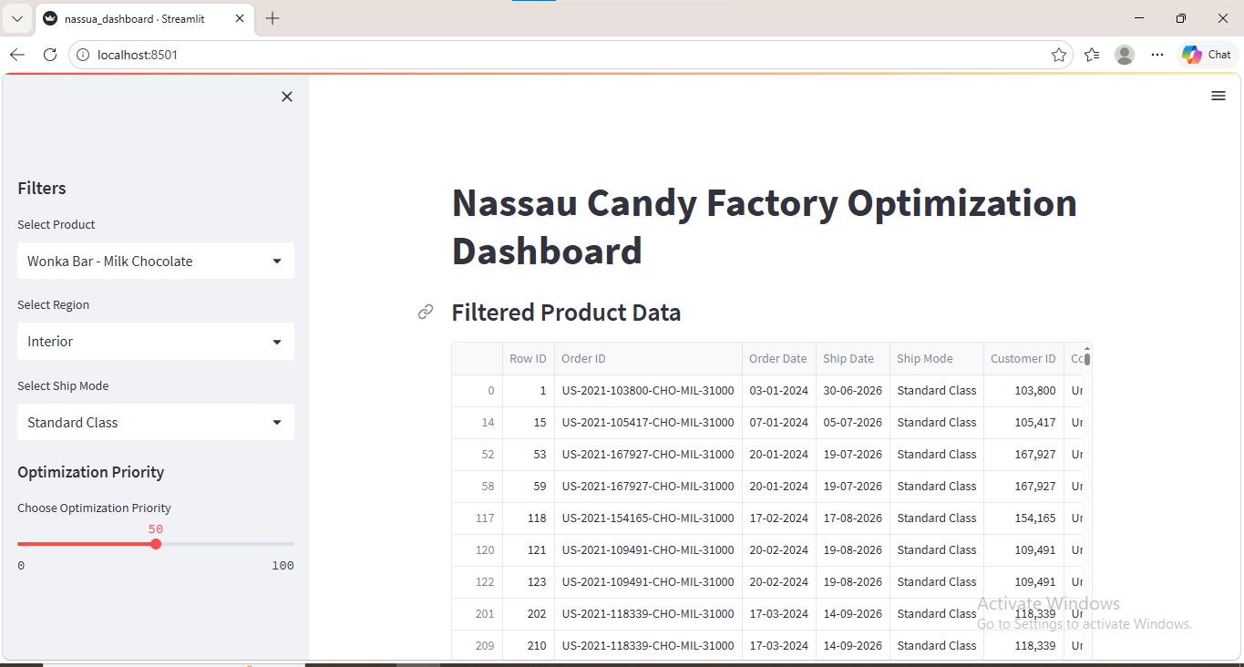
FIGURE 4.1: STREAMLIT DASHBOARD – PRODUCT AND ANALYSIS

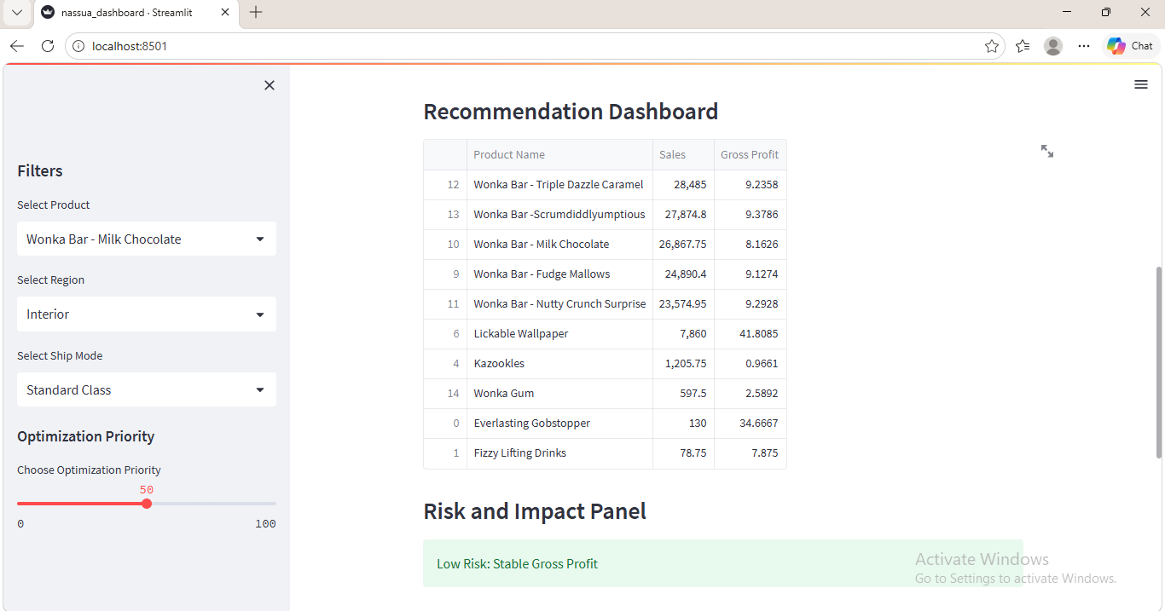
FIGURE 4.2: STREAMLIT DASHBOARD – KPI METRICS AND RECOMMENDATION PANEL

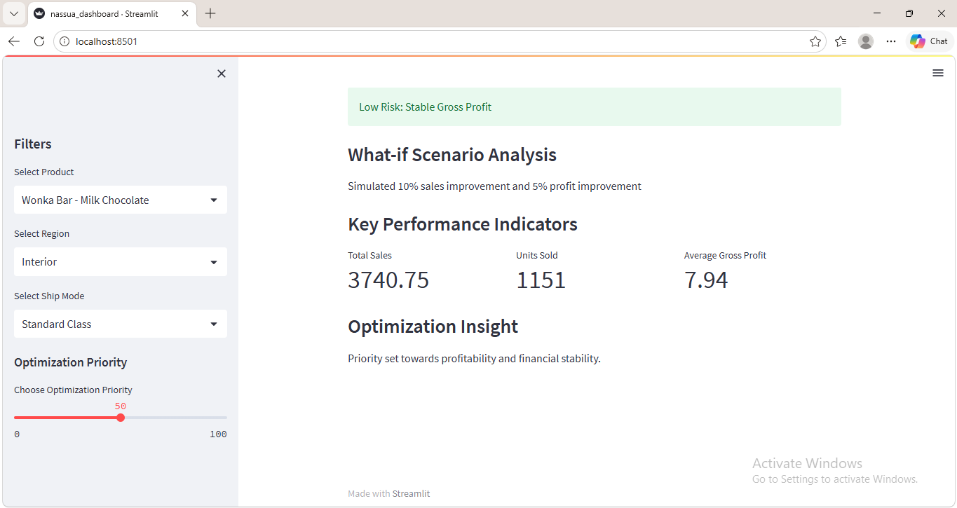
FIGURE 4.3: STREAMLIT DASHBOARD – OPTIMIZATION AND WHAT-IF ANALYSIS

DASHBOARD FEATURES:
- Product Selector
- Region Selector
- Ship Mode Filter
- KPI Metrics Dashboard
- Recommendation Dashboard
- Risk And Impact Panel
- Optimization Priority Slider
- What –If Scenario Analysis

CONCLUSION
This project successfully developed a Factory Reallocation and Shipping Optimization Recommendation System for Nassau Candy Distributor using business analytics and machine learning techniques. Exploratory Data Analysis (EDA), predictive modeling, clustering, and scenario simulation were performed to understand business patterns and improve operational decision-making.

Among the predictive models, Random Forest Regressor achieved the best performance with the highest prediction accuracy and lowest error values. Route and product clustering helped identify performance similarities, while scenario simulation provided business improvement insights.

The Streamlit dashboard improved data visualization and business interaction through filters, KPI metrics, and recommendation analysis. Overall, the project supports optimized business decision-making, operational efficiency, and profitability improvement.

FUTURE SCOPE
- Integration with real-time business databases for live analytics.

- Advanced predictive models for more accurate forecasting.

- Cloud deployment for easier business accessibility.

- Inclusion of real-time shipping and logistics tracking.

- Enhanced recommendation systems using advanced optimization techniques.

REFERENCES

1. Python Programming Language Documentation – https://www.python.org

2. Pandas Documentation – https://pandas.pydata.org

3. Scikit-learn Documentation – https://scikit-learn.org

4. Matplotlib Documentation – https://matplotlib.org

5. Streamlit Documentation – https://streamlit.io

6. Google Colab – https://colab.research.google.com

7. Nassau Candy Distributor Dataset (Internship Project Dataset)

8. Unified Mentor Private Limited Internship Resources

