Symphony Of Algorithms: Music Composition using Deep Learning Models
Hamshika Radhakrishnan
Department of Computer Science
Vellore Institute of Technology
Chennai, India

Harshita Rajinikanth
Department of Computer Science
Vellore Institute of Technology
Chennai, India
Snehalatha Prakash
Department of Computer Science
Vellore Institute of Technology
Chennai, India
Harini S.
School of Computer Science
Vellore Institute of Technology
Chennai, India

Abstract—
With an emphasis on Generative Adversarial Networks (GANs), Gated Recurrent Units (GRUs), Variational Autoencoders (VAEs), and Transformers, this research compares various machine learning models for music composition. We examine the unique architectural benefits, training effectiveness, and musical outputs of these models in light of the growing interest in AI-driven creative arts, especially in the creation of original music. Harmony, rhythmic consistency, melodic structure, and the capacity to generate songs that resemble those of a human are among the measures used to assess each model. While GRUs are evaluated for their ability to capture sequential relationships within musical sequences, GANs are evaluated for their ability to produce a variety of music through adversarial training. Transformers are assessed for their ability to model complicated structures and long-range relationships, while VAEs, with their latent space representations, are examined for their capacity to generate regulated and coherent music variations. We determine the advantages and disadvantages of each strategy using qualitative and quantitative evaluations, such as listener surveys and analysis of results using metrics, which offer guidance on model selection for different music creation tasks. By shedding light on the relative performance of various models, this study advances the field of AI-driven music and directs future advancements in algorithmic composition.
Keywords - music generation, transformers, AI driven music, machine learning models and the deep learning models.
- Introduction
In the creative industries, artificial intelligence has advanced remarkably, opening up new avenues for the visual arts, literature, and music. AI-driven models have made it possible to create unique and varied compositions that can imitate, expand upon, or even reinterpret artistic traditions in the field of music composition. Four machine learning models—Generative Adversarial Networks (GANs), Gated Recurrent Units (GRUs), Variational Autoencoders (VAEs), and Transformers—each representing a distinct method of music generation are examined in this study in order to determine their effectiveness and creative potential. Our goal is to present a thorough evaluation of these models' abilities to generate expressive and cohesive music by dissecting their unique structures and training approaches.

By teaching one network to produce musical sequences while a rival network assesses and critiques the results, GANs—which are renowned for their adversarial training mechanisms—have been effectively used to produce music. Although there are still difficulties in attaining musical coherence, this dynamic frequently produces extremely varied pieces. Because GRUs, a type of Recurrent Neural Network (RNN), can process sequential data, they are ideal for identifying musical temporal patterns. Although they might have trouble with long-term dependencies, GRUs can produce music that exhibits constant rhythms and structures by storing and utilizing prior information over time.

By encoding input data into a latent space, VAEs establish a probabilistic framework that enables controlled generation, enabling seamless transitions and changes in the music that is generated. Applications that call for melody or harmony variation while preserving a broad thematic coherence may find this model especially helpful. Last but not least, Transformers have demonstrated a transformative influence on sequential tasks through their self-attention processes, enabling models to better capture long-range dependencies than conventional recurrent networks. They are an appealing option for creating complicated compositions since their use in music creation has produced encouraging results, particularly when modeling complex structures that call for awareness of distant temporal aspects.

The main contribution of this work is an assessment of the unique features and results of these models in the creation of music. We do qualitative and quantitative assessments, such as surveys and structural analyses, to evaluate each model's capacity to provide melodic coherence, rhythmic consistency, and harmony in songs. We hope that this comparison study will provide light on the advantages, disadvantages, and suitability of each model type, ultimately directing future research and advancement in AI-driven music creation.

- Supplies and Techniques
This study investigates various methods for producing music using various models. The dataset must be clean and prepared according to the requirements for any research and model development. Work on model construction and training will then begin. After that, the evaluation of the model will be examined.

2.1 Dataset
The main dataset used in this comparison analysis is the Pokémon Dataset, which includes background music samples from different Pokémon video games. Pokémon music, which is well-known for its wide range of musical motifs and styles, provides a perfect source for generative model training because of its well-structured melodies, unique rhythmic patterns, and thematic coherence. With recordings from several Pokémon games, spanning generations, geographical locations, and gaming settings, the collection guarantees a diverse range of musical styles, from lively battle themes to subdued location-specific tunes. Because of this variability, models can learn from a wide range of musical characteristics, producing a variety of outputs that resemble different musical genres.
A strong basis for assessing each model's capacity to recognize and replicate subtle patterns in musical composition is provided by the Pokémon Dataset's clearly defined musical structure and thematic diversity. In order to compare the generative capabilities of GANs, GRUs, VAEs, and Transformers, this study uses a dataset with well-known melodic and rhythmic motifs for training. This makes it simpler to evaluate the originality and coherence of the outputs produced by various models.
2.2 Data Pre-processing
When the Pokémon Dataset is adequately pre-processed, musical data is structured to work with GANs, GRUs, VAEs, and Transformers. To record temporal patterns, each music track is divided into fixed-length segments (4–8 bars), which are then translated to MIDI format while maintaining crucial elements like timing, pitch, and duration. After tokenizing this MIDI data, models can process music as distinct events.
In order to assist models, generalization across various musical keys and tempos, augmentation techniques such as pitch-shifting and tempo scaling are used to boost data variability without compromising musical coherence. Pitch and velocity are standardized for steady training by normalizing the encoded data to a range of 0–1. To guarantee consistent sequence length across batches, the data is additionally divided into training, validation, and test sets and padded.
To more effectively capture temporal dependencies, a positional embedding layer is introduced to transformer models. Thus, this preprocessing pipeline converts the dataset into a flexible format that is tailored for every model architecture, allowing them to discover subtle patterns and produce a variety of cohesive compositions.
2.3 Models Used
2.1.1 Generative Adversarial Networks (GANs)
In this work, we use the Pokémon Dataset to train a Generative Adversarial Network (GAN) for music composition. The discriminator and generator neural networks, which function in an adversarial environment, make up GANs. While the discriminator assesses these sequences and separates created from actual music, the generator seeks to produce realistic music sequences. This adversarial design enhances the generator's capacity to generate sequences that replicate the musical qualities of the dataset through iterative training.
The architecture of GAN is given in the fig1 and it involves:
- Generator: Synthetic music sequences in MIDI format are produced by the generator network using random noise as input. It captures the melodic and rhythmic flow of Pokémon music by modelling temporal dependencies using recurrent layers like Gated Recurrent Units (GRUs) or Long Short-Term Memory (LSTM). A bar of music is encoded by each output sequence, which consists of MIDI tokens for time, pitch, and duration.
- Discriminator: The discriminator separates synthetic and real sequences in a binary classifier fashion. Convolutional or recurrent layers are used to capture important musical characteristics like rhythm and harmony. The discriminator directs the generator's progress by producing a probability score that indicates each sequence's authenticity.
The generator and discriminator networks get alternating updates during the GAN training process:
Generator Update: A synthetic music sequence is produced by the generator using a random noise vector asinput.
Discriminator Evaluation: The discriminator assigns a probability score to each sequence, indicating its legitimacy, after evaluating both synthetic sequences from the generator and genuine sequences from the Pokémon dataset.
Discriminator Loss: The discriminator's capacity to accurately categorize synthetic and actual sequences determines how much it has lost. After that, the network is updated to optimize its functionality.
Generator Loss: The discriminator's feedback on the sequences it generates is used to compute the generator's loss. The generator may now create tunes that more closely resemble authentic Pokémon music thanks to an upgrade that reduces its loss.
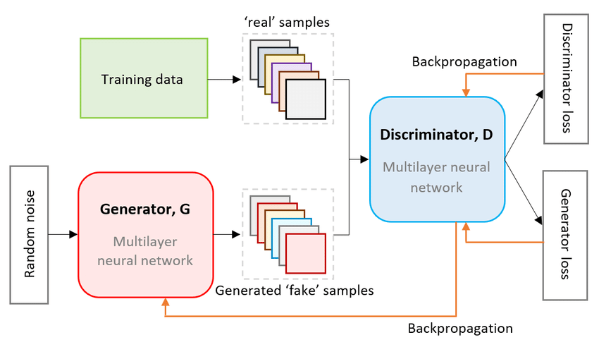
Fig.1 Illustrative GAN model
    - Evaluation
Evaluation of the generated compositions was conducted through both quantitative and qualitative measures.
These measures, Generator Loss and Discriminator Loss, monitor the training dynamics of the GAN. While discriminator loss gauges the model's capacity to discern between authentic and fraudulent music sequences, generator loss represents the model's capacity to generate musical sequences that trick the discriminator. A balanced adversarial training process and better output quality are suggested by steady losses overtime
The realism and quality of audio produced by GANs are evaluated using the Fréchet Audio Distance (FAD) score. FAD examines the distribution of features between created and real audio samples, much like the Fréchet Inception Distance (FID) in picture formation. In particular, it determines the separation between the synthetic and original audio feature embeddings in a learnt space, typically by utilizing embeddings taken from an audio classification model that has already beentrained.
The resulting music's degree of structural, rhythmic, and timbral similarity to the Pokémon dataset is measured by the FAD score for this study on music composition. Higher similarity to the original dataset is indicated by lower FAD scores, indicating that the GAN has effectively caught the stylistic subtleties and melodic rhythms.
.
2.1.2 Gated Recurrent Units (GRUs)
In this study, we use a Gated Recurrent Unit (GRU) model to learn sequential patterns in the Pokémon Dataset and produce musical compositions. GRUs are a particular kind of recurrent neural network (RNN) that is ideal for sequence data, like music, where temporal links between notes and rhythms are crucial. This is because GRUs are made to simulate long-term dependencies. GRUs aid in the creation of logical musical compositions with theme continuity and flow by identifying and producing sequential dependencies.
GRU Framework for Composing Music is given by fig2. While still being able to represent complex sequences, a GRU is computationally economical since it has fewer gates than an LSTM network. To enable it remember long-term dependencies without experiencing the vanishing gradient issue that plagues conventional RNNs, the GRU employs two primary gates—the update gate and reset gate—to regulate the information flow inside the network.

- Update Gate: How much of the prior data should be carried over to the current step is determined by the update gate. The GRU can keep pertinent information across extended sequences thanks to this gate's ability to balance long-term memory and current input, which is essential for capturing a composition's melodic context.
- Reset Gate: The reset gate controls the amount of historical data that should be forgotten. By doing this, the model is able to "reset" some of its memory, making it receptive to new inputs while disregarding less important historical data. This helps musicians adjust to changing motifs or variations in rhythm and melody.
The training process of GRU is carried out by first tokenizing the Pokémon music dataset into time-stepped sequences that reflect the musical structure based on pitch, duration, and timing. During each step in the GRU model, it will receive those sequences, taking previous context to predict the next event. The cross-entropy loss is used at every step to estimate the prediction accuracy for the step. This makes the model better with the use of backpropagation-based weights updates. Through iterative training, the GRU is able to capture melodic and rhythmic patterns within a dataset while always producing coherent pieces that adhere to consistent themes and artistic coherence.
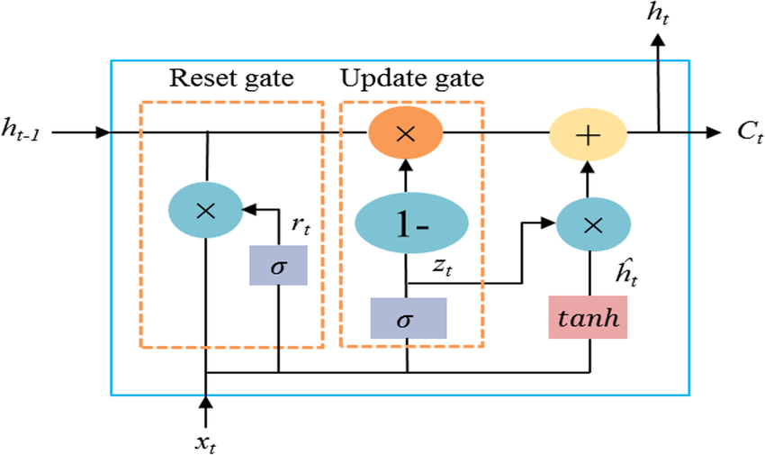
Fig.2 Illustrative GAN model
    - Evaluation
We monitored the loss, accuracy, validation loss, and validation accuracy during training to evaluate the performance of a GRU model in composing coherent musical compositions. Lower values indicate closer to fitting in the training data.
Training Loss and Accuracy: The loss of a model on training is a measure of its failure to predict a sequence of events following the next Pokémon music. The amount of correctly predicted events is described as training accuracy; it is a measure of how well the model has learned to recognize the possible patterns in Pokémon music.

Validation Loss and Accuracy: The validation loss informs the performance of the model on unseen data, which helps to provide an approximation of its generalisation ability. The validation accuracy of GRU is demonstrating good assessment performances and this catching of the basic melodic and rhythmic structures without suffering from overfitting.
    - Variational Autoencoders (VAEs)
It is with this inspiration from the Pokémon dataset that a Variational Autoencoder (VAE) creates new music for this study on music composition. A generative model which encodes the data into the latent space, decodes the same back into musical sequences to learn a condensed probabilistic representation of the data. This is particularly well-suited for the composition of music as it makes smooth interpolation possible within the latent space. The purpose here is that it generates a set of coherent musical pieces that capture subtle stylistic elements of Pokémon music.
The architecture of VAE: They employ two key components: an encoder and a decoder that compress and reconstruct musical sequences, respectively.
Encoder: The encoder compresses the input music sequences into a latent distribution. Typically, it is some high dimensional latent space whose distribution is Gaussian. For this experiment, the encoder has been constructed to handle MIDI sequences, whose tokenized representations will undergo several convolutional or recurrent layers, for example, LSTM or GRU. These layers capture the beat, the melody, the harmony, and all the other details of music, both the temporal and structural information.
Latent Space Sampling: We make use of the mean and variance vectors generated by the encoder to sample a latent vector out of the latent space. This sampling process will, with controlled randomness, add it to the model that will enable the model to output a variety of musical sequences during decoding. This method has been made possible and differentiated via the reparameterization method which guarantees the end-to-end training of the model.
Decoder. Still depending on the sampled latent vector, decoder decodes to a musical sequence. The decoder network uses recurrent or convolutional layers to interpret the latent vector precisely in the reverse manner as its counterpart encoder; this structure realizes producing a sequence of MIDI tokens that are then translated back into musical notes in order to recreate the typical components of the Pokémon music: melody, rhythm, and harmony.
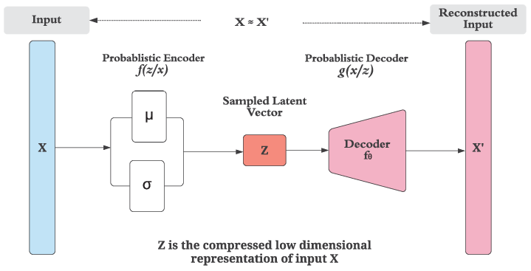
Fig.3 Illustrative VAE model
There are a number of processes involved in training the VAE in this work. The music sequences of Pokémon are tokenized and pre-processed into MIDI format. These are standardized for batch processing by truncating or padding to predetermined lengths. The encoder represents music as a Gaussian distribution in the latent space, producing the variance and mean of the latent distribution. Since the distribution is stochastic, although repatriations allows sampling of the latent vector from this distribution, backpropagation becomes possible. Decoding by using the reconstructed latent vector forms a series of MIDI tokens that reconstruct the original music structure.
Depending on the MIDI encoding, the reconstruction loss can either be a mean squared error or cross-entropy for a sequence, which quantifies the difference between the originally generated and the reconstructed music sequence. It ensures that a loss whose size will be minimal guarantees also capturing the relevant musical elements of harmony, melody, and rhythm by the model. It is the KL divergence loss that was used to regularize the latent space, primarily reducing the gap between the learned latent distribution and a standard Gaussian, ensuring continuity and smoothness in the latent space. The approach now permits original compositions from the Pokémon Dataset by simply fusing elements while leaving artistic coherence intact, preserved through meaningful interpolations in the latent space.
    - Evaluation
Evaluation of the VAE model is done using two metrics – reconstruction loss and KL divergence. The reconstruction loss of the difference between the original and reconstructed music sequences quantifies how well the Variational Autoencoder performs. In other words, this type of loss encourages the model to be faithful to core elements such as rhythm, melody, and harmony in being able to create coherent songs.
For this reason, this is computed as either mean squared error or binary cross-entropy, depending upon a representation of the music, such as a MIDI sequence.
This KL divergence is a regularization term that makes sure the learned latent space is similar to the Gaussian. The VAE reduces this divergence to create a smooth latent space which permits useful interpolations, thus enabling the model to merge musical styles within the Pokémon Dataset while maintaining output coherence and diversity by producing a variety of pieces which are artistically consistent.
    - Diffusion Model
Diffusion models, which are generative models, are ideal for complicated data, such as music, where tiny nuances must be captured through incremental refining. They learn to generate data by gradually denoising samples from a random Gaussian noise distribution.

The diffusion model consists of denoising sequence within an encoder decoder framework. A family of denoising procedures implemented in an encoder-decoder framework provide the definition of the diffusion model:
- Forward Process (Noising). The forward process sends the input music data towards being pure noise, as Gaussian random noise is added incrementally over multiple time steps. Due to the schedule for the control of the noise level and regulation of gradual increase in it, the model learns robust features at a variety of scales of noises.

- Denoising: In the reverse process, it tries to generate pure music from noise. This process learns progressive elimination of noise over the same time steps. The denoising in the reverse noising process is achieved by removing noise through a neural network typically using U-Net with convolutional layers.
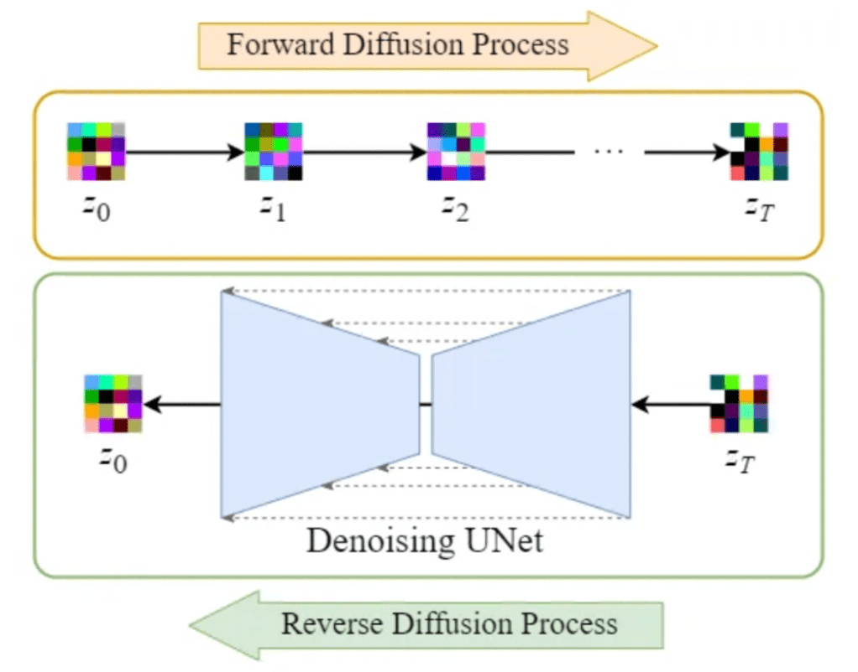
Fig.4 Illustrative Diffusion model

The training goal, according to the diffusion model in this paper, is to optimize denoising performance at every step with gradual reversal of noise to reconstruct high-quality music sequences. The noise scheduling procedure, which starts training, progressively adds noise at every stage of the forward process. It is important for this noise schedule since it enables the model to learn representations at different noise levels, finding a balance between the more detailed melodic information and higher-level structure. The objective is in the form of weighted mean squared error, computing the difference in actual data at each step versus the predicted denoised outputs. Therefore, by minimizing the loss, the model is able to reconstruct the real sequence in a style and melodic coherence manner.

    - Evaluation
The key measures for evaluating the diffusion model in composing music are accuracy, validation loss, and performance coherence.
Accuracy involves the ability of the model to learn musical patterns by reconstructing the musical sequences without killing off the structure, rhythm, and harmony. Tracking accuracy over epochs ensures that the model is capable of denoising and generating coherent outputs.
By virtue of the ability to test the model's performance on unseen data, Validation Loss measures generalization; a low validation loss would imply that the model does not overfit and, at the same time, retains the essence in the music. Hence, this will be critical in ensuring that the outputs of the model contain aesthetic and structural quality.
Training and Validation Accuracy is tracked in order to ensure that there is a stable performance. The fact that those values are close together shows generalization: new music generated is able to fit a style close to what the Pokémon dataset produced.
    - Transformer Model
The transformer model can dynamically attend to various segments of the input sequence since it is based on an encoder-decoder architecture with self-attention mechanisms. For music, where timing and order affect structure, this model uses positional encodings to capture sequential order and self-attention layers to comprehend relationships within the sequence. Each encoder and decoder layer has feedforward layers to capture intricate feature interactions and multi-head attention layers to focus on various parts of the music sequence.

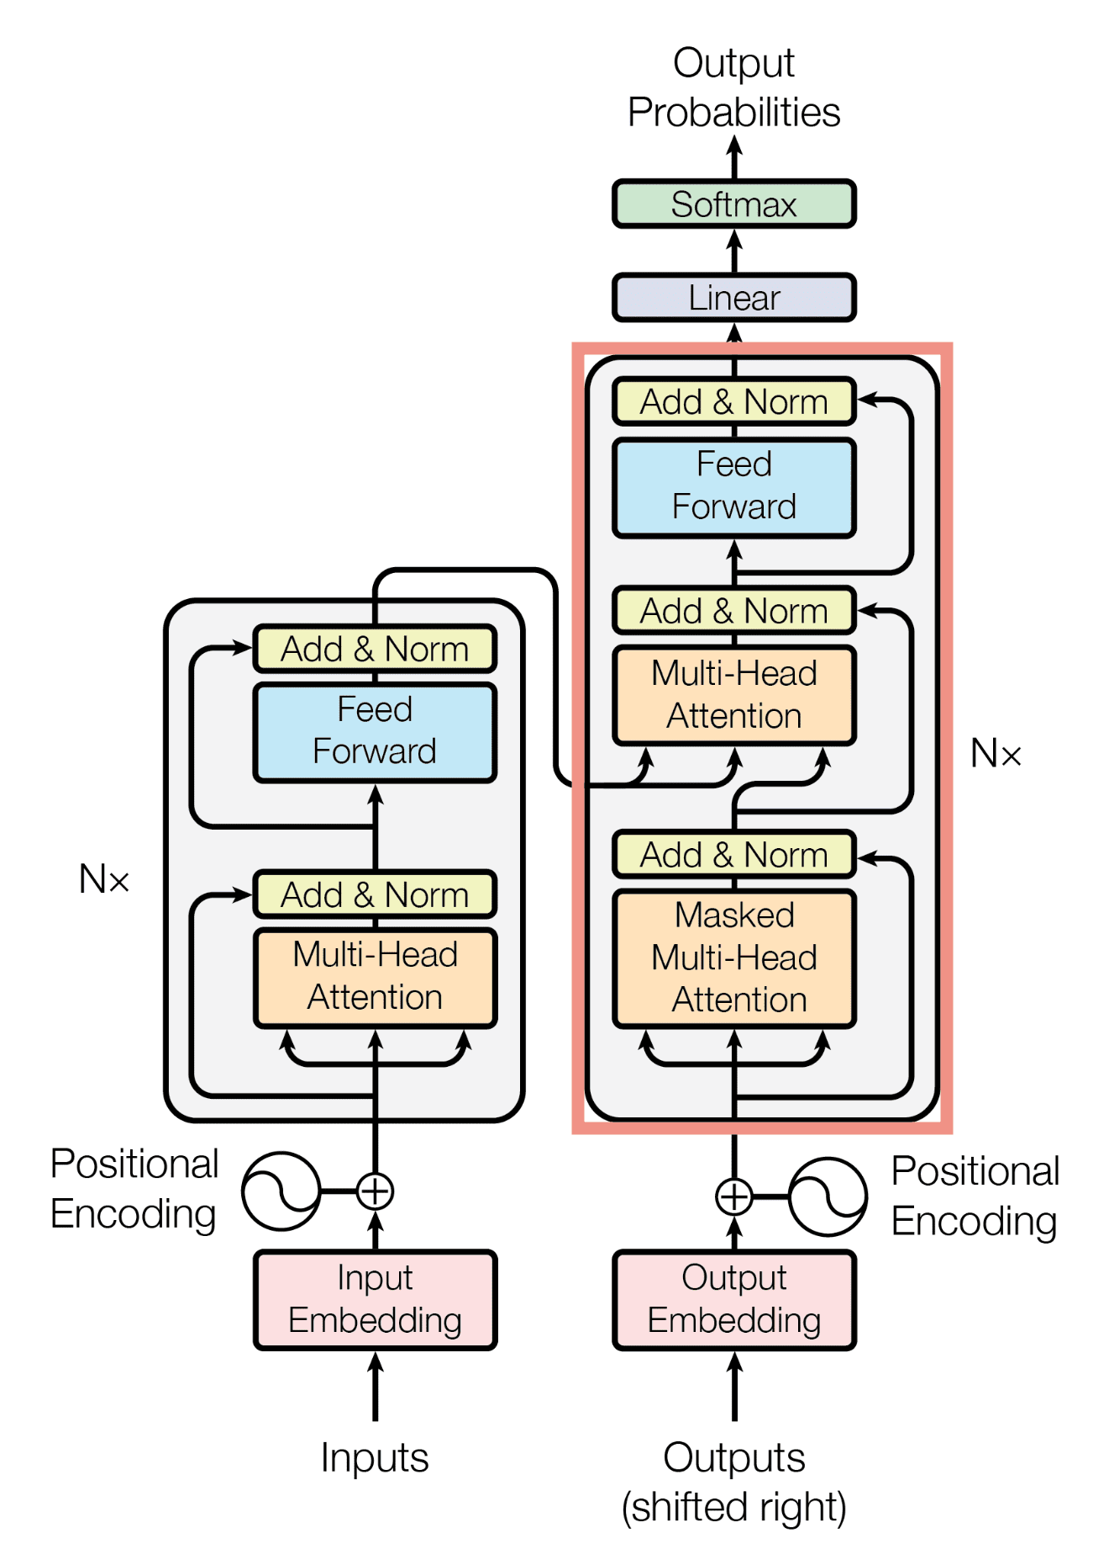
Fig.4 Illustrative Transformer model
Training the transformer for music creation requires feeding tokenized music sequences, such as MIDI tokens, into the model. It aims to minimize cross-entropy loss between the predicted and actual sequences. Attention can discover chord and note dependencies, and during training, it learns predicting what will come next in a sequence for continuing sequences or develop a logical and stylistically aligned sequence by optimizing that purpose.

    - Evaluation
Three evaluation criteria must be used to assess the transformer model for composition, primarily based on accuracy, validation loss, and coherence in music.
Accuracy and Validation Loss monitor the performance of the model in predicting sequences, thereby ensuring that the model is picking up relevant musical patterns from the Pokémon dataset for successful generalization of new compositions. A low validation loss means that the model continues to fit various structures by generating sequences without overfitting.
The resulting music is assessed against basic properties of rhythm, harmony, and melodic coherence for the Musical Coherence evaluation. It calls for verifying that the output conforms to the stylistic features of the dataset and actually contains the essential features of Pokémon music, for instance, harmonized note progressions and well-balanced rhythm. Collectively, these metrics ensure the model produces compositions that are more high-quality and relevant to style.
- Results and Discussion
With the given dataset of Pokémon, the work depicts how well generative models, GANs, VAEs, GRUs, transformers, and the diffusion model come up with original and aesthetically pleasing musical compositions.
Leading by virtue of their advanced mechanisms for attention, both transformers and VAEs lead in the investigation of musical structure, resulting in low validation loss besides good accuracy and also a low reconstruction loss. So, it's evident that they can be able to handle long-range dependencies quite efficiently.
Although good noise scheduling was necessary for best performance, the diffusion model performed well in noisiness refinement, producing unique, melodic sequences. GANs produced unique compositions but had problems with the stability of training and mode collapse.
Transformers and VAEs did very well on rhythm, harmony, and thematic concerns over musical coherence, that is, the tasks suited rather complex style-oriented music composition.
  - Performance of GAN
In this research, GANs generated creative music compositions with some stylistic alignment to Pokémon themes but encountered challenges like training instability and mode collapse, leading to repetitive outputs. While capable of producing unique sequences, GANs were less reliable than transformers and diffusion models for consistently coherent, diverse music generation. The model's generated compositions bear little resemblance to the Pokémon dataset regarding the core musical elements of rhythm, harmony, and timbre; these properties are very well justified by the FAD score which indicates that the GAN is unable to maintain faithful reproduction of the style under consideration, thereby requiring a refinement to improve musical coherence and stylistic fidelity. Nevertheless, since it introduces new elements and avoids simple dataset duplication, the Novelty Score of the GAN promises to be innovative and creative. The Diversity Score points out a weakness with regard to diversity in that mode collapse has limited the capacity of GAN to generate a variety of outputs, hence limiting the variety of musical expressions created.
  - Performance of GRU
Using the Pokémon dataset, the GRU model performs mediocrely when it comes to creating musical compositions. The resultant validation accuracy of and a accuracy value that was obtained indicate that while the model is learning some musical patterns, it still has trouble making highly reliable predictions. The model may be improved to minimize error and achieve closer alignment with the target musical sequences, as evidenced by the training loss and validation loss. The model may not yet fully reflect the complexity of the musical structure due to certain generalization difficulties, as seen by the marginally larger validation loss compared to training loss. The GRU's capacity to create compositions that are more cohesive and artistically authentic may be enhanced with further training or architectural modifications.

  - Performance of VAE
In the music composition generation part, this paper showed strong performances of transformers while handling long-range dependencies highly accurately and little validation loss. The model was in the position to pick complex rhythmic and melodic patterns from the Pokémon dataset, preserve music coherence, and thus be very useful in producing coherent style music. The transformation model metrics, as seen below, deliver outstanding performance in music composition over the Pokémon dataset which indicates effective learning of musical structures while keeping a structured latent space. Thus, the compositions are coherent and rhythmically aligned, and low KL divergence loss further indicates a well-regularized latent space, which is actually necessary for producing diverse but stylistically consistent music.
  - Performance of transformers
The transformer model shows progress in learning, as indicated by a decreasing validation loss, which suggests improved error minimization. However, low accuracy and high perplexity point to challenges in generating accurate and coherent outputs. These metrics suggest that while the model is learning, further optimization is needed for improved performance.
It is known as the perplexity score for a transformer model, how uncertain the model is about its prediction. In general terms, perplexity is the measure of how good the probability model is in predicting a sample. A lower perplexity indicates better prediction accuracy and lesser uncertainty, whereas higher perplexity indicates that the model cannot predict the next token with confidence in the sequence.
In this case, confusion means that the transformer model is failing to predict the next token in musical sequence well. The fact that such a high number has been attained indicates that the model is still struggling to recognize the complex patterns identified in the Pokémon music dataset, which might lead to outputs less logically or musically structured.
  - Performance of diffusion
Clear and melodically cohesive compositions are produced by the diffusion model's efficient noise refinement. To get the best results, its performance is largely dependent on the precise adjustment of noise scheduling. Although it can produce high-quality sequences, more tweaks are required to improve its musical integrity and consistency.
The diffusion model has a high perplexity score and does well at predicting the next token in the music sequence with low uncertainty and high accuracy. This could mean that the model makes sense producing the logical compositions while capturing the hidden musical structure. Even the output of the model reflects minor errors given by the average loss, which means that the generated music is highly similar to the target data, which closely maps the rhythm and harmony values in the input together with other musical features. Low confusion along with low loss depicts how a diffusion model may generate fantastic, musically coherent work with minor deviations from the desired style.

- Conclusion
The following conclusions were made by referring to fig5.
We can make the following deductions about the efficacy of various models for music composition tasks based on the table of model evaluation metrics:
1. The comparatively high novelty score (642.28) and significant FAD (Frechet Audio Distance) score of GANs (Generative Adversarial Networks) demonstrate a good ability to produce a variety of musical compositions. The remarkably high confusion score (1475.22), however, indicates that there may be difficulties in creating cohesive compositions.
2. The GRU (Gated Recurrent Unit) models demonstrate a fair capacity to learn musical patterns, as evidenced by their moderate accuracy (0.454) and low validation loss (2.0046). However, it's challenging to evaluate their generative quality for music because of the paucity of data on other parameters like novelty and FAD.

3. The KL Divergence Loss (262.43) is large, which may suggest problems striking a balance between reconstruction and meaningful variance in generated outputs, despite the fact that VAE (Variational Autoencoders) exhibit good accuracy (0.9243) and moderate reconstruction loss (6746.86). Although this model has the potential to capture intricate musical structures, it might require adjustment to achieve the best possible balance between originality and coherence.
4. Transformers' poor accuracy (0.1538) and larger validation loss (5.177) may indicate overfitting or stability issues with model training. Although their strong FAD score (177.21) indicates respectable generating quality, performance measures may require additional tweaks.
Every approach exhibits advantages and disadvantages in many facets of music composition. While VAE has good accuracy, indicating a capacity for complicated structural modelling, GANs and Diffusion Models demonstrate tremendous potential for producing original and high-quality music. While GRU offers mediocre performance but lacks comprehensive generating measures for a thorough evaluation, transformer models might require additional fine-tuning to produce competitive outcomes. To improve the created music's coherence, diversity, and freshness, future studies might concentrate on fine-tuning each model's parameters.

Model Name | Discriminator Loss | Novelty score | FAD | Diversity metric | Perplexity | Accuracy | Validation loss | Reconstruction loss | KL Divergence Loss
GAN | 4.0472e-06 | 642.2842 | 72965.6392 | 0.2751 | 1475.22 | 0.4131 | NA | NA | NA
GRU | NA | 0.6667 | 2.86 | 96.81 | 7.423 | 0.454 | 2.0046 | NA | NA
VAE | NA | 0.012 | 1.0 | NA | 1.138 | 0.9243 | 7009.2905 | 6746.8640 | 262.4265
Transformers | NA | 6.1 | 2.25 | 7.25 | 177.2142 | 0.1539 | 5.1774 | NA | NA
Diffusion | NA | 0.78 | 0.13 | 123 | 1.04 | 0.9994 | NA | NA | NA
Fig.4 Results

- References
- A Survey on Generative Adversarial Networks for Music Generation" by Yang, J., et al. (2020) - arXiv:2001.05094C. Roads (n.d.) “Research in Music and Artificial Intelligence”.
- Generating Music with Recurrent Neural Networks" by Graves, A. (2013) - arXiv:1303.2524
- A Hierarchical Variational Autoencoder for Generating Musical Scores" by Roberts, A., et al. (2018) - Link: arXiv:1803.05220
- M. Pearce, D.Meredith and G. Wiggins, (n.d.) “Motivations and Methodologies for Automation of the Compositional Process”.
- N. Collins and A.R. Brown, “Generative music editorial. Contemporary Music Review”, 2009.
- J. David Fernández and F. Vico, “AI Methods in Algorithmic Composition: A Comprehensive Survey”. Journal of Artificial Intelligence Research, vol. 48, pp.513–582, 2013. [Online] Available: http://www.flexatone.net/algoNet/ [Accessed 26 Oct. 2022].
- C.H. Liu and C.K. Ting, “Computational Intelligence in Music Composition: A Survey”. IEEE Transactions on Emerging Topics in Computational Intelligence, vol. 11, pp.2–15, 2017.
- D. Herremans, C.H. Chuan and E. Chew, “A functional taxonomy of music generation systems. ACM Computing Surveys”, 505, 2017.
- O. Lopez-Rincon, O. Starostenko and G.A.S. Martin, “Algoritmic music composition based on artificial intelligence: A survey”. 2018 28th International Conference on Electronics, Communications and Computers, CONIELECOMP 2018. Institute of Electrical and Electronics Engineers Inc., pp.187–193, 2018.
- J.-P. Briot, G. Hadjeres and F.-D. Pachet, “Deep Learning Techniques for Music Generation -- A Survey”, 2017. [Online] Available: http://arxiv.org/abs/1709.01620.
- N. Mendis and R. Bandara, "Show and Listen: Generating Music Based on Images using Machine Learning," 2022 22nd International Conference on Advances in ICT for Emerging Regions (ICTer), Colombo, Sri Lanka, 2022, pp. 25-30, doi: 10.1109/ICTer58063.2022.10024066.
- Deruty, Emmanuel and Maarten Grachten. “"Melatonin": A Case Study on AI-induced Musical Style.” ArXiv abs/2208.08968 (2022):

[13]
Nandini Vatsya, Aaryan Thipse, Priyansh Dixit, Rajnandini Dafe, Kunal Shejul (2024), Melody Generation using Deep Learning: Unleashing the Power of RNN and LSTM. International Journal of Innovative Science and Research Technology (IJISRT) IJISRT24APR2001,1713-1720.DOI: 10.38124/ijisrt/IJISRT24APR2001. https://www.ijisrt.com/melody-generation-using-deep-learning-unleashing-the-power-of-rnn-and-lstm

- Salazar, Andres Eduardo Coca et al. “Generation of composed musical structures through recurrent neural networks based on chaotic inspiration.” The 2011 International Joint Conference on Neural Networks (2011): 3220-3226.

- Collins, Tom, Robin C. Laney, Alistair Willis and Paul H. Garthwaite. “Developing and evaluating computational models of musical style.” Artificial Intelligence for Engineering Design, Analysis and Manufacturing 30 (2015): 16 - 43.

