WEEK 3 REPORT
Exploratory Data Analysis and Visualization Techniques
Project: Student Placement Prediction and Skill-Gap Analysis Using Python
Prepared by: Hamsika | YUVA Intern – Data Science
Dataset: student_placement_raw_data.csv
Repository: https://github.com/Hamsika890/student-placement-prediction1

1. Abstract
This report presents an exploratory data analysis (EDA) of the student placement dataset used in the project “Student Placement Prediction and Skill-Gap Analysis Using Python.” The CSV contains 1,010 records and 14 columns. EDA is used before modelling to understand the structure, distribution, quality, and relationships in the data. Pandas is used for tabular summaries and statistical measures, while Matplotlib is used to create histograms, scatter plots, box plots, and categorical comparisons. The analysis focuses on academic performance (CGPA), aptitude and technical scores, placement status, department, and salary where available. The findings should be interpreted as patterns in this dataset, not proof that one factor causes placement. The report also identifies data-quality issues and explains how the observations can guide later preprocessing, feature engineering, and model evaluation.

2. Objectives
- Understand the dataset's dimensions, variable types, and completeness.
- Summarize numeric variables using mean, median, standard deviation, variance, minimum, maximum, and quartiles.
- Visualize distributions, relationships, category counts, and potential outliers.
- Interpret patterns in a student-placement context without making unsupported causal claims.
- Identify next steps for cleaning, feature engineering, and predictive modelling.

3. Dataset Overview
The loaded dataset has 1,010 rows and 14 columns. Numeric columns detected by Pandas: age, cgpa, backlogs, aptitude_score, technical_score, salary_lpa.
Unique student IDs: 1,000. Exact duplicate rows: 10.
The number of rows exceeds the number of unique student IDs, so repeated IDs should be reviewed. A repeated ID is not automatically an exact duplicate; inspect the records before deciding whether to remove them.
Variables include student identifiers, department and demographic/category fields, academic and skill scores, experience-related features, placement status, and salary. The target variable for later classification is 'placement_status'; salary_lpa may be analysed separately for salary-related patterns.

4. Methodology and Code Logic
- Step 1 — Load data: Read the CSV with pandas.read_csv() and confirm that it opens correctly.
- Step 2 — Inspect structure: Use df.shape, df.head(), df.info(), and df.dtypes to inspect size, sample records, and data types.
- Step 3 — Check data quality: Use df.isna().sum() for missing values, df.duplicated().sum() for exact duplicate rows, and nunique() for identifier uniqueness.
- Step 4 — Calculate descriptive statistics: Use df.describe() for count, mean, standard deviation, minimum, quartiles, and maximum. Calculate median and variance separately where needed.
- Step 5 — Visualize distributions: Use a histogram for CGPA and a box plot for salary to inspect spread, skewness, and possible extreme values.
- Step 6 — Explore relationships: Use a scatter plot for aptitude versus technical scores and a department-by-placement comparison for categorical patterns.
- Step 7 — Interpret and document: Relate each plot to the project question, note limitations, and identify preprocessing or modelling actions.

5. Data Quality Checks
Missing values detected by column:
Column | Missing values
student_id | 0
department | 0
gender | 0
age | 0
cgpa | 15
backlogs | 0
internship_experience | 12
projects_completed | 0
certifications | 0
aptitude_score | 10
technical_score | 0
communication_skill | 10
placement_status | 0
salary_lpa | 138
Total missing cells: 185. Missingness should be handled according to the meaning of each field. For example, a missing salary may mean that salary is not applicable or not recorded, rather than a numeric zero. Before modelling, determine whether salary is available only for placed students and avoid using it as a predictor if it leaks the outcome or is unavailable at prediction time.
Exact duplicate rows: 10. Duplicate rows and repeated student IDs should be inspected separately. Do not delete records automatically until it is confirmed whether they are data-entry duplicates or legitimate observations.

6. Descriptive Statistics
Mean is the arithmetic average and can be influenced by extreme values. Median is the middle observation and is more robust to skew. Variance measures average squared deviation from the mean; standard deviation is its square root and is expressed in the original units. Quartiles divide sorted values into four parts: Q1 is the 25th percentile, Q2 is the median, and Q3 is the 75th percentile. The interquartile range (IQR = Q3 − Q1) describes the middle half of the data and helps flag potential outliers.
Variable | Count | Mean | Median | Std. dev. | Variance | Min | Max
age | 1010 | 22.00 | 22.00 | 1.39 | 1.94 | 20.00 | 24.00
cgpa | 995 | 7.45 | 7.44 | 1.04 | 1.09 | 4.34 | 11.50
backlogs | 1010 | 0.46 | 0.00 | 0.92 | 0.84 | 0.00 | 4.00
aptitude_score | 1000 | 67.51 | 67.15 | 14.49 | 210.02 | 22.80 | 100.00
technical_score | 1010 | 65.34 | 65.45 | 16.62 | 276.33 | 10.00 | 105.00
salary_lpa | 872 | 5.76 | 5.80 | 1.12 | 1.25 | 2.43 | 9.53
Note: variance and standard deviation are sample estimates calculated by Pandas (ddof=1). Values are rounded to two decimal places.

7. Visualizations and Interpretation

Figure 1. Histogram of CGPA
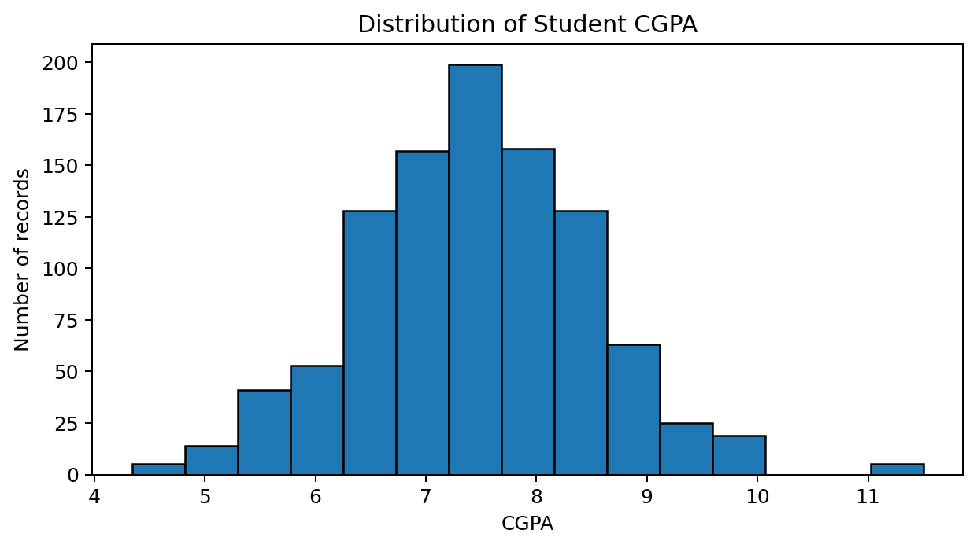
A histogram groups CGPA values into intervals and shows where observations are concentrated. A narrow central peak suggests many students have similar CGPAs; a long tail or isolated bars may indicate skewness or unusual values. Use the observed distribution to decide whether scaling or robust summaries may be useful. Missing CGPA values are excluded from this plot.

Figure 2. Aptitude score versus technical score
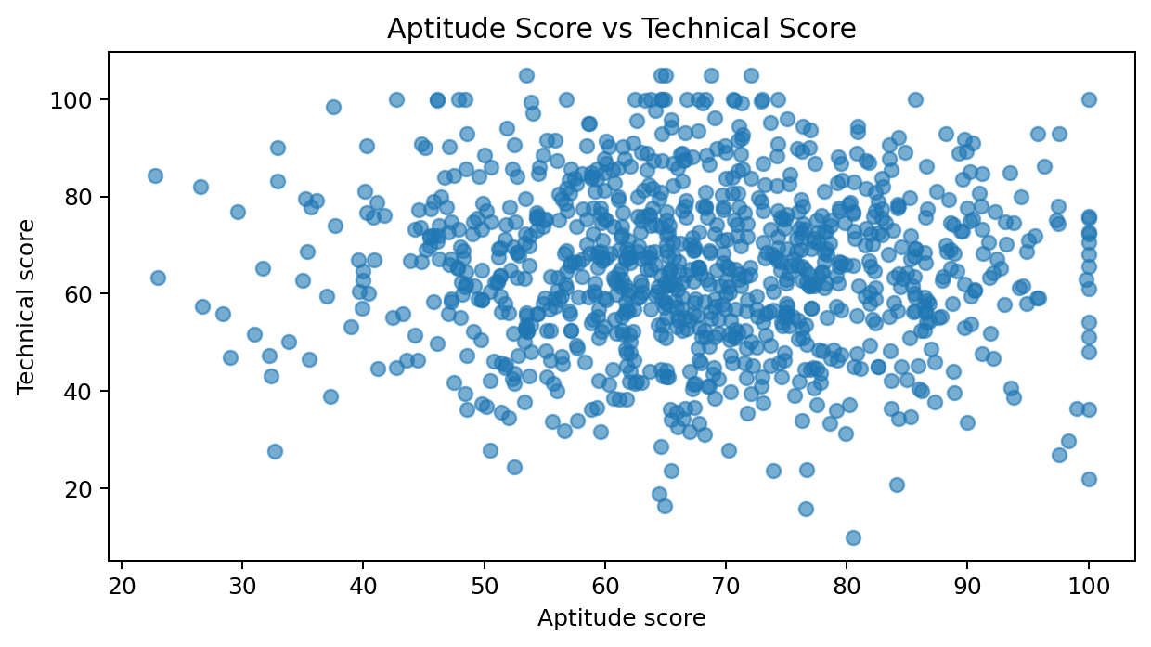
Each point represents a record with both scores present. An upward pattern suggests a positive association; a diffuse cloud suggests a weaker linear relationship. Overlapping points are possible. Correlation describes association, not causation, and other variables may affect both scores.

Figure 3. Salary distribution and potential outliers
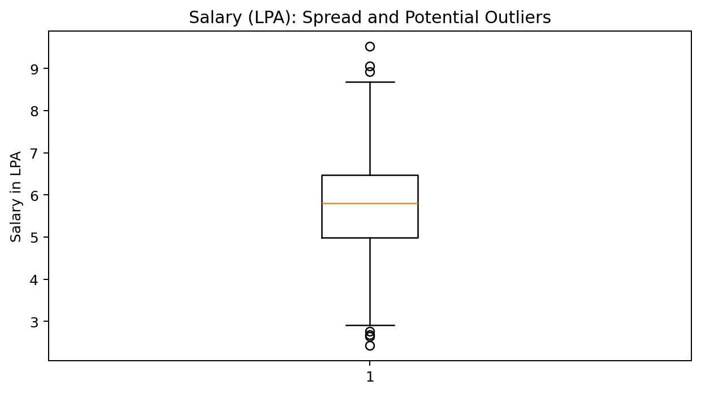
The box shows the interquartile range, the line inside the box is the median, and whiskers show the spread according to the plotting convention. Points beyond the whiskers are potential outliers, not automatic errors. Salary may be missing or structurally unavailable for students who are not placed, so interpret this chart in that context.

Figure 4. Placement-status counts
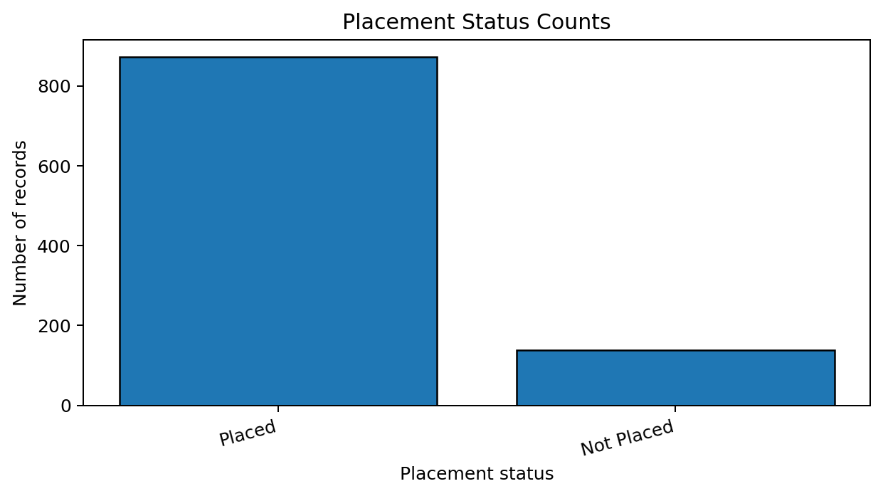
The bar chart compares the number of records in each placement-status category. Large class imbalance can affect a classifier's apparent accuracy; later evaluation should include precision, recall, F1-score, and a confusion matrix rather than accuracy alone.

Figure 5. Placement status by department
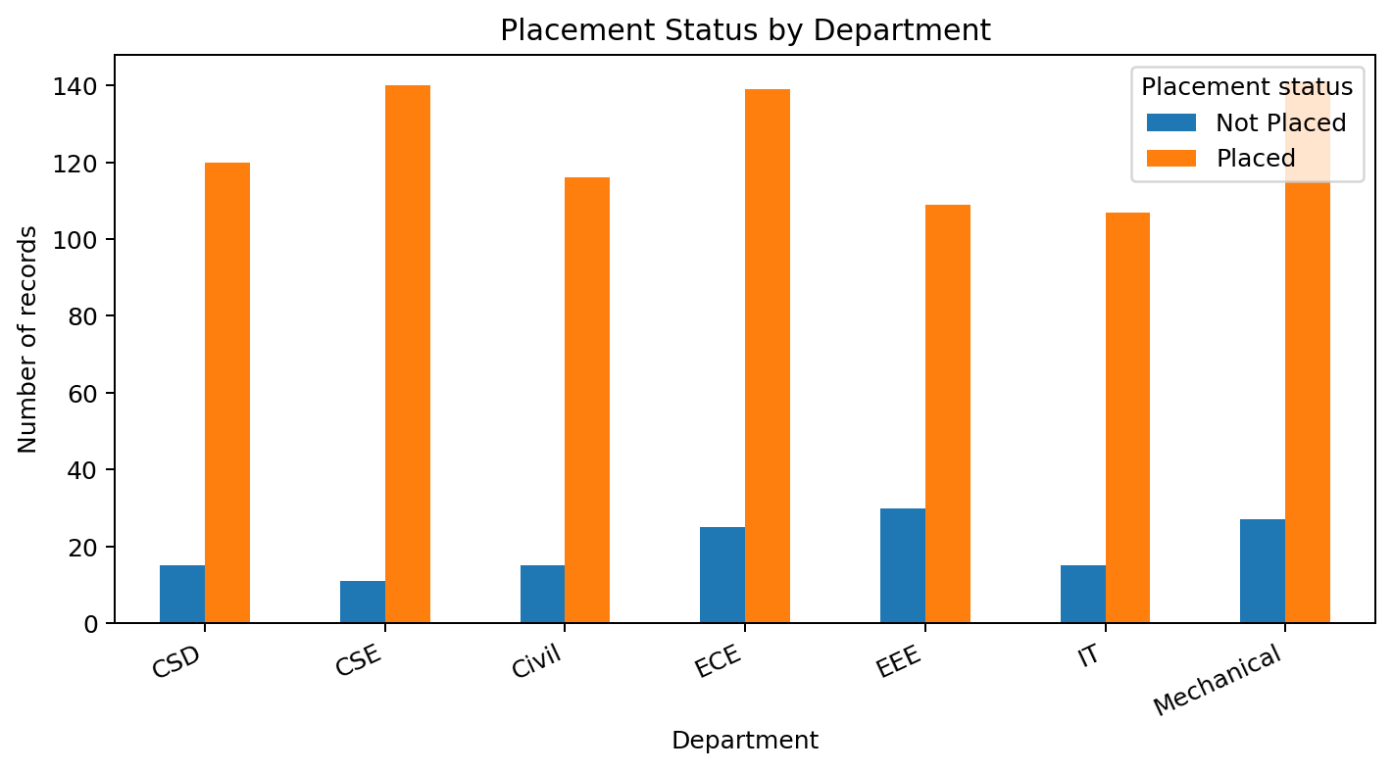
This grouped bar chart compares placement-status counts across departments. Differences may point to areas for further investigation, but raw counts depend on department sample size. For fair comparisons, calculate within-department placement rates and show denominators before drawing conclusions.

8. Key Findings and Anomalies
• The analysis includes 1,010 rows and 14 columns, providing a structured basis for exploratory review.
• The dataset contains 185 missing cells across 5 columns. Missingness must be treated deliberately rather than replaced blindly.
• There are 10 exact duplicate rows. These should be investigated before model training.
• The Pearson correlation between aptitude_score and technical_score among complete paired records is -0.027. This summarizes linear association only.
• Placement-status category counts: Placed: 872; Not Placed: 138.
• The IQR rule flags 7 non-missing salary values as potential outliers. These values require contextual review and should not be removed solely because they are extreme.
These observations are descriptive. They do not establish that CGPA, aptitude, technical scores, or department cause placement outcomes.

9. Implications for Further Analysis and Model Development
- Investigate duplicate records and repeated student IDs; document the rule used to retain or remove records.
- Choose missing-value strategies by column and consider whether missingness itself carries information.
- Check numeric ranges and category spellings, and verify that score scales are consistent.
- Engineer interpretable features only when justified, such as score aggregates or experience indicators, while avoiding target leakage.
- Split training and test data before fitting imputers, scalers, or other transformations to prevent leakage.
- Compare baseline models and evaluate with stratified train/test splits where appropriate; use precision, recall, F1-score, ROC-AUC when suitable, and a confusion matrix.
- For departmental comparisons, calculate rates rather than comparing counts alone and consider fairness and sample-size limitations.

10. Conclusion
Exploratory data analysis provides a foundation for responsible student-placement prediction by revealing distributions, relationships, missingness, duplicates, and possible outliers before modelling. The histogram, scatter plot, box plot, and categorical charts each answer a different question: how values are distributed, how numeric variables relate, how spread and extremes appear, and how outcomes vary across categories. Statistical measures complement the visuals by quantifying central tendency and variability. The next phase should resolve data-quality questions, prevent target leakage, and test models using suitable evaluation metrics. All findings should be rechecked whenever the dataset is updated.

11. Tools and Reproducibility
Python libraries: pandas, Matplotlib, and python-docx for report generation. The charts in this report were generated from the CSV available for this project.
Suggested repository layout:
- data/raw/student_placement_raw_data.csv
- notebooks/eda_visualization.ipynb
- reports/Week3_EDA_Visualization_Hamsika.docx
- reports/figures/ (optional chart exports)
Repository URL: https://github.com/Hamsika890/student-placement-prediction1
Submission note: upload this DOCX into the repository's reports/ folder (or docs/ if your internship instructions require all reports there), commit the change, and submit the repository URL without the .git suffix.

