YUVA INTERN
WEEK 5 REPORT
INTERPRETATION AND COMMUNICATION
OF ANALYTICAL FINDINGS
Student Placement Prediction and Skill-Gap Analysis Using Python
YUVA Intern — Data Science Internship
Prepared by: Hamsika Chinthakindi
B.Tech – Computer Science and Data Science
Primary Language: Python
Repository: https://github.com/Hamsika890/student-placement-prediction1

Executive Summary
This report interprets the results of the student placement prediction project and translates the analytical evidence into practical recommendations. The project uses a dataset containing 1,010 rows and 14 columns. After removing 10 exact duplicate rows, 1,000 records remained for modeling: 863 Placed and 137 Not Placed. Four approaches were compared on the same stratified held-out test set: a majority-class baseline, Logistic Regression, Decision Tree and Random Forest.
The most important finding is that overall accuracy alone can give a misleading picture when the outcome classes are imbalanced. The majority baseline reached 86.5% accuracy while detecting none of the Not Placed test cases. Random Forest reached 87.0% accuracy but detected only 14.8% of Not Placed cases. Logistic Regression achieved the highest Not Placed recall (81.5%) and F1-score (0.436) among the tested classifiers. Therefore, Logistic Regression is the most useful initial model when the goal is to identify students who may need additional placement support. These are exploratory results for this dataset, not guaranteed predictions of individual employment outcomes.

1. Project Background and Objective
The project, Student Placement Prediction and Skill-Gap Analysis Using Python, examines whether student academic, technical, aptitude, experience and communication-related attributes contain patterns associated with placement status. The target variable is placement_status, with two classes: Placed and Not Placed. Week 5 brings together the earlier data preparation, exploratory analysis and predictive modeling work to explain what the results mean and how they may support responsible decisions.
The purpose is not to rank students or automate hiring decisions. It is to explore whether a carefully evaluated analytical model could help educational institutions identify broad support needs, guide training activities and plan employability interventions.

2. Dataset and Analytical Context
Item | Verified value
Original dataset | 1,010 rows × 14 columns
Exact duplicate rows removed | 10
Records after exact deduplication | 1,000
Placed records | 863 (86.3%)
Not Placed records | 137 (13.7%)
Held-out test set | 200 records: 173 Placed and 27 Not Placed
Target variable | placement_status

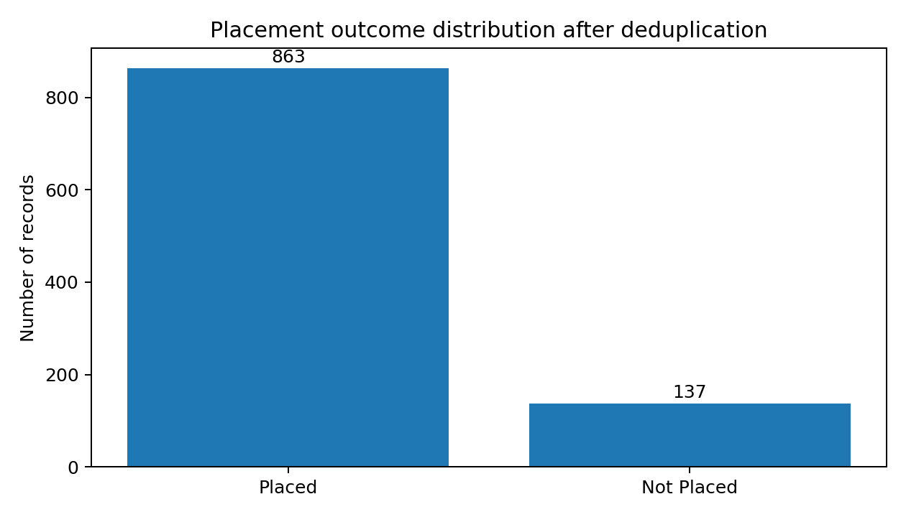
Figure 1. Placement outcome distribution after deduplication. The dataset is imbalanced: Placed records form 86.3% of the sample, while Not Placed records form 13.7%. This imbalance makes class-specific recall and F1-score essential when interpreting model performance.

3. Main Findings from Predictive Modeling
The Week 4 experiment compared a simple majority-class baseline with three machine-learning classifiers. Precision, recall and F1-score in the following table refer specifically to the Not Placed class, which was treated as the positive class. Accuracy refers to the proportion of all test records classified correctly.
Model | Accuracy | Not Placed precision | Not Placed recall | Not Placed F1
Majority-class baseline | 0.865 | 0.000 | 0.000 | 0.000
Logistic Regression | 0.715 | 0.297 | 0.815 | 0.436
Decision Tree | 0.555 | 0.202 | 0.778 | 0.321
Random Forest | 0.870 | 0.571 | 0.148 | 0.235

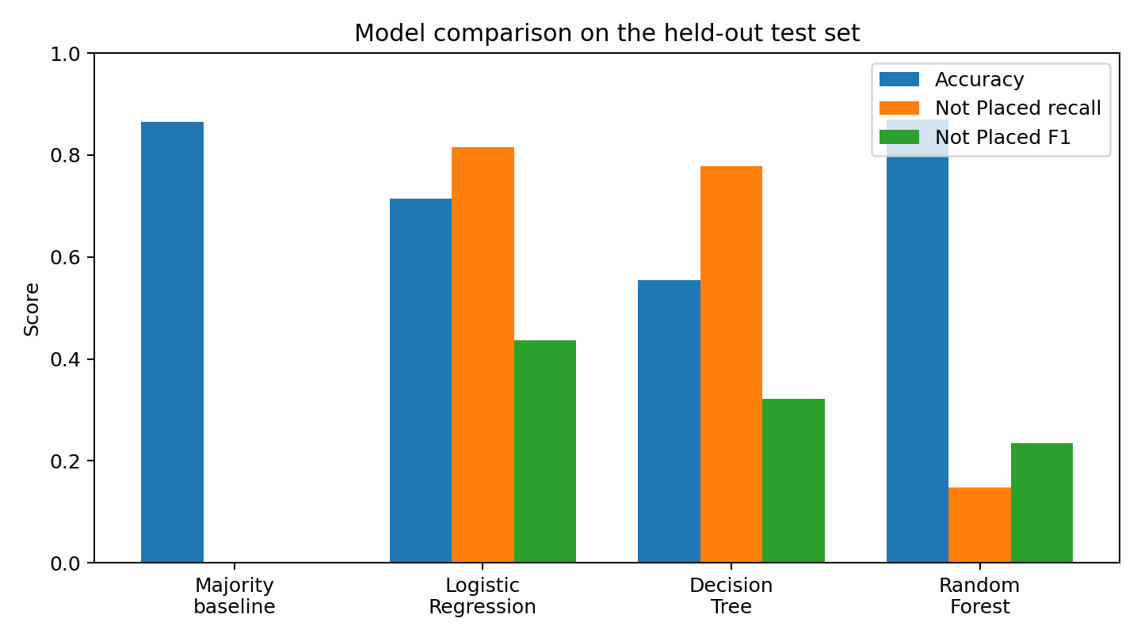
Figure 2. Model comparison. Random Forest has the highest accuracy, but Logistic Regression has the strongest recall and F1-score for the Not Placed class. The preferred model therefore depends on the practical objective and the relative cost of different errors.

4. Interpretation of the Findings

4.1 Accuracy is not sufficient
The majority baseline predicts the dominant Placed class and achieves 86.5% accuracy, yet its recall for Not Placed is zero. This means it fails to identify any of the minority-class cases in the test set. A stakeholder looking only at accuracy might incorrectly conclude that this baseline is useful. The result demonstrates why multiple evaluation metrics must be reported.

4.2 Logistic Regression is the strongest initial support-screening option
Logistic Regression detects 22 of the 27 actual Not Placed test records, giving a recall of 0.815. It misses 5 Not Placed records, while also flagging 52 Placed records as Not Placed. This trade-off means it may be useful for identifying students for a supportive review, but its predictions should be checked by a human and should never be treated as a final judgment.

4.3 Random Forest's high accuracy hides missed cases
Random Forest achieves 0.870 accuracy and 0.571 precision for Not Placed, but its recall is only 0.148. It identifies 4 of the 27 actual Not Placed test records and misses 23. If the purpose is early identification of students who may need support, this low recall is a serious limitation despite the high overall accuracy.

4.4 Decision Tree provides a different trade-off
The Decision Tree detects 21 of the 27 Not Placed test records, but it also flags many Placed records as Not Placed. Its accuracy is 0.555 and its Not Placed F1-score is 0.321. Its rules may be easier to explain than some ensemble models, but the current result does not make it the best overall option in this experiment.

5. Error Analysis: What the Confusion Matrix Shows
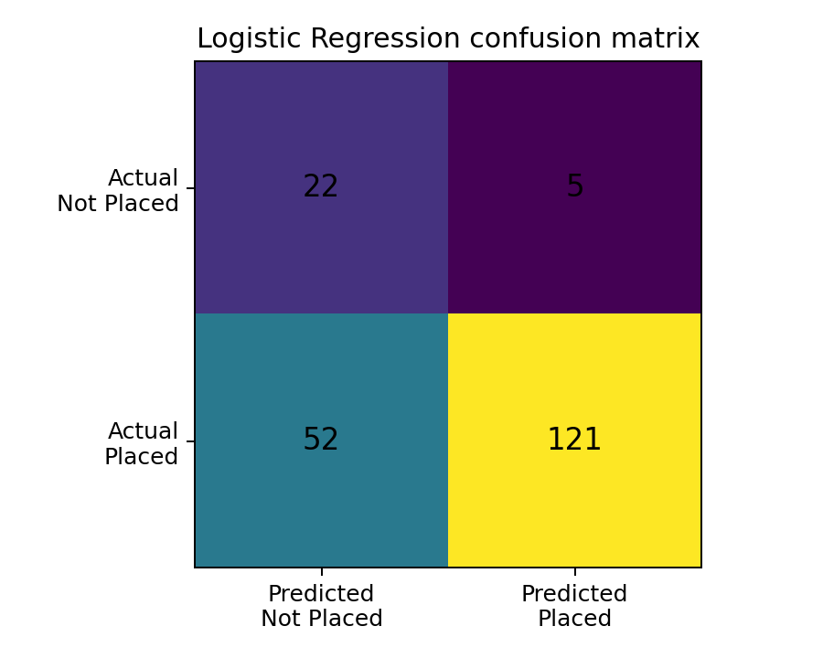
Figure 3. Logistic Regression confusion matrix, with Not Placed treated as the positive class. The model correctly identifies 22 Not Placed records and misses 5. It also produces 52 false alerts among students who were actually Placed, while correctly classifying 121 Placed records.
Outcome | Count | Meaning
True positive | 22 | Actual Not Placed predicted as Not Placed
False negative | 5 | Actual Not Placed predicted as Placed
False positive | 52 | Actual Placed predicted as Not Placed
True negative | 121 | Actual Placed predicted as Placed

For a student-support use case, false negatives may be particularly concerning because a student who could benefit from help may not be flagged. False positives also matter: they can lead to unnecessary reviews or make students feel incorrectly labelled. The institution should therefore decide on an appropriate threshold and support process before considering any real-world use.

6. Potential Business, Educational and Research Implications
For colleges and placement cells, an appropriately validated model could help organize optional career counselling, interview preparation, technical workshops and communication-skills support. Aggregated patterns may help departments identify areas where additional training resources could be useful. For students, the most constructive use is to provide timely guidance and learning opportunities rather than to label individuals as successful or unsuccessful.
For researchers, the comparison illustrates the importance of matching evaluation metrics to the research objective. It also shows that class imbalance, dataset representativeness and the cost of different prediction errors should be discussed alongside model scores. The current results are not evidence that any one skill causes placement; they show predictive associations within the available dataset and experimental setup.

7. Actionable Recommendations
- Use Logistic Regression as the leading candidate for further testing when the priority is to detect the Not Placed class; do not describe it as a production-ready model.
- Present accuracy together with class-specific precision, recall, F1-score and confusion matrices in every model review.
- Use model flags only to offer voluntary support such as mentoring, mock interviews, aptitude practice and technical training.
- Keep student identifiers and unnecessary personal attributes out of model inputs and public reports.
- Have educators or placement professionals review any proposed intervention; do not automate admission, recruitment, rejection or other high-impact decisions.
- Document the data source, preprocessing steps, feature definitions, random seed, model settings and evaluation split so the experiment can be reproduced.

8. Limitations and Responsible Interpretation
- The dataset contains 1,000 records after deduplication, and only 137 belong to the Not Placed class. The held-out test set contains just 27 Not Placed cases, so minority-class metrics may change substantially with another split.
- The dataset's source and sampling process have not been independently validated. Results may not generalize to other colleges, regions, academic years or employers.
- Important influences such as hiring cycles, interview performance, role availability and employer-specific requirements may not be fully represented.
- The model comparison is an initial experiment. Repeated stratified cross-validation, threshold analysis and independent external validation are still required.
- Predictive relationships do not establish causation. The report does not claim that any single academic or skill variable causes placement success.

9. Future Work and Further Research
- Run repeated stratified cross-validation on the training data and report mean scores and variability.
- Tune Logistic Regression and compare additional classifiers using a consistent validation procedure while keeping the final test set untouched.
- Study threshold selection and precision-recall trade-offs based on the practical consequences of false negatives and false positives.
- Conduct feature-level interpretation using suitable coefficients or explainability methods, and verify that interpretations are stable.
- Evaluate performance across relevant departments or groups where sample sizes permit, and investigate possible disparities responsibly.
- Collect or obtain a larger, independently sourced dataset and test whether the findings hold across institutions and time periods.

10. Conclusion
The Week 5 interpretation shows that a useful placement-analysis model must be judged by more than overall accuracy. Although Random Forest achieved the highest accuracy in the current test, its low recall for Not Placed means it missed most students in that class. Logistic Regression provided the strongest Not Placed recall and F1-score among the tested models, making it the most promising initial candidate for further evaluation when early identification is the objective. Its false positives and the small number of minority-class test examples must also be considered.
The project demonstrates how data preparation, exploratory analysis and predictive modeling can be communicated as practical insights. The responsible next step is further validation and, if appropriate, a human-reviewed student-support pilot. Predictions should remain estimates, not guarantees of employment or automated decisions about students.

11. Repository Structure and Submission Checklist
Folder / file | Purpose
docs/Week5_Interpretation_Communication_Hamsika.docx | Week 5 report (this document)
src/train_model.py | Model training and evaluation script from Week 4
notebooks/week4_modeling.ipynb | Modeling notebook
reports/week4_model_metrics.csv | Model evaluation metrics
reports/week4_confusion_matrices.csv | Confusion-matrix counts
data/raw/student_placement_raw_data.csv | Raw project dataset

- Save this report in the repository's docs/ folder.
- Keep the Week 4 script, notebook and evaluation CSV files in their existing locations.
- Check that the charts display correctly after opening the DOCX.
- Commit the new Week 5 report to the existing student-placement-prediction1 repository.
- Open the GitHub repository and verify that the DOCX is visible inside docs/.

GitHub repository: https://github.com/Hamsika890/student-placement-prediction1
Week 5 report path: docs/Week5_Interpretation_Communication_Hamsika.docx

References
- Scikit-learn. Model evaluation: https://scikit-learn.org/stable/modules/model_evaluation.html
- Scikit-learn. Pipeline and composite estimators: https://scikit-learn.org/stable/modules/compose.html
- Scikit-learn. Logistic Regression: https://scikit-learn.org/stable/modules/generated/sklearn.linear_model.LogisticRegression.html
- Week 1 Research Proposal: Week1_Research_Proposal_Hamsika.docx.
- Week 4 Predictive Modeling and Evaluation Report: Week4_Predictive_Modeling_Evaluation_Hamsika.docx.

