|  |
| --- |
|  |

|  |
| --- |
| **eMart (Mid-Tier C#, Phase 2) v1.0** |
| Case Study |
|  |
| This document covers Software Requirements of eMart, along with list of Technologies to be used to develop this Software System, and also includes some details on the Architecture |
|  |
| **IIHT** |
| **1/10/2019** |
|  |

Table of Contents

1. Business Requirement(eMart) 2

1.1. Roles 2

1.1.1. Buyer Use Cases. 2

1.1.2. Seller Use Cases 2

1.1.3. Admin Use Cases(optional) 3

1.1.4. Data Fields 3

2. Design Inputs 6

3. Entity Classes 6

4. Model Classes 8

5. Other Core C# Implementation 9

6. Architecture Diagram(just for reference) 9

7. Full Stack Technologies 10

8. Technical Spec – Solution Development Environment 11

8.1. Front End Layer 11

8.2. Middle Tier Layer 11

8.3. Database & Integration Layer 11

8.4. Ancillary Layer 11

Controllers can be tested using Postman Tool 11

8.5. Security 11

8.6. Deployment & Infrastructure 11

8.7. Editors 12

9. Assessment Deliverables 12

10. Important Instructions 12

# Business Requirement(eMart)

eMart is a online eCommerce portal used to search and buy an item online. Buyer can add items to the cart, checkout and perform other operations. Admin can block/unblock Seller, Buyer, selling items. Below are eMart Features in detail.

## Roles

Below are the different roles, which need to be supported by above Software System.

#1. Buyer

#2. Seller

#3.Admin(optional)

Below are the Use Cases which need to be supported by each of above Roles

### Buyer Use Cases.

Login/Logout

Signup

Should be able to search an Item.

Once list of items are displayed, it should be possible to filter items based on Price, Manufacturer, etc...

When a specific item is selected by Buyer, complete details of item need to be displayed along with picture(one or more) and (list of)specifications which depends on Category and Sub Category of the item. Add to Cart button need to be provided.

It should be possible to open the Cart and checkout. Tax amount need to be displayed.

Items in the Cart can be deleted

It should be possible to apply discount, before checking out.

It should be possible to view History of purchases, along with Item, numbers

Integration with any Payment Gateway(optional)

### Seller Use Cases

Login/Logout

Signup with details such as Company/individual name, email id, Postal Address, GSTIN, Bank details

Add an item to be sold along with the number of items(in Stock)

Should be able to view Inventory(items sold and remaining)

Should be able to generate report like number of items sold and which items, over certain period.

Tax Calculation need to be performed.(optional)

### Admin Use Cases(optional)

Login/Logout

Block/Unblock a specific Seller

Block/Unblock a specific item sold by a Seller

Block/Unblock a specific Buyer

Add/remove Categories, Sub Category along with GST

Add/update discounts - discount code, start date, end date

View daily Turnover Category wise

**NOTE: Shipping/Delivery Tracking related Use Cases are not in the scope, it is assumed that Seller need to manage Shipping/Delivery Tracking offline.**

### Data Fields

Below are data fields, for your reference. Based on your Analysis Data fields can be added/removed

**Buyer:**Buyer’s login and profile details

id

username

password

emailid

mobile number

createddatetime

**Seller:**Seller’s login and Selling company details

id

username

password

companyname

GSTIN

brief about company

postal_address

website

emailid

contact number

**Category:**List of Categories, for example Electronic, Fashion, etc…

category_id

category_name

brief_details

**Subcategory:**Sub Category of each Category. For example Electronic Category can have Mobile, TV, Laptop, etc… as Sub categories

subcategory_id

subcategory_name

category_id

brief_details

GST %

For example Mobiles, TV, etc... can be Sub Catgeories in Electronic Category

**Items:**Selling Item details

id

category_id

subcategory_id

price

item_name

description

stock_number

remarks

**Purchase History:**

Id

Buyer_id

Seller_id

Transaction_id

Item_id

Number_of_items

Date_time

remarks

**Transactions:**Transactions performed during Checkout, etc…

id

user_id

seller_id

transaction_type(Eg. debit or credit)

date_time

remarks

**Discounts:**Discount details

Id

Discount_code

percentage

start_date

end_date

description

# Design Inputs

Next sections in this document provides inputs on designing the solution for above requirements.

Design inputs provided in this document are just for your reference purpose, Associates can make changes or additions to the Design, based on their analysis.

# Entity Classes

Below are the activities which need to be performed as part of this

1. Identify all Entity Classes and its fields. An Entity class is the one which is mapped to underlying DB Table
2. Identify relationship(such as One to One, One to Many, Many to One, Many to Many) between Entity classes, if required
3. Develop the source code of Entity classes

Entity classes can also include validation related details, such as [Required], etc…

Below are some sample Entity Classes. Similarly identify all the Entity classes based on the requirements.

**BuyerEntity:**Buyer’s login and profile details

id

username

password

emailid

mobile number

createddatetime

**SellerEntity:**Seller’s login and Selling company details

id

username

password

companyname

GSTIN

brief about company

postal_address

website

emailid

contact number

**CategoryEntity:**List of Categories, for example Electronic, Fashion, etc…

category_id

category_name

brief_details

**SubcategoryEntity:**Sub Category of each Category. For example Electronic Category can have Mobile, TV, Laptop, etc… as Sub categories

subcategory_id

subcategory_name

category_id

brief_details

GST %

For example Mobiles, TV, etc... can be Sub Catgeories in Electronic Category

**ItemsEntity:**Selling Item details

id

category_id

subcategory_id

price

item_name

description

stock_number

remarks

**PurchaseHistoryEntity:**

Id

Buyer_id

Seller_id

Transaction_id

Item_id

Number_of_items

Date_time

remarks

**TransactionsEntity:**Transactions performed during Checkout, etc…

id

user_id

seller_id

transaction_type(Eg. debit or credit)

date_time

remarks

**DiscountsEntity:**Discount details

Id

Discount_code

percentage

start_date

end_date

description

# Model Classes

Model Classes are the classes which are required to transfer the databetween

1. REST API Controllers and Angular Client, (in JSON format)
2. Service Layer and Repository Layer

As part of this Phase identify all Model classes, and develop source code for the same.

Model classes are just normal POCO classes with data members, constructors, Properties

This Phase comprises identifying and developing Mid Tier’s Model classes(in C#) which are required to be used in the next Phases.

# Other Core C# Implementation

This Phase also comprises development of other source code required for the Project.

# Architecture Diagram(just for reference)

Below Microservice Architecture would be required in next Phases

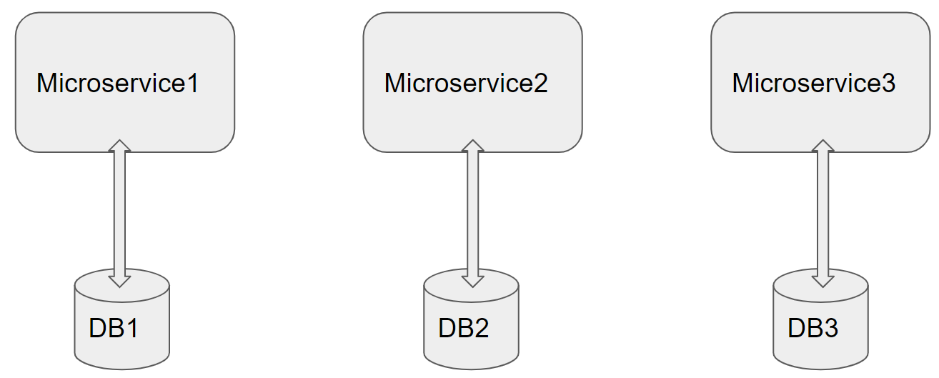

Architecture of a Single Microservice with REST Controller, Service, Model & Entity Classes and Repository classes

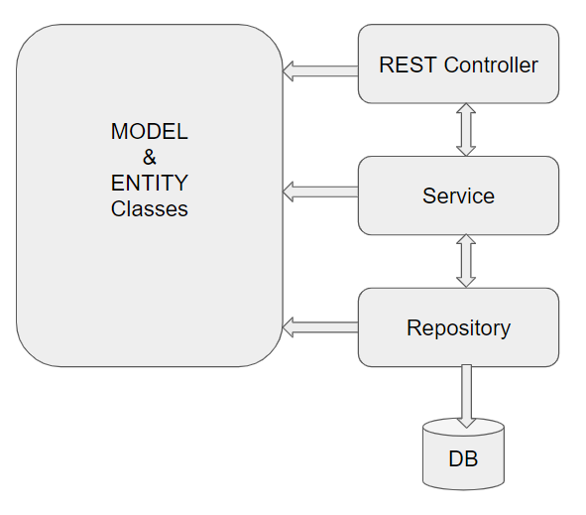

# Full Stack Technologies

The technologies included in Full Stack are not limited to following but may consist of:

* UI Layer (HTML5, CSS3, Bootstrap 4, JavaScript, Jquery, Angular 6/8)
* Middleware Restful API (Web API Core&MicroServices)
* Database Persistence ( Entityframework Core)
* Database layer (SQL SERVER)
* Ancillary skills (GIT, Jenkins(CI/CD), Docker) etc.

To complete this case study, you should be comfortable with basic single page web application concepts including REST and CRUD. You may use angular-cli to create your template project. All web pages need to be responsive.

Ref1: https://cli.angular.io/

Ref2: <https://github.com/angular/angular-cli>

# Technical Spec – Solution Development Environment

## Front End Layer

|  |  |
| --- | --- |
| **Framework(s)/SDK/Libraries** | **Version** |
| **Framework(s)/SDK/Libraries** | **Version** |
| Angular with TypeScript | 6/8 |
| Bootstrap | 3.0 or above |
| CSS | 3 |
| HTML | 5 |
| JavaScript | 1.8 or above |

## Middle Tier Layer

|  |  |  |
| --- | --- | --- |
| **Technology** | **Framework(s)/SDK/Libraries** | **Version** |
| .Net Stack | .Net Framework | 4.5 or above |
| .Net Core | 2.2 or above |
| Web API Core | 2.0 or above |

## Database & Integration Layer

|  |  |  |
| --- | --- | --- |
| **Technology** | **Framework(s)/SDK/Libraries** | **Version** |
| .Net Stack | Entity Framework Core | 2.2 or above |
| LINQ |  |
| SQL SERVER | 2014 or above |

## Ancillary Layer

|  |  |  |
| --- | --- | --- |
| **Technology** | **Framework(s)/SDK/Libraries** | **Version** |
| Source Code Management Tool | GIT | 2.14.2 |
| Testing Tool/.Net Stack | NUnit/Xunit/Moq | 3.x |

## Controllers can be tested using Postman Tool

## Security

|  |  |
| --- | --- |
| **Name** | **Version** |
| JWT |  |

## Deployment & Infrastructure

|  |  |  |
| --- | --- | --- |
| **Technology** | **Framework(s)/SDK/Libraries** | **Version** |
| Docker | - |  |
| IIS | - |  |
| Jenkins(CI/CD) | - |  |
| Node | - |  |

## Editors

|  |  |
| --- | --- |
| **Name** | **Version** |
| Visual Studio |  |
| Visual Studio Code |  |

Agile/Scrum Software development Model can be used

# Assessment Deliverables

1. Source code of Compiled Entity Classes
2. Source code of Compiled Model Classes

# Important Instructions

1. Consider using below C# features
2. Lambda Expressions
3. Collections
4. Generics
5. Sample Design provided is just for reference, Associates can make changes over it or follow their own Design.
6. Based on your current work, alternate Technologies can be used, for example ReactJS instead of Angular, etc…, however prior approval from the Mentor is required.
7. Please make sure that your code does not have any compilation errors while submitting your case study solution.
8. The final solution should be a zipped code having solution. Solution code will be used to perform Static code evaluation.
9. Implement the code using best design standards/family Design Patterns.
10. Use Internationalization for all the labels and messages in Rest API Development.
11. Use appropriate logging methods for logging statements/variable/return values.
12. Write web service which takes input and return required details from database.
13. Use JSON format to transfer the results.
14. Use JSON format to transfer the results.

For any further queries you can contact fullstack@iiht.com