|  |  |
| --- | --- |
| The auto ticket machine | *This is a machine to buy ticket public and there have function - First if we press the enter button the machine will show the menu to choose some function : choose destination want to go,…. - Second we can choose payment method by cash, by using credit card, and QR code. *And if we booking complete the machine will show payment method and if we use QR code the QR code will be minus your money in your bank and comfirm your booking. And the QR code will show when you choose. |
| Functional of manchine | The ticket vendor machine should be able to display a list of available tickets and their prices and design to meet the public transport industry such as: train or bus ticket.  The ticket vendor machine should allow customers to select the type and quantity of tickets they wish to purchase and will provide the routine of destination and information.  The ticket vendor machine should be able to accept payment in various forms, such as cash, credit/debit cards, or mobile payments(QR code).  The ticket vendor machine should print a receipt for the purchased ticket if payment complete.  The ticket vendor machine should be able to dispense the purchased ticket(s) and any change due.  The ticket vendor machine should allow customers to cancel their transaction if they change their mind before the purchase is completed. |
| Non-Function of machine | The ticket vendor machine should be user-friendly and easy to  navigate and the process should be quickly and efficently.  The ticket vendor machine should be reliable and maintain a high level of availability.  The ticket vendor machine should be able to handle high volumes of transactions without errors or delays.  The ticket vendor machine should be secure and protect customer information and payment details. |
| Domain of machine | The ticket vendor machine should be designed to meet the specific needs of the transportation industry, such as train or bus tickets.  The ticket vendor machine should be able to handle various ticket types, such as single tickets, day passes, and weekly or monthly passes and some type of ticket(normal, luxury).  The ticket vendor machine should be able to provide information on schedules and routes and information.  The ticket vendor machine should be able to handle multiple languages and currencies to accommodate international travelers.  The system should be able to comply with relevant regulations and standards, such as data privacy and security regulations |

Use Case modelling:

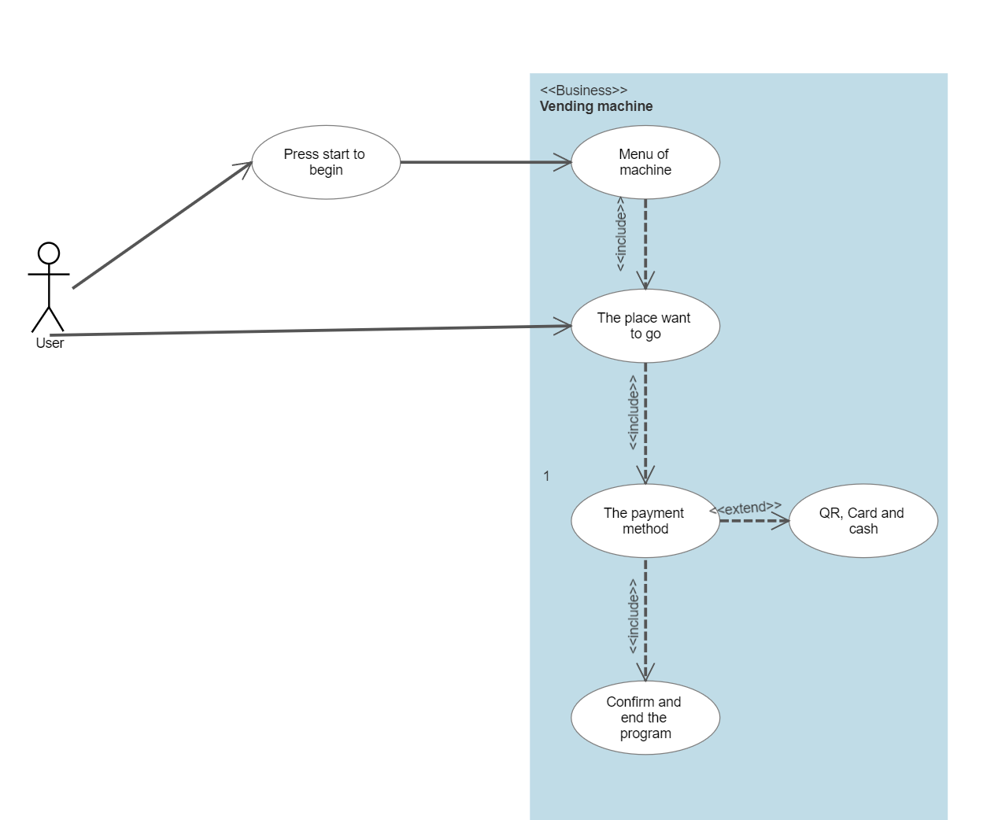

Activity diagram:

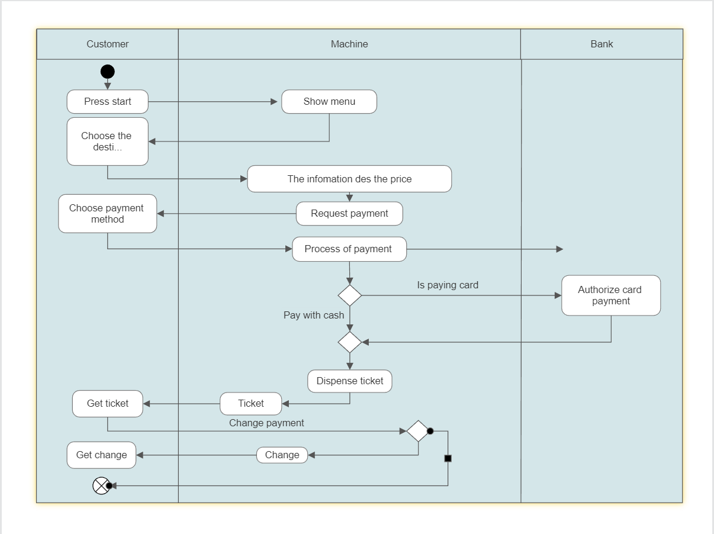

The sequence diagram:

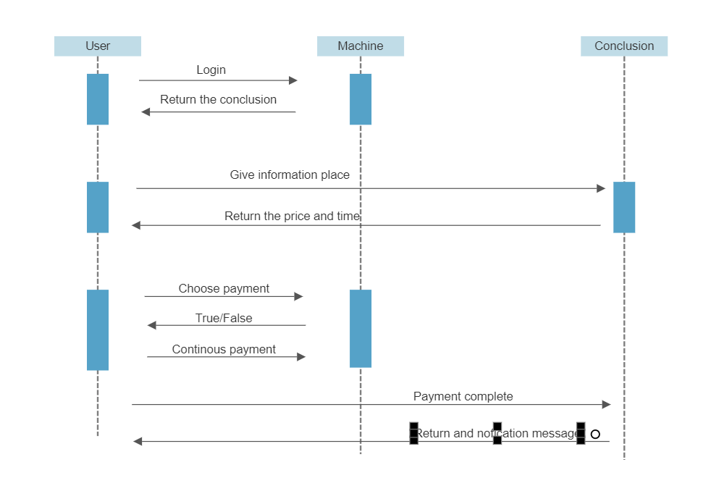

State chart diagram:

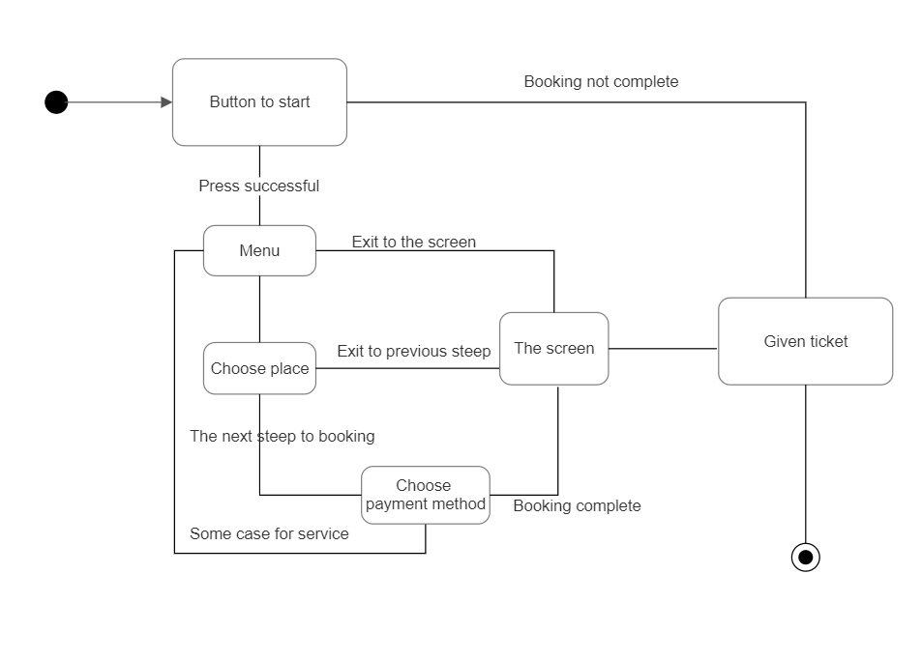

Class diagram:

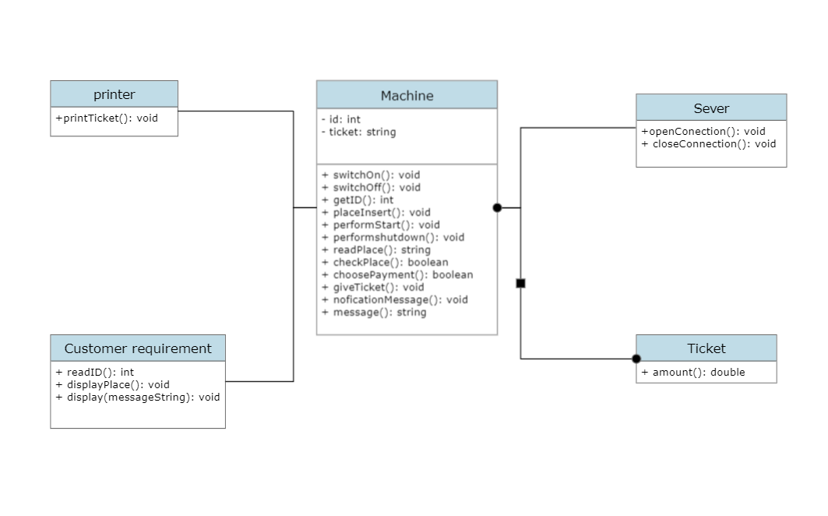

Architecture design:

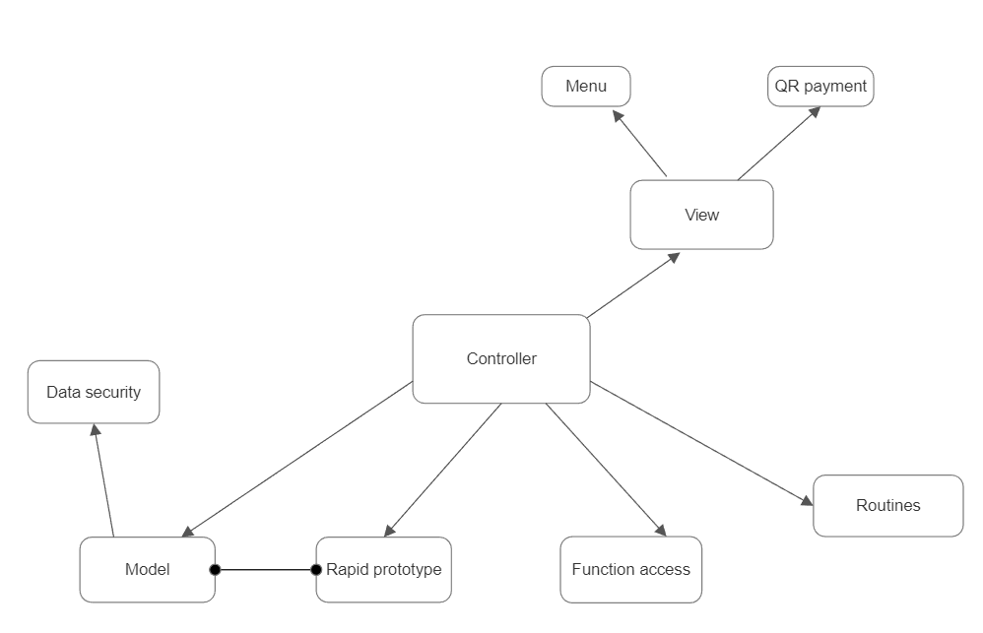

wireframe/mockup:

