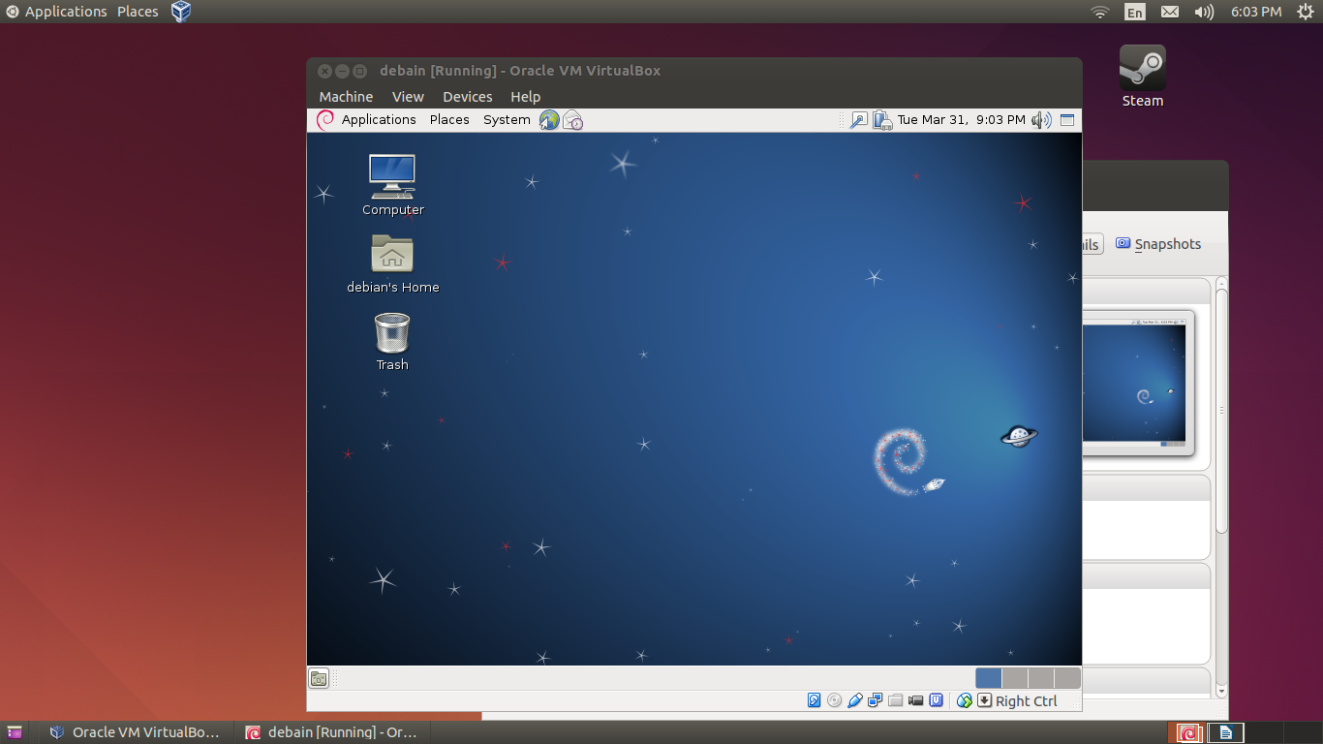
2, After successfully setup your virtual machine, start the Debian virtual machine and login. Please provide a screen shot for this step to prove you have successfully installed the virtual machine and it works properly.

Working virtual machine hosting debian 6.

3, After you log in the virtual machine, click the menu on the top left corner, Applications→ Accessories→Terminal, which causes a terminal window to open up. Type the command uname –a in this terminal window then press Enter Key. Please provide a screen shot for this step to prove you have successfully typed in the command and executed it. Make sure the screen shot includes the output that the command uname –a returns.
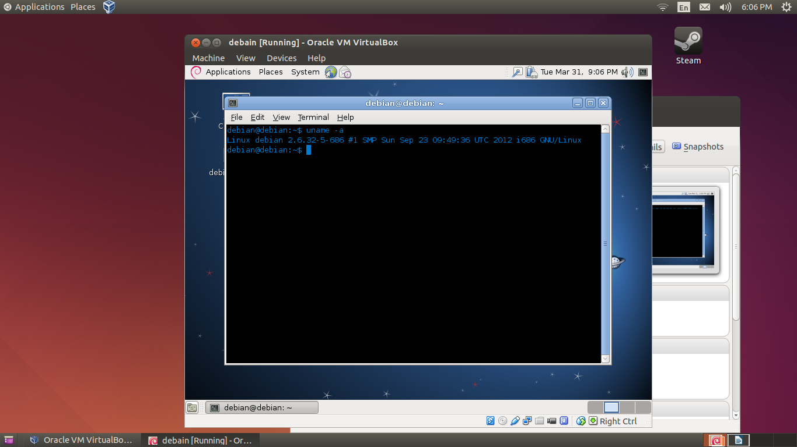
Command uname -a run in the debian virtual machine.
4, By following the instructions provided in the lecture notes, you are required to install anyConnect on your own computer in order to access VPN facilities. Please provide a screen shot for this step to prove you have successfully installed anyConnect and it connects properly.
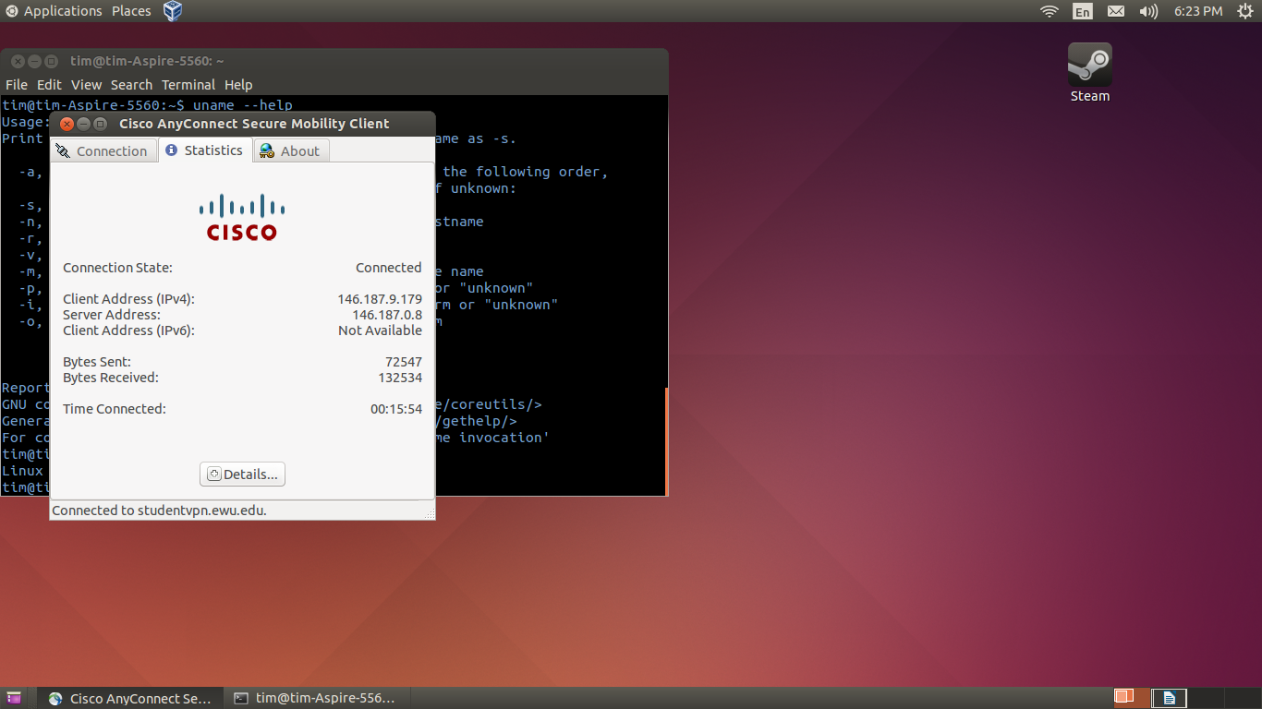
Image of anyConnect established connection to studentvpn.ewu.edu.

5, By following the instructions provided in the lecture notes, you are required to install WinSCP(with putty.exe, putty can be downloaded on the same page as WinSCP) on your own computer in order to access cslinux machine. Please provide a screen shot for this step to prove you have successfully installed WinSCP and it can connect to cslinux properly. (Launch the installed anyConnect and connect first before you connect to cslinux if you are off campus.) If you are Mac user, you can skip this step, but anyConnect in step is still required.

Skipped, using Ubuntu and winSCP is not necessary.

6, Open a putty terminal window through WinSCP interface, remote log in cslinux.eastern.ewu.edu. Type the command uname –a in this terminal window then press Enter Key. Please provide a screen shot for this step to prove you have successfully opened the putty terminal window, and typed in the command and executed it. Make sure the screen shot includes the output that the command uname –a returns. ( Note it must be a putty terminal window. ) If you are Mac user, please show me the command you used in your terminal for remote login. After login, please provide result of the command of uname –a.
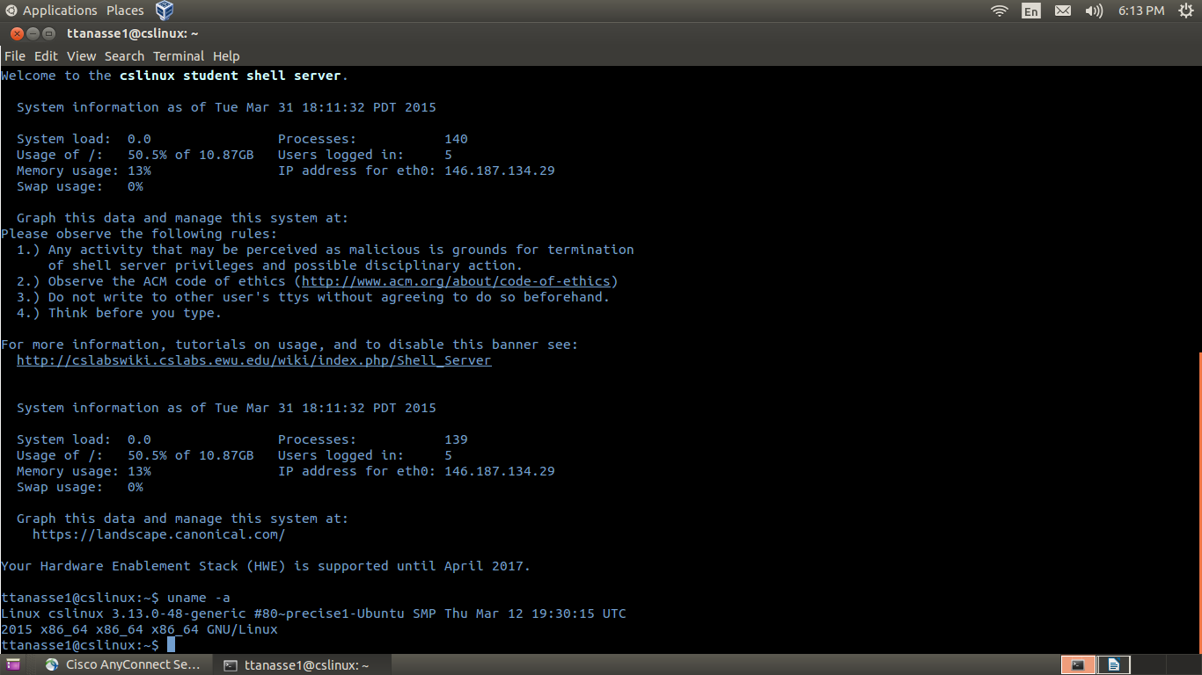
image of ssh into cslinux server. And returned uname -a command in bash.

