***RLAI Racing***

**Table of Contents**

**1. Introduction**

1.1. Overview…………………………………………………………2

1.3. Glossary………………………………………………………….3

**2. General Description**

2.1. Product/System Functions…………………………………….4

2.2. User Characteristics and Objectives………………………….5

2.3. Operational Scenarios………………………………………….6

2.4. Constraints……………………………………………………....7

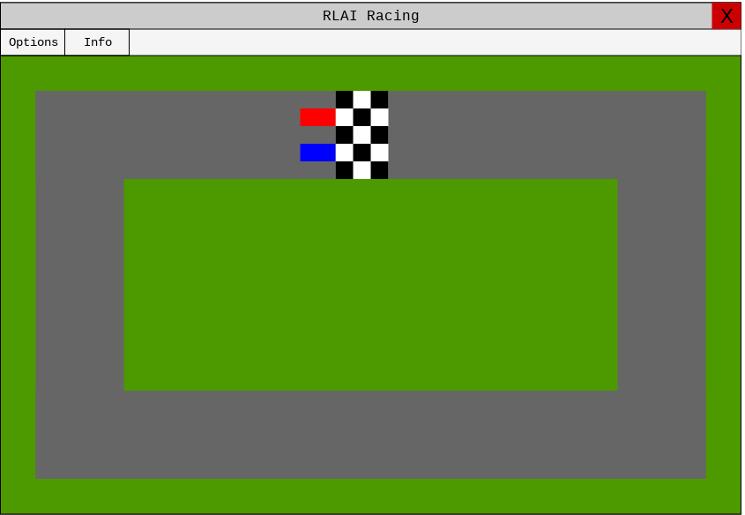

*RLAI Racing Window*

**1.1. Overview**

RLAI Racing is the application being created over the course of this project. It will feature a top-down, real-time, racing game environment that allows for a machine learning algorithm to engineer varying difficulties of an AI opponent. Reinforcement learning will be the dataset that is enforced. There is a distinct lack of interactive reinforcement learning demonstrations online and this project would lend itself to alleviating that.

The user will be given the opportunity to compete with an AI opponent on a simple racetrack from a birds-eye view. They will use various keyboard inputs to control their car. Both agents will be represented by red and blue cars and expected to compete with each other for the best lap. Both cars will be able to pass through each other without collision. The user may then view a leaderboard compiling the best time achieved by them and the AI opponent.

The end goal is to create a thorough demonstration of reinforcement learning within an interactive environment. RLAI Racing aims to be an example of the versatility and flexibility found in reinforcement learning and how it can be effectively applied to all manner of projects, from simple games to practical problem solvers.

**1.2. Glossary**

1. **Python:** High-level programming language used for primarily imperative-style programming, but can also be used for functional and object-oriented programming.
2. **OpenAI Gym:** Open-source toolkit for developing and comparing reinforcement learning algorithms. Created by the AI research company, OpenAI.

**2.1. Product/System Functions**

The program will be contained within a Python script, but it will take full advantage of the new modules that the OpenAI Gym toolkit introduces. Box2D will be imported to allow for the creation of 2D shapes to represent the racetrack and cars. Various utilities from Gym itself will also be incorporated. Any other important modules such as sys and math will be imported and used whenever necessary.

There will be a main menu where the user can choose between starting the game, viewing the leaderboard and exiting the program. The leaderboard will provide