ReadMe

1. Environment configuration: Please use jdk17 version, which can be downloaded from the official website.

It is best to use idea editor

Verify that all dependencies are imported in pom.xml before use

javafx configuration: Operate as shown

In edit

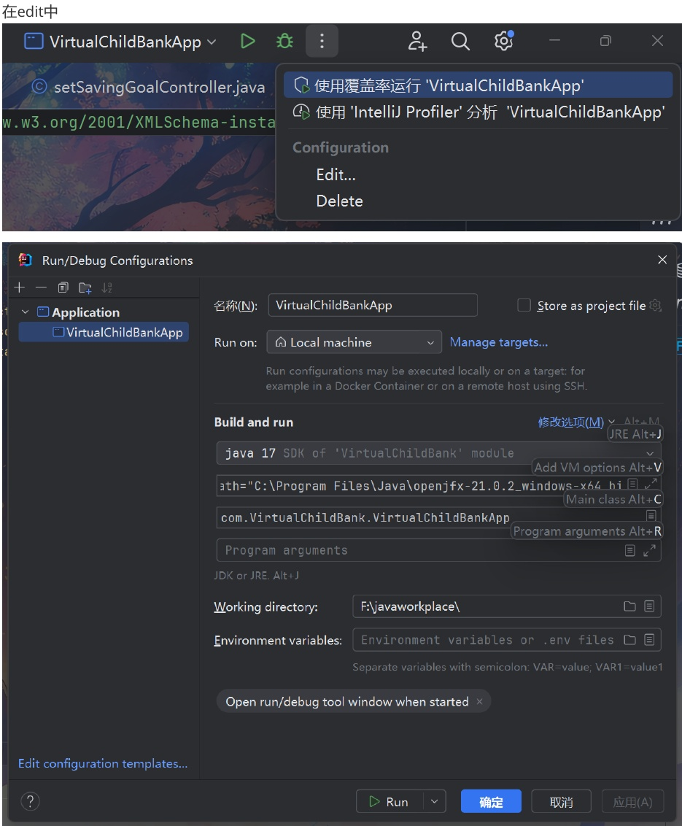

Second line of build and run

Complete the following code:

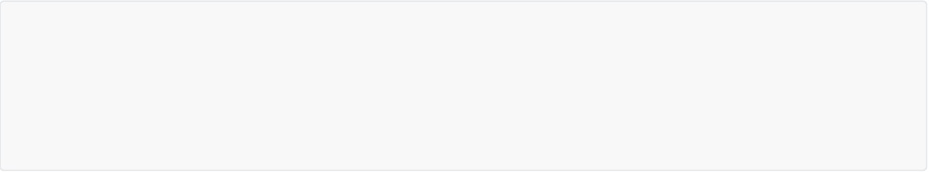

--module-path="C:\Program Files\Java\openjfx-21.0.2_windows-x64_bin-sdk\javafx-sdk-21.0.2\lib" --add-modules=javafx.controls,javafx.fxml --add-opens javafx.graphics/com.sun.glass.utils=ALL-UNNAMED --add-opens javafx.base/com.sun.javafx=ALL-UNNAMED --add-opens javafx.graphics/com.sun.javafx.tk=ALL-UNNAMED

Will --module-path="C:\Program Files\Java\openjfx-21.0.2_windows-x64_bin-sdk\ Javafx-SDK-21.0.2 \lib" The path here is changed to the lib path of Javafx-SD-21.0.2 for the package of javafx you received, Package name openjfx-21.0.2_windows-x64_bin-sdk Do not modify the rest

2. Change the saved data path

Since the data is saved using the absolute path, you will need to change the path in userdao



private static final String JSON_FILE_PATH = "F:\\javaworkplace\\VirtualChildBank\\src\\main\\resources\\json\\users.json";

Change to the absolute path to users.json in the code you downloaded

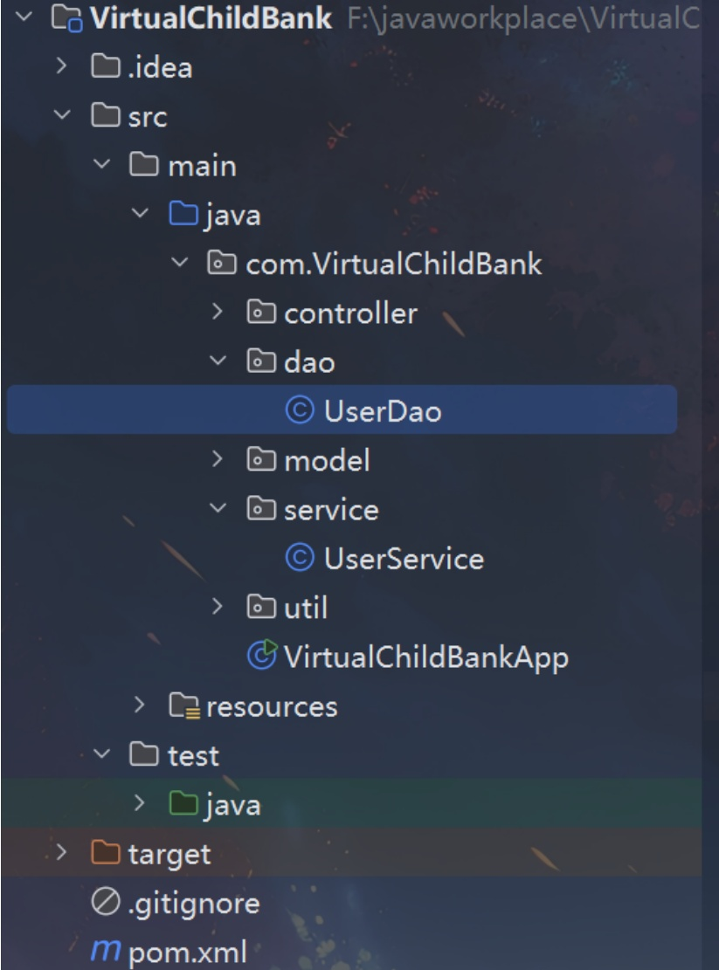

users.json is in resources, please do as shown in the image below

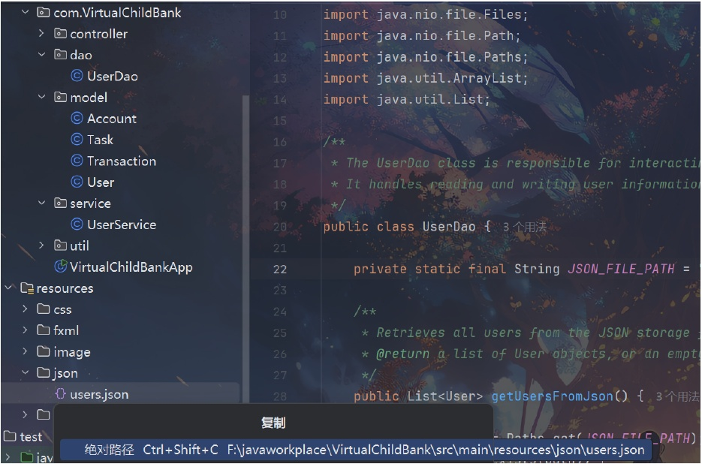

You should copy the absolute path

Then change it again

This way you can read the user manual to use the full functionality of the software!