CyberFinanceIntegerate – Project Report
Name :Hamyal
Roll no :22f-3184

1. Executive summary
CyberFinanceIntegerate is a small analytical project centered on a single Jupyter notebook that explores whether cyber-security threat activity can help forecast a widely used financial stress indicator (the St. Louis Fed Financial Stress Index, STLFSI4). The notebook implements a complete workflow including data loading, data cleaning, temporal alignment, feature engineering, anomaly detection, model training, performance evaluation, and explainability outputs. The intended final output is a next-step prediction of financial stress (labeled StressIndex in the notebook) using recent history of engineered cyber and financial features.

2. Inventory of files
The folder contains the following files, which together define the full scope of the project.
1. CyberFinance.ipynb
2. CyberFinanceIntegerate_Report.docx
3. STLFSI4.csv
4. cyber_data.csv
5. generate_report.py

3. Data inputs and structure
The project uses two data sources. The first is cyber_data.csv, which contains cyber threat telemetry by attack date and country, including measures such as Spam, Ransomware, Local Infection, Exploit, Malicious Mail, Network Attack, On Demand Scan, and Web Threat. The file also includes ranking columns for several categories. The second input is STLFSI4.csv, which contains the financial stress index values over time with the columns observation_date and STLFSI4. This financial series appears to be reported at a weekly cadence.
Within the notebook, the financial column STLFSI4 is renamed to StressIndex, and multiple derived financial features are computed to capture short-term smoothing, longer-term trend, and short-window variability. The cyber dataset is converted to numeric where possible and missing values are filled in a way that permits model training; this is convenient for experimentation, but it also makes assumptions about the meaning of missingness, which should be documented explicitly in any production setting.

4. Data processing and feature engineering
Cyber data processing begins by parsing AttackDate into a datetime value using multiple fallback parsing strategies. A composite ThreatScore is constructed as a weighted sum of the underlying cyber categories. The data is then aggregated by date, producing daily-level summary statistics such as mean, maximum, and standard deviation for ThreatScore, along with additional descriptive statistics for selected categories (for example, average and maximum Ransomware and Network Attack metrics, and the count of ransomware observations).
Financial feature engineering starts with the conversion of observation_date to a datetime and conversion of STLFSI4 to a numeric series. The notebook computes rolling moving averages over 7 and 30 days, a 7-day rolling standard deviation as a volatility proxy, and a percentage-change return feature. It also creates lagged versions of StressIndex over several horizons (1, 3, and 7) to provide autoregressive signal to the models. A binary high-risk indicator is generated when StressIndex exceeds 0.5; this is not used directly as the primary modeling target in the notebook, but it can be useful for classification or threshold-based monitoring extensions.
Temporal alignment is performed by identifying the overlapping date range across both datasets, generating a daily date grid, and merging the cyber aggregates and finance features onto this shared timeline. Cyber features are forward-filled and then set to zero if still missing, while finance features are linearly interpolated, then backfilled, and set to zero if still missing. An interaction feature between ThreatScore_mean and StressIndex is also constructed when both are present.

5. Anomaly detection
The notebook implements a simple anomaly detection approach using z-scores. Cyber anomalies are flagged when the absolute z-score of ThreatScore_mean exceeds a configurable threshold (default 2.5). Financial anomalies are flagged analogously for StressIndex. A correlated anomaly indicator is then created when a cyber anomaly is followed by at least one financial anomaly within the subsequent 7-day window. This logic provides an exploratory signal for potential short-lag relationships between cyber events and financial stress, although it should be treated as heuristic rather than statistically validated inference.

6. Forecasting formulation and model training
The forecasting problem is implemented as a supervised next-step prediction task. The aligned dataset is converted into sequences using a sliding window. For each training example, the feature matrix consists of a fixed-length history of engineered features, and the label is the next-day StressIndex value. In the main execution path of the notebook, the sequence length is set to 10 days. The data is split into train, validation, and test subsets. Features are standardized using StandardScaler, with the scaler fitted on the training subset and applied to validation and test subsets.
Three deep learning architectures are defined in PyTorch: a DualStreamLSTM model, a custom Temporal Fusion Transformer style encoder model, and a GRU model with attention pooling. The training routine uses mean squared error loss, the Adam optimizer, and a ReduceLROnPlateau learning-rate scheduler. The notebook trains these models for 50 epochs when sufficient sequence data is available. If the aligned data is too small, the notebook will skip neural network training to avoid unstable results.
In addition to the neural networks, the notebook trains several classical machine learning models on flattened sequence features, including RandomForestRegressor, XGBoost, and LightGBM models tuned with GridSearchCV. It also fits a stacking ensemble using a linear regression final estimator. These models typically provide strong baselines for tabular time-series features and are often more practical for small to medium data volumes.
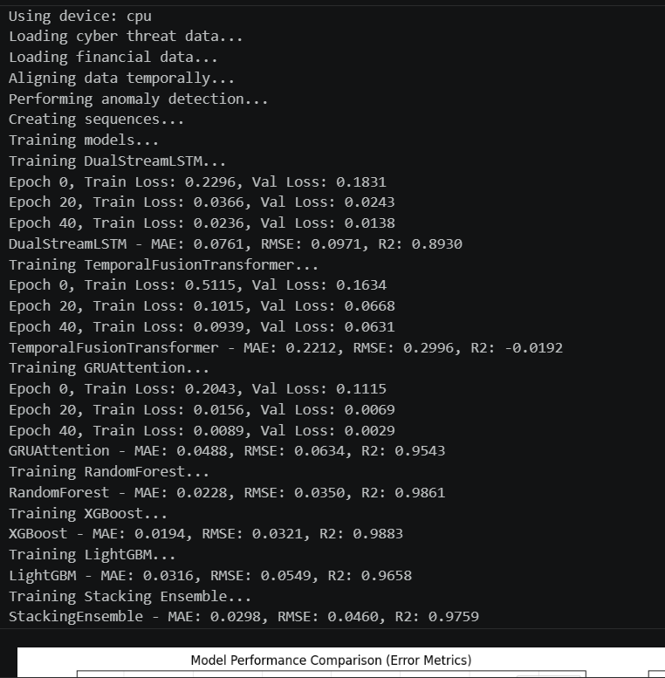

7. Evaluation, model selection, and explainability
Model evaluation is performed using mean absolute error, root mean squared error, and coefficient of determination (R²) on the held-out test set. The notebook selects a best model by choosing the model with the minimum RMSE. For interpretability, SHAP values are computed for supported models. TreeExplainer is used for tree-based models, and KernelExplainer is used for models without native SHAP support, although KernelExplainer can be computationally expensive and is therefore applied to a limited sample.

8. Visualizations and saved outputs
The notebook produces multiple plots intended to summarize both model performance and the relationship between cyber and financial variables. These include model comparison charts, predicted versus actual scatter plots for the best model, residual diagnostics, time-series overlays of StressIndex and cyber-derived threat measures with anomaly markers, a correlation matrix heatmap, and feature importance plots for models that expose such attributes. For attention-based neural models, attention heatmaps can also be saved for inspection.
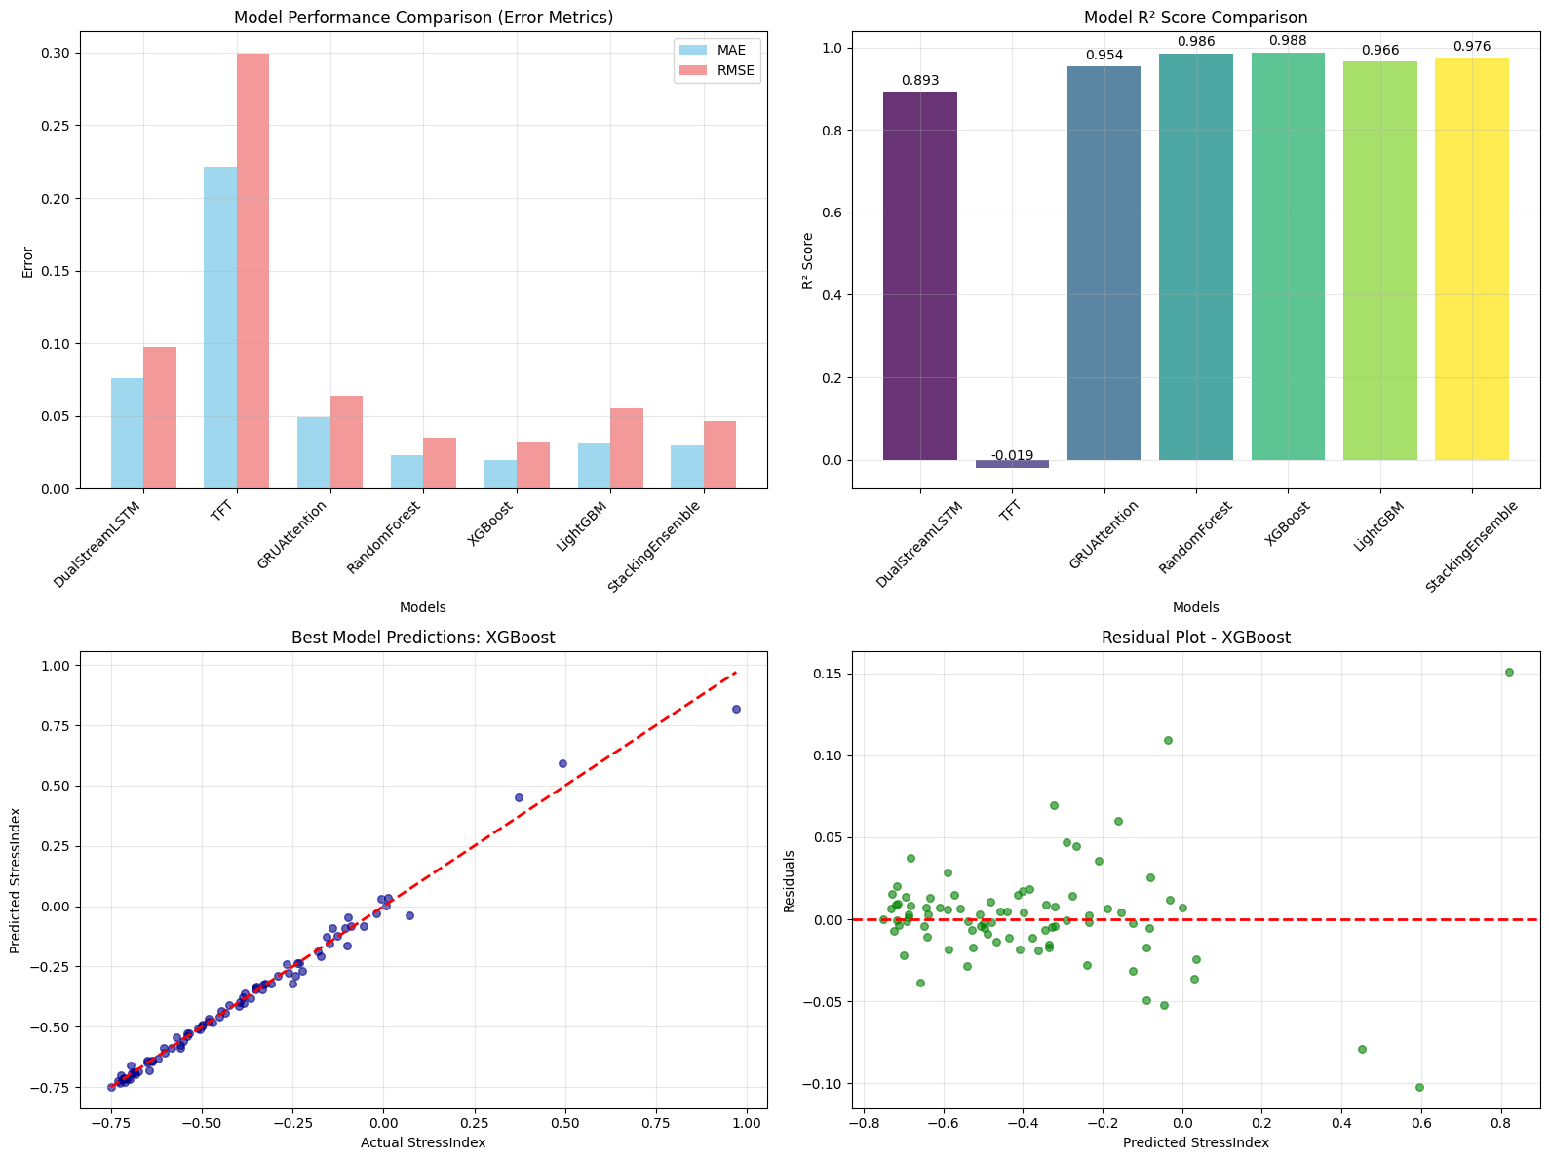
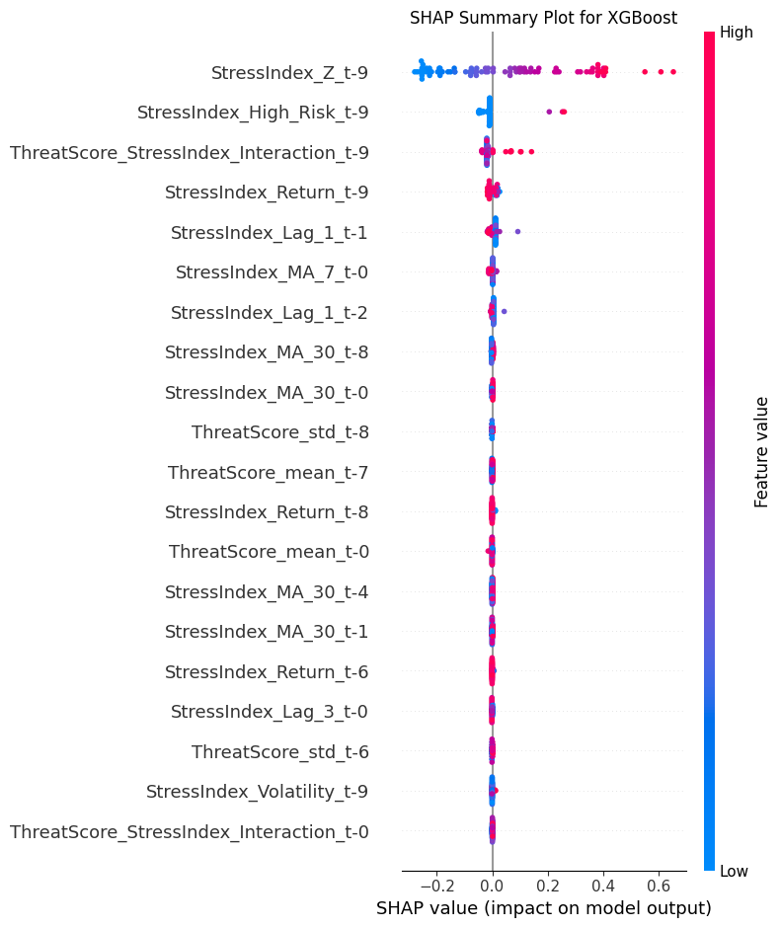

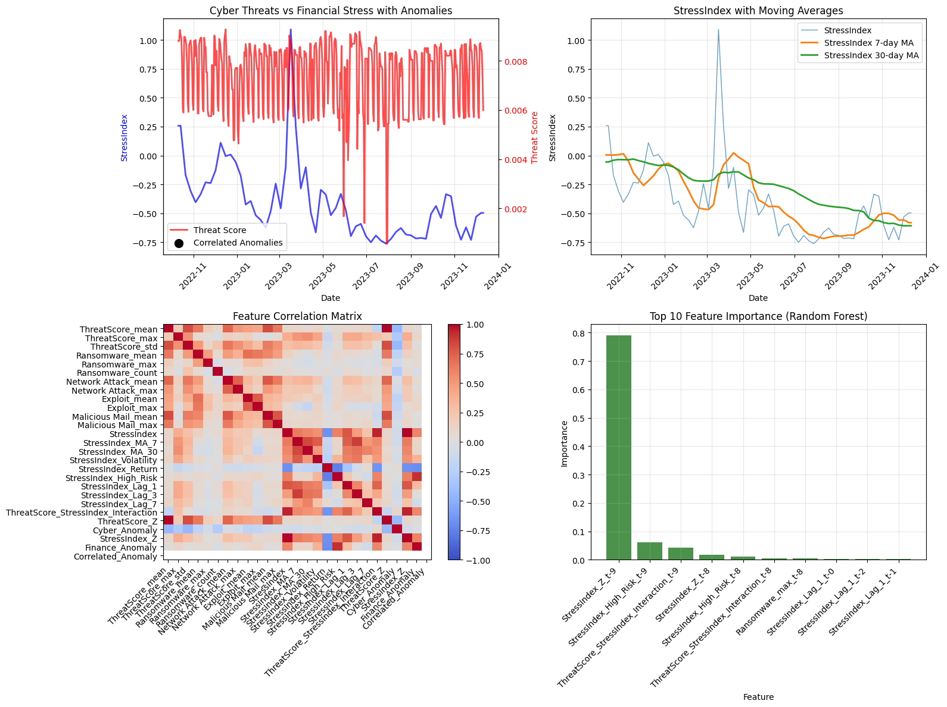

9. Execution instructions
The recommended way to run the analysis is to open CyberFinance.ipynb in Jupyter Notebook or JupyterLab and execute the notebook in an environment where the required libraries are installed. The two CSV files, cyber_data.csv and STLFSI4.csv, must be available in the same working directory as the notebook, as the notebook loads them using relative file paths. If required, the notebook can be exported to a Python script; in that case, it contains a main function and a standard __main__ entry point that can be used as an execution driver.

10. Dependencies and environment considerations
The notebook imports and relies on pandas, numpy, matplotlib, seaborn, plotly, scikit-learn, PyTorch, SciPy, SHAP, and gradient-boosting libraries including XGBoost and LightGBM. A GPU is optional; the notebook will use CUDA if available. Runtime may be significant on CPU because it combines multiple hyperparameter searches and optional SHAP computations.

11. Technical observations and limitations
There are several implementation details worth noting. First, while the DualStreamLSTM class is conceptually framed as a dual-input model, the current main execution path feeds the same input tensor into both the cyber and finance LSTM components, rather than explicitly splitting features into separate cyber and finance streams. Second, the correlated anomaly flag is set using chained indexing in pandas, which can lead to SettingWithCopy warnings and unintended behavior in certain circumstances. Third, the project imports additional estimators (for example SVR and some linear models) that are not trained in the main path, which suggests the notebook has been iterated over time and could benefit from cleanup or consolidation. Finally, the approach of filling missing cyber values with zeros and interpolating finance values introduces assumptions that may materially affect outcomes and should be validated against domain expectations.

