# **KFUPM PHOTO CLUB WEBSITE**

**Project Phase III**

# **Team Members:**

# **Hamza Alshaikhi 202173730**

# **Abdulrahman Amin 202045000**

# **Waleed Alzahrani 201927310**

# **Mohammed Alamri 201933490**

# **Abdulaziz Altamimi 201962250**

# I. Identification of the project's main motivation:

The mean gool of this web application is to help PhotoClub with there work of applauding and sharing of their photos and event to their fans. Also, the application will make the process of searching for specific photo much easier. Furthermore, the application will have a special space for photographers to shire their creativities and their experiences.

# II. Users of the web app:

1. PhotoClub administrators:

Create events, upload pictures in the events, and may remove pictures from the space.

2-    Web viewers:

Able to view events, photos, and create accounts.

3-    Users of the web (who have account in the application):

Able to upload photos, interact with other people photos.

4-    Face recognition API

we are planning to use a face recognition API to ease the search for someone picture

5-    OpenAI API

OpenAI API might help in searching for pictures by their content in the space by using  some keywords or tags like cars, Building 59,etc

# III. Tentative Project Plan (Schedule):

1. Design and Front-End Development:

a. Website Design (led by Waleed)

  - UI/UX design phase.

  - Create sample designs and mockups.

  - Finalize the design based on feedback.

b. Front-End Development (led by Abdulrahman)

  - Develop the user interface of the website.

  - Implement user registration and login features.

  - Set up events and photo viewing pages.

  - Begin integrating OpenAI API for content-based search.

2. Back-End Development

a. Back-End Setup (led by Mohammed)

  - Select a suitable back-end framework (e.g., Django, Flask, or Express.js)

  - Create the database schema for users, events, and photos.

  - Set up user authentication and authorization.

b. Core Functionality (led by Abdulaziz)

  - Implement event creation and management features for administrators.

  - Enable photo upload and management (upload, delete) for administrators and users.

  - Start working on user interactions with photos.

3- Face Recognition Integration

a. API Selection and Setup(led by Hamza)

  - Finalize the choice of the face recognition API.

  - Integrate the API for face detection and recognition.

  - Test face recognition functionalities.

4- OpenAI API Integration

a. OpenAI Integration(led by Hamza)

  - Integrate OpenAI API for content-based photo search.

  - Implement keyword and tag-based searching.

-b. Testing and Optimization(led by Waleed)

  - Thoroughly test the OpenAI integration for search functionality.

  - Optimize the search algorithms and UI.

5- Testing and Quality Assurance

-a. Testing Phase(led by Abdulrahman)

  - Conduct testing for the final app

  - Fix any bugs or issues identified during testing.

6- Documentation (no one is leading anything here)

note: we are not planning to make someone do the job by himself in order to distribute the work as much as possible and to give each person a chance to practice in many things. So, we just made each one to be responsible for a certain tasks even though all of us might work on it. (we might not even stick to it since it's just a small team)

# IV. Requirements Modeling:

**Functional Requirements:**

1. **Photo Display:**
   1. The app should display all the event photos to both visitors and registered users.
   2. The app should also display club events to visitors and users.
2. **Photo Uploading:**
   1. The administrator should have the ability to upload photos either one by one, in groups, or by folder.
   2. The registered users are able to post their own photos in a separate space than the events.
3. **Search Functionality:**
4. Visitors and users should be able to search for photos using two methods:
   1. By face: Implementing facial recognition to allow users to search for photos with specific individuals.
   2. By text: Provide a search bar for text-based searches to find photos based on keywords, event names, or descriptions.(might be used in photographer space)
5. **Photographer Space:**
   1. Create a dedicated space within the application for photographers to share their creative works and experiences. This space should include photos that are uploaded by the users
   2. user can interact with each other posts through this space using likes, comments, etc.
   3. photos in space can appear sorted by (likes, popularity, recent)

**Non-Functional Requirements:**

1. **Availability:**

The application should be available and functional 24/7. It should be a accessible to users at all times.

1. **Search Performance:**

The search function should return results within one minute or less.

1. **Cross-Platform Compatibility:**

Make the application accessible on various devices and platforms, including desktops, smartphones, and tablets.

4. **User Support:**

Provide user support through customer service channels, FAQs, or a knowledge base to assist users with any issues they encounter.

1. **Error Prevention and recovery:**

trying to minimize the error rate by different type of users and help them to recover fast

# V. Domain Modeling:

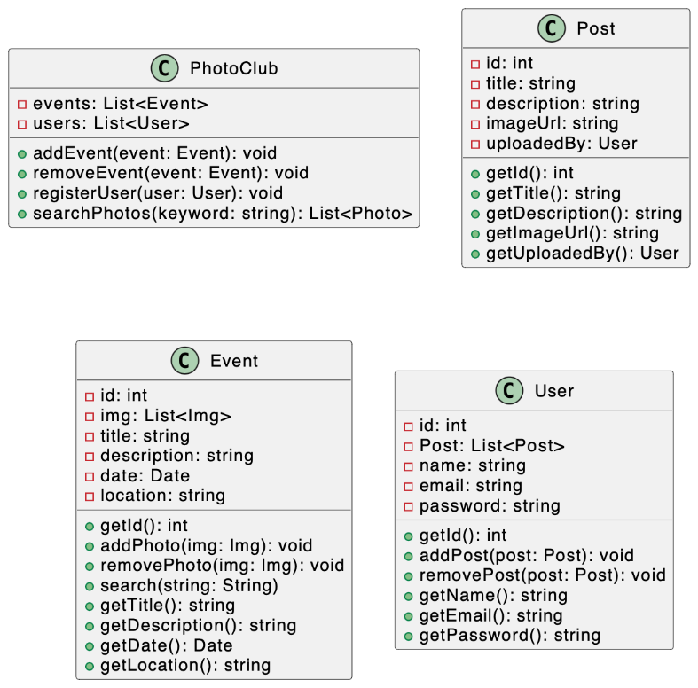

1. PhotoClub class is representing the Admin in the system where he can add, delete, or modify events

2. Post class is the class representing the post object which is uploaded by a user

3. Event class represents an event by the club

4. User class is obviously the representing the user objects

# VI. Navigation Modeling:

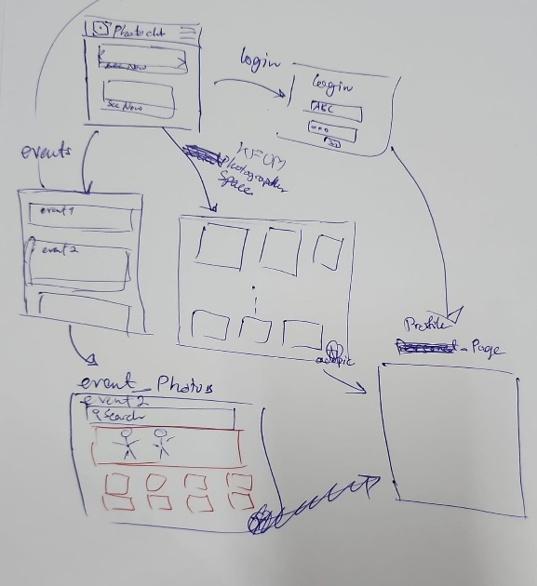

Main interfaces:

1. main screen: where new and latest events are shown a user can either go to screens 2,3,4 through it

2. events screen: where a user can see events -he may filter them- then select the event he wants to get to screen 5

3. is the photographer space where the trending pictures that are taken by the users are shown you can go from it to screen 6

4. login/ register page where a user may enter his data and register or login if he already have an account

5. event pictures where a picture of certain events are uploaded

6. profile page for a certain user the user may see someone else pictures

# VII. Low-Fi User Interface Design:

<https://www.figma.com/proto/m73ZOUTbFndARm2F32tC3a/Untitled?type=design&node-id=1-3&t=E2eDSRTjy3ey9LoV-0&scaling=scale-down&page-id=0%3A1&starting-point-node-id=1%3A3>

the user interface design in the link above are for the main and event pages.

# VIII. References and Definitions:

[https://chatuml.com/edit/new#](https://chatuml.com/edit/new) for UML figures